

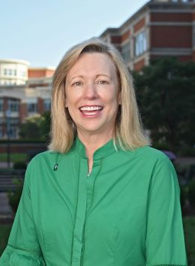
Welcome to UNC Charlotte, North Carolina’s urban research university. As you work toward your undergraduate or graduate degree, please think of UNC Charlotte’s dedicated faculty and staff as partners in your success. Their expertise and support, along with the many University resources and services available to you, will enable you to meet your academic, personal and professional aspirations.

Founded in 1946, UNC Charlotte has enjoyed an astounding trajectory over its history, made possible by visionary leaders, extraordinary students, stellar faculty and staff, and dedicated alumni.

As part of “Shaping What’s Next,” our 10-year strategic plan, there’s a renewed commitment to transforming students’ lives as we also embrace a bold new vision as a globally recognized top-tier research university.

Our promise is to not only provide a supportive community in Niner Nation but also to help you complete your degree on time, and to be equipped to thrive in a diverse and ever-changing world. There are many great things happening here in Niner Nation – but at the core of all of it is our commitment to the success of our students. We are focused on providing the resources and support for you to succeed.

Over the past decade – through the combined efforts of faculty, staff and students – we’ve developed comprehensive programs to increase student retention and graduation rates. We call these programs cumulatively “The Charlotte Model” of student success. This innovative work has transformed our University, raised our graduate rates and reduced the equity gap. Today, UNC Charlotte is considered a national model in the areas of student success and social mobility, and we are one of the fastest rising universities in the U.S. News & World Report rankings.

During your time here, explore all the possibilities available! Take advantage of leadership and volunteer opportunities; attend cultural events and lectures; join a student organization; participate in intramural sports; and cheer on your Charlotte 49ers whenever they are competing.

The past few years have been tough for many of us. Please speak up if you are struggling and don’t be afraid to ask for help. We have many resources on campus to assist you. Please also get involved on campus and be an active partner in your education.

It is truly a privilege to serve as your chancellor. Please know that I will do everything in my power to support and strengthen our academic enterprise, ensure a great college experience for you, and always place the highest priority on the safety and well-being of our campus community.

I am delighted that you’ve made UNC Charlotte your university of choice. I look forward to seeing you on campus. Go Niners!

Sincerely,


Sharon L. Gaber
Chancellor

