Academic

Programs

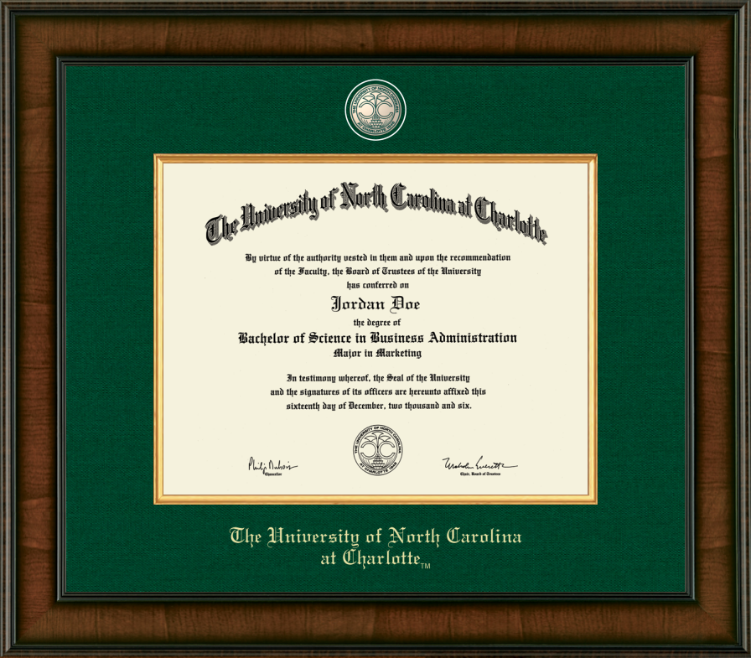

Academic
Programs
academics.charlotte.edu

College and Program | Degree/Certification Awarded
 | Bachelor's | Minor | Undergraduate Certificate | Graduate Early Entry Program
College of Arts + Architecture
Architecture | BA
Art  3D Interdisciplinary Studies: Art in Space  Art Education  Digital Media  Illustration  Painting  Photography  Print Media  Cross-Disciplinary | BA, BFA
Art History | BA
Dance  Applied Dance  Dance Education  Performance, Choreography, and Theory | BA
Graphic Design | BFA
Jazz Studies
Music  Composition  Elective Study in an Outside Field  Music Education, Instrumental/General  Music Education, Choral/General  Jazz Studies  Performance, Instrumental  Performance, Vocal | BA, BM
Musical Theatre
Theatre  Applied Theatre  Design/Tech  Directing, Dramaturgy, and Dramatic Writing (3-D)  Performance  Theatre Education | BA
Belk College of Business
Accounting | BS
Business Analytics | BSBA
Economics  Business  Liberal Arts | BS
Entrepreneurship
Finance  Finance  Finance/Accounting  Risk Management and Insurance | BSBA
International Business | BSBA
International Management
Management  Human Resource Management  Organizational Management | BSBA
Management Information Systems | BSBA
Marketing  Marketing  Marketing Analytics | BSBA
Operations and Supply Chains Management | BSBA
 | Bachelor's | Minor | Undergraduate Certificate | Graduate Early Entry Program
College of Computing and Informatics
Artificial Intelligence
Bioinformatics and Genomics
Computer Science  AI, Robotics, and Gaming  Bioinformatics  Cybersecurity  Data Science  Human-Computer Interaction  Information Technology  Software, Systems, and Networks  Software Engineering  Web and Mobile Applications | BA, BS
Cybersecurity
Data Science
Information Technology
Game Design and Development
Human-Centered Design
Interactive Programming
Software and Information Systems
Software Development
Software Systems
Cato College of Education
Child and Family Development | BA
Elementary Education | BA
Foreign Language Education (K-12)
Global Education, Applied Understandings
Middle Grades Education | BA
Reading Education
Secondary Education
Special Education  Adapted Curriculum  General Curriculum  Academically or Intellectually Gifted | BA
Special Education | Elementary Education (dual) | BA
Teaching English as a Second Language
Urban Youth and Communities
The William States Lee College of Engineering
Construction Management  Applied Energy and Sustainable Systems | BSCM
Engineering
Civil Engineering  Energy Infrastructure  Land Development Engineering | BSCE
Computer Engineering | BSCpE
Electrical Engineering  Power and Energy Systems | BSEE
Environmental Engineering | BS
Mechanical Engineering  Biomedical Engineering  Energy Engineering  Motorsports Engineering  Precision Engineering and Metrology | BSME
Systems Engineering | BSSE

 | Bachelor's | Minor | Undergraduate Certificate | Graduate Early Entry Program
The William States Lee College of Engineering (continued)
Engineering Technology
Civil Engineering Technology  Applied Energy and Sustainable Systems | BSET
Electrical Engineering Technology  Applied Energy  Electromechanical | BSET
Fire and Safety Engineering Technology  Fire Safety  Occupational Safety | BSET
Mechanical Engineering Technology  Applied Energy  Electromechanical | BSET
College of Health and Human Services
Clinical Research Management
Exercise Science  Health and Fitness  Pre-Professional  Strength and Conditioning | BS
Health Informatics and Analytics
Health Systems Management | BS
Nursing  RN-to-BSN | BSN
Nutrition
Outdoor Adventure Leadership
Public Health | BSPH
Respiratory Therapy | BSRT
Social Work | BSW
Sports Analytics
College of Liberal Arts & Sciences
Actuarial Mathematics
Aerospace Studies
Africana Studies  Health and Environment  Popular Culture and Digital Media  Social Justice and the Law | BA
Anthropology  Applied Anthropology | BA
American Studies
Arabic Studies
Biology | BA, BS
Biotechnology
Capitalism Studies
Chemistry  Biochemistry  Education | BA, BS
Children’s Literature and Childhood Studies
Chinese
Classical Studies
Cognitive Science
Communication Studies  Communication Studies  Rhetoric, Culture and Social Change  Health Communication  Media & Technology Studies  Organizational Communication  Public Relations | BA

College of Liberal Arts & Sciences (continued)
 | Bachelor's | Minor | Undergraduate Certificate | Graduate Early Entry Program
Criminal Justice  Crime Analytics | BA
Diverse Literatures and Cultural Studies
Earth and Environmental Sciences | BS
English  Creative Writing  Language and Digital Technology  Literature and Culture  Pedagogy | BA
Environmental Studies  Education | BA
Film Studies
Francophone Studies
French  Business  Translating | BA
French Education (K-12) | BA
Geography  Education | BA, BS
Geology | BS
German  Business  Education  Translating | BA
Gerontology
Health & Medical Humanities
History  Education | BA
Humanities, Technology, and Science
Interdisciplinary Studies | BA
International Public Relations
International Studies  Asian Studies  Development and Sustainability  European Studies  Holocaust, Genocide, and Human Rights  Peace, Conflict, and Identity | BA
Italian
Japanese  Business  Translating | BA
Journalism
Latin American Studies | BA
Leadership Studies
Legal Studies
Linguistics
Mathematics  Actuarial Science  Statistics  Education | BA, BS
Mathematics for Business | BA, BS
College of Liberal Arts & Sciences (continued)
 | Bachelor's | Minor | Undergraduate Certificate | Graduate Early Entry Program
Meteorology | BS
Military Science
Philosophy | BA
Physics | BA
Physics | Computer Engineering (dual) | BA, BS
Physics | Electrical Engineering (dual) | BS
Physics | Mechanical Engineering (dual) | BS
Political Science  Security and Intelligence Systems | BS
Psychology | BA
Religious Studies | BS
Russian  Translating | BA
Sociology
Organizations, Occupations, and Work
Social Problems and Policy
Sociological Social Psychology
Southern Studies | BA
Spanish
Applied Language
Business
Literature and Culture
Education
Translating
Statistics | BA
Technical and Professional Writing
Urban Studies
Video Production
Women’s and Gender Studies
Writing, Rhetoric, and Digital Studies | BA
School of Data Science
Data Science BS
Sports Analytics
Health Informatics and Analytics | BS
School of Professional Studies
Professional Studies
 | BS

Accreditations
assessment.charlotte.edu/accreditations/accreditation

Accreditation is important for the University to be able to receive and distribute state and federal funds. Also, accreditation is important for the acceptance and transfer of college credits. The Office of Institutional Effectiveness and Analytics serves as the accreditation liaison for the University and is responsible for assuring that compliance with accreditation requirements is incorporated into planning and evaluation processes of the institution.

Institutional accrediting bodies conduct comprehensive reviews of institutions of higher education. This review ensures that "the institution (1) has a mission appropriate to higher education, (2) has resources, programs, and services sufficient to accomplish and sustain that mission, and (3) maintains clearly specified educational objectives that are consistent with its mission and appropriate to the degrees it offers and that indicate whether it is successful in achieving its stated objectives" (Principles of Accreditation: Foundations for Quality Enhancement). The accreditation granted encompasses the entire institution, including all degree programs, instructional sites, and online programs.

UNC Charlotte
UNC Charlotte is accredited by the Southern Association of Colleges and Schools Commission on Colleges (SACSCOC) to award baccalaureate, master’s, and doctoral degrees. UNC Charlotte also may offer credentials such as certificates and diplomas at approved degree levels. Questions about the accreditation of UNC Charlotte may be directed in writing to the Southern Association of Colleges and Schools Commission on Colleges at 1866 Southern Lane, Decatur, GA 30033-4097, by calling (404) 679-4500, or by using information available on SACSCOC’s website (www.sacscoc.org).

The University of North Carolina at Charlotte was reaffirmed by SACSCOC for the next ten years. The decision was made at the December 2013 Annual Meeting of the Southern Association of Colleges and Schools Commission on Colleges (SACSCOC).

College of Arts + Architecture
The Bachelor of Architecture and Master of Architecture are accredited professional degree programs as recognized by the National Architectural Accrediting Board (NAAB).

The Bachelor of Arts in Art, Bachelor of Fine Arts in Art, Bachelor of Fine Arts in Graphic Design, and Bachelor of Arts in Art History are accredited degree programs as recognized by the National Association of Schools of Art and Design (NASAD).

The Bachelor of Arts in Music and Bachelor of Music are accredited degree programs as recognized by the National Association of Schools of Music (NASM).

The Bachelor of Arts in Dance is an accredited degree program as recognized by the National Association of Schools of Dance (NASD).

All arts education programs leading to K-12 licensure (art, dance, music, and theatre education) are accredited by their national accrediting body (the National Association of Schools of Art and Design, National Association of Schools of Dance, National Association of Schools of Music, and National Association of Schools of Theatre) and approved as Educator Preparation Programs by the North Carolina Department of Public Instruction (NCDPI).

College of Business
The programs in business and accounting are accredited by AACSB International, the Association to Advance Collegiate Schools of Business. AACSB International is the premier accrediting agency for bachelor's, master's, and doctoral degree programs in business administration and accounting.

College of Education
The College’s professional education programs for BK-12 teachers, counselors, and administrators are approved by the North Carolina Department of Public Instruction (NCDPI) and accredited by the Council for the Accreditation of Educator Preparation (CAEP).

Counseling programs in Counselor Education are accredited by the Council for Accreditation of Counseling and Related Educational Programs (CACREP).

College of Engineering
The baccalaureate programs in civil, computer, electrical, mechanical, and systems engineering are accredited by the Engineering Accreditation Commission of ABET, www.abet.org.

The civil, electrical, and mechanical engineering technology baccalaureate programs are accredited by the Engineering Technology Accreditation Commission of ABET, www.abet.org.

The construction management baccalaureate program is accredited by the Engineering Technology Accreditation Commission and the Applied and Natural Science Commission of ABET, www.abet.org.

College of Health and Human Services
The baccalaureate degree in nursing/master's degree in nursing/Doctor of Nursing Practice and/or post-graduation APRN certificate at the University of North Carolina at Charlotte is accredited by the Commission on Collegiate Nursing Education (www.ccneaccreditation.org).

The undergraduate nursing programs are approved by the North Carolina Board of Nursing.
The Nursing Anesthesia program is accredited by the Council on Accreditation of Nurse Anesthesia Education Programs (COA).

The Exercise Science program is accredited by the Commission on Accreditation of Allied Health Education Programs (www.caahep.org) upon the recommendation of the Commission on Accreditation for the Exercise Sciences (CoAES).

The Clinical Exercise Physiology concentration of the Master of Science in Kinesiology is accredited by the Commission on Accreditation of Allied Health Education Programs (www.caahep.org) upon the recommendation of the Commission on Accreditation for the Exercise Sciences (CoAES).

The Bachelor of Science in Respiratory Therapy (program #500001) and Master of Science in Respiratory Care (program #520001) at UNC Charlotte have been provisionally accredited by the Commission on Accreditation for Respiratory Care (coarc.com). CoARC accredits respiratory therapy education programs in the United States. To achieve this end, it utilizes an ‘outcomes-based’ process. Programmatic outcomes are performance indicators that reflect the extent to which the educational goals of the program are achieved and by which program effectiveness is documented (coarc.com/students/programmatic-outcomes-data).

The Master of Health Administration program is accredited by the Commission on Accreditation of Healthcare Management Education (CAHME).

The Public Health programs (BSPH, MPH, Ph.D. in Public Health Sciences, and Ph.D. in Health Services Research) are accredited by the Council on Education for Public Health (CEPH).

Both the Bachelor of Social Work (BSW) and the Master of Social Work (MSW) are accredited by the Council on Social Work Education (CSWE).

College of Liberal Arts & Sciences
The Department of Chemistry is on the approval list of the American Chemical Society.

The Public Relations program within the Department of Communication Studies is certified by the Public Relations Society of America (PRSA).

The Clinical Psychology program within the Ph.D. in Health Psychology is accredited by the American Psychological Association (APA).

The Master of Public Administration program is accredited by the National Association of Schools of Public Affairs and Administration (NASPAA).

Graduate School
The University is a member of the Council of Graduate Schools, the Conference of Southern Graduate Schools, and The North Carolina Conference of Graduate Schools.

