School of

Professional Studies

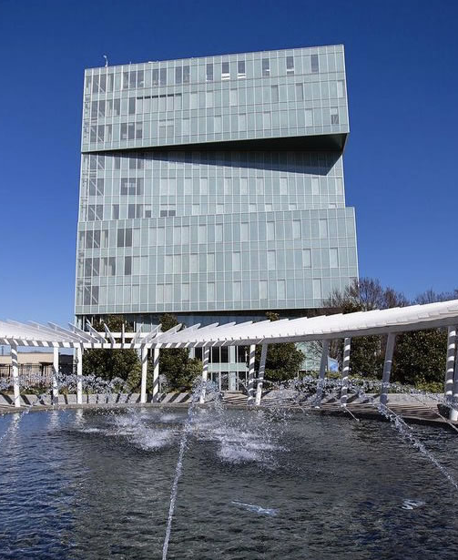

School of
Professional Studies
professional.charlotte.edu

The UNC Charlotte School of Professional Studies ensures that all learners, regardless of age, level of experience, or previous education, have opportunities to learn, grow, and achieve their personal and professional goals with a UNC Charlotte education. We believe that everyone deserves lifetime access to education that enables a lifelong journey of personal and professional growth.

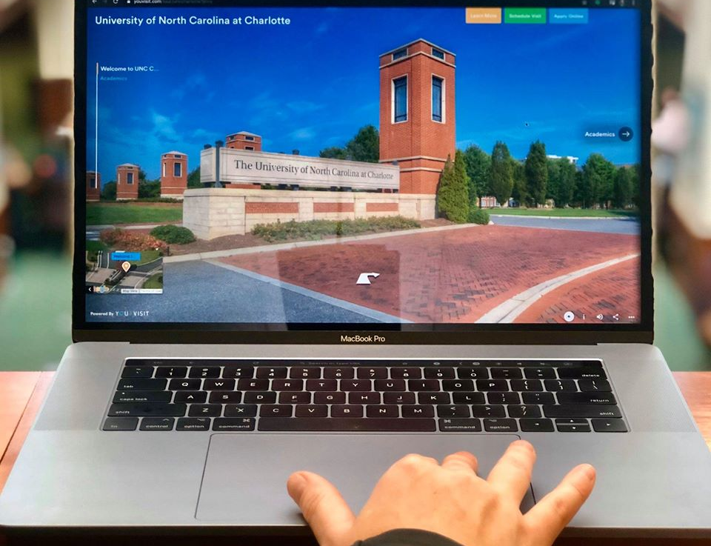
Online Academic Programs

Charlotte Online extends learning opportunities to professionals hoping to advance their careers on their own time. Our growing selection of online and distance education programs are taught by award-winning faculty and are nationally recognized for quality. Students can connect to campus from anywhere in the U.S. and enroll in undergraduate and graduate programs to fit their needs in industries like healthcare, education, engineering, data and computing, and more.

Options for delivery include sending a UNC Charlotte faculty member to an off-campus location to teach a course in person, delivering courses completely online or via Hybrid delivery combining face-to-face and online delivery of instruction. Visit professional.charlotte.edu/online for more details.

Professional Credit

Professional credit is a term used for the University’s non-academic-credit programs within the School of Professional Studies. These programs provide upskilling and re-skilling opportunities in short-format options that are convenient for adults’ busy schedules. Many of these programs also allow professionals to maintain their license in their profession. A professional-credit course can provide fresh material and insight as well as feedback and direction from industry leaders and instructors. Learners can earn continuing education credits in some courses and complete a professional certificate to add to one’s resume or use toward certifications.

Employer Solutions

It’s a competitive world out there. Organizations need talent development strategies and tools to help their workforce stay relevant and thrive.

The Employer Solutions difference is an integrated approach that combines strategic partnerships, talent acquisition and talent development solutions.

UNC Charlotte Employer Solutions serves businesses and organizations with Custom Solutions and Talent Pathways:
- Through Custom Solutions we create and customize strategically-designed training programs for organizations that build skill-centered results and lasting impact.
- Through Talent Pathways we consult with clients to map custom pathways through academic education, professional training, custom learning solutions, and associated services to meet their talent management objectives.

Visit professional.charlotte.edu/employer-solutions for more details.

Undergraduate Programs

Undergraduate Programs
- B.S. in Professional Studies



Bachelor of Science in Professional Studies
The multi/interdisciplinary major in Professional Studies is intentionally designed to allow transfer and returning students to build on past educational and professional experiences and work with faculty and professional staff to grow knowledge and skills needed to secure employment in a desired field. Students complete a plan of study that includes a core of applied professional skills, an exploration of human social relationships and institutions, two concentrations, and culminates in a capstone project.

All program-level Admission and Progression Requirements are in addition to the University of North Carolina at Charlotte Admissions Requirements.

Admission Requirements
Transfers
The Professional Studies degree is available to transfer students and returning degree-seeking UNC Charlotte undergraduate students.

Prospective students interested in the Professional Studies degree should have at least 75 transferable credit hours. A maximum of 64 credit hours from two-year institutions is allowed. See Academic Policy for details. Transfer students with an Associate degree that does not meet the General Education exemption will have their prior coursework evaluated upon application and may qualify for admission directly to the Professional Studies degree or the Professional Studies pre-major. Prospective and newly admitted students will consult with the Office of Adult Students and Extended Services (OASES) for advising. Students who do not have 75 transferable credit hours but otherwise meet the criteria for admission will be admitted to UNC Charlotte as a pre-major where they will work with an OASES advisor to secure admission to the Professional Studies program.

In addition to the online application and required fee, official transcripts from every college attended, and an official high school transcript, the following requirements apply:

- Applicants must present an overall 2.0 grade point average according to calculations performed by the Undergraduate Admissions office.
- Internationally‐educated students must have their foreign credentials translated and evaluated by an accredited credential evaluation service. Transfer applicants must have a "course by course report" completed by the service, and they must present the equivalent of a high school diploma in addition to college‐transferable coursework.
- Applicants must be in good standing and eligible to return to the last institution attended.

Currently Enrolled Students
- Declaration of Major: Students must have a 2.0 cumulative GPA and have completed at least 75 earned credit hours. The final grades of the prerequisite courses must be posted on their transcript.
- Submit the Professional Studies Major Application to request the Professional Studies major.

Degree Requirements
General Education Courses (37-43 credit hours)
For details on required courses, refer to the General Education Program.

Credit for Prior Learning (optional)
Up to 23 credit hours (see policy for transfer credit).

Major Core Courses (12 credit hours)
Sociology Courses (6 credit hours)
SOCY 2115 - Introduction to Organizations (3)
SOCY 4111 - Social Inequality (3)
or SOCY 4112 - Sociology of Work (3)
or SOCY 4114 – Professionalism in Sociology (3)
or SOCY 4115 - Organizational Sociology (3)

Professional Studies Courses (6 credit hours)
Professional Competency Courses (3 credit hours)
Select one of the following Professional Competency series. The three credit hours may be completed in a consecutive course series or selected from a different professional competency. Special topics (PROS 3000) may also be used to satisfy the professional competency requirement.

Project Management Series
PROS 3101 - Project Management: Foundations (1)
PROS 3102 - Project Management: Practitioner (1)
PROS 3103 - Project Management: Specialist (1)

Leadership Essentials Series
PROS 3201 - Leadership Essentials: Foundations (1)
PROS 3202 - Leadership Essentials: Practitioner (1)
PROS 3203 - Leadership Essentials: Specialist (1)

Human Resource Management Series
PROS 3301 - Human Resource Management: Foundations (1)
PROS 3302 - Human Resource Management: Practitioner (1)
PROS 3303 - Human Resource Management: Specialist (1)

Capstone Course (3 credit hours)
PROS 4600 - Professional Studies Capstone (1 to 3)

Area Courses or Optional Minor (18 credit hours)
Complete at least nine credit hours in two areas. Only three credit hours from the 1000-level may be counted toward each area. A minor of 18 credit hours may be substituted for the two areas. Appropriate courses in the area may be substituted with advisor approval.

Area Courses (18 credit hours)
Accounting (9 credit hours)
Select from the following:
ACCT 2xxx – 4xxx (9)

Anthropology (9 credit hours)
Select from the following:
ANTH 1101 - Introduction to Anthropology (3)
ANTH 3112 - Globalization and Culture (3)
ANTH 3113 - Economic Anthropology (3)
ANTH 3116 - Cultures and Conflicts (3)
ANTH 3117 - Narratives and Conflicts (3)
ANTH 3132 - Aging and Culture (3)
ANTH 3135 - Origins of Globalization (3)
ANTH 3136 - Globalization and Resistance (3)
ANTH 3160 - Gender, Culture, and Communication (3)
ANTH 4120 - Intercultural Communications (3)

Architecture Studies (9 credit hours)
ARCH 2xxx-4xxx (9)

Art: Graphic Design (9 credit hours)
ARTG 2xxx-4xxx (9)

Business Information Systems (9 credit hours)
INFO 2xxx-4xxx (9)

Capitalism Studies (9 credit hours)
Select from the following:
CAPI 2050 - Topics in Capitalism Studies (3)
CAPI 2100 - Introduction to Capitalism Studies (3)
CAPI 3050 - Topics in Capitalism Studies (3)
CAPI 4050 - Topics in Capitalism Studies (3)

Civil and Environmental Engineering (9 credit hours)
CEGR 2xxx-4xxx (9)

Civil/Environmental Engineering Tech (9 credit hours)
ETCE 1xxx-4xxx (9)
Only three credit hours from the 1000-level may be counted toward ETCE area courses.

Communication Studies (9 credit hours)
Select from the following:
COMM 1101 - Public Speaking (3)
COMM 2102 - Advanced Public Speaking (3)
COMM 2103 - Argumentation and Debate (3)
COMM 2105 - Small Group Communication (3)
COMM 2107 - Interpersonal Communication (3)
COMM 3052 - Topics in Media & Technology Studies (3)
COMM 3054 - Topics in Organizational Communication (3)
COMM 3120 - Media, Technology & Communication (3)
COMM 3125 - New Media for Communications (3)
COMM 3130 - Rhetoric and Public Culture (3)
COMM 3135 - Leadership, Communication, and Group Dynamics (3)
COMM 3136 - Leadership, Service, and Ethics (3)
COMM 3141 - Organizational Communication (3)

Computing and Information Systems (9 credit hours)
ITSC 1xxx-4xxx (9)
Only three credit hours from the 1000-level may be counted toward ITSC area courses.

Computer Science (9 credit hours)
ITCS 1xxx-4xxx (9)
Only three credit hours from the 1000-level may be counted toward ITCS area courses.

Construction Management (9 credit hours)
CMET 1xxx-4xxx (9)
Only three credit hours from the 1000-level may be counted toward CMET area courses.

Criminal Justice (9 credit hours)
Select from the following:
CJUS 1100 - Introduction to Criminal Justice (3)
CJUS 3363 - Mediation and Conflict Resolution (3)
CJUS 3381 - Security and Loss Prevention (3)
CJUS 4362 - Computer Crime (3)
CJUS 4363 - Gender, Race, and Justice (3)
CJUS 4370 - Data Analytics and Crime (3)
CJUS 4372 - Drug Analytics (3)
CJUS 4373 - Intelligence Analysis and Security Analytics (3)
CJUS 4374 - Geospatial Analytics and Crime (3)
CJUS 4376 - Social Network Analysis (3)
CJUS 4377 - Crime Measurement and Data Visualization (3)

Data Science (9 credit hours)
DTSC 1xxx-4xxx (9)
Only three credit hours from the 1000-level may be counted toward DTSC area courses.

Economics (9 credit hours)
ECON 1xxx-4xxx (9)
Only three credit hours from the 1000-level may be counted toward ECON area courses.

Education - Learning, Design, Tech (9 credit hours)
ELDT 4xxx (9)

Electrical and Computer Engineering (9 credit hours)
ECGR 2xxx-4xxx (9)

Electrical Engineering Technology (9 credit hours)
ELET 1xxx-4xxx (9)
or ETEE 1xxx-4xxx (9)
Only three credit hours from the 1000-level may be counted toward ELET or ETEE area courses.

Energy and Electromechanical Systems (9 credit hours)
ENER 4xxx (9)

Engineering (9 credit hours)
ENGR 1xxx-4xxx (9)
Only three credit hours from the 1000-level may be counted toward ENGR area courses.

Engineering Technology (9 credit hours)
ETGR 1xxx-4xxx (9)
Only three credit hours from the 1000-level may be counted toward ETGR area courses.

English (9 credit hours)
Select from the following:
ENGL 2116 - Introduction to Technical Communication (3)
ENGL 3162 - Language and the Virtual World (3)
ENGL 3180 - Language and Digital Technology (3)
ENGL 4008 - Topics in Advanced Technical Communication (3)
ENGL 4180 - Theories of Technical Communication (3)
ENGL 4181 - Writing and Designing User Documents (3)
ENGL 4182 - Information Design and Digital Publishing (3)
ENGL 4183 - Editing with Digital Technologies (3)

Entrepreneurship (9 credit hours)
ENTR 3xxx (9)

Film Studies (9 credit hours)
Select from the following:
FILM 2201 - Introduction to Film (3)
FILM 3120 - The Fundamentals of Video/Film Production (3)
FILM 3121 - Cinematography (3)
FILM 3220 - Introduction to Screenwriting (3)
FILM 3221 - Intermediate Screenwriting: Feature Film (3)
FILM 4120 - Production and Directing (3)
FILM 4121 - Documentary Film Production (3)
FILM 4220 - Film Festivals: Production and Theory (3)
FILM 4221 - Community-Based Film Production (3)

Finance (9 credit hours)
FINN 3xxx-4xxx (9)

Fire Safety Engineering Technology (9 credit hours)
ETFS 1xxx-4xxx (9)
Only three credit hours from the 1000-level may be counted toward ETFS area courses.

Geography (9 credit hours)
GEOG 1xxx-4xxx (9)
Only three credit hours from the 1000-level may be counted toward GEOG area courses.

Gerontology (9 credit hours)
Select from the following:
GRNT 2100 - Aging and the Lifecourse (3)
GRNT 3125 - Older Worker and Retirement (3)
GRNT 3132 - Aging and Culture (3)
GRNT 4110 - Sociology of Aging (3)
GRNT 4150 - Older Individual and Society (3)
GRNT 4260 - Women: Middle Age and Beyond (3)

Health and Medical Humanities (9 credit hours)
HHUM 2xxx-4xxx (9)

Health Systems Management (9 credit hours)
HSMT 2xxx-4xxx (9)

Industrial Engineering Technology (9 credit hours)
ETIN 3xxx-4xxx (9)

International Studies (9 credit hours)
Select from the following:
INTL 3112 - Globalization and Culture (3)
INTL 3115 - Globalization and Digital Media (3)
INTL 3116 - Cultures and Conflicts (3)
INTL 3117 - Narratives and Conflicts (3)
INTL 3127 - Global Media (3)
INTL 3131 - Diplomacy in a Changing World (3)
INTL 3135 - Origins of Globalization (3)
INTL 3137 - International Human Rights (3)
INTL 3151 - International Political Economy (3)

Journalism (9 credit hours)
JOUR 2xxx-4xxx (9)

Legal Studies (9 credit hours)
LEGL 1xxx-4xxx (9)
Only three credit hours from the 1000-level may be counted toward LEGL area courses.

Management (9 credit hours)
MGMT 3xxx-4xxx (9)

Manufacturing Engineering Technology (9 credit hours)
ETMF 3xxx (9)

Marketing (9 credit hours)
MKTG 3xxx-4xxx (9)

Mathematics (9 credit hours)
MATH 1xxx-4xxx (9)
Only three credit hours from the 1000-level may be counted toward MATH area courses.

Mechanical Engineering (9 credit hours)
MEGR 1xxx-4xxx (9)
Only three credit hours from the 1000-level may be counted toward MEGR area courses.

Mechanical Engineering Technology (9 credit hours)
ETME 1xxx-4xxx (9)
Only three credit hours from the 1000-level may be counted toward ETME area courses.

Military Science (9 credit hours)
MSCI 1xxx-4xxx (9)
Only three credit hours from the 1000-level may be counted toward MSCI area courses.

Nursing
NURS 2xxx-4xxx (9)

Operations and Supply Chain Management (9 credit hours)
OPER 3xxx (9)

Operations Research (9 credit hours)
OPRS 3xxx-4xxx (9)

Philosophy (9 credit hours)
PHIL 1105 - Critical Thinking (3)
PHIL 2105 - Deductive Logic (3)
PHIL 3210 - Ethical Theory (3)
PHIL 3310 - IT Ethics (3)
PHIL 3320 - Engineering Ethics (3)
PHIL 3340 - Business Ethics (3)
PHIL 3810 -Social and Political Philosophy (3)
PHIL 3990 - Topics and Identity/Society (3)
PHIL 4990 - Advanced Topics in Identity/Society (3)

Physics (9 credit hours)
PHYS 1xxx-4xxx (9)
Only three credit hours from the 1000-level may be counted toward PHSY area courses.

Political Science and Public Administration (9 credit hours)
Select from the following:
POLS 1110 - American Politics (3)
POLS 2120 - Introduction to Public Policy (3)
POLS 3104 - Mass Media (3)
POLS 3119 - State and Local Government (3)
POLS 3125 - Health Care Policy (3)
POLS 3126 - Introduction to Public Administration (3)
POLS 3137 - International Human Rights (3)
POLS 3151 - International Political Economy (3)
POLS 3159 - Diplomacy in a Changing World (3)
POLS 3177 - Social & Political Philosophy (3)
POLS 4380 - Intelligence in a Democratic Society (3)
POLS 4381 - Critical Thinking Skills for Intelligence (3)
POLS 4383 - Analytic Writing and Briefing (3)

Professional Studies (9 credit hours)
PROS 3xxx (9)
PROS courses cannot double count as major core courses. Students taking a PROS course from this area must select different courses outside the 6 hours of PROS major core courses.

Psychology (9 credit hours)
Select from the following:
PSYC 1101 - General Psychology (3)
PSYC 2130 - Introduction to Social Psychology (3)
PSYC 2137 - Introduction to Positive Psychology (3)
PSYC 2171 - Introduction to Industrial/Organizational Psychology (3)
PSYC 3114 - Motivation (3)
PSYC 3123 - Social and Personality Development (3)
PSYC 3125 - Older Worker and Retirement (3)
PSYC 3135 - Psychology of Personality (3)
PSYC 3140 - Basic Processes in Psychological Assessment (3)
PSYC 3172 - Psychology of Personnel: Employee Selection and Classification (3)
PSYC 3174 - Organizational Psychology (3)

Public Health Sciences (9 credit hours)
HLTH 2xxx – 4xxx (9)

Social Work (9 credit hours)
Select from the following:
SOWK 1101 - The Field of Social Work (3)
SOWK 2182 - Human Behavior in the Social Environment I (3)
SOWK 2183 - Human Behavior in the Social Environment II (3)
SOWK 3120 - Diversity and Populations-at-Risk (3)
SOWK 3133 - Community Engagement and Outreach (3)
SOWK 3180 - Case Management (3)
SOWK 3199 - Professional Behaviors, Ethics, and Communication (3)
SOWK 3201 - Foundations of Social Welfare (3)
SOWK 3202 - Social Welfare Policy (3)
SOWK 4109 - Systems of Care for Vulnerable Populations (3)
SOWK 4365 - Grief and Loss Across the Lifespan (3)

Sociology (9 credit hours)
Select from the following:
SOCY 2100 - Aging and the Lifecourse (3)
SOCY 3125 - Older Worker and Retirement (3)
SOCY 3143 - Social Movements (3)
SOCY 3250 - Political Sociology (3)
SOCY 3251 - Political Sociology (3)
SOCY 3271 - Sociology of Culture (3)
SOCY 3325 - Community and Identity (3)
SOCY 4116 - Sociology of Economic Life (3)
SOCY 4117 - Sociology of Gender, Work, and Family (3)
SOCY 4140 - Social Networks (3)
SOCY 4150 - Older Individual and Society (3)
SOCY 4263 - Group Processes (3)
SOCY 4264 - Status Processes (3)

Software and Information Systems (9 credit hours)
ITIS 1xxx-4xxx (9)
Only three credit hours from the 1000-level may be counted toward ITIS area courses.

Statistics (9 credit hours)
STAT 1xxx-4xxx (9)
Only three credit hours from the 1000-level may be counted toward STAT area courses.

Systems Engineering (9 credit hours)
SEGR 2xxx-4xxx (9)

Writing, Rhetoric, and Digital Studies (9 credit hours)
WRDS 1xxx-4xxx (9)
Only three credit hours from the 1000-level may be counted toward WRDS area courses.

Optional Minor (18 credit hours)
Select any 18 credit hour minor approved in consultation with advisor.

Unrestricted Elective Courses (0-30 credit hours)
As needed to complete the credit hours required for graduation.

Degree Total = 120 Credit Hours

Progression Requirements
A GPA of 2.0 in the major is required for graduation, as well as grades of C or above in all courses.

