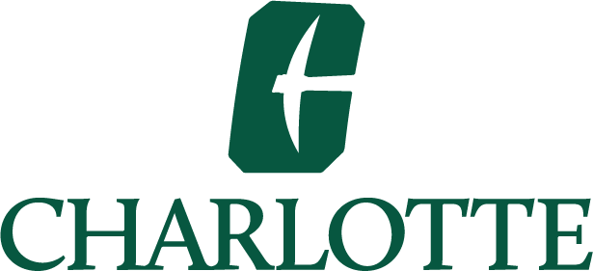

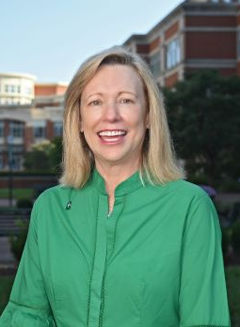
Welcome to UNC Charlotte, North Carolina’s urban research university.

Founded in 1946 to serve returning veterans, UNC Charlotte has had an astounding trajectory over its history, made possible by visionary leaders, extraordinary students, stellar faculty and staff, and dedicated alumni.

Great things are happening at Charlotte. There’s strong momentum. Last fall, Charlotte achieved the position as one of the nation’s top 100 public universities, at No. 96, in the 2024 U.S. News & World Report Best Colleges rankings. Overall, the University climbed 41 spots and is one of the fastest rising universities in the U.S.

Among our most significant achievements is our progress toward achieving top-tier research status. With record research expenditures and new areas of emerging research, The Chronicle of Higher Education has projected that Charlotte will officially be classified as an R1 research university in early 2025. The R1 classification by Carnegie will be a recognition of all of our efforts to date and the trajectory of where we are going.

As a student attending an emerging top-tier university, you also benefit through the opportunity to work on cutting-edge research projects and to be taught and mentored by top professors who share the latest knowledge in the classroom.

Our promise is to not only provide a supportive community in Niner Nation but also to help you complete your degree on time, and to be equipped to thrive in a diverse and ever-changing world.

As you work toward your degree, please think of UNC Charlotte’s dedicated faculty and staff as partners in your success. Their expertise and support, along with the many University resources and services available to you, will enable you to meet your academic, personal and professional aspirations.

While growing our research capabilities, we also have strengthened our commitment to undergraduate education. Over the past decade – through the combined efforts of faculty, staff and students – we’ve developed comprehensive programs to increase student success. We call these programs “The Charlotte Model.” This innovative work has transformed our University, raised our graduate rates and reduced the equity gap. Today, UNC Charlotte is known as a national model in the areas of student success and social mobility.

During your time here, explore all the possibilities available. Take advantage of leadership and volunteer opportunities; attend cultural events and lectures; join a student organization; participate in intramural sports; and cheer on your Charlotte 49ers whenever they are competing.

Please speak up if you need help. We have many resources on campus to assist you. Please also get involved on campus and be an active partner in your education.

It is truly a privilege to serve as your chancellor. Please know that I will do everything in my power to support and strengthen our academic enterprise, ensure a great college experience for you, and always place the highest priority on the safety and well-being of our campus community.

I am delighted that you’ve made UNC Charlotte your university of choice. I look forward to seeing you on campus. Go Niners!

Sincerely,


Sharon L. Gaber
Chancellor

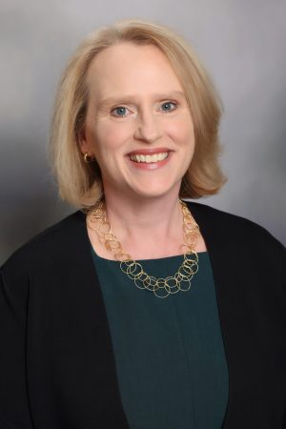
If this is your first year at UNC Charlotte, welcome to our dynamic community! If you are returning, we are pleased to welcome you back.

You are part of an engaged and enterprising university that is interconnected with North Carolina’s largest city. Because we are situated in a growing and dynamic region, our institution is alive with possibilities to learn and grow. As you explore the academic opportunities available, know that we believe in your ability to succeed and our amazing faculty and staff are ready to help you achieve your goals.

We are dedicated to your education and offer resources to help you along your journey at UNC Charlotte. Niner Central is the place to go with any of your questions about registration, student accounts or financial aid and the University Center for Academic Excellence houses many tools to support success in your classes. Please meet with your academic advisor early and often, and get to know your professors whether it’s in class, in the lab or during office hours.

Remember, too, that there is more to the collegiate experience than coursework. I encourage you to become involved in some of the many activities or student organizations. By getting involved, you will build relationships with both your fellow students and our faculty and staff that you will cherish in the years to come.

I hope you will take advantage of the excellent resources available here and explore all that our University has to offer. But don’t stop there – explore research, community engagement and professional development opportunities in the greater Charlotte area and in the world beyond. We’re here to help you get started.

We are pleased that you have chosen UNC Charlotte. As our University continues to grow, we look forward to seeing your growth as a person, a scholar and a future alum.

Sincerely,


Jennifer Troyer
Provost and Vice Chancellor for Academic Affairs

