Financial

Information



Financial
Information
ninercentral.charlotte.edu

Undergraduate Tuition and Fees

UNC Charlotte is a publicly supported institution and primarily receives its revenue from the State of NC appropriations, in addition to tuition and fees. It is the combination of tuition and fees that primarily supports the operations and expansion of UNC Charlotte. Tuition and fees are approved by the Student Representatives, UNC Charlotte Board of Trustees, and the UNC Board of Governors. Tuition rates are also approved by the NC General Assembly. These fees are mandatory to every student and cannot be waived.

Tuition and fees are billed by credit hour for Fall, Spring, and Summer terms. 12 or more credit hours are considered full-time for undergraduate students, and 9 or more credit hours are considered full-time for graduate students.

Charges for tuition and fees vary according to the student's status as a resident or non-resident of North Carolina. A non-resident student pays a higher rate of tuition than a legal resident. For more details, see the heading for Residence Status for Tuition Purposes later in this section.

For a complete list of current tuition and fees, visit https://ninercentral.charlotte.edu/billing-payments-refunds/tuition-and-fees/.

The University reserves the right, with the approval of proper authorities, to make changes in tuition and fees at any time. The University also reserves the right to correct any clerical errors on a student's account. For the most current listing of tuition and fees at The University of North Carolina at Charlotte, see ninercentral.charlotte.edu.

Fixed Tuition Program
The Fixed Tuition program provides eligible, in-state undergraduate students with the same tuition rate for a specific period of continuous enrollment. The Fixed Tuition program only includes tuition and not fees. Fees may be increased annually.

For eligible Freshmen seeking a 4-year bachelor’s degree, the tuition rate will be fixed for eight consecutive semesters. For eligible Transfer students, the tuition rate will be fixed for a prorated period of time based on the prior credit they have earned or transferred in from other institutions. Students may view their fixed tuition eligibility period in Banner Self Service (under Student Services/Student Accounts > Fixed Tuition Information).

For more information, visit ninercentral.charlotte.edu/billing-payments-refunds/tuition-and-fees/fixed-tuition-program.

Residence Status for Tuition Purposes
Tuition charges are based upon classification of a student as a resident or a non-resident of North Carolina for tuition purposes. The North Carolina Residency Determination Service (RDS), the sole authority for residency determinations, shall determine whether a student is a resident or non-resident for tuition purposes.

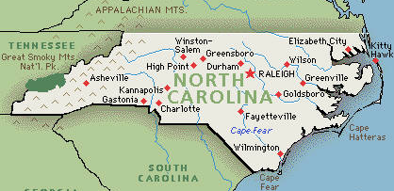

Residency Application Procedure
A new, incoming, or current student who wishes to request a residency classification will apply using the Residency Determination Service (RDS). RDS is the entity responsible for all new classifications of residency in North Carolina. To begin the process, visit www.NCresidency.org. ALL student inquiries about initial determinations, reconsiderations, or appeals, should be directed to RDS. Students may contact RDS at 844-319-3640 or rdsinfo@ncresidency.org.

Appeal Procedure
A new, incoming, or current student who has exhausted the residency application procedure and has been classified as a non-resident for tuition purposes, may request further consideration of that decision to the Residency Determination Service (RDS). RDS is the entity responsible for all classifications of residency in North Carolina. ALL student inquiries about initial determinations, reconsiderations or appeals, should be directed to RDS. Students may contact RDS at 844-319-3640 or rdsinfo@ncresidency.org.

Required Fees
The required fees included in the Tuition and Fees table above are explained below.

49er Card Access Fee
This fee supports the University’s 49er Card operations and support. The ID card is not only used for identification purposes, but also as a library card and as a campus card for dining and vending purchases. This fee does not cover the replacement of a lost or stolen card.

Ed and Tech Fee
This fee is directly related to the infrastructure supporting student technology needs across campus including hardware and software applications, supplies for educational materials, web services, laboratory expenses and equipment, public student computing labs, central email and Internet services, training classes and classrooms, and central help desk services.

Food Service Facilities Fee
This fee provides funds to support year-round access, maintenance, repairs, and operation of campus dining facilities.

Health Services Fee
This fee funds health and counseling services for students, which includes the operations of the Student Health Center, the Center for Counseling and Psychological Services, and the Center for Wellness Promotion.

Niner Course Pack Fee
This fee funds the Niner Course Pack for students, which provides textbook rental course materials to students who remain opted into in the program. Students who wish to remove this fee must opt out of the program by the posted deadline each semester.

Safety and Security Fee
This fee provides funding for several of the recommendations made by the UNC Board of Governors’ 2013-14 UNC [system-wide] Campus Security Initiative report which include, but are not limited to: (1) campus police officer and telecommunicator compensation; (2) highly qualified and trained investigators and hearing officers for reports of serious offenses, such as sexual violence; (3) Title IX and Clery Act compliance coordination; (4) substance abuse counselors, case managers, and/or other counseling staff; and (5) system-level safety and security training, coordination, and audit functions. The fee may also provide funding to meet some additional campus-specific safety and security needs consistent with the report’s recommendations. The structure for this fee allows $26 of the $30 collected from each student per academic year to fund campus level and shared-services activities, while $4 of the $30 is allocated by the UNC General Administration for system-wide coordination, trainings, and other shared services functions.

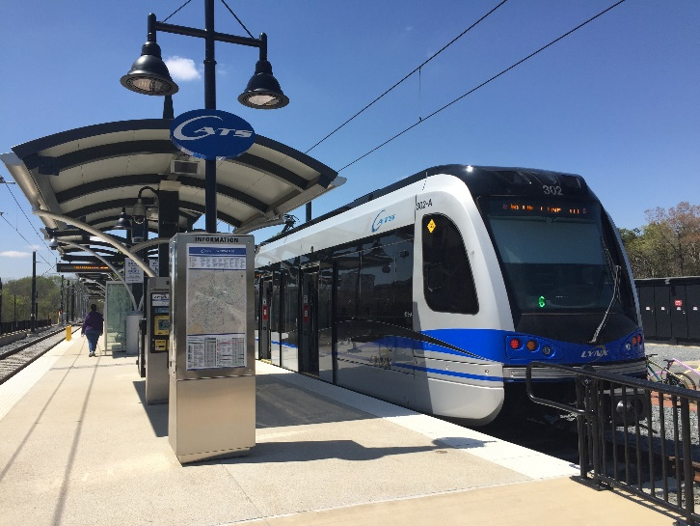

Transportation Service Fee
This charge supports funding for Niner Transit (campus shuttle system), the Niner Paratransit service and the CATS All-Access Pass. The services provide UNC Charlotte with efficient and safe campus transportation, reduce vehicular congestion, and decrease the demand for proximity parking.

UNC System Student Association Fee
This fee is a University of NC system-wide fee charged to all system students to support the University Of North Carolina Association of Student Governments. This association is a student led advocacy group whose main purpose is to ensure that the benefits of the University of North Carolina are extended to the people of North Carolina, as far as practicable, free of expense.

University Fee
This is a consolidated fee that relates to University debt service payments (to construct new facilities and purchase administrative computing systems) and to support other activities/operations including Athletics programs and events, Student Activity Center operations, and Cone University Center operations. The following fees are consolidated into the University Fee:

- Athletics - Funds intercollegiate athletics, including salaries and maintenance and operation of athletic facilities.
- Student Activities - Funds non-academic student services (student unions, intramural facilities, student organizations, newspapers, yearbooks, and entertainment programs).
- Debt Service - Funds the principal and interest for capital projects. Examples for UNC Charlotte include the Student Union, Football Stadium, and Student Activity Facility.

Special Fees
The following additional major or course fees are charged to cover the cost of supplies or special materials:

ADDITIONAL MAJOR/COURSE FEES
(PER SEMESTER)

Major/Course | Fee
College of Arts + Architecture Student Fee | $125*
College of Computing and Informatics Student Fee | $112.50*
College of Engineering Student Fee | $150*
College of Health and Human Services Student Fee | $125*
Experiential Learning Fee/Co-op | $60
International Student Fee (students with Visa type F or J) | $100
KNES 1290 - First Aid: Responding to Emergencies | $20

* These fees apply to students enrolled in 6+ credit hours; students enrolled in 1-5 credit hours are charged half the fee listed.

Application Fee
A $75 application fee must be submitted with the application for admission. The fee is nondeductible and nonrefundable.

Credit by Examination Fee
A written examination for a course requires a fee of $15. A laboratory examination requiring the arrangement of such things as laboratory materials will require a fee of $25. A combination of a laboratory and written examination will require a fee of $30.

Matriculation Fee
Instead of paying separate fees for such things as new student convocation, commencement, and hardcopy academic transcripts, UNC Charlotte students pay a matriculation fee and receive these and other services at no charge. Students are charged the $150 matriculation fee upon entry into a baccalaureate, graduate certificate/master's, and doctoral program at UNC Charlotte.

Dining, Housing,
and Parking
aux.charlotte.edu
housing.charlotte.edu
pats.charlotte.edu

Dining and Meal Plans
Meal plans, the 49er Account, and the Optional Dining Account all reside on the UNC Charlotte 49er ID.

For dining locations, menus, meal plans, and meal plan policies, visit aux.charlotte.edu/dining/meal-plans.

A meal plan purchase provides these advantages:
- Convenience: The 49er ID is used for all campus dining purchases.
- Variety and Flexibility: Meal plans to meet your dining needs; numerous places to eat on campus including late evening and weekend dining and many popular, national brands.
- Diet Preferences: Vegetarian, vegan and healthy options are available at Social 704 in the Student Union, SoVi and Charlotte Greens in South Village Crossing and most retail locations.



Overview of Meal Plans
All first-year students living on campus, regardless of their housing assignment, are required to purchase The Daily Plan. This meal plan must be purchased each semester of occupancy.

Upper-class students assigned to residence halls without private kitchens are also considered to be living in “required housing” and must choose a meal plan as part of the housing contract. These residences include Holshouser, Hunt, Sanford, Scott, Hawthorn, Laurel, Lynch, Oak and the suites in Belk, Levine, Miltimore, Wallis and Witherspoon.

For a listing of available dining locations, menus, meal plans, and meal plan policies, visit aux.charlotte.edu/dining/meal-plans.

Housing
Below are the current academic year’s per semester rates for housing at UNC Charlotte. Rates include rent, utilities (including internet, cable, and laundry) and membership in the Resident Students Association (RSA). Prices and plans are subject to change. Housing types are based on availability. Current pricing can be found online at housing.charlotte.edu/apply/rates.

HOUSING PER SEMESTER

Type | Fee
Tower (Double Occupancy) | $3,380 - $3,700
Tower (Single Occupancy) | $4,550
Suite | $4,250 - $5,100
Apartment | $4,700 – $5,400
Greek Village | $4,450 - $4,500

Admission to UNC Charlotte does not guarantee residence hall space. Arrangements for on-campus housing are made, after admission, with the Office of Housing and Residence Life. Shared Residence Hall space is not available to spouses or children of enrolled students.

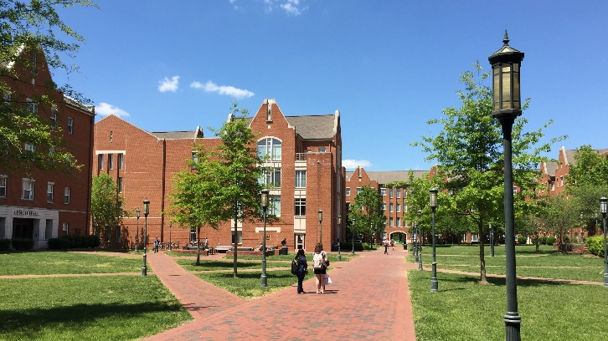

Housing Deposit
A $200 deposit must be submitted with all housing applications. The deposit is not applied toward payment of fees. It is refunded only after the student has left on-campus housing and only if the student has met all financial obligations to the University. In the case of contract cancellation, the date of receipt of the written request for cancellation will determine, in part, the student’s financial obligation to the University (please see the Housing Contract for the current academic year for specific terms and cancellation dates).

Parking
Students attending UNC Charlotte (and faculty and staff) are required to purchase a virtual parking permit or pay a visitor fee in order to park on campus. Vehicle registration and virtual permit purchase is available online. Virtual permits are required at all times when parked on campus, unless parked in a visitor parking area. For students, two categories of virtual permits are issued: Resident, for students living on-campus, and Commuter, for students living off-campus. Lot-specific, discount permits are available on a first come, first served basis.

The 2024-2025 annual rate for a resident or full-time commuter student is $480. Please see pats.charlotte.edu for a complete list of fees, permit information, and where each type of permit allows you to park. Full-time virtual permits are valid from August 1 of one year through August 14 of the following year.

Parking permits are available to purchase for the fall semester only or the full academic year. Discount remote lot and night permits are also available to commuters. Night permits are valid only after 3 p.m. Parking before 3 p.m. requires parking and payment in a visitor space.

The primary factor that determines permit prices is the cost of new deck construction and replacing flat lots with decks. Neither tuition dollars nor state funds are used toward parking facilities; therefore, parking fees must pay for construction and maintenance of all decks, lots and associated operations.

Penalties for Parking Violations
- Parking and Traffic regulations are enforced 24 hours a day, seven days
a week. Currently, permits are enforced at all times, and meters are enforced from 5 a.m. on Monday through 10 p.m. on Friday.
- Violators of University parking regulations are subject to penalties
ranging from $20 to $480, depending on the severity of the violation.
- If a citation is not paid or appealed within ten (10) business days, the
penalty will be applied to the student's University account. Subsequent registration may be withheld for non-payment.
- Copies of parking regulations and the citation penalty list are posted
on the PaTS website.

The Parking and Transportation Services website, pats.charlotte.edu, has current UNC Charlotte parking ordinances, parking policy information, virtual permit and citation FAQs. It is also a source for transportation information, updates and changes or disruptions to campus parking and transportation.

Questions concerning parking on campus should be directed to Parking and Transportation Services Communications Center at 704-687-0161; open 5 a.m. Monday through 10 p.m. Friday, except on holidays when the University is closed. Office hours are 8 a.m. to 5 p.m., Monday-Friday. Emergency situations and questions at other times should be directed to the Campus Police at 704-687-2200.

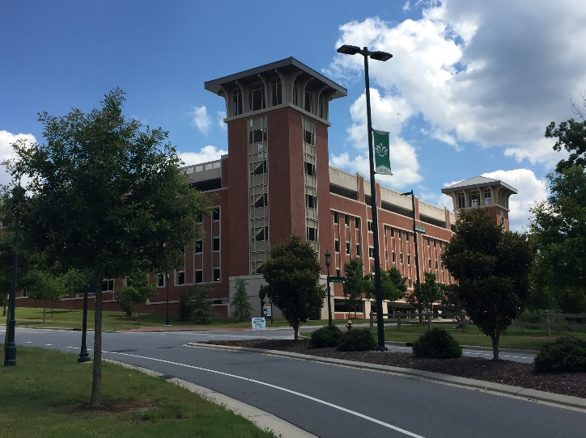

Financial Aid
ninercentral.charlotte.edu/financial-aid

UNC Charlotte administers financial aid without regard to race, color, national origin, religion, gender, sexual orientation, age, or disability.

The University offers a comprehensive program of student financial aid (scholarships, grants, loans, and part-time employment) to assist both graduate and undergraduate students in meeting educational expenses. Reasonable educational expenses include tuition and fees, room and board, books, supplies, transportation, miscellaneous personal expenses, and expenses related to maintenance of a student's dependents.

Eligibility
The programs of student financial aid are administered according to a nationally accepted policy that the family, meaning parents (or those acting in place of parents) and/or spouse, is responsible for a student's educational expenses. Therefore, eligibility for financial aid will be determined by a comparison of a budget (educational expenses as defined above) for the period of attendance with what the student's family can reasonably be expected to contribute.

A financial aid applicant will be considered for available assistance for which they are eligible if the student:

- Completes the application process and related forms only after thoroughly reading all instructions.
- Completes the admission application process and is accepted for enrollment at UNC Charlotte.
- Is working toward a degree or certificate and not simply taking courses.

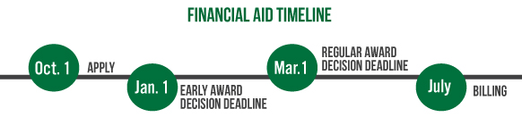

Satisfactory Academic Progress (SAP) Policy
Federal and state regulations require that students maintain a certain level of academic performance in order to be eligible for and keep their financial aid. This is known as Satisfactory Academic Progress (SAP). All students who wish to qualify for financial aid must meet three standards known as SAP. These standards include:

- Minimum cumulative Grade Point Average (GPA)
- Minimum credit hour completion rate
- Completion of a degree or program of study within a maximum number of credit hours

All prior coursework, attempted and earned, is reviewed in the determination of SAP. Students who have been readmitted as a result of the Forgiveness Policy are still subject to Satisfactory Academic Progress standards for all attempted coursework at UNC Charlotte.

For more complete details on Satisfactory Academic Progress, see the Financial Aid website at ninercentral.charlotte.edu/financial-aid-loans/keeping-your-aid/satisfactory-academic-progress.

Application Process
To apply for the following programs, students must complete the Free Application for Federal Student Aid using the instructions provided online at www.fafsa.gov. The federal school code for UNC Charlotte is 002975.

- Federal Direct Student Loan
- Federal Pell Grant*
- Federal Supplemental Educational Opportunity Grant*
- Federal TEACH Grant
- Federal Work Study
- Next North Carolina Scholarship*
- University Loans

*For undergraduate students only

Renewal Process
Renewal of financial aid is based upon a student making satisfactory academic progress. The Free Application for Federal Student Aid is required each year that a student applies for financial aid.

Financial Aid Programs
When students apply for financial aid through FAFSA, they receive an aid offer (or "package") that includes a combination of these types of aid, based on their financial need and eligibility. Students may earn more than one type of financial aid. For details about the below financial aid options, please visit finaid.charlotte.edu.

Grants
Federal
Federal Grants, with the exception of TEACH, are awarded to students demonstrating significant financial need as determined by the FAFSA. TEACH is not a need-based grant and could require repayment if the recipient does not fulfill the service agreement.

Completion of the FAFSA is required for grant funding. Grant funding does not have to be repaid, however, the availability of grant funding can be limited. Completing the FAFSA by March 1 will ensure the maximum financial aid award.

- Pell Grant
- Federal Work Study (FWS)
- Supplemental Educational Opportunity Grant (FSEOG)
- TEACH Grant (requires repayment if Agreement to Serve is not fulfilled)

State
State grants are awarded to North Carolina residents based on funding availability and need. Recipients are determined by the state of North Carolina and must be seeking their first undergraduate degree. Restrictions regarding credit hours and semesters completed may apply.

- Next North Carolina Scholarship

Institutional
Students that apply for financial aid by the established priority date of January 1 are considered for institutional need-based awards provided funding is available.

- State Appropriated Grant (SAG)
- Tuition Assistance Grant (TAG)

Loans
Loans are funds that students borrow from the federal government or other lenders and that must be repaid when students are out of school. Repayment begins six months after students graduate, withdraw, or drop below full-time. We recommend that students borrow only what they need.

- Federal Direct Loan Program
- Federal PLUS Direct Loans
- Alternative Loans

Federal Work Study
Federal Work-Study is a work program through which students earn money to help them pay for school. Since Federal Work-Study funding is limited, it is not included in all student awards. Priority is given to students with higher calculated financial eligibility who indicate on the FAFSA that they are interested in student employment. Students can work a maximum of 20 hours per week.

Other Assistance
Education for the Vocationally Disabled
Vocationally disabled students are eligible for aid provided by the North Carolina State Division of Vocational Rehabilitation. This aid takes the form of services that include vocational counseling and guidance and placement. Payment of expenses such as training, medical treatment, room and board, books, fees, and tuition may be available. A vocational rehabilitation officer is available in Charlotte for interviewing applicants. Appointments may be made by contacting Vocational Rehabilitation Services at 704-568-8804. Their offices are located at 5501 Executive Center Drive in Charlotte.

Veterans Benefits
UNC Charlotte’s Veterans Student Services Office (VSSO) works with the Veterans Administration to assist in administering the various programs of benefit to veterans or eligible relatives of veterans. The VSSO Certifying Official certifies enrollment and transmits necessary credentials and information to the proper Veterans Administrative Office.

Admission to the University should be obtained before the student makes application for veteran's benefits. Applicants must be accepted into a degree program to receive benefits.

In order to be eligible for the full monthly allowance under any of the above laws, an undergraduate student must be enrolled for 12 or more semester hours and a graduate student must be enrolled for nine or more semester hours. Those enrolled on a part-time basis will be eligible for part-time compensation. Students are responsible for reporting any change in enrollment status to the VSO Certifying Official.

For details about available programs, please visit veterans.charlotte.edu or call the VA’s toll-free number at 1-800-827-1000.

Children of Veterans
The North Carolina Department of Veterans Affairs awards scholarships for the children of certain deceased or disabled veterans. Those awarded "full" scholarships are entitled to tuition, mandatory fees, board allowance, and room allowance; those awarded "limited" scholarships are entitled to tuition and mandatory fees. Written requests for benefits information may be directed to: VA Atlanta Regional Office, Post Office Box 100022, Decatur, GA 30031-7002 (telephone 888-442-4551).

Before the time of registration, each eligible student who wishes to enter the University should: (1) apply for admission following University procedures and (2) apply for a scholarship award to the North Carolina Department of Veterans Affairs.

Scholarships
scholarships.charlotte.edu

UNC Charlotte provides all new freshmen, transfer, and returning undergraduate and graduate students the opportunity to apply for scholarships at the start of each academic year. Scholarships can be merit-based or need-based, and may also focus on other criteria defined by the individual donor or donors who fund the award. Scholarships can be used to offset tuition, room and board, books, or study abroad experiences, and do not have to be repaid.

UNC Charlotte committed to offering students an elite scholarship resource on campus by establishing the University Scholarship Office in 2015. This designated student service office exists to make it easier for newly admitted and continuing students to find and apply for scholarship opportunities, while serving as the single point of contact to students, parents, faculty, and staff who have scholarship-related questions.

NinerScholars Portal
NinerScholars serves as the common application system for all scholarships offered by a college, department, office, or program at UNC Charlotte. NinerScholars uses the University's student information system to build a scholarship profile specific to each student's academic history and current status. The Portal then compares a student's profile to the criteria for each UNC Charlotte scholarship, matches them with those scholarships they are eligible for, and provides the student with the ability to apply in real-time.

The NinerScholars Portal gives students direct access to apply to more than 2,000 scholarship opportunities with one application, through one online system. To access the NinerScholars Portal, learn more about the scholarship opportunities below, or take advantage of additional scholarship resources, visit the University Scholarship Office website at scholarships.charlotte.edu.

Scholarship Opportunities
University Scholarships
Each year, UNC Charlotte awards more than 2,000 scholarships to recognize outstanding students for prior and sustained academic achievement, and provide assistance to students with demonstrated financial need. All University scholarships must be applied for through the NinerScholars Portal for a student to be considered. To be considered for need-based scholarships, a student must complete a Free Application for Federal Student Aid (FAFSA) for the upcoming academic year and have no outstanding requirements or financial obligations to the University.

Outside Scholarships
The University Scholarship Office maintains a comprehensive database of scholarship opportunities that are administered and awarded by organizations, or individual donors, outside the University. This resource is free and allows students to filter external scholarship opportunities, specific to their major, GPA, or professional goals. This resource can be found at scholarships.charlotte.edu.

Levine Scholars Program
The Levine Scholars Program is UNC Charlotte’s most prestigious merit scholarship program established in 2009 by benefactors Sandra and Leon Levine. The inaugural class of Levine Scholars entered in the Fall semester of 2010 and a new cohort of approximately 20 students is selected to join the program each year. Levine Scholars carry a high honor, one that bestows tremendous opportunities and assumes high expectations of its recipients – as students, as leaders within the university, and as citizens of the global community. No matter what their interests, Levine Scholars find campus and community partners eager to embrace their contributions and enhance their education through hands-on experiences. To complement classroom learning, Levine Scholars participate in rich and varied opportunities in the vibrant commercial and cultural center of Charlotte. To learn more about the Levine Scholars, visit levinescholars.charlotte.edu.

Honors College Scholarships
Albert Engineering Leadership Scholars Program
The Albert Engineering Leadership Scholars Program was established by Craig Albert (’85) to invest in the next generation of engineering student leaders, and to produce graduates distinguished by their excellence in applied learning, campus involvement, and professional development. This scholarship is awarded to incoming freshmen and is renewable for up to three additional years contingent upon maintaining a cumulative GPA of 3.0, continuing full-time enrollment, and meeting program requirements. Albert Scholars receive an award equal to the cost of tuition, room and board, and books.

Freeman Scholarship
The Freeman Scholarship was established by Craig and Darla Albert (‘85 and ‘83) in 2019. Freeman Scholars are impressive, thoughtful, and persistent in overcoming challenges. They all demonstrate intellectual curiosity and a strong academic foundation; community-mindedness and dedication to service; and capacity for reflection, leadership, and growth. Recipients of the Freeman Scholarship are awarded in-state tuition and fees renewable for three additional years, membership in a multi-year honors program and support from the Honors College, and access to honors housing in Levine Hall.

Johnson Scholarship
In establishing the Johnson Scholarship, Gene and Vickie Johnson ('71 and '82) intend to create a perpetual endowment for the purpose of increasing opportunity at UNC Charlotte for middle-income students whose families do not qualify for federal grant aid programs and may struggle to afford a college education. Johnson Scholars may be enrolled in any major and must be eligible for one of the University's honors programs. In addition, recipients must have substantial unmet financial need and come from middle-income families who exceeded the threshold for federal grant aid. Recipients are awarded in-state tuition and fees renewable for three additional years.

Martin Scholars Program
The Martin Scholars Program is one of UNC Charlotte's leading merit scholarship programs, established in 2016 through the generosity of UNC Charlotte alumni Demond T. and Twakia "Kia" Martin (’97 and ’98). Martin Scholars are promising, motivated students from underrepresented groups who demonstrate the highest level of financial need in pursuing a college education. Awards are made to new freshmen and transfer students, as well as continuing students. Martin Scholarships are renewable, and award amounts range with the purpose being to eliminate the burden of student loans for each recipient.

To learn more about these Honors Programs scholarships, visit
https://honorscollege.charlotte.edu/about-us/merit-scholarships. Eligible students can access the application for these and all other University scholarships at scholarships.charlotte.edu.

Payment
ninercentral.charlotte.edu

The Office of the Bursar bills students for tuition, room and board, and various other University charges. Students with a balance receive an email to their UNC Charlotte email address informing them that their bill is available online at my.charlotte.edu. It is the student's responsibility to regularly check their UNC Charlotte email account regularly. Failure to receive a billing statement or view their account online will not exempt students from having their registration canceled for non-payment.

Payment can be made by cash, check, online from a checking or savings account (eCheck), or by credit card (Visa, MasterCard, American Express, or Discover). All payments must be in U.S. currency. Remittance should be made payable to “UNC Charlotte” and identified with the student name and ID number.

UNC Charlotte offers a payment plan which allows students to spread out their tuition and fees, on-campus housing and dining, and other charges billed to the student’s account into multiple installment payments.

Returned Check Policy
If a check is returned by the bank, students are notified via their UNC Charlotte email account, indicating that a penalty of $35 has been assessed to their student account. A hold is placed on the student's record until the returned check is covered and the penalty is paid.

A student who pays a previous balance with a check in order to have a registration hold flag lifted will have their registration canceled if the check is returned by the bank for any reason.

Parent Information/Authorized Payers
Authorized Payers are family and friends that have been given the ability to access the Student Account information ONLY. In compliance with the Family Educational Rights and Privacy Act of 1974 (FERPA), student financial records may not be shared with a third party without the student’s written consent. Adding an authorized payer is the student’s written consent that an individual may view their account information and make payments on their behalf. Please note that authorized payers DO NOT have access to a student’s stored payment methods, academic records, or other personal information.

Students can add Authorized Payers by logging in to my.charlotte.edu and then clicking the “View or Add Authorized Payer” button located in the My Student Account block.

Authorized Payers will receive an email informing them that they have been granted access to the student’s account information. The email notification will include access information that will be used when accessing the information from the Payment/Billing Suite at ecom.charlotte.edu/C21561_tsa/web/login.jsp.

Refunds
ninercentral.charlotte.edu

Fall and Spring Semesters
Students who officially withdraw (drop all courses) from the University during the Fall or Spring semester will receive a refund as follows:

TUITION AND FEES REFUNDS

Period of Withdrawal | Percent of Tuition and Fees Refunded
Before last day to Add/Drop course(s) with no grade | 100%
Period 1* | 90%
Period 2* | 50%
Period 3* | 25%
Period 4* | 0%

*Generally, each period is two weeks in length; however, for specific dates of each period, please visit the Refunds Schedule on the Niner Central website at ninercentral.charlotte.edu/billing-payments-refunds/refunds-reductions-hours/refunds-withdrawal.

Summer Terms
Students who officially withdraw (drop all courses) from the University during a Summer term will receive a refund as follows:

TUITION AND FEES REFUNDS

Period of Withdrawal  (Summer Terms) | Percent of Tuition and Fees Refunded
Period 1* | 100%
Period 2 | 0%

*Generally, the first period is very short due to the condensed Summer terms; however, for specific dates of each period, please visit the Refunds Schedule on the Niner Central website at ninercentral.charlotte.edu/billing-payments-refunds/refunds-reductions-hours/refunds-withdrawal.

Exceptions
Charges are refundable by administrative action on a prorated basis for the unexpired portion of the term for the following reasons: death of the student, withdrawal for adequate medical reason as certified by the University’s Student Health Center or family doctor, death in the immediate family that necessitates student withdrawal, and dismissal or suspension from school. Immediate family is defined as wife, husband, parent, child, brother, sister, grandparent, and grandchildren, and includes step-, half- and in-law relationships. Appropriate documentation must be submitted to Student Assistance and Support Services.

Appeal Procedure for Refunds
Students are provided an opportunity to appeal charges associated with tuition, fees, housing, and dining. The student will have the burden of proving a case for appeal by a preponderance of evidence. Appeals will not be considered that arise from a student's error on registration or situations resulting from a deliberate decision or series of decisions by the student, such as a failure to be aware of deadlines and/or due dates. Full reductions or refunds are typically not granted for students who attend any portion of a semester. Appeals must be substantiated with supporting documentation or verification of extenuating circumstances that warrant basis for the appeal. Extenuating circumstances may include personal or family emergencies as a result of the illness or death of a family member, medical and/or mental health reasons, orders requiring military service, or errors committed by the University. At both levels of appeal, review and consideration for a decision will be based upon the information provided in the appeal as well as the supporting documentation accompanying the appeal. Appeals submitted without supporting documentation will not be processed for review and consideration until supporting documentation is provided. Students must submit a first level appeal within one calendar year from the date the fee was initially charged to the student. The second level of appeal must be submitted within ten (10) business days of the delivery of the first appeal decision. See thd.charlotte.edu for more details.

