Honors

College

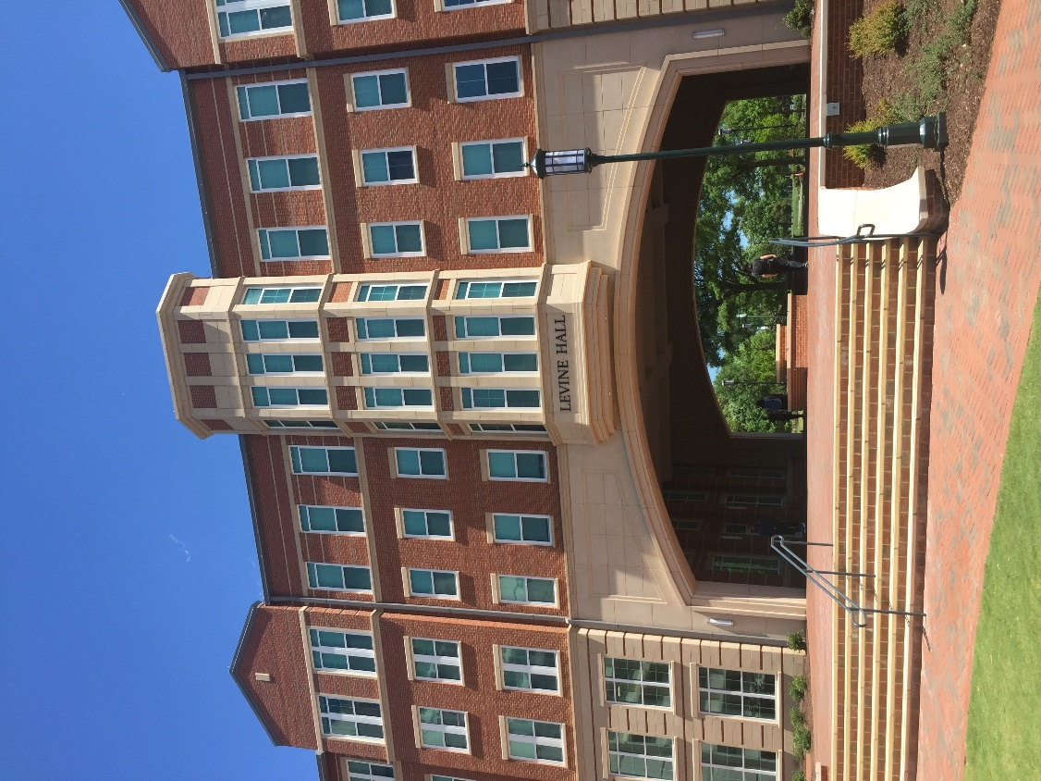

Honors
College
honorscollege.charlotte.edu

The Honors College offers academically motivated, high-potential learners from all communities access to opportunities for intellectual breadth, undergraduate research, service learning, and a community feeling within the context of a large public research university. Comprised of thirty distinct honors programs, each with its own admission and graduation requirements, the Honors College is a campus hub for undergraduate honors courses, enrichment opportunities, merit scholars programs, honors scholarships, study abroad, community service, faculty lectures, and University-wide advising for nationally competitive awards such as the Rhodes, Truman, and Goldwater Scholarships. An honors residence option in Levine Hall is also available for students in the Honors College, with priority for freshmen.

The University Honors Program in the Honors College
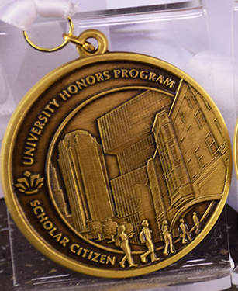
The University Honors Program (UHP) in the Honors College offers a unique, interdisciplinary undergraduate experience. The program centers around honors coursework, community engagement, and leadership opportunities. In addition to academic and professional development, UHP offers a supportive community of students and faculty who mutually invest to help members develop to their fullest potential as scholar citizens. Students are encouraged to participate in varied enrichment activities, internships, research, and study abroad programs with the goal of broadening perspectives.

The UHP curriculum requires successful completion of HONR 1700, CTCM 2530 (honors sections only), 12 credit hours of honors electives, and completion of an honors capstone thesis/project. An Advanced Entry option is available for students entering the program with substantial early college or transfer credit. Students in UHP also may join a disciplinary honors program during their time at UNC Charlotte. The Honors College website maintains a current listing of all honors programs available at UNC Charlotte. Credit for certain honors courses in disciplinary honors programs may count toward UHP requirements. As their culminating honors curricular requirement, UHP students complete a capstone thesis/project through UHP or through their disciplinary honors program.

Admission Requirements
Students who may apply to UHP include entering freshmen, transfer and continuing students in any major who: expect to be at UNC Charlotte for at least two years to complete their degree program, have a strong record of academic success, and feel they are a good fit with the UHP mission. Continuing students must have a GPA of 3.4 to apply. All members of UHP must maintain a 3.0 overall GPA, a 3.2 GPA in honors courses, and meet co-curricular expectations each semester.

Course Requirements
To graduate with University Honors distinction noted on the transcript, students must satisfy the following course requirements:

Required Courses
HONR 1700 - University Honors Program Colloquium (1) (with a grade of B or above)
CTCM 2530 - Critical Thinking and Communication (3) (honors sections only) (typically taken in the sophomore year)

Required Elective Courses
Select 12 credit hours of HONR courses and/or honors sections of fundamental themes general education courses. At least 6 credit hours of honors elective courses should be at the 3000 level or higher. Students accepted as Advanced Entry may be exempted from 6 credit hours of lower division honors coursework if they enter with 60+ credit hours, and may be exempted from 3 credit hours of lower division honors coursework if they enter with 30-59 credit hours.

Required Capstone Courses
Students in UHP must complete an honors capstone project. Students can satisfy this requirement by applying to a disciplinary honors program and completing their capstone/thesis proposal and capstone/thesis project in their discipline (leading to dual honors; see below), or can complete their capstone project in UHP by completing HONR 3790 and HONR 3791. Both the capstone proposal and capstone project must receive a grade of A for graduation with honors.

Other Requirements
- Complete the Application to Candidacy process for graduating with honors, as directed by the Honors College
- Maintain a minimum overall GPA of 3.0, and a 3.2 GPA in honors coursework
- Maintain good standing through required activities participation in UHP

Dual Honors
Students may graduate with dual honors by completing all departmental/college honors program requirements, in addition to UHP requirements. In this case, the departmental/college capstone thesis/project experience will satisfy the UHP capstone requirement.

Students in departmental/college honors programs with curricular requirements beyond the capstone sequence may also count one 3000 or 4000-level honors course toward their honors electives.

Study Abroad
Students studying abroad may request up to 3 credit hours as an honors elective course through the UHP Canvas page.

Residence
UHP students are encouraged to live in the Honors College residence, Levine Hall, which provides an environment especially conducive to community-building, academic study and cooperative learning. The Honors College office suite is conveniently located in Levine Hall.

The Dubois Center
The Honors College offers some honors classes, an honors student lounge (5th floor), and several honors activities each semester at The Dubois Center campus in uptown Charlotte. UHP students are particularly encouraged to make use of honors spaces at The Dubois Center, easily accessible via light rail.

Student Association
Students in the UHP are members of the University Honors Program Student Association (UHPSA). The student-led organization coordinates social events, special discussions, student mentoring, and community service projects. All UHP students are required to attend meetings and complete co-curricular requirements in order to remain in good standing.

Merit Scholars Programs
The Albert Engineering Leadership Scholars Program, Freeman Scholars, Johnson Scholars, and the Martin Scholars Program are housed in the Honors College; Albert Scholars are members of the UHP; Freeman, Johnson, and Martin Scholars must be members of any honors program.

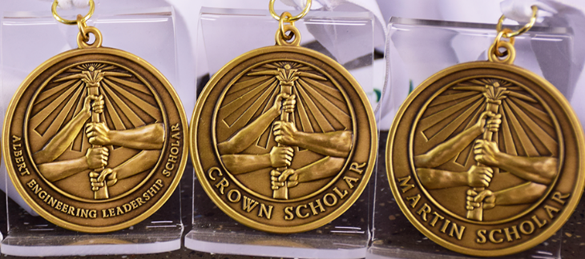

Honors Programs in Departments and Colleges
Many academic departments and colleges have disciplinary honors programs enabling students to graduate with honors distinction in their major department or college. This recognition will appear on students’ official academic transcripts.

Honors programs in colleges include:
- College of Arts + Architecture
- College of Business
- College of Computing and Informatics
- College of Education
- College of Engineering

Honors programs in departments and interdisciplinary programs include:
- Africana Studies
- Anthropology
- Applied Physiology, Health, and Clinical Sciences
- Art History
- Biological Sciences
- Chemistry
- Communication Studies
- Criminal Justice and Criminology
- English
- Geography and Earth Sciences
- Global Studies
- History
- Languages and Culture Studies
- Latin American Studies
- Mathematics and Statistics
- Nursing
- Philosophy
- Physics and Optical Science
- Political Science and Public Administration
- Psychological Science
- Public Health and Health Systems Management
- Religious Studies
- Social Work
- Sociology

Information on how to apply to and graduate with disciplinary honors can be found in this Catalog under each academic discipline with an honors program.



Nationally Competitive Scholarships Advising
The Honors College, working with the University Endorsement Committee, supports students across campus who wish to apply for nationally and internationally competitive scholarships for advanced undergraduate study, leadership development, experiences abroad, and graduate programs. These scholarships, from a number of foundations and national organizations including Rhodes, Marshall, Harry S. Truman, Barry M. Goldwater, DAAD, Phi Kappa Phi, and the National Science Foundation, require extensive application procedures and faculty support. They are awarded to only the most outstanding applicants. For other awards, such as the Fulbright US Student Program, the Honors College collaborates with campus partners (i.e. The Office of Education Abroad). Students with exemplary academic records—importantly, combined with service and leadership—will be in the best position to excel in these awards competitions. Several of these awards require an on-campus review and institutional endorsement of completed applications. Students wishing to strengthen their applications may register for HONR 2720, offered regularly for competitive applicants across campus, whether they are in honors programs or not.

The Honors College also coordinates the UNC Charlotte Alumni Association Scholarships, which give preference to students in honors programs, as well as scholarships specifically for honors students: the Delbridge E. Narron Scholarship and Travel Award, and the Al Maisto Honors College Scholarship.

Honors Societies
The Honors College supports the campus chapters of three major national honors societies: Phi Beta Kappa, Phi Kappa Phi and Sigma Xi. Nominated students can be inducted into the societies and participate in chapter activities, such as guest speakers, community service projects and social events.

