Office of

Undergraduate Education

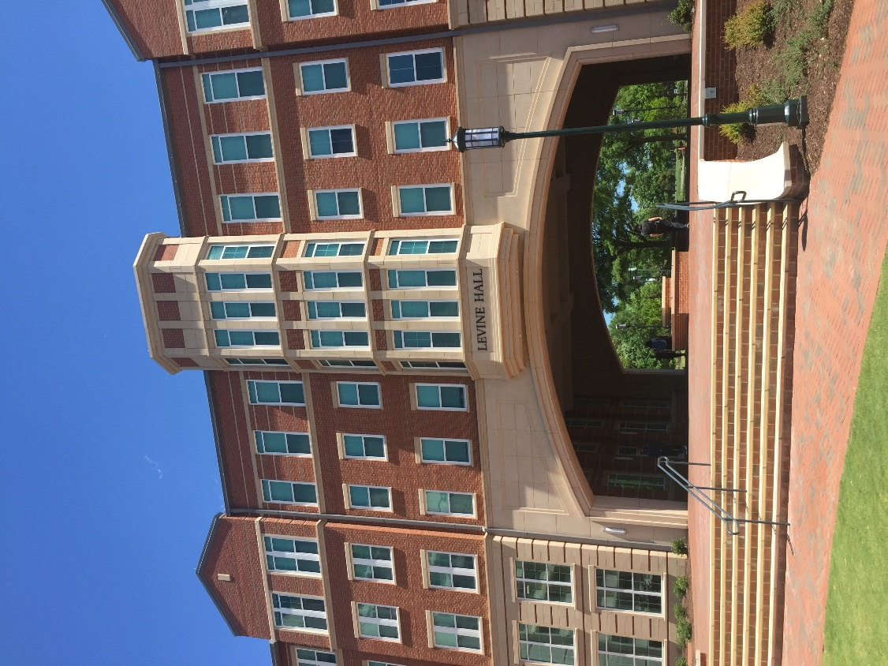

Office of
Undergraduate Education
uge.charlotte.edu


The Office of Undergraduate Education at UNC Charlotte enriches the academic community by offering a broad range of initiatives promoting student success, ensuring access, and enhancing the educational experience of all students. Broadly speaking, the Office of Undergraduate Education’s responsibilities fall in two areas: (1) curriculum and integrated learning, and (2) advising and experiential learning. Through transition programs, learning communities, support for student-athletes, career services, experiential learning, disability services, tutorial programs and other success services, the Office of Undergraduate Education supports students in cultivating life skills critical to successful graduation and global citizenship. In addition, through its faculty development programs, curriculum improvement and innovation initiatives, leadership on advising, and community outreach, the Office of Undergraduate Education engages the University’s academic units, faculty, and staff in efforts to enhance and improve both the quality and effectiveness of our academic programs. Working with students and stakeholders to address the needs of a diverse student population, the Office of Undergraduate Education utilizes an integrated student-centered approach that reinforces rigorous academic expectations and encourages student engagement from the time of enrollment through graduation.

The Office of Undergraduate Education consists of the following:

- Advising Systems
- Athletic Academic Center
- Communication Across the Curriculum
- Disability Services
- First Year and Transition Programs
- Ninerways Quality Enhancement Project (QEP)
- Office of Undergraduate Research
- University Advising Center (including Pre-Health Advising)
- University Career Center (including Pre-Law Resources)
- University Center for Academic Excellence
- University College
- University Transfer Center

Advising Systems
advising.charlotte.edu/manage-your-academic-journey/technology-your-journey

The Advising Systems Team works with the campus community in supporting student success by utilizing academic software systems for early alerts, appointments, notifications, notes, and student progression/performance tracking. These systems include CONNECT, Navigate Student, and DegreeWorks. Faculty in 1000- and 2000-level courses report early alerts by the fourth week in the semester using CONNECT. An early alert triggers an email sent to a student’s UNC Charlotte email account. This email contains information related to missing assignments, missing classes, or demonstrating low performance. Students are able to make appointments with academic advisors and other academic support services, such as tutoring and academic consultations, to improve performance in their courses. Navigate Student is a mobile app that allows students to be able to keep track of university deadlines, provides tips to success, and links to CONNECT. DegreeWorks, managed by the Office of the Registrar, is the official degree audit system to track progress towards degree completion and has degree planning features.

Athletic Academic Center
charlotte49ers.com/sports/athletic-academic-center

The Charlotte 49ers Athletic Academic Center (AAC) is committed to empowering all Charlotte varsity student-athletes to take ownership of their personal academic experience. The center provides a framework of support services designed to meet the unique needs of student-athletes, assisting them to achieve academic and personal success at the University while ensuring the student athlete’s compliance with all National Collegiate Athletic Association (NCAA), Conference and University regulations.

The Athletic Academic Center operates dual centers: the ATAC AAC located in the Miltimore-Wallis Athletics Training and Academic Center adjacent to the Barnhardt Student Activity Center and the Board of Trustees (BOT) AAC is located in the Rose Football Center adjacent to McColl-Richardson Field. The academic facilities have study areas, computer labs, private tutor rooms, and offices.

Communication Across the Curriculum
cxc.charlotte.edu

Communication Across the Curriculum (CxC) supports student success through programs designed to integrate writing and speaking into disciplinary curricula and general education. CxC’s vision is that all students have multiple, high quality opportunities throughout their academic careers to develop their communication skills. CxC staff partner with academic colleges, departments, and individual faculty to facilitate curricular transformations that broaden and deepen student learning and engagement. The following programs are offered on a regular basis by CxC:



Curriculum Consultation
CxC consults with departments in all disciplines to strengthen student learning experiences and content knowledge through communication-enhanced curricula. This comprehensive approach identifies areas of strength and opportunities for growth in the teaching and learning of writing and speaking. On a smaller scale, CxC consults with faculty of all ranks and in all disciplines, in small groups and individually, to assist with specific course and assignment design, as well as pedagogy and teaching practice.

Professional Development
CxC facilitates various professional development opportunities for faculty throughout the year that seek to develop communication across the disciplines, including:

- CxC Webinars
- -CTCM 2530 Course Prep
- Communication-Enhanced Teaching Academy
- Workshops (customized to group needs, upon request)

Student Communication Consultants
CxC administers a student peer-mentoring program, providing opportunities for students to work as Communication Consultants with faculty and departments who develop communication-enhanced curricula and teaching practice. The consultant’s role when working with students is to act as an engaged reader/listener, providing informed, constructive criticism directed toward the focus, scope, evidence, analysis, organization, clarity, and style of papers and presentations. Consultants also provide faculty with constructive feedback on how students are experiencing communication-enhanced curricula and assignments.

Disability Services
ds.charlotte.edu

The Office of Disability Services is the University office designated to determine reasonable accommodations for students with disabilities. Their mission is to provide access to education and campus life at the University and to support a culturally rich, inclusive, and accessible campus environment. They work with undergraduate, graduate, and continuing education students to help ensure that programs, services, and the campus are accessible in accordance with Section 504 of the Rehabilitation Act of 1973, the Americans with Disability Act, and the ADA Amendments Act. Students who plan to request accommodations must submit documentation of their disability to Disability Services for review. Information about the process for registering with disability services and appropriate documentation forms can be accessed at https://ds.charlotte.edu/students/how-register-services/

Once documentation is reviewed and a determination is made, students are notified via their University email regarding eligibility status and next steps. Once eligible for services, students must schedule a Registration appointment with a DS staff member to establish accommodations through the interactive process. Students with documented disabilities may be eligible for a variety of reasonable accommodations and services.

The Disability Services staff recognize there are often differences in services and accommodations between high school and college, and services can even vary from university to university. Students are encouraged to contact Disability Services with questions about eligibility, services, and accommodations at UNC Charlotte.

First-Year & Transition Programs

Recognizing the importance of the first year in shaping a student’s college experience, the First-Year & Transition Programs work across the University to develop and coordinate programs that support new students. These include:

Prospect for Success

The Office of Undergraduate Education coordinates the University's Prospect for Success program. Prospect for Success is a campus-wide academic engagement initiative for all incoming first-year students. Students engage with the Prospect for Success program during their first semester at UNC Charlotte.

Through carefully designed courses and out-of-class experiences, every first-year student at UNC Charlotte develops their own commitment to success, inquiry skills, and cultural awareness as a participant in Prospect for Success. While this may look different for each student, depending on the coursework and requirements for their particular college, the commitment to seeing students thrive at UNC Charlotte remains the same.

Each college at UNC Charlotte has a Prospect for Success curriculum that fits the needs of students in their programs. The Prospect course that all new students take addresses three learning outcomes: commitment to success, inquiry, and cultural awareness. Prospect for Success also provides structured activities that engage students with their advisors, campus resources, and co-curricular opportunities. More information may be found at prospect.charlotte.edu.

Learning Communities
UNC Charlotte's Learning Communities Program enhance the way students live, learn, and succeed in their academic endeavors. Learning communities help new students transition through academic and social challenges by providing small, supportive learning environments. Students who participate in a learning community interact closely with Charlotte faculty, staff, and peer mentors through areas of common interest, enroll in two or three of the same courses, and -- in many cases -- live together in the same residence hall. Students in the year-long learning communities make friends and develop close relationships.

While some learning communities are residentially based, most do not require living on campus. Additionally, while most learning communities are designed for first-year students, some are specifically designed for new transfer students.

Contact and application information for UNC Charlotte's Learning Communities can be found online at lc.charlotte.edu.

NINERways
The NINERways is a university initiative to boost student success in mathematics and statistics in general education courses required for their majors. The primary aim of NINERways is to enhance the learning experience and support systems in introductory mathematics and statistics courses to ensure that students are well-prepared to excel in their chosen fields of study. This initiative is based on three key pillars:
Pillar 1: Math Pathways Structure and Alignment
NINERways aims to tailor mathematics and statistics courses to align with students' academic programs. This means designing courses that are not only essential for progressing in their majors but also provide the necessary knowledge and skills for success in related courses. Structuring these gateway courses in a way that reflects students' academic paths will provide students better support as they pursue their educational goals.
Pillar 2: Course Curricula Coordination
NINERways emphasizes the importance of consistency in teaching. Coordinated faculty teaching teams work to ensure coherence and uniformity in course delivery. This approach aims to provide students with a consistent learning experience ultimately enhancing their academic performance.
Pillar 3: Evidence-Based Pedagogies and Classroom Practices
NINERways seeks to enhance teaching practices through evidence-based pedagogies. Faculty members consistently undergo professional development to learn and implement effective teaching strategies that have been shown to enhance student learning. By equipping instructors with the tools and techniques to engage students and facilitate understanding, NINERways aims to improve overall student success to promote equity in education ultimately leading to a timely graduation. Overall, NINERways is designed to empower students to succeed in math and achieve their academic aspirations.

Office of
Undergraduate Research
our.charlotte.edu

The Office of Undergraduate Research (OUR) supports UNC Charlotte students, faculty, and staff in their endeavors to expand the quantity and enhance the quality of undergraduate research experiences on campus. We strive to be an office that supports access to opportunities for research training and development while fostering academic and professional growth for students. The goal of OUR is to build community amongst scholars, artists, and researchers at UNC Charlotte.

The mission for the Office of Undergraduate Research at UNC Charlotte is to promote scholarly identities through experiential learning by advancing access to and engagement with mentored research and creative activities as an integral part of the undergraduate curricular and co-curricular programs for Charlotte’s diverse student body.

Our vision is to expand research opportunities and promote academic success for undergraduate students through innovation, mentored scholarship, creative expression, and entrepreneurship. This high-impact practice enhances students’ ability to construct knowledge and prepares them to become life-long learners and to address future problems as enlightened citizens and leaders.

Key aspects of fulfilling this vision include:

- Creating equitable opportunities for all undergraduates to engage in creative learning and critical inquiry that increases relevant career competencies and curiosity about how they can impact their personal and professional communities.
- Removing financial, social, and/or cultural barriers, so research can become a central feature of the undergraduate experience for all interested students at UNC Charlotte.
- Serving as the primary campus resource for students, faculty, and staff seeking guidance or support related to each of these activities.

OUR provides undergraduate research fellowships and opportunities to communicate research to others through multiple research symposia and funding to local, regional, and national conferences to present the research. OUR fosters the professional development of mentors and research students through workshops, learning communities, and scholarly discussions.

University
Advising Center
ucol.charlotte.edu/advising/academic-advising

The University College Advising Center provides academic advising services to students who are undeclared, exploring, or transitioning between majors.

Academic Advisors in the Advising Center collaborate with faculty Academic Advisors from each of the Colleges to support students in making decisions regarding major declaration and to ensure smooth transitions to and from majors. The Academic Advisors, in collaboration with many campus partners, work to provide new and creative opportunities for students to explore majors and careers that align with their abilities, interests, and strengths. The University College Advising Center works closely with other services within the Office of Undergraduate Education to ensure consistent and frequent referrals to academic enrichment and support services.

University Career Center
career.charlotte.edu

The University Career Center (UCC) offers comprehensive career services designed to assist undergraduate and graduate students in all stages of career development. Each student has a specific career advisor (based on the student’s major and including undeclared majors). Career advisors assist students with exploring majors and careers, gaining experience, conducting job and internship searches, and transitioning after graduation. In addition to individual appointments and group workshops, the UCC hosts career fairs and events throughout the year and provides a host of resources online at career.charlotte.edu. UCC staff collaborate with academic colleges to coordinate experiential learning, and career advisors teach career-related sections of freshman and transfer seminars. The UCC offers the following programs.

Preparation for Professional Schools
An education at UNC Charlotte can prepare students for a number of professional careers. Students who plan to enter a professional school are advised to plan their program of study so that general requirements for their degree are met in addition to the requirements for the professional program being considered. This can begin with a discussion with an academic advisor as soon as a student starts to explore professional schools. Students should become familiar with the requirements of the professional schools of interest. That school, not UNC Charlotte, will determine which UNC Charlotte credits will be accepted.

Professional school entrance requires an extensive commitment and focused career choice. Certain careers require an advanced degree, and the University Career Center (UCC) can help students identify what kind of graduate study will best prepare them for the specific career of interest. In addition, the career resource collection in the UCC contains information on preparing for professional school exams, select fellowships and grants, and in-depth career information. Hire-A-Niner, the UCC’s online job and internship database, includes relevant job shadowing, internship, and work opportunities. Résumé critique sessions, application essay reviews, and mock interviews offered by the UCC can be geared toward professional school admissions, based on student need. Professional programs recruit on campus career fairs that happen throughout the academic year.

It is important to note that there are more application requirements for professional programs than for undergraduate programs. Application is often an extensive and in-depth process. The UCC can help students plan the application and career development processes, which includes career exploration through job shadowing, self-assessment, career research, and internships.

Pre-Law Advising
Admission to law school is determined mainly by undergraduate grade point average and the score on the Law School Admissions Test (LSAT). Applicants must also submit letters of recommendation and a recitation of extracurricular activities, and personal statement, but those items are secondary to the GPA and LSAT. There is no defined program of pre-law courses, and law schools do not favor or require a specific major. Law schools look for students who have taken courses that are academically rigorous, including writing intensive and research-oriented courses.

To learn more about law school, please visit the UNC Charlotte Pre-Law Society website at unccprelaw.com or contact the Department of Criminal Justice and Criminology. For law-related student organizations, please visit the Student Organizations website at studentorgs.charlotte.edu.

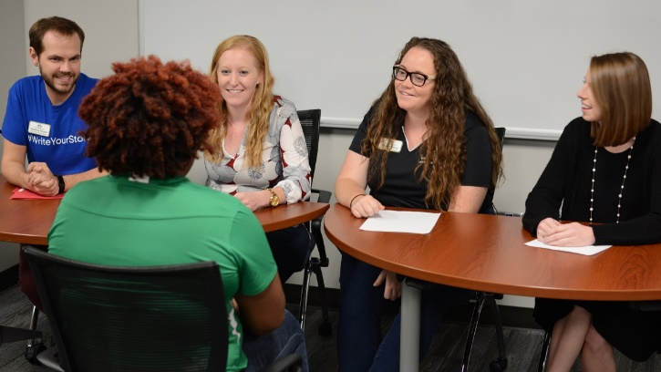

Part-Time Employment On/Off-Campus
The UCC’s Job Location and Development (JLD) Program assists students in obtaining off-campus jobs including part-time, summer, temporary/seasonal, and full-time (non-degree). Job listings may be viewed online in Hire-A-Niner at hireaniner.charlotte.edu and often include career-related positions in various fields. In addition, all on-campus jobs can be found in Hire-A-Niner (both Federal Work Study eligible and non-Federal Work Study).

Experiential Learning Programs
The majority of UNC Charlotte students are expected to and do participate in University-sanctioned experiential learning programs. Opportunities are available for both undergraduate and graduate students to receive course credit, or other recognition for supervised experiences in public and private agencies within the community, nationally, and internationally. These opportunities are offered through experiential learning programs including over 670 courses involving clinical rotations, cooperative education, internships, and practicums. For full description of related courses, see the Course Descriptions section of this Catalog.

Cooperative Education
This career-related professional program is available to students in the College of Computing and Informatics and College of Engineering. Participants must be enrolled full-time in an undergraduate degree program, and have a cumulative GPA of at least 2.5, and complete course requirements specified by their department. Transfer students must complete 12 hours at UNC Charlotte before applying to the program. Co-op students work two to three semesters either part-time or full-time (depending on college requirements) with an employer in a paid work experience. Participants receive transcript notation, not academic credit.

Academic Internships
Some academic departments award students credit for completing relevant internships. Students are encouraged to check with their academic department for further information and academic eligibility requirements.

University Professional Internship Program
The University Professional Internship Program (UPIP) offers paid on-campus internships to full-time sophomores, juniors, and seniors. Internships are designed to provide professional knowledge and skill development consistent with the student’s major/career goals. Students work through their home academic department for approval of academic credit for their internship. UNC Charlotte faculty and administrators serve as mentors to interns, with each internship paying $10 per hour for 10-15 hours per week during the Fall and Spring semesters.

Office of Pre-Health Advising

Office of Pre-Health Advising
UNC Charlotte offers pre-professional preparation for undergraduate, graduate, and post-baccalaureate students interested in pursuing a career in medicine, dentistry, veterinary medicine, pharmacy, optometry, physician assistant, physical therapy, podiatry, and related healthcare careers. Opportunities and services available to students include:

- Strong academic preparation in the required prerequisite core of
science and math courses
- Broad selection of recommended complementary non-science
courses

- Pre-Health Professions Advising for
academic and nonacademic
requirements for professional school
admission
- Assistance with the application process,
including essay preparation and interviews
- Faculty Evaluation Committee that prepares
composite recommendation letters on the
student’s behalf
- Opportunities to participate in research
- Pre-Health student organizations that offer guest speakers,
community service, and peer support

Like most universities, UNC Charlotte does not offer a formal pre-health major, minor, or program. Students must select a major and are responsible for completing the prerequisites for their chosen professional school in addition to courses for their major and Bachelor’s degree. There is no requirement to major in science, but strong preparation in science and math must be demonstrated, regardless of the major. A Pre-Health Advisor will assist the student with identifying the appropriate pre-professional courses and formulating a timeline for their completion.

All pre-health students are encouraged to consult with a Pre-Health Advisor to plan and review their preprofessional course of study and other requirements necessary for admission into professional schools. Additional information may be found on the Pre-Health Professional Academic Advising page at advising.charlotte.edu/pre-health, including prerequisite course lists for various professions.

For health-related student organizations, visit studentorgs.charlotte.edu.

Prerequisite Core Courses
The basic minimum requirements for entrance to most health professions schools are as follows:

Subjects | Credit Hours
Biology (with labs) | 8
General Chemistry (with labs) | 8
Organic Chemistry (with labs) | 8
Physics (with labs) | 8
English | 6

Note: These are the common minimum requirements; additional courses may be required at the discretion of the professional school. Most students will need additional coursework and healthcare-related extracurricular activities to be competitive for admission. Community service is also highly recommended.

Faculty Evaluation Committee for Pre-Health Professions
The UNC Charlotte Pre-Health Professions Faculty Evaluation Committee serves as the main recommending body for UNC Charlotte students seeking entrance to medical, dental, veterinary, and optometry schools. Students must have competitive credentials to qualify for a committee letter. In order to obtain a recommendation from the committee, the student should contact the Office of Pre-Health Advising during the year in which applications to professional schools are being submitted.

University Center for Academic Excellence
ucae.charlotte.edu

The University Center for Academic Excellence (UCAE) provides academic support services and resources that increase learning effectiveness, enhance student success, and promote academic excellence. All services are free to enrolled UNC Charlotte students. For additional information on any of the programs and services offered by the UCAE, visit ucae.charlotte.edu. The UCAE offers the following programs and services:

Academic Skill Workshops
A wide variety of workshops and presentations are offered each semester on topics that help students achieve academic success. These interactive workshops are led by staff and graduate students on-site and across campus. Topics include: Time Management, Goal Setting, Effective Note Taking, Motivation, the Science of Learning, and more.

Learning Commons
The Learning Commons is a place where students can come to study in a welcoming environment with academic support only a few steps away. They can make use of computers and pay-for-print services, as well as a library of resources including books and study guides.

Peer-Assisted Learning
The Peer-Assisted Learning (PAL) program assists students in historically difficult courses in fields such as biology, chemistry, physics, engineering, mathematics, business, and the social sciences. In weekly scheduled group study sessions, trained peer leaders help students refine the unique skills necessary for succeeding in the target course. Peer leaders plan sessions that focus on collaboration and active learning. Data show that students regularly participating in Peer-Assisted Learning sessions are better prepared and average significantly higher final course grades compared to non-participants. The program has been nationally certified through the College Reading and Learning Association (CRLA).

Academic Consultations
Academic Consultations are one-on-one meetings tailored to the academic needs of the student. They are designed to help students discover more about themselves and develop personalized strategies for comprehensive collegiate success. Assessments of study habits/attitudes can also be administered and interpreted during consultations. Students may sign up for one-time or ongoing appointments to address their academic success goals.

Academic Coaching
The 49er Connect program links UNC Charlotte students to trained academic coaches, called Success Guides, who provide academic support and accountability. Success Guides are there to help their peers strengthen academic skills like time management and note-taking. They work with students to troubleshoot issues in classes or to navigate campus resources. In addition to regular email check-ins, they provide reminders about University deadlines and share study tips throughout the semester.

Students Obtaining Success
Students Obtaining Success (SOS) is a peer-mentoring program for students experiencing academic difficulty at UNC Charlotte. SOS is a semester-long program that is individually tailored to help students overcome their unique challenges, improve academic performance, and return to good academic standing. SOS empowers students to identify strengths, develop academic and personal strategies to be successful, and connect with appropriate campus resources. Any student experiencing academic difficulty is eligible to register for SOS, though priority is given to students participating in 49er Rebound. Each participant meets weekly with a well-trained undergraduate peer mentor for support and guidance. The SOS program has been nationally certified through the College Reading and Learning Association (CRLA) at Level II, Advanced Mentor.

Tutorial Services
Serving all UNC Charlotte undergraduate students, the Tutorial Services Program provides free tutoring by appointment and drop-in sessions. Recurring and online appointments are available. Tutoring is offered for courses in various subjects including mathematics, science, business, engineering, health and human services, foreign languages and others as needed. Peer tutors emphasize learning skill development and content mastery. UCAE Peer Tutors are selected based on expertise in their area of academic discipline and faculty endorsements. Along with tutor professional development and tutee learning facilitation, Tutorial Services progressively updates its practices and policies as a nationally certified program through the College Reading and Learning Association (CRLA) at Level III.

49er Rebound
49er Rebound is an academic recovery program to assist students who are on academic probation at the end of their first year of enrollment at UNC Charlotte. New freshmen and transfer students from all colleges participate in the program. The UCAE collaborates with all eight colleges, secondary advising centers, and staff members across campus to offer a range of options for participating students. These options include both a credit and a non-credit bearing academic success course, or peer mentoring for more individualized support. 49er Rebound works! Students who complete 49er Rebound have significant GPA improvement and return to good academic standing at higher rates than those who do not complete the program.

University College
ucol.charlotte.edu

The University College serves as the academic home for undeclared students, offering a supportive environment for exploration and decision-making. Designed to assist students in discovering their academic and career interests, the University College provides guidance, resources, and advising to help students make informed decisions about their academic paths. With a focus on holistic development, it serves as a bridge to various academic disciplines, fostering a smooth transition for students as they explore and choose a major that aligns with their passions and goals.

The populations of students that form the University College include undergraduate students who are exploring their options before choosing a major or transitioning between majors. Students within the University College will have several Meta-Major options to choose from. Meta-Majors provide a clear pathway to declaring a major and help make connections between academics and different career tracks. Before students declare a major, they are advised in the University College Advising Center. The Advising Center staff are also able to refer students to a variety of support offices available to assist students.

See the “Degree Requirements and Academic Policies” section of this Catalog for details on the General Education Program at UNC Charlotte.

University Transfer Center
transfercenter.charlotte.edu

The University Transfer Center provides support and advocacy to promote transfer student success. Through collaboration with campus and external partners, the mission of the UTC is to provide resources and information to empower transfer students and increase their retention and graduation rates. This mission is primarily accomplished through advising and engagement activities focused on prospective and newly enrolled transfer students.

Advising
The UTC provides supplemental advising for currently enrolled transfer students and serves as a resource to all advisors on campus. Pre-transfer advising is primarily offered to prospective transfer students through the 49erNext program, outreach at community colleges, and in collaboration with the Office of Undergraduate Admissions Transfer Student Tours. The University Transfer Center also partners with community college advisors and maintains the university’s Transfer Guides to provide information about course and program requirements to ensure a seamless transition for students who transfer from North Carolina community colleges.

Engagement
The University Transfer Center offers programming and outreach to both celebrate transfer student success on campus and promote a sense of community and belonging for recent transfer students. In addition to Gold Rush and National Transfer Student Week events, the UTC is the home of Tau Sigma and a Forty-Niner Intensive Transition (FIT) cohort for transfer students.

