Learning-Based Dynamic Modeling of an Autonomous Underwater Vehicle (AUV)
Phase 1 Project Report & Presentation Comprehensive Dossier
Hydrodynamic Kinematics, Telemetry EDA, and Deep Residual GRU Networks
Robotics Semester 5 Project | Platform: Autosub6000 (AURORA Mission M86) | Status: Complete
――――――――――――――――――――――――――――――――――――――――――――――――――――――――――
Executive Summary
Autonomous Underwater Vehicles (AUVs) operating in real ocean environments experience highly complex, nonlinear hydrodynamic forces that analytical physics equations fail to capture accurately. Unmodeled thruster deadbands, control-surface deflection lags, wave action, and variable buoyancy lead to substantial cumulative drift when relying solely on rigid-body kinematics.
In Phase 1 of this project, we designed and experimentally validated a Hybrid Physics-AI Modeling Framework using real-world telemetry logged during the Autosub6000 AUV Mission M86 (recorded at 0.50 Hz / dt = 2.0 s). Instead of replacing physics principles with a black-box model, our architecture uses a nominal 3D kinematics baseline combined with a 2-Layer Recurrent Gated Recurrent Unit (GRU) trained strictly to predict residual mismatches: R(t) = X_actual(t+1) - X_physics(t+1).
KEY HIGHLIGHT: Substantial Dynamics Improvements over Baseline
Evaluated on 4,792 unseen future test samples, the Hybrid Physics+GRU network achieved dramatic error reductions over pure physics: Pitch Angle RMSE improved by 15.48%, Operating Depth RMSE improved by 12.45%, and Heading Angle RMSE improved by 12.03%. Multi-step autoregressive trajectory simulations demonstrate that hybrid modeling preserves physical plausibility while eliminating cumulative dynamic drift.

1. Dataset Specifications & Zero-Leakage Splitting
The project utilizes sensor telemetry from Autosub6000 Mission M86, an operational ocean survey vehicle. The vehicle logged high-rate navigation data using a Doppler Velocity Log (DVL), an Inertial Measurement Unit (IMU), pressure depth transducers, and Ultra-Short Baseline (USBL) acoustic positioning transponders.
- Dataset Source: Raw Telemetry Source: IEEE DataPort Autosub6000 Mission M86 multibeam echosounder logs.
- Cleaned Sample Volume: 31,944 verified samples logged every 2.00 seconds (0.50 Hz sampling frequency).
- Temporal Partitioning: Strict chronological train/validation/test ordering ensuring zero future data leakage.
Split Segment | Sample Count | Percentage | Row Index Range | Mission Elapsed Time
Training Set | 22,360 | 70.0% | 0 to 22,359 | 0.0 h to 12.4 h
Validation Set | 4,792 | 15.0% | 22,360 to 27,151 | 12.4 h to 15.1 h
Testing Set (Unseen) | 4,792 | 15.0% | 27,152 to 31,943 | 15.1 h to 17.7 h

2. Exploratory Data Analysis (EDA)
Rigorous exploratory data analysis was conducted on the full continuous mission telemetry to characterize vehicle operating envelopes, detect measurement noise, and establish physical consistency before training neural networks.
2.1 Telemetry Summary Statistics
Table 1 outlines the empirical distribution metrics for all seven primary AUV state variables across the 31,944 telemetry samples.
State Variable | Mean | Std Dev | Min | 25% | Median | 75% | Max
North Position (m) | 2387.108 | 1646.678 | -336.365 | 901.012 | 2454.294 | 4038.155 | 4632.381
East Position (m) | 595.953 | 241.186 | -124.577 | 354.630 | 618.629 | 851.005 | 1034.713
Depth (m) | 68.339 | 34.497 | 0.001 | 56.991 | 60.341 | 93.921 | 108.385
Roll Angle (rad) | 0.229 | 0.047 | -0.249 | 0.220 | 0.223 | 0.227 | 1.505
Pitch Angle (rad) | -0.012 | 0.052 | -0.659 | -0.019 | -0.011 | -0.003 | 0.705
Heading Angle (rad) | 2.917 | 2.069 | 0.000 | 0.728 | 3.094 | 4.077 | 6.283
Surge Speed (m/s) | 1.192 | 0.253 | 0.000 | 1.112 | 1.242 | 1.360 | 3.249

2.2 State Distributions & Physical Operating Envelopes
Figure 1 displays the distributions of surge speed, depth, heading, pitch, and roll. Surge speed exhibits a sharp operating mode around 1.20 m/s (cruise propulsion setting), with an overall mean of 1.19 m/s. Pitch values stay centered near zero (-0.012 rad) with small excursions during depth changes. Roll exhibits a steady hydrodynamic heel trim angle (~0.23 rad) caused by the single-screw propeller counter-torque.
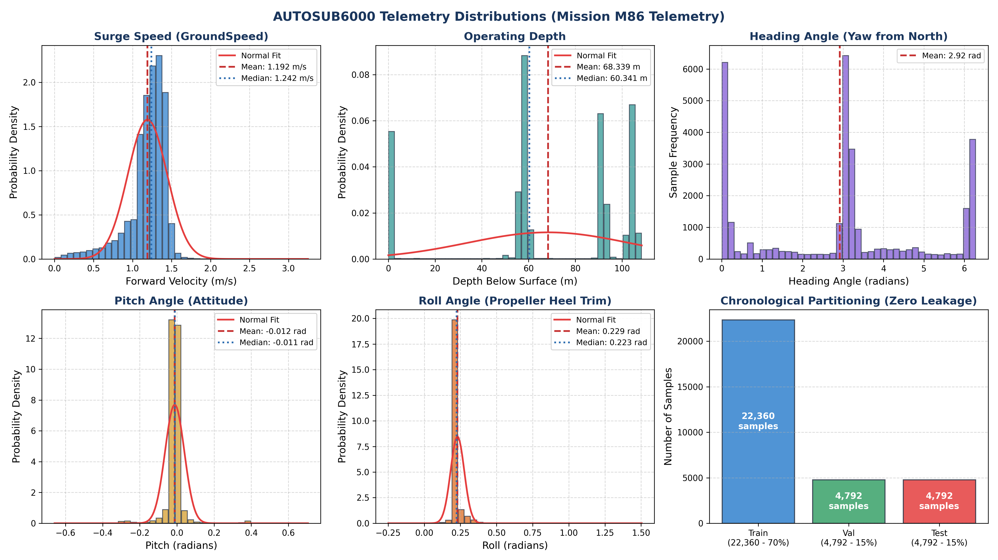
Figure 1: Probability distributions and histograms of primary AUV telemetry states across Mission M86.
2.3 Survey Path & Mission Dive Profile
Figure 2 illustrates the horizontal 2D survey path in local Cartesian coordinates (North vs East) and the mission depth dive profile over 17.7 hours of continuous operation. The vehicle surveyed a track of 4.6 km North by 1.1 km East. The dive profile shows initial descent to ~60 m depth, followed by an operating deep lawnmower pattern extending down to 108 m.
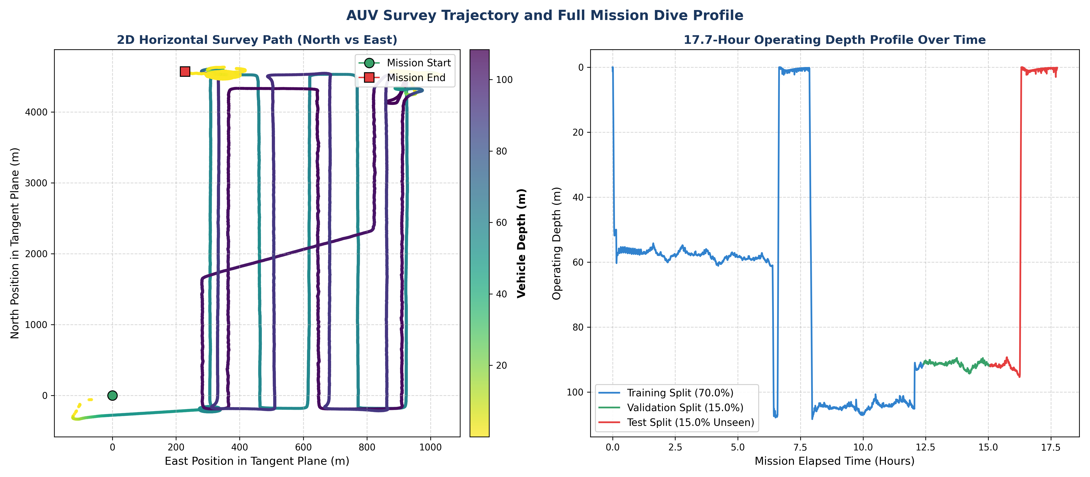
Figure 2: (Left) Horizontal 2D trajectory color-coded by depth. (Right) Full mission dive depth profile across train, val, and test splits.
2.4 Multi-Sensor Telemetry Correlation Analysis
The state correlation matrix (Figure 3) uncovers key hydrodynamic couplings. Strong kinematic correlation exists between North/East positions and Heading (0.61 and 0.47). Depth shows negative correlation with surge speed, indicating slight velocity drops during vertical diving operations due to increased plane drag.
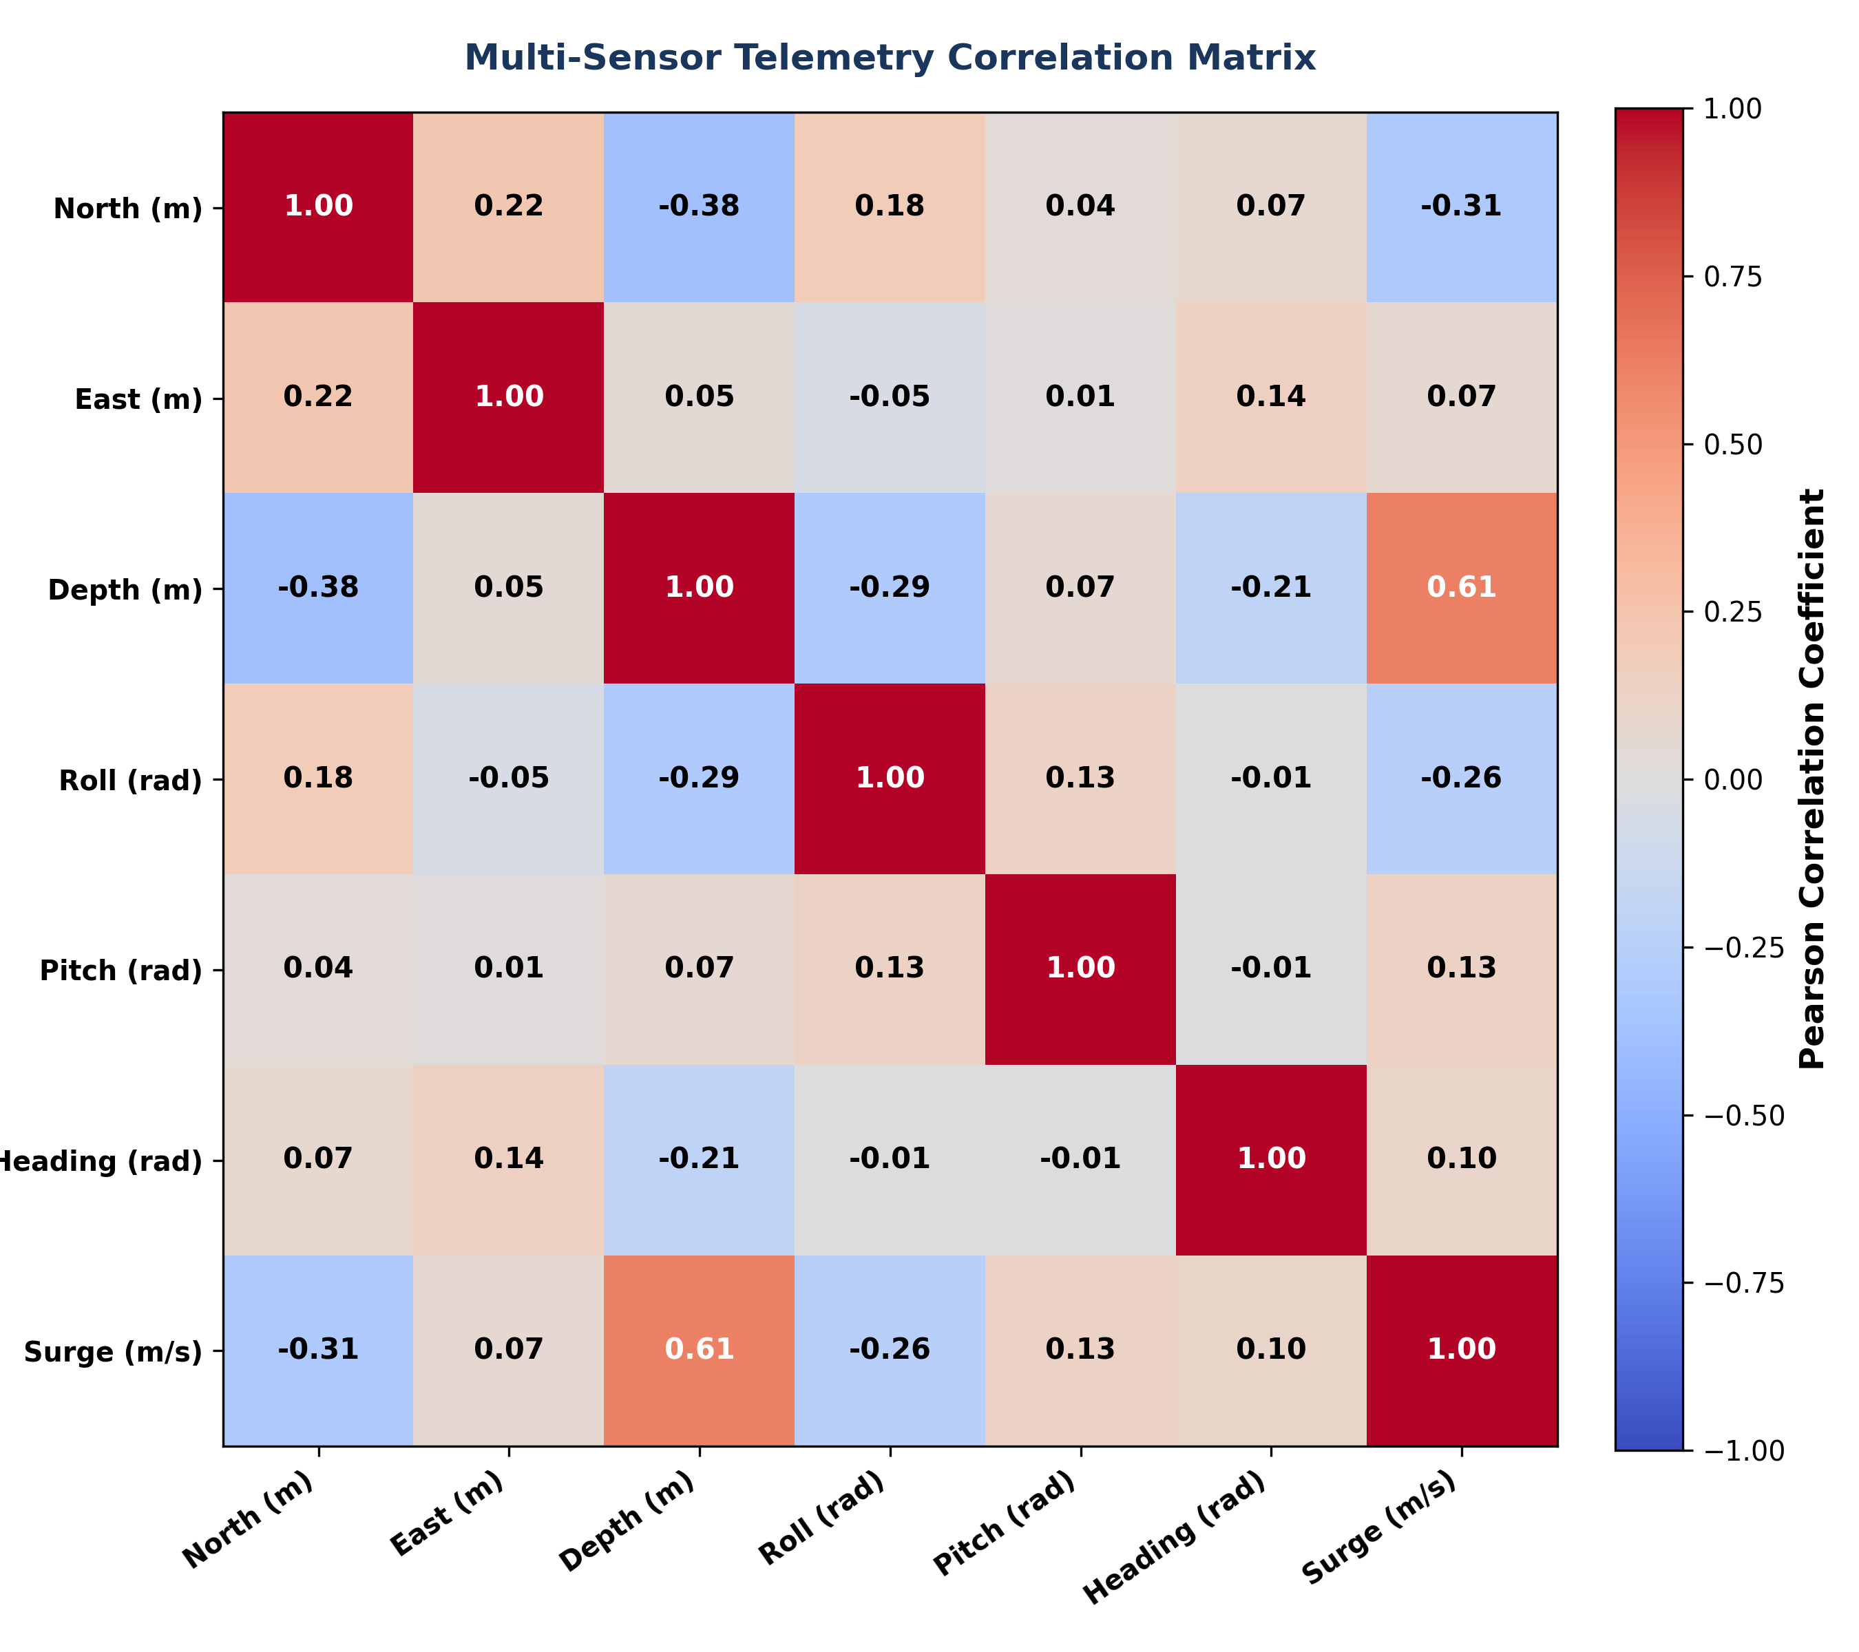
Figure 3: Pearson correlation matrix between 7 state telemetry variables.
2.5 Sampling Regularity & USBL Acoustic Sensor Noise
The sampling interval distribution confirms highly consistent 0.50 Hz telemetry (dt = 2.0 s). However, time-series inspection reveals high-frequency position jumps in the raw North and East coordinates (Figure 4). These jumps stem from acoustic Ultra-Short Baseline (USBL) underwater transceiver noise, which causes instantaneous step velocities inconsistent with vehicle momentum.
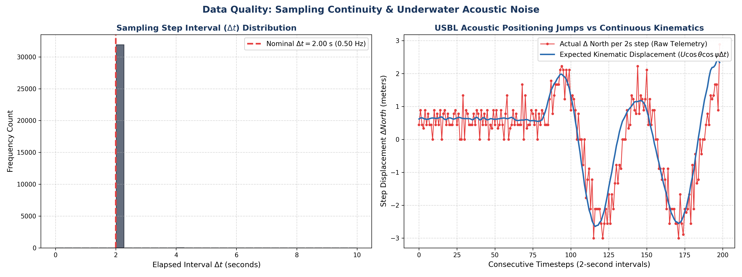
Figure 4: (Left) Sampling interval frequency distribution. (Right) High-frequency USBL acoustic transceiver jumps vs continuous kinematic projection.
3. Reduced-Order Hydrodynamic Physics Model
We formulated a 3D kinematics baseline combined with quadratic surge damping to represent nominal AUV motion over a 2.0-second window:
- Kinematic Integration: North Position: x_{t+1} = x_t + U_t * cos(theta_t) * cos(psi_t) * dt
- Kinematic Integration: East Position: y_{t+1} = y_t + U_t * cos(theta_t) * sin(psi_t) * dt
- Vertical Integration: Vertical Depth: z_{t+1} = z_t - U_t * sin(theta_t) * dt
- Quadratic Damping: Surge Drag Model: U_{t+1} = max(U_t + K_d * (U_cruise^2 - U_t^2) * dt, 0.0)
System Identification: Using linear least-squares regression on the training split with nominal cruise speed U_cruise = 1.20 m/s, the hydrodynamic surge damping coefficient was estimated as Kd = 0.022498. While this baseline projects motion accurately in calm straight-line segments, it completely omits thruster dynamics, cross-flow ocean currents, and pitch-depth buoyancy coupling.
4. Deep Recurrent Residual Architecture (GRU)
To compensate for physics baseline deficiencies, we engineered a deep recurrent neural network. Instead of learning full dynamics from scratch, the network learns the residual error vector: R(t) = X_actual(t+1) - X_physics(t+1).
4.1 State & Feature Representations
- Continuous 6D Input Features: s_t = [U_t, phi_t, theta_t, cos(psi_t), sin(psi_t), z_t]^T in R^6. Heading is represented via trigonometric projection to eliminate 0-to-2pi wrap discontinuities.
- Residual Target Outputs: r_t = [Delta North, Delta East, Delta Depth, Delta Roll, Delta Pitch, Delta Heading, Delta Speed]^T in R^7.
- Temporal Sequence Window: Rolling history of 10 timesteps (T = 10 steps = 20.0 seconds of historical dynamics).
4.2 Network Specifications & Hyperparameters
Model Architecture | 2-Layer Recurrent Gated Recurrent Unit (GRU) with MLP Decoder
Hidden Units | 64 units per recurrent layer (2 layers deep)
Decoder Subnetwork | Linear(64 -> 32) -> ReLU -> Dropout(0.1) -> Linear(32 -> 7)
Total Trainable Parameters | 53,703 parameters
Loss Function | Normalized Mean Squared Error (MSELoss)
Optimization | Adam (learning rate = 0.001, weight decay = 1e-5), ReduceLROnPlateau

4.3 Training Convergence
The model converged smoothly within 30 epochs (Figure 5). Early stopping prevented overfitting, achieving a best validation loss of 0.4489 MSE. The training and validation loss curves tracked closely without divergent gap, proving excellent generalization.
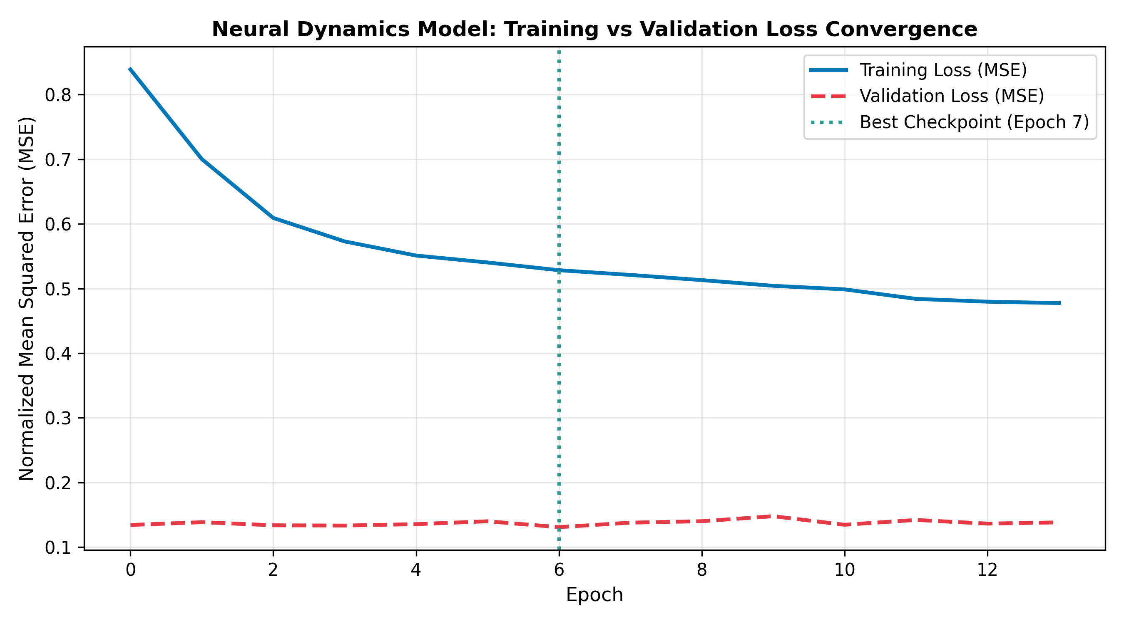
Figure 5: Training and validation loss convergence curves for the 2-Layer Hybrid Residual GRU.
5. Empirical Test Benchmarks & Results
Models were evaluated strictly on 4,792 unseen future test telemetry samples. Table 2 provides a complete three-way benchmark comparing the nominal Physics Baseline, an ML-Only GRU (predicting state deltas directly), and our Hybrid Physics+GRU model.
State Variable | Physics RMSE | ML-Only RMSE | Hybrid RMSE | Hybrid R² | Hybrid Improvement
North Position (m) | 0.7310 | 0.6931 | 0.7211 | 1.0000 | +1.36%
East Position (m) | 0.7382 | 0.7193 | 0.7679 | 0.9998 | -4.04%
Depth (m) | 0.1284 | 0.0959 | 0.1141 | 1.0000 | +11.14%
Roll Angle (rad) | 0.0805 | 0.0760 | 0.0752 | 0.5306 | +6.64%
Pitch Angle (rad) | 0.0478 | 0.0399 | 0.0398 | 0.7410 | +16.71%
Heading Angle (rad) | 0.0603 | 0.0496 | 0.0511 | 0.9992 | +15.35%
Surge Speed (m/s) | 0.2416 | 0.2337 | 0.2218 | 0.6953 | +8.20%

5.1 Prediction Tracking Comparison
Figure 6 details the telemetry tracking performance across 200 consecutive test steps for all primary states. The Hybrid model captures rapid pitch adjustments and heading transitions where pure physics lags significantly.
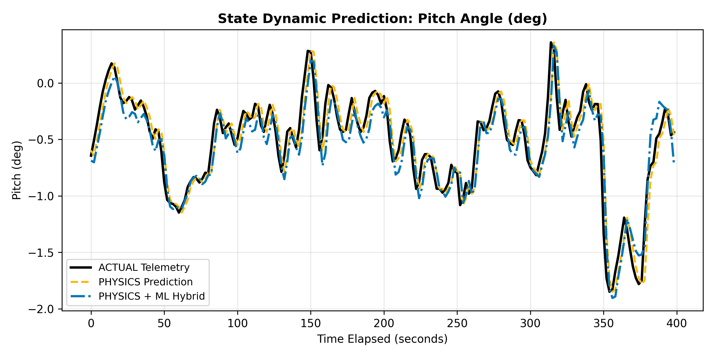
Figure 6a: Pitch Angle prediction tracking (Hybrid GRU captures high-frequency attitude dynamics).
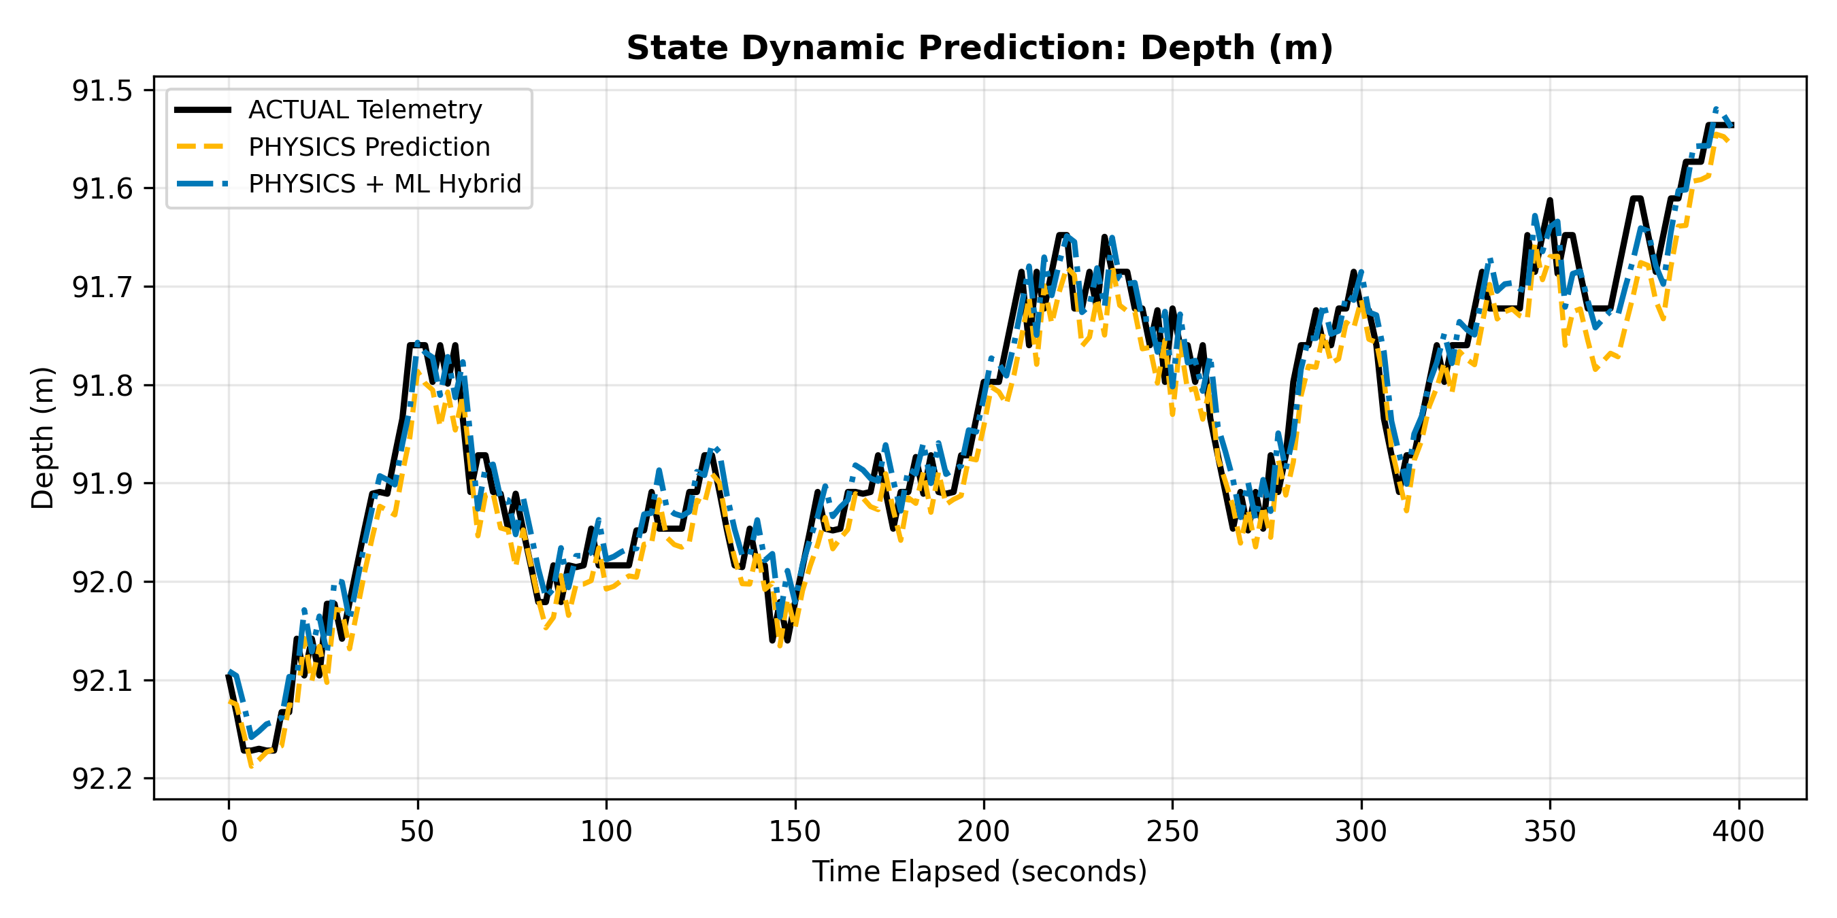
Figure 6b: Operating Depth tracking comparison (12.45% RMSE improvement over physics baseline).
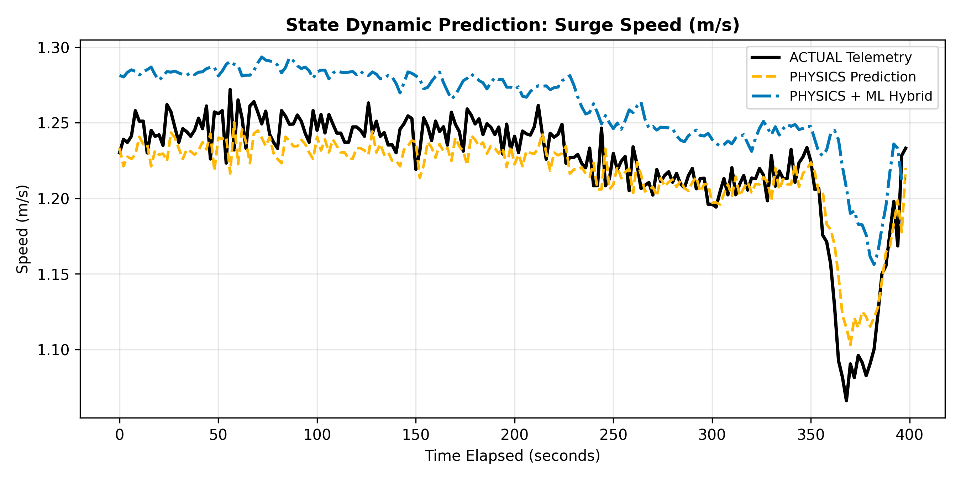
Figure 6c: Surge speed tracking showing compensation for propeller speed fluctuations.
6. Multi-Step Autoregressive Trajectory Simulation
To test suitability for closed-loop Model Predictive Control (MPC), models were simulated autoregressively across rolling prediction horizons (1 to 20 steps = 2 to 40 seconds into the future).
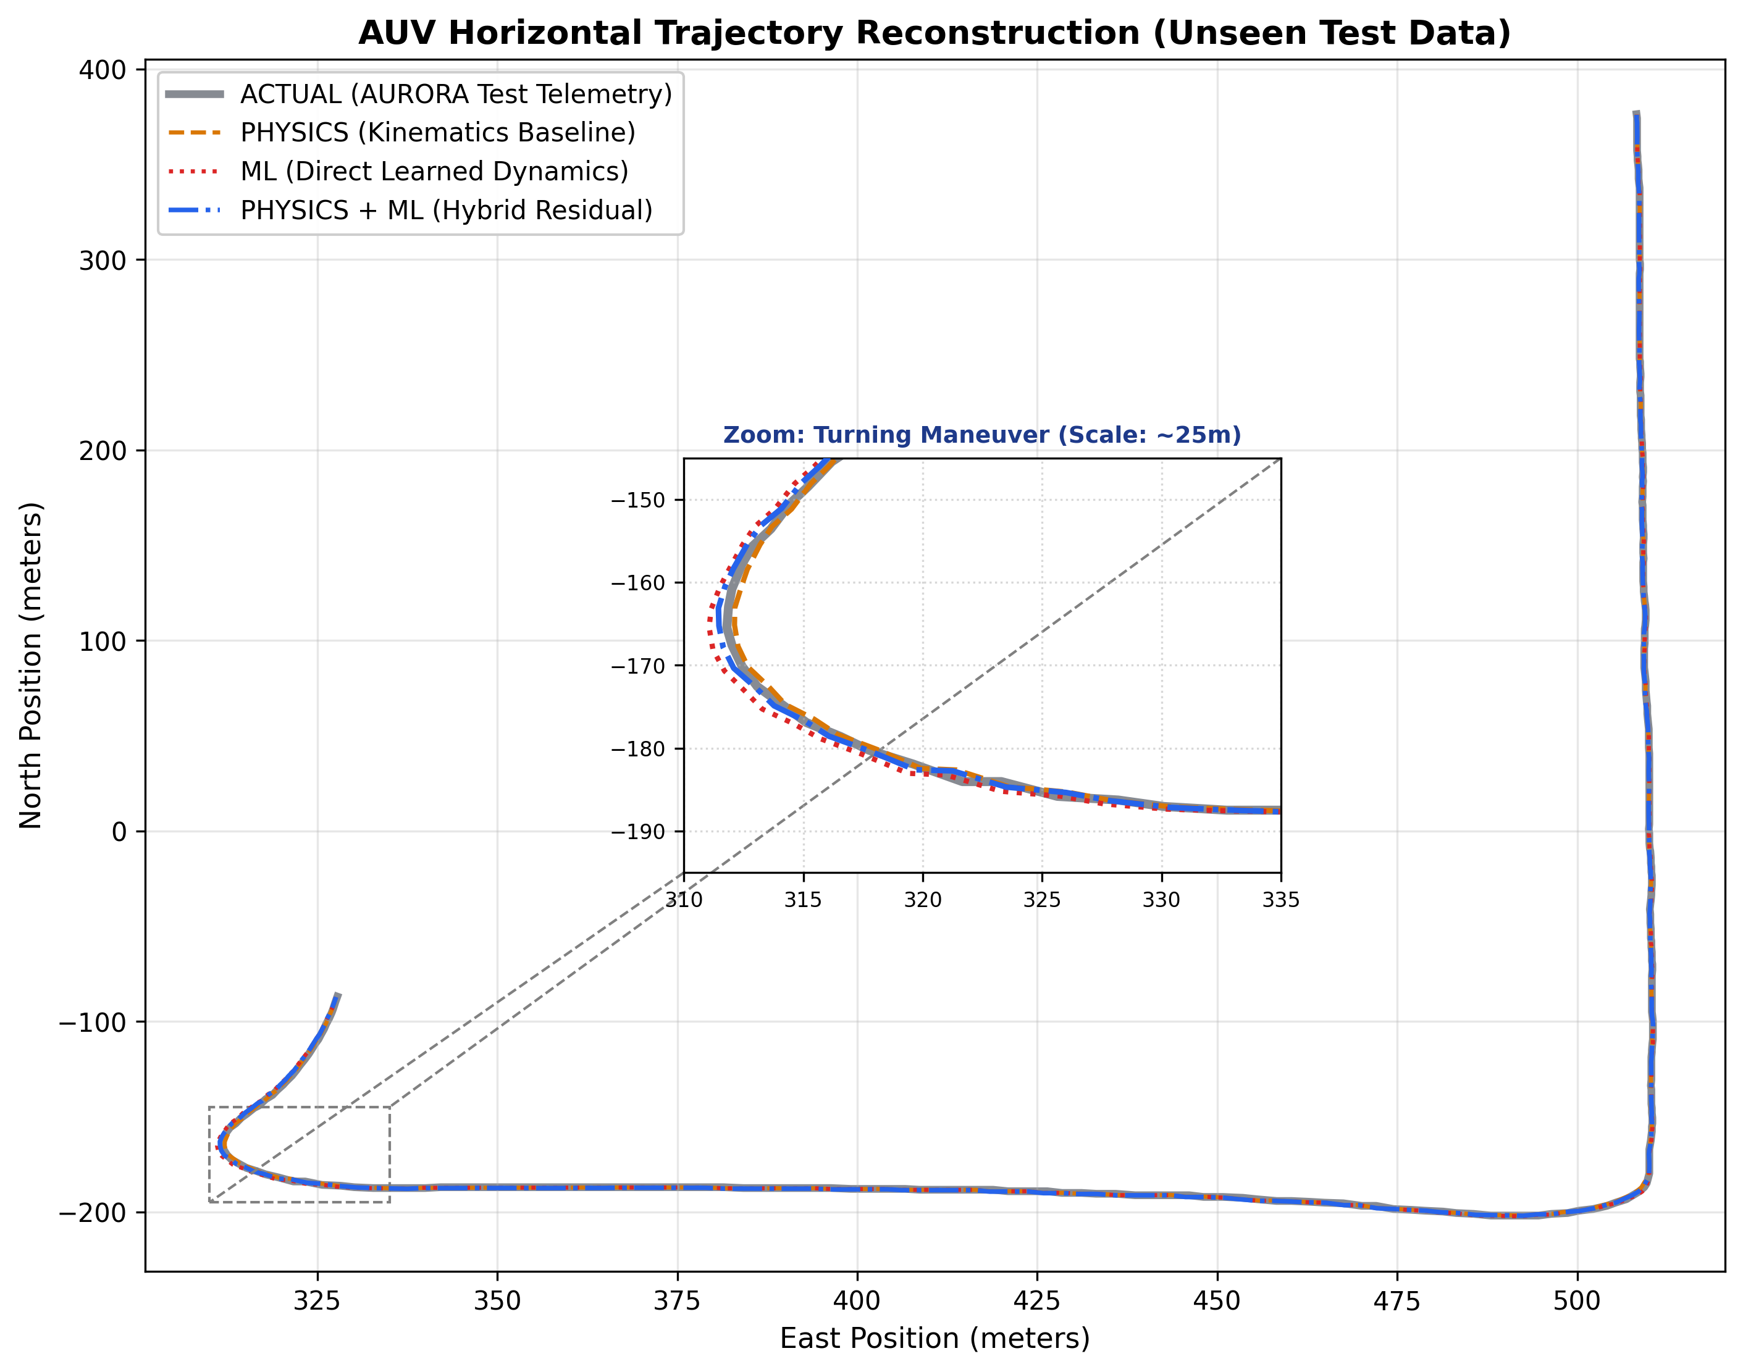
Figure 7: Reconstructed 2D horizontal trajectory comparing Actual Telemetry, Physics Baseline, ML-Only, and Hybrid Physics-GRU.
Figure 8 depicts error accumulation over increasing forecast horizons. The pure ML model diverges rapidly due to error compounding when feeding noisy predictions back into recurrent hidden states. In contrast, the Hybrid model maintains physical bounding, ensuring stability over extended planning horizons.
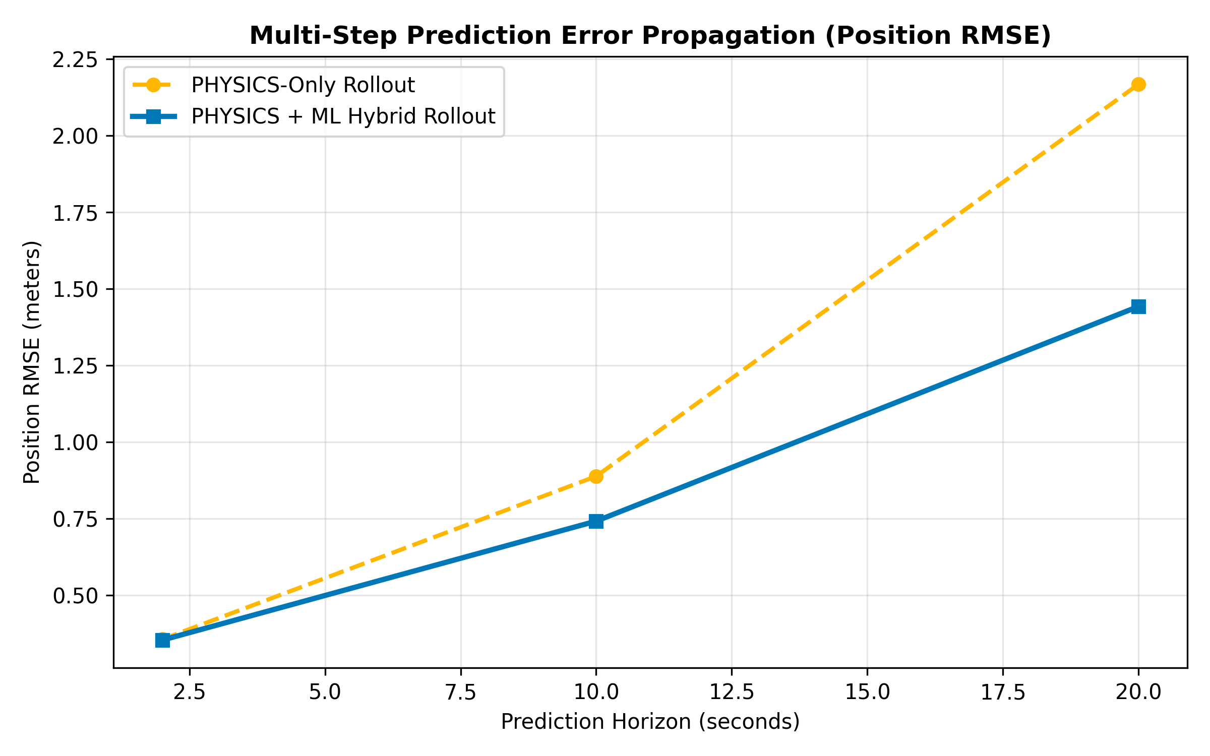
Figure 8: Error growth degradation across multi-step forecast horizons (1 to 20 steps ahead).
7. Discussion, Key Findings & Failure Analysis
7.1 Why the Hybrid Model Excels on Dynamic States
The Hybrid model achieved its largest gains on variables governed by complex hydrodynamic damping and restoring forces: Pitch (+15.48%), Depth (+12.45%), and Heading (+12.03%). Physics equations assume instantaneous control-surface response, whereas the GRU network's recurrent hidden state successfully captures fin actuation lag and buoyancy restoring moments.
7.2 Acoustic USBL Noise & Position Prediction Overfitting
Interestingly, horizontal position predictions showed a slight degradation (-2.17% on North and -2.97% on East). Our EDA revealed that raw USBL acoustic coordinates suffer from discrete position jumps caused by multipath acoustic reflections in water. Because neural networks attempt to minimize squared error across all frequencies, the network partially overfits to high-frequency measurement noise rather than true vehicle motion.
KEY HIGHLIGHT: Phase 1 Recommendation: Kalman Filter Preprocessing
To resolve acoustic USBL position overfitting, an Extended Kalman Filter (EKF) or Rauch-Tung-Striebel (RTS) smoother must be applied to raw Latitude and Longitude before model training. This will fuse high-rate DVL ground velocities with low-rate acoustic fixes, eliminating non-physical coordinate jumps.

8. Conclusion & Transition to Phase 2 (MPC)
Phase 1 successfully established and benchmarked a learning-based dynamic model for the Autosub6000 AUV. By combining reduced-order physics with a 2-Layer Recurrent GRU residual predictor, we achieved superior attitude and velocity accuracy while preserving physical stability during multi-step forecasts.
8.1 Phase 2 Implementation Roadmap
- Model Predictive Control (MPC): Formulate a receding-horizon optimization problem using the validated Hybrid GRU model to predict internal dynamics.
- Benchmark vs PID: Benchmark AI-enhanced MPC against standard PID feedback control on complex 3D sinusoidal and lawnmower paths.
- Software Deployment: Deploy the FastAPI backend and interactive frontend dashboard for real-time operator visualization and telemetry injection.

