

COMP8157-5-R-2022W

Advanced Database Topics

# Final Milestone Project Report

# Submitted to:

**Dr. Kalyani Selvarajah**

**Submitted by:**

Eswaran Badrinarayanan Venkateswaran – Student ID: 10069235

Hani Pankajkumar Bhavsar – Student ID: 110072568

Vishal Jayaraman – Student ID: 110067134

**Project Overview:**

The management of the flow of goods and services has been largely transformed by automation software. However, there has always been a persisting mismatch between supply and demand globally, leading to an imbalance in a company's inventory management. As a result, small-scale businesses need to retrieve employee's work record through Query Optimization techniques to enhance overall production rate of resource.

**Database Design:**

Microsoft SQL Server is used in this project. The main purpose of the database is to fetch the data of employee that are required to calculate the efficiency of the employee over a given period of time. Because the data is time series data the volume of the data is huge. Therefore, the design of the database should be in such a way that

1. The database should be normalized to the maximum level

2. Implementation of query optimization is possible.

By taking the above-mentioned conditions into consideration the database was designed. There are three tables with the respective attributes in the database.

1. Employee - EID(Primary Key), Name, Contact

2. Product - PID(Primary Key), Name, Description

3. production - Date_of_Production, EID(Foreign Key), PID(Foreign Key), Produced_Quantity, Total_Quantity, Work_hours(Date_of_Production, EID(Foreign Key), PID(Foreign Key)(Primary Key)

**Entity Relationship Diagram**

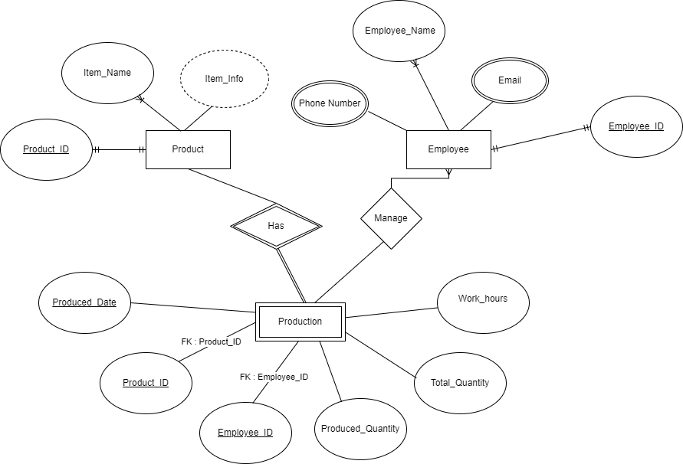

Produced_Date, Product_ID and Employee_ID – Composite Primary Key.

**Challenges:**

There were several challenges encountered throughout the project's implementation.

Organizations, governments, clicks, online servers, business partners, and even the human body generate data. However, no data was accessible online since the project was one-of-a-kind and only served as a simple demonstration of query optimization in SCM databases. As a result, dummy data was developed, which is not as realistic as a real-time dataset.

Even while the waterfall approach is the greatest fit for this project, it does present some issues. The waterfall model is fully based on a step-by-step approach to project management. This provides very little flexibility for future modifications. It is very difficult to execute an unanticipated modification in the future.

It is risky to delay the testing phase till the end of a project, yet Waterfall forces teams to wait until the last step to test their products. The code will be tested later, when the queries have been optimized. Because the project has most likely taken the assigned amount of time to finish, major adjustments might create severe delays.

**Analysis of Impact in Social and Environmental terms:**

* Inventory management provides for the saving of both time and money. As a result, people can be more productive and efficient.
* An optimized query yields faster results, which makes the programme look faster to the user. As a result, consumers are more likely to use online programmes since they can connect with them more quickly and easily.
* This development would assist both the economy and internet enterprises. Because each request takes less time than an unoptimized request, the system can process more requests in less time.
* Businesses can function in real time thanks to programmes that provide instant access to query results. With a strong query processing engine, most queries may be completed in less than a second. Henceforth, decisions are made more quickly and responses are delivered more quickly.
* Companies that use well-designed query strategies can process more data at a cheaper cost since they use fewer resources. This results in a more efficient server operation.

Furthermore, information insights regarding management's output will assist to better forecast future objectives and provide the groundwork for their achievement. Market competitions between firms may be investigated and compared using several indicators. As a result, it promotes small-scale start-ups to take the first step and gives strategies for competing with large commercial companies. Thus, this will instil drive in the minds of aspiring young entrepreneurs, allowing them to profit from deducing analyses for the successful expansion of their firms.

This project aims to eliminate potential obstacles to starting a business based on predictive analytics and for the sustainable use of resources achieved by an efficient analytics and management system. Support entrepreneurial ideology through the use of costs and other costs. It effectively impacts Canada's economy and boosts Covid19-influenced growth. Ideally, this will provide a competitive platform for start-ups in the coming years.

**GitHub Link:**

<https://github.com/EswarVenkat2070/ADT-Project-Query-Optimization-of-Employee-Performance-in-SCM.git>

**References:**

* Services, S. B. T. M. (2021, December 15). *Key Small Business Statistics*. SME research and statistics. Retrieved March 13, 2022, from https://www.ic.gc.ca/eic/site/061.nsf/eng/h_02689.html
* Overview of the food and beverage processing industry - agriculture.canada.ca. (2021, October 28). Agriculture Canada. https://agriculture.canada.ca/en/canadas-agriculture-sectors/food-processing-industry/overview-food-and-beverage-processing-industry
* Yevtushenko, A. (2019, April 24). Supercharge Your SQL Queries for Production Databases. Sisense. https://www.sisense.com/blog/8-ways-fine-tune-sql-queries-production-databases
* Adrienne, W., & Nelson, E. (2014). eCampusOntario DSpace: eCampusOntarioDSpace.https://openlibraryrepo.ecampusontario.ca/jspui/handle/123456789/2
* Gunjal, Bhojaraju. (2003). Database System: Concepts and Design.
* Thalheim, Bernhard. (1993). Database Design Strategies. 267-285. 10.1007/978-3-7091-2704-9_14.
* Sheakh, Dr.Tariq. (2018). A Study of Inventory Management System Case Study. Journal of Dynamical and Control Systems. 10. 1176-1190.
* Plinere, Darya & Borisov, Arkady. (2015). Case Study on Inventory Management Improvement. Information Technology and Management Science. 18. 10.1515/itms-2015-0014.
* Anulika, Nwafor & A, Idoko & Agbo, Jonathan & Emeka, Nnaemeka. (2020). Design and Optimization of An Inventory Management System for Central Stores. International Journal of Innovative Research and Development. 05. 119.