Deep Co-Image-Label Hashing for Multi-label Image Retrieval

In this paper author is introducing new algorithm called DCILH (Deep Co-Image-Label Hashing) which combine two algorithms such as Alexnet and Vector label encoder and decoder. Alexnet will capture image visual information in the form of hashing (each image will have different hash code based on its available features) and then Encoder-Decoder algorithm get trained on image label vector and both models get combine to predict labels from the images. All existing algorithms were using hashing technique with single model so their label prediction accuracy is less. Encoder model will encode all labels as numeric vector and after prediction numeric model can be converted to labels using Decoder model.

To implement this project author has used FLICKR, NUSWIDE and MS-COCO data and I used FLICKR dataset to implement this project. Other two datasets contains more than 90000 images so it require high configuration super computer for training.

Below is the dataset images used to train DCILH algorithm

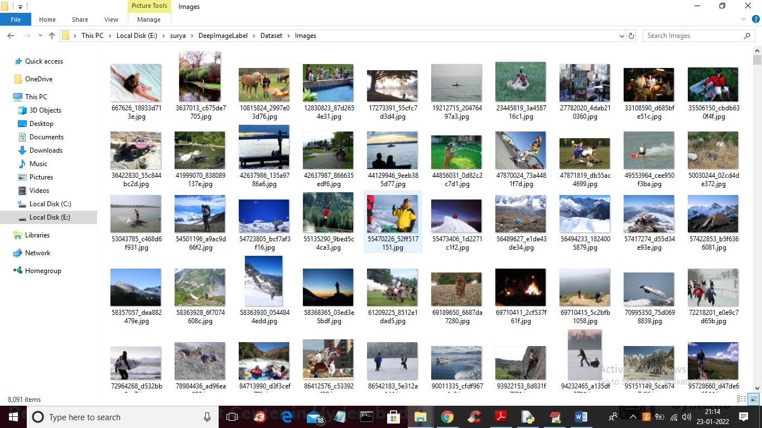

After training above images with DCILH (combination of Alexnet and Encoder-Decoder algorithms) we can predict labels from images.

SCREEN SHOTS

To run project double click on ‘run.bat’ file to get below output

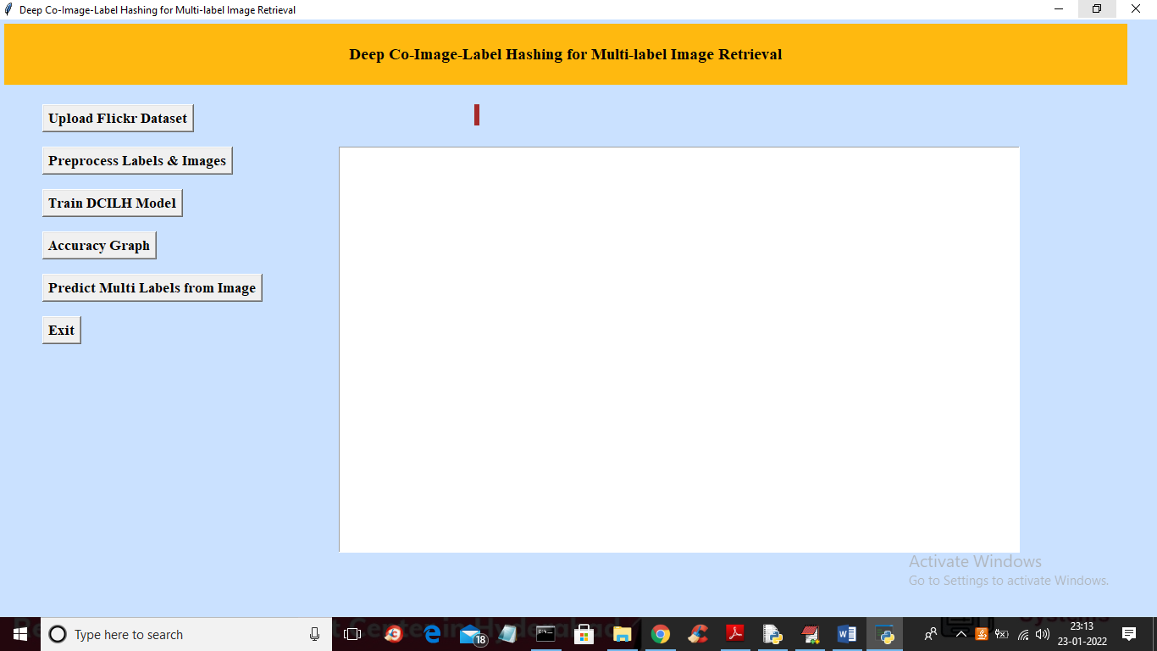

In above screen click on ‘Upload Flickr Dataset’ button to upload dataset folder and to get below screen

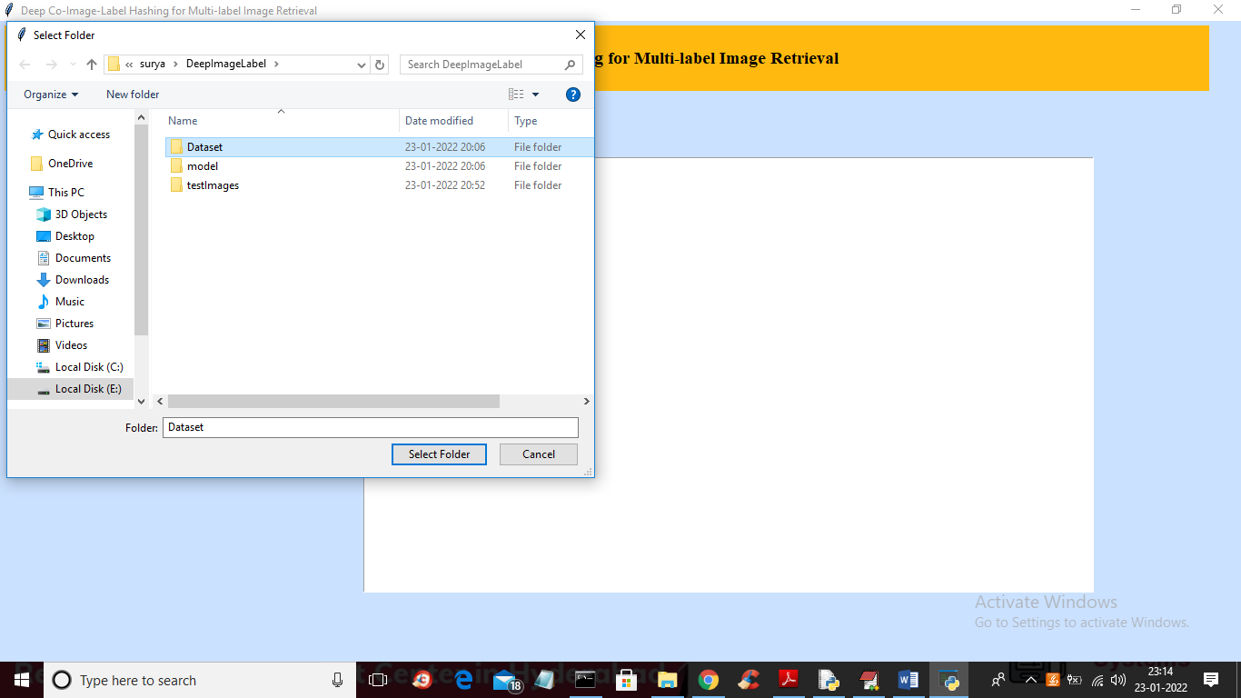

In above screen selecting and uploading ‘Dataset’ folder and then click on ‘Select Folder’ button to load dataset and to get below screen

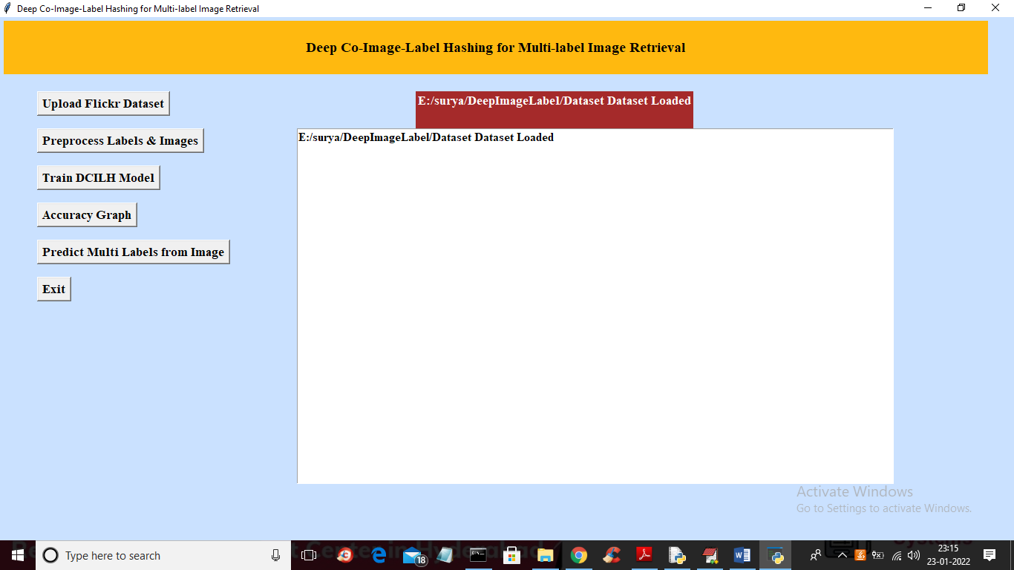

In above screen dataset loaded and now click on ‘Preprocess Labels & Images’ button to read all images and its labels and form a image hashing and label vector

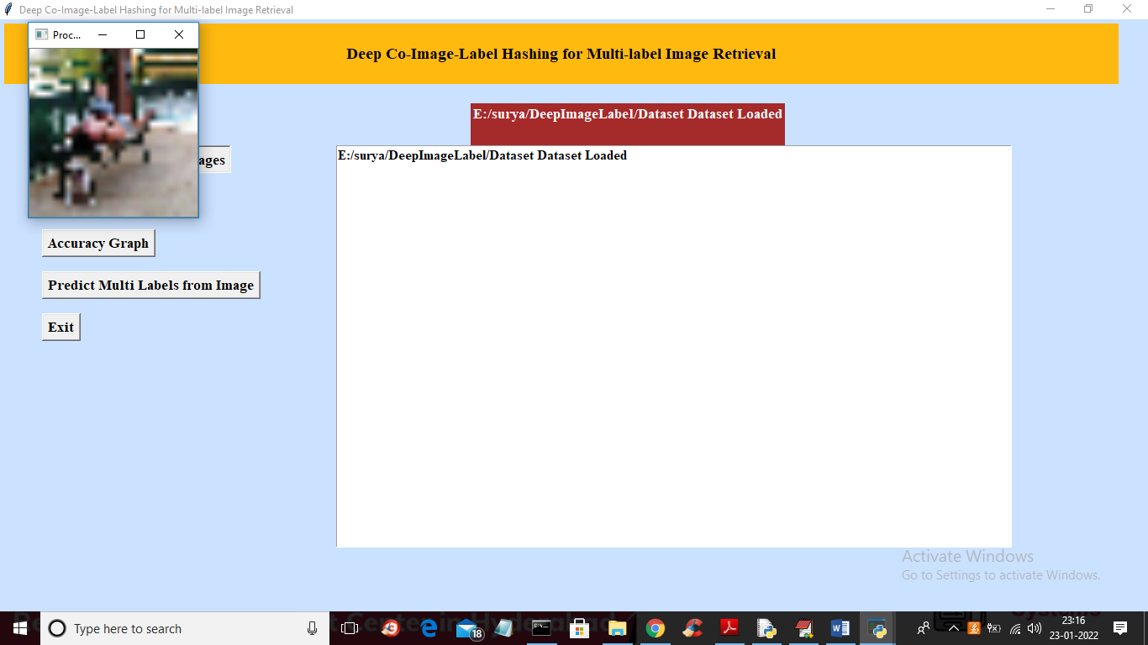

In above screen all images and labels are loaded and displaying one sample image to see images are loaded with hashes and now close above image and then click on ‘Train DCILH Model’ button to train propose DCILH algorithm on loaded images and labels vector and then calculate precision, recall and accuracy

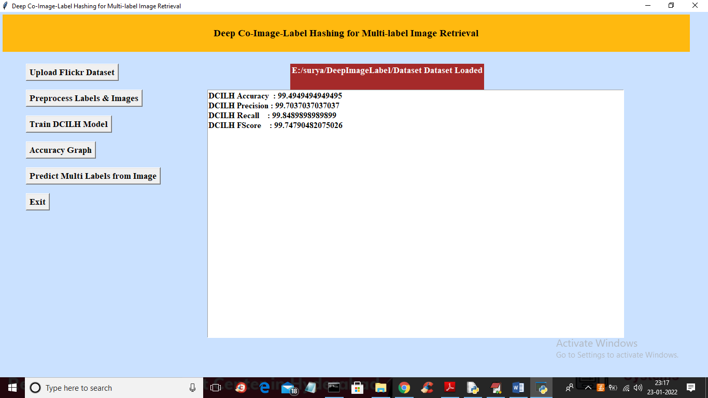

In above screen DCILH model is trained and we got its accuracy as 99% and now model is trained and now click on ‘Accuracy Graph’ button to get below DCILH training accuracy graph

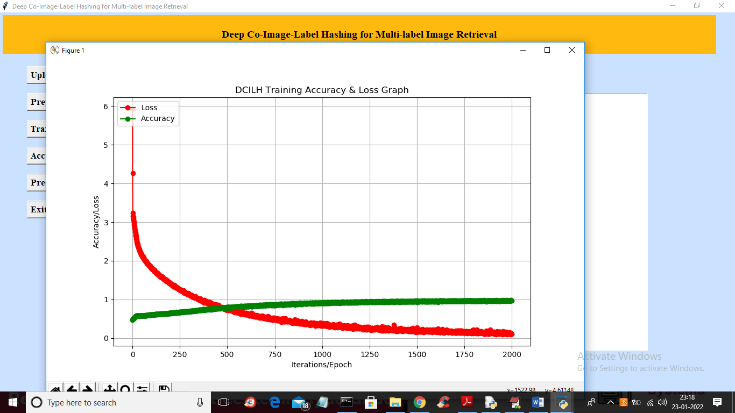

In above graph x-axis represents EPOCH/iterations and y-axis represents accuracy/loss values and green line represents accuracy and red line represents LOSS and in above graph we can see with each increasing epoch accuracy get increase and reached closer to 100% and loss values starts at 6 and then drop to 0. Increasing accuracy and decreasing loss values indicates accurate model generated. Now close above graph and then click on ‘Predict Multi Labels from Image’ button to upload test image predict multi labels

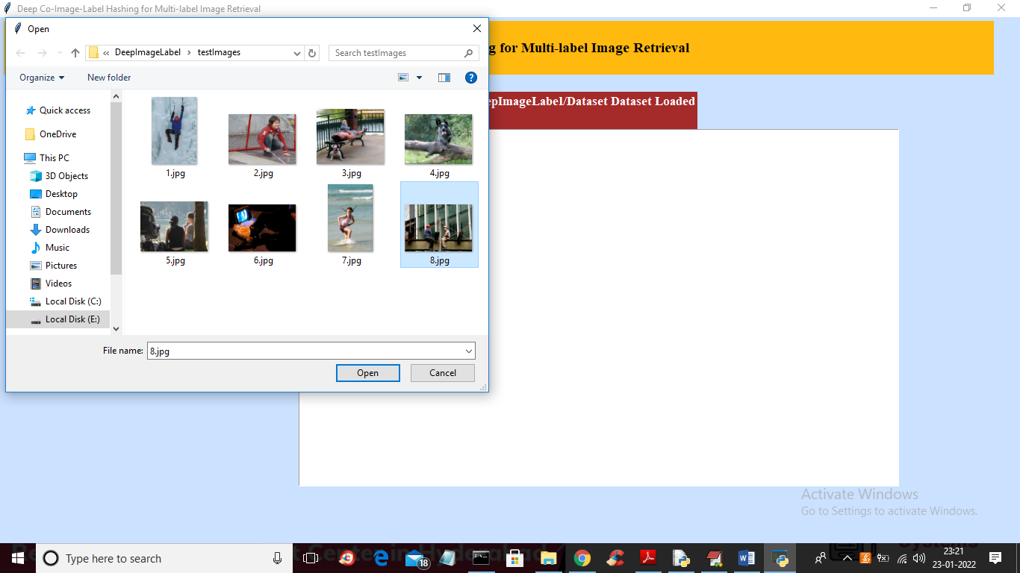

In above screen selecting and uploading ‘8.jpg’ file and then click on ‘Open’ button to load image and get multi labels output

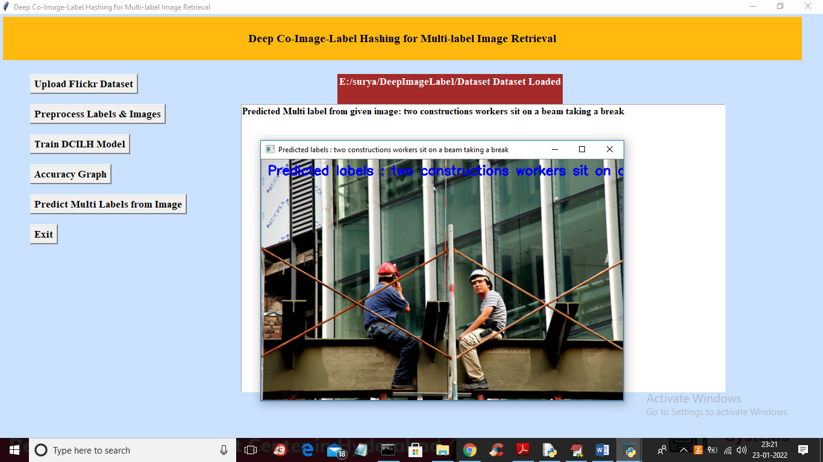

In above screen in text area and in image blue colour we got predicted labels as ‘two workers sitting on a beam’ and labels are predicted correctly and now test other image

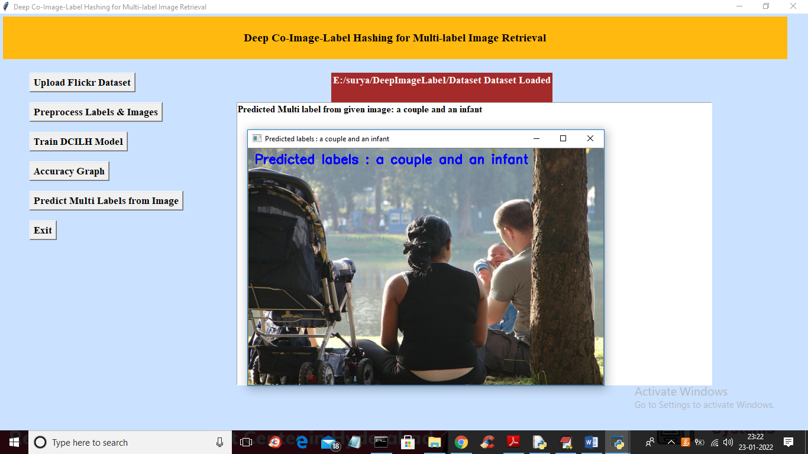

In above screen we got predicted labels as ‘couple with infant’ and similarly you can upload other image and test