Daily Status Report
Name : B. Vamsi
Date : 14-10-2025
Developed with Spring Boot, the backend provides RESTful APIs for CRUD operations on doctor data.
Uses Spring Data JPA to interact with the Oracle database and map entities to tables.
Handles errors and responses, allowing seamless communication with the frontend.
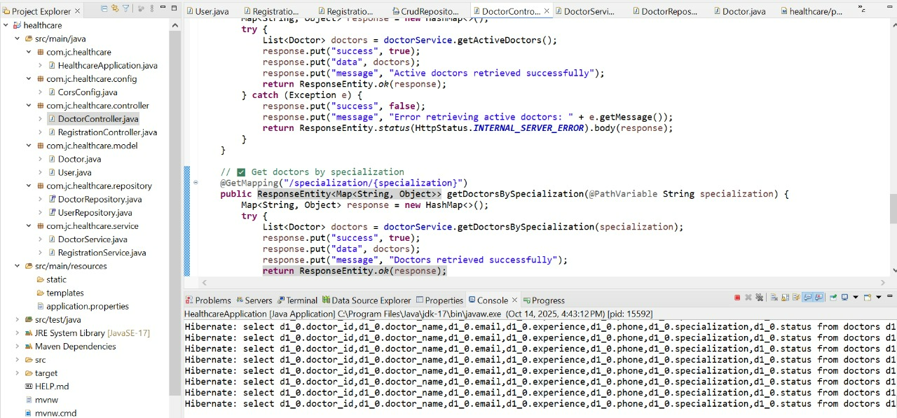
Built with React.js, the frontend displays a dynamic Doctors List Table with action buttons for viewing, editing, deleting, and adding doctors.
Uses Axios to fetch data from the backend and FontAwesome icons for UI.
Includes loading indicators and error handling for a smooth user experience.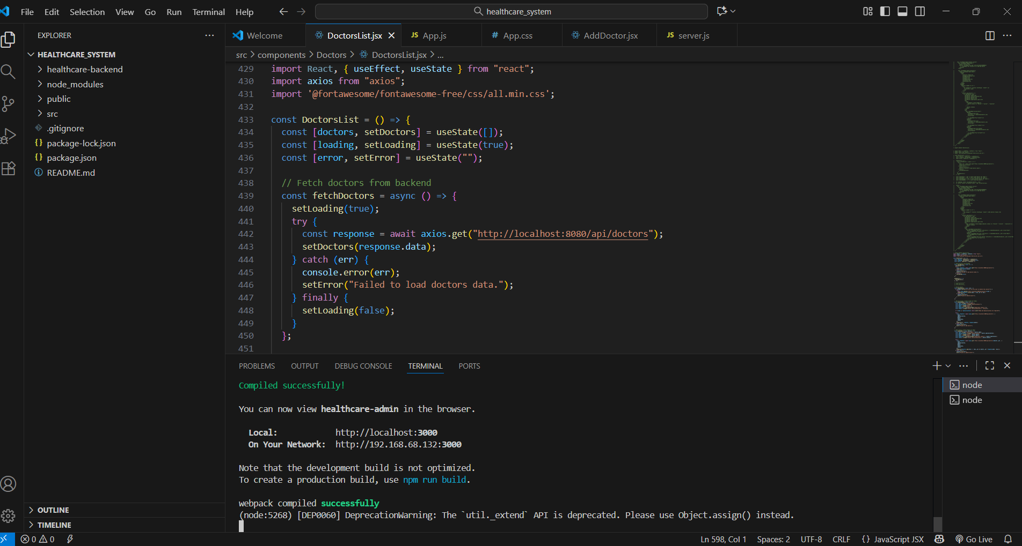
The database is Oracle, hosting a doctors table with fields such as Name, Specialization, Phone, Email, Experience, and Status. The backend interacts with the database using Spring Data JPA, allowing dynamic CRUD operations. Changes in the database are reflected in real time on the frontend. The database ensures secure, structured, and reliable storage of doctor data.
