Jhaishna products

1.Electric Scooters
HSN CODE:- 87116020

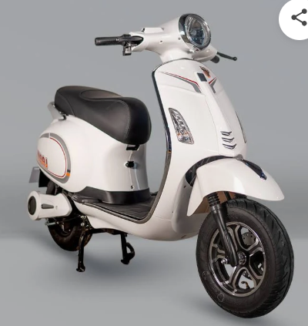

2.Scooters with electric motor
HSN CODE:- 87116010
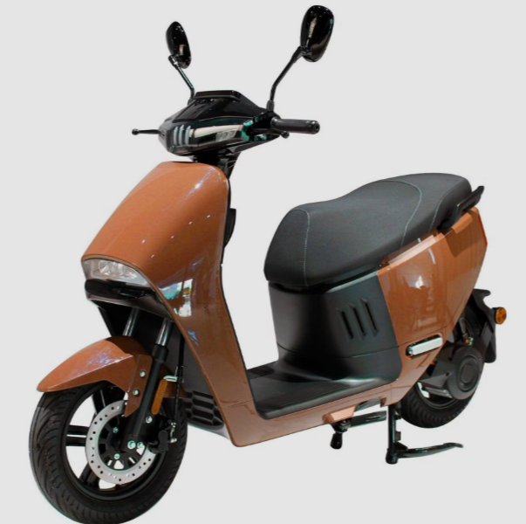

3.ironing board
HSN CODE:- 73239990

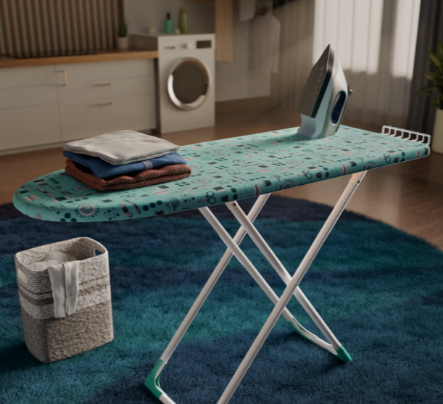

4.Electric Kettle
HSN CODE:- 85167920

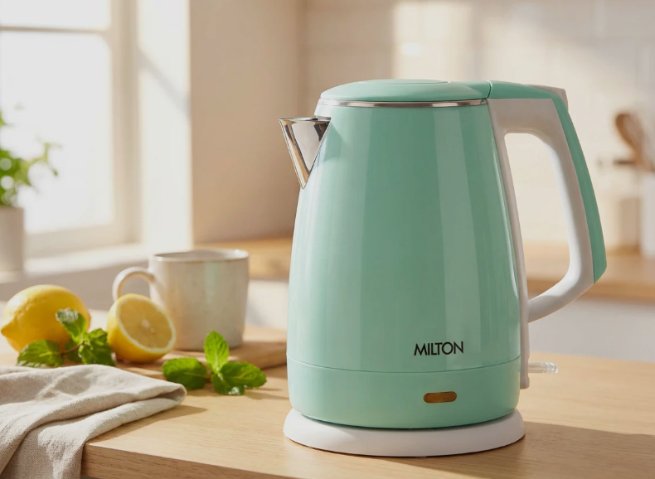

5.single-door refrigerator (mini fridge)
HSN CODE:- 8418 29 00

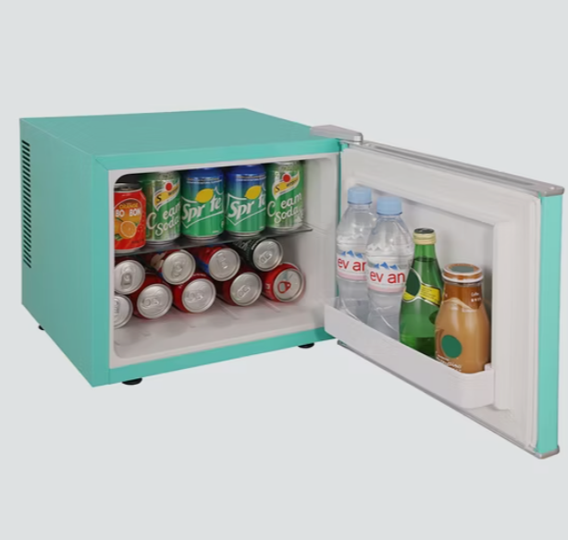

6.Mattress (bed mattress)
HSN CODE:- 9404

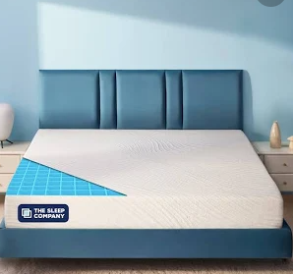

7.Hair Dryer
HSN CODE:- 8516 31 00

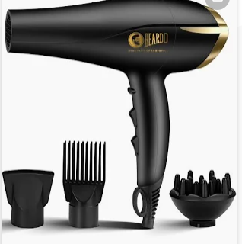

8.Comforter / Quilt (bed covering)
HSN CODE:- 94049099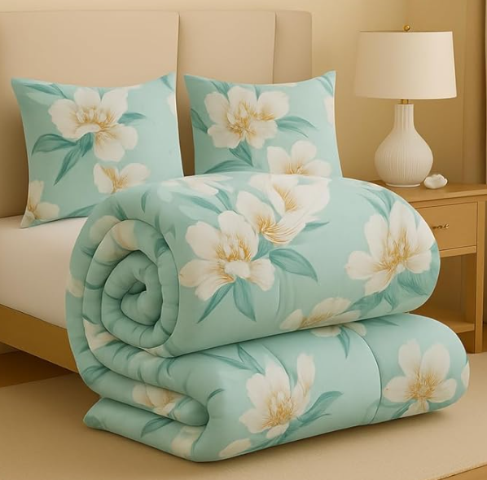

9.Blanket / Quilt (Bed covering)
HSN CODE:- 63014000

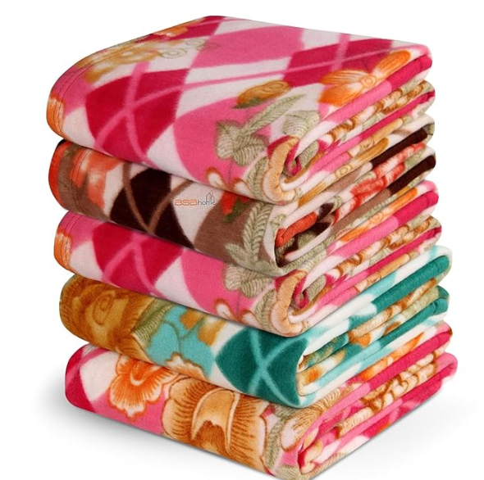

10.Pillow
HSN CODE:- 94049010

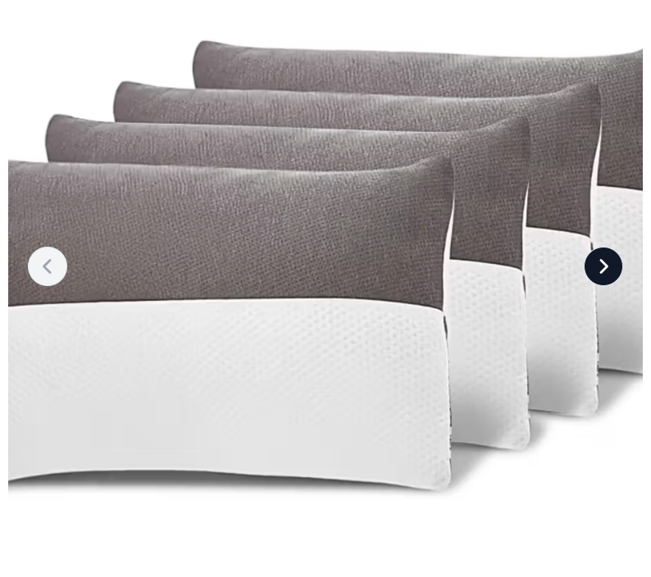

11. Bathroom Mirror Cabinet / Wall Mirror with Shelf
HSN CODE:- 7009 91 00

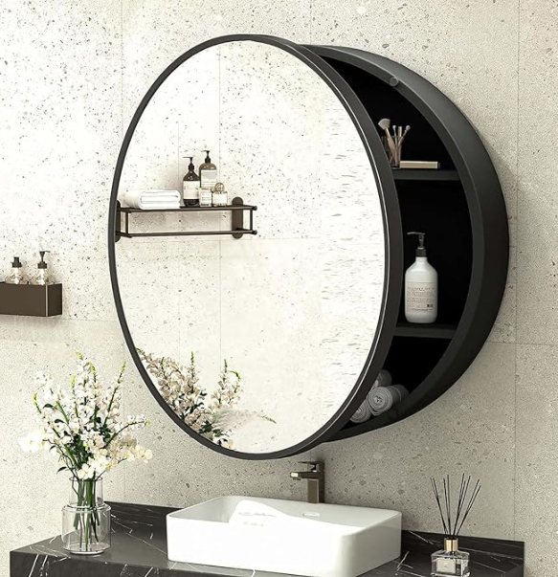

12. Electric Dry Iron (Iron Box)
HSN CODE:- 8516 40 00

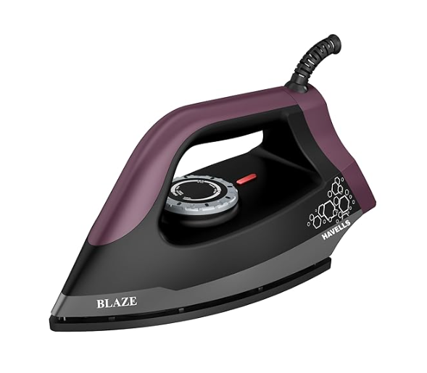

13. Whirlpool Bathtub (Jacuzzi type)
HSN CODE:- 39221000

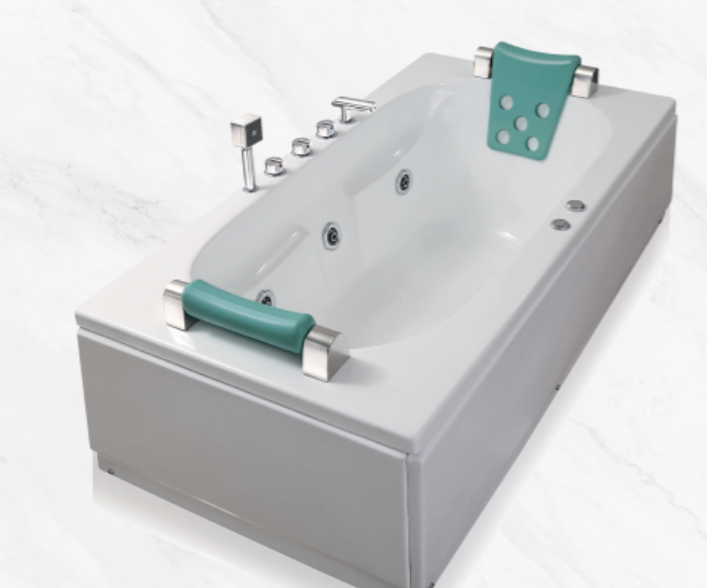

14. Shoe Shining Machine / Shoe Polish Machine.
HSN CODE:- 8479 89 99
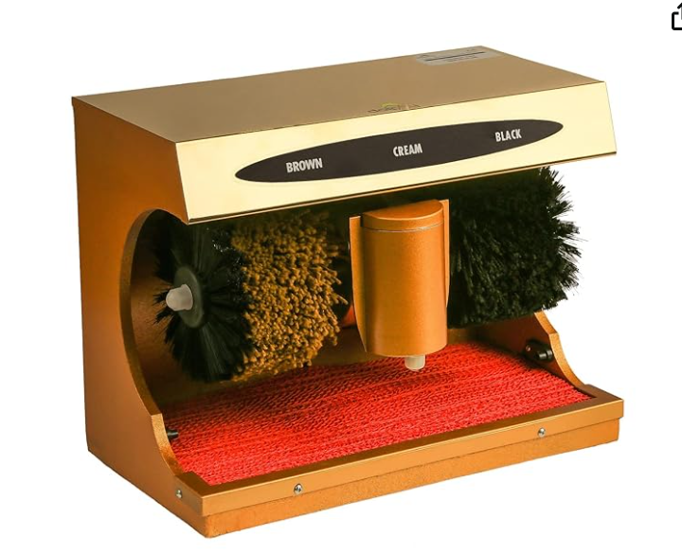

15. Plastic / Acrylic Shower Cabin
HSN CODE:- 3922 10 00
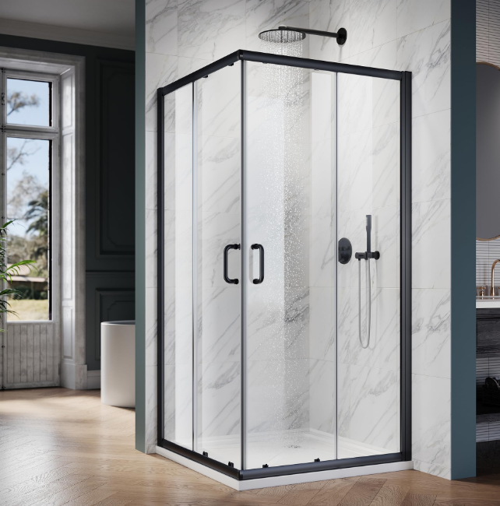

16. Glass Shower Enclosure / Cabin
HSN CODE:- 7020 00 90
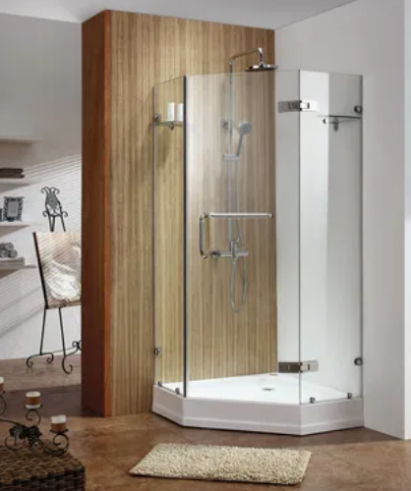

17. Television (LED / Smart TV)
HSN CODE:- 8528 72 00
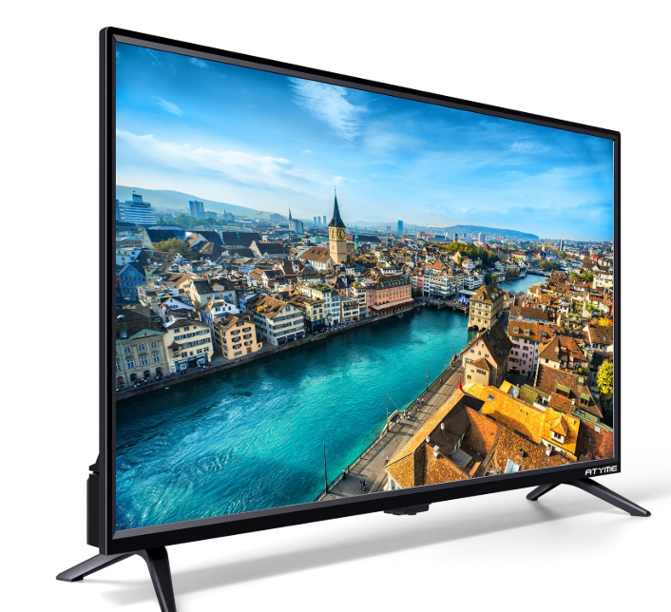

18. Solar Garden Light / Outdoor Solar LED Light
HSN CODE:- 9405 40 90
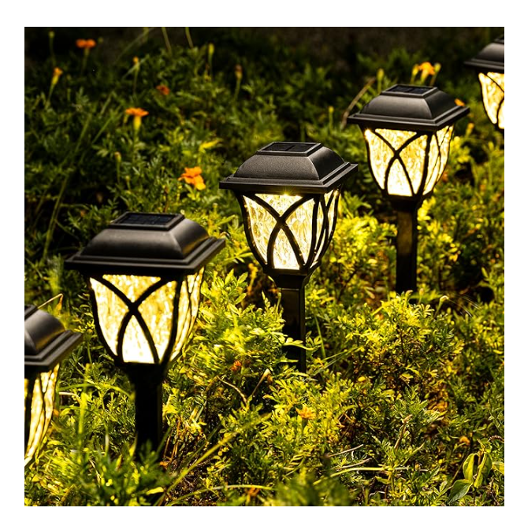

19. Solar Powered LED Light
HSN CODE:- 9405 50 40

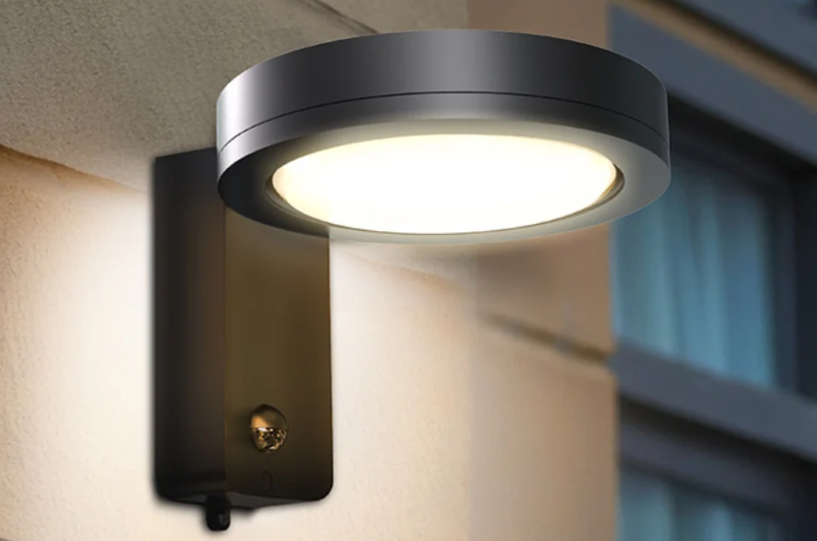

20. Portable Office Cabin (Portable Container House
HSN CODE:- 9406 90 00

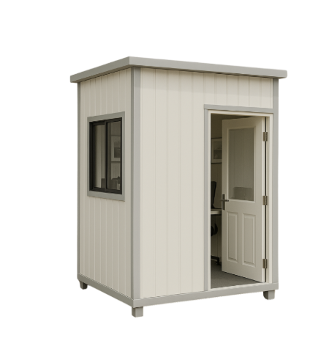

21.Sofa Cum Bed / Convertible Sofa Chair Bed
HSN CODE:- 9401 40 00

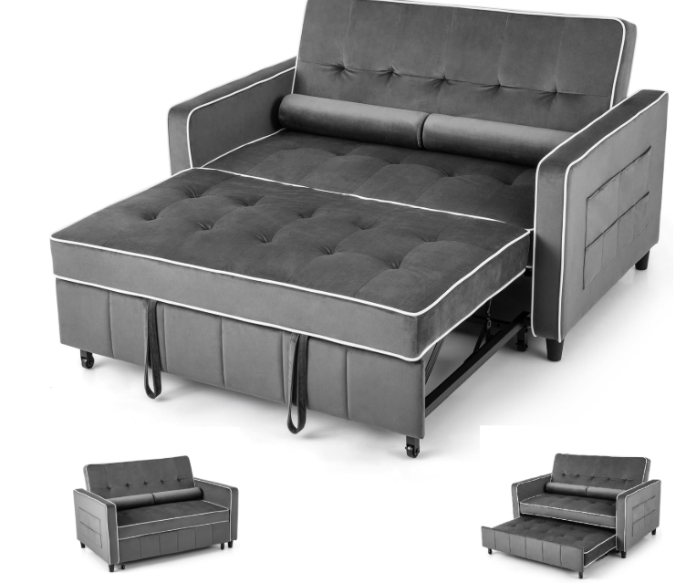

22. Smart Touch Switch for Lights & Fans
HSN CODE:- 8536 50 90
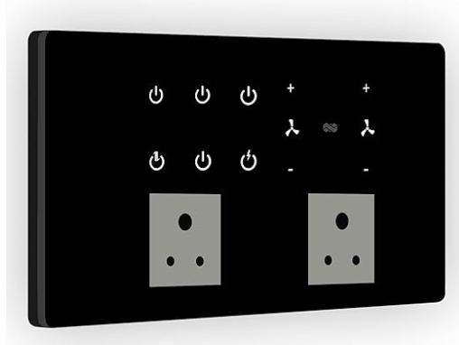

23. Facial Tissue Box / Paper Tissue
HSN CODE:- 48182000

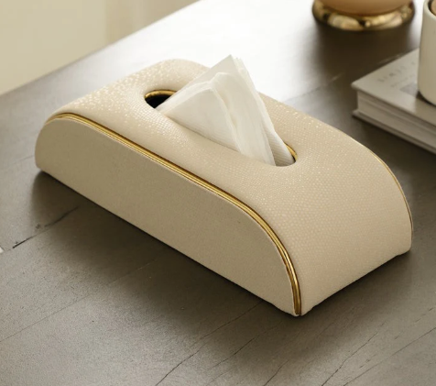

24. Solar CCTV Camera / Solar Security Camera
HSN CODE:- 8525 80 20

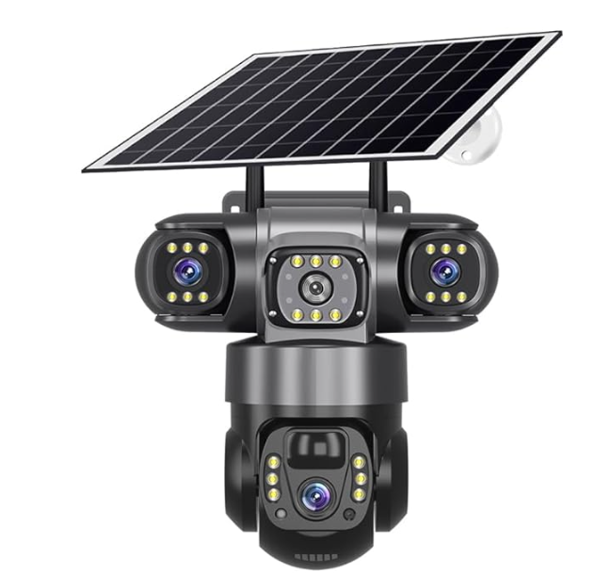

25. LED Display Panel / Screen
HSN CODE:- 8528 59 00
