Daily status report
Name : M. Eswari
Date : 08-11-2025

AdminDashboard.jsx
Displays real-time summary of FPS dealers, their delivery statuses, and stock availability.
Shows key metrics like total dealers, pending deliveries, and active transactions.Provides detailed tables for incoming deliveries and inventory snapshots for quick monitoring.
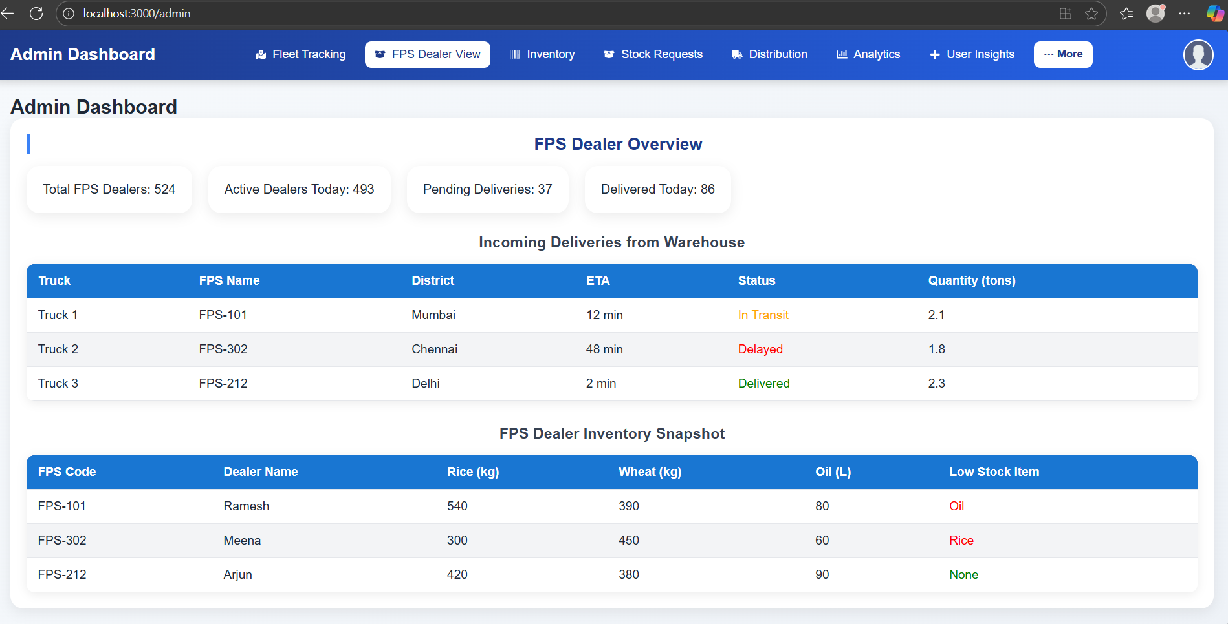
Online inspection module to verify stock, operations, and cardholder feedback.Displays last 6-month distribution data and previous inspection history.Generates real-time inspection reports with API-based stock integration.
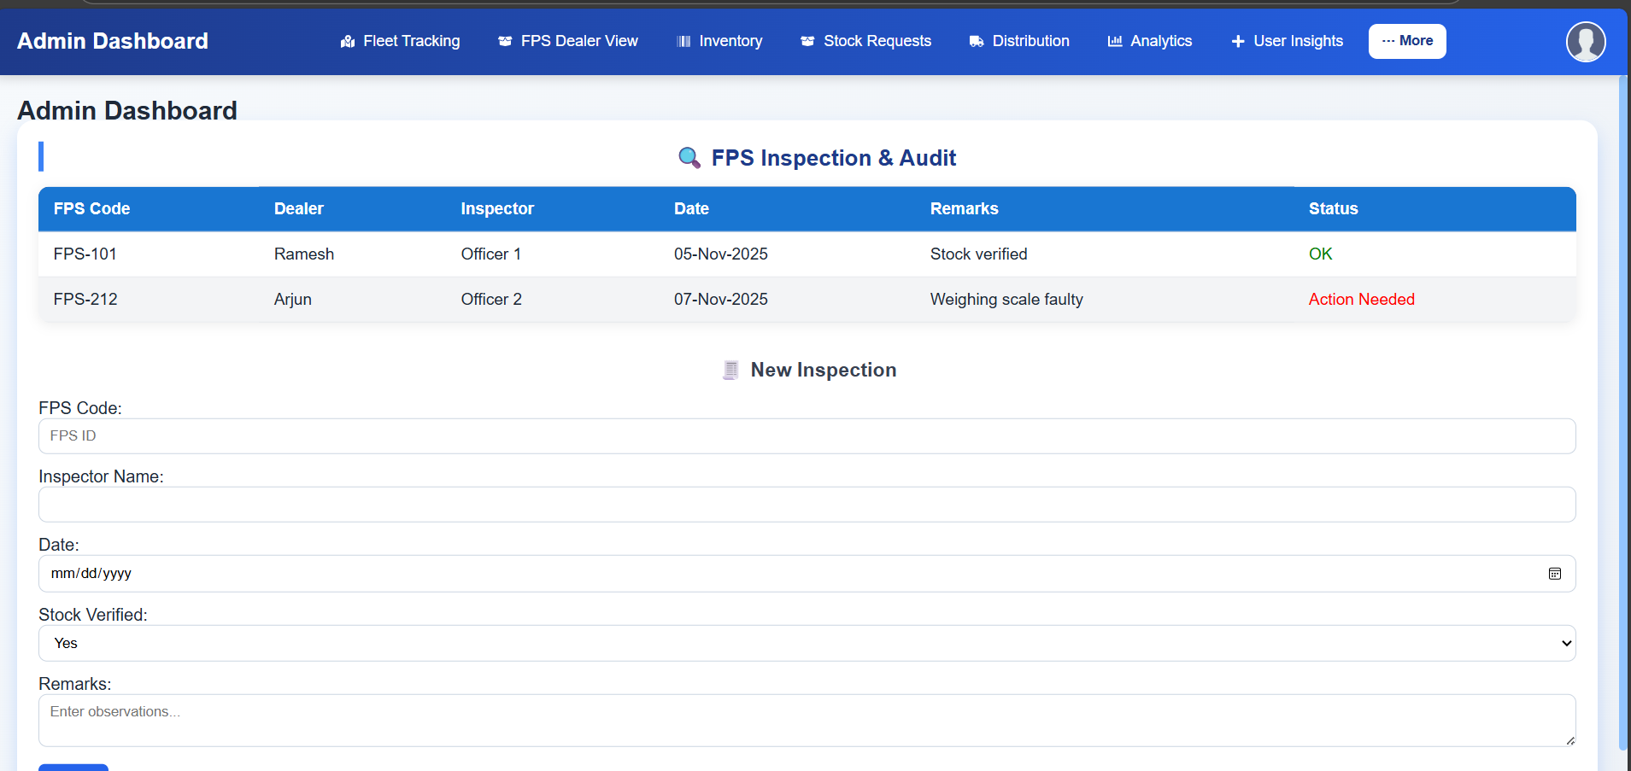
Monitors customer engagement, product reviews, FPS ratings, and feedback trends.
Provides summarized insights such as average ratings, verified purchase ratios, and reported review counts.Helps admins detect service issues, analyze sentiment, and track dealer performance through data-driven insights.
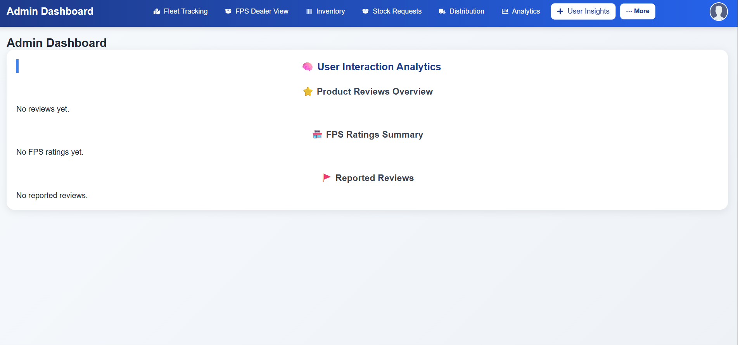

Transforms FPS outlets into retail mini-marts for non-PDS goods and services.Includes brand partner onboarding, catalogue management, and commission setup.Tracks dealer requests, approvals, and partner performance metrics.
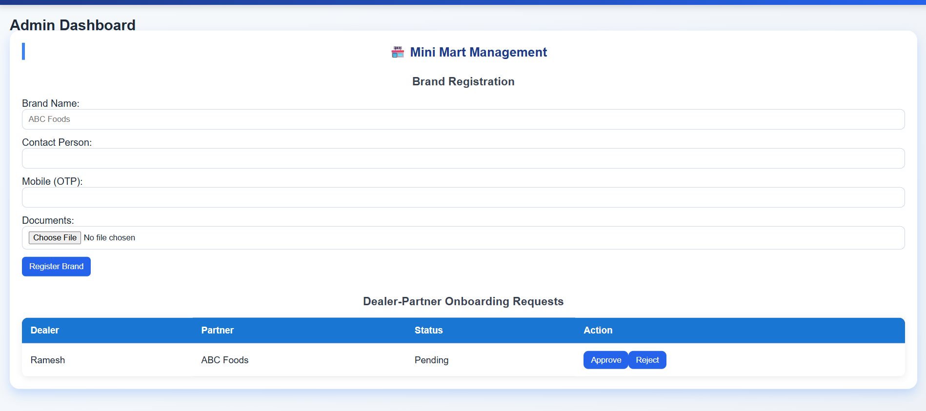
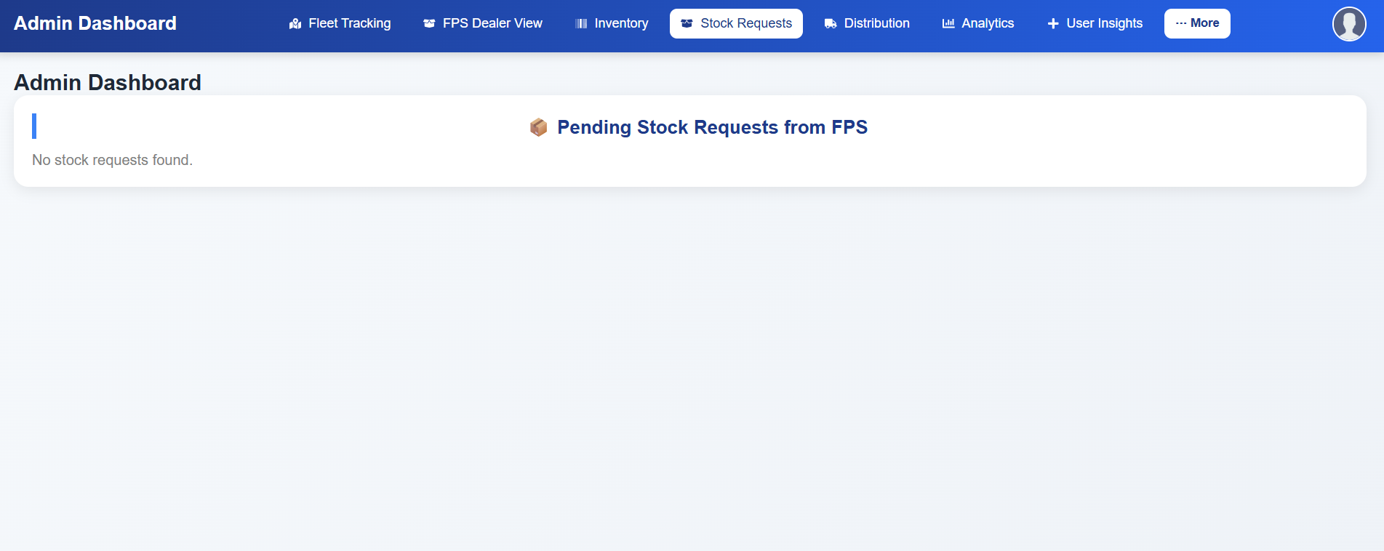

UserInterface.jsx
Improved the FPS Map section with a modern card layout, centered Andhra Pradesh view, and smooth map styling.Each FPS marker now shows detailed popups with shop info and a “Get Directions” button linked to Google Maps. The section is fully responsive, visually clean, and theme-aligned for a better user experience.
