Work update on July 29, 2025
As per requirement quickpay regarding Auto pay and Smart upi
Modified Function: actionAutopayPayment()
- Description:
Enhanced to streamline the Auto Pay process and ensure Smart UPI compatibility.
- Key Improvements:
  - Better payment flow management.
  - Additional compatibility checks for Smart UPI.
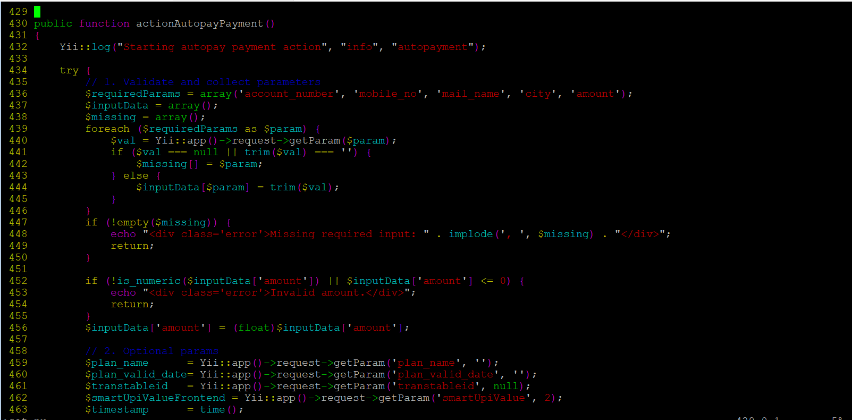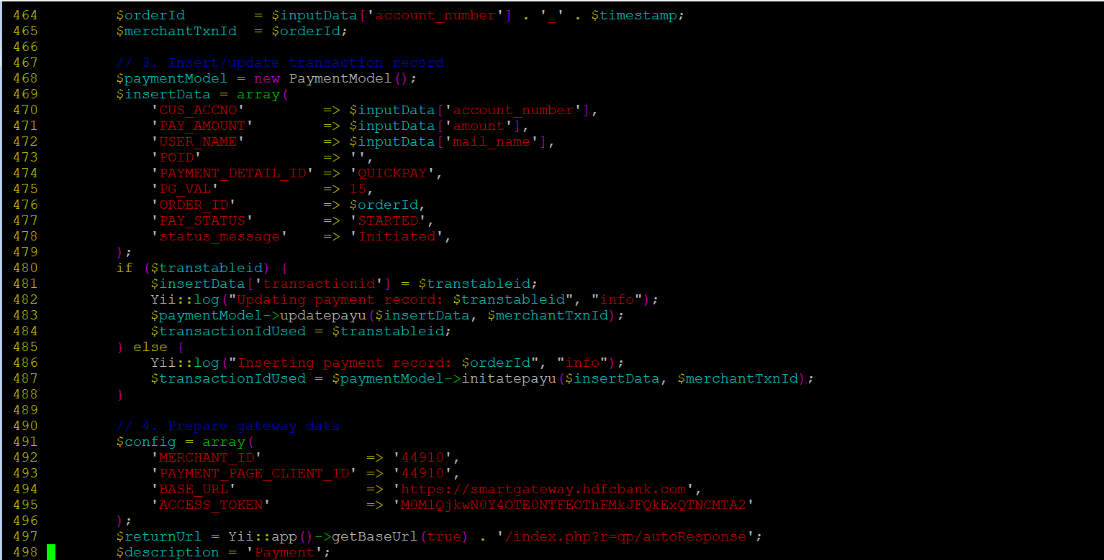

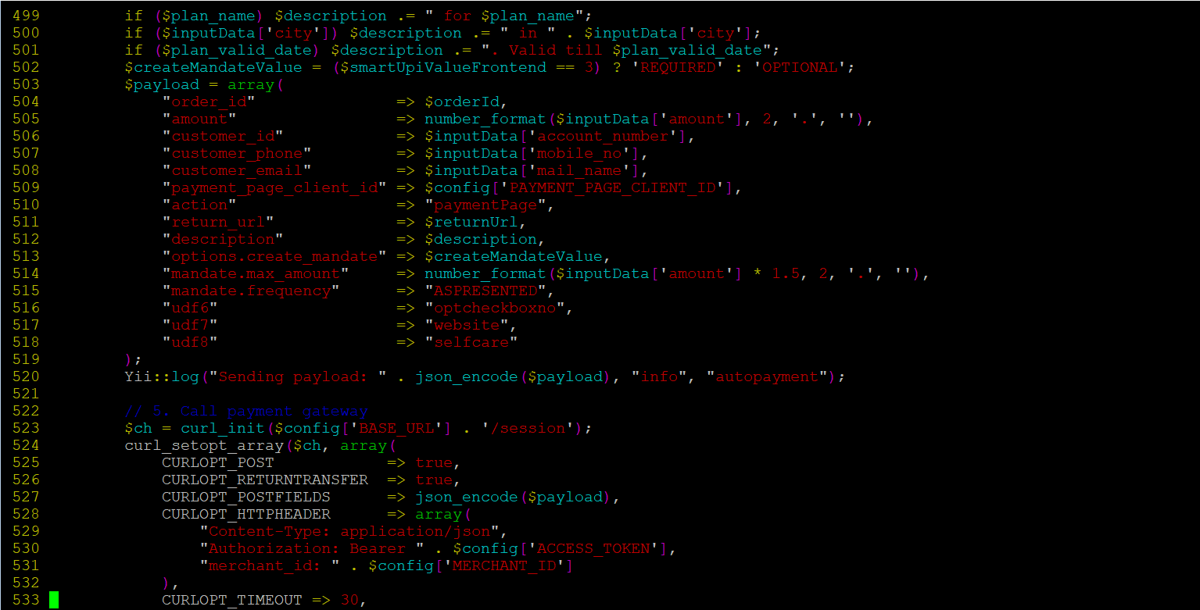
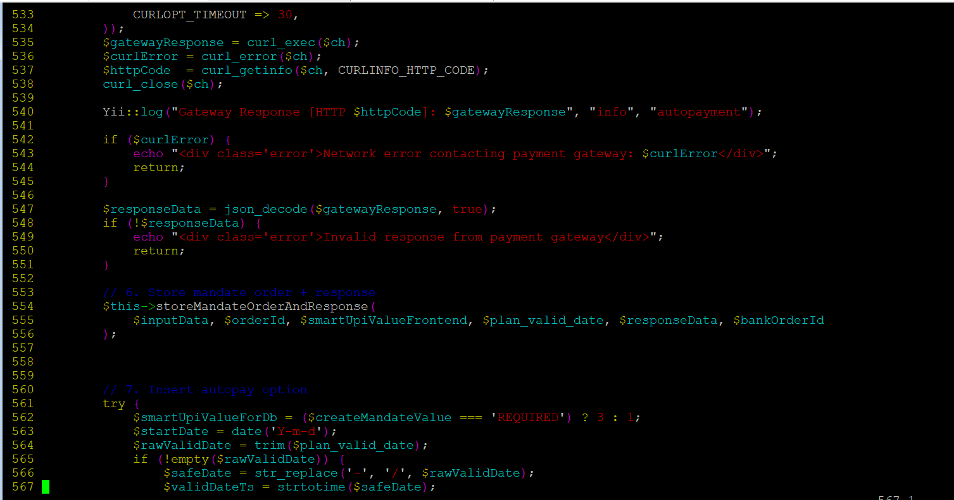

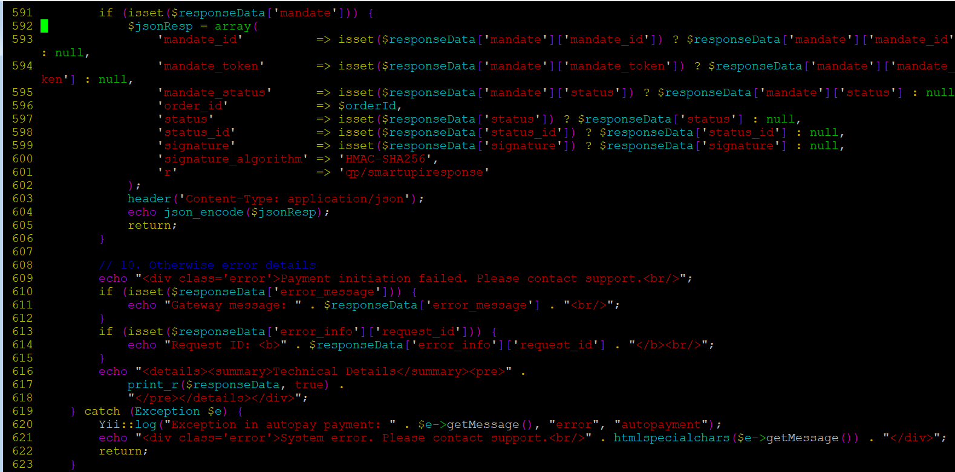
Added Function: storeMandateOrderAndResponce()
Description:
Added for systematic storage of mandate order details and HTTP responses.
Functionality:
Receives and records input parameters for mandate orders.
Persists order and payment response data in the DB.
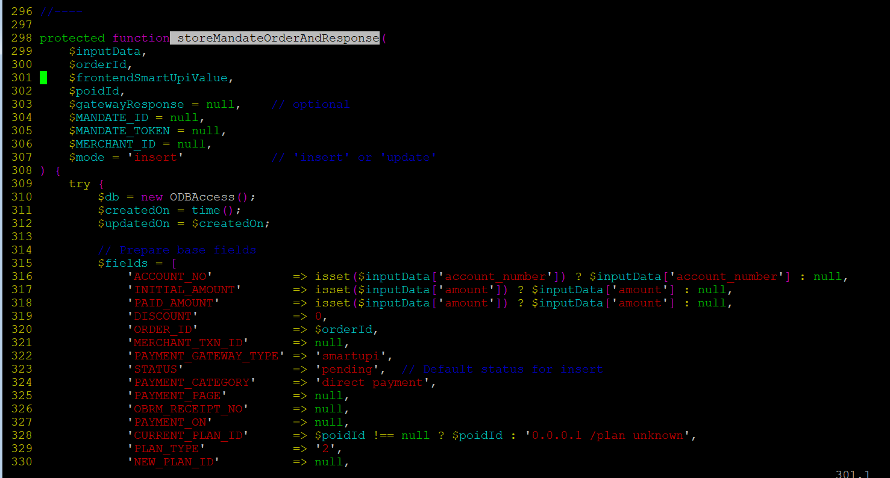

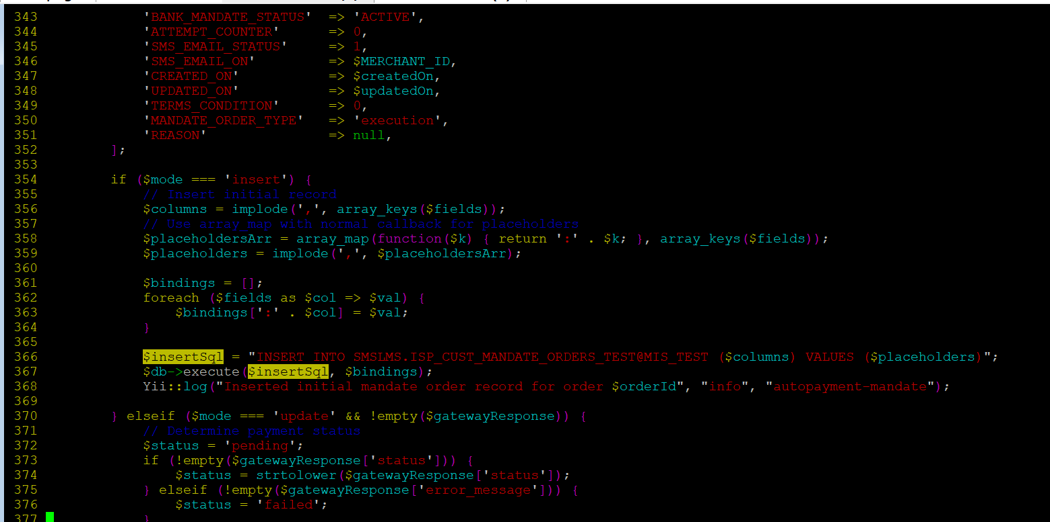

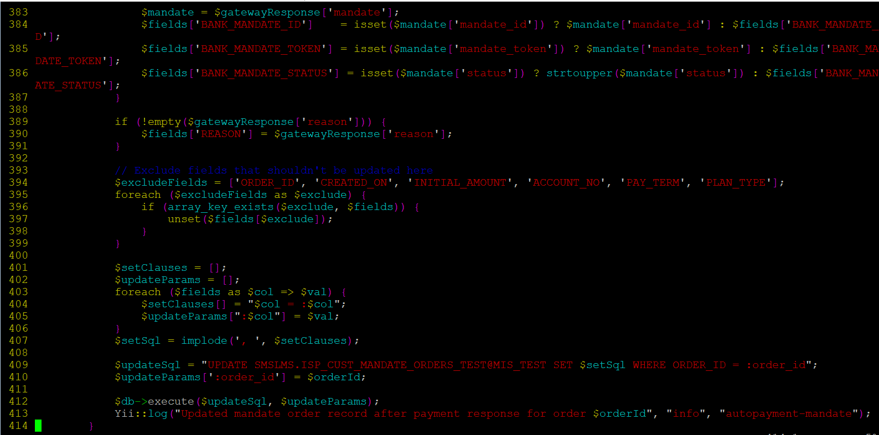

Testing and Verification
- Tested Auto Pay and Smart UPI transaction scenarios.
- Verified correct database logging of mandate order and payment response information.
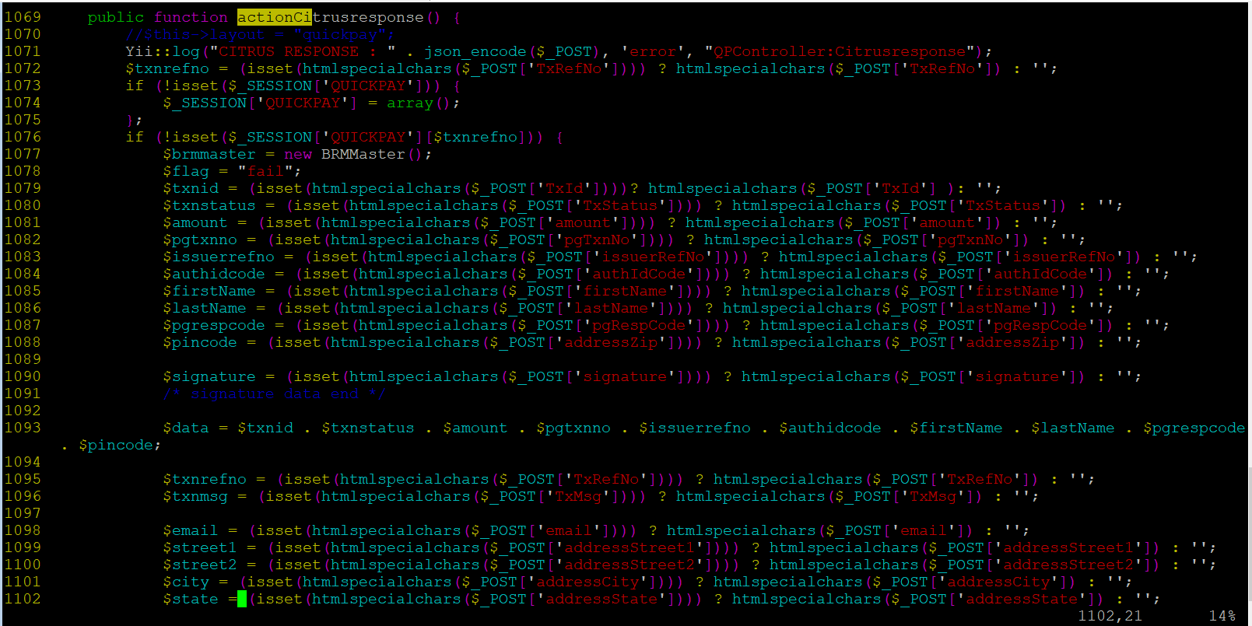
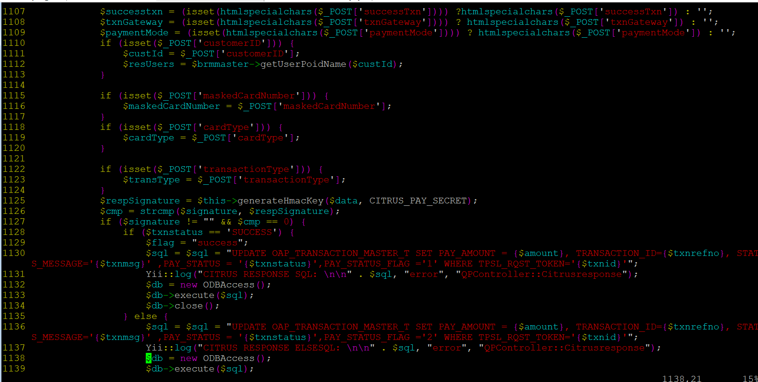
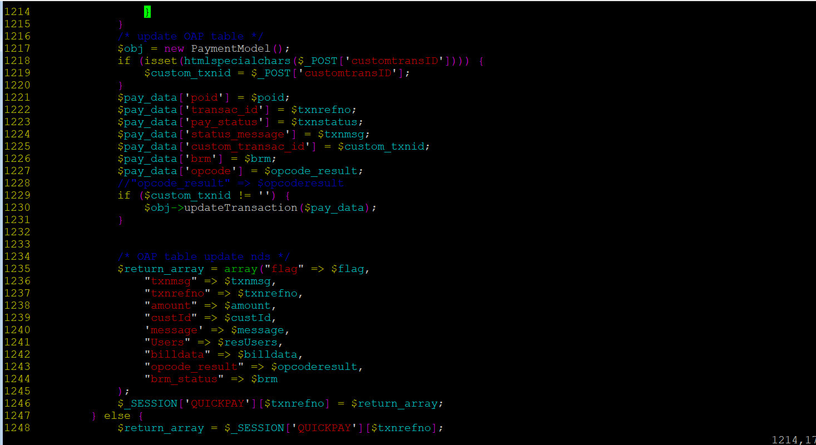
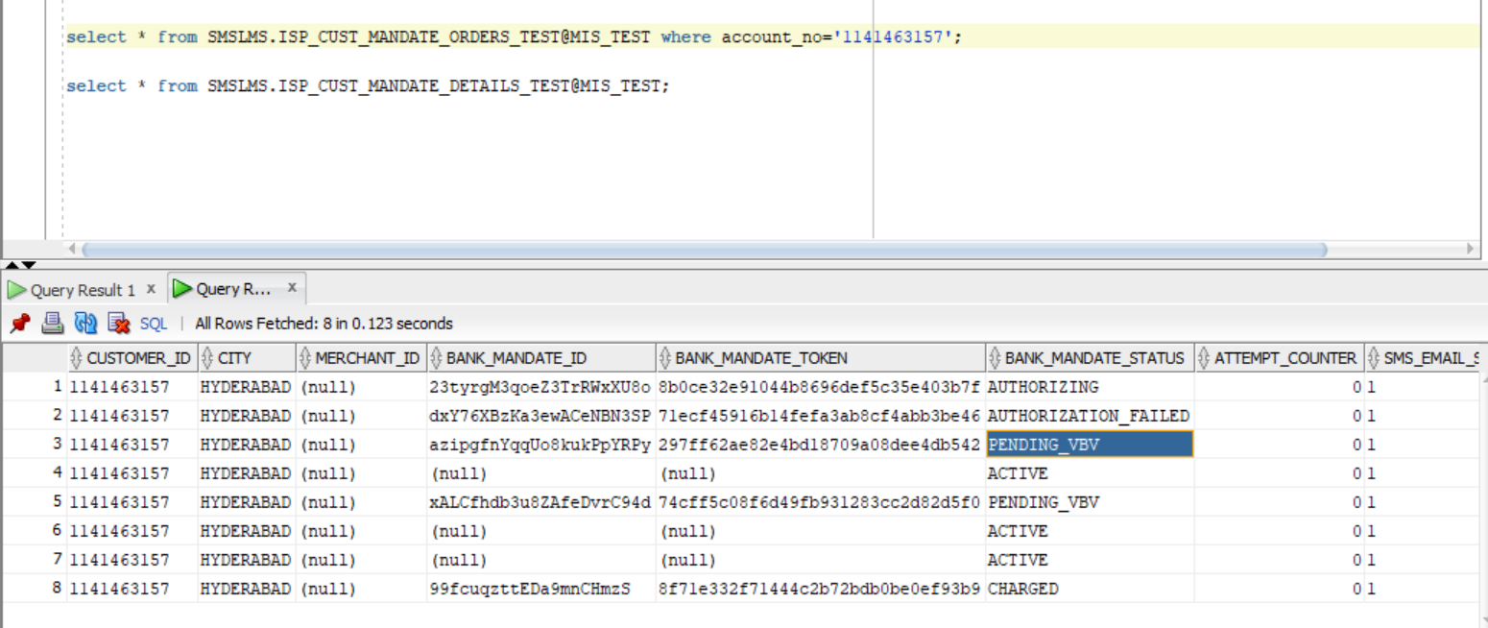

Insert a screenshot here showing a success message or confirmation from the application/UI after a transaction is completed
====that’s it today ===========

