Daily Status Report
Name : M. Eswari
Date : 14-10-2025
The backend is developed using Node.js with Express.js to handle HTTP requests. It provides RESTful APIs to perform CRUD operations on doctor data, including retrieving, adding, updating, and deleting records. Mongoose is used to model the doctor schema and interact with MongoDB Atlas. CORS is enabled to allow requests from the frontend. The backend ensures proper error handling and sends responses for seamless frontend updates.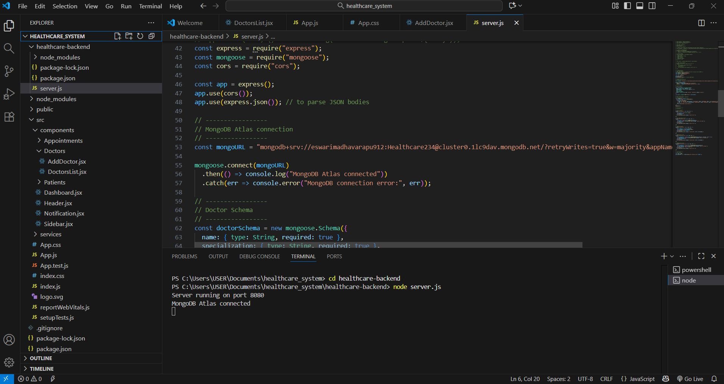
The frontend is built using React.js, utilizing functional components and hooks for state management and lifecycle events. It displays a dynamic Doctors List Table that fetches data from the backend. Users can view, edit, delete, or add doctors through action buttons, with FontAwesome icons for a modern UI. Loading indicators and error messages enhance user experience. API calls are handled via Axios to communicate with the backend.
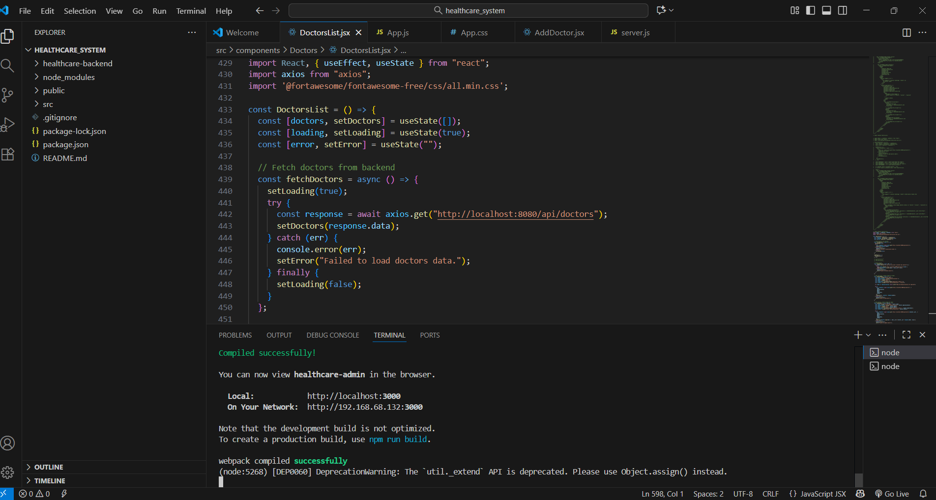
The database is Oracle, hosting a doctors table with fields such as Name, Specialization, Phone, Email, Experience, and Status. The backend interacts with the database using Spring Data JPA, allowing dynamic CRUD operations. Changes in the database are reflected in real time on the frontend. The database ensures secure, structured, and reliable storage of doctor data.
