Name : D Sri Ramya
Date : 8-4-2026
I focused on improving the FPMS Dashboard layout and resolved several UI alignment issues, including fixing the sidebar spacing, breadcrumb positioning, and card alignment using proper flexbox adjustments. I also handled table overflow and ensured responsive behavior across the page. Currently, the UI is stable, but I am facing a “Failed to fetch” issue from the API, which I will be working on next by verifying backend services and endpoints.
The FPMS (File Processing Management System) Dashboard is an important feature within the Scrutiny Panel that allows users to monitor file-related operations efficiently. It acts as a centralized interface where users can view file statistics and manage records.
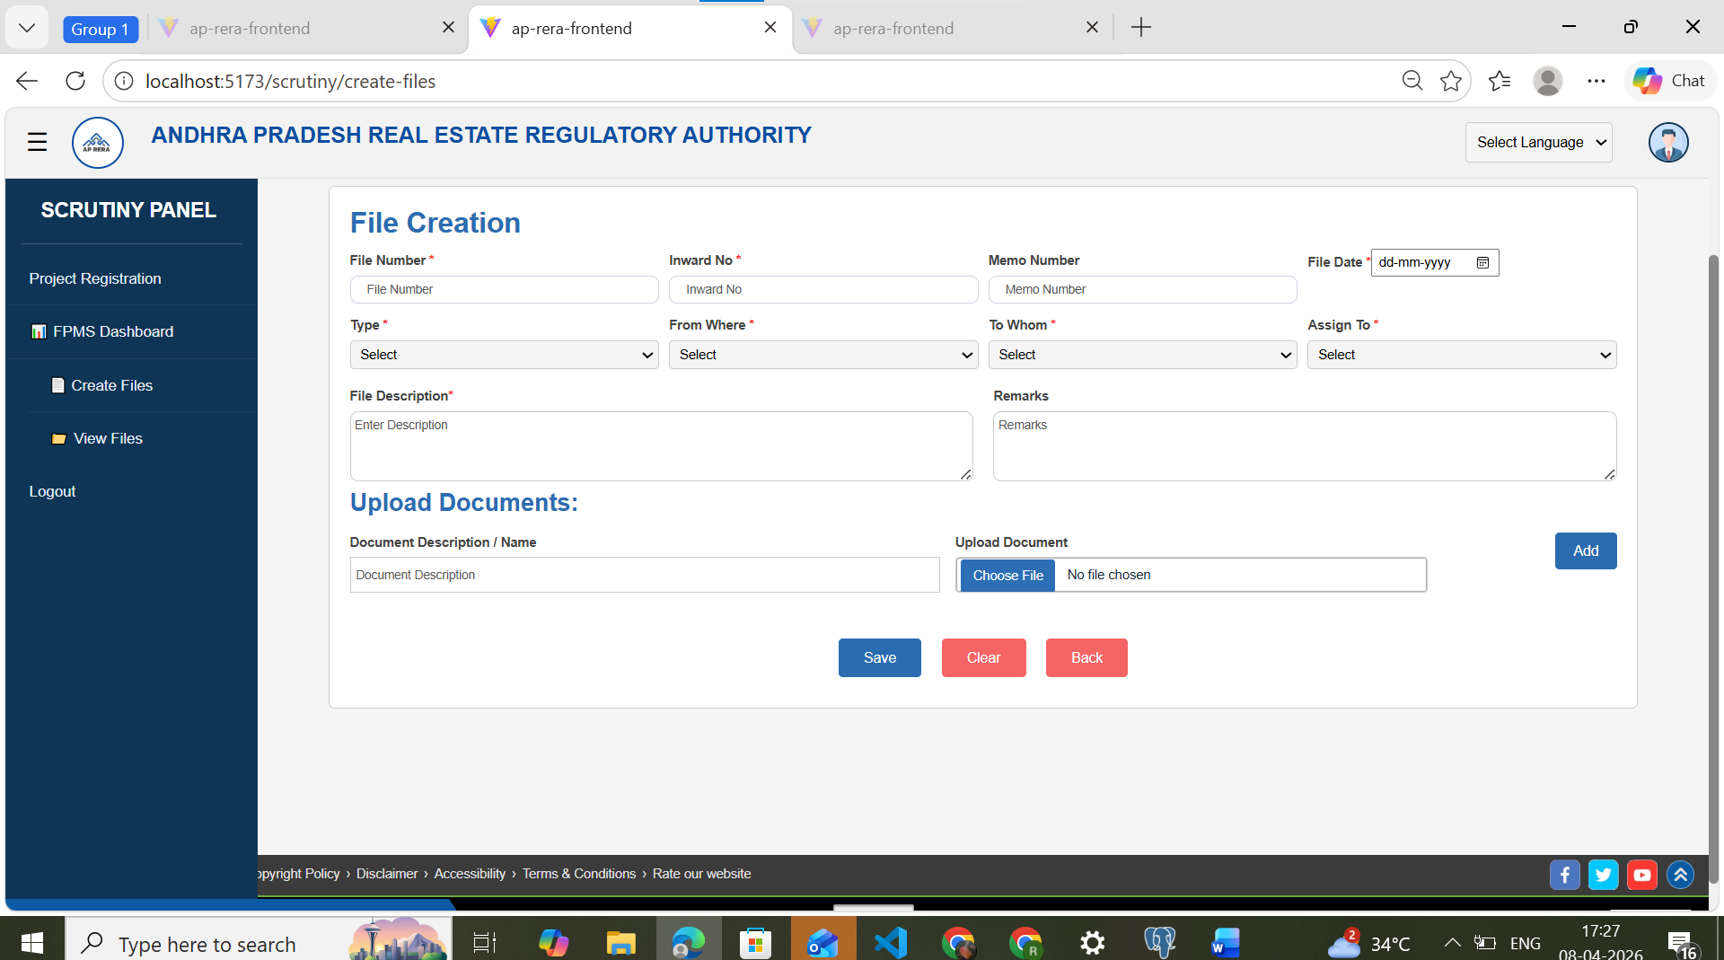
This task mainly focused on improving:
- UI structure and alignment
- Layout consistency with sidebar
- Responsive behavior of components
- Handling frontend errors during API calls

2. Functional Components of Dashboard
The dashboard is composed of multiple UI elements designed to provide a structured and user-friendly experience.
2.1 Navigation Panel
A fixed sidebar positioned on the left side of the screen containing:
- Dashboard access
- File creation module
- File viewing section
- Logout option
This panel remains static and guides navigation throughout the module.

2.2 Summary Cards Section
Three cards are displayed to show quick statistics:
- Total Files
- Open Files
- Closed Files
Each card is color-coded and visually separated to improve readability.

2.3 Breadcrumb Indicator
A small navigation indicator showing:
“You are here: FPMS Dashboard”
This helps users understand their current location in the application.
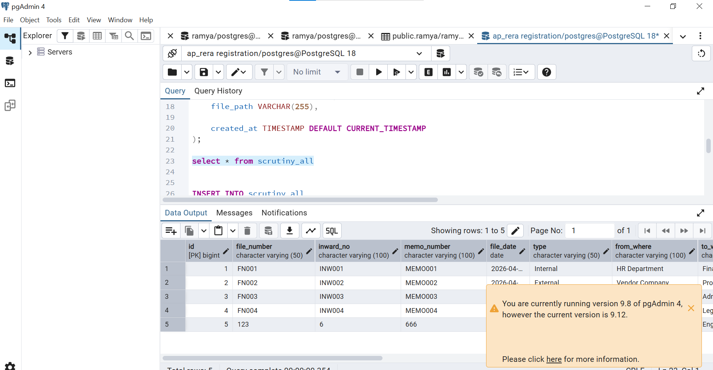

2.4 Data Table Section
The table displays detailed information such as:
- File Number
- Inward Number
- Filed Date
- Description
- Assignment details
It supports scrolling and dynamic data loading.

3. Challenges Faced
During implementation, several issues were encountered:
3.1 Improper Alignment
- Breadcrumb was not aligned with the sidebar
- Cards were appearing centered instead of left-aligned
- Extra spacing was visible between sections
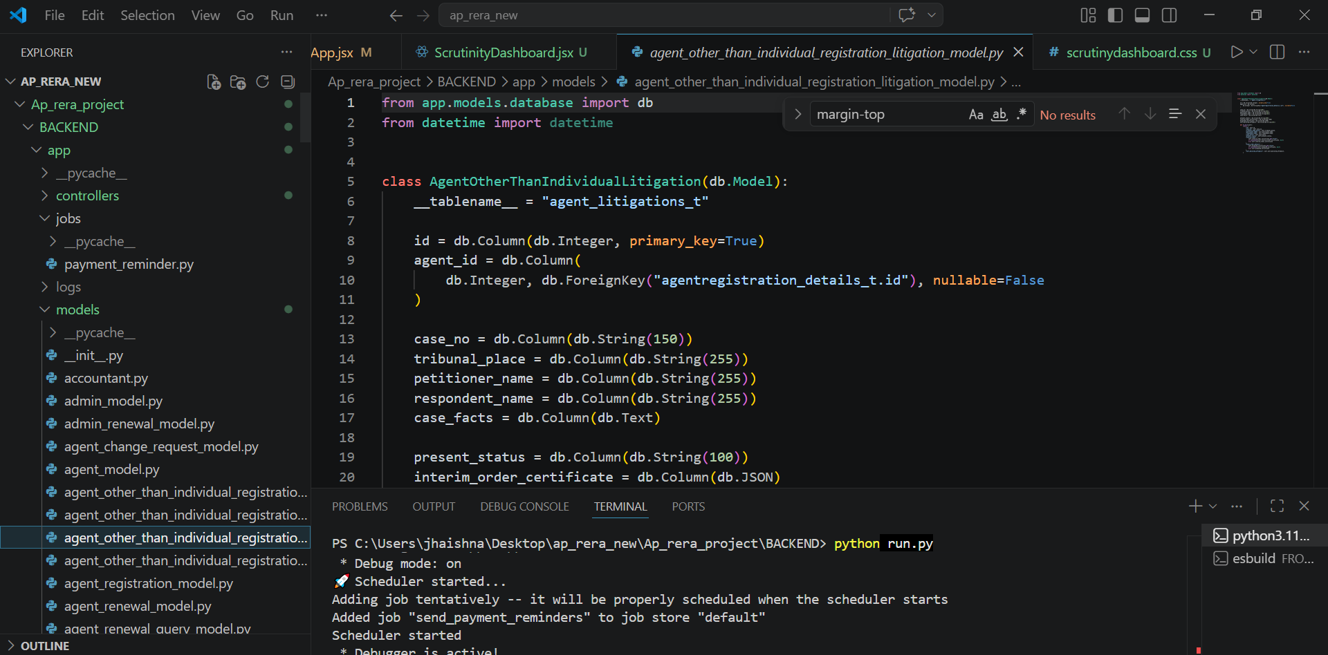

3.2 CSS Conflicts
- Use of margin: auto caused unintended centering
- Flexbox properties led to uneven card distribution

3.3 Layout Overflow Issues
- Horizontal scrolling affected the full page
- Table width exceeded container boundaries

3.4 Data Fetching Error
- Dashboard displayed “Failed to fetch”
- No records were shown in the table

4. Solutions Applied
4.1 Layout Correction
- Removed unwanted centering properties
- Ensured content starts immediately after sidebar

4.2 Flexbox Optimization
- Adjusted flex properties to align cards properly
- Introduced fixed widths for consistent layout

4.3 Spacing Adjustments
- Reduced unnecessary margins and padding
- Maintained uniform spacing across components

4.4 Table Handling
- Wrapped table inside a scrollable container
- Prevented layout break using minimum width

4.5 Error Handling Improvement
- Identified API connectivity issue
- Planned debugging steps for backend integration

5. Current Status of Development
At present, the frontend UI is functioning correctly with:
- Proper alignment across all components
- Clean and structured layout
- Improved responsiveness
However, the backend integration is pending resolution due to the API error.

6. Future Enhancements
The following improvements are planned:
- Fix API connectivity and display real-time data
- Add loading indicators for better UX
- Implement validation and error messages
- Optimize performance for large datasets

