Today work update

NAME : B PAVAN SANTHOSH
DATE : 11-04-2026
TIME : 9:00 TO 6:00

Today I changed also css for project details also
Frontend:
- Added a shared scrutiny layout using ScrutinyLayout.jsx so the sidebar/top header are consistent across the scrutiny project-registration flow.
- Applied that layout to the scrutiny project registration pages and action page.
- Updated ScrutinitySidebar.jsx navigation so it points to the real scrutiny routes.
- Wired ScrutinyCreateFile.jsx to submit create-file data with FormData.
- Wired ScrutinyFpmsDashboard.jsx to fetch live dashboard data, show counts, search, and paginate table rows.
Backend:
- Added POST API for create file in scrutiny_projectregistation_controller.py and insert logic in scrutiny_projectregistation_model.py.
- Final create-file endpoint is POST /api/scrutiny/create-file.
- Added GET API for FPMS dashboard data from scrutiny_all.
- Dashboard endpoint is GET /api/scrutiny/fpms-dashboard.

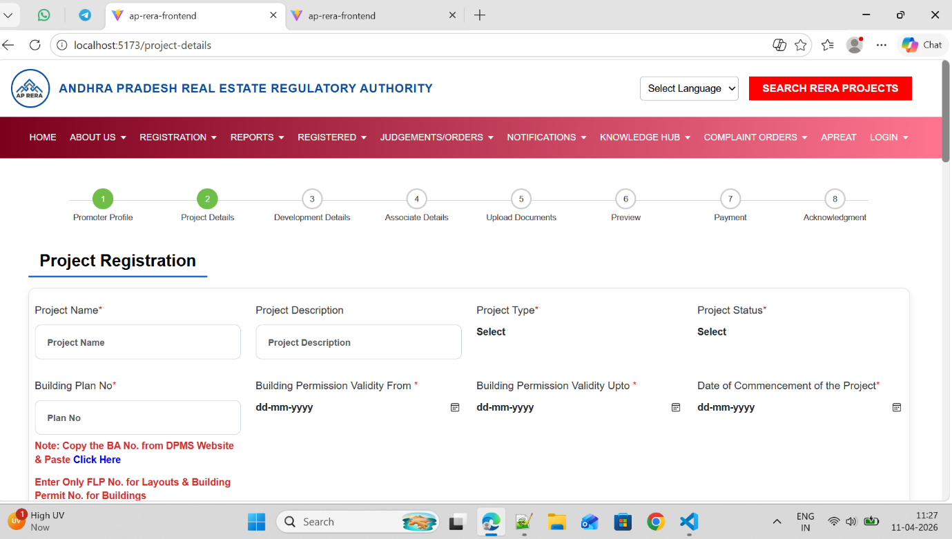

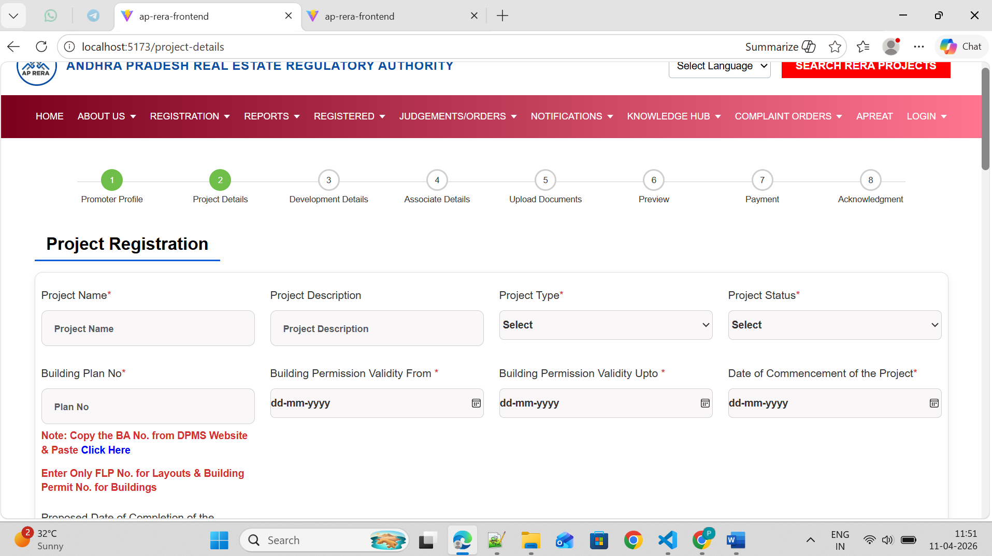

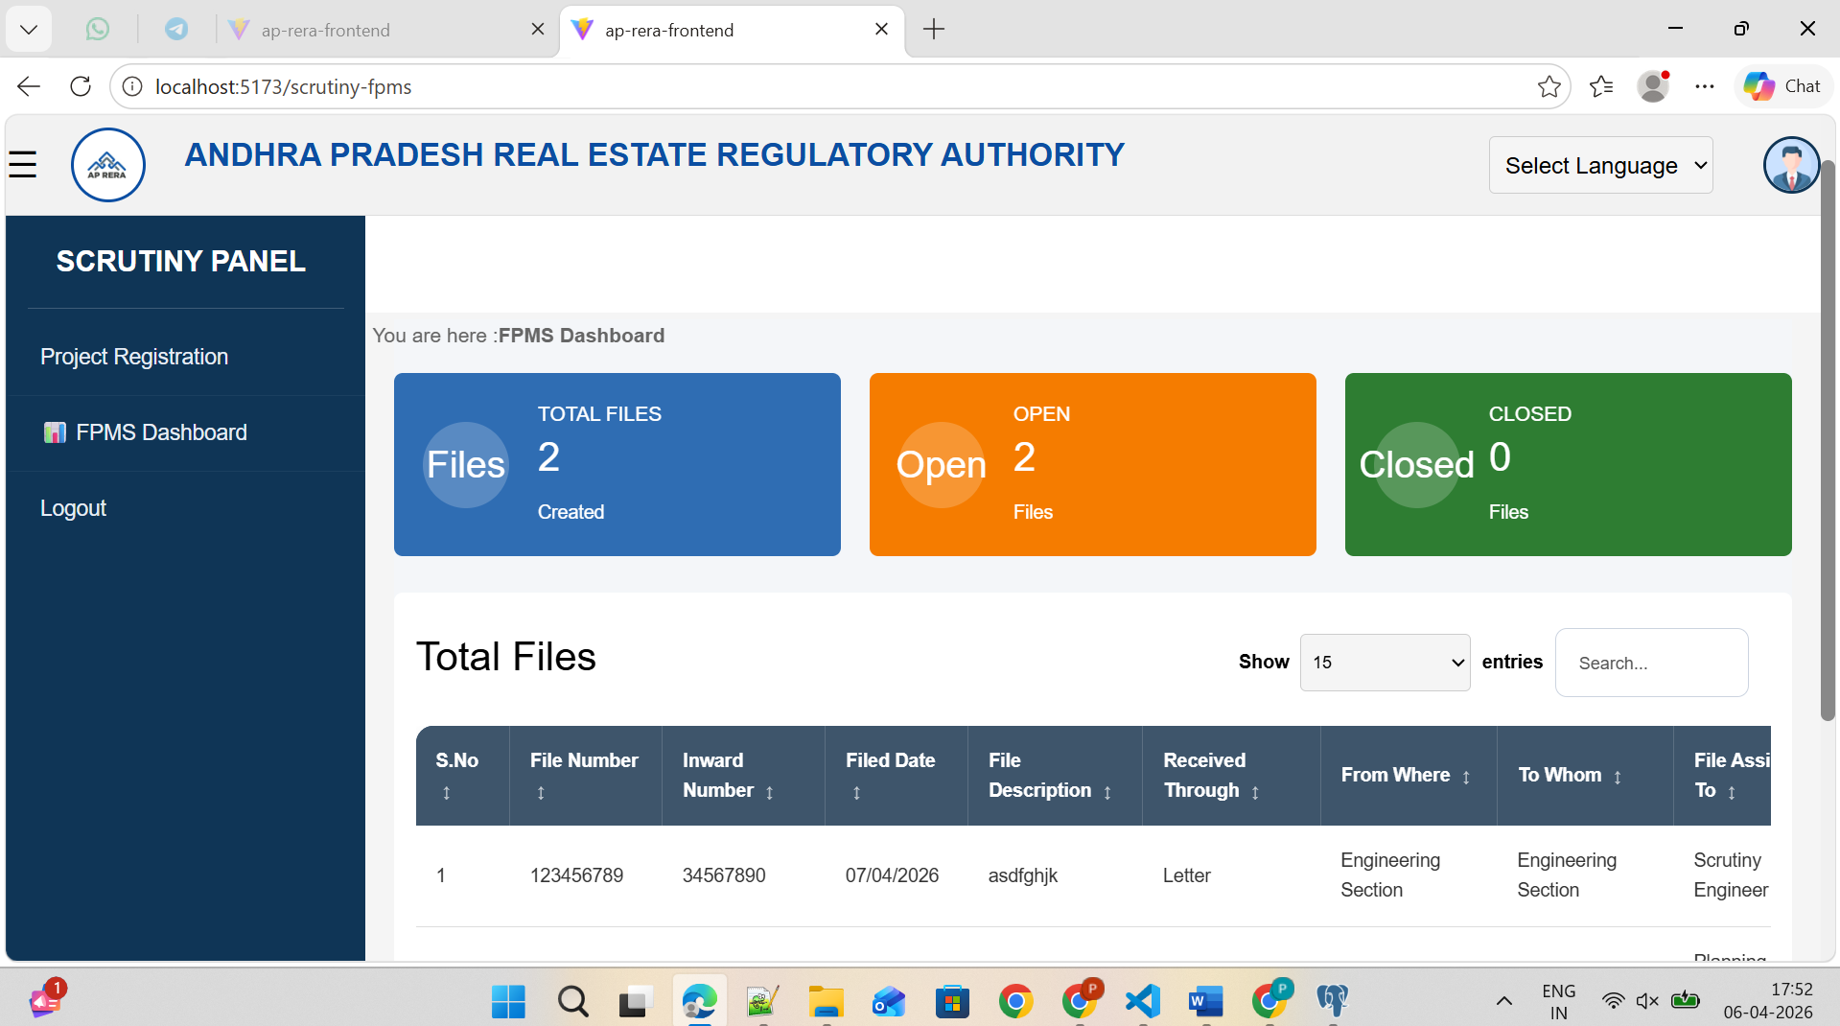

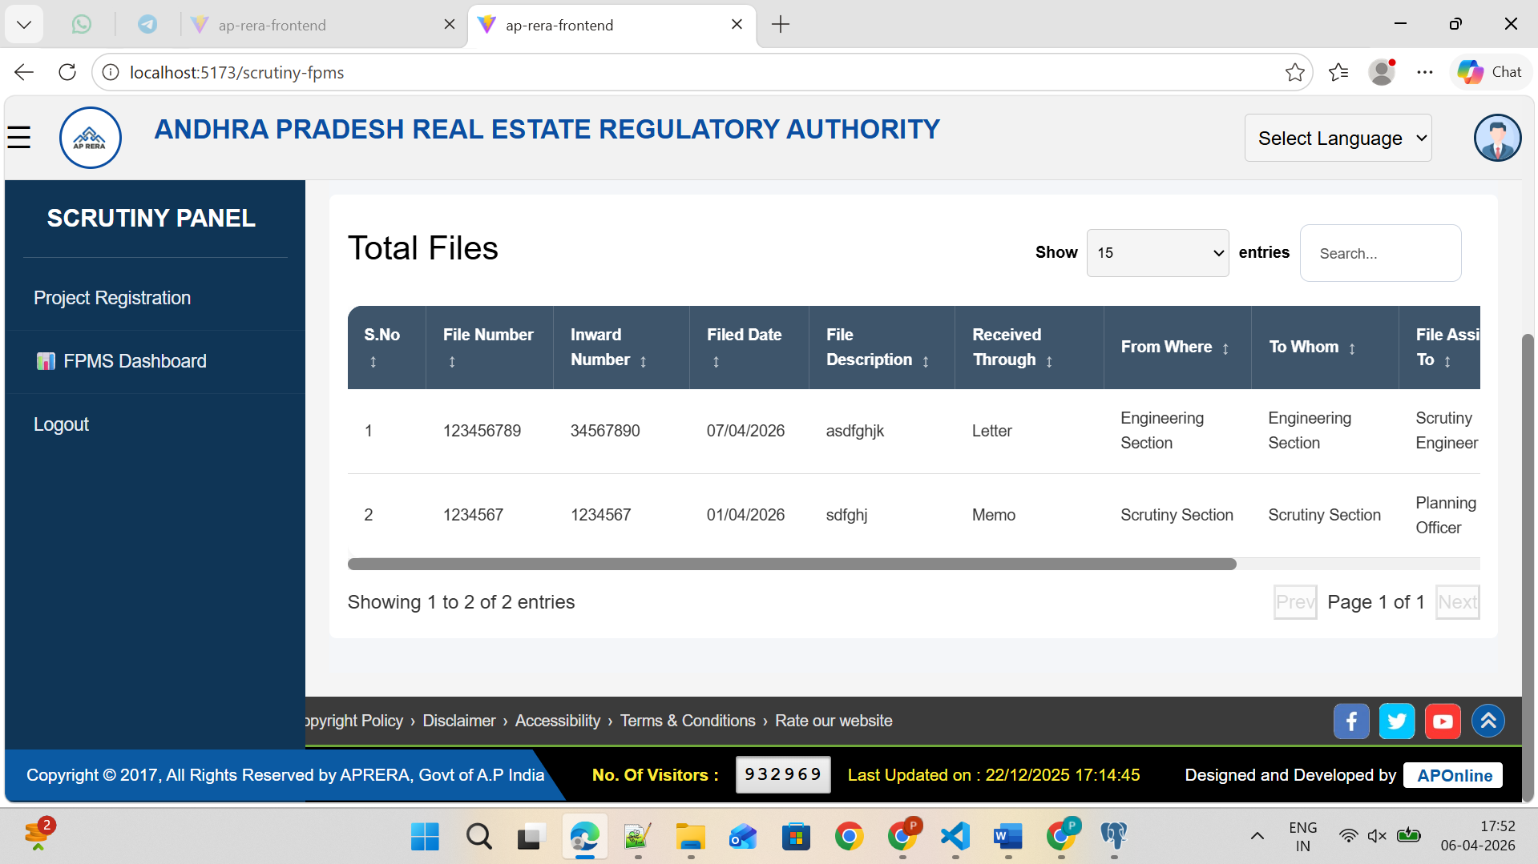

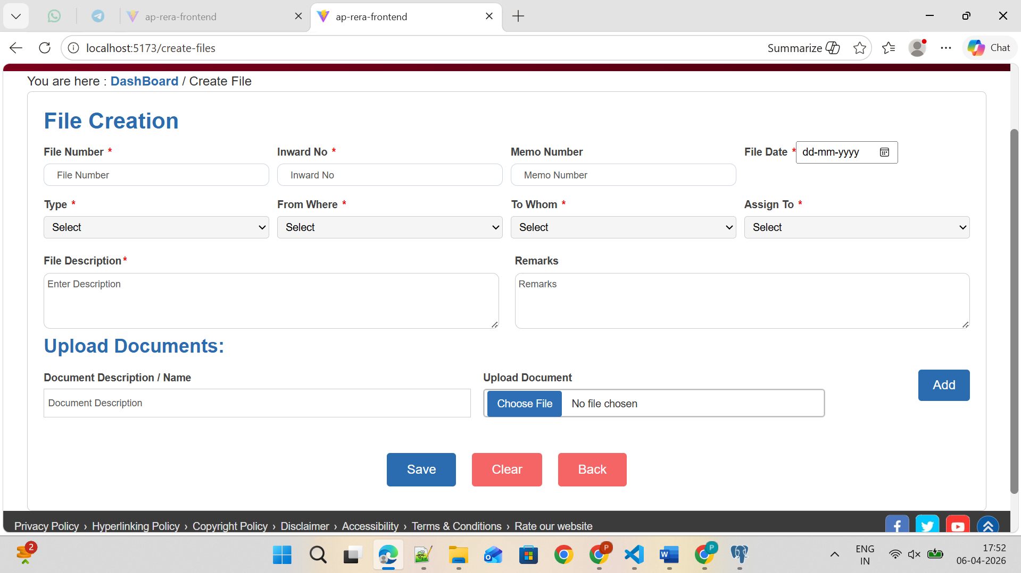

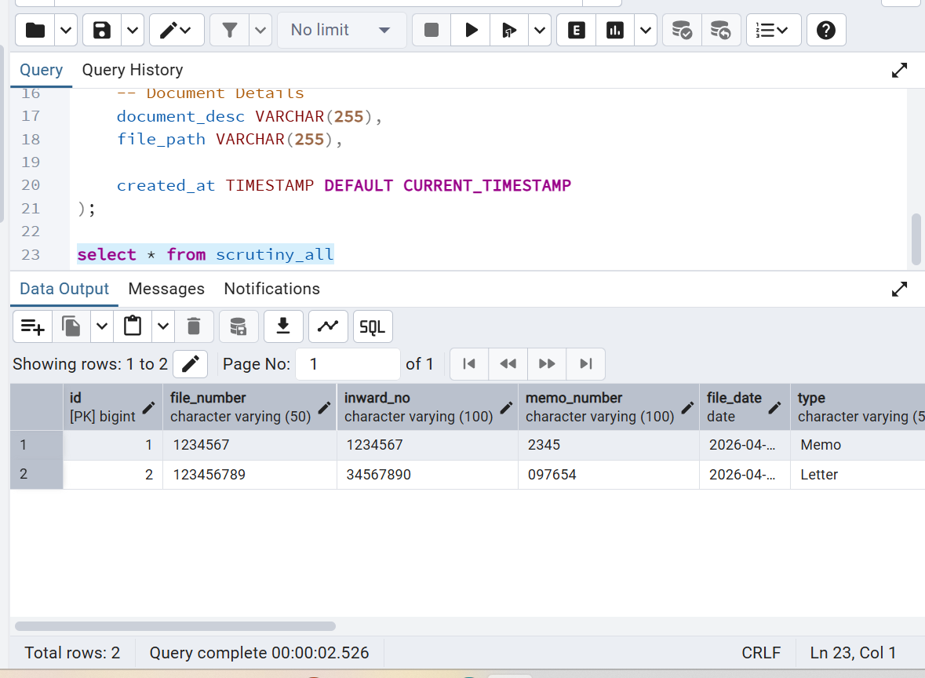
Thank you

