Eswar vardhan kottana

eswarkottana07@gmail.com

Dynamic Pricing for Urban Parking Lots

Capstone Project of Summer Analytics 2025 hosted by Consulting & Analytics Club × Pathway

**Key technologies used**;

1)Pathway : To simulate the real time streaming data

2)Python [ Numpy , Pandas ] : For Data processing

3) Bokeh : For real time price visualization

**Phase – 1** Exploratory Data Analysis (EDA)

**Step-1**- Profile the data to understand its structure types and its ranges

**Step-2** -Clean the data by handling the missing values

**Step-3**-Analyze Feature Ditributions:.

• Occupancy over time – Occupancy rises steadily in the morning from 11AM and starts declining after 3PM.

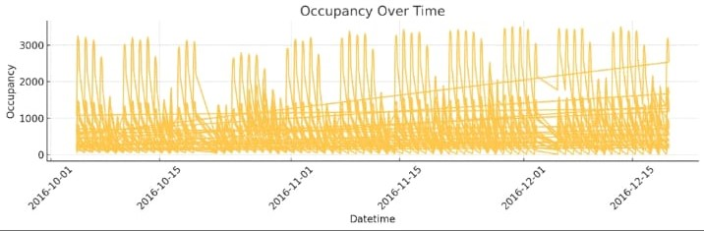

• Queue length by hour – Queue lengths are high around peak hours (11AM – 2PM) ,aligining with occupancy peaks , this suggests that demand exceeds capacity during those hours causing longer wait times.

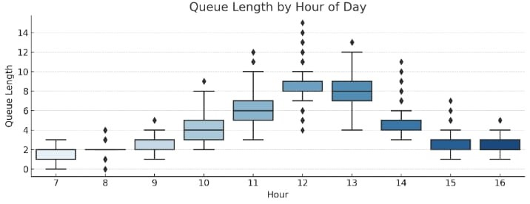

• Occupancy by hour of the day – Occupancy starts low at low and peaks at midday and then decreases after 3PM,this trend supports the need for time based pricing (e.g. higher at noon, lower in the morning.)

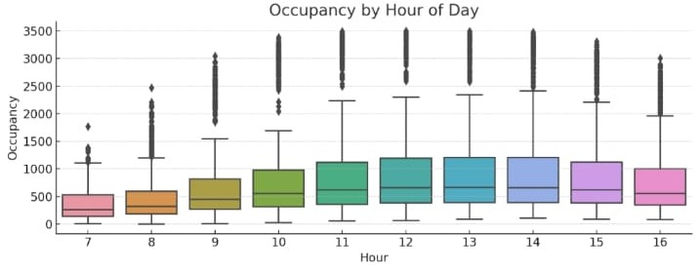

•Occupancy by traffic condition – Occupancy is high when traffic is high it shows that external road congestion directly influences parking demand and can be used as a pricing signal .

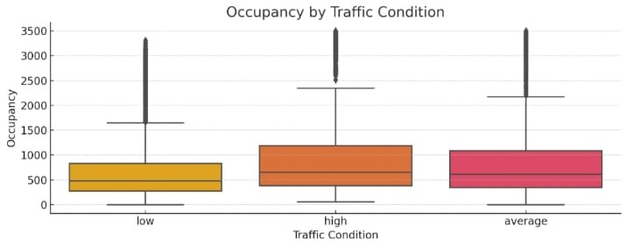

• Traffic condition Distribution – Occupancy most data points fall under average or huge traffic which supports the idea of using traffic as a regular component in pricing models .

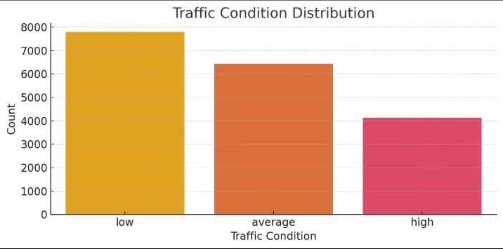

Observations :

These patterns observed strongly demand responsive pricing strategy.

Hence the Phase-1 comes to an end, from the Exploratory Data analysis (EDA) ,

This section details the initial exploration of the provided dataset, focusing on understanding its structure, key features, and identifying preliminary patterns relevant to developing a dynamic pricing strategy for urban parking lots.

**Phase – 2**

**Model development section**

**Model1 : Baseline Linear Model**

**Formula :**

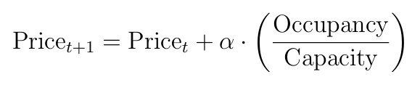

•Implemented using pandas and matplotlib seaborn

•It’s a basic linear model and a linear growth with Occupancy which is used as a benchmark model

Where the values taken are α = 2 , Base price = $ 10 .

Here is the sample output

S.NO Datetime Occupancy Capacity Occupancy Ratio Linear price

0 2016-10-04 07:59:00 61 577 0.105719 10.211438

1 2016-10-04 08:25:00 64 577 0.110919 10.221837

2 2016-10-04 08:59:00 80 577 0.138648 10.277296

3 2016-10-04 09:32:00 107 577 0.185442 10.370884

4 2016-10-04 09:59:00 150 577 0.259965 10.519931

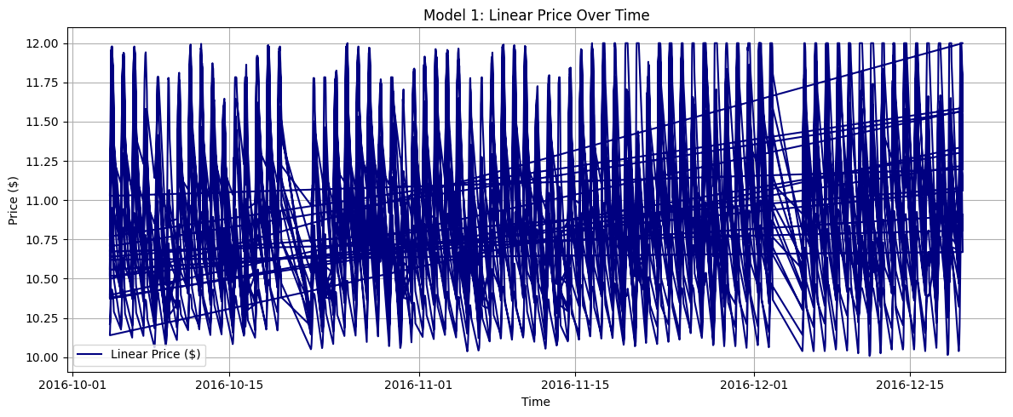

Observation from the graph :

The "Real-time Pricing and Occupancy Rate Over Time" plot clearly demonstrates that the parking price directly correlates with the lot's occupancy rate. As occupancy increases (e.g., during peak hours), the price rises, and conversely, as occupancy decreases, the price either stabilizes or declines slightly (relative to its previous value).

**Conclusion:** This confirms that Model 1 effectively implements its core objective: to make pricing reactive to the immediate availability and current utilization of the parking space.

**Model 2 :**

Formula :

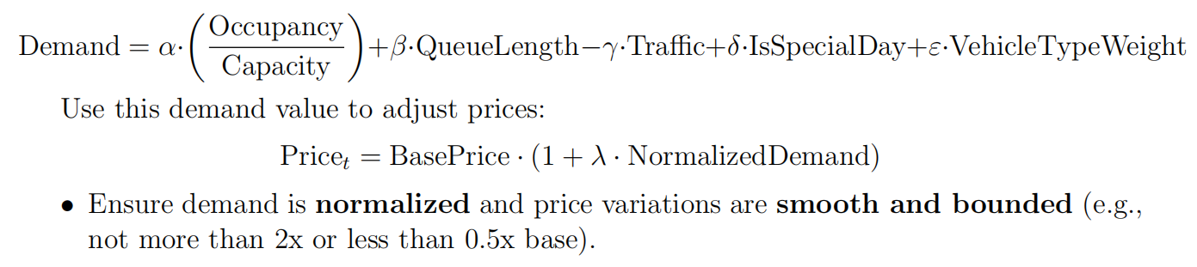

Weight Used :

α=2, β=1, γ=1, δ=2, ε=1

heres the bokeh visualization :

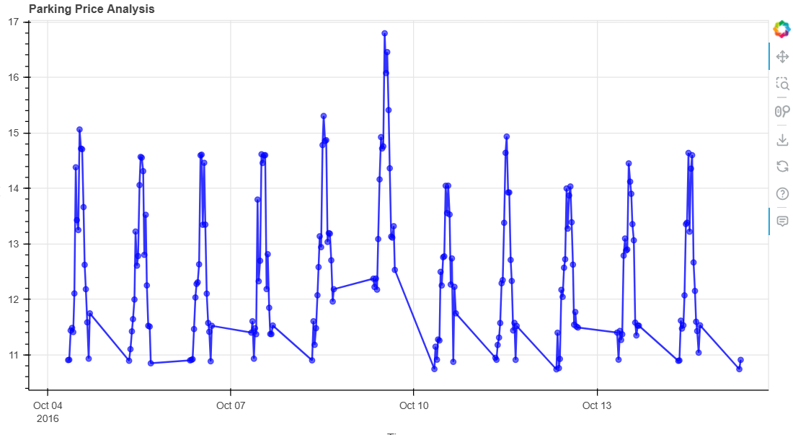

Observations from the graph :

Prices reflect real-time demand changes, rising during high traffic ,long queues, and special days . this model performs better in adapting to real -world conditions

**Model 3**

Formula logic :

Final Price =

**Implementation logic**

First applied only to one parking lot ( e.g., BHMBCCMKT01) where the Competitors assumed to have fixed demand based prices

And your price is adjusted based on proximity and comparison

Adjustment logic

If you are full and competitors are cheaper the demand price decreases and that’s the final price

If you are not full and competitors are expensive the demand price increases and that’s the final price

Else conditions the implemented model2 price will be the final price

Here is the bokeh visualization

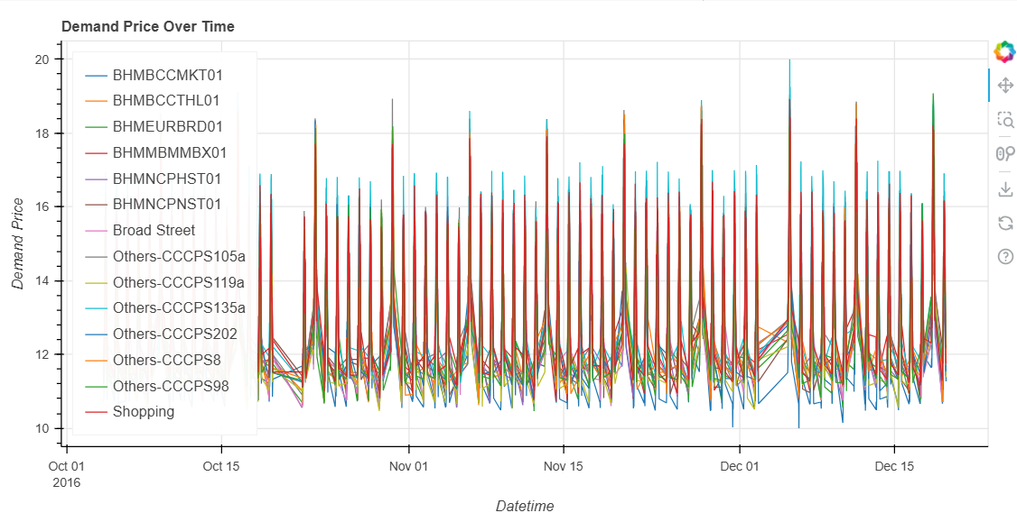

Observations :

This model introduces competitiveness and price adapts not only to demand but also to the market environment which aligns to the real- world strategy.

**🔄 Real-Time Streaming with Pathway**

To simulate real-time dynamic pricing, the dataset was streamed row-by-row using Pathway, a Python-based data streaming framework. The data was parsed in timestamp order and fed into our pricing models as if it were arriving live from sensors.

The streaming logic involved:

Ingestion of historical data using pw.io.csv.read() in streaming mode

Feature processing and price calculation using custom @pw.udf functions

Price prediction using:

Model 2: Demand-based pricing

Model 3: Competitive pricing (for one selected lot)

Pathway enabled real-time row-by-row computation, simulating how a smart parking system would adapt prices live as new data (occupancy, traffic, queue) becomes available.

**📈 Real-Time Visualization with Bokeh**

The price outputs from Pathway were streamed to a Bokeh dashboard, using ColumnDataSource.stream() to update plots dynamically.

Two types of live visualizations were created:

**Model 2 Plot: Demand-based price stream for a single parking lot**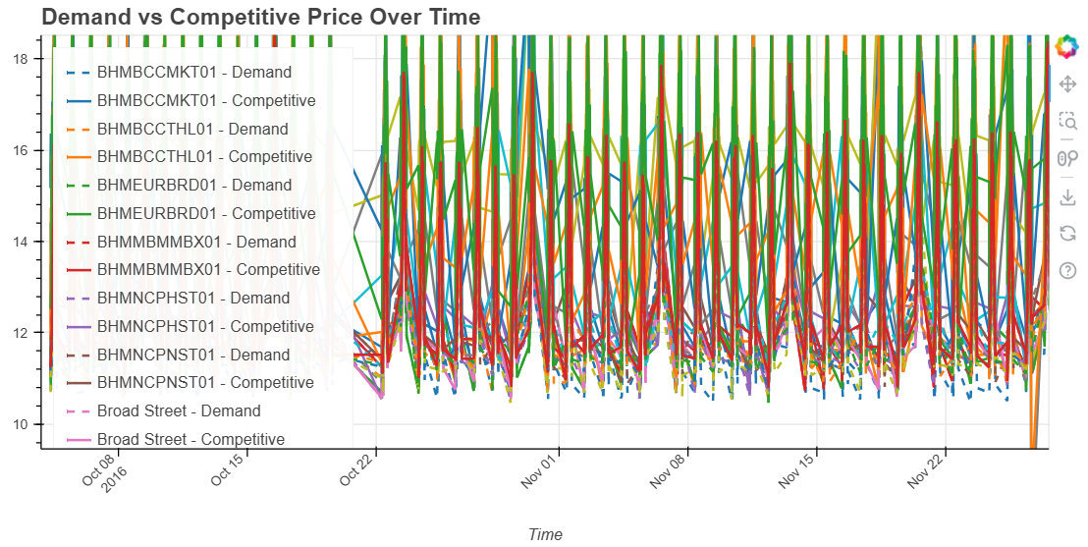

**Model 3 Plot: Competitive pricing stream (adjusted based on nearby lot prices)**

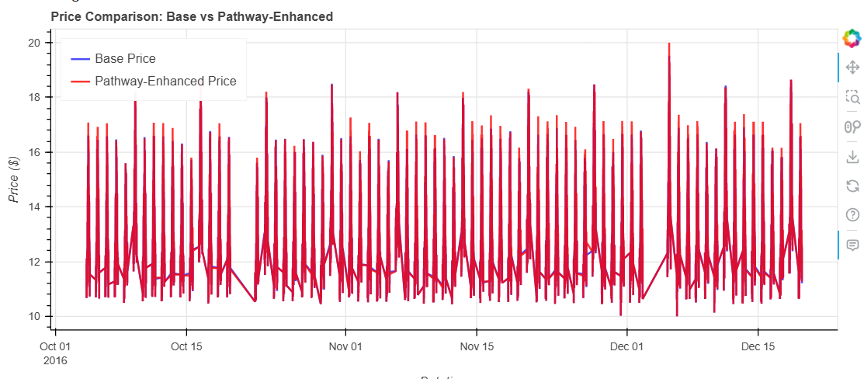

**(adjusted based on nearby lot prices)**

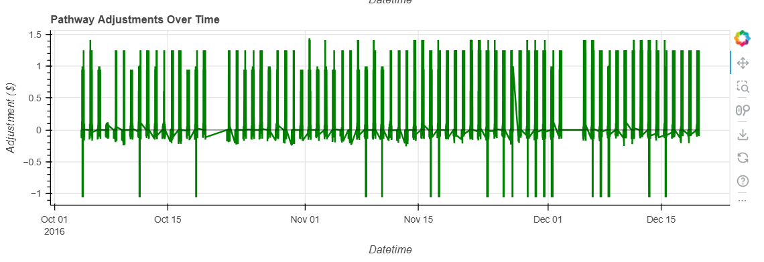This allowed for monitoring how price changes in real time with respect to external conditions.

**📊 Observations from Graphs**

**Model 2: Demand-Based Pricing**

Prices steadily increase during peak hours (11 AM–2 PM).

Sudden spikes in price were observed during special days or high traffic events.

Queue length also plays a significant role in increasing price pressure.

**Model 3: Competitive Pricing**

Prices dynamically adjusted up or down based on competitor prices.

When nearby lots were cheaper, the selected lot lowered its price to stay competitive.

This behavior reflects market-aware adaptation, mimicking real business strategies.

**✅ Conclusion**

This project successfully demonstrated how real-time data can be used to dynamically adjust parking prices using intelligent, interpretable models.

Model 1 provided a baseline approach using occupancy alone.

Model 2 introduced feature-based dynamic pricing.

Model 3 extended this further with competition-aware pricing logic.

By combining Pathway for streaming and Bokeh for visualization, we created a system that closely resembles a real-world smart parking platform — capable of real-time decision-making and adaptive pricing based on evolving urban conditions.