/global/cfs/cdirs/m3195/ascot

/global/cfs/cdirs/m3195/ascot

PSFC-MFE: R$$647_b 4/29/2021

python $dir_prep/Poincare.py -fn group_go_1183.h5

/global/cfs/cdirs/m3195/ascot

mse2021: 203.230.125.58

pip install -l python/a5py –user

The “--user" command must go after everything: “pip install -l python/a5py --user”. This will install python packages somewhere in your local user directory.

Now, about the version. I’m not sure how pip actually works in terms of what version it is compatible with… so far in my case, doing “pip3 install ….” worked fine for my python3 version. I think this worked for you in the past too?

pip3 install multiprocessing_on_dill --user

to get to mse1

* terminate all other vpns. must work from home, not thru PC at PSFC
* establish vpn using ciscoAnyConnect. ~~vpn.nfri.re.kr~~ **vpn.kfe.re.kr** k-sscott remy$Zenna20
* then noMachine to 172.17.250.11 (SSH) port 2201. username = sscott (?) pswd = Tmzkt39@)12
* create a new virtual desktop … continue … OK … display the menu panel as a window … OK … right click … open terminal ….
* takes me to sscott@nx-term4 ~]$

+++++++++++++++++++++++++++++++++++++++++++++++

to create a 3D conformal wall:

python

import mypython.wall_3d as wall

wall.write_sparc_conformal_3D_wall()

python $dir_mypython/export_vtp_norm.py ascot_34225159.h5 0.588

+++++++++++++++++++++++++++++++++++++++++++++++++++++++++

9/11/2020

To get a new version e.g. 82f6801b for a5py/a5py/wallloads

1. git clone <python repository name from ascot web site?
2. navigate to affected directory, in this case …a5py/wallloads
3. git checkout 826801b

++++++++++++++++++++++++++++++++++++++++++++++++++++++++++

<https://www.geeksforgeeks.org/tri-surface-plot-in-python-using-matplotlib/>

source code and shell scripts to build ascot and its utilities

/global/cfs/cdirs/m3195/ascot/ascot5-knl/ascot5

to restart a remote windows: From the remote computer's Start menu, select Run, and run a command line with optional switches to shut down the computer:

1. To shut down, enter: shutdown.
2. To reboot, enter: shutdown –r.

xxxxxxxxxxxxxxxxxxxxxxxxxxxxxxxxxxxxxxxxxxxxxxxxxxxx

myprocessp 32084518 'v1e.geq' '1.0' 'v1e_profiles_3.txt’

python group_hybrid_452.py check_gcf ascot_31621874.h5 3.e-4 v1e.geq

python group_hybrid_420.py plot_orbits ascot_31364564.h5 0 'v1e.geq'

/global/cfs/cdirs/m3195/ascot

**to zip a directory:** zip -rv myzip_name.zip my_directory_name

**public IP addresses**

wget -qO – icanhazip.com

sparc-rws01: 18.18.167.12

mferws01: 198.125.183.50

mfews01: 198.125.183.222

mfews02: 198.125.183.122

mfews03: 198.125.183.123

mfews04: 198.125.183.124

mfews05: 198.125.183.125

mfews06: 198.125.183.126

mfews07: 198.125.183.127

mfews11: 198.125.183.131

pppl: 192.188.106.50

NERSC: not sure it has a public IP address …

mse2021: 203.230.125.58

cannot ping PPPL from sparc-rws01

cannot ping PPPL from mferws01

can ping sparc-rws01 from mferws01

can copy from sparc-rws01 to mferws01

cannot copy from mferws01 to sparc-rws01

when on sparc-rws01, cannot copy a file from mferws01

**psfc workstation backup codes 4/28/2020**

57630308

33875087

83593454

10111122

04766287

31886768

30464146

06429291

19277120

95395848

**HOW TO FIX A5GUI**

somehow, the character string ‘a5gui’ invokes /global/homes/s/sscott/.local/cori/3.6-anaconda-4.4/bin/a5gui

and that script invoked a version of python that is too old. So with Pablo’s help, I modified the first line to be:

#!/usr/common/software/python/3.7-anaconda-2019.07/bin/python

and now (4/21/2020) … it works!

**To make Illustrator stuff editable:**

1. dorasterized = False in python
2. in Illustrator, object 🡪 clipping mask 🡪 release

Steve -   
  We set up a VM for you to do your work on.  It is SPARC-RWS03. There   
are two ways which you can get to it:   
1. nomachine - ssh connection to power.mit.edu port 9223, then ssh -Y   
sparc-rws03   
2. ssh - ssh -Y power.mit.edu -p 9224, and then ssh -Y sparc-rws03   
This VM is (for now) for your exclusive use, and is pretty beefy.  Let   
me know how things work for you.   
-Josh

vpn.nfri.re.kr

source activate ascot

pip install -I …/a5py (see Libby’s instructions)

On pppl scp [sscott@18.18.167.12:/home/sscott/file.txt](mailto:sscott@18.18.167.12:/home/sscott/file.txt) .

on pppl: scp [sscott@mferws01.psfc.mit.edu:/home/sscott/file.txt](mailto:sscott@mferws01.psfc.mit.edu:/home/sscott/file.txt) . (4/8/2020

On rws01: scp <filename> [sscott@mfews01.psfc.mit.edu:/home/sscott](mailto:sscott@mfews01.psfc.mit.edu:/home/sscott).

scp

4/15: had to be on rws01:

scp ripple_multi_z75.ps sscott@mfews11.psfc.mit.edu:/home/sscott/.

from mpl_toolkits.mplot3d import Axes3D

import matplotlib.pyplot as plt

import numpy as np

fig = plt.figure()

ax1 = fig.add_subplot(111, projection='3d')

xpos = [1,2,3,4,5,6,7,8,9,10]

ypos = [2,3,4,5,1,6,2,1,7,2]

num_elements = len(xpos)

zpos = [0,0,0,0,0,0,0,0,0,0]

dx = np.ones(10)

dy = np.ones(10)

dz = [1,2,3,4,5,6,7,8,9,10]

ax1.bar3d(xpos, ypos, zpos, dx, dy, dz, color='#00ceaa')

plt.show()

mport matplotlib.pyplot as plt

# An "interface" to matplotlib.axes.Axes.hist() method

n, bins, patches = plt.hist(x=d, bins='auto', color='#0504aa',

alpha=0.7, rwidth=0.85)

plt.grid(axis='y', alpha=0.75)

plt.xlabel('Value')

plt.ylabel('Frequency')

plt.title('My Very Own Histogram')

plt.text(23, 45, r'$\mu=15, b=3$')

maxfreq = n.max()

# Set a clean upper y-axis limit.

plt.ylim(ymax=np.ceil(maxfreq / 10) * 10 if maxfreq % 10 else maxfreq + 10)

[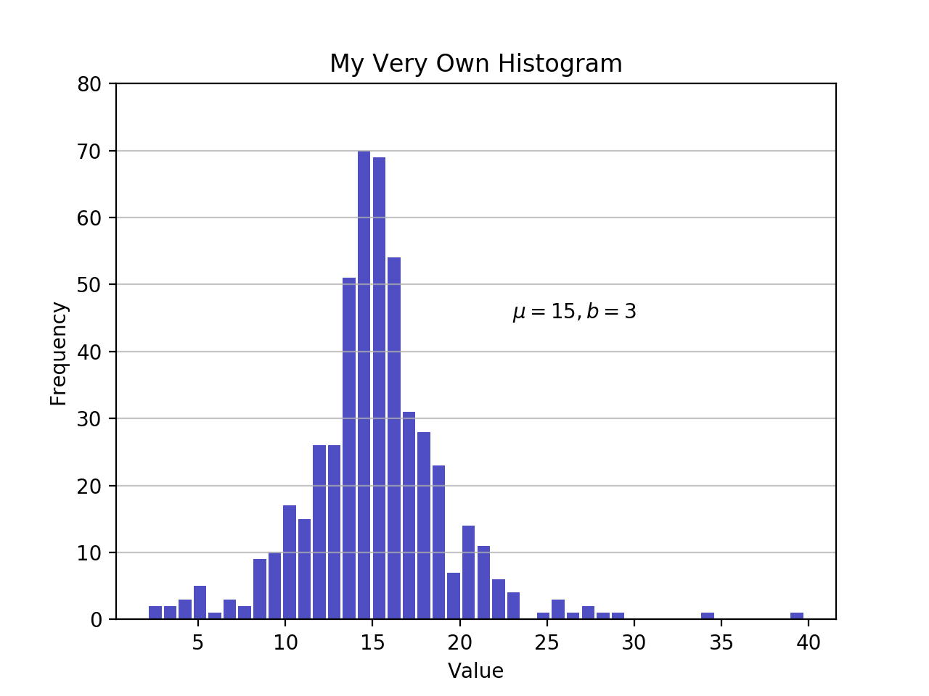](https://files.realpython.com/media/my_very_own_histogram.d411ea1cb95c.png)

As defined earlier, a plot of a histogram uses its bin edges on the x-axis and the corresponding frequencies on the y-axis. In the chart above, passing bins='auto' chooses between two algorithms to estimate the “ideal” number of bins. At a high level, the goal of the algorithm is to choose a bin width that generates the most faithful representation of the data. For more on this subject, which can get pretty technical, check out [Choosing Histogram Bins](http://docs.astropy.org/en/stable/visualization/histogram.html) from the Astropy docs.

Staying in Python’s scientific stack, Pandas’ Series.histogram() [uses matplotlib.pyplot.hist()](https://github.com/pandas-dev/pandas/blob/cbec58eacd8e9cd94b7f42351b8de4559c250909/pandas/plotting/_core.py#L1310) to draw a Matplotlib histogram of the input Series:

import pandas as pd

# Generate data on commute times.

size, scale = 1000, 10

commutes = pd.Series(np.random.gamma(scale, size=size) ** 1.5)

commutes.plot.hist(grid=True, bins=20, rwidth=0.9,

color='#607c8e')

plt.title('Commute Times for 1,000 Commuters')

plt.xlabel('Counts')

plt.ylabel('Commute Time')

plt.grid(axis='y', alpha=0.75)

[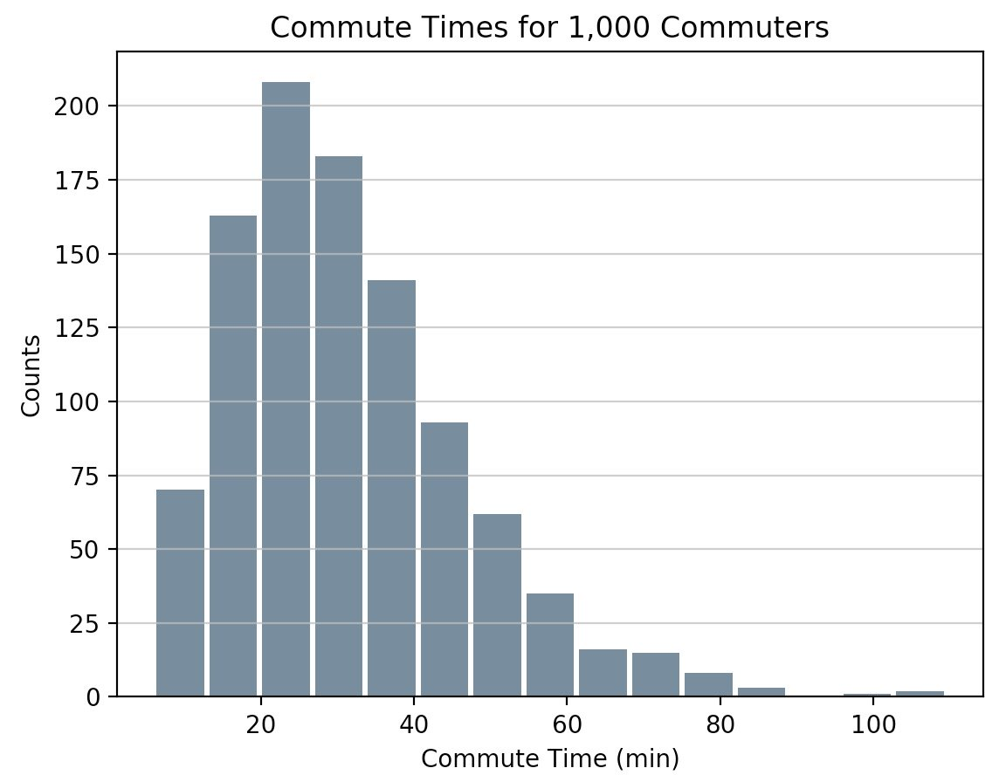](https://files.realpython.com/media/commute_times.621e5b1ce062.png)

pandas.DataFrame.histogram() is similar but produces a histogram for each column of data in the DataFrame.

<https://askubuntu.com/questions/1031400/mouse-cursor-turned-into-a-thick-plus-cannot-click-but-mouse-can-move>

10.3.19. MIT-dropbox: [sscott@psfc.mit.edu](mailto:sscott@psfc.mit.edu) RR$m995krqR5

xxxxxxxxxxxxxxxxxxxxxxxxxxxxxxxxxxxxxxxxxxxxxxxxxxxxxxxxxxxxxxxxx

Here is what we did, after a few iterations, to install the MATLAB license.  Keep in mind that it is now August 8.  We hadn’t been using MATLAB for some months … I think that if we had used it in July, we would have gotten warnings that the license was about to expire. But instead, when I tried to use it yesterday, the license had simply expired.

1. One mse1, type ‘matlab’.  This brings up a screen with saying that the license is expired.  It also gives a name, which today was 001fc69bfb6a.  Also the release was 2015b.  we wrote down both numbers.
2. Then nuke the VPN to mse1, so that we can get to the Internet.
3. Lee then got a license file from the MATHWORKS web site.  I think he needed to give it the name 001fc …   and this generated a license file  = license.lic (ascii) which was downloaded to my PC.
4. I then used SecureFX to copy license.lic to home/sscott/ on cmodws107.  **Importantly, this node is a trusted client by nfri.**
5. Establish a vpn to nfri again and open a terminal to mse1.  Then in /home/sscott do   scp [sscott@198.125.183.107:/home/sscott/license.lic](mailto:sscott@198.125.183.107:/home/sscott/license.lic) .
6. We then tried to run matlab again to install the license, but it wouldn’t let us copy the license file to the appropriate directory because we didn’t have write priviliges.
7. So establish a new terminal, log in as root.  (I have the password and so does Josh I think).
8. Then we could successfully run matlab and import the license file.

xxxxxxxxxxxxxxxxxxxxxxxxxxxxxxxxxxxxxxxxxxxxxxxxxxxxxxxxx

h5ls -r <filename>.h5 🡨 lists all groups and data sets

h5ls -r <filename>.h5/groupN/subgroupM/dataset5 🡨 lists stuff for the dataset

h5ls -d <filename>.h5/groupN/subgroupM/dataset5

Lee: The CFS emails are Google Apps addresses. I believe that if you go to gmail.com and log in with your CFS credentials, you should see your CFS emails displayed. If so, at the top right of the screen, you should see a small gear icon.

Click it and then select Settings. Then select the Forwarding and POP/IMAP choice.

1. In the "Forwarding" section, click Add a forwarding address.
2. Enter the email address you want to forward messages to.
3. Click Next and then Proceed and then OK.
4. A verification message will be sent to that address. Click the verification link in that message.
5. Go back to the settings page for the Gmail account you want to forward messages from, and refresh your browser.
6. Click the Forwarding and POP/IMAP tab.
7. In the "Forwarding" section, select Forward a copy of incoming mail to.
8. Choose what you want to happen with the Gmail copy of your emails. We recommend Keep Gmail's copy in the Inbox.
9. At the bottom of the page, click Save Changes.

That should do it. If not, you may have to contact someone at CFS as they manage their own emails through G-Apps. Let me know if you need any help.

[mheer@lbl.gov](mailto:mheer@lbl.gov); 🡨 nersc account help

<https://docs.nersc.gov/connect/nx/>

MATLAB license at mse1 (From Lee. 8/26/2019)

If you need it. here are directions on how to update the MATLAB license.

<https://www.mathworks.com/matlabcentral/answers/96751-how-do-i-update-my-matlab-license-file-for-an-individual-or-designated-computer-license>

-Lee

**From:** Lee Berkowitz <[ljb@psfc.mit.edu](mailto:ljb@psfc.mit.edu)>   
**Sent:** Monday, August 26, 2019 9:13 AM  
**To:** 'Mark London' <[mrl@psfc.mit.edu](mailto:mrl@psfc.mit.edu)>; 'sscott@psfc.mit.edu' <[sscott@psfc.mit.edu](mailto:sscott@psfc.mit.edu)>; 'Stephen Lane-Walsh' <[slwalsh@psfc.mit.edu](mailto:slwalsh@psfc.mit.edu)>; 'Fernando Santoro' <[fsantoro@mit.edu](mailto:fsantoro@mit.edu)>  
**Subject:** RE: FW: installing yearly MATLAB license on mse1 at KSTAR at NFRI

Hi All,

Attached is a new license file for MATLAB on MSE1.

-Lee

**From:** Mark London <[mrl@psfc.mit.edu](mailto:mrl@psfc.mit.edu)>   
**Sent:** Thursday, August 22, 2019 3:29 PM  
**To:** [sscott@psfc.mit.edu](mailto:sscott@psfc.mit.edu); 'Stephen Lane-Walsh' <[slwalsh@psfc.mit.edu](mailto:slwalsh@psfc.mit.edu)>; 'Fernando Santoro' <[fsantoro@mit.edu](mailto:fsantoro@mit.edu)>; Lee Berkowitz <[ljb@psfc.mit.edu](mailto:ljb@psfc.mit.edu)>  
**Subject:** Re: FW: installing yearly MATLAB license on mse1 at KSTAR at NFRI

Steve - If Lee was the person that purchased the matlab license forgot the kstar workstation, he must have created an account on mathworks, in order to obtain the license.  So I am cc'ing him.

Lee - Here's the mathworks web page for signing in to renew the license. - Mark

<https://www.mathworks.com/login?uri=%2Flicensecenter%2F>

On 8/22/2019 2:48 PM, [sscott@psfc.mit.edu](mailto:sscott@psfc.mit.edu) wrote:

**From:** [sscott@psfc.mit.edu](mailto:sscott@psfc.mit.edu) [<sscott@psfc.mit.edu>](mailto:sscott@psfc.mit.edu)   
**Sent:** Tuesday, August 13, 2019 3:43 PM  
**To:** 'Stillerman,Joshua A.' [<jas@psfc.mit.edu>](mailto:jas@psfc.mit.edu)  
**Subject:** FW: installing yearly MATLAB license on mse1 at KSTAR at NFRI

**From:** steve scott <[sscott@psfc.mit.edu](mailto:sscott@psfc.mit.edu)>   
**Sent:** Wednesday, August 8, 2018 3:38 PM  
**To:** [lberkowitz@psfc.mit.edu](mailto:lberkowitz@psfc.mit.edu); 'Mark London' <[mrl@psfc.mit.edu](mailto:mrl@psfc.mit.edu)>; 'Brandon Savage' <[bsavage@psfc.mit.edu](mailto:bsavage@psfc.mit.edu)>  
**Cc:** '고진석' <[jinseok@nfri.re.kr](mailto:jinseok@nfri.re.kr)>  
**Subject:** installing yearly MATLAB license on mse1 at KSTAR at NFRI

Hi all,

Here is what we did, after a few iterations, to install the MATLAB license.  Keep in mind that it is now August 8.  We hadn’t been using MATLAB for some months … I think that if we had used it in July, we would have gotten warnings that the license was about to expire. But instead, when I tried to use it yesterday, the license had simply expired.

Steps:

1. One mse1, type ‘matlab’.  This brings up a screen with saying that the license is expired.  It also gives a name, which today was 001fc69bfb6a.  Also the release was 2015b.  we wrote down both numbers.
2. Then nuke the VPN to mse1, so that we can get to the Internet.
3. Lee then got a license file from the MATHWORKS web site.  I think he needed to give it the name 001fc …   and this generated a license file  = license.lic (ascii) which was downloaded to my PC.
4. I then used SecureFX to copy license.lic to home/sscott/ on cmodws107.  **Importantly, this node is a trusted client by nfri.**
5. Establish a vpn to nfri again and open a terminal to mse1.  Then in /home/sscott do   scp [sscott@198.125.183.107:/home/sscott/license.lic](mailto:sscott@198.125.183.107:/home/sscott/license.lic) .
6. We then tried to run matlab again to install the license, but it wouldn’t let us copy the license file to the appropriate directory because we didn’t have write priviliges.
7. So establish a new terminal, log in as root.  (I have the password and so does Josh I think).
8. Then we could successfully run matlab and import the license file.

A simple 8-step process …

Thanks for your collective help!

xxxxxxxxxxxxxxxxxxxxxxxxxxxx

One way to do this is to create an ascotpy object (say, called "apy"), then use apy.evaluate(orb["r"], orb["phi"], orb["z"], orb["time"], "psi").  See code for ascotpy here: <https://version.aalto.fi/gitlab/ascot/python/blob/master/a5py/a5py/ascotpy/ascotpy.py>​

import pdb

pdb.set_trace() 🡨 effectively an IDL ‘stop’

pip install h5py –user 🡨 installs just for me Pable 8/7/19

for use with python 3, need to change: import . ascot5file 🡪 import ascot5file

At nersc: module load idl

pip 🡪 typically installs only into python2

pip3 🡪 installs into python3

<https://www.nersc.gov/users/software/user-environment/modules/>

Syun’ichi worked intensively with me to find a work-around for the missing module ‘hdf5-parallel’ that was caused by the recent software ‘upgrade’ at NERSC. He replaced make libascot CC=mpicc with libascot CC=cc which I think just invokes the standard compiler. **This seems to have worked**. We were able to run your simple test case and plot out the result.

Can you envision any problems down the road that might result from changing the compiler?

* Build ascot5_main from: ascot5/my_build_ascot.sh
* Make runs from the ascot5/runs directory