Importing ‘Engineering’ PFC shapes into ASCOT

Steve Scott

CFS

April 6, 2022

this file*: ascot_engineering_PFC_01.docx*

1. On my PSFC PC, invoke the FreeCAD app (= Orange F with a blue gear to the right of the F).

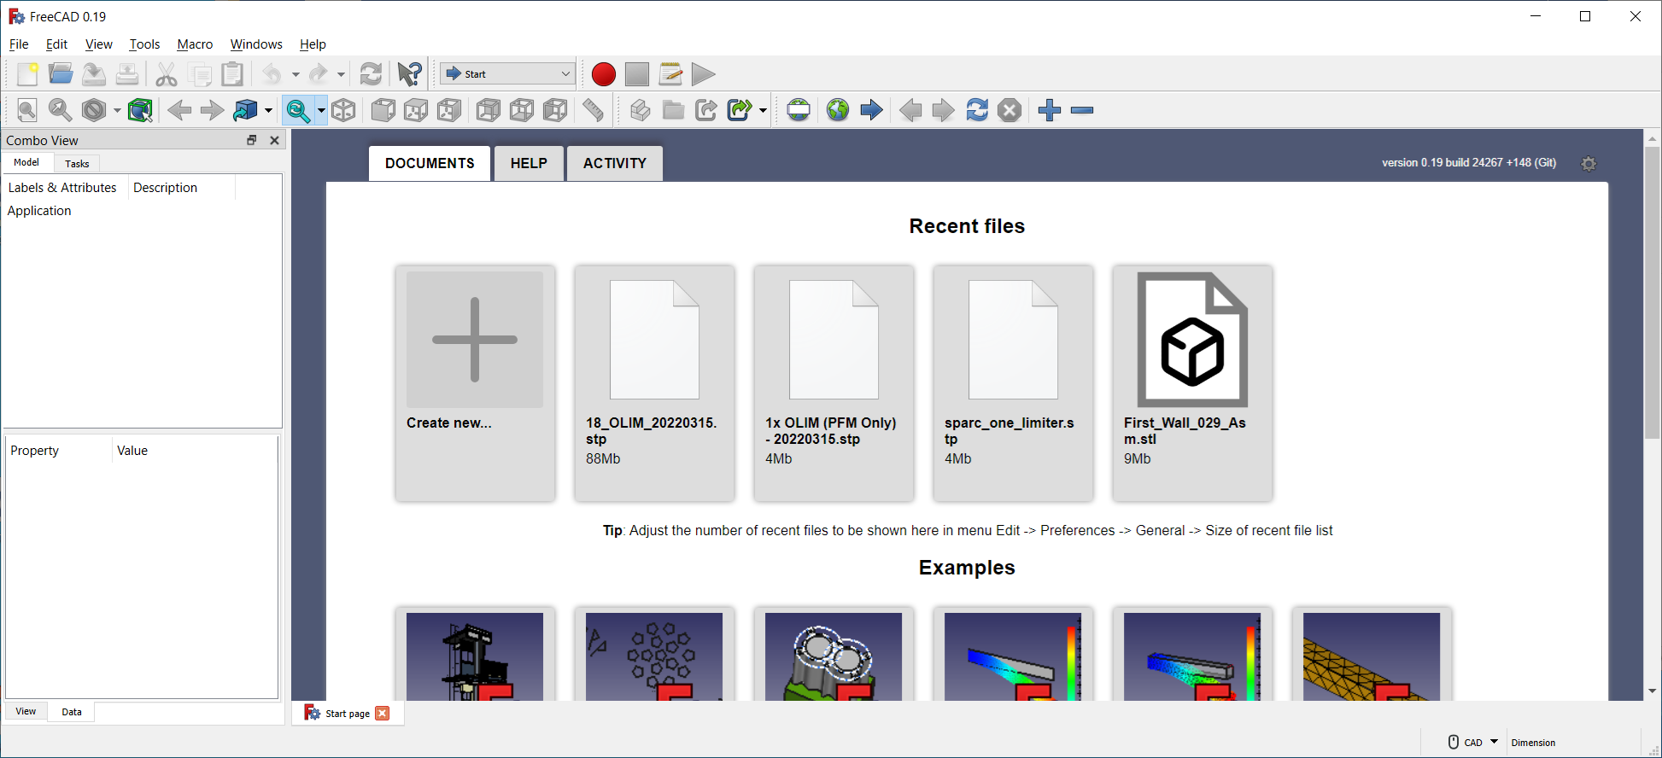

1. Upper left: File 🡪 open

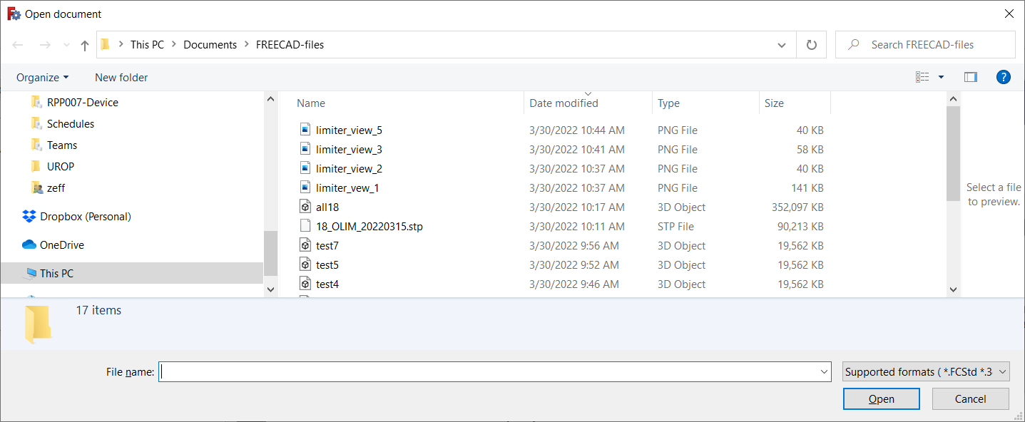

1. Navigate to folder with .stp file. In this case, I clicked on sparc_one_limiter.stp. The following appears:

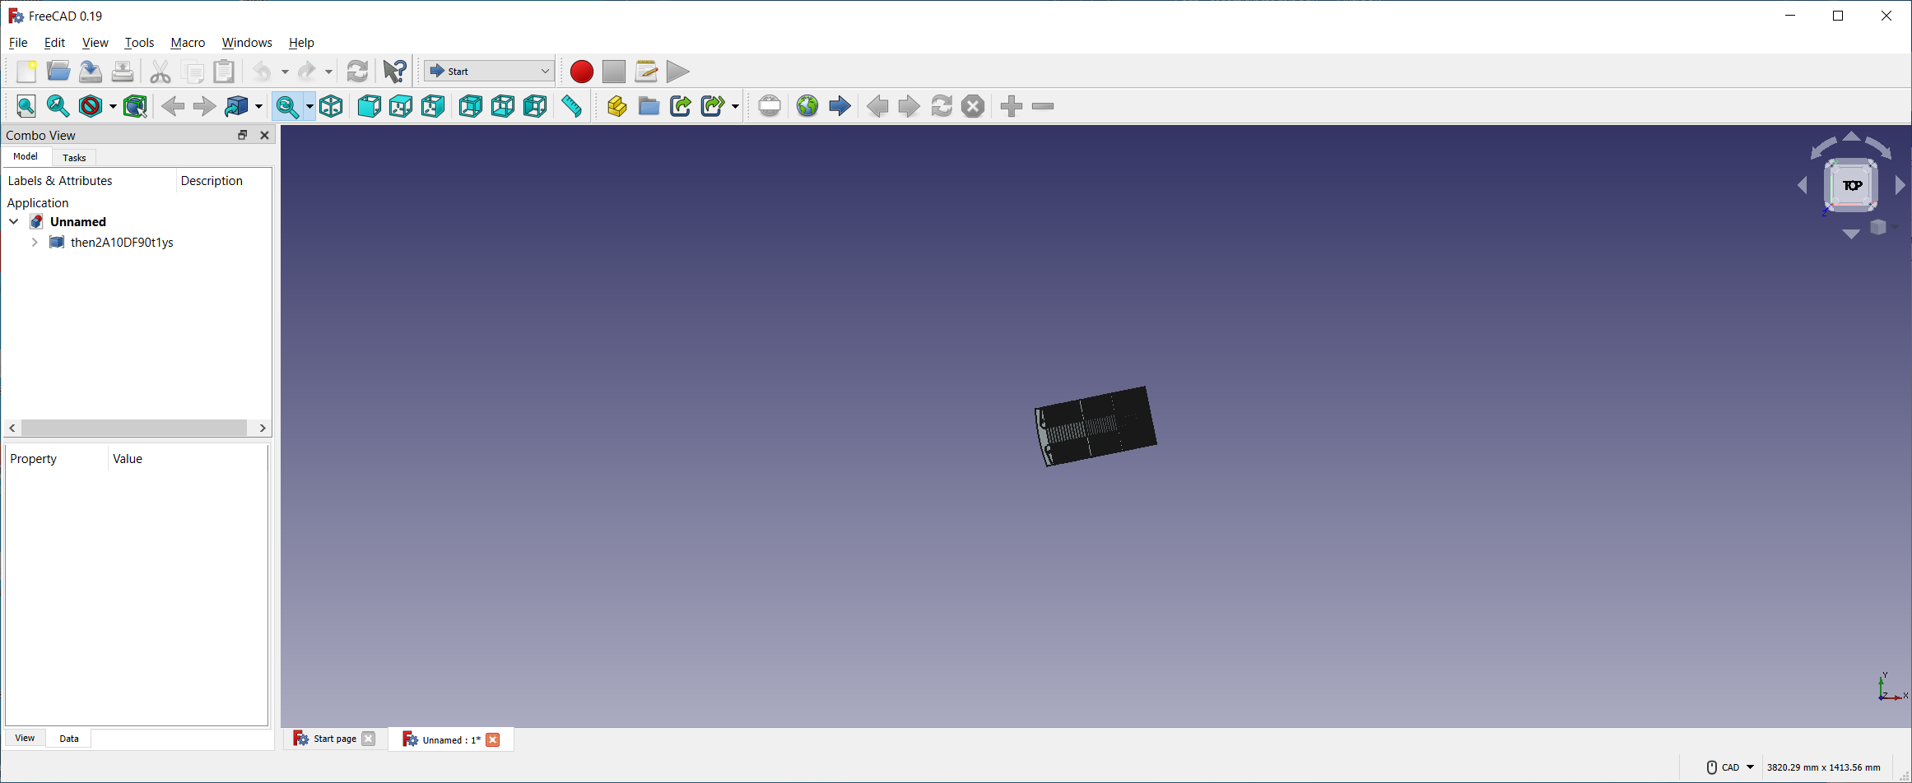

1. Can then expand it etc. Do ctrl-A to select everything in the screen. It will be highlighted in light green

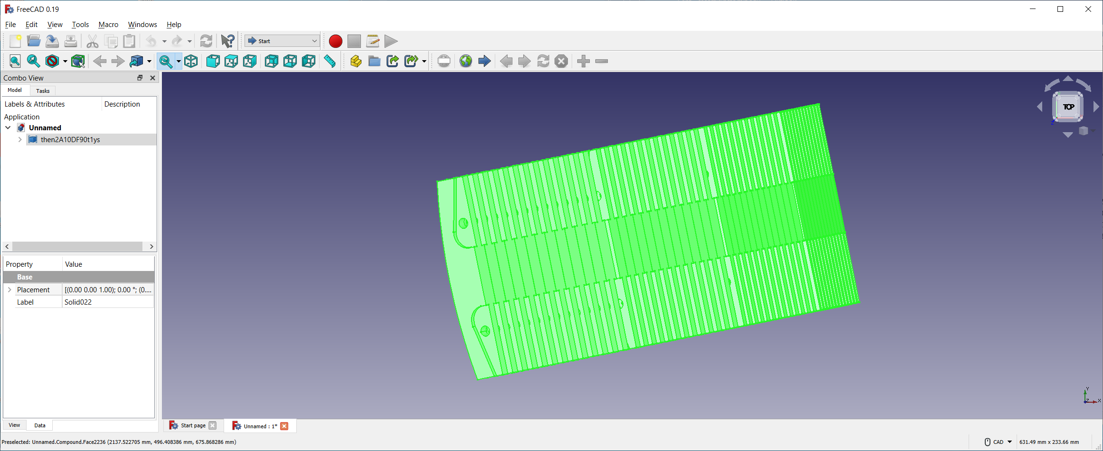

1. Under File 🡪 save AS. Under Export choose STL Mesh and choose a filename. The created file will be of type “3D Object” and will be maybe 4-5 times larger than the parent .stp file
2. Copy the .stl file to NERSC
3. AT NERSC:

python

import read_stl_write_triangles as RS

RS. read_stl_write_triangles()

… give it the name of the stl file and the name of the output .txt file.

* It will generate a flat-ascii file with 9 columns, which represent the [x,y,z] coordinates of the three corners of each triangle.

1. In order to actually use this wall shape, in the ASCOT input code (e.g. group_go_1066.py)

# ----------------------------

# - 3D wall shape -

# ----------------------------

wall_settings={}

aa_wall = sparc_proc.write_3d_wall(fn_hdf5, fn_wall_3d, wall_settings, desc=my_description)

… and then near the bottom:

fn_wall_3d = 'stl_triangles.txt' # provides 3D wall shape

1. To generate the .vtp file which contains the 3D information about the surface power density, see section in this manual “Rendering 3D output”