ETEL TECHNOLOGY AND BUSINESS GROUP
Etel Delivery & Ride Platform
INSA Cyber Security Audit Request — Technical Documentation Package
Prepared for submission to: Information Network Security Administration (INSA), Cyber Security Audit Division
Hawassa, Sidama Region, Ethiopia · ethelmarket.com/delivery/
Document version: Draft 1 — prepared by Dagmawi Dikasso Aydiko (Dagi), Founder & Technical Architect

0. How to Use This Document
This package follows the exact structure INSA's Web Applications Audit Request Requirements Document (OF/AEAD/001) asks for, section by section, so it can be submitted through INSA's Audit Request Portal (cyberaudit.insa.gov.et) with minimal rework.
- Sections in black text are filled in from what is already known about the ETEL Delivery & Ride platform.
- Sections in red italics marked [TO COMPLETE: ...] need a decision, a real value, or a document that only exists outside this narrative (e.g. the Trade License number) — fill these in before submitting.
- This package covers ETEL Delivery & Ride only. The same structure should be reused for EtelTaxi, EtelGebeya, and EtelAI — each is architecturally distinct and INSA will likely expect a separate submission, or at minimum a separate technical annex, per product. Confirm the exact scoping (one submission covering shared EtelID/EtelPay infrastructure plus per-app annexes, vs. fully separate submissions) directly with INSA's Audit Division before submitting all of them.

1. Legal and Administrative Documents (Mandatory)
Per INSA requirement 4.1, attach the following as separate scanned files with this submission:
Document | Status
Updated Trade License (for the legal entity operating Delivery & Ride) | Attached separately (scanned PDF) - Business License, Sidama National Regional State Trade and Market Development Bureau, Hawassa City. Principal Registration No. SMD/STMB/1/0042554/2018, issued 14/12/2018, in the name of Etel Family Technology and Business Group (Owner: Degimaw Dikaso Aydiko), field of business: Land transport and related services (code 71113).
TIN Number or National ID | Attached separately (scanned PDF, same certificate as above) - TIN 0073428763.
System/Product Patent Certificate | Not applicable unless one has been filed — leave blank if none exists

2. Business Architecture and Design

2.1 Data Flow Diagram — Context Level (Level 0)
Shows the platform as a single process and every external entity it exchanges data with.
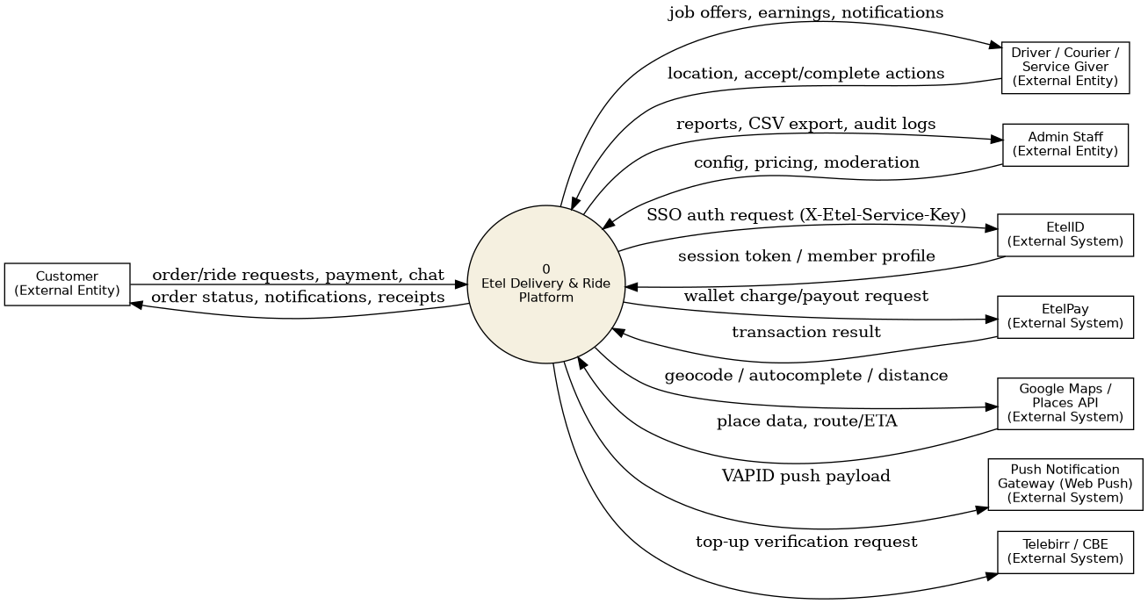
Figure 1 — Context-level Data Flow Diagram (Level 0)

2.2 Data Flow Diagram — Detailed (Level 1)
Breaks the platform down into its core processes for the order/ride lifecycle, and the data stores each process reads from or writes to.
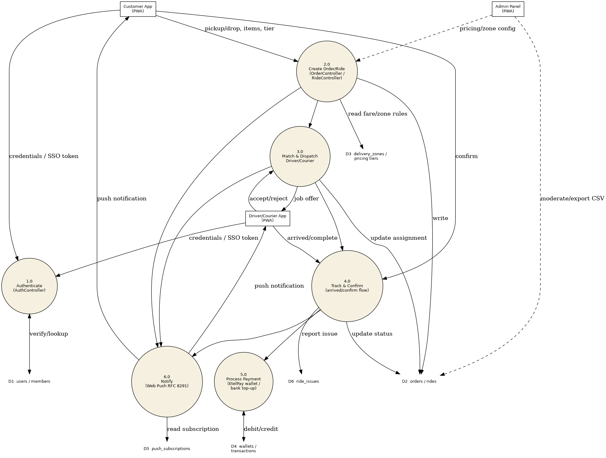
Figure 2 — Level 1 Data Flow Diagram: order/ride lifecycle

2.3 System Architecture Diagram
Deployment is single-tenant PHP 8 / MySQL on shared cPanel hosting (account ethelmfz, ethelmarket.com), fronted by LiteSpeed with ModSecurity WAF. There is no SSH/console access to the server; all deployment is via file upload through a custom Admin Updater tool.
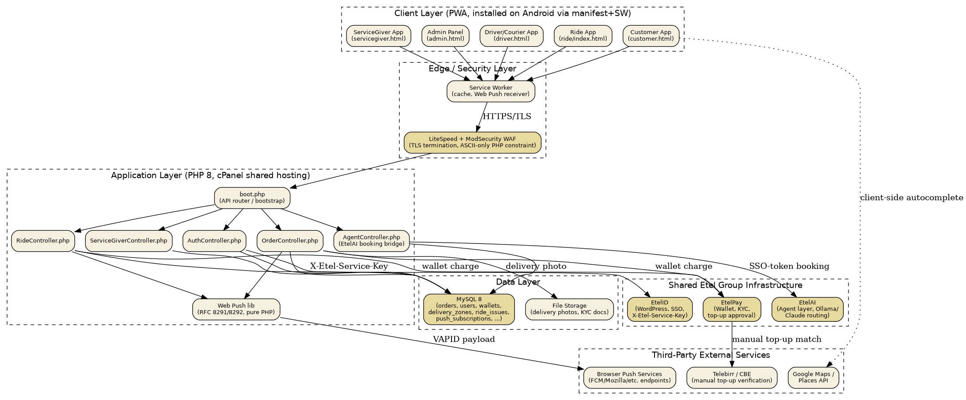
Figure 3 — System architecture and component communication

Security layers already in place
- TLS termination at the LiteSpeed/WAF edge (HTTPS enforced)
- ModSecurity WAF in front of all PHP execution
- Shared X-Etel-Service-Key header authenticates server-to-server calls between Delivery/Ride, EtelID, and EtelPay
- Session tokens (etel_sso) issued by EtelID's EtelID_Auth::create_session(), stored httponly
- Recipient-phone/name masking applied server-side before data reaches the courier's device

Known open items (disclose — INSA audits are more useful when these are flagged upfront, not discovered)
- Backups directory (delivery/api/backups/) - CONFIRMED and FIXED. It was publicly web-accessible with no explicit deny rule (only directory-listing was disabled). A deny-all .htaccess (Require all denied, with an Order allow,deny / Deny from all fallback for older Apache, plus Options -Indexes) was added and merged into the codebase.
- Hardcoded admin password in delivery/updater.php - CONFIRMED remediated (fixed in a prior session, verified directly in the current code this pass): the password now loads from api/.env (UPDATER_PASSWORD) via a fail-closed check - the tool refuses to start (HTTP 503) if the variable is unset, rather than falling back to any default value. No hardcoded password string remains.
Both items reconfirmed as of this remediation pass and closed as described above. Full evidence (files touched, verification method) is in docs/INSA_FINDINGS.md, Section 7, in the platform's source repository.

2.4 Entity Relationship Diagram (ERD)
Core entities, keys, and fields requiring encryption/access control (shaded).
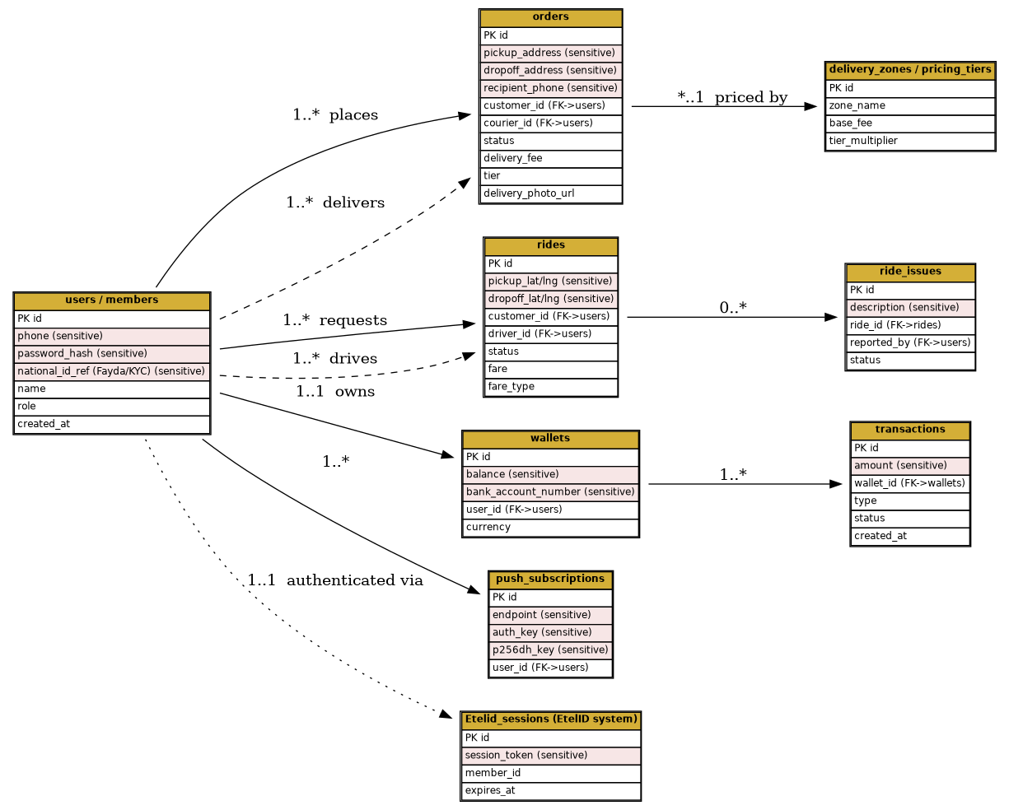
Figure 4 — Entity Relationship Diagram with sensitive fields marked
Note: table/column names above are illustrative based on the current schema description and should be verified against the live database structure (e.g. via a schema export) before submission, since exact naming may differ slightly from what is shown.

3. Features of the Web Application
Attribute | Detail
Development stack | PHP 8 (vanilla, no framework) + MySQL, vanilla JavaScript front end, PWA (manifest + service worker)
Libraries / plugins | Google Maps / Places API (client-side autocomplete), pure-PHP Web Push implementation (RFC 8291/8292, no third-party push SDK)
Custom modules / APIs | OrderController, RideController, AuthController, ServiceGiverController, AgentController (EtelAI booking bridge), shared ride_fare.php library
Third-party integrations | EtelID (SSO), EtelPay (wallet/payments), Google Maps/Places, Telebirr/CBE (manual bank top-up verification), browser push services
Actor / user types | Customer, Driver, Courier, Service Giver, Admin, Dispatcher-level admin roles
System dependencies | PHP 8 on LiteSpeed/cPanel shared hosting; no SSH access; ASCII-only PHP source (WAF strips non-ASCII bytes)
Existing security infrastructure | LiteSpeed + ModSecurity WAF, HTTPS/TLS, shared service-key auth, httponly session cookies

4. Testing Scope (Mandatory)
Assets and endpoints in scope for this audit. Test accounts must be created specifically for INSA's use — never share real customer/driver credentials.
Asset | URL / Path | Test Account
Customer App | ethelmarket.com/delivery/customer.html | Phone 0945485932 / Password Meri1616.
Ride App | ethelmarket.com/delivery/ride/index.html | Phone 0945485932 / Password Meri1616. (same account as Customer App - both apps share one customer identity)
Driver App | ethelmarket.com/delivery/driver.html | Phone 0938847379 / Password Bini7379
Courier App | ethelmarket.com/delivery/courier/index.html | Phone 0936533606 / Password Emu1616.
ServiceGiver App | ethelmarket.com/delivery/servicegiver.html | Phone 0912461100 / Password Tamu1616.
Admin Panel | ethelmarket.com/delivery/admin.html | Phone 0924445206 / Password EtelAnan1616.
API base | ethelmarket.com/delivery/api/boot.php | Same as above, tested per role
Provide these as real, working credentials at submission time — INSA's stated review clock (5 working days) starts from a complete submission, so incomplete test accounts are a likely cause of delay.

5. Security Functionality Document

5.1 User roles and access control
- Role-based access: Customer, Driver, Courier, Service Giver, Admin — enforced at the controller level per action
- Admin panel is a separate PWA scope (admin.html) from customer-facing apps
Authorization is enforced server-side on every controller action - never relied on client-side (JS) role hiding. Every action in every controller calls a shared gate function before doing anything sensitive: require_auth() (any logged-in role), require_admin($pdo, 'capability') (role must be admin AND hold that specific capability), require_courier() (courier or admin), or an explicit role/ownership check. A full line-by-line review of every action in OrderController.php, RideController.php, AuthController.php, ServiceGiverController.php, and AgentController.php was completed as part of this remediation pass (see docs/INSA_FINDINGS.md Section 1).
Two IDOR (Insecure Direct Object Reference) issues were found and fixed: check_pickup_confirmation and check_delivery_confirmation in OrderController.php checked that the caller was a courier, but not that the specific order belonged to that courier - any courier could query another courier's order status by passing an arbitrary order_id. Fixed by adding the same ownership check already used by the sibling actions in that file.
One item is disclosed here rather than fixed, as a deliberate design decision requiring a product-level call: RideController.php has no onboarding-verification gate on driver-privileged actions (accepting a ride, collecting payment) - any authenticated role, including a plain customer account, can call them before identity verification (selfie/license/EtelID cross-check) completes. This is documented in the code as an intentional progressive-onboarding tradeoff, but is flagged here for INSA's awareness and for a decision on where exactly to add a gate.

5.2 Input validation and sanitization
All 15 controllers use PDO prepared statements with bound parameters throughout - a full sweep of every SQL query in every controller (roughly 700 queries total) found zero instances of a raw request value concatenated into a SQL string. Numeric IDs are consistently passed through intval() before use; a shared validate.php centralizes phone-number and monetary-amount validation (bounded, finite, range-checked). The delivery-photo upload path (api/upload.php) validates file type by inspecting the real file bytes (mime_content_type(), not the client-supplied Content-Type header) against a hard image-type whitelist, enforces a 5MB size cap, and generates the destination filename entirely server-side - the client's original filename never reaches the filesystem path, eliminating path-traversal risk. See docs/INSA_FINDINGS.md Section 6 for the full per-controller review.

5.3 Session management
The Delivery & Ride API's own primary authentication is a custom bearer token, not a cookie: a client logs in via the login action, receives an HMAC-SHA256-signed token (embedding user id, issue time, and a revocable token_version), and sends it as an Authorization: Bearer <token> header on every subsequent request. This is separate from the EtelID SSO cookie described below.
A separate bridge file (api/etelid_auth.php) supports EtelID's browser-based SSO login path and does use a PHP session cookie for that path only - it is already correctly hardened: HttpOnly, Secure (checked against the real request scheme, including behind a forwarding proxy), SameSite=Lax, and an 8-hour inactivity timeout.
Bearer token expiry/renewal (confirmed directly from the code): a hard 7-day expiry is enforced server-side on every request, independent of client behavior; there is no silent/automatic token refresh anywhere in the codebase - an expired token always returns a clean 401 requiring the user to log in again. Logout, password change, and password reset all immediately revoke every outstanding token for that user across every device (a server-side token_version bump), not just a client-side "forget it" - a stolen token cannot outlive an explicit logout. Full detail in docs/INSA_FINDINGS.md Section 4.

5.4 Error handling and logging
- Prior audit remediation: silent-swallow catch blocks (errors caught and discarded without logging) were identified and fixed in the Delivery/Ride codebase
Confirmed via a full sweep of all 62 PHP files in the Delivery/Ride codebase (not just the files touched by the prior audit pass) for silently-discarded exceptions. Roughly 60 empty/comment-only catch blocks were found and each triaged individually; the large majority are an established, intentional soft-fail pattern already documented inline (e.g. "table may not exist yet" schema-migration fallbacks) and were correctly left alone. Nine genuine gaps - guarding real DB writes, an audit-log trail, brute-force rate-limiting, and order/ride auto-dispatch logic - were found with no existing fallback comment and were fixed by adding error_log() calls, matching the logging pattern already established elsewhere in the same files. See docs/INSA_FINDINGS.md Section 5 for the per-file list.

5.5 Secure communications
- HTTPS/TLS enforced at the WAF/LiteSpeed edge for all client-server traffic
- Server-to-server calls (Delivery <-> EtelID <-> EtelPay) authenticated via shared X-Etel-Service-Key header over HTTPS

6. Secure Coding Standard Documentation (if available)
Provide if a formal internal checklist exists; if not, this section can state the de facto practices already followed:
- Working method: every fix is syntax-validated before deployment; every deploy is verified server-side rather than assumed successful
- All PHP source is constrained to pure ASCII (a hosting-WAF requirement, incidentally also simplifies static analysis)
SQL injection: confirmed parameterized/prepared-statement usage throughout. A full audit of every SQL query (prepare/query/exec calls) in the six controllers with the most search/filter/report/CSV-export surface (OrderController, RideController, AuthController, ServiceGiverController, AgentController, AdminController - roughly 550 queries) found zero real SQL injection findings. Every dynamic WHERE/filter/ORDER-BY value is bound via a ? placeholder; the only places a variable is concatenated directly into a query string are column/table names, and each of those traces back to a hardcoded internal array, never request input.
XSS (output escaping): a real gap was found and fixed. Front-end templates (admin.js, customer.js, courier.js, servicegiver.js, driver.js, ride.js) rendered several user-controlled fields - recipient names/phones, delivery addresses/notes, Service Giver item names and descriptions (including the Amharic name_am/description_am fields), and account display names shown to admin staff - directly into innerHTML without escaping, a stored-XSS risk. Six such sinks were fixed by wrapping the interpolated value in the codebase's existing escapeHtml()/esc() helper before insertion (the highest-severity case reached the admin panel itself, i.e. an attacker-controlled account name could have executed script in an administrator's session). The fix was propagated into the live-served, versioned JS bundles, not just the unbundled source files. Full detail in docs/INSA_FINDINGS.md Section 3 (XSS) and Section 2 (SQL injection).

7. Previous Security Testing Reports (if available)
Disclose prior internal audit history — INSA's requirement (4.2.6) explicitly asks for this, and providing it demonstrates an active security practice rather than a one-off scramble before a government audit:
- Internal audit tooling: etel_project_audit.py (9 analysis modules, 0-100 scoring) and etel_system_review.py (11 check categories), run routinely against the codebase
- Remediation history includes: hardcoded credentials moved to environment variables, silent-swallow catch blocks fixed, backup rotation added
[TO COMPLETE: attach the actual most recent internal audit report/output if you want to include it (optional but strengthens the submission)]

8. API Security Audit Requirements
Delivery & Ride exposes internal APIs consumed by its own front-end apps, and server-to-server APIs consumed by EtelID, EtelPay, and EtelAI. Complete this section if INSA's scope includes API-level testing (it does, per their published requirements section 5).

8.1 API type and format
REST-style, JSON request/response, routed through a single boot.php entry point per platform (Delivery/Ride, EtelID, EtelPay each have their own).

8.2 Authentication mechanism
- Customer/driver-facing: session token (etel_sso) issued at login, validated per request
- Server-to-server (Delivery <-> EtelID/EtelPay): shared X-Etel-Service-Key header
- EtelAI booking bridge: service-key + etel_sso token double authentication, scoped to ride-by-distance/open-meter booking only

8.3 Endpoint inventory
Endpoint / Action | Controller | Public / Internal
Order creation, status, tracking | OrderController.php | Public (authenticated)
Ride request, matching, fare | RideController.php / ride_fare.php | Public (authenticated)
Login / SSO bridge | AuthController.php | Public
Service Giver order/item management | ServiceGiverController.php | Public (authenticated, Service Giver role)
Agent-initiated ride booking | AgentController.php | Internal (service-key + SSO-token only)
Admin ride issue resolution, CSV export, pricing config | admin-* endpoints in OrderController/RideController | Internal (Admin role only)
Full inventory (~325 distinct actions, all controllers) and sample request/response JSON for the four critical flows are provided in full in Section 8.6 and 8.7 below, generated directly from the live boot.php route table and each controller's own code - not a summary.

8.6 Full API Endpoint Inventory
Complete inventory of every action registered in boot.php's router and its 16 controller files (~325 distinct actions total), generated directly from the code (not a sample) - see docs/INSA_FINDINGS.md Section 8 in the platform repository for the source review this was built from. All actions are called via POST with a JSON body ({"action": "...", ...fields}); the router also accepts the action name via a GET query string, though the real front-end apps always POST. The one deliberate GET-only exception is noted per-row: actions named sse_* (Server-Sent-Events streams) and *_beacon_ping (navigator.sendBeacon) accept the bearer token via a ?token= query parameter instead of the Authorization header, since EventSource and sendBeacon cannot set custom headers.

8.6.1 boot.php — inline actions
Action | Method | Access Level
admin_purge_cache | POST | Admin (any)
get_my_notifications | POST | Authenticated — any role
ping, db_ping | POST | Public
version_check | POST | Public
logout | POST | Public (optional auth — no-ops cleanly with no/invalid token)
get_config | POST | Public (returns Google Maps API key)
get_patch_info | POST | Authenticated — any role
get_profile, my_profile | POST | Authenticated — any role
get_zones | POST | Public
get_delivery_tiers | POST | Public
get_bank_accounts | POST | Public
admin_get_service_givers, admin_get_service_givers_list | POST | Admin (any)
admin_get_users | POST | Admin (any)
admin_get_couriers | POST | Admin (any)
admin_update_courier | POST | Admin (any)
admin_get_live_couriers | POST | Admin (any)
admin_get_orders, get_orders | POST | Admin (any)
admin_dashboard_stats | POST | Admin (any)
admin_verify_service_giver | POST | Admin (any)
admin_suspend_service_giver | POST | Admin (any)
admin_create_service_giver | POST | Admin (any)
get_items, customer_get_items | POST | Public (item/menu catalog)
etelid_members_list | POST/GET | Internal — ETELID_SERVICE_KEY header
etelid_member_detail | POST/GET | Internal — ETELID_SERVICE_KEY (header or ?key=)
sse_admin_delivery_system_test | GET (SSE, ?token=) | Admin, orders.manage
sse_admin_system_test | GET (SSE, ?token=) | Admin, rides.manage
sse_ride_status | GET (SSE, ?token=) | Authenticated (scoped: ride's own passenger)
sse_driver_stream | GET (SSE, ?token=) | Authenticated — any role
reset_request, send_reset_otp | POST | Public (password-reset step 1)
reset_verify, verify_reset_otp | POST | Public (password-reset step 2)
reset_password | POST | Public (password-reset step 3)

8.6.2 controllers/AuthController.php
Action | Method | Access Level
register | POST | Public
login | POST | Public
sg_login | POST | Public
etelid_login | POST | Public (EtelID SSO exchange)
admin_etelid_login | POST | Public (EtelID SSO exchange, staff path)
change_password | POST | Authenticated — any role

8.6.3 controllers/AdminController.php (require_admin + named capability on every action except get_feature_flags)
Action | Access Level (capability)
get_feature_flags | Public
admin_list_etelpay_overrides | Admin, owner.only
admin_set_etelpay_override | Admin, owner.only
admin_remove_etelpay_override | Admin, owner.only
admin_list_support_threads | Admin, orders.view
admin_get_support_thread | Admin, orders.view
admin_reply_support_message | Admin, orders.view
admin_toggle_feature | Admin, owner.only
admin_list_release_channels | Admin, owner.only
admin_set_release_channel | Admin, owner.only
admin_promote_canary_to_stable | Admin, owner.only
admin_rollback_stable | Admin, owner.only
admin_add_canary_tester | Admin, owner.only
admin_remove_canary_tester | Admin, owner.only
admin_search_canary_candidates | Admin, owner.only
admin_run_code_audit | Admin, owner.only
admin_get_audit_settings | Admin, owner.only
admin_save_audit_settings | Admin, owner.only
admin_create_user | Admin, users.manage
admin_assign_service_giver | Admin, service_givers.manage
admin_add_item | Admin, items.manage
admin_get_all_items | Admin, items.view
admin_update_item | Admin, items.manage
admin_delete_item | Admin, items.manage
admin_toggle_item | Admin, items.manage
get_service_givers | Admin, service_givers.view
admin_get_service_giver | Admin, service_givers.view
admin_update_order | Admin, orders.manage
admin_get_order_receipt | Admin, orders.view
admin_get_service_giver_statistics | Admin, service_givers.view
admin_get_confirmations | Admin, orders.view
admin_backfill_order_service_giver_ids | Admin, orders.manage
admin_force_confirm | Admin, orders.manage
admin_analytics | Admin, analytics.view
admin_backfill_cash_commission | Admin, finance.manage
admin_topup_etel_money | Admin, finance.manage
admin_get_pending_etel_topups | Admin, finance.view
admin_approve_etel_topup | Admin, finance.manage
admin_reject_etel_topup | Admin, finance.manage
admin_ride_growth | Admin, analytics.view
admin_get_ride_fare_rules | Admin, pricing.manage
admin_update_ride_fare_rule | Admin, pricing.manage
admin_add_vehicle_type | Admin, pricing.manage
admin_delete_vehicle_type | Admin, pricing.manage
admin_update_ride_surge_multiplier | Admin, pricing.manage
admin_get_goal_tiers | Admin, pricing.manage
admin_save_goal_tier | Admin, pricing.manage
admin_delete_goal_tier | Admin, pricing.manage
admin_run_system_test | Admin, rides.manage
admin_get_ride_peak_windows | Admin, pricing.manage
admin_update_ride_peak_windows | Admin, pricing.manage
admin_get_zones | Admin, settings.view
admin_update_zone | Admin, settings.manage
admin_add_zone | Admin, settings.manage
admin_get_delivery_tiers | Admin, settings.view
admin_update_delivery_tier | Admin, settings.manage
admin_get_bank_accounts | Admin, finance.view
admin_update_bank_account | Admin, finance.manage
admin_create_announcement | Admin, settings.manage
admin_get_announcements | Admin, settings.view
admin_delete_announcement | Admin, settings.manage
admin_get_launch_checklist_state | Admin, settings.view
admin_toggle_launch_checklist_item | Admin, settings.manage
admin_get_ride_issues | Admin, rides.view
admin_resolve_ride_issue | Admin, rides.manage
admin_get_order_issues | Admin, orders.view
admin_resolve_order_issue | Admin, orders.manage
admin_get_sos_alerts | Admin, sos.view
admin_resolve_sos | Admin, sos.manage
admin_delete_zone | Admin, settings.manage
admin_list_role_permissions | Admin, owner.only
admin_update_role_permissions | Admin, owner.only
admin_delete_role_permissions | Admin, owner.only
admin_get_my_capabilities | Admin (any)

8.6.4 controllers/EquityController.php (founder financial/ownership data)
Action | Access Level
equity_get_settings | Admin, equity.view
equity_update_settings | Admin, equity.manage
equity_list_investors | Admin, equity.view
equity_link_investor_user | Admin, equity.manage
equity_unlink_investor_user | Admin, equity.manage
investor_portal_am_i_investor | Authenticated — any role
investor_portal_get_my_view | Authenticated (scoped: linked to an investor row)
investor_portal_get_my_growth_planner_data | Authenticated (same scoping)
equity_add_investor | Admin, equity.manage
equity_update_investor | Admin, equity.manage
equity_regenerate_investor_token | Admin, equity.manage
equity_delete_investor | Admin, equity.manage
equity_get_dashboard | Admin, equity.view
equity_preview_distribution | Admin, equity.view
equity_distribute_profit | Admin, equity.manage
equity_list_distributions | Admin, equity.view
equity_get_distribution | Admin, equity.view
equity_export_investors_csv | Admin, equity.view

8.6.5 controllers/InvestorPortalController.php (legacy token-link portal, NOT admin-gated)
Action | Access Level
investor_portal_get_view | Public — gated by possession of a personal investor token in the request, not a login
investor_portal_get_growth_planner_data | Public — same personal-token gating

8.6.6 controllers/SystemResetController.php (full production data-wipe — DANGER ZONE)
Action | Access Level
system_reset_preview | Admin, system.reset (not included by a generic Owner grant — must be added explicitly)
system_reset_backup | Admin, system.reset
system_reset_execute | Admin, system.reset

8.6.7 controllers/EqubController.php
Action | Access Level
equb_am_i_permitted | Authenticated — any role
equb_create_group | Admin, equb.manage
equb_join_group | Authenticated — any role
equb_leave_group | Authenticated — any role
equb_start_group | Admin, equb.manage
equb_get_my_groups | Authenticated — any role
equb_get_group_detail | Authenticated — any role
equb_admin_create_package | Admin, equb.manage
equb_admin_update_package | Admin, equb.manage
equb_admin_list_packages | Admin, equb.view
equb_list_packages | Authenticated — any role
equb_select_package | Authenticated — any role
equb_admin_add_member | Admin, equb.manage
equb_list_open_groups | Authenticated — any role
equb_admin_grant_access | Admin, equb.manage
equb_admin_revoke_access | Admin, equb.manage
equb_admin_list_participants | Admin, equb.view
equb_admin_force_process_round | Admin, equb.manage
equb_admin_list_groups | Admin, equb.view

8.6.8 controllers/PlanningController.php
Action | Access Level
planning_list_hires | Admin, planning.view
planning_add_hire | Admin, planning.manage
planning_update_hire | Admin, planning.manage
planning_delete_hire | Admin, planning.manage
planning_get_notes | Admin, planning.view
planning_save_notes | Admin, planning.manage
planning_reset_and_seed_demo | Admin, planning.manage

8.6.9 controllers/PlatformEconomicsController.php
Action | Access Level
platform_economics_get_costs | Admin, platform_economics.view
platform_economics_update_costs | Admin, platform_economics.manage
platform_economics_get_growth_assumptions | Admin, platform_economics.view
platform_economics_save_growth_assumptions | Admin, platform_economics.manage
platform_economics_reset_growth_assumptions | Admin, platform_economics.manage
platform_economics_get_summary | Admin, platform_economics.view

8.6.10 controllers/DriverFuelController.php (module-level require_auth; data scoped to caller's own rows)
Action | Access Level
driver_add_fuel_log | Authenticated — any role
driver_list_fuel_logs | Authenticated — any role
driver_delete_fuel_log | Authenticated — any role
driver_get_fuel_summary | Authenticated — any role

8.6.11 controllers/CourierFuelController.php (same pattern as 8.10)
Action | Access Level
courier_add_fuel_log | Authenticated — any role
courier_list_fuel_logs | Authenticated — any role
courier_delete_fuel_log | Authenticated — any role
courier_get_fuel_summary | Authenticated — any role

8.6.12 controllers/PushController.php (module-level require_auth)
Action | Access Level
save_push_subscription | Authenticated — any role
remove_push_subscription | Authenticated — any role
test_send_push | Authenticated — any role

8.6.13 controllers/AgentController.php (EtelAI booking connector — every action calls agent_verify_service_key() first)
Action | Access Level
agent_find_and_quote | Internal — ETELID_SERVICE_KEY header
agent_search_items | Internal — ETELID_SERVICE_KEY header
agent_order_quote | Internal — ETELID_SERVICE_KEY header
agent_place_order | Internal — ETELID_SERVICE_KEY header
agent_ride_quote | Internal — ETELID_SERVICE_KEY header
agent_book_ride | Internal — ETELID_SERVICE_KEY header
agent_ride_status | Internal — ETELID_SERVICE_KEY header
agent_cancel_ride | Internal — ETELID_SERVICE_KEY header
agent_order_status | Internal — ETELID_SERVICE_KEY header

8.6.14 controllers/OrderController.php
Action | Access Level
customer_create_order | Authenticated (business rule further restricts to customer/admin inside delivery_execute_order_creation())
customer_get_orders | Authenticated (scoped to caller's own orders)
submit_order_issue | Authenticated — any role
customer_get_order_issues | Authenticated — any role
courier_get_available_orders | Courier or admin
courier_accept_order | Courier or admin
courier_update_order_status | Courier or admin
courier_get_profile | Courier or admin
courier_go_online | Courier or admin
courier_update_location | Courier or admin
courier_go_offline | Courier or admin
courier_get_kpi_summary | Courier or admin
courier_get_my_orders | Courier or admin
rate_order | Authenticated — any role
get_order_ratings | Admin, orders.view
track_order | Authenticated — any role
schedule_order | Authenticated — any role
get_scheduled_orders | Authenticated — any role
request_pickup_confirmation | Courier or admin
check_pickup_confirmation | Courier or admin (ownership-checked — see Section 1 fix)
sg_pending_confirmations | Role service_giver or admin
sg_confirm_pickup | Role service_giver or admin
request_delivery_confirmation | Courier or admin
check_delivery_confirmation | Courier or admin (ownership-checked — see Section 1 fix)
customer_pending_confirmations | Authenticated — any role
customer_confirm_delivery | Authenticated — any role
customer_wallet_history | Authenticated — any role
customer_get_favorites | Authenticated — any role
customer_toggle_favorite | Authenticated — any role
customer_get_addresses | Authenticated — any role
customer_add_address | Authenticated — any role
customer_update_address | Authenticated — any role
customer_delete_address | Authenticated — any role
customer_get_messages | Authenticated — any role
customer_send_message | Authenticated — any role
customer_get_referral_info | Authenticated — any role
customer_get_settings | Authenticated — any role
customer_update_settings | Authenticated — any role
initiate_telebirr_payment | Authenticated — any role
check_telebirr_payment | Authenticated — any role
admin_list_telebirr_payments | Role admin
admin_confirm_telebirr_payment | Role admin
confirm_bank_payment | Authenticated (customer submits own claimed transfer)
admin_list_bank_payments | Role admin
admin_confirm_bank_payment | Role admin
admin_financial_report | Role admin AND capability finance.view
get_payment_method_logos | Authenticated — any role
admin_set_payment_logo | Role admin

8.6.15 controllers/ServiceGiverController.php
Action | Access Level
sg_profile | Role service_giver or admin
sg_update_profile | Role service_giver or admin
sg_orders | Role service_giver or admin
sg_accept_order | Role service_giver or admin
sg_get_kitchen_ticket | Role service_giver or admin
sg_update_order_status | Role service_giver or admin
sg_order_detail | Role service_giver or admin
sg_scan_qr | Role service_giver or admin
sg_complete_order | Role service_giver or admin
sg_stats | Role service_giver or admin
sg_set_online | Role service_giver or admin
sg_notifications | Role service_giver or admin
sg_add_item | Role service_giver or admin
sg_get_my_items | Role service_giver or admin
sg_update_item | Role service_giver or admin
sg_delete_item | Role service_giver or admin
sg_get_staff | Role service_giver or admin (owner-tier for staff-management sub-actions)
sg_add_staff | Role service_giver or admin, owner-tier within the business
sg_remove_staff | Role service_giver or admin, owner-tier
sg_update_staff_role | Role service_giver or admin, owner-tier
sg_list_roles | Role service_giver or admin
sg_save_role | Role service_giver or admin, owner-tier
sg_delete_role | Role service_giver or admin, owner-tier
sg_my_role | Role service_giver or admin
sg_financial_report | Role service_giver or admin
sg_get_pending_payout_request | Role service_giver or admin
admin_list_payout_requests | Role admin
admin_review_payout_request | Role admin

8.6.16 controllers/RideController.php (module-level require_auth — every action needs a valid token at minimum; see Section 1 for the driver-privilege gap)
Action | Access Level
ride_get_vehicle_types | Authenticated — any role
ride_estimate_fare | Authenticated — any role
passenger_get_nearby_drivers | Authenticated — any role
book_ride | Authenticated — any role
get_etelpay_merchant | Authenticated — any role
get_ride_path | Authenticated — any role
ride_status | Authenticated — any role
my_active_ride | Authenticated — any role
cancel_ride | Authenticated — any role
rate_ride | Authenticated — any role
rate_rider | Authenticated — any role
ride_get_share_link | Authenticated — any role
ride_stop_sharing | Authenticated — any role
ride_schedule | Authenticated — any role
ride_get_scheduled | Authenticated — any role
ride_cancel_scheduled | Authenticated — any role
ride_history | Authenticated — any role
driver_go_online | Authenticated — any role *(see Section 1 judgment call)*
driver_go_offline | Authenticated — any role
driver_update_location | Authenticated — any role
driver_beacon_ping | GET (?token=) — Authenticated
admin_get_rides | Role admin + rides.view
admin_get_ride_stats | Role admin + rides.view
admin_cancel_ride | Role admin + rides.manage
admin_get_drivers | Role admin + users.view
admin_get_live_drivers | Role admin + users.view
admin_get_suspended_drivers | Role admin + users.view
admin_suspend_driver | Role admin + users.manage
admin_unsuspend_driver | Role admin + users.manage
admin_get_flagged_identities | Role admin + users.manage
admin_approve_driver_identity | Role admin + users.manage
admin_reject_driver_identity | Role admin + users.manage
driver_get_nearby_requests | Authenticated — any role *(see Section 1)*
driver_get_goal_tiers | Authenticated — any role
driver_get_profile | Authenticated — any role
driver_get_earnings_for_date | Authenticated — any role
driver_get_kpi_summary | Authenticated — any role
driver_get_announcements | Authenticated — any role
driver_mark_announcement_read | Authenticated — any role
driver_get_referral_info | Authenticated — any role
submit_ride_issue | Authenticated — any role
sos_trigger | Authenticated — any role
driver_cashout | Authenticated — any role *(see Section 1)*
driver_topup_etel_money | Authenticated — any role *(see Section 1)*
driver_submit_manual_topup | Authenticated — any role
driver_get_topup_history | Authenticated — any role
driver_update_profile | Authenticated — any role
driver_get_pending_vehicle_change | Authenticated — any role
admin_get_pending_vehicle_changes | Role admin + rides.view
admin_approve_vehicle_change | Role admin + rides.manage
admin_reject_vehicle_change | Role admin + rides.manage
driver_accept_ride | Authenticated — any role *(see Section 1)*
driver_hail_customer | Authenticated — any role *(see Section 1)*
driver_start_ride | Authenticated — any role *(see Section 1)*
driver_toggle_wait | Authenticated — any role
driver_arrived | Authenticated — any role *(see Section 1)*
customer_confirm_arrival | Authenticated — any role
driver_complete_ride | Authenticated — any role *(see Section 1)*
driver_cancel_ride | Authenticated — any role
passenger_get_ride_history | Authenticated — any role
send_ride_message | Authenticated (scoped: ride participant or admin)
ping_ride_typing | Authenticated (same scoping)
get_ride_messages | Authenticated (same scoping)
ride_get_favorite_routes | Authenticated — any role
ride_add_favorite_route | Authenticated — any role
ride_delete_favorite_route | Authenticated — any role
ride_get_messages | Authenticated — any role

8.7 Sample Request/Response Pairs
Sanitized sample request/response JSON for the four critical flows, built directly from the live controller code's actual field names and the shared ok()/fail() response envelope in boot.php (not invented). No real customer data - all values below are fictitious placeholders.

8.7.1 Order creation — customer_create_order
OrderController.php → delivery_execute_order_creation() in lib/delivery_order_core.php
Request:
{
"action": "customer_create_order",
"items": [
{ "item_id": 42, "quantity": 2 },
{ "item_id": 57, "quantity": 1 }
],
"to_zone": "Tabor",
"recipient_name": "Test User",
"recipient_phone": "0911000000",
"notes": "Leave at the gate, call on arrival",
"payment_method": "cash",
"delivery_tier": "moto",
"delivery_lat": 7.0650,
"delivery_lng": 38.4850
}

Success response:
{
"success": true,
"data": {
"order_id": 10321,
"order_code": "ORD-10321",
"status": "pending",
"service_giver_id": 14,
"subtotal": 255.00,
"delivery_tier": "moto",
"delivery_photo_url": null,
"delivery_fee": 40.00,
"service_charge": 5.00,
"total": 300.00,
"payment_method": "cash",
"items_count": 2,
"message": "Order created and assigned to service giver"
},
"v": "3.7.4"
}
order_code, delivery_fee, service_charge depend on live zone/tier pricing —
field names are exact, values are illustrative.

8.7.2 Ride request — book_ride
RideController.php, requires Authorization: Bearer <token>, any authenticated role
Request:
{
"action": "book_ride",
"pickup_lat": 7.0500,
"pickup_lng": 38.4700,
"dropoff_lat": 7.0650,
"dropoff_lng": 38.4850,
"pickup_addr": "Mehal Ketema, near the main square",
"dropoff_addr": "Tabor, Etel Group office",
"payment_method": "cash",
"vehicle_type": "bajaj",
"route_km": 3.2
}

Success response:
{
"success": true,
"data": {
"request_id": 88213,
"fare": 150.00,
"distance_km": 3.20,
"surge": false
},
"v": "3.7.4"
}
request_id is the new rides.id. An optional quote_token from a prior
ride_estimate_fare call can be sent instead of raw lat/lng+route_km to price-lock the
fare exactly as quoted.

8.7.3 Login — login
AuthController.php, no auth required
Request:
{
"action": "login",
"phone": "0911000000",
"password": "TestPassword123"
}

Success response:
{
"success": true,
"data": {
"token": "a1b2c3d4e5f6...<opaque bearer token>",
"user": {
"id": 501,
"name": "Test User",
"phone": "0911000000",
"role": "customer",
"staff_role": null
}
},
"v": "3.7.4"
}
token is used as Authorization: Bearer <token> on all subsequent authenticated
calls. staff_role is non-null only for EtelGroup-managed staff accounts.

8.7.4 Wallet charge — driver_topup_etel_money
RideController.php — the actual "charge the Etel Money wallet via Etel Pay" flow in this codebase; requires Authorization: Bearer <token>, any authenticated role. The driver first pays through the separate Etel Pay app/USSD, then submits the resulting transaction reference here for server-side verification.
Request:
{
"action": "driver_topup_etel_money",
"amount": 150.00,
"tx_ref": "ETP-TEST-000123456",
"receipt_image_url": "https://ethelmarket.com/delivery/uploads/receipts/test-receipt.jpg"
}

Success response:
{
"success": true,
"data": {
"tx_ref": "ETP-TEST-000123456",
"amount": 150.00,
"status": "pending",
"receipt_image_url": "https://ethelmarket.com/delivery/uploads/receipts/test-receipt.jpg",
"message": "Payment verified. Your top-up of ETB 150.00 is pending admin approval before it applies to your balance."
},
"v": "3.7.4"
}
The transaction is verified against Etel Pay server-side via etel_pay_verify_tx()
before this response is returned — a fabricated tx_ref fails with HTTP 402 and never
reaches this shape. The balance only moves once an admin calls
admin_approve_etel_topup — a deliberate two-step gate documented in the controller.

8.4 Third-party integrations affecting API security
- Google Maps/Places API — client-side key, used for geocoding/autocomplete/distance
- EtelPay wallet API — server-to-server, service-key authenticated
- Browser push endpoints (FCM, Mozilla, etc.) — receive VAPID-signed payloads, no inbound trust required

8.5 Test account for API testing
Reuses the same accounts listed in Section 4 (Customer/Ride, Driver, Courier, ServiceGiver, Admin). Obtain a bearer token via POST api/boot.php with action=login and the phone/password above, then call any action as Authorization: Bearer <token>.

8.8 Re-Audit Update — 2026-09-21
A second pass was performed after this package was first prepared, scoped to code added to the Delivery & Ride codebase since the original audit: a new NFC-card service integration (NfcController.php, called server-to-server by EtelID after a courier's NFC card is tapped and the scanning person authenticates on EtelID's own side), a driver compliance-documents feature (insurance / technical inspection / Road Fund document submission and admin review, in RideController.php), and a new admin document library (DocumentsController.php plus two standalone multipart upload/download endpoints). None of these three features existed when Sections 1–8 above were written. Full detail, including every file/line/function cited, lives in docs/INSA_FINDINGS.md, Section 10 of this repository's own working copy; this subsection summarizes the outcome for the audit package.

Findings
- Clean: NfcController.php (5 new actions: nfc_driver_status, nfc_start_ride, nfc_list_courier_orders, nfc_confirm_pickup, nfc_confirm_delivery) — verified clean. Every action is gated by the same shared-service-key mechanism already documented in Section 8.2, with ownership scoping that reuses the same patterns already verified clean elsewhere in this package (the three-tier service-giver ownership check, an exact customer_id match, and the driver-onboarding gate from Section 5.1's remediation).
- Clean: Driver compliance-documents feature (7 new actions) — verified clean. Admin actions require role plus capability; driver actions are scoped to the authenticated caller's own user id; the one dynamic SQL column-name spot is constrained both by an application-level whitelist and by a MySQL ENUM column, so it is safe by construction.
- Fixed (Medium/High severity): Admin document library (7 actions plus 2 standalone endpoints) — one real finding, fixed. documents_download.php served .html/.htm/.js documents inline by default, and the admin viewer loads that response into an <iframe> via a blob: URL, which inherits the application's own origin. An account holding only the documents.manage capability (not necessarily a full admin) could plant a malicious HTML document that would steal a higher-privileged admin's bearer token (held in localStorage, the same token scheme documented in Section 5.3) the moment they opened it to review — a real privilege-escalation path, not merely self-XSS. Fixed by forcing Content-Disposition: attachment for .html/.htm/.js files regardless of the client-requested disposition, derived from the actual file being streamed (correct for older document versions too). PDFs, Office documents, images, and inert text types are unaffected.
Updated endpoint count: approximately 344 distinct actions across the platform (the ~325 counted in Section 8.6, plus the 19 listed above).

9. Contact Information
Name | Role | Email | Phone
Dagmawi Dikasso Aydiko (Dagi) | Founder / Technical Architect | dagmawidikasso16@gmail.com | +251 924 445 206

10. Submission Checklist
- Section 1 legal documents attached as separate files
- All [TO COMPLETE] placeholders resolved
- Test accounts created and verified working, for every role listed in Section 4
- Two known open security items (public backups directory, hardcoded admin password) reconfirmed closed
- Source code / APK, if requested, prepared on CD/DVD for physical delivery — never uploaded through the portal
- Submit via cyberaudit.insa.gov.et; confirm scope question (one submission vs. per-platform) with Tilahun Ejigu (Ph.D.), Cyber Security Audit Division Head, tilahune@insa.gov.et, +251 937 456 374, before submitting the other five Etel Group platforms

