
LAUNCH PLAYBOOK · ETEL GROUP · HAWASSA
ETEL Delivery & Ride
A step-by-step plan to take ETEL Delivery & Ride from a working platform to a paying business in Hawassa.
Model | Commission | Payments | Launch
Two-sided marketplace | 5% per merchant order | Telebirr, bank, EtelPay | One district first

THE BIG PICTURE

Five phases from setup to scale
Timings are planning assumptions. Move to the next phase only when the exit check of the current one is met.
When | Phase | Focus
Weeks 1-2 | Foundations | Legal, licences, bank and Telebirr accounts; pricing and commission rules; support line and team roles
Weeks 3-6 | Build supply | Sign first merchants; recruit and vet couriers and drivers; train on the apps
Weeks 7-10 | Soft launch | One district with invited customers; fix issues daily; test payouts end to end
Weeks 11-20 | Grow | Open the city with public campaigns; promo codes and referrals; add merchant tools
Month 6+ | Scale | Cross-sell Gebeya and Taxi; corporate accounts; plan the next city
STEP BY STEP

Ten steps to launch

01 Lock the legal and financial base
Management · Weeks 1-2 · Output: licences, accounts, contracts
- Confirm business licence and any transport or delivery permits
- Open the bank account and confirm Telebirr merchant access
- Draft merchant, courier and driver agreements
- Decide who is responsible for finance, support and operations
- Set up accounting and daily reconciliation
- Buy insurance where required

02 Set pricing and commission
Finance · Weeks 1-2 · Output: price sheet
- Confirm the 5% merchant commission
- Set delivery fees by Hawassa zone
- Set ride fares: metered and fixed
- Decide courier and driver earning share
- Write refund and cancellation rules
- Enter all rates in the admin settings

03 Choose the launch district
Operations · Weeks 2-3 · Output: district map and target list
- Pick one dense district with many restaurants and shops
- List 60 candidate merchants and rank them
- Map pickup points and typical delivery distances
- Check road and traffic patterns
- Identify taxi stands and hotels for ride pickups
- Set the district border and delivery radius

04 Sign the first merchants
Merchant success · Weeks 3-6 · Output: 20 signed merchants
- Visit in person with a one-page offer
- Load menus, items and photos into the platform
- Give each merchant a login and a short training
- Agree preparation times
- Explain payouts and the 5% commission clearly
- Leave a printed quick guide and a support number

05 Recruit and vet couriers and drivers
Operations · Weeks 3-6 · Output: verified fleet
- Advertise through agents, taxi stands and social media
- Check ID, licence, vehicle and references
- Register each in the driver or courier app
- Train on accepting jobs, navigation and customer handling
- Explain earnings and how wallet payouts work
- Set a minimum-earnings guarantee for the first weeks

06 Test everything end to end
Product · Weeks 5-7 · Output: test report
- Place real small orders from every merchant
- Test every payment route: Telebirr, bank, EtelPay, cash if used
- Test payouts to merchant, courier and driver
- Test cancellations, refunds and failed payments
- Run a security check on admin and payment endpoints
- Take a full backup and rehearse a restore

07 Soft launch with invited customers
Growth · Weeks 7-10 · Output: first 200 orders
- Invite friends, staff and nearby offices with a promo code
- Watch every order live in the admin panel
- Call customers after delivery to collect feedback
- Hold a daily 15-minute review of problems
- Fix the top three issues each week
- Publish nothing publicly yet

08 Open to the public
Marketing · Weeks 11-14 · Output: public launch
- Launch on social media with a clear first-order offer
- Put posters at merchants, taxi stands and campuses
- Turn on referral rewards
- Announce through local media and community groups
- Feature the best merchants
- Add a welcome message in English and Amharic

09 Improve reliability and retention
Operations · Weeks 14-20 · Output: weekly scorecard
- Review the KPI table every week
- Remove merchants and drivers with poor ratings
- Reward top performers
- Add loyalty rewards and wallet top-up bonuses
- Shorten dispatch time with better courier positioning
- Prepare a stronger hosting setup

10 Expand
Management · Month 6+ · Output: growth plan
- Open more districts one at a time
- Add corporate accounts and merchant advertising
- Cross-sell Gebeya, Taxi and EtelPay
- Use the calculator to confirm profit per order
- Plan funding for the next city
- Update this playbook with real numbers

HOW IT WORKS

The two core journeys

Delivery order
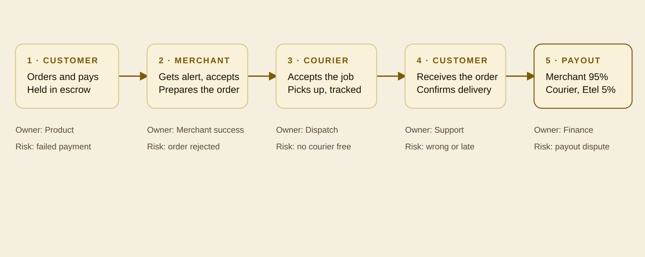
Merchant share is the order value minus the 5% commission. The courier fee comes from the delivery fee.

Ride
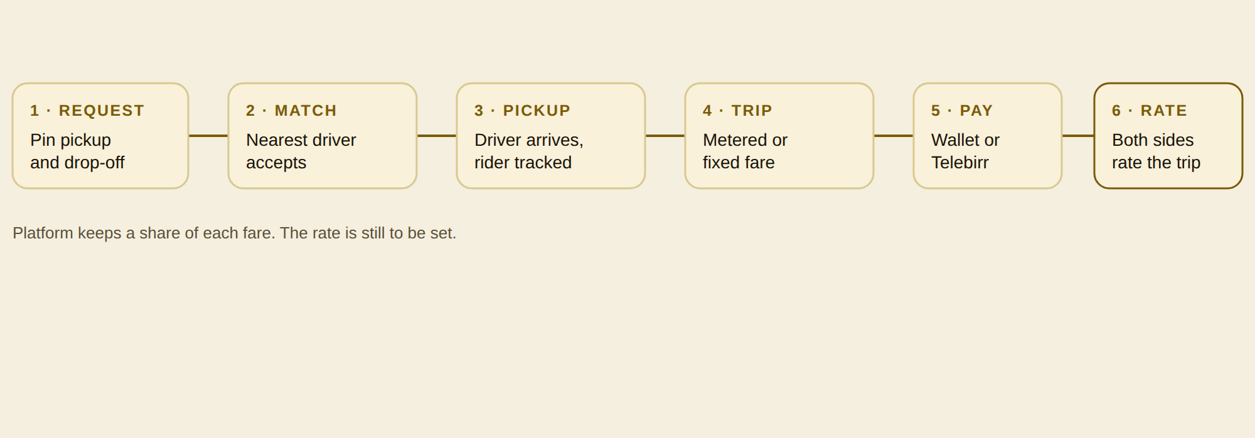
Platform keeps a share of each fare. The rate is still to be set.
WHY ETEL CAN WIN

One identity, one wallet, many services
EtelID and EtelPay sit under every Etel app. A customer who signs up for delivery already has an account and a wallet for rides, the marketplace and taxi.
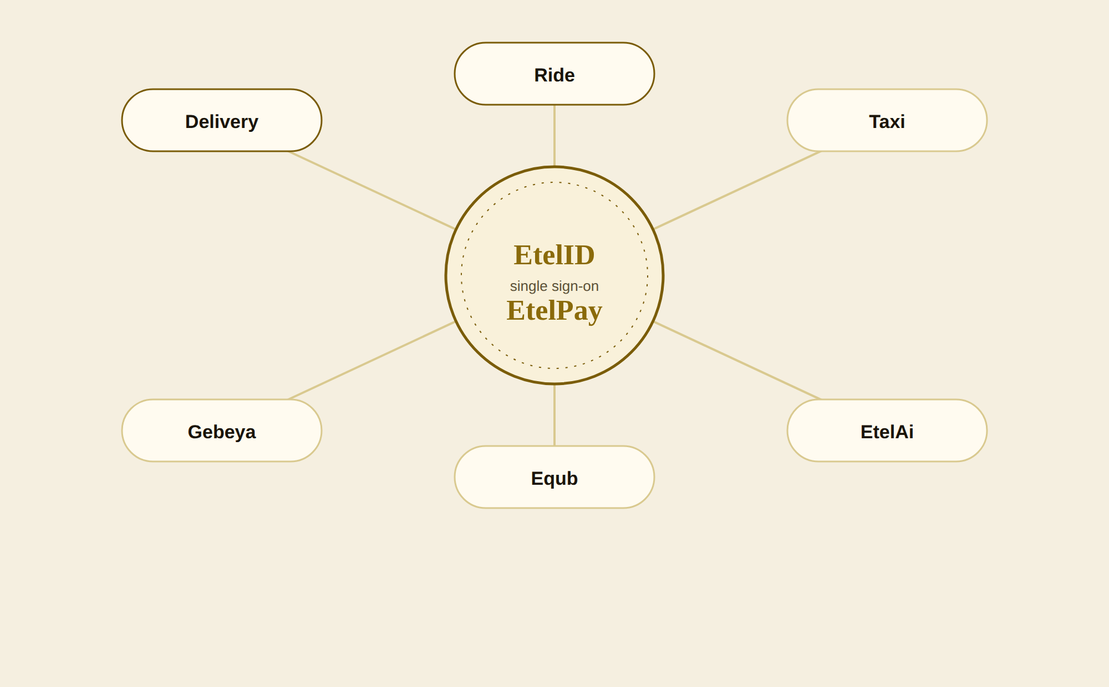
MONEY

Unit economics
Example inputs only. Replace them with your real numbers before making decisions.
Input (example) | Value
Average order value | 400 ETB
Commission on order | 5%
Delivery fee charged | 60 ETB
Courier share of fee | 80%
Orders per day | 100
Payment fee per order | 3 ETB
Monthly fixed costs | 150,000 ETB

Result | Value
Commission per order | 20 ETB
Delivery margin per order | 12 ETB
Payment fee per order | -3 ETB
Contribution per order | 29 ETB
Monthly contribution (30 days) | 87,000 ETB
Monthly fixed costs | -150,000 ETB
Monthly result | -63,000 ETB
Break-even orders per day | 173
MEASURE

What to track every week
Set a target for each metric with the team before the soft launch.
Metric | Why it matters | How to measure | Target
Orders per day | Demand and revenue driver | Completed orders in the admin panel | [set]
Rides per day | Ride demand | Completed trips | [set]
Active merchants | Supply choice for customers | Merchants with at least one order in 7 days | [set]
Active couriers and drivers | Speed of pickup | Accounts online in 7 days | [set]
Minutes to delivery | Customer trust | Order placed to delivery confirmed | [set]
Repeat customers | Retention | Customers with 2 or more orders in 30 days | [set]
Cancelled or failed orders | Lost revenue and reputation | Cancelled divided by placed | [set]
Contribution per order | Profit health | Calculator, using real data | [set]
BE READY

Risks and how to handle them
Risk | Level | What to do
Too few couriers or drivers, so pickups are slow | High | Recruit ahead of demand, guarantee minimum earnings in the first weeks, launch one district only.
Merchants do not stay active | High | Weekly visits, fast payouts, show them their order numbers.
Payment or payout errors | High | Test payouts with small real orders before launch, daily reconciliation, clear dispute steps.
Platform downtime on shared hosting | Medium | Backups, uptime alerts, plan a move to stronger hosting before scaling.
Security and data protection | Medium | Keep audits current, limit admin access, review INSA findings.
Competitors copy prices | Medium | Compete on reliability and the one-login, one-wallet experience, not on discounts alone.
Regulation on wallets and ride-hailing | Medium | Confirm licences early with the relevant offices and get advice in writing.
IDENTITY

Brand kit
The mark is an E built from three bars, with a dotted route leaving it and ending at a location pin. It says both things the business does: it moves goods and people.
Carbon | Gold | Bright gold | Cream
#0D0B08 | #D4AF37 | #F2CC6B | #F5EFE0
Type: Cormorant Garamond for headlines, DM Sans for text. Keep clear space around the mark equal to the width of one bar of the E.

