
INSA Web Application Security Audit Package
EtelPay — Etel Group Digital Wallet Platform
Prepared for submission to the Information Network Security Agency (INSA), Ethiopia
Structured per INSA's Web Applications Audit Request Requirements Document (OF/AEAD/001)
Etel Family Technology and Business Group
Hawassa, Sidama National Regional State, Ethiopia
Prepared by: Dagmawi Dikasso Aydiko (Dagi) — Founder / Technical Architect
Live system: ethelmarket.com/Etel.Pay/wallet/
2026-09-24

0. How to Use This Document
This package follows the same structure as the ETEL Delivery & Ride, ETEL-ID, and EtelGebeya INSA Audit Packages, mirroring INSA's Web Applications Audit Request Requirements Document (OF/AEAD/001), so it can be submitted through INSA's Audit Request Portal (cyberaudit.insa.gov.et) with minimal rework.
Sections in black text are filled in from what is already known about the EtelPay platform, including the outcome of a three-pass, code-level security review completed and fixed in September 2026 (see Section 7, full detail in docs/INSA_FINDINGS_EtelPay.md).
Sections in red italics marked [TO COMPLETE: ...] need a decision, a real value, or a document that only exists outside this narrative — fill these in before submitting.
EtelPay is the shared digital wallet behind every other Etel Group product: instead of each app (Delivery & Ride, EtelGebeya) handling its own payments independently, EtelPay centralizes balance, transaction history, escrow holds, and payouts, and authenticates through EtelID for SSO. It settles money on behalf of two sibling systems through dedicated server-to-server bridges — EtelGebeya's marketplace escrow (ep_platform_transfer) and Delivery & Ride's driver payouts (ep_partner_credit) — which makes its security posture load-bearing for the rest of the group, not just for EtelPay's own users.

1. Legal and Administrative Documents (Mandatory)
Per INSA requirement 4.1, attach the following as separate scanned files with this submission. This is the same legal entity that operates Etel Delivery & Ride, ETEL-ID, EtelGebeya, and every other Etel Group product — one set of documents covers all submissions.
Document | Status
Updated Trade License (for the legal entity operating EtelPay) | Attached separately (scanned PDF) — Business License, Sidama National Regional State Trade and Market Development Bureau, Hawassa City. Principal Registration No. SMD/STMB/1/0042554/2018, issued 14/12/2018, in the name of Etel Family Technology and Business Group (Owner: Degimaw Dikaso Aydiko).
TIN Number or National ID | Attached separately (scanned PDF, same certificate as above) — TIN 0073428763.
System/Product Patent Certificate | Not applicable unless one has been filed — leave blank if none exists.

2. Business Architecture and Design

2.1 Data Flow Diagram — Context Level (Level 0)
Shows EtelPay as a single process and every external entity it exchanges data with. Wallet-holder/merchant traffic comes from the public internet through the mobile web PWA; EtelID handles the SSO exchange; Delivery & Ride and EtelGebeya settle money server-to-server through their own bridge actions; Telebirr/CBE and Telegram are the external payment and messaging gateways; Dagi reaches the system both as an admin and, separately, through the standalone Updater deploy tool.
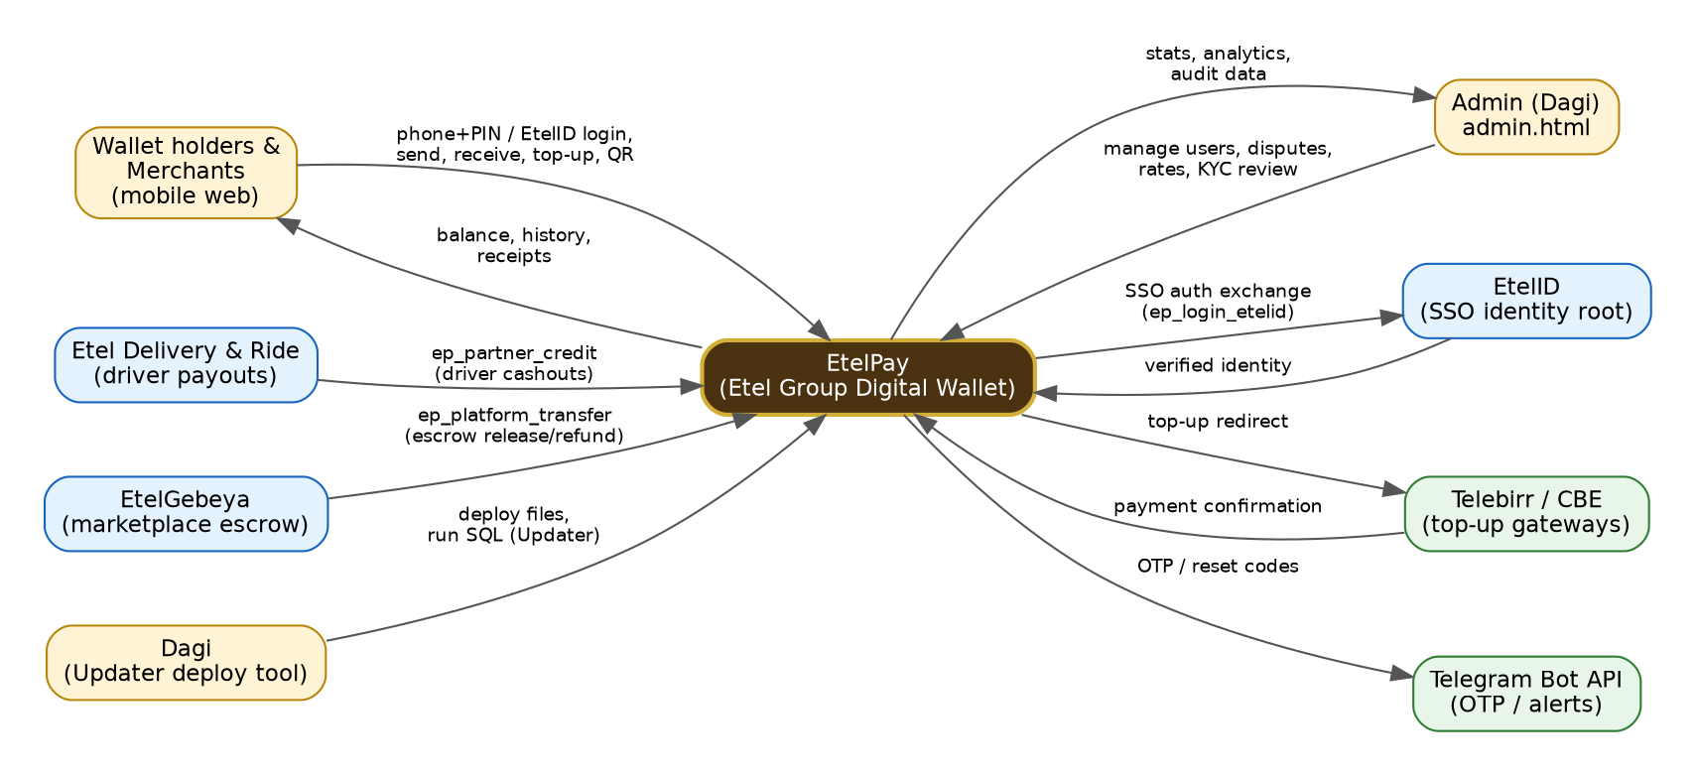
Figure 1 — Context-level Data Flow Diagram (Level 0)

2.2 Data Flow Diagram — Detailed (Level 1)
Breaks the single EtelPay process into its nine main functional processes and the database tables each one reads from or writes to.
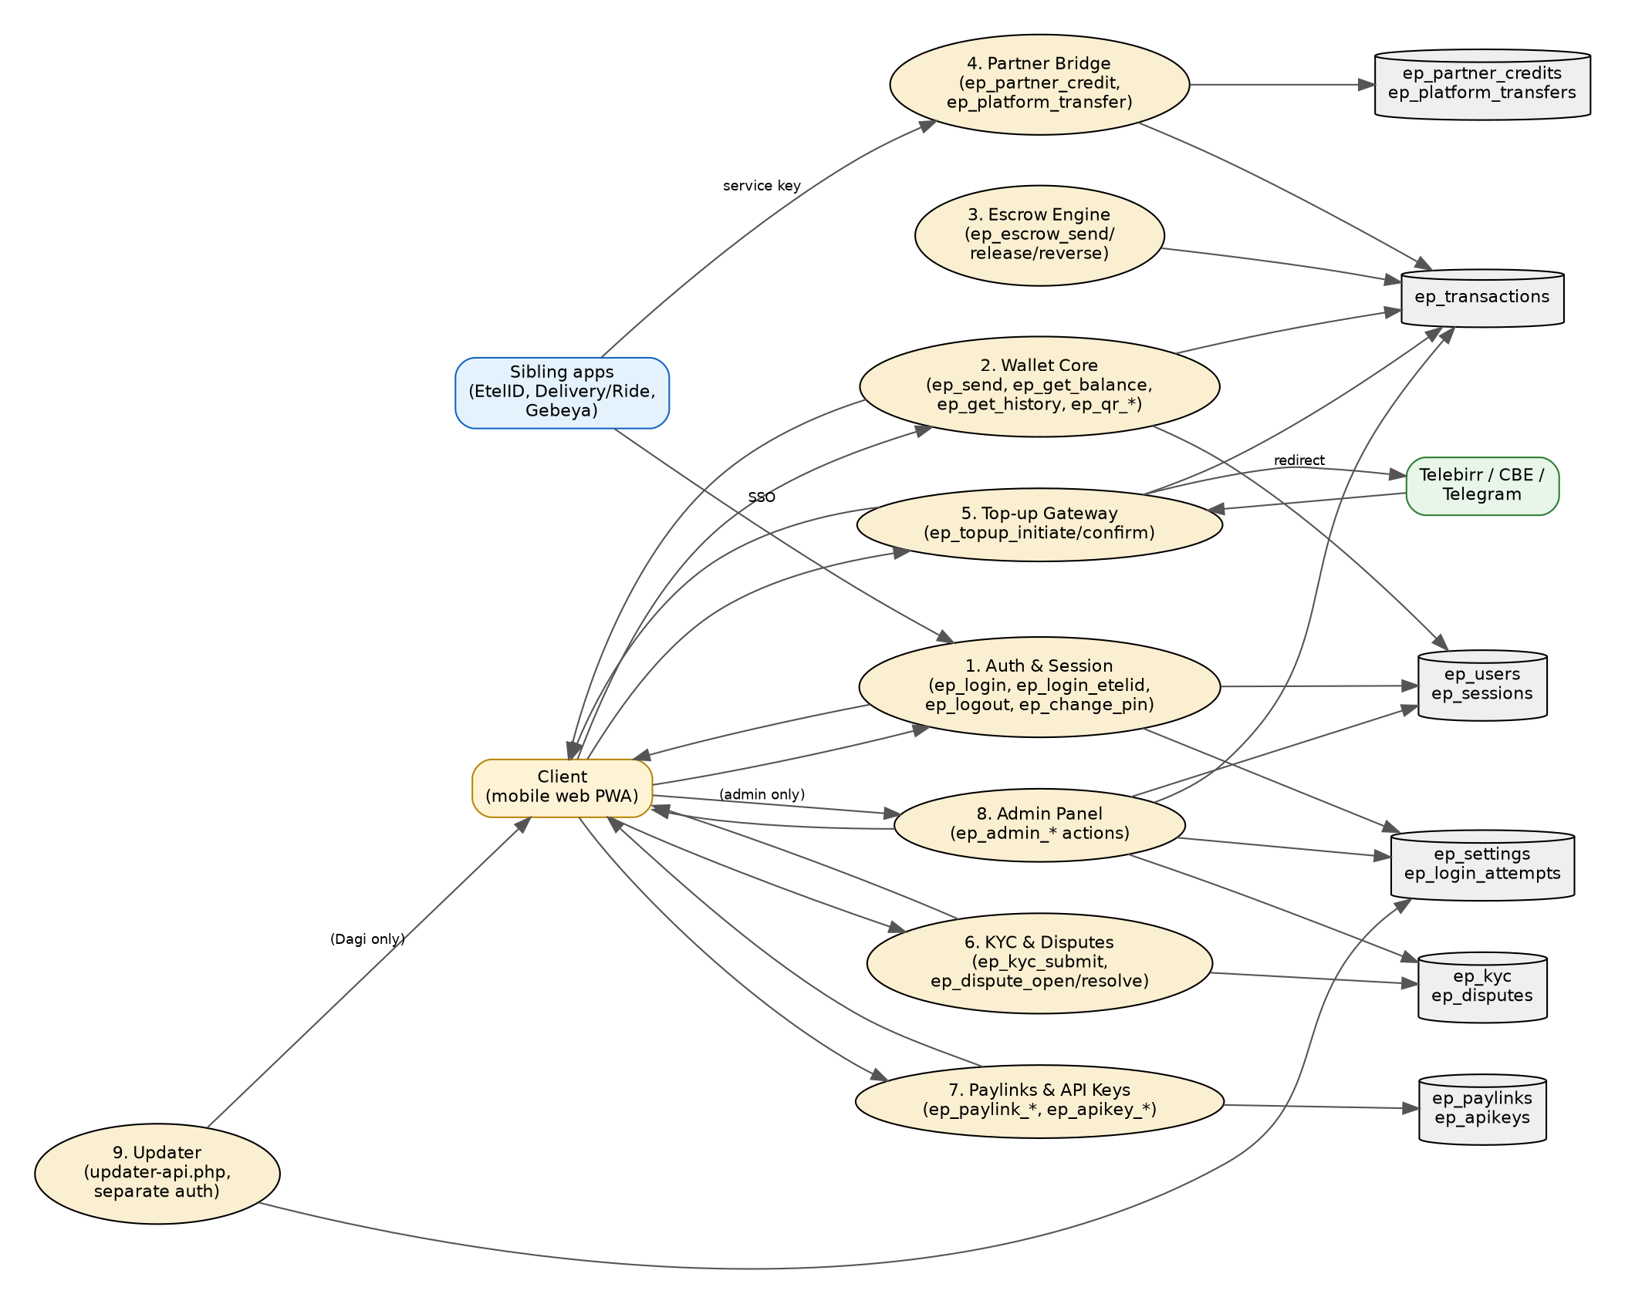
Figure 2 — Detailed Data Flow Diagram (Level 1)

2.3 System Architecture Diagram
EtelPay runs as a flat PHP router (no MVC framework, no ORM) on the same shared cPanel hosting account as the rest of the Etel Group stack, with its own MySQL database. A single entrypoint, v2_verify.php, reads the requested action from the JSON body (or query string) and dispatches it to one of three required route-handler files (ep_r1.php, ep_r2.php, ep_r3.php); every case '<action>': inside those three switch statements is the entire access-control surface for that action. Four standalone scripts bypass this router entirely for server-to-server calls, and the Updater deploy tool (updater-api.php) is a fully separate router with its own password-plus-signed-token auth scheme.
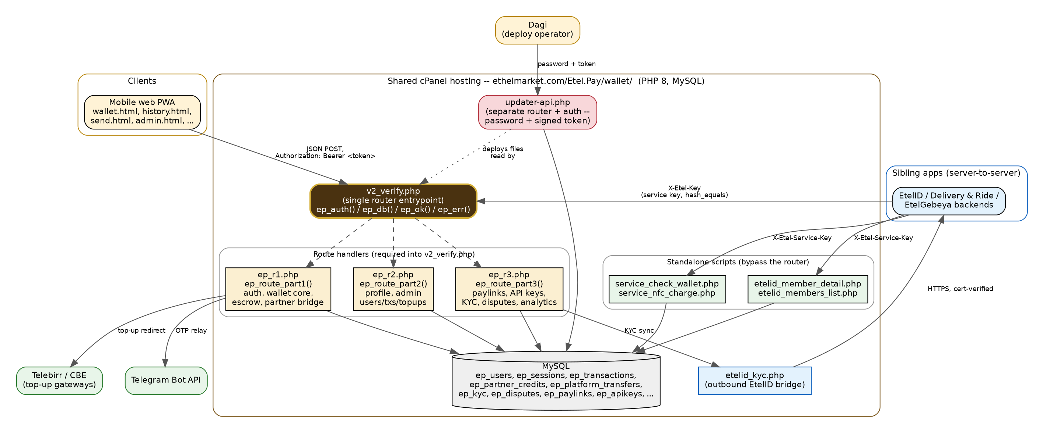
Figure 3 — System Architecture Diagram

Security layers already in place
- Session tokens are a real, server-side, database-backed opaque bearer token (bin2hex(openssl_random_pseudo_bytes(32))) — not a self-encoding, forgeable JWT-style scheme; there is no signature to bypass, since revocation means deleting the database row.
- Real server-side revocation on logout, PIN change (every session for that user), admin account closure, and — added in this review — an 8-hour inactivity cutoff on top of the existing 7-day hard cap.
- Every service-to-service, money-moving action (escrow release/reverse, verify-tx, partner credit, platform transfer) requires a shared secret compared with hash_equals(), and now fails closed instead of accepting the shipped placeholder value.
- Idempotency reservations — a database INSERT enforced unique per partner reference, made before any balance is touched — on both cross-company settlement bridges, so a retried or concurrent call cannot double-process.
- Every real balance debit uses an atomic UPDATE … WHERE balance_etb >= ? plus an explicit ROW_COUNT() check, guarding against two concurrent debits both passing an earlier balance pre-check.
- A single, consistently-used output-escaping helper (EP_CORE.esc()) wherever another user's free-text field (name, note, transaction label) is rendered into HTML.
- Login and the Updater's own login are both rate-limited (per-phone/per-IP, and per-IP respectively) after this review.

Known open items (disclose — INSA audits are more useful when these are flagged upfront, not discovered)
- ep_admin_self_topup lets any account holding is_admin mint new balance into their own wallet from nowhere, with no counterparty debit — a by-design admin capability (mirrors ep_admin_credit, which does the same for other users), not a bug, but a real concentration of blast radius behind a single admin credential.
- updater-api.php's run_sql action grants an authenticated Updater session arbitrary raw SQL execution against the production database — consistent with this class of single-operator deploy tool across the whole Etel Group codebase, and now properly gated by a placeholder-password fix, but still a high-blast-radius capability with no second factor.
TO COMPLETE: Confirm whether shared cPanel hosting for ethelmarket.com currently restricts inbound traffic to a known CDN/proxy range, or document that it does not (accepted risk).

2.4 Entity Relationship Diagram (ERD)
Core tables: ep_users (one row per wallet holder/merchant, holding balance and KYC status), ep_sessions (opaque bearer tokens, now with an 8-hour idle cutoff), ep_transactions (every money movement, tagged by direction relative to the caller), ep_partner_credits and ep_platform_transfers (the two cross-company settlement bridges, each idempotent on a unique partner reference), ep_kyc (two-pass identity documents), ep_disputes (transaction disputes and their resolution), ep_paylinks and ep_apikeys (merchant-facing payment links and API credentials), and ep_settings / ep_login_attempts (platform configuration and brute-force tracking).
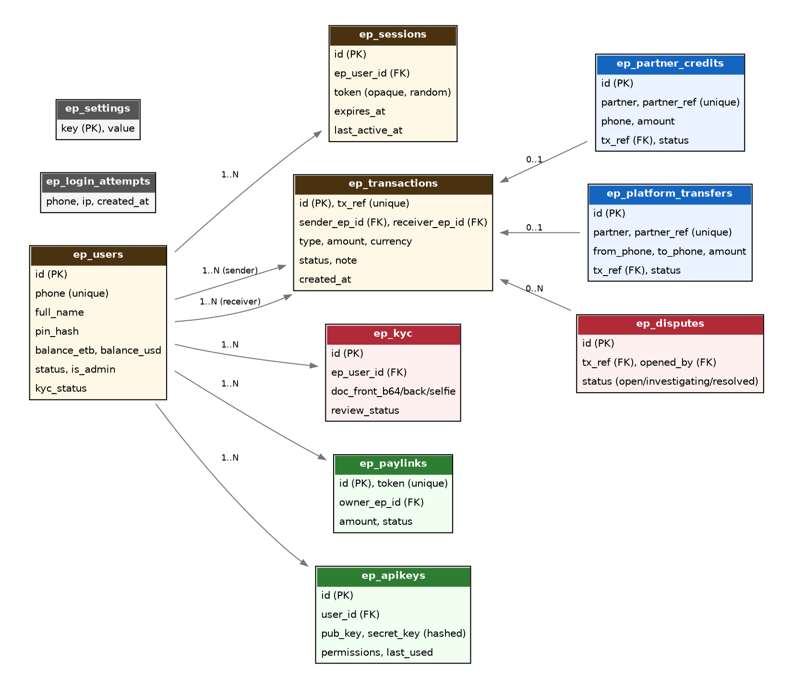
Figure 4 — Entity Relationship Diagram (ERD)

3. Features of the Web Application
- Phone + PIN sign-in with rate-limited brute-force protection, and EtelID SSO sign-in (auto-provisions a wallet from an already-verified EtelID identity).
- Send/receive money between wallets, searchable/filterable transaction history, and QR code generation/scanning for in-person payments.
- Escrow holds (send / release / reverse) supporting EtelGebeya's buy-now-pay-on-confirmation marketplace flow.
- Cross-company settlement bridges: EtelGebeya marketplace escrow release/refund, and Etel Delivery & Ride driver payout/cashout — both idempotent, and capped per-call and per-24-hour-per-partner.
- Wallet top-up via Telebirr/CBE (redirect + confirmation), plus admin approval for manual/cash top-ups.
- Payment links and merchant API keys with permission scoping, for merchants collecting payments outside the wallet UI.
- NFC tap-to-pay, trusting EtelID to have already verified both parties' passwords on-device before the charge is ever called in.
- Two-pass KYC document submission and admin review.
- Dispute lifecycle: a user opens a dispute against a transaction they were actually party to; an admin resolves it (refund or reject) behind an idempotent status-flip guard.
- Multi-currency display rates alongside the platform's own ETB ledger.
- Admin panel: user management, transaction reversal, dispute/KYC review, rate and settings management, analytics, and a dedicated Updater tool (separate password + signed token) for deploying files and running SQL directly against production.

4. Testing Scope (Mandatory)
In scope: all eleven PHP files under Etel.Pay/wallet/api/ (v2_verify.php, ep_r1.php, ep_r2.php, ep_r3.php, etelid_kyc.php, etelid_member_detail.php, etelid_members_list.php, service_check_wallet.php, service_nfc_charge.php, updater-api.php, plus the login-rate-limiter helpers in v2_verify.php); every front-end HTML/JS page under Etel.Pay/wallet/ (wallet.html, history.html, send.html, admin.html, kyc.html, pay.html, pay-links.html, topup.html, login.html, qr.html, profile.html, updater.html, diag.html, analytics.html, js/core.js, js/api.js); and Etel.Pay/wallet/backups/. Explicitly in scope given EtelPay's role as shared settlement infrastructure: the two cross-company bridges (ep_partner_credit, ep_platform_transfer) and the four standalone service-to-service scripts.
Out of scope for this submission: the sibling applications themselves (ETEL-ID, Etel Delivery & Ride, EtelGebeya, EtelTaxi) — each is covered by its own separate INSA submission. The underlying shared cPanel hosting infrastructure (network firewall, WAF configuration, server hardening) is also out of scope for this application-level submission.
TO COMPLETE: Confirm with INSA whether they want a live penetration test against a staging copy, or a code-level review against this repository plus the architecture described here.

5. Security Functionality Document

5.1 User roles and access control
- Wallet holder / Merchant — the default role for anyone signed in; every user-facing action resolves the acting user's own ID from the session token (ep_auth_id()), never from a request parameter. Ownership-scoped actions (ep_apikey_revoke, ep_topup_confirm) additionally filter by user_id / the caller's own reference in the SQL WHERE clause.
- Admin — a single is_admin column checked by _ep_require_admin() (with an admin_phones setting fallback), gating all roughly 20 ep_admin_*/ep_analytics actions; never trusts any request-body field for the privilege decision, and is never itself writable by any non-admin-gated action.
- Service-to-service caller — not a user account at all; five money-moving actions and the four standalone scripts authenticate purely via a shared secret header (X-Etel-Key / X-Etel-Service-Key), compared with hash_equals() and failing closed on the shipped placeholder value.
- Merchant API key — a narrower-scoped alternative to a full session, gating ep_get_balance and ep_paylink_create (requiring the receive permission) as the first two real consumers of the stored permissions field.
- Updater operator — a fully separate auth scheme (password + signed token) from the wallet's own session system, gating file-deploy and raw-SQL actions.

5.2 Input validation and sanitization
- Every SQL query is a real parameterized statement (PDO::ATTR_EMULATE_PREPARES => false on all four independent PDO construction sites); the only string-concatenated values are hardcoded table-name constants, never request input.
- Amount validation is consistent and real everywhere a balance is touched: positive-amount checks, a 1 ETB minimum on peer transfers, and explicit per-call/rolling-24-hour caps on both cross-company bridges.
- Phone numbers are normalized to a single canonical format before every phone-based lookup.
- Image uploads (avatar, KYC documents) are content-sniffed by magic bytes (PNG, and — added in this review — JPEG) rather than trusted by extension, and size-capped (500 KB avatar; ~3 MB on all three KYC document fields, extended in this review from just the front document).
- ep_send_tg_otp's OTP parameter must now match a 4–8 digit numeric pattern and is rate-limited, closing what was previously an unauthenticated, unlimited relay through the official Telegram bot.

5.3 Session management
- Sessions are a real, server-side, database-backed opaque bearer token — not a self-encoding, forgeable JWT-style scheme; there is nothing to HMAC-bypass, since the token carries no embedded, independently-verifiable data.
- 7-day hard expiry plus — added in this review — an 8-hour inactivity cutoff, checked and refreshed on every authenticated call.
- Real revocation: logout deletes that one session row; PIN change and admin account-closure delete every session row for that user, forcing re-login everywhere, not just on the device that triggered it.
- Account suspension is re-checked on every authenticated request, not only at login — an admin suspending a user takes effect on their very next call even with an unexpired token.
- No cookie of any kind is set anywhere in this codebase (confirmed by a direct, zero-result grep for setcookie() across the whole tree) — Secure/HttpOnly/SameSite flags are not applicable because there is no cookie to set them on.

5.4 Error handling and logging
- ep_db()'s connection-failure handler returns a generic "Database connection failed" message, never the raw exception (which could echo the DSN or credentials).
- Three previously fully-unauthenticated diagnostic actions (ep_diag_db, ep_diag_sessions, ep_diag_telebirr) — which carried a comment claiming an IP gate that was never actually implemented — now require _ep_require_admin() as their first line.
- A debug fingerprint that leaked roughly a third of a shared service key's characters on a failed match (etelid_members_list.php) has been removed entirely.
- The Updater's own deploy-audit-log write failure is no longer silently swallowed — a failed write now at least reaches error_log().

5.5 Secure communications
- Etel.Pay/wallet/.htaccess sets a full security-header set via mod_headers: X-Frame-Options: SAMEORIGIN, a locked-down Content-Security-Policy (frame-ancestors 'none'), HSTS with preload, and Referrer-Policy: strict-origin-when-cross-origin.
- etelid_kyc.php's outbound calls to EtelID use CURLOPT_SSL_VERIFYPEER => true — never disabled for convenience.
- Service-to-service calls authenticate via a shared secret header, never a credential in the URL or query string, compared with a constant-time hash_equals().

6. Secure Coding Standard Documentation (if available)
No formal written secure-coding standard document exists yet. In practice, the codebase follows a consistent set of conventions enforced through code review during development:
- Parameterized queries only — no string-concatenated SQL built from request input anywhere in the codebase.
- hash_equals() for every secret or service-key comparison, never a plain == or ===.
- Fail-closed behavior on missing or placeholder configuration (documented per-finding in Section 7).
- An atomic status-flip-before-money-move pattern on every admin or escrow action that both changes a status and moves a balance.
- An idempotency-reservation-before-crediting pattern on every service-to-service money endpoint.
- A single, consistent output-escaping helper (EP_CORE.esc()) for any field that can contain another user's free text.
TO COMPLETE: Decide whether to formalize the above conventions into a written secure-coding standard document before submission, or submit this section as-is with a note that conventions are enforced through review rather than a standalone document.

7. Previous Security Testing Reports (if available)
A three-pass, code-level security review of the EtelPay codebase — all eleven backend PHP files, every front-end page, and the Updater deploy tool — was completed in September 2026. Twenty-two findings were identified across the three passes; every one was fixed prior to this submission except two accepted-risk, by-design admin capabilities and one cosmetic item, each explicitly disclosed below rather than silently left out. Full detail, including exact file/line references and verification steps (php -l, an ASCII-byte diff, and node --check where JavaScript was touched), is in docs/INSA_FINDINGS_EtelPay.md.
Severity | Finding | Resolution
Critical | Five service-to-service, money-moving actions (escrow release/reverse, verify-tx, partner credit, platform transfer) authenticated against the shippable placeholder EP_SECRET instead of the safe, auto-derived EP_SECRET_FINAL. | Switched to EP_SECRET_FINAL (fixed ahead of this review's first pass; re-verified here).
Critical | The Updater's own password gate accepted the shipped placeholder CHANGE_ME as a valid password, due to a case-sensitive comparison against lowercase changeme. | Comparison is now case-insensitive and trimmed before checking against the placeholder set.
Critical | Updater's read_file action bypassed $PROTECTED_FILES, letting an authenticated session read config.php/.env in plaintext (DB password, EP_SECRET, ETELID_SERVICE_KEY, Telebirr credentials). | read_file now rejects any path in $PROTECTED_FILES.
Critical | Escrow release/reverse credited a balance before flipping the transaction's status — the reverse order of every other status-flip-then-move-money action — letting a concurrent/retried call double-pay. | Status now flips atomically (checking ROW_COUNT()) before any balance is touched, matching every other admin money-action.
High | Updater login had zero brute-force protection, unlike the main wallet's ep_login. | Added a per-IP rate limiter (5 failed attempts / 15 minutes) on the login action.
Medium | ep_admin_dispute_resolve's refund branch had no idempotent status-flip guard, allowing double-crediting on a retried or double-clicked request. | Same atomic status-flip-then-credit pattern applied as the other admin money-actions.
Medium/High | A debug fingerprint on a failed service-key match leaked the real key's exact length plus its first and last 6 characters. | Debug fingerprint removed entirely; the endpoint now returns only a generic mismatch message.
Medium | Three diagnostic actions (ep_diag_db/sessions/telebirr) claimed an IP gate in a code comment that was never actually implemented, exposing row counts and infrastructure fingerprinting data to any unauthenticated caller. | _ep_require_admin() added as the first line of all three.
Medium | ep_send_tg_otp accepted any free-text value as an "OTP" with no rate limiting — an open message-relay through the official Telegram bot. | OTP must now match a 4–8 digit format, and the action reuses the existing login rate limiter.
Medium | QR-code and payment-link payments checked only the payer's account status, never the receiving/link-owner account's — a suspended fraudulent merchant could keep collecting money. | Both actions now check the receiver's / link owner's account status before crediting.
Medium | ep_dispute_open never verified the caller was actually party to the referenced transaction — anyone could open a dispute against any tx_ref. | Ownership check added; the refund-resolution path cross-checks the same as defense-in-depth.
Low | The merchant API-key system generated keys and a permissions field, but nothing anywhere authenticated a request with them or enforced permissions. | Real API-key authentication (X-Api-Key/X-Api-Secret) wired into ep_get_balance and ep_paylink_create.
Low | .htaccess files were not excluded from Updater overwrites — a compromised Updater session could remove the very protections closing the item above. | All three .htaccess paths in the wallet tree added to $PROTECTED_FILES.
Low | The backups/ directory (222 real timestamped files already checked in) had no access protection or directory-listing block — any file was directly fetchable by URL. | New backups/.htaccess: deny-all plus Options -Indexes.
Low | No session idle timeout existed, only a flat 7-day hard cap from issuance. | An 8-hour inactivity cutoff added, checked and refreshed on every authenticated call.
Low | ep_upload_avatar only magic-byte-checked for PNG and assumed any other upload was a valid JPEG. | A real JPEG magic-byte check (FF D8 FF) added.
Low | ep_kyc_submit's size cap was enforced only on the front-document field, not the back document or selfie. | The ~3 MB cap is now enforced on all three document fields.
Low | The Updater's own deploy-audit-log write failure was silently swallowed by an empty catch block. | The catch block now calls error_log() on a failed write.
Functional (not security) | register.html posted to a non-existent backend action; self-service registration was broken end-to-end. | The dead form was removed; EtelID-SSO auto-provisioning remains the only way a wallet is created.
Low (cosmetic) | Amounts are handled as PHP floats with no explicit rounding, a display/reconciliation inconsistency against MySQL's own DECIMAL rounding. | Not changed — no value can be created or destroyed, since a debit and its matching credit are symmetric. Flagged for awareness.
Accepted (by design) | ep_admin_self_topup lets any admin mint unlimited balance into their own wallet with no counterparty debit. | Not changed — a legitimate, by-design admin power mirroring ep_admin_credit for other users; flagged for whether a secondary approval step is wanted given its blast radius.
Accepted (by design) | run_sql in the Updater grants arbitrary raw SQL execution behind a single shared password. | Not changed — consistent with this class of single-operator deploy tool across the whole Etel Group codebase, and now properly gated by the placeholder-password fix above.

TO COMPLETE: Attach the full internal audit write-up (docs/INSA_FINDINGS_EtelPay.md) as a separate annex if INSA requests supporting detail beyond this summary table.

8. API Security Audit Requirements

8.1 API type and format
Two flat, PHP switch-statement routers, no MVC framework and no ORM: v2_verify.php (single entrypoint — reads the action from the JSON body, falling back to a query-string parameter — dispatching to ep_route_part1()/ep_route_part2()/ep_route_part3() in order) for roughly 53 user- and service-facing actions, and updater-api.php (its own router, its own password-plus-signed-token auth scheme) for 13 deploy/SQL actions. Four standalone scripts bypass both routers entirely for server-to-server calls. All JSON in/out; every successful response is wrapped {"success": true, "data": {...}, "message": "...", "v": "<EP_VER>"} and every failure {"success": false, "data": {"message": "..."}, "v": "<EP_VER>"} with the matching HTTP status code.

8.2 Authentication mechanism
- User session: Authorization: Bearer <opaque token>, verified against ep_sessions (database-backed, not self-verifying).
- Service-to-service: X-Etel-Key or X-Etel-Service-Key shared secret, compared with hash_equals(), fails closed if never configured.
- Merchant API key: X-Api-Key / X-Api-Secret headers (or a query-string fallback for this host's known header-stripping issue), with permissions-string enforcement.
- Updater: a shared password exchanged for a signed session token, entirely independent of the wallet's own session system.

8.3 Endpoint inventory
Full per-endpoint detail is in Section 8.6 below. Summary by surface:
Surface | Action count | Auth model
ep_r1.php (ep_route_part1) | 19 | Public / rate-limited / user session / service key (mixed per action — see 8.6.1)
ep_r2.php (ep_route_part2) | 23 | User session / admin (see 8.6.3)
ep_r3.php (ep_route_part3) | 19 | User session / admin / public by design (see 8.6.4)
Standalone service scripts | 4 | Service key (X-Etel-Service-Key), independent of v2_verify.php
updater-api.php | 13 | Separate router — password login, then a signed Updater token

8.4 Third-party integrations affecting API security
- EtelID — the SSO identity root; ep_login_etelid exchanges an EtelID phone/password for an EtelPay session and auto-provisions a wallet, and etelid_kyc.php syncs KYC status outbound.
- Telebirr / CBE — wallet top-up redirect and payment confirmation.
- Telegram Bot API — OTP and password-reset codes, relayed through the official Etel bot.
- Sibling Etel Group apps (Delivery & Ride, EtelGebeya) — the consumers of the two cross-company settlement bridges (ep_partner_credit, ep_platform_transfer) and the standalone service scripts.

8.5 Test account for API testing
TO COMPLETE: Provide one live wallet-holder test account (phone + PIN) with a normal role, one merchant account with an issued API key, and confirm whether a separate admin-role test account should also be provided for testing the ep_admin_* endpoints.

8.6 Full API Endpoint Inventory

8.6.1 ep_r1.php — ep_route_part1()
Action | Access Level
ep_ping | Public
ep_send_tg_otp | Public (rate-limited + OTP-format-checked)
ep_check_tg_link | Public
ep_diag_db | Admin
ep_diag_sessions | Admin
ep_diag_telebirr | Admin
ep_login, etel_pay_login | Public (rate-limited)
ep_logout, etel_pay_logout | Public (no-ops cleanly with no/invalid token)
ep_get_balance, etel_pay_get_balance | Authenticated (or merchant API key)
ep_get_history, etel_pay_get_history | Authenticated (scoped to caller's own transactions)
ep_get_rates, etel_pay_get_rates | Public
ep_send, etel_pay_send | Authenticated
ep_escrow_send | Authenticated
ep_escrow_release | Service key (atomic status-flip-then-credit)
ep_escrow_reverse | Service key (atomic status-flip-then-credit)
ep_verify_tx, etel_pay_verify_tx | Service key
ep_partner_credit | Service key (idempotent, capped)
ep_platform_transfer | Service key (idempotent, capped)
ep_qr_generate, etel_pay_qr_generate | Authenticated
ep_qr_process, etel_pay_qr_process | Authenticated (checks QR owner's account status)

8.6.2 Standalone service-to-service scripts (bypass v2_verify.php entirely)
File | Access Level
etelid_member_detail.php | Service key (X-Etel-Service-Key header or ?key=)
etelid_members_list.php | Service key
service_check_wallet.php | Service key
service_nfc_charge.php | Service key

8.6.3 ep_r2.php — ep_route_part2()
Action | Access Level
ep_get_profile, ep_portal_get_profile | Authenticated
ep_update_profile | Authenticated
ep_change_pin | Authenticated (revokes all sessions on success)
ep_upload_avatar | Authenticated (JPEG/PNG magic-byte checked)
ep_admin_stats | Admin
ep_admin_users | Admin
ep_admin_get_user | Admin
ep_admin_toggle_user | Admin
ep_admin_credit | Admin
ep_admin_self_topup | Admin (accepted-risk item — Section 7)
ep_admin_debit | Admin
ep_admin_txs | Admin
ep_admin_reverse_tx | Admin (idempotent status-flip guard)
ep_admin_search | Admin
ep_admin_rates | Admin
ep_admin_update_rate | Admin
ep_admin_settings | Admin
ep_admin_save_settings | Admin
ep_admin_delete_user | Admin (revokes all sessions)
ep_topup_initiate | Authenticated
ep_topup_confirm | Authenticated (scoped to caller's own top-up request)
ep_admin_topup_approve | Admin (idempotent status-flip guard)
ep_admin_topup_list | Admin

8.6.4 ep_r3.php — ep_route_part3()
Action | Access Level
ep_paylink_create | Authenticated (or merchant API key with the receive permission)
ep_paylink_info | Public by design — a payment link exists to be opened before login
ep_paylink_pay | Authenticated (checks link owner's account status)
ep_paylink_list | Authenticated (scoped to caller's own links)
ep_apikey_create | Authenticated
ep_apikey_list | Authenticated (scoped)
ep_apikey_revoke | Authenticated (scoped — WHERE id=? AND user_id=?)
ep_kyc_submit | Authenticated (size cap on all 3 document fields)
ep_admin_kyc_list | Admin
ep_admin_kyc_review | Admin
ep_analytics | Admin
ep_my_analytics | Authenticated (scoped to caller)
ep_dispute_open | Authenticated (verifies caller was sender or receiver)
ep_admin_dispute_list | Admin
ep_admin_dispute_resolve | Admin (idempotent status-flip guard, cross-checks tx parties)
ep_etelid_kyc_sync, etel_pay_etelid_kyc_sync | Authenticated
ep_etelid_resolve | Authenticated
ep_login_etelid | Public (EtelID SSO exchange — auto-provisions a wallet)
ep_nonce, etel_pay_nonce | Public

8.6.5 updater-api.php — separate router, own auth scheme
Action | Access Level
ping | Public
login | Public (password check, rejects the shipped placeholder; now rate-limited)
list_files | Updater token
read_file | Updater token (blocks $PROTECTED_FILES, including config.php/.env/.htaccess)
update_file | Updater token (blocks $PROTECTED_FILES)
upload_file | Updater token (blocks $PROTECTED_FILES; delegates to ZIP path for .zip)
upload_zip | Updater token
upload_multiple | Updater token
list_backups | Updater token
restore_backup | Updater token
delete_backup | Updater token
run_sql | Updater token (accepted-risk item — Section 7)
info | Updater token

8.7 Sample Request/Response Pairs

8.7.1 Login — ep_login
(ep_r1.php, no auth required, rate-limited)
POST api/v2_verify.php
{
"action": "ep_login",
"phone": "0911000000",
"pin": "1234"
}
Success response:
{
"success": true,
"data": {
"token": "a1b2c3d4e5f6...<64-hex-char opaque bearer token>",
"expires_at": "2026-09-27 12:00:00"
},
"message": "Login successful",
"v": "1.1.0"
}
Rate-limited: 5 failed attempts per phone in 15 minutes, 20 failed attempts per IP in 1 hour, both return HTTP 429.

8.7.2 Send money — ep_send
(ep_r1.php, requires Authorization: Bearer <token>)
{
"action": "ep_send",
"receiver": "0922000000",
"amount": 150.00,
"currency": "ETB",
"note": "Lunch"
}
Success response:
{
"success": true,
"data": {
"tx_ref": "EP-A1B2C3D4E5F6",
"amount": 150.00,
"currency": "ETB",
"receiver_phone": "+251922000000",
"receiver_name": "Test User",
"note": "Lunch"
},
"message": "Transfer successful",
"v": "1.1.0"
}

8.7.3 Partner credit (server-to-server) — ep_partner_credit
(ep_r1.php, requires X-Etel-Key: <EP_SECRET_FINAL> header — not a user session)
{
"action": "ep_partner_credit",
"phone": "0933000000",
"amount": 250.00,
"partner": "delivery",
"partner_ref": "DEL-DRIVER-PAYOUT-2026-09-20-001",
"note": "Driver earnings payout"
}
A retried call with the same partner + partner_ref returns {"idempotent_replay": true, ...} instead of crediting twice.

8.7.4 NFC tap-to-pay (server-to-server) — service_nfc_charge.php
(standalone script, not through v2_verify.php; requires X-Etel-Service-Key)
POST api/service_nfc_charge.php
{
"receiver_phone": "+251911000000",
"payer_phone": "+251922000000",
"amount": 45.00,
"note": "Coffee"
}

9. Contact Information
Name | Role | Email | Phone
Dagmawi Dikasso Aydiko (Dagi) | Founder / Technical Architect | dagmawidikasso16@gmail.com | +251 924 445 206

10. Submission Checklist
☐ Trade License + TIN scanned PDF attached (Section 1)
☐ Diagrams reviewed for accuracy against the live system (Section 2)
☐ Testing scope confirmed with INSA — live pentest vs. code review (Section 4)
☐ Test account credentials filled in (Section 8.5)
☐ Sample request/response pairs captured with real test credentials (Section 8.7)
☐ Confirmed with INSA whether this is a standalone submission or an annex referenced by EtelID's own submission (Section 0)
☐ Final read-through for any remaining [TO COMPLETE] markers before submitting

