
System & Architecture Design Document (SDD)
Etel Ride Platform
Version 1.2 | Etel Group
Prepared for the INSA Cyber-Security Audit application (Etel Ride scope), submitted in support of the Road Transport license application with the Ministry of Transport and Logistics.

Document contents
1. Architectural Overview
2. Technology Stack
3. Key Components
4. System Architecture Diagram
5. Data Flow Diagrams (Level 0 and Level 1)
6. Data Flow Explanation
7. Module Design
8. Data Architecture
9. Interface Design
10. Deployment Architecture
11. Traceability
Version 1.1 adds Sections 2 to 6 (Technology Stack, Key Components, System Architecture Diagram, Data Flow Diagram and Data Flow Explanation) requested by the INSA reviewer, and is supplied as PDF. All content is derived from the production source under /delivery/ in the Etel-FTBG repository. v1.2 correction: the ride lifecycle now records arrived as a real status reached at the drop-off (driver ends the trip), with the passenger's confirmation completing the ride, as verified in RideController.php and described in the TDD/LLD v1.1 Section 3.1.

1. Architectural Overview
Etel Ride follows a single-entrypoint, controller-dispatch architecture shared with Etel Delivery: every client request (from the Ride or Driver app, or from server-to-server integrations) is routed through one file, api/boot.php, which authenticates the caller (bearer token or shared service key), then dispatches by an 'action' name to the relevant controller under api/controllers/. There is no separate framework/router layer, and no separate deployment for Ride versus Delivery — they are one backend serving two service lines.

1.1 Scope
Etel Ride shares its backend and database with Etel Delivery, Etel Group's parcel and food delivery service line; both are served by the same api/boot.php dispatch entrypoint. This SDD documents the architecture as it relates to Ride. Shared components (authentication, the admin access-control mechanism, hosting) are described because Ride depends on them. Delivery-only modules are noted as out of scope rather than omitted silently.

1.2 Explicitly out of scope
The following components exist in the same codebase/repository but serve Etel Delivery, not Etel Ride, and are not described further in this document set:
• OrderController.php — delivery order lifecycle
• ServiceGiverController.php — storefront/business operations
• Courier and Service Giver roles and their apps (courier/, servicegiver.html)
• Delivery-zone, delivery-tier, and item-catalog data and admin tooling
• DocumentsController.php, SystemResetController.php, EquityController.php, PlatformEconomicsController.php, PlanningController.php — platform-wide admin tooling unrelated to the ride-hailing function specifically (internal document library, full-system data reset, investor/equity management, cost-planning tools)

2. Technology Stack
Layer | Technology | Where it is used
Client | HTML5, CSS3, vanilla JavaScript (no framework); Progressive Web App; installable as Android Trusted Web Activity (TWA) | ride/, driver/, admin.html, login.html; per-app manifest files
Client build | Node.js + terser: per-app source compiled to minified bundles, synced to versioned release folders (stable/canary channels) | js/build-bundles.js, js/releases/{app}/{version}/
Offline / caching | Service worker: cache-first static assets, network-first API calls with 5-minute cache, offline fallback page | sw.js, offline.html
Maps and location | Google Maps JavaScript API (map, markers, polylines, Places Autocomplete), Geocoding API, browser Geolocation | ride and driver apps; server-side geocoding helpers
Server language | PHP 8.1 (procedural, controller-dispatch); no third-party framework | api/boot.php, api/controllers/*
Database | MySQL / MariaDB, utf8mb4, accessed through PDO with prepared statements (emulated prepares disabled); session time zone aligned with PHP (Africa/Addis_Ababa) | api/boot.php, api/migrations/*.sql
Authentication | Custom HMAC-SHA256 signed bearer token with token_version revocation; EtelID SSO; shared service key (hash_equals) for machine-to-machine calls | boot.php, AuthController, etelid_auth.php
Real-time | Server-Sent Events (SSE) for live ride status and driver location | sse_ride_status, sse_driver_stream
Notifications and alerting | Web Push with VAPID (RFC 8292); Telegram Bot API for operational alerts | api/webpush.php, push.php, telegram_webhook.php
Payments integration | EtelPay server-to-server transaction verification (etel_pay_verify_tx) | api/etel_pay_bridge.php
Background jobs | cPanel cron calling key-protected PHP scripts | cron_close_stuck_rides.php, cron_dispatch_scheduled.php, equb_cron.php
Hosting and deployment | Shared cPanel hosting (Apache/LiteSpeed), HTTPS; no SSH; deploys through in-app Admin Updater with backup and patch_log; GitHub Actions workflow for zip-on-merge | api/updater.php, .github/workflows/deploy-zip-on-merge.yml

3. Key Components
Component | Type | Responsibility | Trust boundary / security role
Ride app (passenger) | Client PWA/TWA | Registration and login, fare estimate, booking, live tracking, chat, SOS, ratings, favourite and scheduled rides | Untrusted. Holds bearer token only; every action re-authorised server-side.
Driver app | Client PWA/TWA | Onboarding, go online/offline, GPS pings, accept/arrive/start/complete, earnings, cash-out, top-up | Untrusted. Privileged actions gated by rides_require_onboarded().
Admin console | Client web app | Pricing, driver approvals, vehicle-change review, issue and SOS handling, release channels | Untrusted client; each action requires admin role plus capability via role_permissions.
boot.php | Gateway | Request parsing, token / service-key authentication, rate limiting, action whitelist, dispatch | Single choke point for all API traffic.
Controllers | Business logic | Auth, Ride, Admin, Equb, Agent, Nfc, DriverFuel, Push | Ownership checks per ride; capability checks per admin action.
ride_fare.php / hexgrid.php | Library | Fare calculation shared by the app and EtelAI; hex-grid nearest-driver matching | Pure computation; no external input trusted.
SSE endpoints | Real-time | Push ride status and driver position to the participants | Authenticated; scoped to the caller's own ride.
upload.php | Service | Driver selfie, licence and document uploads | Content-sniffed MIME whitelist, size cap, server-generated file names.
Cron scripts | Background | Close stuck rides, dispatch scheduled rides, Equb processing | Standalone, protected by a secret key from .env.
MySQL database | Data store | Users, rides, drivers, GPS path, fares, payouts, permissions | Reached only through PDO prepared statements.
EtelID, EtelPay, EtelAI | External group systems | Identity / SSO, wallet verification, AI booking agent | Shared service key over HTTPS, constant-time comparison.
Google Maps, Telegram, Web Push | External third parties | Maps and geocoding, operational alerts, browser notifications | API key / bot token / VAPID key held server- or domain-restricted.

3.1 Component inventory (files)
Component | Responsibility
api/boot.php | Shared dispatch entrypoint: request parsing, auth (token or service key), rate limiting, action routing. Serves both Ride and Delivery.
api/controllers/RideController.php | Ride-hailing lifecycle: fare estimation, booking, driver matching, ride state machine, driver earnings/compliance
api/controllers/AuthController.php | Identity & session (shared with Delivery)
api/controllers/AdminController.php | Platform administration; only its ride fare/pricing, driver-account, and ride/driver-issue-resolution actions are in scope here. Its order/service-giver/zone management actions serve Delivery only and are out of scope for this document.
api/controllers/EqubController.php | Rotating-savings benefit, used by drivers (and, out of scope here, couriers)
api/controllers/AgentController.php | EtelAI machine-to-machine integration; only its ride_* actions are in scope
api/controllers/NfcController.php | EtelID NFC-tap bridge; only nfc_start_ride is in scope (its courier-pickup/delivery actions serve Delivery)
api/lib/ride_fare.php | Ride fare calculation, shared identically between the Ride app and the EtelAI agent integration
api/lib/hexgrid.php | Geospatial hex-grid driver matching
Ride app / Driver app | The two Ride-facing PWAs, each independently versioned and installable as an Android TWA
sw.js (service worker) | Offline caching, install/activate lifecycle, cache versioning (shared mechanism, per-app cache namespace)
EtelID (external) | Group-wide identity provider; SSO login, driver identity cross-check, NFC-tap bridge
EtelPay (external) | Wallet/payment app; verifies driver Etel Money top-up transactions

4. System Architecture Diagram
Etel Ride is a four-tier system. Thin PWA/TWA clients talk over HTTPS to a single PHP gateway (boot.php), which authenticates every request and dispatches it to a controller. Controllers read and write the MySQL database and call a small set of external services. Nothing in the client tier is trusted: authorization, ownership and fare calculation are all enforced on the server.
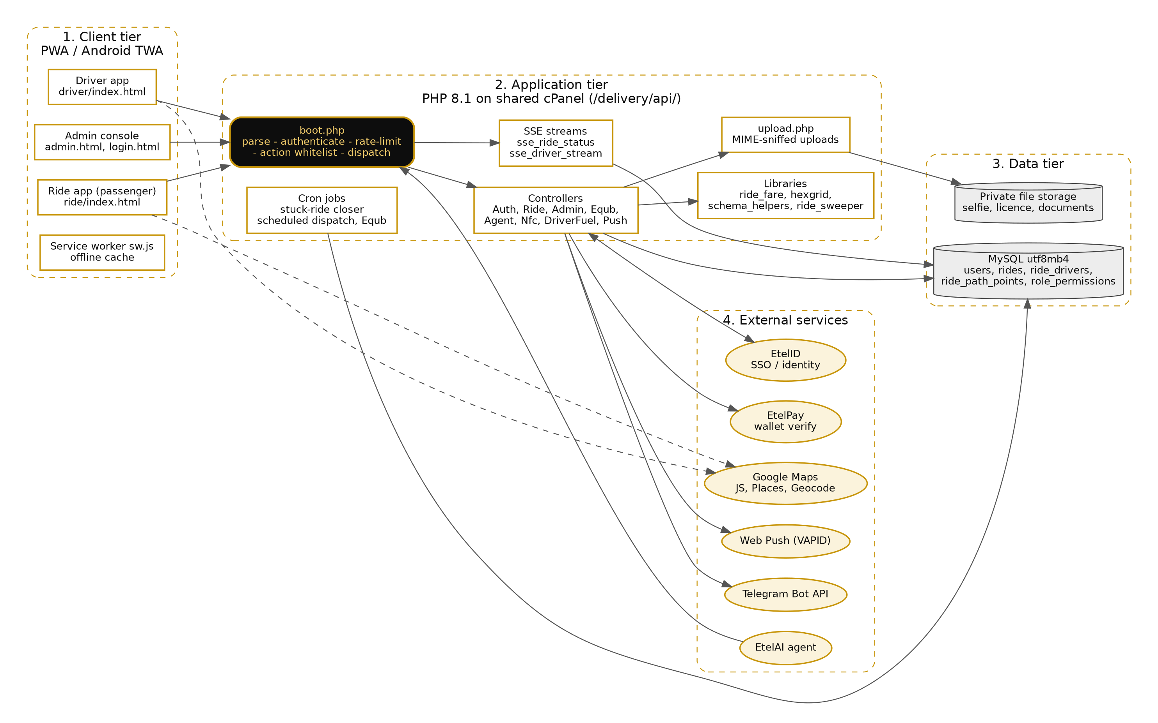
Figure 1 - Etel Ride system architecture (dashed arrows: browser-direct calls to Google Maps)

5. Data Flow Diagrams

5.1 Level 0 - context diagram
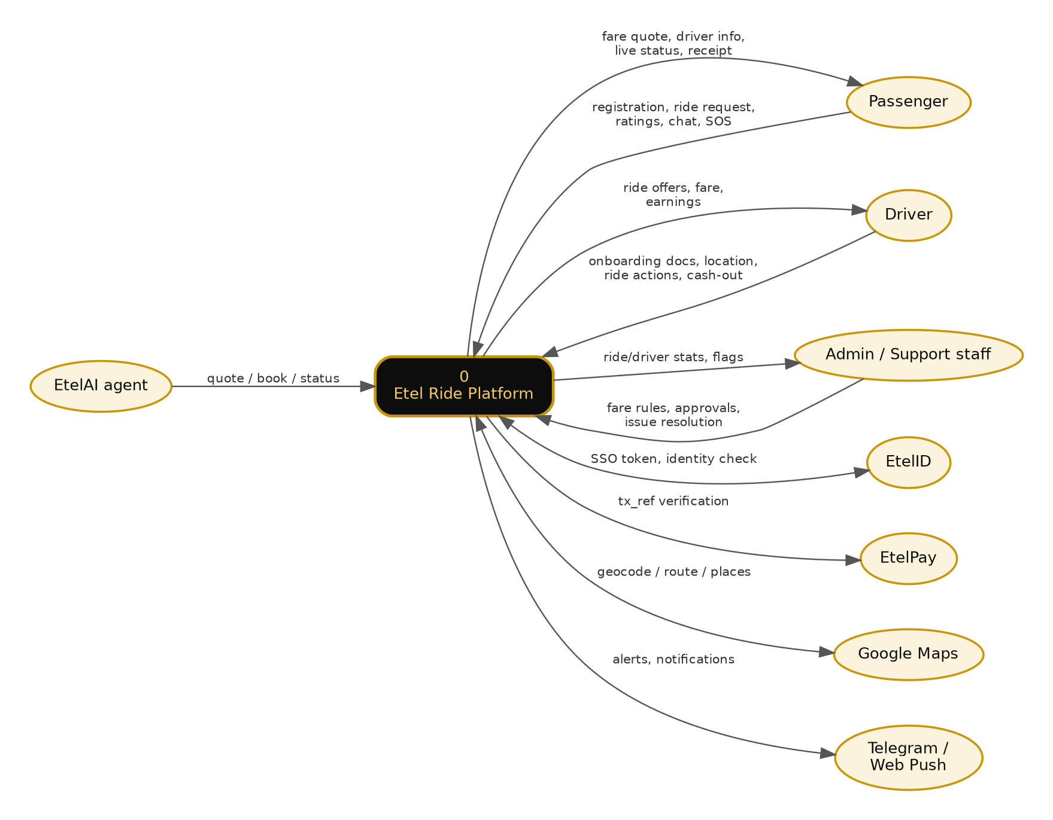
Figure 2 - Level 0 DFD: Etel Ride and its external entities

5.2 Level 1 - process decomposition
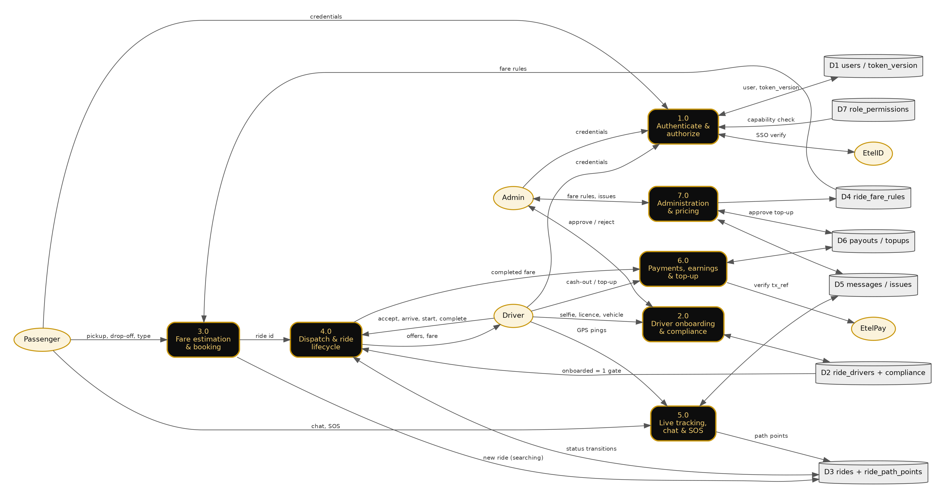
Figure 3 - Level 1 DFD: processes 1.0 to 7.0, data stores D1 to D7, external entities

6. Data Flow Explanation

6.1 External entities
Entity | Sends to Etel Ride | Receives from Etel Ride
Passenger | Registration, login, pickup and drop-off, vehicle type, chat, SOS, ratings | Fare quote, nearby drivers, driver details, live status and location, receipt
Driver | Onboarding documents (selfie, licence, vehicle), GPS pings, ride actions, cash-out and top-up requests | Ride offers, fare, earnings, announcements
Admin / support staff | Fare rules, driver and vehicle-change decisions, issue resolution, top-up approval | Ride and driver statistics, flagged identities, SOS and issue queues
EtelID | SSO token verification result, role check, NFC-tap ride start | SSO token, driver identity cross-check request
EtelPay | Transaction verification result | tx_ref, expected sender and amount
Google Maps | Map tiles, places, geocode results | Coordinates and address queries
EtelAI agent | Quote, book, status and cancel requests (service key) | Quote, ride status
Telegram / Web Push | - | Operational alerts and rider/driver notifications

6.2 Processes
1. 1.0 Authenticate and authorize. The user submits phone and password (or an EtelID SSO token). Login is rate-limited (login_attempts, keyed by phone). On success the server issues an HMAC-SHA256 bearer token embedding user id, issue time and the user's current token_version. Every later request passes through boot.php, which verifies the signature (hash_equals), the 7-day lifetime and that token_version still matches D1, so logout or password change revokes all tokens at once. Admin actions additionally check D7 (role_permissions) for the required capability.
2. 2.0 Driver onboarding and compliance. The driver uploads selfie, licence photo and vehicle details through upload.php (content-sniffed MIME whitelist, size cap, server-generated names). The identity is cross-checked with EtelID; mismatches are flagged for admin review. Admin approval sets ride_drivers.onboarded = 1 in D2. Later vehicle changes create a pending request and only take effect when an admin approves.
3. 3.0 Fare estimation and booking. The passenger sends pickup, drop-off and vehicle type. ride_fare.php reads the per-vehicle rules from D4, computes the fare server-side (client values are never trusted) and returns a quote. On booking, a ride row is written to D3 with status searching.
4. 4.0 Dispatch and ride lifecycle. hexgrid.php finds nearby online drivers. A driver must pass the onboarding gate (D2) before accepting. The ride moves searching, accepted, in_progress, arrived, completed or cancelled in D3; every transition checks that the caller owns the ride and that the previous status is valid, so a duplicate or replayed action is rejected. Stuck rides are closed by the sweeper and cron script.
5. 5.0 Live tracking, chat and SOS. The driver app posts GPS points, stored as ride_path_points in D3. SSE endpoints stream status and position to the two ride participants only. Chat messages, issues and SOS events are stored in D5; SOS and operational alerts are forwarded to staff through Telegram and Web Push.
6. 6.0 Payments, earnings and top-up. When the passenger confirms the trip (or, for cash rides, after a timeout) the fare is posted to the driver's earnings and a 5% commission is deducted from the driver's prepaid Etel Money balance. For an Etel Money top-up the driver supplies a tx_ref, which is verified server-to-server against EtelPay before a pending row is created in D6; the balance moves only after a second, independent admin approval. Cash-outs are recorded in D6.
7. 7.0 Administration and pricing. Capability-scoped admin actions edit fare rules (D4), resolve issues (D5), approve drivers and vehicle changes (D2) and approve top-ups (D6). Release channels control which app bundle version users receive.

6.3 Typical end-to-end flow (ride request)
1. Passenger app sends ride_estimate_fare to boot.php with its bearer token. boot.php authenticates, whitelists the action and dispatches to RideController.
2. RideController reads D4, computes the quote and returns it. The passenger confirms and book_ride writes a searching ride to D3.
3. Nearby drivers receive the request. A driver calls driver_accept_ride; the onboarding gate and an atomic status update ensure only one driver wins.
4. driver_start_ride moves the ride to in_progress; driver_update_location records the path while SSE keeps the passenger updated.
5. At the drop-off the driver calls driver_arrived (or driver_complete_ride), which stores the fare breakdown and moves the ride to arrived. The passenger confirms with customer_confirm_arrival (wallet payments are verified with EtelPay first); rides_complete_and_pay() then completes the ride, credits wallet-paid earnings, deducts the 5% commission from the driver's Etel Money balance, and the passenger can rate. If the passenger never confirms, the sweeper completes cash rides after a timeout.

6.4 Data in transit and at rest
• All client-server and server-server traffic uses HTTPS; bearer tokens travel in the Authorization header only.
• Passwords are stored hashed; tokens are not stored server-side, only the per-user token_version.
• All SQL is parameterised; dynamic identifiers come from fixed whitelists.
• Uploaded documents are stored under server-generated names; runtime deploy backups are blocked from web access (Require all denied).
• Service-to-service calls use a shared key compared with hash_equals(), with a query-parameter fallback for hosts that strip custom headers.

7. Module Design (Ride-relevant)

7.1 AuthController — Identity & Session
Handles register, login, etelid_login, admin_etelid_login, change_password. Shared unchanged with Etel Delivery. Implements a custom bearer-token scheme (not PHP sessions, not JWT): gen_token()/verify_token() in boot.php produce an HMAC-SHA256-signed token embedding user_id, issued_at, and a token_version counter, giving immediate server-side revocation on logout or password change without a token blacklist table.

7.2 RideController — Ride-Hailing Lifecycle
The largest Ride-relevant module (65 actions, ~210KB). Covers fare estimation and locking, nearby-driver discovery (hex-grid matching), booking, the full driver-side state machine (accept → start → arrived at drop-off → passenger confirms → completed), cancellation, rating, in-ride chat, live GPS path tracking, SOS, favorite routes, scheduled rides, driver earnings/cashout/Etel Money top-up, driver compliance documents, and driver vehicle-change requests. Design note: rides_require_onboarded() is a single shared gate function applied to every driver-privileged action, added specifically so that onboarding-completeness is enforced in exactly one place rather than duplicated per action.

7.3 AdminController — Ride-Relevant Subset
Administration is capability-scoped: every action is gated through require_admin($pdo, 'capability'), checking both the admin role and a specific capability string against the role_permissions table. Ride-relevant capabilities configure ride fare rules and pricing, and resolve ride/driver issues. The same controller also serves Delivery-only administration (order/service-giver/zone management) — those actions are out of scope for this document, but are noted here for transparency since they live in the same file and share the same capability-checking mechanism.

7.4 EqubController — Rotating Savings
19 actions implementing a traditional Ethiopian Equb (rotating savings group) as a benefit available to drivers (and, out of scope here, couriers). Group create/join/leave/start, package selection, contribution tracking, payout rounds, plus admin-side participant/access management.

7.5 AgentController — EtelAI Integration (Ride actions)
agent_ride_quote, agent_book_ride, agent_ride_status, agent_cancel_ride. Every action requires a shared service key (constant-time hash_equals() check against ETELID_SERVICE_KEY); member-specific actions additionally resolve a real etel_sso_token to a specific local user. This controller also exposes Delivery-order actions (agent_order_quote, agent_place_order, etc.), out of scope here.

7.6 NfcController — EtelID NFC Bridge (Ride action)
nfc_start_ride, gated only by the shared service key with no independent role check — a deliberate design choice trusting that EtelID has already verified the scanning party's role before calling in, and independently re-verifying the resolved driver's onboarding status before allowing the ride to start. This controller also exposes courier pickup/delivery confirmation actions for Delivery, out of scope here.

8. Data Architecture (Ride-relevant tables)
Server-Sent Events (SSE) endpoints (sse_ride_status, sse_driver_stream) push live ride status/driver location updates to connected clients, avoiding client-side polling.
Entity | Key relationships | Notes
users | 1—1 ride_drivers (via user_id) | Shared identity table for all roles; role column distinguishes passenger/driver/admin. Also used by Delivery (customer/courier/service_giver roles), out of scope here.
rides | N—1 users (passenger_id), N—1 users (driver_id) | Core ride-hailing entity; status searching/accepted/in_progress/arrived/completed/cancelled (created as an ENUM, widened to VARCHAR at runtime)
ride_drivers | 1—1 users | Driver profile: vehicle, identity verification, onboarded flag, earnings
ride_path_points | N—1 rides | GPS breadcrumb trail
ride_fare_rules | referenced by vehicle_type | Per-vehicle-type fare configuration (base fare, per-km rate, wait rate, min fare)
driver_compliance_requests / driver_vehicle_change_requests | N—1 users (driver) | Admin-approved change workflows
driver_payouts / driver_etel_money_topups | N—1 users (driver) | Cash-out and wallet top-up records
ride_messages / ride_typing | N—1 rides | In-ride chat
equb_groups / equb_members / equb_contributions | N—N users via equb_members | Rotating savings (drivers and couriers)
role_permissions | referenced by role_name string, not FK | Capability list per admin role/staff_role

9. Interface Design

9.1 Internal interfaces (client to server)
Server-Sent Events (SSE) endpoints (sse_ride_status, sse_driver_stream) push live ride status/driver location updates to connected clients, avoiding client-side polling.

9.2 External interfaces
System | Direction | Purpose | Auth mechanism
EtelID | Inbound + Outbound | SSO login, driver identity cross-check, NFC-tap ride-start | Shared service key (both directions)
EtelPay | Outbound | Verify driver Etel Money top-up transaction references | etel_pay_verify_tx() server-to-server call
Telegram Bot API | Outbound | Operational alerting | Bot token
Web Push (VAPID) | Outbound | Browser push notifications | VAPID key pair

9.3 Real-time interfaces
Server-Sent Events (SSE) endpoints (sse_ride_status, sse_driver_stream) push live ride status/driver location updates to connected clients, avoiding client-side polling.

10. Deployment Architecture

10.1 Hosting topology
sw.js implements cache-first for static assets, network-first-with-5-minute-cache for API calls, and a dedicated offline fallback page for navigation. CACHE_NAME must be bumped on every deploy that changes cached files, or clients will continue serving stale bundles despite a successful server-side deploy.

10.2 Release and rollout model
This SDD's modules (Section 2) map 1:1 to the Functional Requirements groups in the SRS and to the controller files cited throughout. The full per-action API contract detail for Ride is maintained in the companion Technical Specifications (TDD/LLD) document.

10.3 Offline / PWA behavior
sw.js implements cache-first for static assets, network-first-with-5-minute-cache for API calls, and a dedicated offline fallback page for navigation. CACHE_NAME must be bumped on every deploy that changes cached files, or clients will continue serving stale bundles despite a successful server-side deploy.

11. Traceability
This SDD's modules (Section 2) map 1:1 to the Functional Requirements groups in the SRS and to the controller files cited throughout. The full per-action API contract detail for Ride is maintained in the companion Technical Specifications (TDD/LLD) document.

