INSA Web Application Security Audit Package
ETEL-ID — Etel Group Digital Identity & Membership Platform
Prepared for submission to the Information Network Security Agency (INSA), Ethiopia
Structured per INSA's Web Applications Audit Request Requirements Document (OF/AEAD/001)
Etel Family Technology and Business Group
Hawassa, Sidama National Regional State, Ethiopia
Prepared by: Dagmawi Dikasso Aydiko (Dagi) — Founder / Technical Architect
Live system: ethelmarket.com/EtelId/
2026-09-16

0. How to Use This Document
This package follows the same structure as the ETEL Delivery & Ride INSA Audit Package, mirroring INSA's Web Applications Audit Request Requirements Document (OF/AEAD/001), so it can be submitted through INSA's Audit Request Portal (cyberaudit.insa.gov.et) with minimal rework.
Sections in black text are filled in from what is already known about the ETEL-ID platform, including the outcome of a full manual security review completed and fixed in September 2026 (see Section 7).
Sections in red italics marked [TO COMPLETE: ...] need a decision, a real value, or a document that only exists outside this narrative — fill these in before submitting.
ETEL-ID is the shared identity/SSO root every other Etel Group product (Delivery & Ride, Etel Pay, EtelGebeya, EtelTaxi, Madeya, EtelAI) authenticates its members against. Because of that role, its security posture should be reviewed by INSA either as its own submission (this package) or as a technical annex referenced by every other product's submission — confirm the exact scoping directly with INSA's Audit Division before submitting all of them.

1. Legal and Administrative Documents (Mandatory)
Per INSA requirement 4.1, attach the following as separate scanned files with this submission. This is the same legal entity that operates ETEL Delivery & Ride, ETEL-ID, and every other Etel Group product — one set of documents covers all submissions.
Document | Status
Updated Trade License (for the legal entity operating ETEL-ID) | Attached separately (scanned PDF) — Business License, Sidama National Regional State Trade and Market Development Bureau, Hawassa City. Principal Registration No. SMD/STMB/1/0042554/2018, issued 14/12/2018, in the name of Etel Family Technology and Business Group (Owner: Degimaw Dikaso Aydiko).
TIN Number or National ID | Attached separately (scanned PDF, same certificate as above) — TIN 0073428763.
System/Product Patent Certificate | Not applicable unless one has been filed — leave blank if none exists.

2. Business Architecture and Design

2.1 Data Flow Diagram — Context Level (Level 0)
Shows ETEL-ID as a single process and every external entity it exchanges data with. Member-facing traffic (registration, login, biometric enrollment) comes from the public internet; sibling-app traffic (SSO) is server-to-server, authenticated with a shared service key rather than a member session.
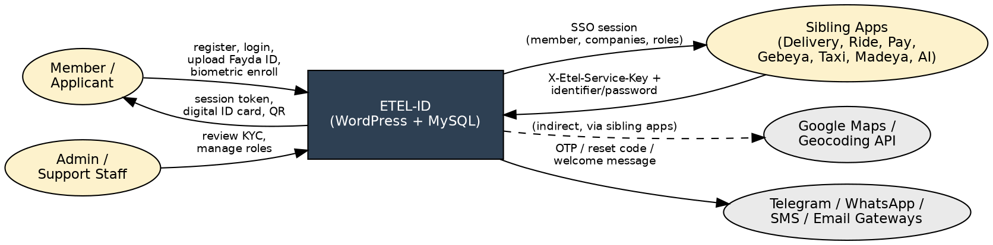
Figure 1 — Context-level Data Flow Diagram (Level 0)

2.2 Data Flow Diagram — Detailed (Level 1)
Breaks the single ETEL-ID process into its five main functional processes and the database tables each one reads from or writes to.
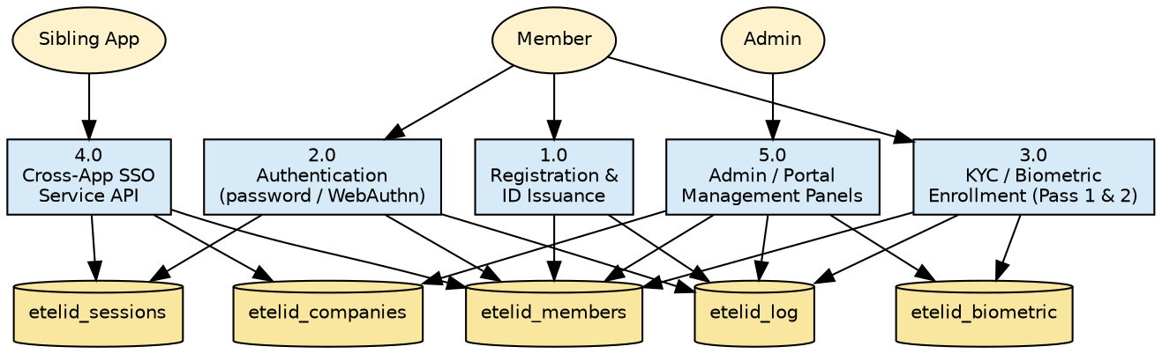
Figure 2 — Detailed Data Flow Diagram (Level 1)

2.3 System Architecture Diagram
ETEL-ID runs as a WordPress plugin (PHP 8.1) on the same shared cPanel hosting account as the rest of the Etel Group stack, with its own MySQL database. It is reached three ways: the member/admin-facing WordPress AJAX layer (session-cookie authenticated), a REST Service API under the etelid/v1 namespace (shared-secret authenticated, used by every sibling app for SSO), and two standalone non-WordPress gateway scripts (etel-os.php, etel-api.php) kept for backward compatibility with older integrations.
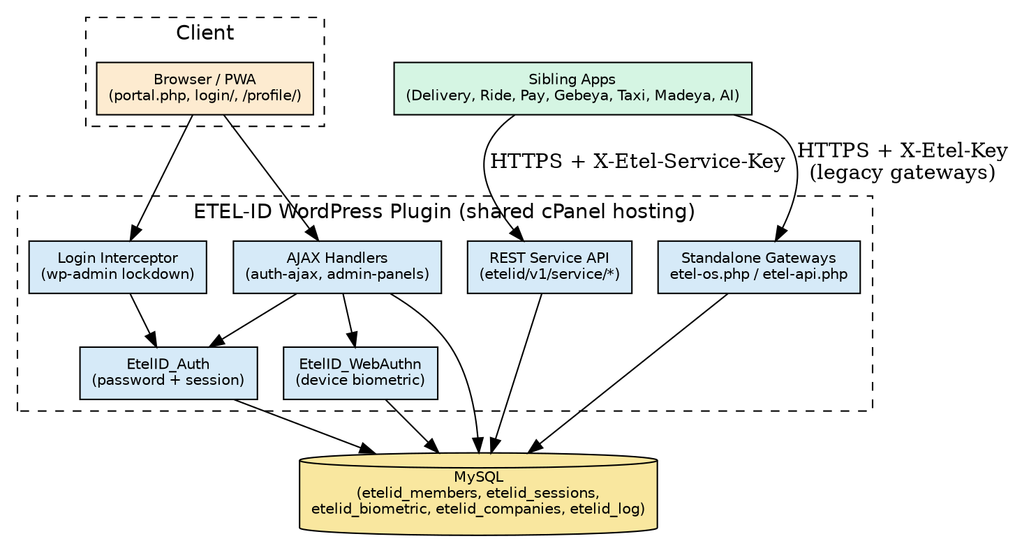
Figure 3 — System Architecture Diagram

Security layers already in place
- Passwords hashed with bcrypt (password_hash / PASSWORD_BCRYPT); legacy SHA-256 hashes transparently upgraded to bcrypt on next successful login.
- Session tokens stored as SHA-256 hashes in the database, never in plaintext — a stolen DB dump/backup alone cannot be used to hijack an active session.
- Two-tier brute-force protection (per-IP and per-account) on every login and password-reset path, including the cross-app Service API and both standalone gateways.
- Real WebAuthn (Face ID / Touch ID / Android biometric / Windows Hello) support with full origin, RP-ID, challenge, and signature verification, plus clone/replay detection via the authenticator's sign counter.
- CSRF protection (WordPress nonces) on every state-changing AJAX action; session cookies set httponly + secure + SameSite=Lax.
- Cross-app SSO gated by a shared X-Etel-Service-Key header, compared with constant-time hash_equals(), fails closed (503) if the key was never configured.
- Admin-only panels (Members, Pages, Media, Menus, Branding, Company Roles, Biometric Center) gated by an explicit is_site_admin() check on every single handler, independent of WordPress's own user/role system — an EtelID admin does not need to also be a WordPress user.
- An emergency wp-admin recovery path (for when no WordPress Administrator account is linked yet) requires the visitor to already hold a valid ETEL-ID session that passes the same admin check, and uses a per-install random secret rather than a fixed one.

Known open items (disclose — INSA audits are more useful when these are flagged upfront, not discovered)
- etel-os.php and etel-api.php are two independent, non-WordPress "gateway" scripts that duplicate the Service API's login/session logic for older integrations. They receive security fixes on the same schedule as the main plugin, but as standalone files they are easy to forget when a future hardening pass only touches the WordPress-side classes — recommend retiring them once every sibling app has migrated to the REST Service API.
- IP-based rate limiting trusts the X-Forwarded-For / CF-Connecting-IP headers (validated as well-formed IPs, with REMOTE_ADDR as a safe fallback) but cannot itself prove the request actually passed through a trusted reverse proxy — full protection depends on the hosting firewall accepting inbound traffic only from that proxy's IP ranges, which is an infrastructure setting outside this codebase's control.
[TO COMPLETE: Confirm whether shared cPanel hosting for ethelmarket.com currently restricts inbound traffic to a known CDN/proxy range, or document that it does not (accepted risk).]

2.4 Entity Relationship Diagram (ERD)
Core tables: etelid_members (one row per registered person, the source of truth every sibling app resolves against), etelid_sessions (SSO session tokens, stored hashed), etelid_biometric (WebAuthn credentials + liveness/KYC level), etelid_companies (which Etel Group company/role each member is linked to — this is what determines payout recipients and staff access across the whole group), etelid_log (full audit trail of every login/registration/status change), and etelid_password_resets (single-use, time-boxed reset codes, stored hashed).
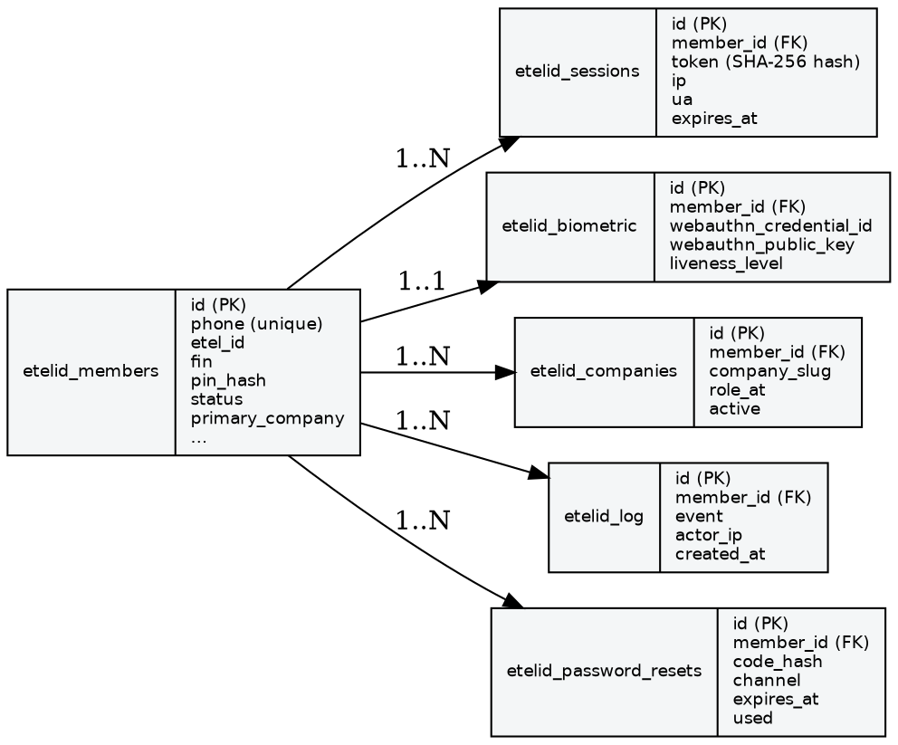
Figure 4 — Entity Relationship Diagram (ERD)

3. Features of the Web Application
- Self-service registration (full form and a fast "Quick Register" path) issuing a unique Etel-ID, FIN, and a printable/QR-verifiable digital ID card.
- Phone + password login, with transparent legacy-hash upgrade, plus passwordless login via real device biometrics (WebAuthn/Face ID/Touch ID/Android biometric/Windows Hello).
- Self-service password reset via a 6-digit code delivered over email, Telegram, WhatsApp, or SMS, with an escalating attempt schedule and anti-enumeration responses (never reveals whether an identifier exists).
- Two-pass KYC: Pass 1 (Fayda national ID front/back capture, either self-service or admin quick-register) and Pass 2 (face biometric + occupation/income/next-of-kin info, unlocking Etel Pay).
- Member portal: profile management, digital ID card + QR code, company/role memberships, recent activity log, password change.
- Cross-app single sign-on: every sibling Etel Group app (Delivery, Ride, Pay, Gebeya, Taxi, Madeya, EtelAI) authenticates its members through ETEL-ID rather than maintaining separate credentials.
- In-portal admin tools (no wp-admin needed) for Members, Pages, Media, Menus, Branding, Company Roles, and a Biometric Center for reviewing/revoking WebAuthn credentials and physical NFC cards.
- Company Roles registry — the canonical record of who is admin/owner/staff for each Etel Group company, which sibling apps query to resolve payout recipients and staff access.
- Telegram/WhatsApp/SMS delivery integrations for OTPs, reset codes, and welcome messages.

4. Testing Scope (Mandatory)
In scope: the ETEL-ID WordPress plugin end to end — public registration/login/reset flows, the member portal, all AJAX and REST endpoints, the admin panels, and the two standalone gateway scripts (etel-os.php, etel-api.php). Explicitly in scope given ETEL-ID's role as shared infrastructure: the cross-app Service API (etelid/v1/service/*) used for SSO by every sibling product.
Out of scope for this submission: the sibling applications themselves (Delivery & Ride, Etel Pay, EtelGebeya, EtelTaxi, Madeya, EtelAI) — each is covered by its own separate INSA submission. The underlying shared cPanel hosting infrastructure (network firewall, WAF configuration, server hardening) is also out of scope for this application-level submission.
[TO COMPLETE: Confirm with INSA whether they want a live penetration test against a staging copy, or a code-level review against this repository plus the architecture described here.]

5. Security Functionality Document

5.1 User roles and access control
- Member — the default role for anyone who registers; can only read/write their own profile, biometric enrollment, and company-role memberships.
- Site Admin — a single designated member (etelid_admin_member_id in Settings), independent of WordPress's own role system; every admin-panel AJAX handler checks this explicitly (EtelID_Auth::is_site_admin()) rather than relying on a WordPress capability alone.
- WordPress Administrator — the underlying CMS role, only reachable by the designated Site Admin member (auto-bridged on login) or by someone who already holds a real WordPress session.
- Sibling-app service accounts — not member accounts at all; authenticated purely by the shared X-Etel-Service-Key header, scoped to the Service API's server-to-server routes only.

5.2 Input validation and sanitization
- All WordPress-side database access goes through $wpdb->prepare() with parameterized placeholders; the standalone gateways use PDO prepared statements — no string-concatenated SQL anywhere in the codebase.
- Phone numbers normalized and matched against Ethiopian mobile formats (9/10/12-digit variants) before any lookup.
- Uploaded Fayda ID / profile / face images validated as real data:image/* payloads before being stored, never trusted as arbitrary base64 blobs.
- Every AJAX handler validates required fields server-side and returns field-specific error messages rather than trusting client-side validation alone.

5.3 Session management
- Session tokens are 32-byte cryptographically random values (random_bytes), stored only as their SHA-256 hash; the raw token exists only in the httponly session cookie and in the one-time response handed to a sibling app on SSO login.
- Sessions expire after 30 days server-side; expired rows are purged on every login. An IP change on an existing session is logged (not hard-blocked, to avoid false-positives for mobile users switching networks) so an admin reviewing etelid_log has a real signal to act on.
- CSRF protection via WordPress nonces on every state-changing action; session cookies set httponly + secure (when served over HTTPS) + SameSite=Lax.

5.4 Error handling and logging
- Every authentication event (login, login_failed, password reset requested/completed, rate-limited attempts, role changes, admin actions) is written to etelid_log with the acting member, IP, and a human-readable detail string — a full audit trail for incident review.
- User-facing error messages are deliberately generic where specificity would leak information (e.g. password reset never reveals whether an identifier exists); internal exceptions are caught and logged server-side rather than surfaced to the client.

5.5 Secure communications
- All member-facing and sibling-app traffic is expected over HTTPS (session cookies conditionally set secure via is_ssl()); WebAuthn additionally verifies the request origin and relying-party ID cryptographically, independent of transport security.
- Cross-app SSO calls use a shared secret header rather than any credential in the URL/query string, compared with a constant-time comparison to avoid timing side-channels.

6. Secure Coding Standard Documentation (if available)
No formal written secure-coding standard document exists yet. In practice, the codebase follows a consistent set of conventions enforced through code review during development: parameterized queries only, bcrypt for all password/PIN hashing, hash_equals() for every secret comparison, fail-closed behavior on missing/placeholder configuration (documented per-finding in Section 7), and an explicit admin-capability check on every privileged handler rather than relying on any single global gate.
[TO COMPLETE: Decide whether to formalize the above conventions into a written secure-coding standard document before submission, or submit this section as-is with a note that conventions are enforced through review rather than a standalone document.]

7. Previous Security Testing Reports (if available)
A full manual security review of the ETEL-ID codebase was completed in September 2026, covering every authentication, session, and admin-privileged code path. Seven findings were identified and fixed prior to this submission:
Severity | Finding | Resolution
Critical | Cross-app login gateway (etel-os.php) had no rate limiting at all — an unthrottled password-guessing surface. | Added the same two-tier (per-IP + per-account) brute-force shield used everywhere else in the system.
Critical | Two standalone gateway scripts stored session tokens in plaintext, reintroducing a vulnerability already fixed elsewhere. | Switched both to SHA-256-hashed storage, matching the main plugin.
High | One gateway compared its shared API key with a non-constant-time operator. | Switched to hash_equals().
High | Both gateways treated the literal placeholder 'CHANGE_ME' as a usable key if unconfigured. | Both now fail closed (HTTP 503) instead.
Medium | Rate-limiting IP resolution trusted client-supplied proxy headers unconditionally. | Validated as well-formed IPs with REMOTE_ADDR as a safe fallback.
Medium | An emergency wp-admin recovery URL granted its bypass cookie to any anonymous visitor with no identity check. | Now requires an already-authenticated ETEL-ID admin session; secret changed to a per-install random value.
Low | A stray, unreferenced duplicate file left in production. | Removed.

A one-line follow-up inconsistency (password-reset minimum length not matching registration's minimum) was found and fixed in the same review cycle. No further findings are open as of this submission.
[TO COMPLETE: Attach the full internal audit write-up as a separate annex if INSA requests supporting detail beyond this summary table.]

8. API Security Audit Requirements

8.1 API type and format
Two API styles coexist: a WordPress AJAX layer (admin-ajax.php, action-based, JSON in/out) for member/admin-facing features, and a REST API under the etelid/v1 namespace (WP REST API, JSON) for cross-app Service calls. Two legacy standalone JSON endpoints (etel-os.php, etel-api.php) exist outside WordPress entirely for older sibling-app integrations.

8.2 Authentication mechanism
- Member-facing AJAX: httponly session cookie (etelid_session) + WordPress nonce per action.
- Service API (etelid/v1/service/*): shared secret in the X-Etel-Service-Key header, checked with hash_equals(), fails closed if unconfigured.
- Standalone gateways: shared secret in X-Etel-Key (or a form field), also hash_equals()-compared and fail-closed as of the September 2026 fixes.
- WebAuthn endpoints: cryptographic signature verification (ES256/P-256) against a stored public key, independent of any shared secret.

8.3 Endpoint inventory
Full per-endpoint detail is in Section 8.6 below. Summary by surface:
Surface | Endpoint count | Auth model
WordPress AJAX (auth-ajax.php) | 14 actions | Session cookie + nonce (public actions additionally rate-limited)
WordPress AJAX (admin-panels.php) | 24 actions | Session cookie + nonce + is_site_admin()
REST Service API (etelid/v1/service/*) | 9 routes | X-Etel-Service-Key (hash_equals, fail-closed)
Standalone gateways (etel-os.php, etel-api.php) | ~15 actions combined | X-Etel-Key / X-Etel-Service-Key (hash_equals, fail-closed) + per-IP/account rate limiting on login

8.4 Third-party integrations affecting API security
- Telegram Bot API — password reset codes and welcome messages, bot token stored server-side, never exposed to the client.
- Meta WhatsApp Cloud API — reset codes via an approved Authentication-category template, permanent System User access token.
- Africa's Talking SMS API — reset codes and OTPs to Ethiopian mobile numbers, API key stored server-side.
- Sibling Etel Group apps (Delivery, Ride, Pay, Gebeya, Taxi, Madeya, EtelAI) — the primary consumers of the Service API, authenticated with the shared service key.

8.5 Test account for API testing
[TO COMPLETE: Provide one live test account (phone + password) with a normal Member role, and confirm whether a second, admin-role test account should also be provided for testing the admin-panel endpoints. Same credential-sharing pattern used in the Delivery & Ride submission applies here.]

8.6 Full API Endpoint Inventory

8.6.1 includes/class-etelid-auth-ajax.php — member-facing AJAX actions
etelid_auth_register, etelid_quick_register, etelid_auth_login, etelid_auth_logout, etelid_auth_portal_data, etelid_auth_change_password, etelid_profile_update, etelid_pass2_submit, etelid_fayda_id_submit, etelid_fayda_quick_register, etelid_webauthn_register_options, etelid_webauthn_register_verify, etelid_webauthn_login_options, etelid_webauthn_login_verify. Registration, login, and WebAuthn login options are rate-limited per IP (and per-account for login); fayda_quick_register additionally requires is_site_admin().

8.6.2 includes/class-etelid-admin-panels.php — admin-only in-portal panels
24 actions across Members Controller, Pages, Media, Menus, Branding, Company Roles, and the Biometric Center (e.g. etelid_panel_members_list, etelid_panel_members_update, etelid_panel_reset_password, etelid_panel_company_roles_set, etelid_panel_biometric_webauthn_revoke). Every single handler calls a shared guard() that requires a valid nonce, a valid current ETEL-ID session, and is_site_admin() on that session — verified line-by-line during the September 2026 review.

8.6.3 includes/class-etelid-service-api.php — cross-app REST Service API (etelid/v1/service/*)
resolve, authenticate (the actual cross-app SSO login path), company_admin, check_role, list_company_roles, set_company_role, remove_company_role, member_count, list_companies. All nine routes share one permission_callback (check_service_key) that hash_equals()-compares X-Etel-Service-Key against the configured secret (plus one rotation-grace old-key check) and fails closed if no key is configured at all. authenticate() additionally rate-limits per IP and per identifier before touching the database.

8.6.4 etel-os.php — standalone cross-app gateway (legacy)
ping (public), login (public, now rate-limited), verify_token, logout (public — both scoped to the presented token itself), stats, get_members, get_member, get_log, set_status, ai_query (all auth()-gated with X-Etel-Key, hash_equals, fail-closed on the 'CHANGE_ME' placeholder as of the September 2026 fix).

8.6.5 etel-api.php — standalone cross-app gateway (legacy, direct MySQL, no WordPress bootstrap)
status (public), login (public, rate-limited per IP and per member_id), verify_token, logout, stats (hash_equals-gated, fail-closed on the placeholder key). Session tokens are SHA-256-hashed on write and on lookup as of the September 2026 fix, consistent with the WordPress-side session table.

8.6.6 includes/class-etelid-password-reset.php — self-service and admin-issued password reset
etelid_forgot_password and etelid_reset_password are public but anti-enumeration (identical generic response whether or not the identifier exists) and rate-limited on three independent tiers (per-IP, per-IP-per-identifier, and an escalating per-account schedule capping at 7 attempts before requiring support intervention). etelid_admin_issue_reset_link bypasses the schedule but is gated by is_site_admin() internally.

8.6.7 includes/class-etelid-login-interceptor.php — wp-admin/wp-login.php lockdown
Not an API endpoint in the traditional sense, but governs access to the underlying WordPress admin surface: only the designated Site Admin member (or an existing WordPress session) can reach wp-admin; everyone else is redirected to the member portal. The emergency recovery bypass (?etelid_admin_access=1) requires an already-authenticated Site Admin session as of the September 2026 fix.

8.7 Sample Request/Response Pairs

8.7.1 Cross-app SSO login — POST /wp-json/etelid/v1/service/authenticate
[TO COMPLETE: Capture a real request/response pair (with the test account from 8.5) once credentials are provided — header X-Etel-Service-Key: <shared secret>, body { "identifier": "<phone>", "password": "<password>", "create_session": true }.]

8.7.2 Member login (portal) — POST /wp-admin/admin-ajax.php?action=etelid_auth_login
[TO COMPLETE: Capture a real request/response pair — body { phone, password, nonce }, response includes redirect and sso_token on success.]

8.7.3 Company role lookup — POST /wp-json/etelid/v1/service/check_role
[TO COMPLETE: Capture a real request/response pair — header X-Etel-Service-Key, body { "company_slug": "<slug>", "phone": "<phone>" }.]

9. Contact Information
Name | Role | Email | Phone
Dagmawi Dikasso Aydiko (Dagi) | Founder / Technical Architect | dagmawidikasso16@gmail.com | +251 924 445 206

10. Submission Checklist
- ☐ Trade License + TIN scanned PDF attached (Section 1)
- ☐ Diagrams reviewed for accuracy against the live system (Section 2)
- ☐ Testing scope confirmed with INSA — live pentest vs. code review (Section 4)
- ☐ Test account credentials filled in (Section 8.5)
- ☐ Sample request/response pairs captured with real test credentials (Section 8.7)
- ☐ Confirmed with INSA whether this is a standalone submission or an annex to every sibling app's submission (Section 0)
- ☐ Final read-through for any remaining [TO COMPLETE] markers before submitting

