
INSA Web Application Security Audit Package
EtelGebeya — Etel Group Multi-Vendor Marketplace Platform
Prepared for submission to the Information Network Security Agency (INSA), Ethiopia
Structured per INSA's Web Applications Audit Request Requirements Document (OF/AEAD/001)
Etel Family Technology and Business Group
Hawassa, Sidama National Regional State, Ethiopia
Prepared by: Dagmawi Dikasso Aydiko (Dagi) — Founder / Technical Architect
Live system: ethelmarket.com/EtelGebeya/
2026-09-18

0. How to Use This Document
This package follows the same structure as the ETEL Delivery & Ride and ETEL-ID INSA Audit Packages, mirroring INSA's Web Applications Audit Request Requirements Document (OF/AEAD/001), so it can be submitted through INSA's Audit Request Portal (cyberaudit.insa.gov.et) with minimal rework.
Sections in black text are filled in from what is already known about the EtelGebeya platform, including the outcome of a full code-level security review completed and fixed in September 2026 (see Section 7, full detail in docs/INSA_FINDINGS_EtelGebeya.md).
Sections in red italics marked [TO COMPLETE: ...] need a decision, a real value, or a document that only exists outside this narrative — fill these in before submitting.
EtelGebeya is a multi-vendor marketplace: customers browse and buy from independent vendors, vendors manage their own catalog/orders/payouts, and payment moves through Etel Pay's escrow so funds are only released to a vendor once an order is confirmed. It authenticates through ETEL-ID for SSO and is one of the sibling products ETEL-ID's own submission references — confirm the exact scoping (standalone submission vs. annex) directly with INSA's Audit Division before submitting all of them.

1. Legal and Administrative Documents (Mandatory)
Per INSA requirement 4.1, attach the following as separate scanned files with this submission. This is the same legal entity that operates ETEL Delivery & Ride, ETEL-ID, and every other Etel Group product — one set of documents covers all submissions.
Document | Status
Updated Trade License (for the legal entity operating EtelGebeya) | Attached separately (scanned PDF) — Business License, Sidama National Regional State Trade and Market Development Bureau, Hawassa City. Principal Registration No. SMD/STMB/1/0042554/2018, issued 14/12/2018, in the name of Etel Family Technology and Business Group (Owner: Degimaw Dikaso Aydiko).
TIN Number or National ID | Attached separately (scanned PDF, same certificate as above) — TIN 0073428763.
System/Product Patent Certificate | Not applicable unless one has been filed — leave blank if none exists.

2. Business Architecture and Design

2.1 Data Flow Diagram — Context Level (Level 0)
Shows EtelGebeya as a single process and every external entity it exchanges data with. Customer/vendor/admin traffic comes from the public internet through role-specific panels; ETEL-ID handles the SSO login exchange, Etel Pay handles wallet charges and escrow hold/release, and Nominatim (OpenStreetMap) is proxied server-side for address search during checkout.
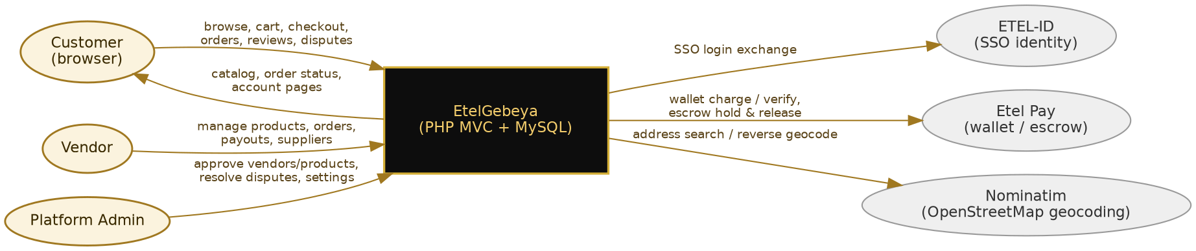
Figure 1 — Context-level Data Flow Diagram (Level 0)

2.2 Data Flow Diagram — Detailed (Level 1)
Breaks the single EtelGebeya process into its five main functional processes (storefront/cart, checkout/escrow, order fulfillment, vendor panel, admin panel) and the database tables each one reads from or writes to.
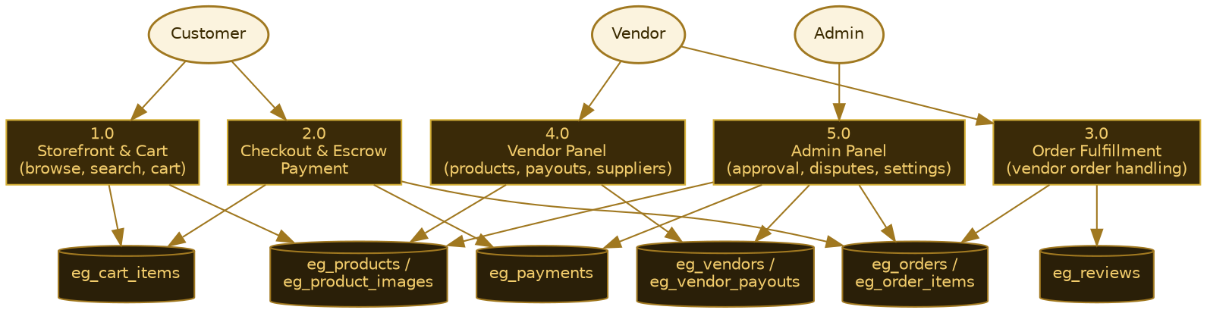
Figure 2 — Detailed Data Flow Diagram (Level 1)

2.3 System Architecture Diagram
EtelGebeya runs as a routed PHP 8.1 MVC application (public/index.php -> App\Core\Router -> app/Controllers) on the same shared cPanel hosting account as the rest of the Etel Group stack, with its own MySQL database. A separate legacy flat action-dispatch API (api/admin.php) drives the static admin.html/admin-panel.js dashboard the platform team actually uses day to day, running alongside the newer MVC-routed /admin/* pages.
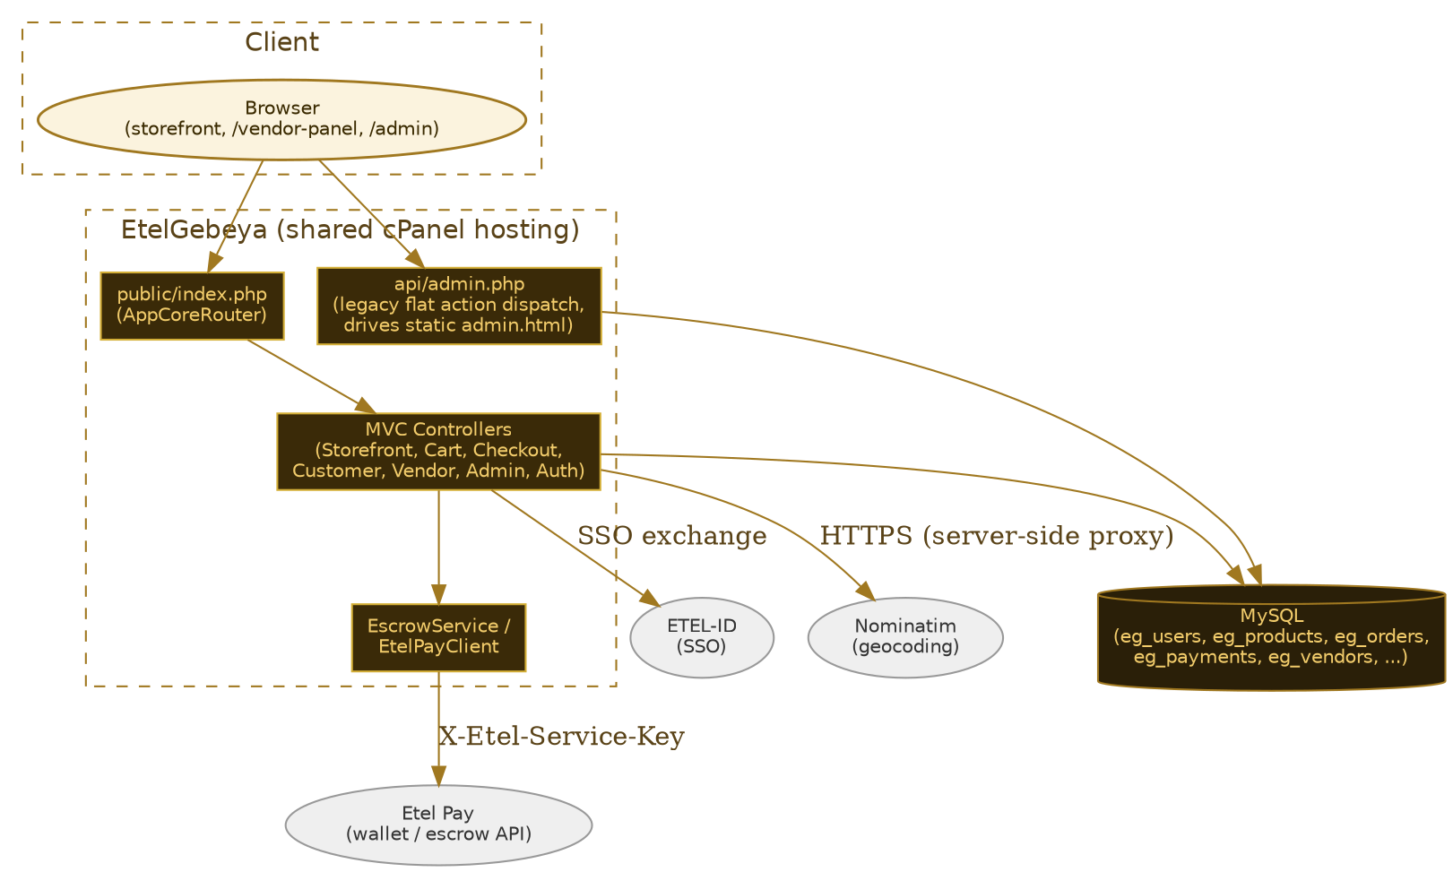
Figure 3 — System Architecture Diagram

Security layers already in place
- Authorization enforced server-side on every controller action, never relied on client-side (JS) checks alone — AdminController gates every action through a constructor guard() (login + isAdmin()), VendorController scopes every query to the caller's own seller_id, CustomerController scopes every query to the caller's own user_id.
- All database access is fully parameterized (PDO with PDO::ATTR_EMULATE_PREPARES => false); a full sweep of every query in every controller/model found zero instances of unwhitelisted dynamic SQL.
- Consistent output escaping — every render path that touches account-holder-chosen free text routes through a single global e() helper (htmlspecialchars with ENT_QUOTES | ENT_SUBSTITUTE), including the legacy admin-panel.js dashboard's own hoisted e() function.
- Session cookies set httponly, SameSite=Strict, and conditionally secure; session ID regenerated on login (session_regenerate_id(true)); a banned account's session is invalidated on its very next request, not just at next login.
- CSRF tokens (32 random bytes, hash_equals() comparison) required on state-changing MVC actions; the legacy api/admin.php requires either the timing-safe-compared master secret or a real per-admin session token scoped by capability.
- Checkout totals and escrow payments are re-derived and re-verified entirely server-side (EtelPayClient::verifyEscrowTx()/verifyTx()) — the client's displayed total/discount/tx_ref is never trusted on its own.
- Login rate limiting (5 failures / 15 min per IP, 10 failures / 15 min per email) against a login_attempts table before allowing another attempt.

Known open items (disclose — INSA audits are more useful when these are flagged upfront, not discovered)
- PaymentController and CourierController are referenced by the router (/payments/*, /courier/* routes) but the controller classes do not exist in the codebase — hitting those routes currently throws and is caught by a generic 500 handler. Not an exposure in itself, but these are dead code paths rather than "gated and safe" routes; needs a decision on whether they are upcoming features or should be removed from the router.
- /checkout/success/{code} looks up an order by its ref code alone with no session/ownership check — a deliberate "guest checkout receipt page" pattern common to e-commerce sites, but the order code's ~24 bits of entropy is worth a conscious sizing decision at the platform's expected scale rather than an unexamined default.
[TO COMPLETE: Confirm whether shared cPanel hosting for ethelmarket.com currently restricts inbound traffic to a known CDN/proxy range, or document that it does not (accepted risk) — same open item already disclosed in the ETEL-ID and Delivery & Ride submissions.]

2.4 Entity Relationship Diagram (ERD)
Core tables: eg_users (customers and vendor owners), eg_vendors (one row per approved seller, linked 1:1 to a user), eg_products / eg_product_images / eg_product_variants (vendor catalog), eg_orders / eg_order_items / eg_order_vendors (a single checkout can span multiple vendors, split per-vendor), eg_payments (escrow transaction records), eg_vendor_payouts (admin-approved vendor withdrawals), and eg_reviews (one review per product per customer, enforced server-side).
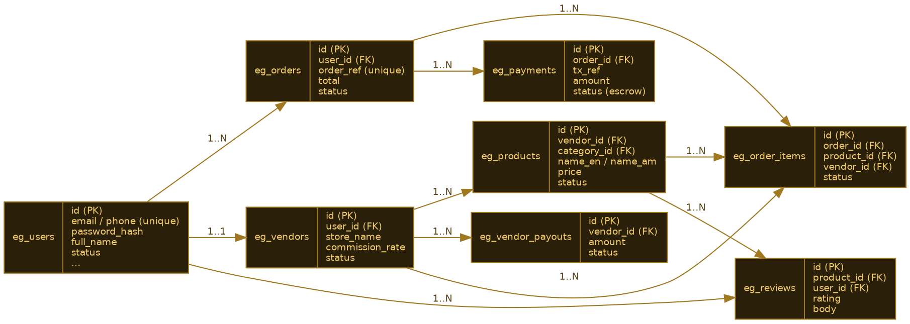
Figure 4 — Entity Relationship Diagram (ERD)

3. Features of the Web Application
- Public storefront: category browse, search, per-vendor storefronts, product detail pages with reviews.
- Session-based shopping cart and a checkout flow that splits a single order across multiple vendors, applies coupons, and computes shipping/service charges entirely server-side.
- Etel Pay wallet checkout with server-side escrow: funds are held in escrow at order placement and only released to a vendor once the customer confirms receipt (or a dispute is resolved by admin).
- Customer account area: order history, order detail/tracking, cancel/confirm-receipt/dispute actions, saved addresses, wishlist, profile, product reviews.
- Vendor panel: self-service signup (/sell), product CRUD with multi-image upload, order fulfillment (status updates, forward-to-supplier), a dropship supplier catalog import, payout requests, and store settings.
- Admin panel (two surfaces: MVC /admin/* pages and the primary static admin.html dashboard driven by api/admin.php): vendor/product approval queues, order and payment oversight, dispute resolution (moves real escrowed money), category/catalog/coupon management, per-admin role capabilities, and a self-hosted AI Code Audit tool (calls Gemini/OpenRouter to review the codebase on demand).
- ETEL-ID single sign-on login alongside local phone/email + password accounts; self-registration is hard-restricted to the customer/vendor roles only, with admin/vendor role grants for SSO users coming only from ETEL-ID's authenticated response, never the request body.

4. Testing Scope (Mandatory)
In scope: the EtelGebeya PHP/MySQL application end to end — the public storefront, cart/checkout, customer account area, vendor panel, both admin surfaces (MVC /admin/* and the legacy api/admin.php-driven dashboard), and the installer (/install).
Out of scope for this submission: the sibling applications themselves (ETEL-ID, Delivery & Ride, Etel Pay, EtelTaxi, Madeya, EtelAI) — each is covered by its own separate INSA submission. The underlying shared cPanel hosting infrastructure (network firewall, WAF configuration, server hardening) is also out of scope for this application-level submission.
[TO COMPLETE: Confirm with INSA whether they want a live penetration test against a staging copy, or a code-level review against this repository plus the architecture described here.]

5. Security Functionality Document

5.1 User roles and access control
- Customer — the default role for anyone who registers; every query is scoped to the caller's own user_id (orders, addresses, wishlist, reviews) — an order code or address id from the URL/body alone is never enough to read or mutate another customer's row.
- Vendor — auto-provisioned a sellers row on first visit to /vendor-panel, scoped to that seller's own seller_id on every query (products, orders, suppliers, payouts); ownership is re-checked server-side on every edit/delete even when the target id comes from the URL.
- Admin — every action in the MVC AdminController runs through a constructor guard() (login required, then isAdmin() required) with no per-action opt-out; the legacy api/admin.php gates every action through auth('capability') with per-role capability rows, falling back to a safe read-only baseline (not full access) for any managed admin role with no configured capabilities.
- Self-registration is hard-restricted to customer/vendor roles only (in_array() check against the client-supplied role); there is no path to self-register as admin, and SSO-granted admin/vendor roles come only from ETEL-ID's own authenticated response, never the request body.

5.2 Input validation and sanitization
- Zero instances found anywhere of a raw $_GET/$_POST value concatenated directly into a SQL string, across every controller, model, and the legacy API — confirmed by a full sweep of every query() / prepare() / fetch() call site.
- Numeric IDs are consistently (int)-cast before use; ORDER BY columns are matched against a hardcoded whitelist of 7 literal strings, never built from raw request input.
- Vendor product-image uploads are now content-sniffed with getimagesize() against a real image-type whitelist, in addition to the existing filename-extension and size checks — fixed this review cycle (see Section 7).
- The installer's database-name field is validated against a strict [A-Za-z0-9_]+ pattern before ever being interpolated into a CREATE DATABASE / USE statement.

5.3 Session management
- Session cookies: httponly always on, secure conditional on the real request scheme, SameSite=Strict, session ID regenerated on login (prevents session fixation across the unauthenticated-to-authenticated transition).
- A banned account's session stops working on its very next request (live status re-checked on every request), not just at next login; logout performs a real server-side session teardown (session_destroy()), not just clearing the in-memory user.
- CSRF tokens are 32 cryptographically random bytes, compared with hash_equals() (timing-safe); the legacy api/admin.php's bearer-token scheme is a separate, non-cookie mechanism (32 random bytes hex-encoded, parameterized DB lookup, 30-day expiry).

5.4 Error handling and logging
- Raw exception messages were previously flashed directly to end users at 9 call sites across 3 controllers — fixed this review cycle by switching to server-side error_log() plus a generic user-facing message (see Section 7).
- The large majority of catch blocks are an established, intentional soft-fail pattern for optional/defensive reads (e.g. falling back to an empty array if a table/column is momentarily missing) — left untouched as by-design, not a logging gap.
- EtelPayClient and the ETEL-ID/Etel-Pay service bridges already error_log() every failure path with a clear prefix and return a structured failure to the caller rather than surfacing exception text.

5.5 Secure communications
- HTTPS is expected for all client-server traffic (session cookies conditionally set secure); server-to-server calls to Etel Pay/ETEL-ID use a shared service-key header rather than a credential in the URL.
- Escrow payment verification (EtelPayClient::verifyEscrowTx()/verifyTx()) independently re-checks sender, receiver, amount, and status server-side before an order is created — the client's own reported transaction result is never trusted.

6. Secure Coding Standard Documentation (if available)
No formal written secure-coding standard document exists yet. In practice, the codebase follows a consistent set of conventions enforced through code review during development: parameterized queries only (PDO::ATTR_EMULATE_PREPARES => false), a single shared e() output-escaping helper used everywhere, hash_equals() for every secret comparison, ownership re-verified server-side on every mutation regardless of what the URL/body claims, and every PHP file constrained to pure ASCII except where the codebase already carries intentional Amharic text.
[TO COMPLETE: Decide whether to formalize the above conventions into a written secure-coding standard document before submission, or submit this section as-is with a note that conventions are enforced through review rather than a standalone document.]

7. Previous Security Testing Reports (if available)
A full code-level security review of the EtelGebeya codebase was completed in September 2026 (docs/INSA_FINDINGS_EtelGebeya.md), covering authorization enforcement, SQL injection, XSS/output escaping, session/cookie security, error handling, and input validation across every controller and the legacy admin API. The findings below were identified and fixed prior to this submission:
Severity | Finding | Resolution
Critical | InstallController::run() (POST /install) had no "already installed" guard at all — an unauthenticated POST could reset DB credentials and the admin account on a live, already-installed site. A separate path-math bug meant even the existing GET-form guard never actually engaged. | Added the isInstalled() guard to run(); fixed the off-by-one __DIR__ path in isInstalled(), writeConfig(), and runChecks().
High | 7 state-changing CustomerController actions (cancel order, confirm receipt, file dispute, save/delete/default address, submit review) had no CSRF check, unlike every sibling controller. | Added a requireCsrf() helper matching the established pattern, plus hidden CSRF fields to the 4 corresponding view forms.
Medium | Vendor product-image uploads were accepted based on filename extension alone, with no check on the file's actual content. | Added getimagesize() content-sniffing against a real image-type whitelist, matching this codebase's own (previously unused) Upload::image() pattern.
Medium | Raw exception messages were flashed directly to end users at 9 call sites across 3 controllers, an information-disclosure gap inconsistent with the rest of the codebase. | Switched to error_log() plus a generic, actionable user-facing message at every site.
Low | A vendor's own store_name (fully vendor-controlled free text) reached Mailer::send()'s From: header unsanitized, allowing CRLF header injection into outbound dropship-supplier emails. | Stripped \r/\n from the value before it reaches the header.
Low | No .htaccess existed inside storage/ or storage/backups/ (which holds ~180 timestamped Updater snapshot files) to defensively deny direct web access, regardless of the live vhost DocumentRoot. | Added deny-all + indexes-off .htaccess files to both directories, mirroring the Delivery & Ride precedent.

No SQL injection, no unescaped XSS output, and no session/cookie security gaps were found anywhere in the codebase during this pass — see docs/INSA_FINDINGS_EtelGebeya.md for the full per-file verification detail. All edited PHP files were verified with php -l and checked to introduce no new non-ASCII bytes.
Remaining open items, disclosed rather than auto-fixed pending a product-level decision: PaymentController/CourierController referenced by the router but not implemented (8 routes currently 500); /checkout/success/{code}'s ownership-free lookup (see Section 2.3); vendor-pasted external image URLs have no scheme/format allowlist; wishlistAdd/wishlistRemove still lack CSRF (lower severity, no financial/PII impact).
[TO COMPLETE: Attach the full docs/INSA_FINDINGS_EtelGebeya.md write-up as a separate annex if INSA requests supporting detail beyond this summary table.]

8. API Security Audit Requirements

8.1 API type and format
Two styles coexist: a routed MVC layer (public/index.php -> App\Core\Router, GET/POST only, server-rendered HTML views) for the storefront/checkout/account/vendor-panel/admin-MVC surfaces, and a legacy flat action-dispatch JSON API (api/admin.php, action read from $_GET/$_POST['action']) that drives the static admin.html/admin-panel.js dashboard the platform team primarily uses.

8.2 Authentication mechanism
- MVC routes: PHP session cookie (App\Core\Auth), role-checked per controller (requireLogin() / requireVendor() / isAdmin()); state-changing POSTs additionally require a CSRF token.
- Legacy API (api/admin.php): either the master ADMIN_SECRET (hash_equals(), loaded from .env, no hardcoded default) or a real per-admin bearer session token (gebeya_admin_sessions, 30-day expiry) scoped by a per-role capability table.
- ETEL-ID SSO: identity is verified by ETEL-ID itself; the local session is only established after ETEL-ID confirms the member, and role grants come only from that response.
- Etel Pay wallet/escrow calls: server-to-server, shared-secret authenticated, with every transaction independently re-verified (amount/sender/receiver/status) rather than trusting the client's reported result.

8.3 Endpoint inventory
Full per-route/action detail is in Section 8.6 below (and in docs/INSA_FINDINGS_EtelGebeya.md Section 8). Summary by surface:
Surface | Endpoint count | Auth model
MVC routes (public/index.php Router) | 27 routes (2 currently 500 — missing controller classes) | Session cookie, per-controller role guard + CSRF on state-changing POSTs
Legacy API (api/admin.php) | ~46 actions | Master secret (hash_equals) or per-admin bearer token + per-role capability

8.4 Third-party integrations affecting API security
- ETEL-ID — SSO login exchange, identity/role source of truth for admin and vendor grants gained through SSO.
- Etel Pay — wallet charge and escrow hold/release, server-to-server, shared-secret authenticated, every transaction independently re-verified server-side.
- Nominatim (OpenStreetMap) — address search / reverse geocoding, proxied server-side with a real identifying User-Agent and results hard-restricted to Ethiopia (countrycodes=et).
- Gemini / OpenRouter — the admin panel's self-hosted AI Code Audit tool, admin-only, DB-backed API keys (excludes live config.php secrets from the scanned payload before upload).

8.5 Test account for API testing
[TO COMPLETE: Provide one live test account per role (Customer, Vendor, Admin) — phone/email + password — for API/functional testing. Same credential-sharing pattern used in the ETEL-ID and Delivery & Ride submissions applies here.]

8.6 Full API Endpoint Inventory

8.6.1 public/index.php — MVC routes (App\Core\Router)
Public (no login): / , /search, /category/{slug}, /vendor/{slug}, /product/{slug}, /protection-policy, /geocode/search, /geocode/reverse, /cart + /cart/add|update|remove, /login, /register, /logout, /lang/{locale}, /checkout/quote-shipping, /checkout/success/{code} (order lookup by ref code only, no ownership check), /sell (vendor signup), /install (until installed). Authenticated (own-data-scoped): /checkout, /checkout/place, /checkout/apply-coupon, /account and every /account/* action (orders, addresses, wishlist, profile, product reviews). Vendor role: /vendor-panel and every /vendor-panel/* action (products, orders, payouts, settings, suppliers, catalog import), all ownership-scoped to the caller's own seller_id. Admin role: /admin and every /admin/* action (vendors, products, orders, payments, users, categories, catalog, settings, the Code Audit tool). Currently unreachable (500, missing controller class): /courier* and /payments/* (6+2 routes) — see Section 2.3.

8.6.2 api/admin.php — legacy flat action-dispatch API
~46 actions gated by auth('capability') (except the 3 login actions and the public status probe). Analytics/read (products.view, vendors.view, orders.view, users.view, analytics.view, marketing.view, finance.view, support.view capabilities): products, vendors, orders, order_items, users, categories, transactions, payouts, coupons, reviews, disputes, stats, chart_revenue, chart_orders, chart_categories, top_products, inventory_snapshot, settings, promotions, couriers, admin_get_my_capabilities. Write/manage (matching *.manage capabilities): product_action, delete_product, product_featured, vendor_action, vendor_commission, order_status, user_status, save_category, delete_category, payout_action (also triggers a real Etel Pay wallet credit, idempotent on partner_ref), save_coupon, delete_coupon, review_action, dispute_resolve (moves real escrowed money), notifications, save_settings, badges. Owner-only (owner.only capability): grant_admin, audit_log, run_audit, run_audit_settings, save_audit_settings, admin_list/update/delete_role_permissions. Authenticated only, no capability: become_vendor (self-scoped to the admin's own account). Public: login, admin_etelid_login, nonce_login (single-use signed HMAC).

8.7 Sample Request/Response Pairs

8.7.1 Checkout — POST /checkout/place
[TO COMPLETE: Capture a real request/response pair (with the test account from 8.5) once credentials are provided — form-encoded body with cart contents, shipping address id, coupon code, CSRF token; response redirects to /checkout/success/{code} on success.]

8.7.2 Admin login — api/admin.php?action=login
[TO COMPLETE: Capture a real request/response pair — body { action: "login", phone/email, password } (or master secret), response includes a bearer token used as the X-Admin-Token/Authorization header on subsequent legacy API calls.]

8.7.3 Vendor product save — POST /vendor-panel/products/save
[TO COMPLETE: Capture a real request/response pair — multipart form body (product fields + up to N image files), CSRF token; response redirects to the vendor's product list on success.]

9. Contact Information
Name | Role | Email | Phone
Dagmawi Dikasso Aydiko (Dagi) | Founder / Technical Architect | dagmawidikasso16@gmail.com | +251 924 445 206

10. Submission Checklist
- ☐ Trade License + TIN scanned PDF attached (Section 1)
- ☐ Diagrams reviewed for accuracy against the live system (Section 2)
- ☐ Testing scope confirmed with INSA — live pentest vs. code review (Section 4)
- ☐ Test account credentials filled in, one per role (Section 8.5)
- ☐ Sample request/response pairs captured with real test credentials (Section 8.7)
- ☐ Decision made on PaymentController/CourierController dead routes (Section 2.3)
- ☐ Confirmed with INSA whether this is a standalone submission or an annex to every sibling app's submission (Section 0)
- ☐ Final read-through for any remaining [TO COMPLETE] markers before submitting

