C:\Users\Administrator\AppData\Roaming\Tencent\Users\1977729334\QQ\WinTemp\RichOle\I]`V297{6N2]_7Z97{P7HBD.png

C:\Users\Administrator\AppData\Roaming\Tencent\Users\1977729334\QQ\WinTemp\RichOle\EJ7(IR9LJ$JR[T{`Z)TOJD1.png

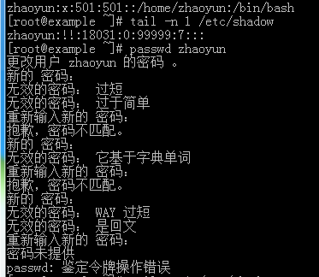

C:\Users\Administrator\AppData\Roaming\Tencent\Users\1977729334\QQ\WinTemp\RichOle\WAX9Z4D$83XTQI68V48T%0P.png

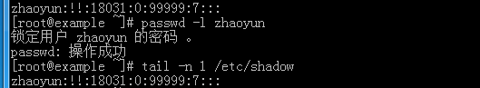

C:\Users\Administrator\AppData\Roaming\Tencent\Users\1977729334\QQ\WinTemp\RichOle\}Q~DFBI}YZS35TF`%`WP}PN.png

