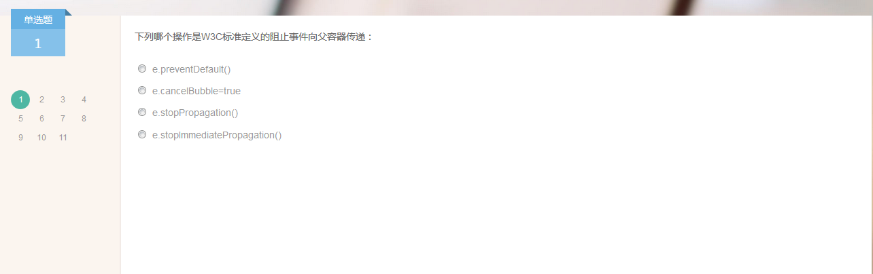

c

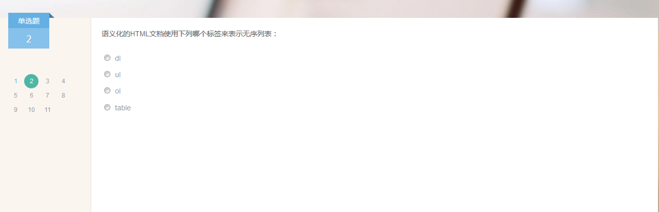

b



e

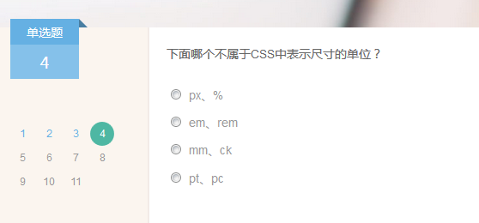

c

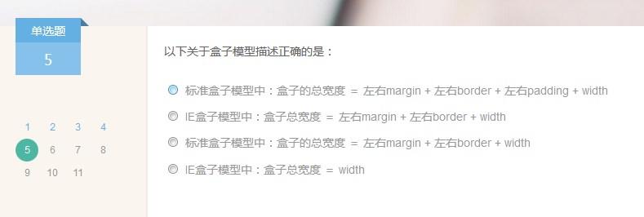

A

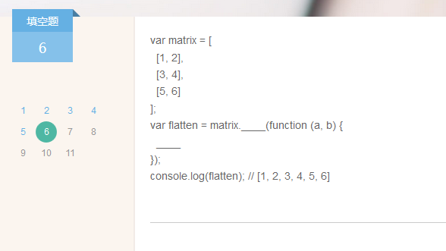

// 二维数组扁平化

var flatten = matrix.reduce(function (previous, current) {

return previous.concat(current);

});

console.log(flatten); // [1, 2, 3, 4, 5, 6]

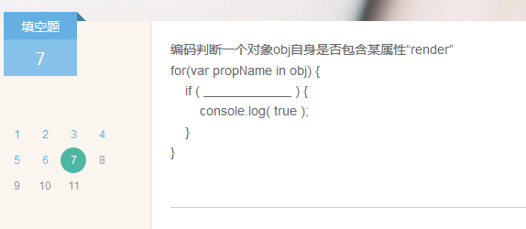

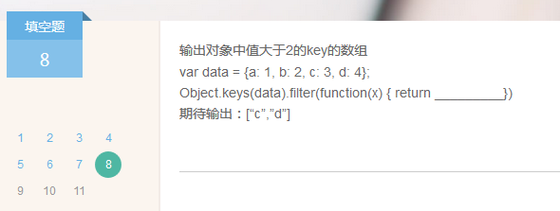

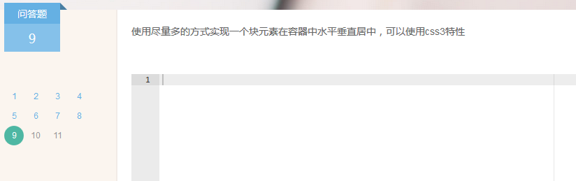

[http://blog.csdn.net/freshlover/article/details/11579669](http://blog.csdn.net/freshlover/article/details/11579669 )



<button id="btnSave" onclick="save();">jj</button>  
    <script>  
        var btn = document.getElementById("btnSave");  
        var click = btn.onclick;  
        btn.onclick = function () {  
            if (window.confirm('是否需要保存吗？')) {  
                click();  
            }  
        }  
    </script>



Js代码：没有测试

var priorityList = {print:{},add:{} ,list:{}};  
  
priorityList.add = function(name,weight){  
priorityList.list [name] = weight;  
}  
  
priorityList.print = function(){  
var array = [];  
for(var item in priorityList.list) {  
array.push(priorityList.list [item]);  
}  
  
var arraysort = array.reverse();  
for(var item in arraysort) {  
console.info(arraysort [item]);  
}  
}

}