User Manual

1. Open terminal in the project directory.
2. Run command “python manage.py runserver”.
3. Open the deployment link at <http://127.0.0.1:8000/>.
4. Startup page will display as below.

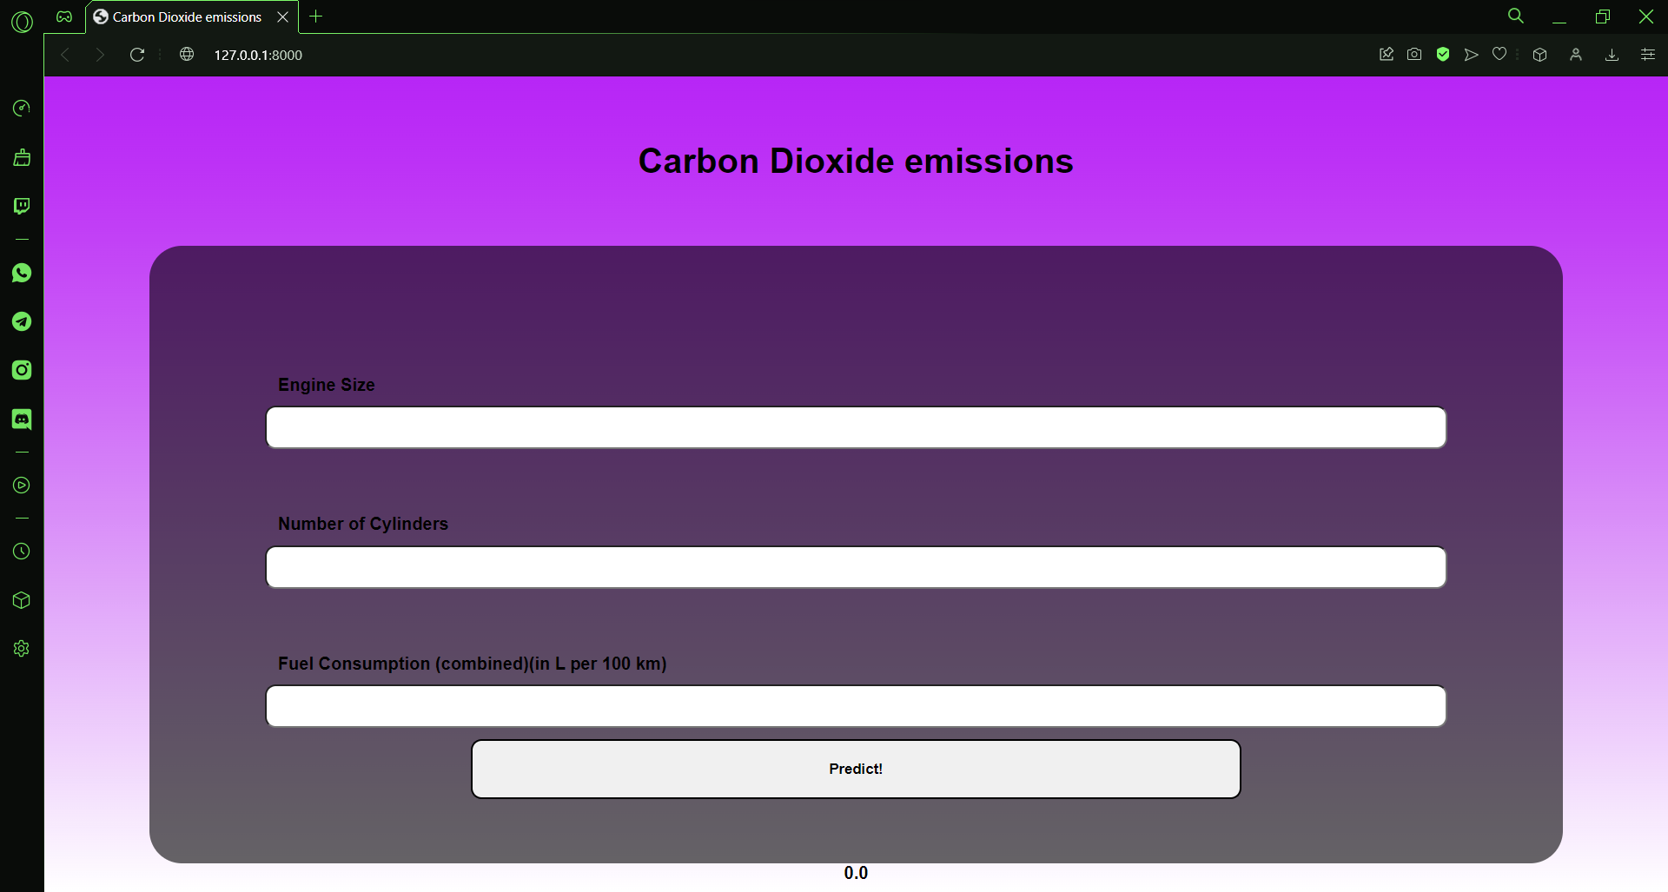

1. Enter the requested values (Engine Size and Fuel Consumption values must be of type float and Number of Cylinder must be of type integer).

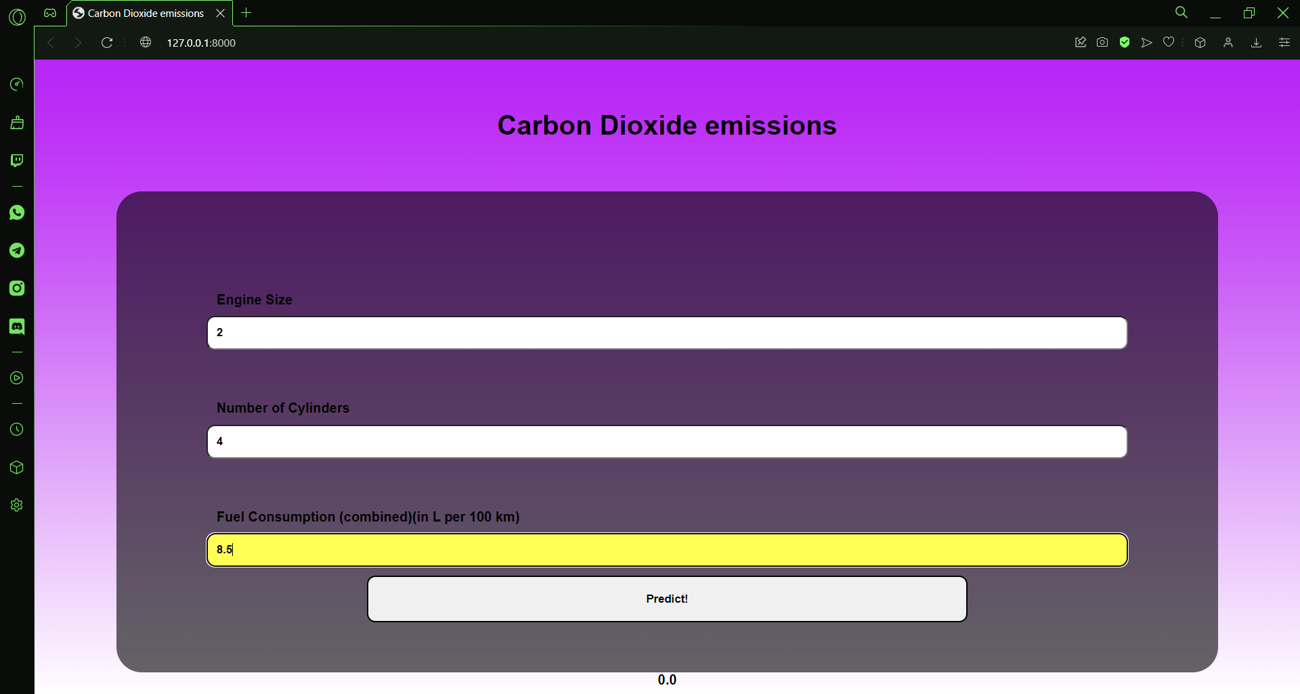

1. Click on Predict to get the predicted value of Carbon Dioxide emission.
2. The output will be as shown below.

