电 子 科 技 大 学
实 验 报 告
学生姓名：关文聪 学 号：2016060601008 指导教师：徐行

实验项目名称：
Scene Recognition with Bag of Words（基于词袋模型的场景检测）

实验原理：
图像词袋特征表示（例如比较流行的图像SIFT特征）：
SIFT，即尺度不变特征变换（Scale-invariant feature transform，SIFT），是用于图像处理领域的一种描述。这种描述具有尺度不变性，可在图像中检测出关键点，是一种局部特征描述子。
SIFT算法具有如下一些特点：
1.SIFT特征是图像的局部特征，其对旋转、尺度缩放、亮度变化保持不变性，对视角变化、仿射变换、噪声也保持一定程度的稳定性；
2.区分性（Distinctiveness）好，信息量丰富，适用于在海量特征数据库中进行快速、准确的匹配；
3.多量性，即使少数的几个物体也可以产生大量的SIFT特征向量；
4.高速性，经优化的SIFT匹配算法甚至可以达到实时的要求；
5.可扩展性，可以很方便的与其他形式的特征向量进行联合。
SIFT特征匹配主要包括2个阶段：
第一阶段：SIFT特征的生成，即从多幅图像中提取对尺度缩放、旋转、亮度变化无关的特征向量。
第二阶段：SIFT特征向量的匹配。
SIFT特征的生成一般包括以下几个步骤：1. 构建尺度空间，检测极值点，获得尺度不变性。2. 特征点过滤并进行精确定位。3. 为特征点分配方向值。4. 生成特征描述子。
词袋模型：
Bag-of-words model (BoW model) 最早出现在神经语言程序学(NLP)和信息检索（IR）领域. 该模型忽略掉文本的语法和语序, 用一组无序的单词(words)来表达一段文字或一个文档. 近年来, BoW模型被广泛应用于计算机视觉中. 与应用于文本的BoW类比, 图像的特征(feature)被当作单词(Word),把图像“文字化”之后，有助于大规模的图像检索.也有人把简写为Bag-of-Feature model(BOF model)或Bag-of-Visual-Word(BOVW model)。
基本思想与关键步骤：
1、提取特征：根据数据集选取特征（如比较流行的SIFT特征），然后进行描述，形成特征数据。
2、学习词袋：利用处理好的特征数据全部合并，再用聚类的方法把特征词分为若干类，此若干类的数目由自己设定，每一个类相当于一个视觉词；
3、利用视觉词袋量化图像特征：每一张图像由很多视觉词汇组成，我们利用统计的词频直方图，可以表示图像属于哪一类。

分类器构建：
最近邻分类器(Nearest Neighbor Classifier)：
通过计算测试集中样本点到训练集中每一个样本点的距离，找到训练集中 距离该样本点最近的K（K一般为奇数 ）个样本，然后根据这K个样本的标签来确定测试集中样本的标签，确定方法为K个样本中出现最多的标签即为测试集 中样本点的标签。样本之间的距离衡量标准常用的有欧氏距离、马氏距离等。

SVM分类器：
支持向量机（support vector machine，SVM）的基本模型是定义在特征空间上间隔最大的线性分类器。是一种二分类模型。其基本原理是（以二维数据为例）：如果训练数据分布在二维平面上的点，它们按照其分类聚集在不同的区域。SVM算法就是找一个超平面，并且它到离他最近的训练样本的距离要最大。即最优分割超平面最大化训练样本边界。

三、实验目的：
图像识别。特征提取+分类器构建和使用。

四、实验内容：
利用给定的训练集与测试集图片，使用特征提取的方法提取图像的特征，并构建词袋模型与训练分类器，在测试集上，用训练得到的模型对图片场景进行分类，计算准确率并输出结果。
1.图像词袋特征表示：
1.1 tiny特征
1.2 SIFT特征
2.分类器构建
2.1 Nearest neighbor classifier：距离计算+归类
2.2 SVM：一对多的策略
3. 词袋构建
3.1 将从训练集获取的特征进行k-means聚类。K的取值决定了后续的效果。

五、实验步骤：
1.图像的resize和tiny特征提取：
修改完善“student.py”文件中的“get_tiny_images”函数，实现功能包括读取图像、裁剪到指定大小、转换成灰度图、缩小图像、像素归一化等。经过修改完善后的代码如下：
- def get_tiny_images(image_paths):
- '''''
- This feature is inspired by the simple tiny images used as features in
- 80 million tiny images: a large dataset for non-parametric object and
- scene recognition. A. Torralba, R. Fergus, W. T. Freeman. IEEE
- Transactions on Pattern Analysis and Machine Intelligence, vol.30(11),
- pp. 1958-1970, 2008. http://groups.csail.mit.edu/vision/TinyImages/

- Inputs:
- image_paths: a 1-D Python list of strings. Each string is a complete
- path to an image on the filesystem.
- Outputs:
- An n x d numpy array where n is the number of images and d is the
- length of the tiny image representation vector. e.g. if the images
- are resized to 16x16, then d is 16 * 16 = 256.

- To build a tiny image feature, resize the original image to a very small
- square resolution (e.g. 16x16). You can either resize the images to square
- while ignoring their aspect ratio, or you can crop the images into squares
- first and then resize evenly. Normalizing these tiny images will increase
- performance modestly.

- As you may recall from class, naively downsizing an image can cause
- aliasing artifacts that may throw off your comparisons. See the docs for
- skimage.transform.resize for details:
- http://scikit-image.org/docs/dev/api/skimage.transform.html#skimage.transform.resize

- Suggested functions: skimage.transform.resize, skimage.color.rgb2grey,
- skimage.io.imread, np.reshape
- '''

- dim = 8
- # 设定dim为8表示将读取的图像resize成8*8的小图像
- tiny_images = np.empty((len(image_paths), dim * dim), dtype=float)
- for i in range(0, len(image_paths)):
- # 读取图像
- im = imread(image_paths[i])
- # 裁剪到指定大小
- mdim = min(im.shape)
- im = im[:mdim, :mdim]
- # 转换成灰度图
- im = rgb2grey(im)
- # 缩小图像
- im = resize(im, (dim, dim), anti_aliasing=True)
- # 将图像像素归一化
- im = im / np.sum(im)
- tiny_images[i, :] = np.reshape(im, (dim * dim))

- return tiny_images

- cells_per_block = (4, 4)
- pixels_per_cell = (4, 4)
- orients = 9

- def get_hogs(image, cells_per_block, pixels_per_cell, orients):
- # 缩小图像以进行调试
- scale = 0.4
- image = resize(image, (int(image.shape[0] * scale), int(image.shape[1] * scale)), anti_aliasing=True)

- out = hog(image, orients, cells_per_block=cells_per_block, pixels_per_cell=pixels_per_cell, feature_vector=True,
- block_norm='L1')

- return out.reshape(-1, cells_per_block[0] * cells_per_block[1] * orients)

2.词袋模型构建与读取：
分别修改完善“student.py”文件中的“build_vocabulary”函数与“get_bags_of_words”函数，进行词袋模型的构建和获取。经过修改完善后的代码如下：
- def build_vocabulary(image_paths, vocab_size):
- '''''
- This function should sample HOG descriptors from the training images,
- cluster them with kmeans, and then return the cluster centers.

- Inputs:
- image_paths: a Python list of image path strings
- vocab_size: an integer indicating the number of words desired for the
- bag of words vocab set

- Outputs:
- a vocab_size x (z*z*9) (see below) array which contains the cluster
- centers that result from the K Means clustering.

- You'll need to generate HOG features using the skimage.feature.hog() function.
- The documentation is available here:
- http://scikit-image.org/docs/dev/api/skimage.feature.html#skimage.feature.hog

- However, the documentation is a bit confusing, so we will highlight some
- important arguments to consider:
- cells_per_block: The hog function breaks the image into evenly-sized
- blocks, which are further broken down into cells, each made of
- pixels_per_cell pixels (see below). Setting this parameter tells the
- function how many cells to include in each block. This is a tuple of
- width and height. Your SIFT implementation, which had a total of
- 16 cells, was equivalent to setting this argument to (4,4).
- pixels_per_cell: This controls the width and height of each cell
- (in pixels). Like cells_per_block, it is a tuple. In your SIFT
- implementation, each cell was 4 pixels by 4 pixels, so (4,4).
- feature_vector: This argument is a boolean which tells the function
- what shape it should use for the return array. When set to True,
- it returns one long array. We recommend setting it to True and
- reshaping the result rather than working with the default value,
- as it is very confusing.

- It is up to you to choose your cells per block and pixels per cell. Choose
- values that generate reasonably-sized feature vectors and produce good
- classification results. For each cell, HOG produces a histogram (feature
- vector) of length 9. We want one feature vector per block. To do this we
- can append the histograms for each cell together. Let's say you set
- cells_per_block = (z,z). This means that the length of your feature vector
- for the block will be z*z*9.

- With feature_vector=True, hog() will return one long np array containing every
- cell histogram concatenated end to end. We want to break this up into a
- list of (z*z*9) block feature vectors. We can do this using a really nifty numpy
- function. When using np.reshape, you can set the length of one dimension to
- -1, which tells numpy to make this dimension as big as it needs to be to
- accomodate to reshape all of the data based on the other dimensions. So if
- we want to break our long np array (long_boi) into rows of z*z*9 feature
- vectors we can use small_bois = long_boi.reshape(-1, z*z*9).

- The number of feature vectors that come from this reshape is dependent on
- the size of the image you give to hog(). It will fit as many blocks as it
- can on the image. You can choose to resize (or crop) each image to a consistent size
- (therefore creating the same number of feature vectors per image), or you
- can find feature vectors in the original sized image.

- ONE MORE THING
- If we returned all the features we found as our vocabulary, we would have an
- absolutely massive vocabulary. That would make matching inefficient AND
- inaccurate! So we use K Means clustering to find a much smaller (vocab_size)
- number of representative points. We recommend using sklearn.cluster.KMeans
- to do this. Note that this can take a VERY LONG TIME to complete (upwards
- of ten minutes for large numbers of features and large max_iter), so set
- the max_iter argument to something low (we used 100) and be patient. You
- may also find success setting the "tol" argument (see documentation for
- details)
- '''

- # TODO: Implement this function!

- global cells_per_block
- global pixels_per_cell
- global orients

- out = np.empty((0, cells_per_block[0] * cells_per_block[1] * orients))
- # vocab = None
- for i in range(0, len(image_paths)):
- # 读取图像
- im = imread(image_paths[i])
- # 转换为灰度图
- im = rgb2grey(im)

- out = np.concatenate((out, get_hogs(im, cells_per_block, pixels_per_cell, orients)))

- # Kmeans聚类，得到聚类簇的中心为词袋模型中的词
- kmeans = KMeans(vocab_size, max_iter=100, tol=1e-4, random_state=0).fit(out)
- vocab = kmeans.cluster_centers_

- print(vocab)
- print(vocab.shape)

- return vocab

- def get_bags_of_words(image_paths):
- '''''
- This function should take in a list of image paths and calculate a bag of
- words histogram for each image, then return those histograms in an array.

- Inputs:
- image_paths: A Python list of strings, where each string is a complete
- path to one image on the disk.

- Outputs:
- An nxd numpy matrix, where n is the number of images in image_paths and
- d is size of the histogram built for each image.

- Use the same hog function to extract feature vectors as before (see
- build_vocabulary). It is important that you use the same hog settings for
- both build_vocabulary and get_bags_of_words! Otherwise, you will end up
- with different feature representations between your vocab and your test
- images, and you won't be able to match anything at all!

- After getting the feature vectors for an image, you will build up a
- histogram that represents what words are contained within the image.
- For each feature, find the closest vocab word, then add 1 to the histogram
- at the index of that word. For example, if the closest vector in the vocab
- is the 103rd word, then you should add 1 to the 103rd histogram bin. Your
- histogram should have as many bins as there are vocabulary words.

- Suggested functions: scipy.spatial.distance.cdist, np.argsort,
- np.linalg.norm, skimage.feature.hog
- '''
- global cells_per_block
- global pixels_per_cell
- global orients

- vocab = np.load('vocab.npy')
- print('Loaded vocab from file.')

- # TODO: Implement this function!

- hist = np.zeros((len(image_paths), len(vocab)))
- for i in range(0, len(image_paths)):
- # 读取图像
- im = imread(image_paths[i])
- # 转换为灰度图
- im = rgb2grey(im)

- out = get_hogs(im, cells_per_block, pixels_per_cell, orients)

- # 创建直方图
- for j in range(0, len(out)):
- dist = cdist(np.array([out[j]]), vocab, metric='cosine')
- bin = np.argsort(dist)[0][0]
- hist[i, bin] = hist[i, bin] + 1

- # 标准化直方图
- norm = np.linalg.norm(hist[i])
- if norm != 0:
- hist[i] = hist[i] / norm

- print(hist)
- print(hist.shape)

- return hist

3.分类器构建：
（1）训练SVM分类器：修改完善“student.py”文件中的“svm_classify”函数，训练SVM分类器并用训练得到的分类器预测结果。经过修改完善后的代码如下：
- def svm_classify(train_image_feats, train_labels, test_image_feats):
- '''''
- This function will predict a category for every test image by training
- 15 many-versus-one linear SVM classifiers on the training data, then
- using those learned classifiers on the testing data.

- Inputs:
- train_image_feats: An nxd numpy array, where n is the number of training
- examples, and d is the image descriptor vector size.
- train_labels: An nx1 Python list containing the corresponding ground
- truth labels for the training data.
- test_image_feats: An mxd numpy array, where m is the number of test
- images and d is the image descriptor vector size.

- Outputs:
- An mx1 numpy array of strings, where each string is the predicted label
- for the corresponding image in test_image_feats

- We suggest you look at the sklearn.svm module, including the LinearSVC
- class.
- '''

- # 训练SVM分类器
- classifier = LinearSVC('l2', multi_class='ovr', random_state=0, max_iter=100)
- # 用训练得到的SVM分类器预测结果
- classifier.fit(train_image_feats, train_labels)

- print('*******')
- print(train_image_feats.shape)
- print(test_image_feats[0].shape)

- out = [''] * len(test_image_feats)
- for i in range(0, len(test_image_feats)):
- out[i] = classifier.predict(test_image_feats[i].reshape(1, -1))

- return np.array(out)

（2）训练最近邻分类器：修改完善“student.py”文件中的“nearest_neighbor_classify”函数，要注意到k值的选取会影响模型的结果，需要进行尝试。经过修改完善后的代码如下：
- def nearest_neighbor_classify(train_image_feats, train_labels, test_image_feats):
- '''''
- This function will predict the category for every test image by finding
- the training image with most similar features. You will complete the given
- partial implementation of k-nearest-neighbors such that for any arbitrary
- k, your algorithm finds the closest k neighbors and then votes among them
- to find the most common category and returns that as its prediction.

- Inputs:
- train_image_feats: An nxd numpy array, where n is the number of training
- examples, and d is the image descriptor vector size.
- train_labels: An nx1 Python list containing the corresponding ground
- truth labels for the training data.
- test_image_feats: An mxd numpy array, where m is the number of test
- images and d is the image descriptor vector size.

- Outputs:
- An mx1 numpy list of strings, where each string is the predicted label
- for the corresponding image in test_image_feats

- The simplest implementation of k-nearest-neighbors gives an even vote to
- all k neighbors found - that is, each neighbor in category A counts as one
- vote for category A, and the result returned is equivalent to finding the
- mode of the categories of the k nearest neighbors. A more advanced version
- uses weighted votes where closer matches matter more strongly than far ones.
- This is not required, but may increase performance.

- Be aware that increasing k does not always improve performance - even
- values of k may require tie-breaking which could cause the classifier to
- arbitrarily pick the wrong class in the case of an even split in votes.
- Additionally, past a certain threshold the classifier is considering so
- many neighbors that it may expand beyond the local area of logical matches
- and get so many garbage votes from a different category that it mislabels
- the data. Play around with a few values and see what changes.

- Useful functions:
- scipy.spatial.distance.cdist, np.argsort, scipy.stats.mode
- '''

- k = 9

- # Gets the distance between each test image feature and each train image feature
- # e.g., cdist
- distances = cdist(test_image_feats, train_image_feats, 'cosine')

- # 1) Find the k closest features to each test image feature in euclidean space
- # 2) Determine the labels of those k features
- # 3) Pick the most common label from the k
- # 4) Store that label in a list

- labels = [None] * len(test_image_feats)
- for i in range(0, len(test_image_feats)):
- nn = np.argsort(distances[i])
- nn_label = np.array(train_labels)
- nn_label = nn_label[nn[:k]]
- mode, cnt = stats.mode(nn_label)
- labels[i] = mode[0]

- labels = np.array(labels)
- return labels

六、实验数据及结果分析：
运行“main.py”文件，程序构建词袋模型并进行训练，训练集数据共有15个场景类别，每类100张图片，总共训练1500张图片（注：训练时间可能会比较长，需要等待）。上述步骤完成后，在“code”目录下生成“vocab.npy”文件，
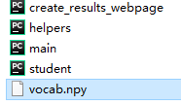它的规模为1500*300，即词袋模型包含了训练集1500张图片，词袋模型中的视觉个数为300。
接下来会应用模型，使用测试集中的图片数据进行测试。测试集数据同样包含15个场景类别，但测试集的图片数量要多于1500张。测试完成后，在“code”目录下会生成“results_webpage”文件夹：
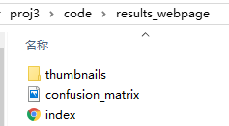其中存放了输出的测试结果，如下图所示：
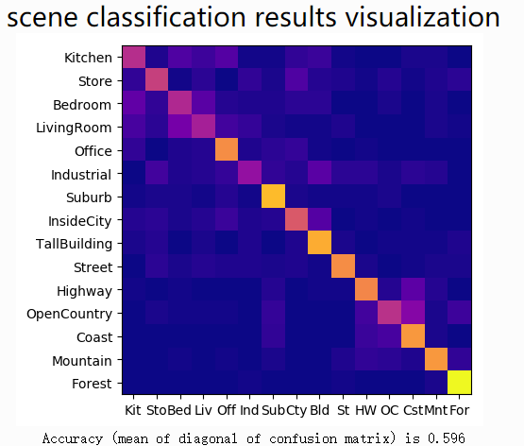
结果的精度（混淆矩阵的对角线的平均值）为59.6%

对于具体每类场景的识别分类精度如下图所示：
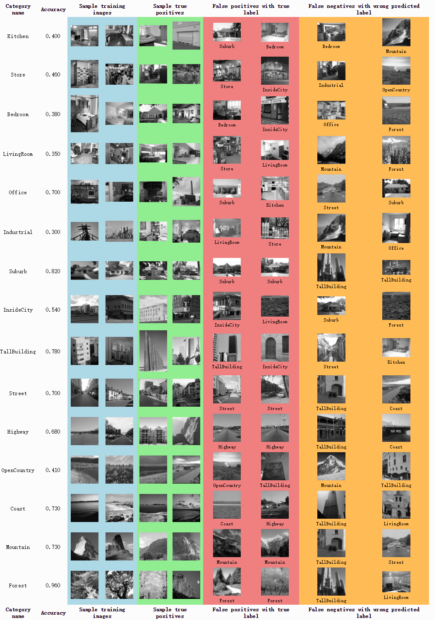
由以上结果可以看出，虽然总体的准确率可以达到接近60%，但是，对于不同具体场景识别分类的准确率差异是巨大的！其中，分类最准确的场景“Forest”的准确率达到了96%，这是非常精确的识别与分类，比较准确的场景“Suburb”也达到了82%。但是，类似“Industrial”“LivingRoom”“Bedroom”“Kitchen”等场景识别分类的准确率就只有30%-40%，效果比较差。

七、实验结论：
在本次实验中，主要实现了图像的特征提取和图像的分类，并综合应用了KMeans聚类算法、最近邻分类器、SVM分类器等算法，构建了视觉词袋模型并实现了场景预测。但是，模型的分类识别准确率并不是很高，综合分析，可能有几个原因。一是训练学习的样本数量太少，少于测试数据，可能有一些特征未能被学习到。二是模型的参数需要调整，比如KMeans聚类的k的取值，还比如距离的选择，是选取欧氏距离还是其它距离等，不同的取值对于结果也有影响。此外，不同场景本身的差异性也影响了模型的判断。

八、总结及心得体会：
本次实验是一次综合性很强的实验，融合了课堂上所学的图像特征、聚类算法、分类算法、词袋模型等等知识，通过动手操作，锻炼了动手能力，也对课堂上所学知识有了更深刻的理解和认识。模型应该还有不小的提升空间，后续可以继续对模型算法和参数进一步优化。

九、对本实验过程及方法的改进建议：
可以提供更详细的文档和实验指导，例如实验指导书等。
模型的训练时间过长，可以考虑减小数据的规模。
报告评分：
指导教师签字：

