**FPT ACADEMY INTERNATIONAL**

**FPT – APTECH COMPUTER EDUCATION**

**Centre Name: ACE-HCMC-2-FPT.**

**Address: 590 Cach Mang Thang 8, District 3, Ho Chi Minh City, Viet Nam.**

**NHL Sport**

|  |  |  |
| --- | --- | --- |
| **Supervisor:** | **Mr. NGO PHUOC NGUYEN** | |
| **Semester:** | **4** | |
| **Batch No:** | **T1.1807.M0** | |
| **Group No:** | **2** | |
| **Order:** | **Full name** | **Roll No.** |
| **1.** | **Le Tran Huu Nghi** | **Student1130989** |
| **2.** | **Che Gia Huy** | **Student1133321** |
| **3.** | **Vu Phi Long** | **Student1132482** |
| **4.** | **Tran Thanh Thien** | **Student1130994** |

**Content**

# Problem Definition:

## Introduction

Online shopping is the process whereby consumers directly buy goods or services from a seller in real-time, without an intermediary service, over the Internet. It is a form of electronic commerce. The sale or purchase transaction is completed electronically and interactively in real-time such as in Amazon.com for new books. However in some cases, an intermediary may be present in a sale or purchase transaction such as the transactions on eBay.com.

## Existing scenario

In present scenario Ecommerce is playing very essential role in the online business. Although it is one of the best & cheapest intermediate for reaching out to new customers in the online market, if ecommerce implemented effectively, it also offers a smart way of doing online business & expanding it more.

An online business ecommerce podium is planned & implemented to make the most of its reach to potential customers and provide them with a convenient, satisfying & protected shopping experience

**Advantages of Ecommerce to the Online Business:**

Ecommerce helps to Increase the sales revenue to the business

* Business people can spend less money and earn high profits with ecommerce
* It is very Easier to scale up online
* sEasily we can track the segment of customers who are happy with purchasing goods through online
* Avoid losing sales to competitors who are online
* Instantaneous global sales presence in quick time
* We can Operate the business in 24/7 basis
* Easily we can increase our business customers
* We set up shop anywhere in the world, self-governing of geographical locations
* Inexpensive way to turn your Web site into a revenue center
* Reduce Customer Support costs via e-mail marketing & customary newsletters
* We can create customized mailing list
* Easily we can drive free traffic to the website
* Instantly we can develop our business across the internet by using various ecommerce strategies
* Customers can easily buy their products by using different payment gateways
* Develop more shopping carts by using ecommerce
* We can easily promote our business website by using various ecommerce digital marketing activities such as Search Engine Optimization, Pay Per Click Management, Email Marketing, Social Media Optimization, Online Banner Advertisement, Online Branding and Affiliate Management etc

# Customer Requirements Specifications:

* Website will be a 24/7 sales channel to provide customers information about the product, order online at the website at any time. Specially, customers can:

+ View detailed information about the product

+ Search products by name or filter products by categories, types,

brands and price

+ Compare products

+ Track recently viewed products

+ Members have registered to manage their personal information,

orders, wishlist and rate products

+ Intelligent systems can suggest products based on rating history

of customers.

+ Order online and manage cart.

+ When shopping can login (member) or not (guest).

+ View business information (address, google map).

* Website providing business management tools (shop owner):

+ Store management: add, delete, edit components of the site

# Functional Requirement Specification:

## Guests (unregistered customers):

* 1. **Description:**

The guest account can use basic functions of the website. These include viewing product details, shop information (stores, contacts, etc.), searching for products, comparing products, ordering orders, and managing shopping carts, displaying product suggestions for guests on the home page, and tracking recently viewed ones Products or registration as a member.

* 1. **Functional Requirement:**

When customers (include guest and member) access the home page, there  
 should be:

* Top bar shows some important items such as hotline number, text box to search product, register / login button

+ Customers can search product by name, system process and reponse to page to display results.

+ Customer can register member account

Website provides a page for guest to register member account by providing necessary information: email (unique), password, name, mobile, address.

* Menu bar including: Home, category, brand, contact us, faq, shopping cart icon.

+ Shopping cart is working for both members and guests.

+ Customers can add products to shopping cart while surfing the website for the creating order step.

+ Customers can view shopping cart, check out order as guest.

## Members (registered customers):

* 1. **Description:**

All customers can register on the website to become a member. After having their accounts, they can still do all function as guests but they will be able to access more features after login. After login, they can update their information including password change.

* 1. **Functional Requirement:**
* Members must provide Email and Password to login into the website (login page should have the function for customers to remember their login information). User can modify their information after login.

**After members login:**

* Members must provide Email and Password to login into the website (login page should have the function for customers to remember their login information). User can modify their information after login.
* Modify their information (except Email).
* Manage their orders: view all orders, check and print every order details.
* Manage their wishlist: view all items, can remove items (one by one or all), and should have an confirmation for removing.
* Make ratings for products: rate for products (from 1 to 5 stars), if rated, they can view their ratings and can update ratings.

## Admin:

1. **Description:**

Adminator after login, they will manage information related to products and customers, follow customers’ orders.

1. **Functional Requirement:**

+ Add, update, delete: data in tables such as: products, categories, types, brands, customers, admins.

Note: if tables in database have a status field (with true of false values), delete function means only changing values of this field to false.

+ Have a page to change the orders’ status with values (listed based on real order): processing (default - 1), shipping (2) and complete (3).

Note: when update status, new value should be validated to make sure previous order of current order not be chosen

# System Requirements:

## Hardware Requirements:

- Pentium IV CPU 2.80 Ghz or higher.

- 2048 Mb of RAM or higher.

## Software Requirements:

- Windows XP, Win 7, Win 8 or Win 10.

- SQL Server 2012 or higher. - Netbean 7.4 or higher.

- JavaEE 7 SDK.

- Java Development Kit (JDK) 1.7

- Glassfish Server 4.0.

- Google Chrome 60.0 or higher.

# **Technologies:**

- JavaEE 7

- Enterprise Java Bean (EJB) 3.0

- Bootstrap 3.7 - HTML 5 + CSS 3

- Javascript - Jquery 1.11.1

- Jquery UI 1.11.1

# Scope of project:

There are some functions not to be included in this project as follows:

- Manage the warehouse: all products with different sizes and colors will be always available.

- Manage promotions: No promotion will be apply.

- Manage the shipping.

- Manage pay

- Manage warehouse

# Use Case and Sequence Diagram

## Use Case

1. 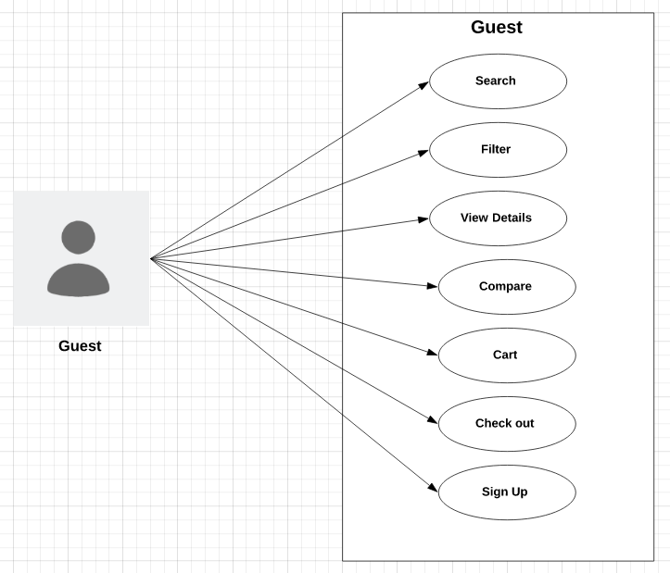**Guest**
2. **Member**

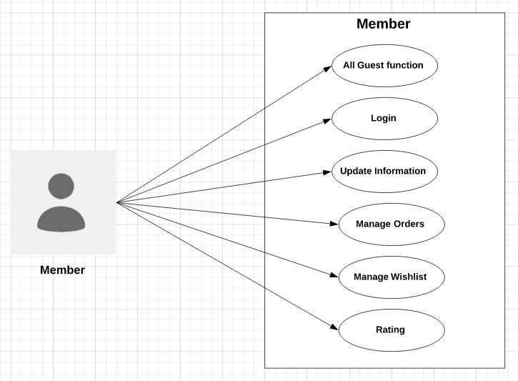

1. **Admin**

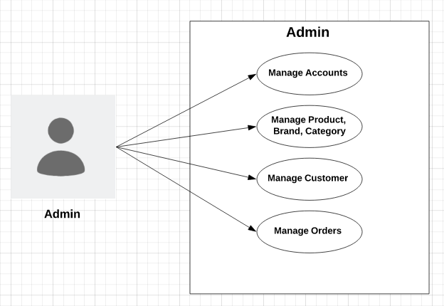

## Sequence Diagram

1. **Search - Button**

|  |  |  |
| --- | --- | --- |
| **Use Case Name** | Search – Search button | |
| **Actors** | Guests and Members | |
| **Description** | When search button is clicked, search result page will be displayed with result list of products and their information | |
| **Requirements** | Search string can not be blank. | |
|  | **Actor Actions** | **System Responses** |
| **Basic flow** | 1. Actor input search string and click on search button. | 2. System check the search string [Exception 1]  3. System create an empty list to contain search result.  4. Search in Products table to find products which have names contain the search string (ignore case) and add them to result list. 4. Display the result list in the search result page. |
| **Exception** | 1. Actor left the search string empty | 1. An error message will be display: “Search string can not be empty” |

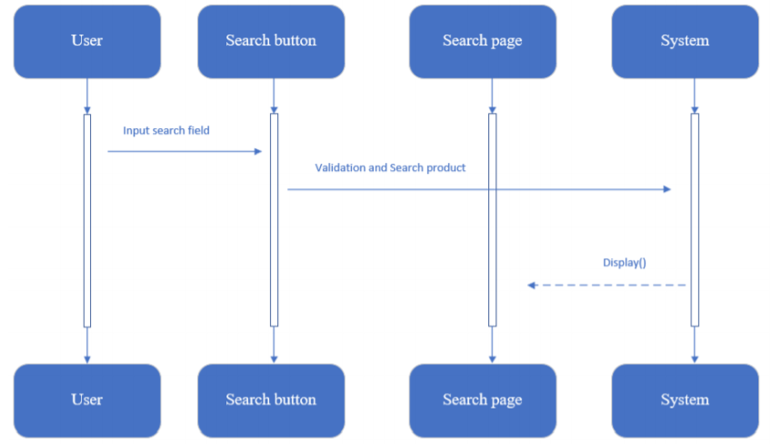

1. **Filter**

|  |  |  |
| --- | --- | --- |
| **Use Case Name** | Filter | |
| **Actors** | Guests and Members | |
| **Description** | Allows customers view all products which are in the same categories, brands. Products will be displayed with the pagination. | |
| **Requirements** | Links of Brands, Categories must be clicked, or range of prices must be chosen | |
|  | **Actor Actions** | **System Responses** |
| **Basic flow** | 1. Clicks on links of Brands, Categories | 2. Receive parameters passing with the links and search products which have Brands or Categories with the parameters.  3. Display the list in the products page. |

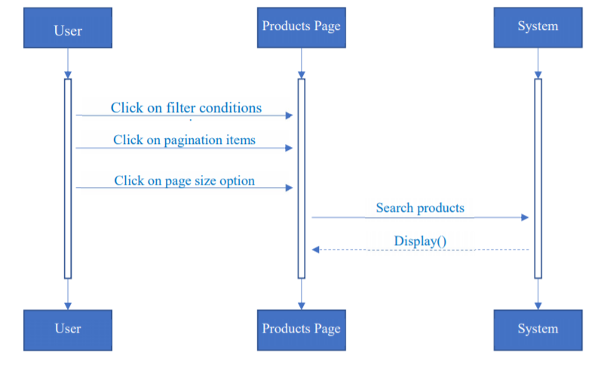

1. **View product details**

|  |  |  |
| --- | --- | --- |
| **Use Case Name** | View product details | |
| **Actors** | Guests and Members | |
| **Description** | Allows customers view all products which are in the same categories, brands. Products will be displayed with the pagination. | |
| **Requirements** | Links of Brands, Categories must be clicked, or range of prices must be chosen | |
|  | **Actor Actions** | **System Responses** |
| **Basic flow** | 1. Clicks on links of Brands, Categories | 2. Receive parameters passing with the links and search products which have Brands or Categories with the parameters.  3. Display the list in the products page. |

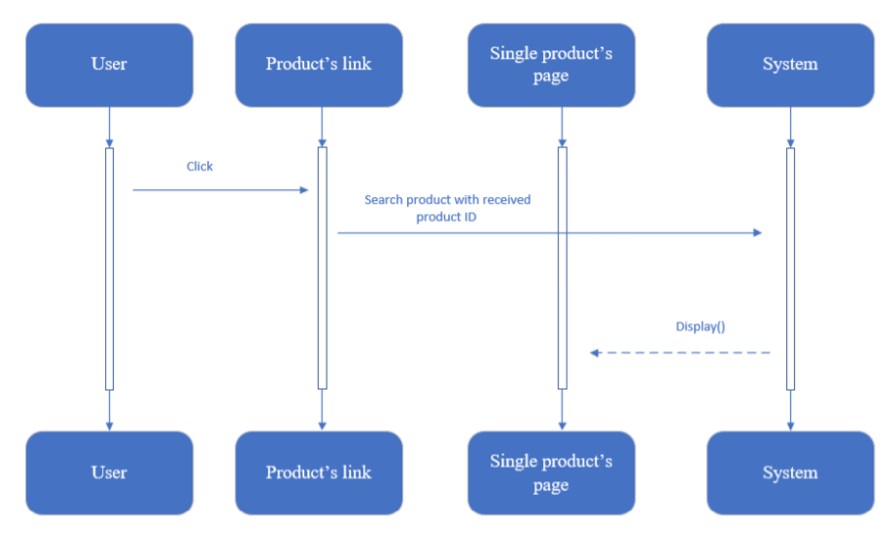

1. **Compare**

**d.1. Add:**

|  |  |  |
| --- | --- | --- |
| **Use Case Name** | Compare - Add | |
| **Actors** | Guests and Members | |
| **Description** | When a customer clicks on “Compare” link in singleProduct page, compare page will appear to display all compared products include added products. | |
|  | **Actor Actions** | **System Responses** |
| **Basic flow** | 1. Clicks on “Compare” link in singleProduct page. | 2. Check the number of compared products:  + if it equals 3, system disable the compare link and display a text “Reach the limit of 3 compared products”.  + else, system add the product to compared products and display compare page. |

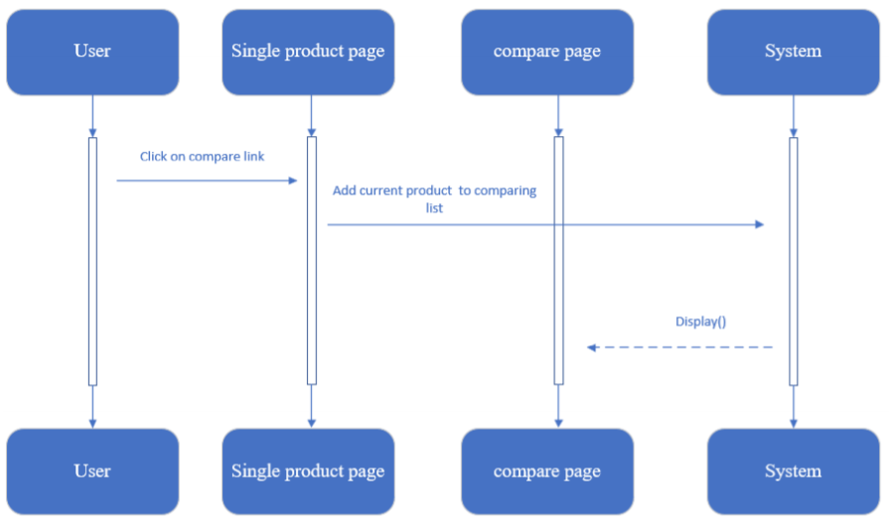

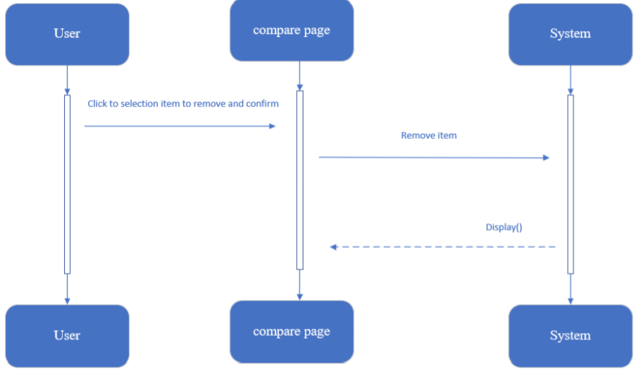**d.2. Remove:**

|  |  |  |
| --- | --- | --- |
| **Use Case Name** | Compare - Remove | |
| **Actors** | Guests and Members | |
| **Description** | When customer clicks on remove links and choose “Yes” to confirm, the selected product will be remove from the compared list. | |
|  | **Actor Actions** | **System Responses** |
| **Basic flow** | 1. Clicks on remove link of compared product in the compare page.  3. Clicks on “Yes” to confirm | 2. Display 2 buttons: “Yes” and “No” for customer confirm the removing.  4. Remove selected product from the compared list and display compare page with updated list. |
| **Alternative flow** | 5. Clicks on “No”. | 6. The 2 buttons disappear. |

1. **Cart**

**e.1. Add:**

|  |  |  |
| --- | --- | --- |
| **Use Case Name** | Cart – Add | |
| **Actors** | Guests and Members | |
| **Description** | When customers select the quantity and clicks on “Add to Cart” in singleProduct page, the current product will be added/updated into list of cart items, and cart page will be displayed with all cart items | |
|  | **Actor Actions** | **System Responses** |
| **Basic flow** | 1. Selects the quantity and clicks on “Add to Cart”. | 2. Check the added product:  + If existed in cart, system will add the quantity to the existed item’s quantity.  + Else, system will add the product with the selected quantity into the list of cart items.  3. Display the cart page with all updated cart items. |

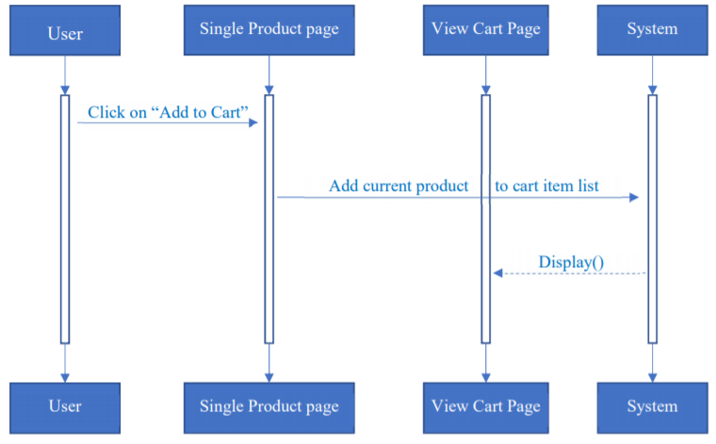

**e.2. Remove**

|  |  |  |
| --- | --- | --- |
| **Use Case Name** | Cart – Remove | |
| **Actors** | Guests and Members | |
| **Description** | When customers clicks on remove links and choose “Yes” to confirm, the selected product will be remove from the list of cart items. | |
|  | **Actor Actions** | **System Responses** |
| **Basic flow** | 1. Clicks on remove link of cart items in the cart page.  3. Clicks on “Yes” to confirm. | 2. Display 2 buttons: “Yes” and “No” for customer confirm the removing.  4. Remove selected product from the list of cart items and display cart page with updated list. |
| **Alternative flow** | 5. Clicks on “No”. | 6. The 2 buttons disappear. |

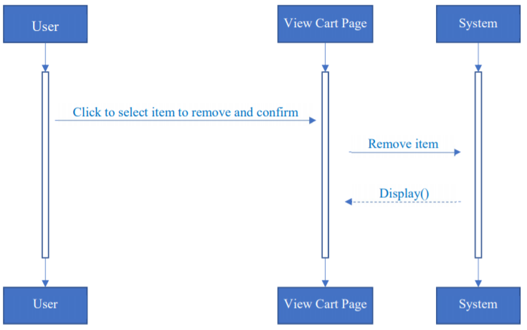

**e.3. Update quantity:**

|  |  |  |
| --- | --- | --- |
| **Use Case Name** | Cart – Update quantity | |
| **Actors** | Guests and Members | |
| **Description** | When customers input quantity field of cart item, system will update the quantity, subtotal, total and display cart page with new information | |
| **Requirements** | Quantity must be greater than 0. | |
|  | **Actor Actions** | **System Responses** |
| **Basic flow** | 1. Updates new number in the quantity field. | 1. Check the new quantity [Exception 1] 2. Update new quantity, subtotal and total of cart items. 3. Display cart page with new information. |
| **Exception** | [Exception 1]   1. Actor input a number less than 0. 2. Actor input a string not in number format | * Display error message “Quantity must be greater than 0”. * Display error message “Quantity is not in number format”. |

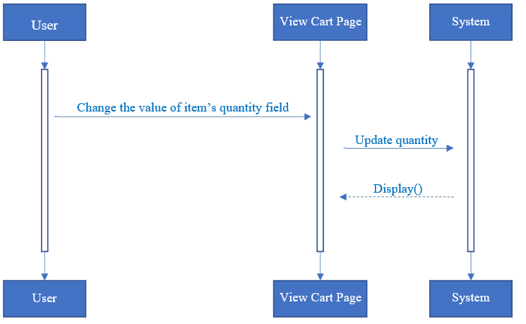

# Database Relationship Diagram

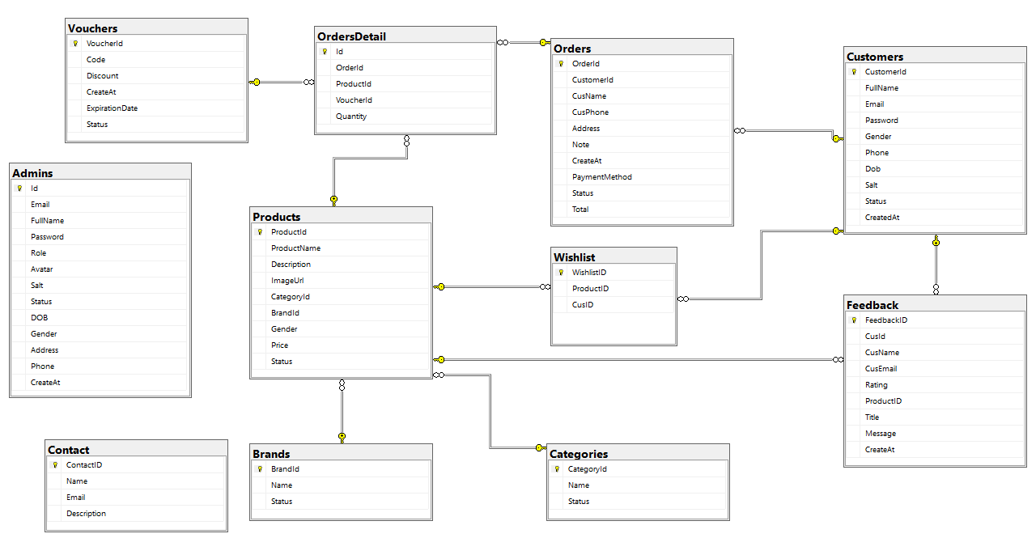

1. **Table Definition**
2. **Customer**

|  |  |  |  |  |  |  |
| --- | --- | --- | --- | --- | --- | --- |
| **Field Name** | **DataType** | **Null** | **Default Value** | **Key** | **Table-Field-Ref** | **Description** |
| CustomerId | int | No | Identity | PK |  | Customer ID |
| FullName | nvarchar | No |  |  |  | Full Name |
| Email | varchar | No |  |  |  | Email Customer |
| Password | varchar | No |  |  |  | Password Customer |
| Gender | bit | Yes |  |  |  | Gender |
| Phone | Varchar | Yes |  |  |  | Phone Customer |
| Dob | Date | Yes |  |  |  | Date of birth |
| Salt | Varchar | No |  |  |  | Password encryption code |
| Status | bit | Yes | Yes |  |  | Status customer |
| CreateAt | date | Yes | getDate |  |  | Created Date |

1. **Categories**

|  |  |  |  |  |  |  |
| --- | --- | --- | --- | --- | --- | --- |
| **Field Name** | **DataType** | **Null** | **Default Value** | **Key** | **Table-Field-Ref** | **Description** |
| CategoryId | int | No | Identity | PK |  | Category ID |
| Name | nvarchar | No |  |  |  | Name Category |
| Status | Bit | No |  |  |  | Status |

1. **Brands**

|  |  |  |  |  |  |  |
| --- | --- | --- | --- | --- | --- | --- |
| **Field Name** | **DataType** | **Null** | **Default Value** | **Key** | **Table-Field-Ref** | **Description** |
| BrandId | int | No | Identity | PK |  | Brand ID |
| Name | nvarchar | No |  |  |  | Name Category |
| Status | Bit | No |  |  |  | Status |

1. **Products**

|  |  |  |  |  |  |  |
| --- | --- | --- | --- | --- | --- | --- |
| **Field Name** | **DataType** | **Null** | **Default Value** | **Key** | **Table-Field-Ref** | **Description** |
| ProductId | int | No | Identity | PK |  | ProductID |
| Name | nvarchar | No |  |  |  | Product Name |
| Price | float | No |  |  |  | Price |
| CategoryID | int | No |  | FK | CategoryID (Categories) | Product Category |
| BrandID | int | No |  | FK | BrandID (Brands) | Product Brand |
| Gender | varchar | Yes |  |  |  | Gender |
| ImageUrl | nvarchar | No |  |  |  | Product Image |
| Status | bit | No |  |  |  | Product Status |
| Description | nvarchar | No |  |  |  | Product Description |

1. **Feedbacks**

|  |  |  |  |  |  |  |
| --- | --- | --- | --- | --- | --- | --- |
| **Field Name** | **DataType** | **Null** | **Default Value** | **Key** | **Table-Field-Ref** | **Description** |
| FeedbackID | int | No | Identity | PK |  | Feedback ID |
| ProductID | int | No |  | FK | ProductID (Products) | Rated Product |
| CusID | int | No |  | FK | CustomerID (Customers) | Customer ID |
| Rating | int | No |  |  |  | Rating Values |
| CreateAt | date | No | getDate |  |  | Rating Date |
| CusName | nvarchar | No |  |  |  | Customer Name |
| CusEmail | varchar | No |  |  |  | Customer Email |
| Title | nvarchar | No |  |  |  | Title |
| Message | nvarchar | No |  |  |  | Description |

1. **Orders**

|  |  |  |  |  |  |  |
| --- | --- | --- | --- | --- | --- | --- |
| **Field Name** | **DataType** | **Null** | **Default Value** | **Key** | **Table-Field-Ref** | **Description** |
| OrderId | int | No | identity | PK |  | Order ID |
| CustomerId | int | No |  | FK | CustomerID (Customers) | OrdersDetails Id |
| CusName | nvarchar | No |  |  |  | Receiver Name |
| CusPhone | varchar | Yes |  | FK |  | Customer ID if login |
| Address | nvarchar | No |  |  |  | Receiver Address |
| Note | nvarchar | Yes |  |  |  | Receiver Note |
| CreateAt | date | Yes | getDate |  |  | Get Order Date |
| Payment Method | nvarchar | Yes |  |  |  | Payment method |
| Status | nvarchar | No |  |  |  | Order Process |
| Total | bit | Yes |  |  |  | Order status |

1. **OrdersDetails**

|  |  |  |  |  |  |  |
| --- | --- | --- | --- | --- | --- | --- |
| **Field Name** | **DataType** | **Null** | **Default Value** | **Key** | **Table-Field-Ref** | **Description** |
| Id | Int | No | identity | PK |  | OrdersDetails ID |
| OrderId | Int | No |  | FK | OrderId(Orders) | OrderId |
| ProductId | Int | Yes |  |  |  | Product Id |
| VoucherId | int | No |  | FK | VoucherID (Voucher) | Voucher Id |
| Quantity | int | No |  |  |  | Quantity |

1. **Wishlist**

|  |  |  |  |  |  |  |
| --- | --- | --- | --- | --- | --- | --- |
| **Field Name** | **DataType** | **Null** | **Default Value** | **Key** | **Table-Field-Ref** | **Description** |
| WishlishID | Int | No | identity | PK |  | Wishlish ID |
| CusID | Int | No |  | FK | CustomerID(Customers) | Customer ID |
| ProductID | int | no |  | FK | ProductID (Products) | Product ID |

1. **Voucher**

|  |  |  |  |  |  |  |
| --- | --- | --- | --- | --- | --- | --- |
| **Field Name** | **DataType** | **Null** | **Default Value** | **Key** | **Table-Field-Ref** | **Description** |
| VoucherId | int | No | identity | PK |  | Voucher ID |
| Code | varchar | No |  |  |  | Code voucher |
| Discount | float | No |  |  |  | Discount |
| CreateAt | float | No |  |  |  | Date create voucher |
| ExpirationDate | date | No |  |  |  | Expiration date |
| Status | bit | No | True |  |  | Status voucher |

1. **Contact**

|  |  |  |  |  |  |  |
| --- | --- | --- | --- | --- | --- | --- |
| **Field Name** | **DataType** | **Null** | **Default Value** | **Key** | **Table-Field-Ref** | **Description** |
| ContactID | Int | No | identity | PK |  | Contact ID |
| FullName | nvarchar | No |  |  |  | Name |
| Email | Varchar | Yes |  |  |  | Email |
| Description | nvarchar | no |  |  |  | Description |

1. **Admins**

|  |  |  |  |  |  |  |
| --- | --- | --- | --- | --- | --- | --- |
| **Field Name** | **DataType** | **Null** | **Default Value** | **Key** | **Table-Field-Ref** | **Description** |
| Id | int | No | Identity | PK |  | Admin ID |
| Email | varchar | Yes |  |  |  | Admin Email |
| Fullname | nvarchar | Yes |  |  |  | Admin Name |
| Password | varchar | Yes |  |  |  | Admin Password |
| Role | nvarchar | Yes |  |  |  | Admin Role |
| Avatar | varchar | Yes |  |  |  | Admin Avatar |
| Salt | varchar | Yes |  |  |  | Password Encryption Code |
| Status | bit | Yes |  |  |  | Status |
| DOB | date | Yes |  |  |  | Date of birth |
| Gender | bit | Yes |  |  |  | Gender |
| Address | nvarchar | Yes |  |  |  | Address |
| Phone | varchar | Yes |  |  |  | Phone |
| CreateAt | date | Yes | getDate |  |  | Get Date Create |

1. **Site Maps**
2. **Customer site**

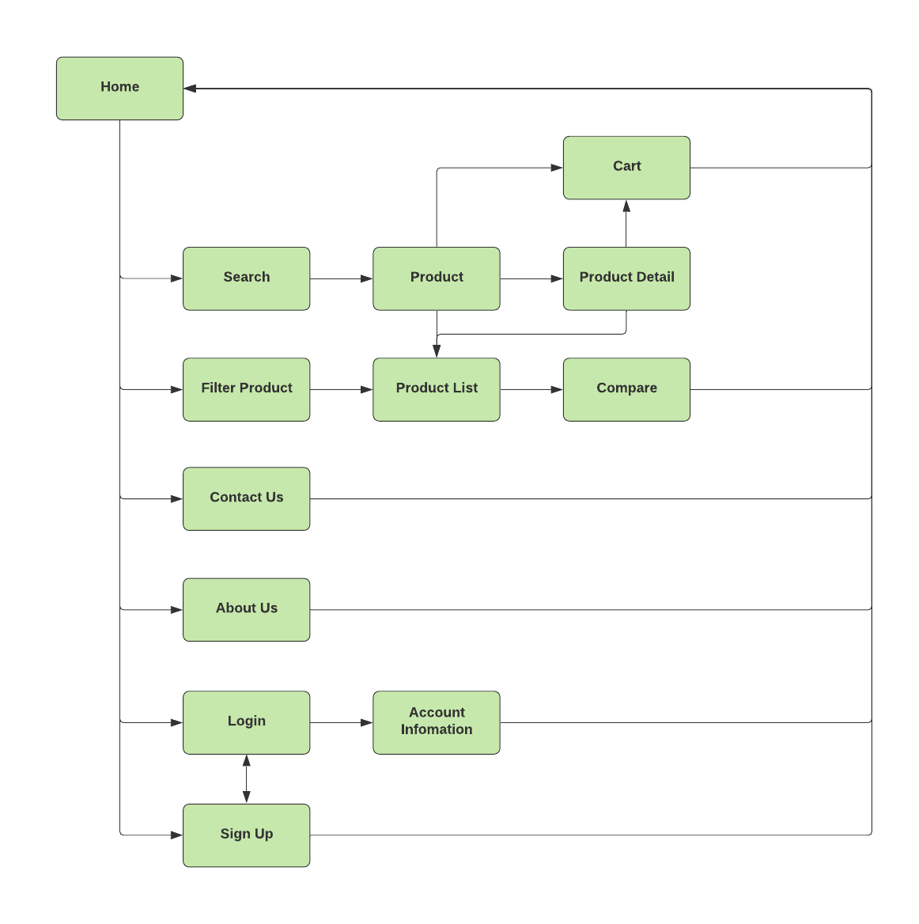

1. **Admin Site**

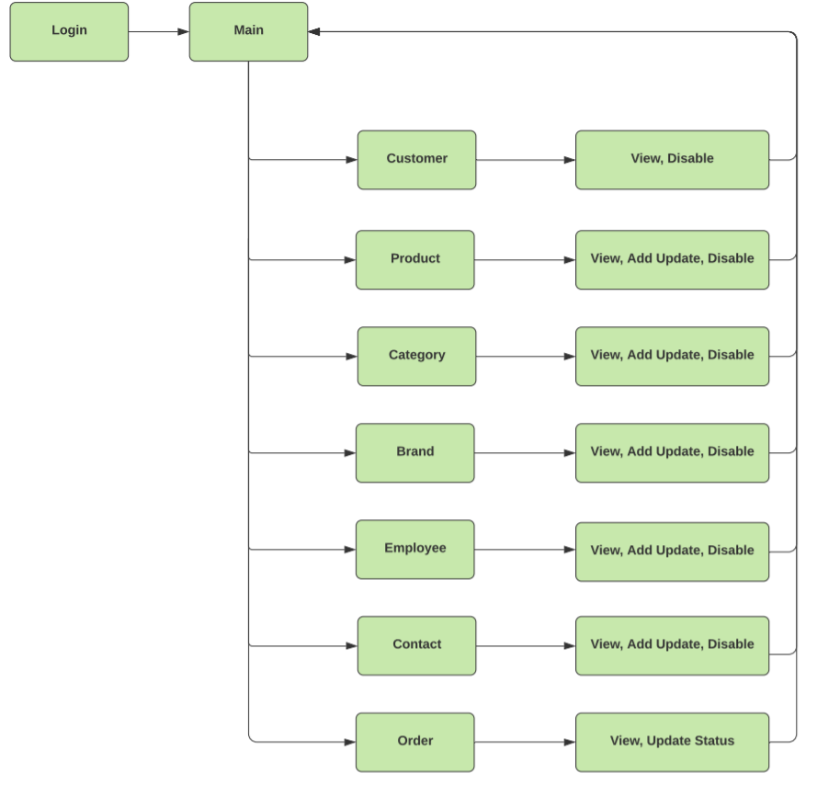

1. **Customers GUI Designc**
2. **Template:**

This is the template of all user page.

1. Header:

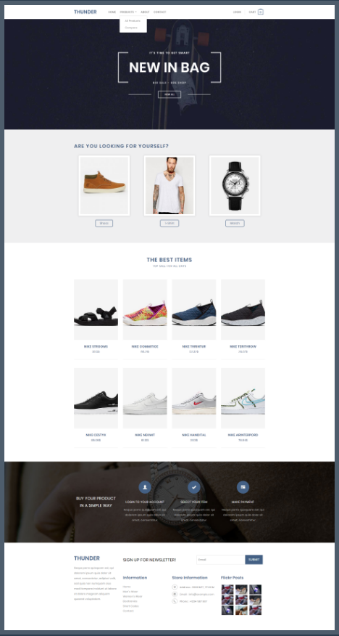

1. **Home:**
2. **Login customer:**

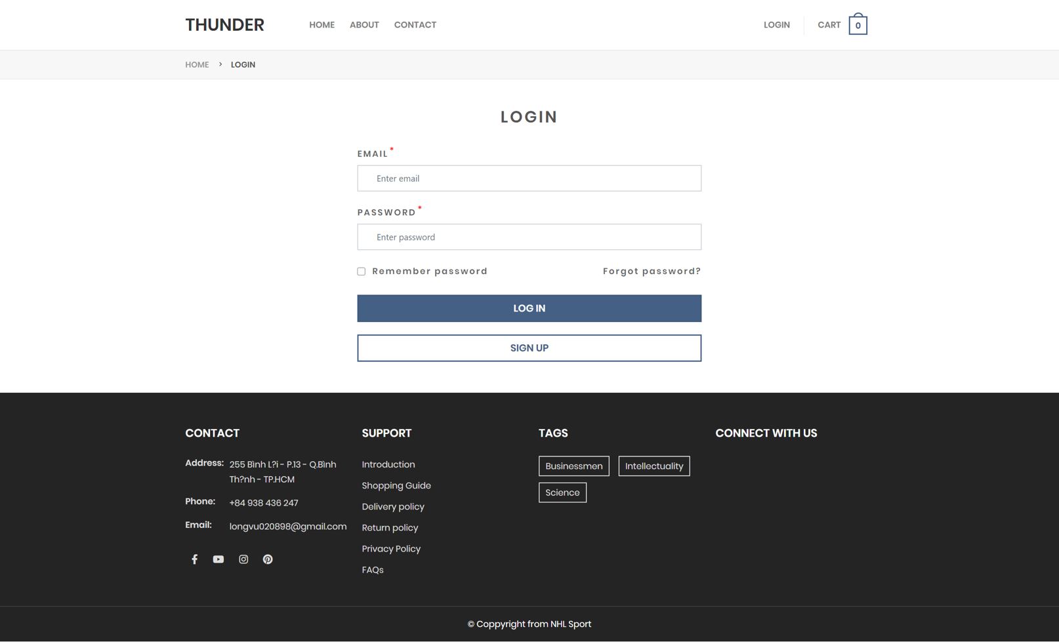

1. **Sign up customer:**

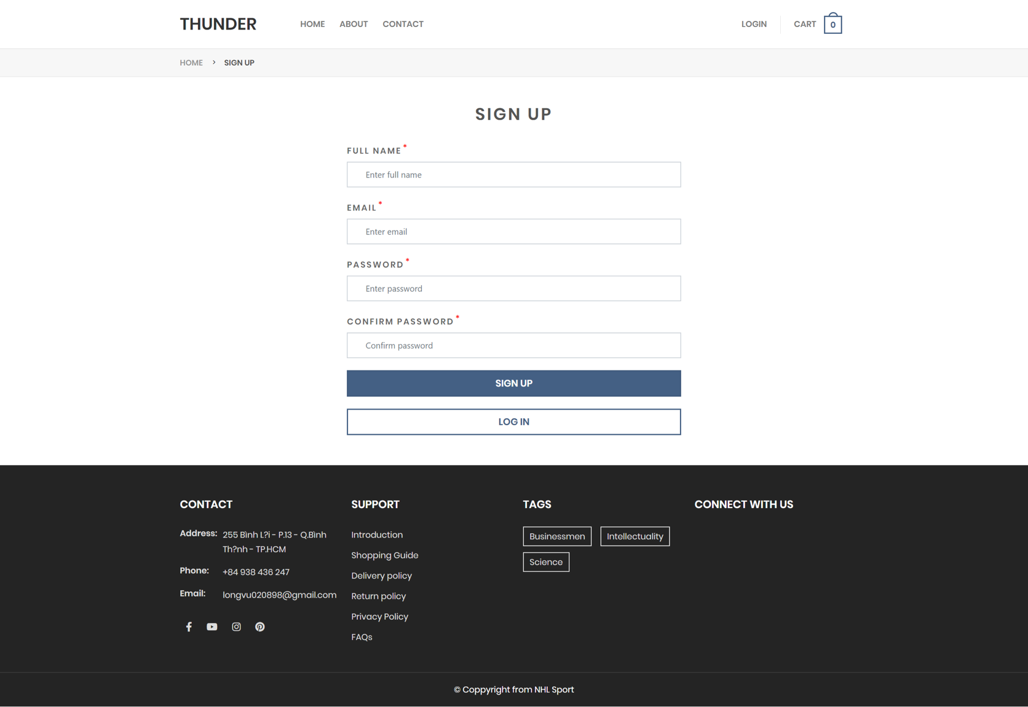

1. 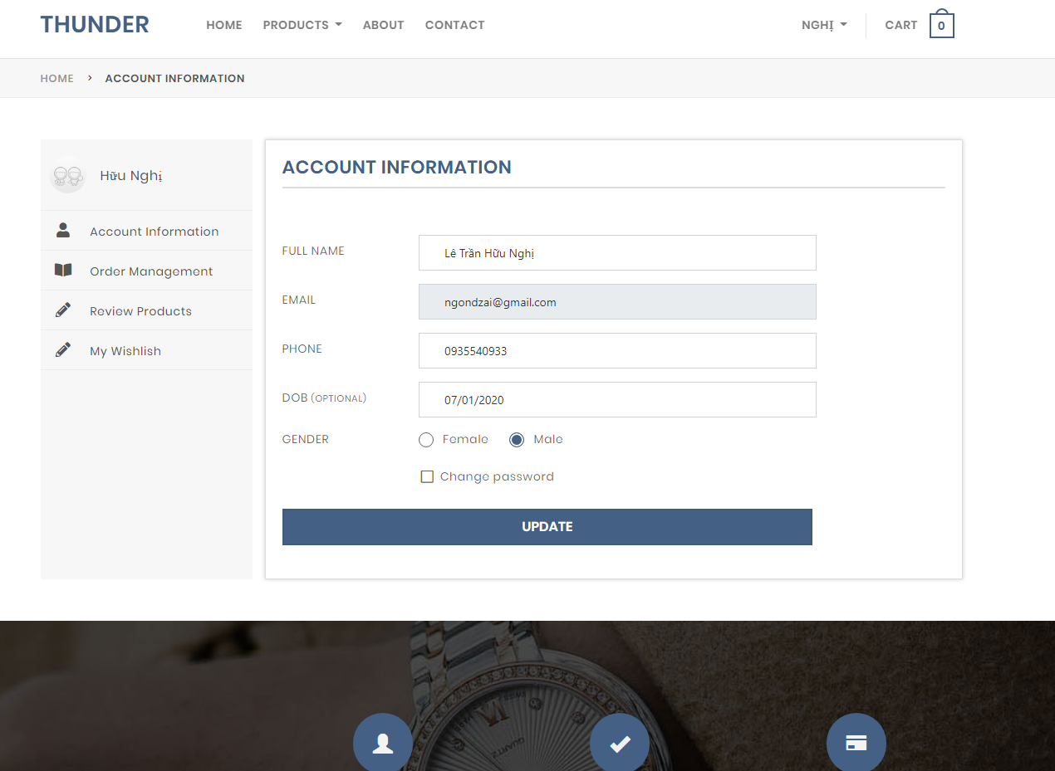**Profile customer:**

If customer want to change password, they can check “Change password”

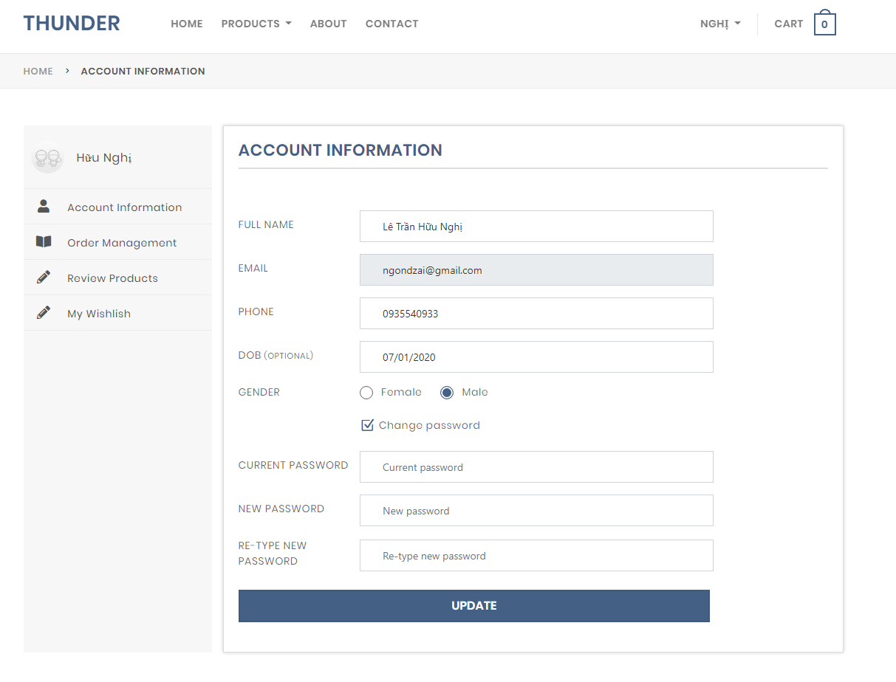

1. 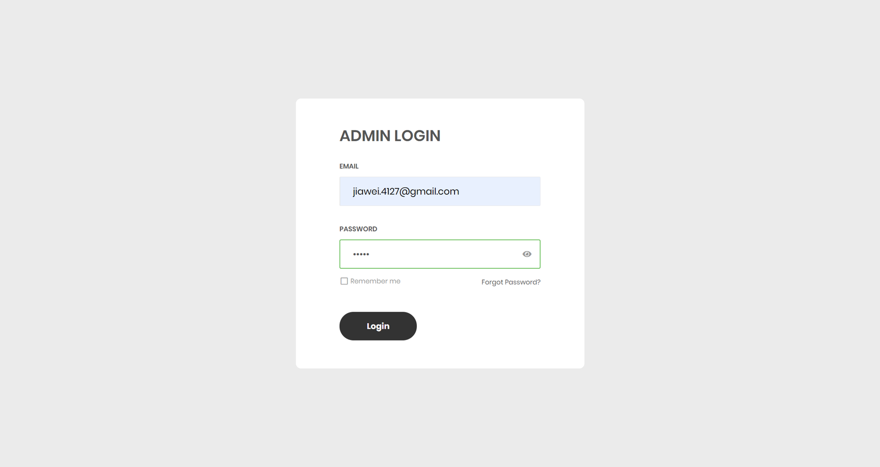**Admin login:**
2. **Employee management for admin:**

Admin can view all information of employees, can add new employee and disable employee. Besides, admin can search employeee

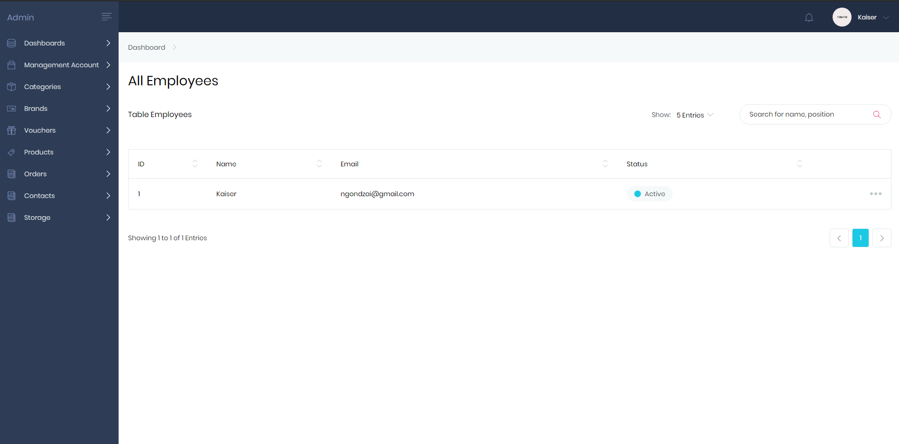

1. **Product management:**

Admin and employee can view all information of product, can add new product, edit product, remove product, set status of product.

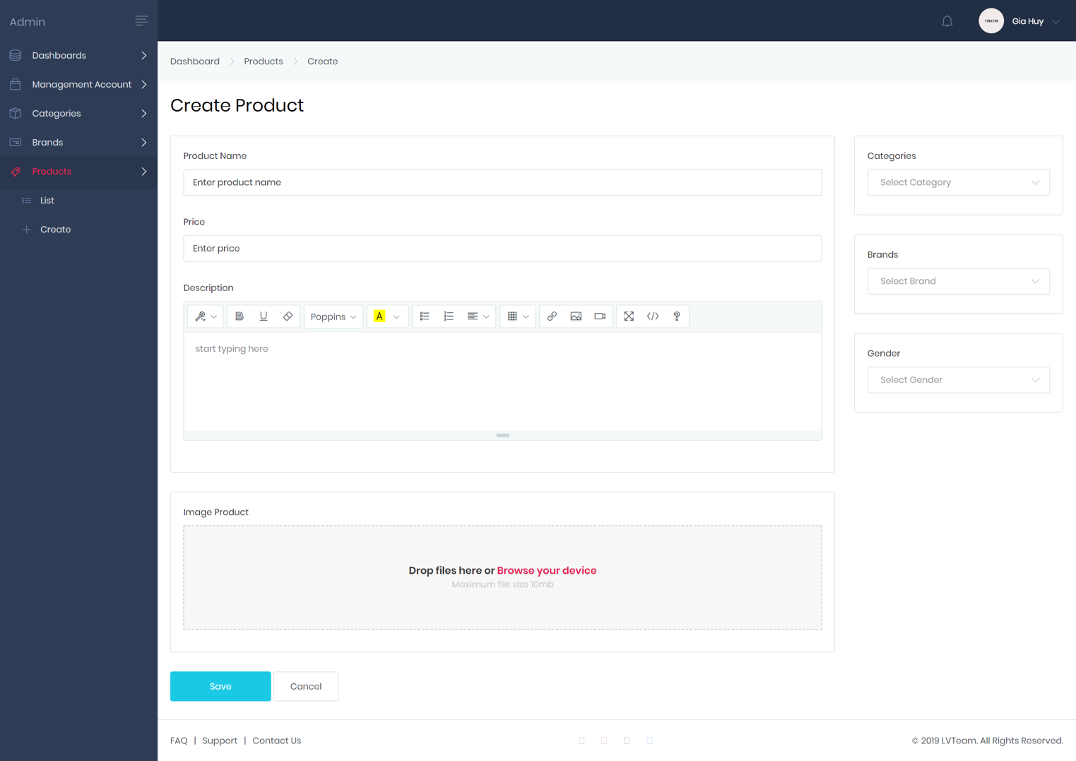

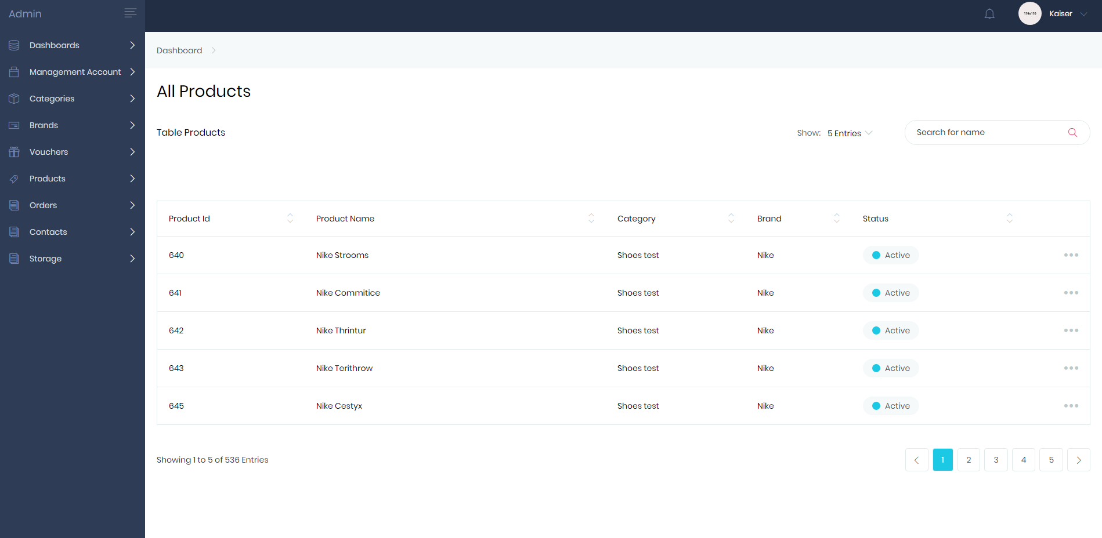

1. **All Voucher**

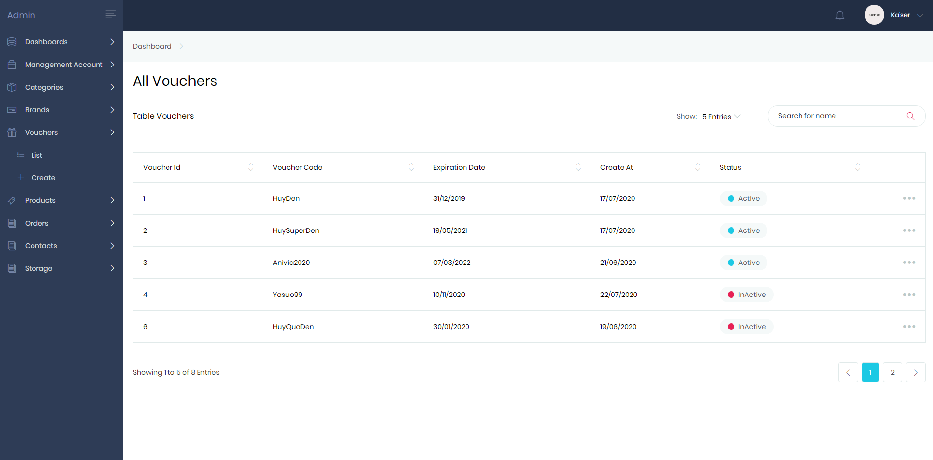

**Create voucher**

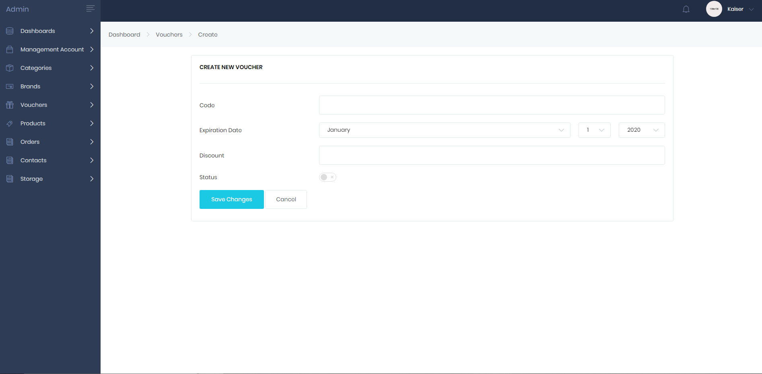**Update Voucher**

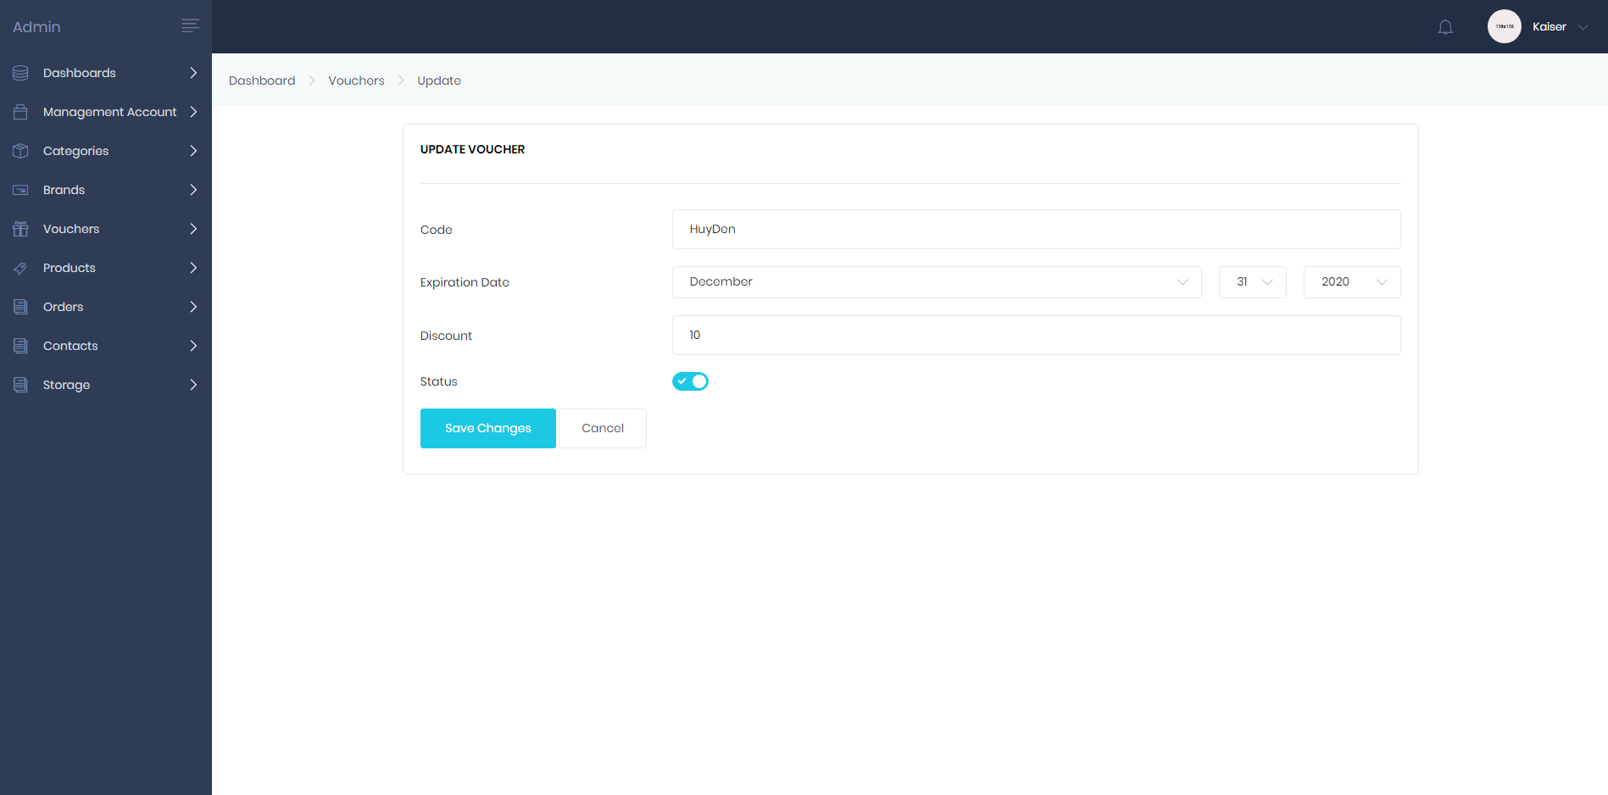

1. 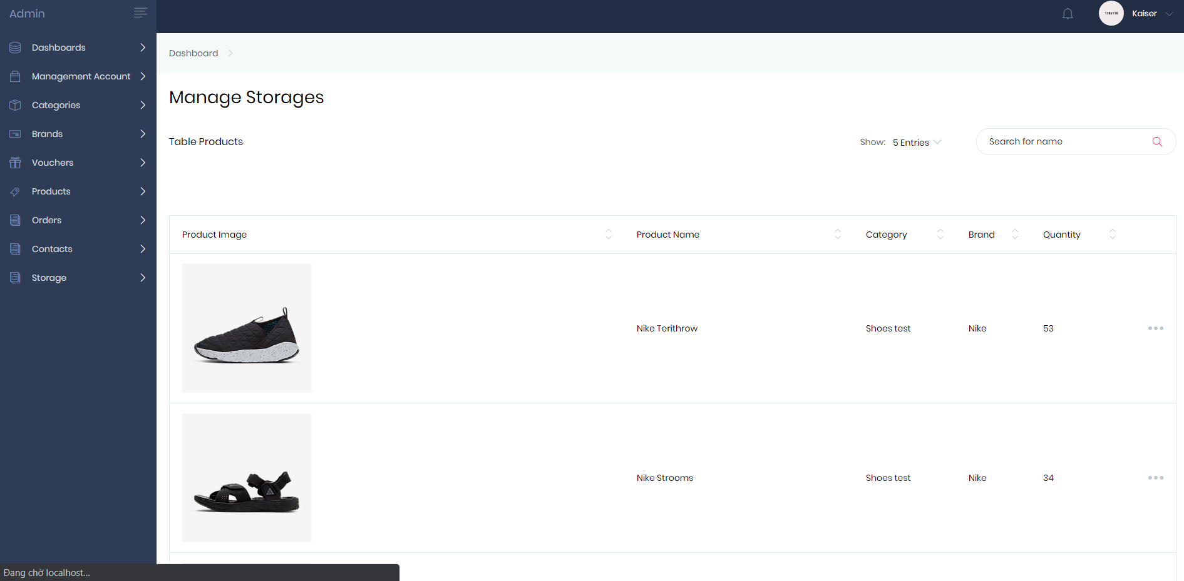**Managed Storages**

Employee can add more or update quantity in storage

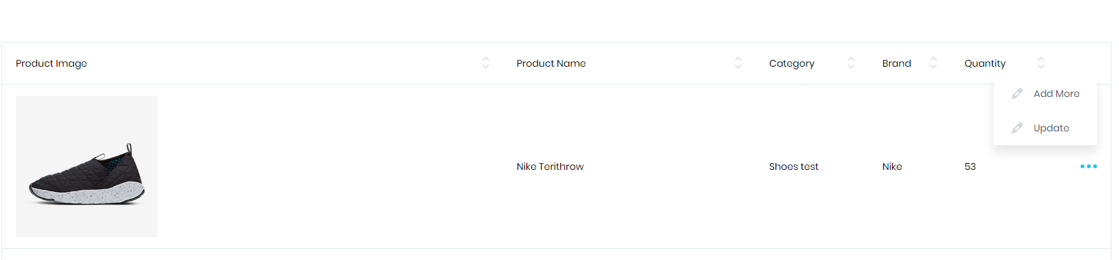

**Update storage**

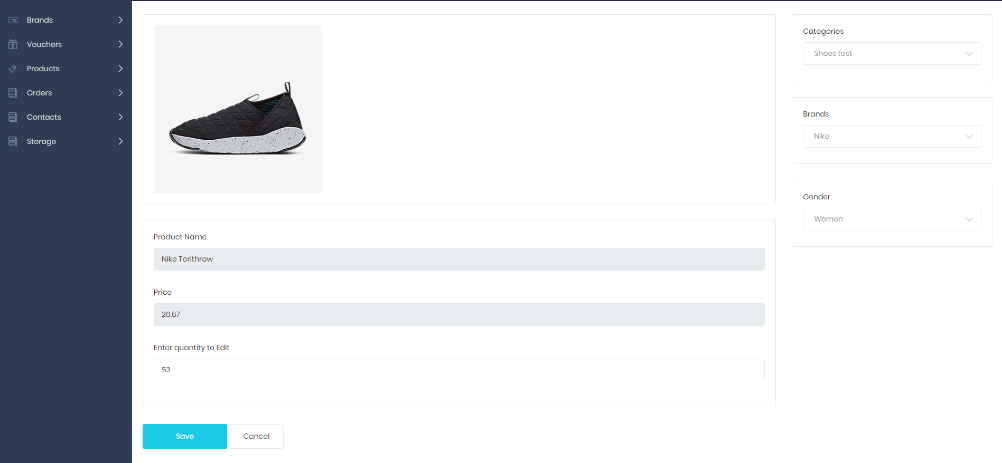

1. **Compare product**

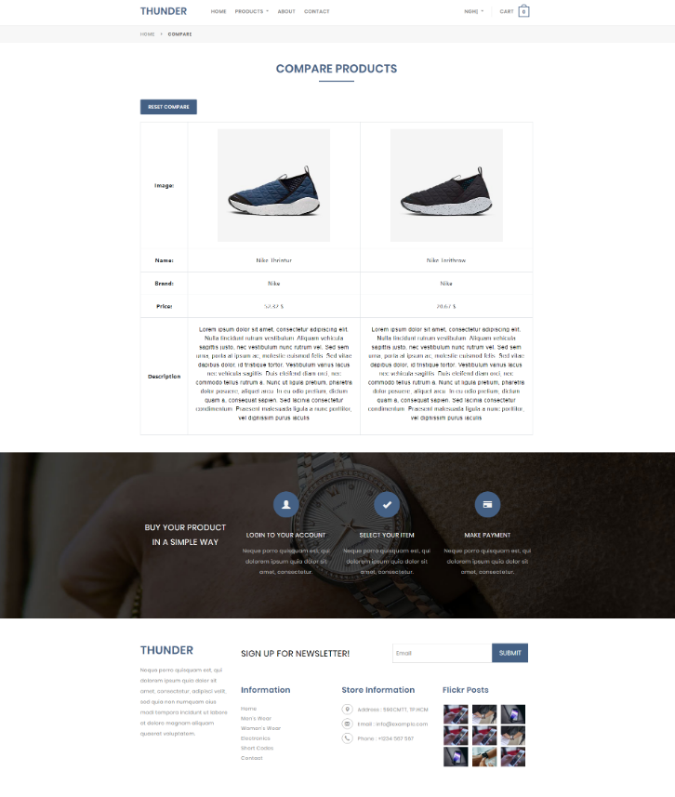

1. **Wishlist** (Customers)

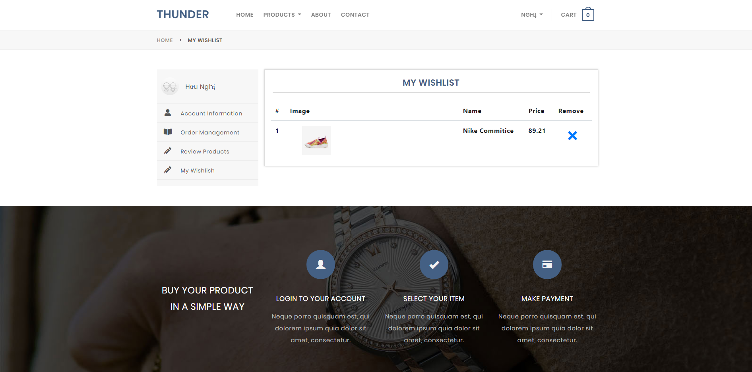

1. **Task Sheet**

|  |  |  |  |  |  |  |  |
| --- | --- | --- | --- | --- | --- | --- | --- |
| **Project Ref. No.:**  **Thunder** | | **Project Title:** | **Activity Plan Prepared By:** | **Date of Preparation of Activity Plan:**  **22/05/2020** | | | |
| **Sr.No.** | **Table** | **Actual Start Date** | **Actual Days** | **Team Mate Names** | **Status** |
|  | Voucher | Thunder | Lê Trần Hữu Nghị | 22/05/2020 | 5 | Lê Trần Hữu Nghị | OK |
|  | Compare product | 22/05/2020 |
|  | Wishlist | 22/05/2020 |
|  | Storages | 22/05/2020 |
|  | Cart | 22/05/2020 | 5 | Vũ Phi Long | OK |
|  | Check out | 22/05/2020 |
|  | Order Detail | 22/05/2020 |
|  | Products | 22/05/2020 | 5 | Chế Gia Huy | OK |
|  | Category | 22/05/2020 |
|  | Admin | 22/05/2020 |
|  | Contact | 22/05/2020 | 5 | Trần Thanh Thiện | OK |
|  | Feedback | 22/05/2020 |
|  | Brand | 22/05/2020 |