**USER GUIDE**

- First, our website is a website about selling sportswear to them.

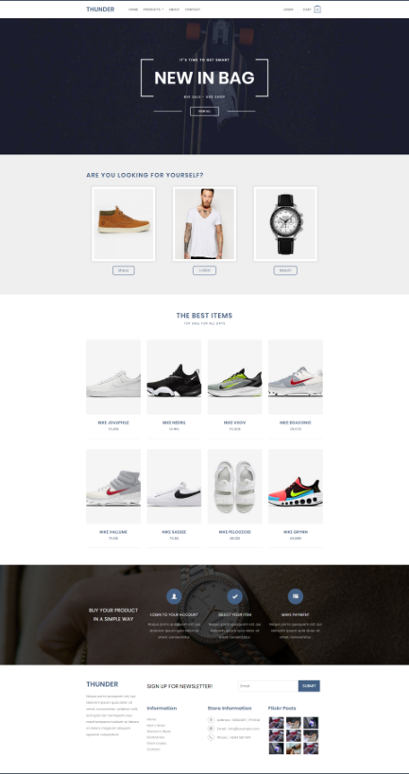-When entering the interface of the homepage, we can see a summary of the site and things like the image of the service displayed on it.

Homepage will show you some new product

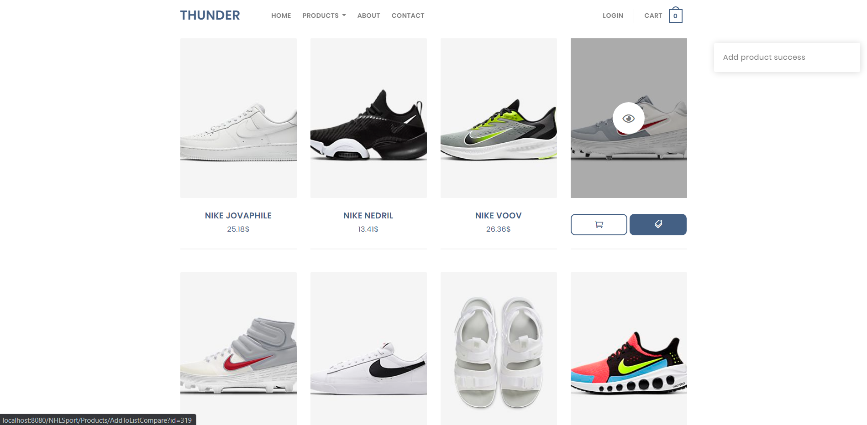

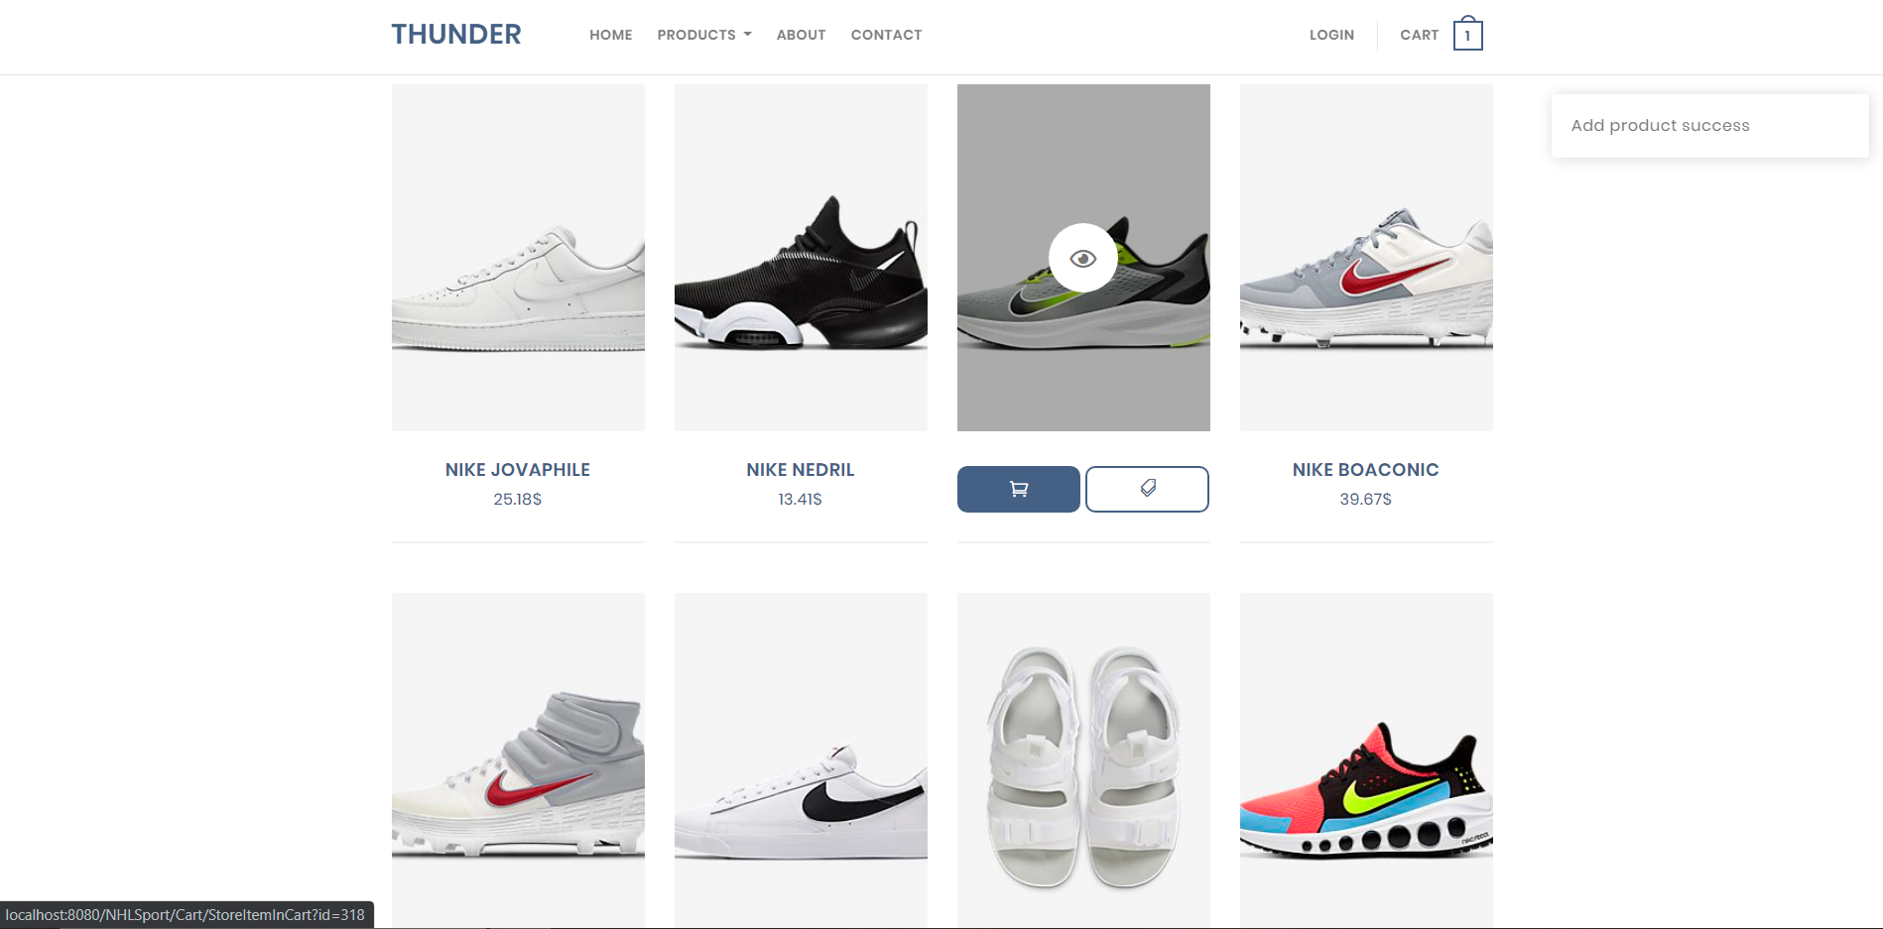 You can compare products by clicking this icon, then a message will appear.

And you can add product to the cart by clicking on this icon.

And if you want to see product details, click on the eye icon in the middle of the product image.

you can go to compare page by clicking product -> compare

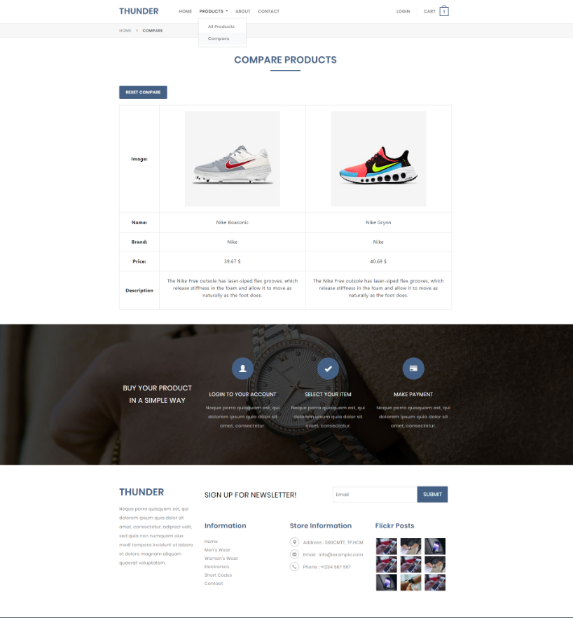

And you can compare the products you have chosen, you can reset list compare by clicking button reset compare

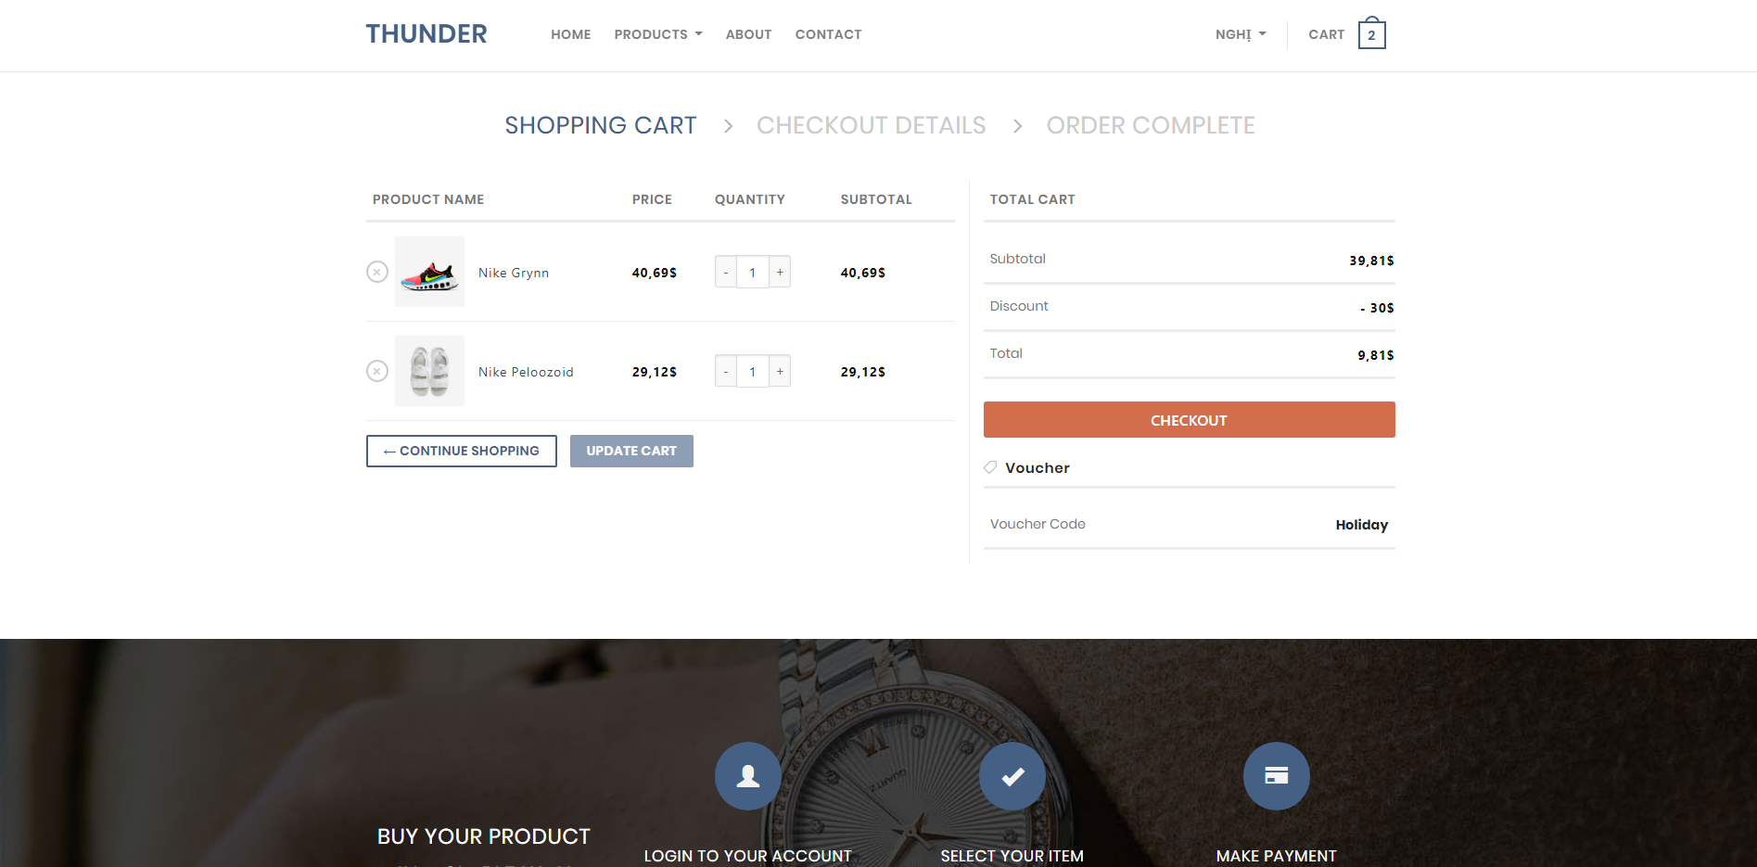Guest and customer can check list product in cart in here   
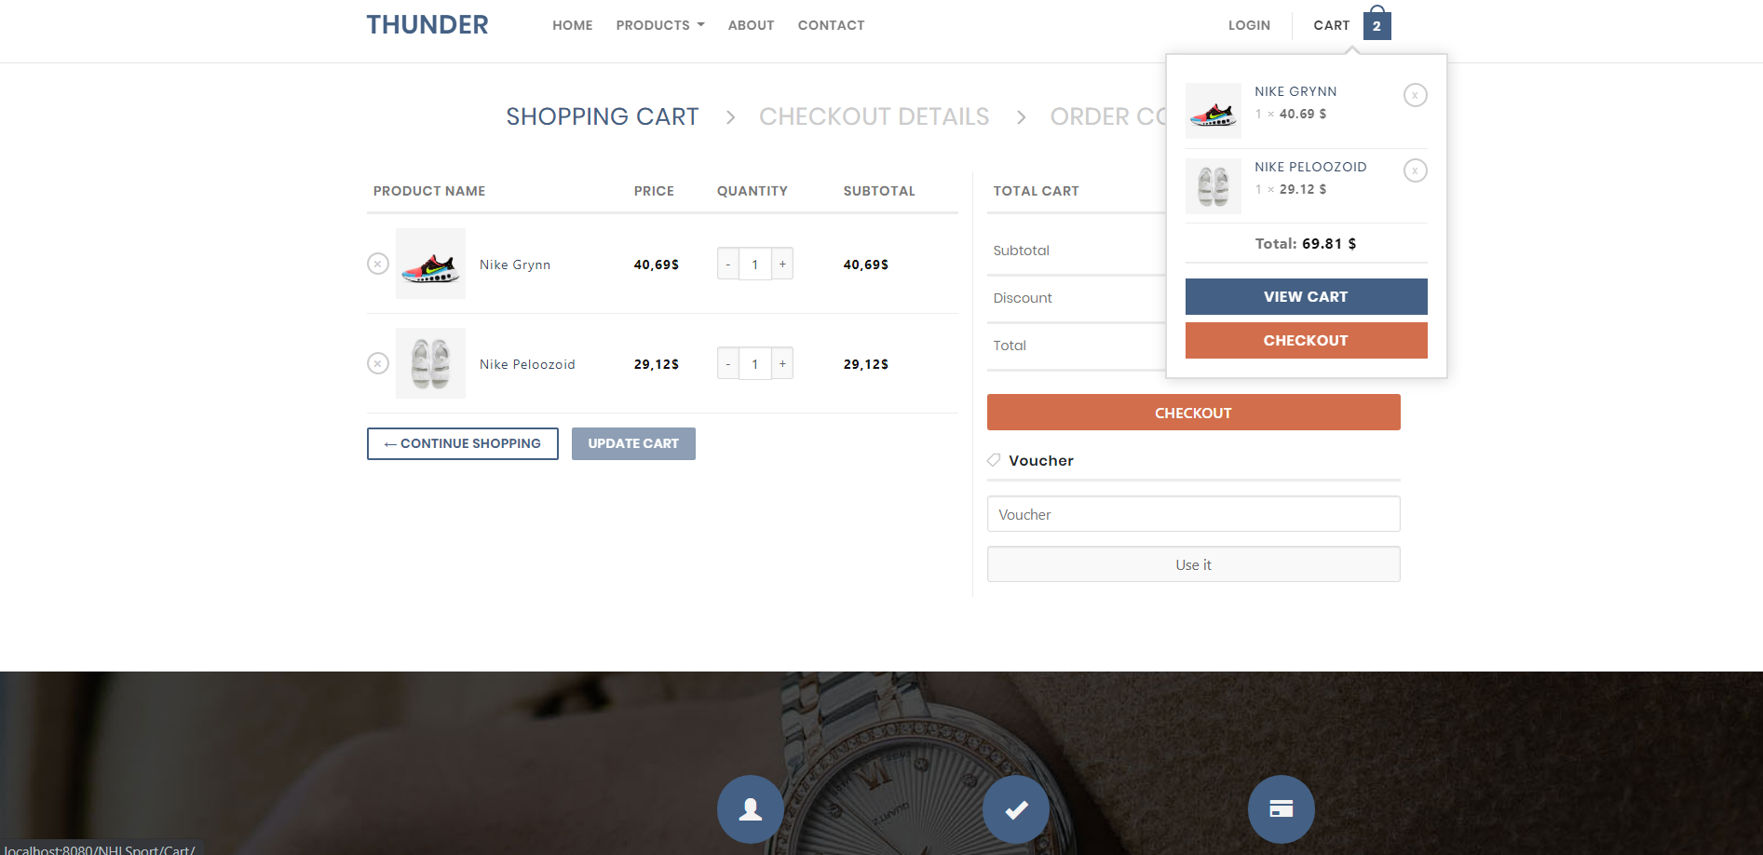  
or Clicking Cart or View Cart

Guest and Customer can enter the voucher, if the voucher exists then the total bill will be discounted.

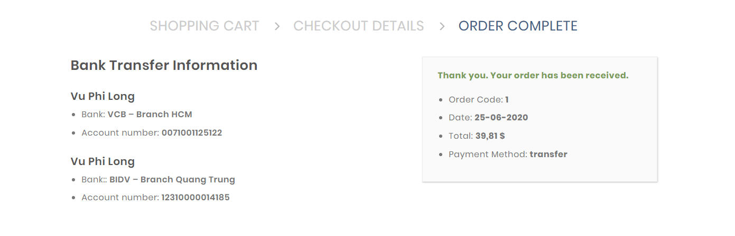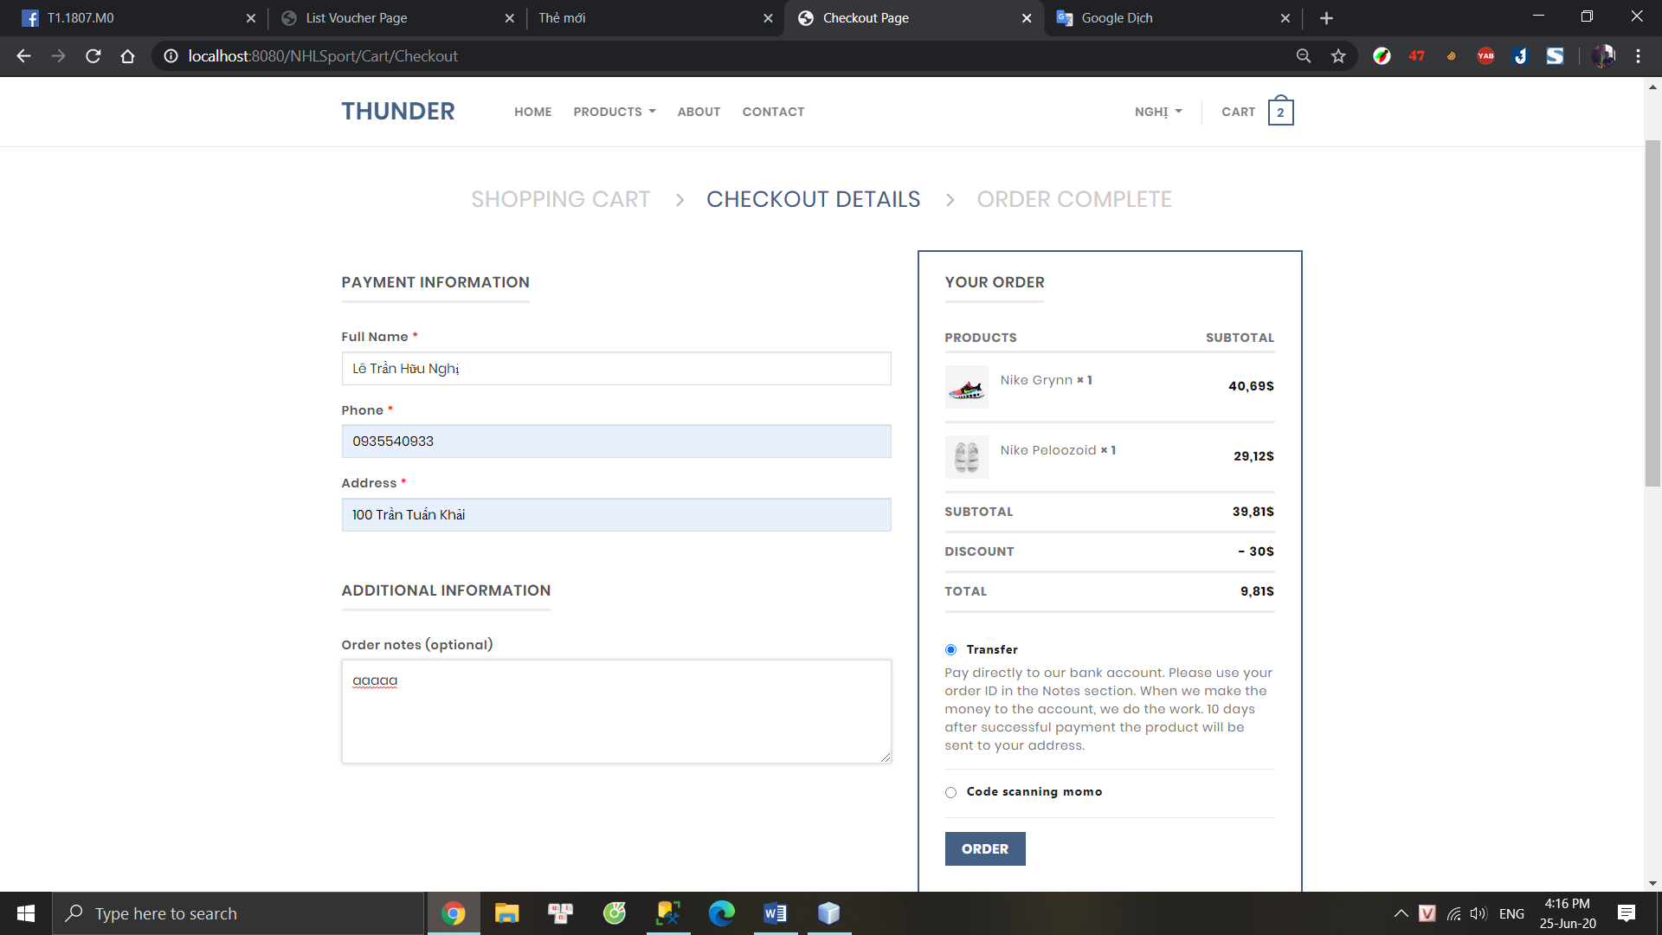Before clicking checkout, guest or customer need to add information

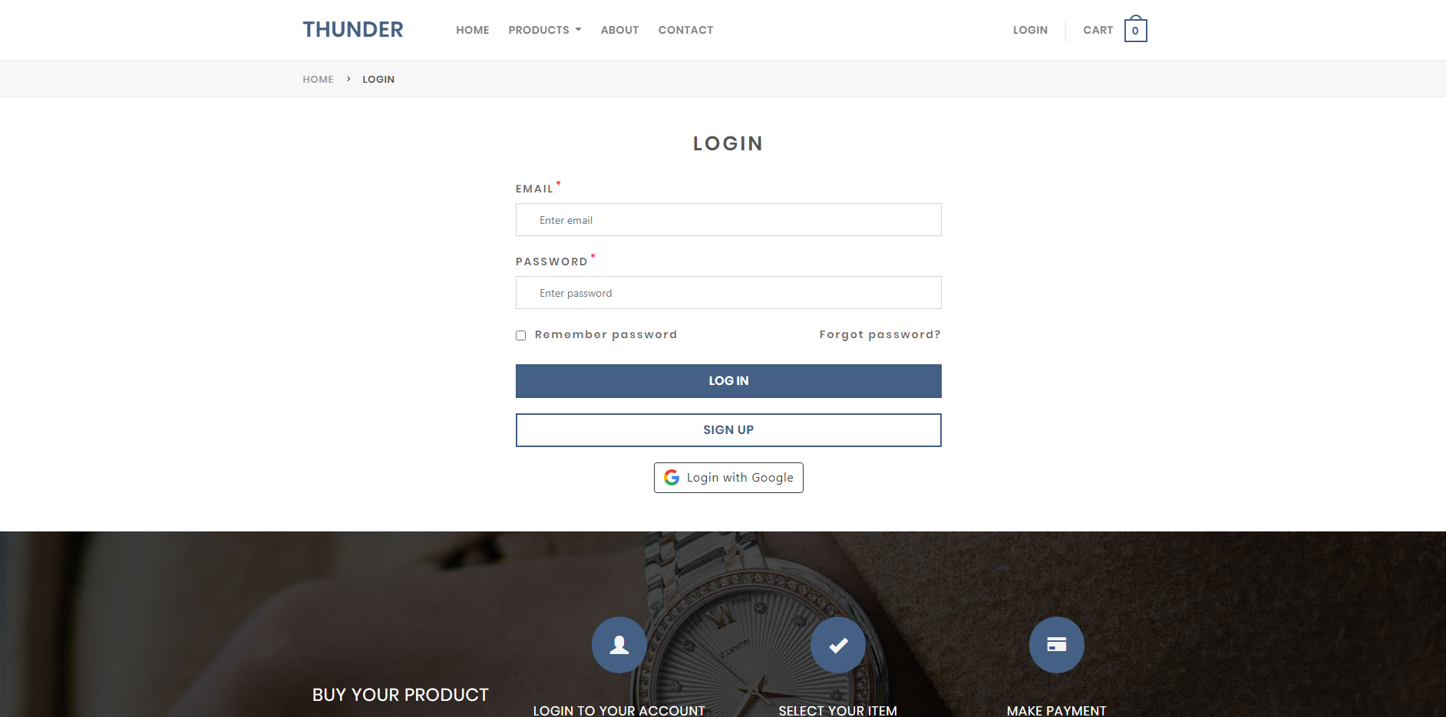

Login Page

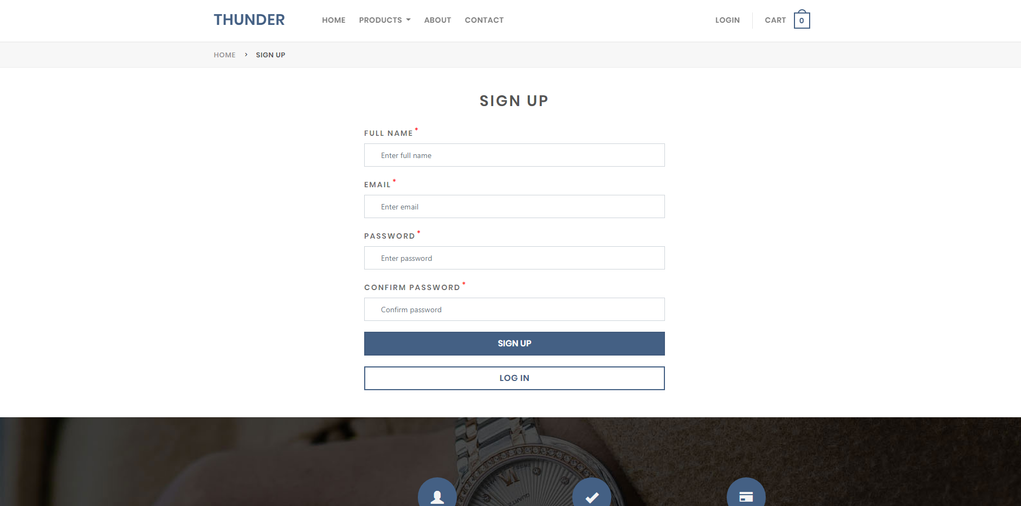

Sign up for Guest

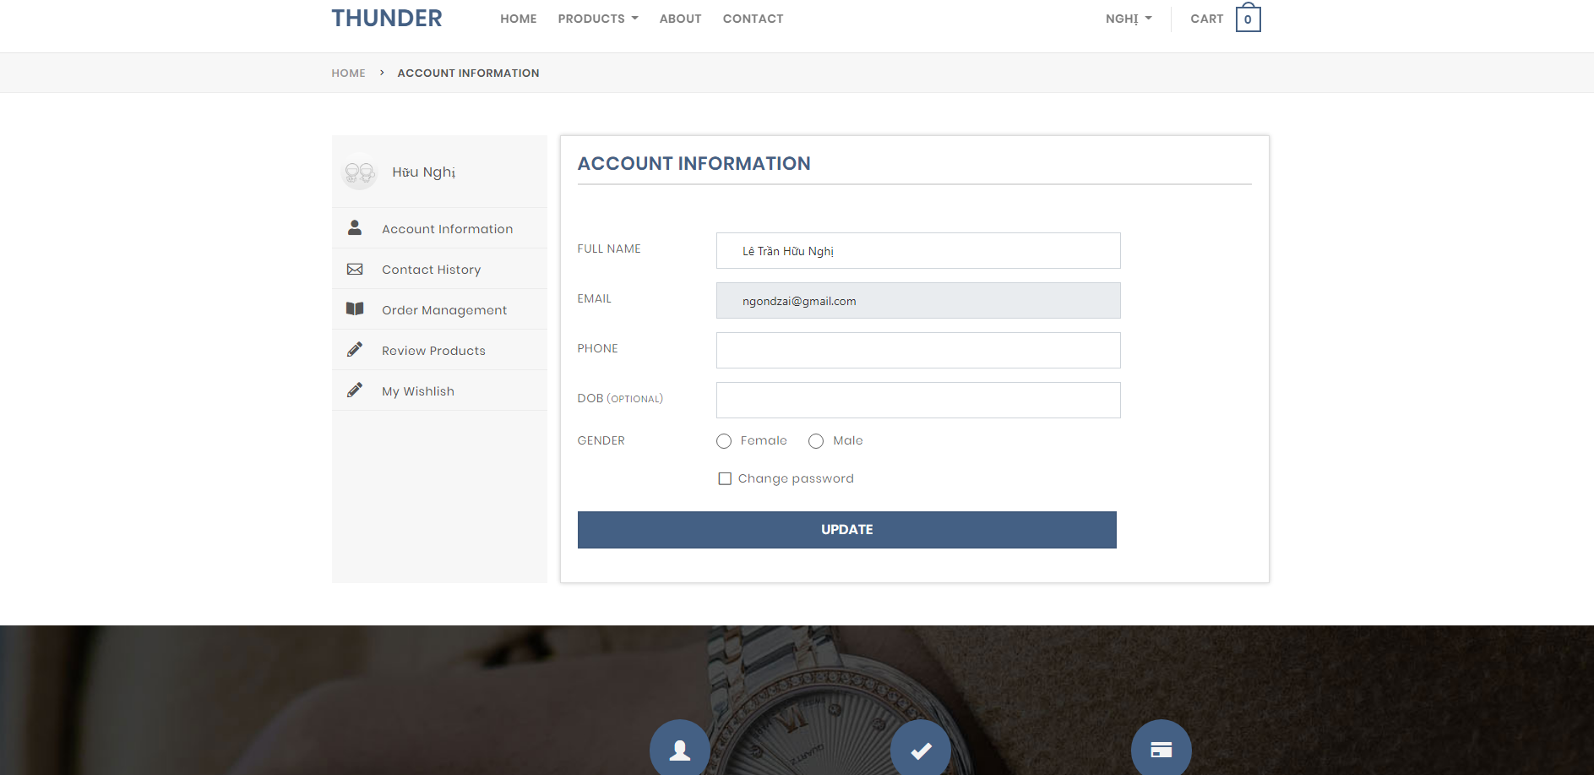

Account information.

Link to login admin page: <http://localhost:8080/NHLSport/Admin/Login>

Email: [admin@gmail.com](mailto:admin@gmail.com)

Password: 123456

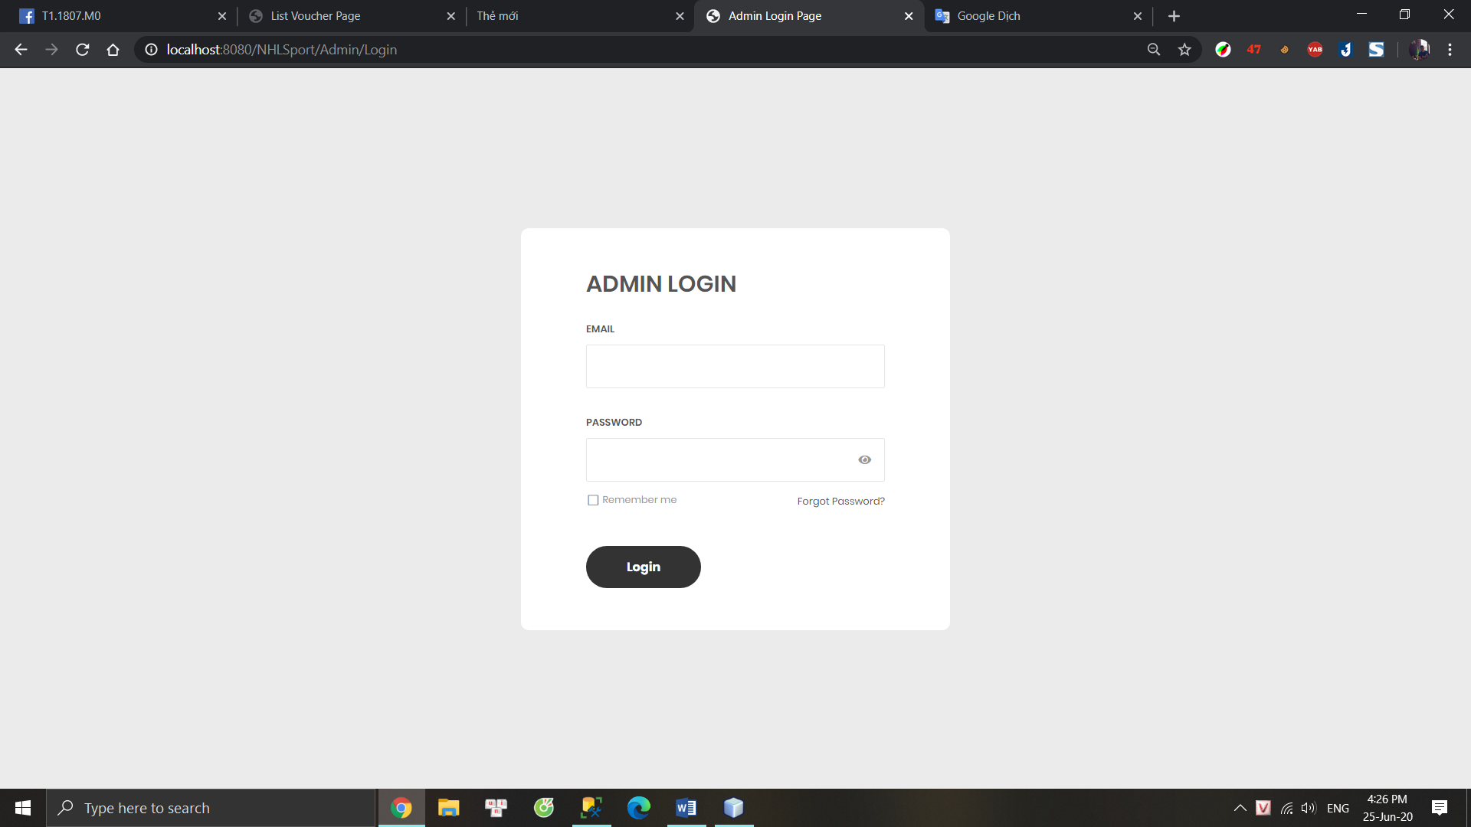

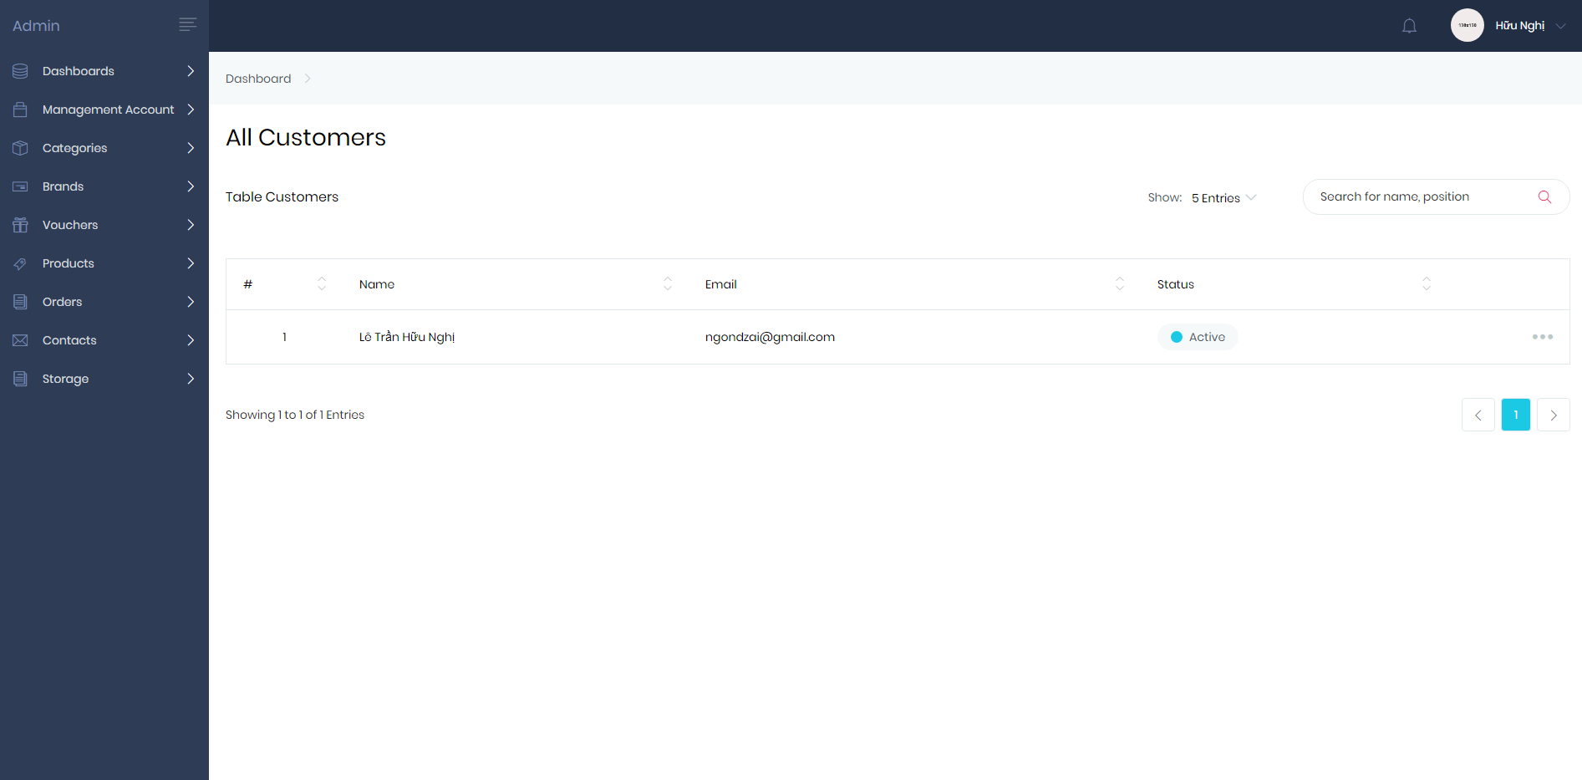Managed Customers, Brand, Product, Storage, Voucher….

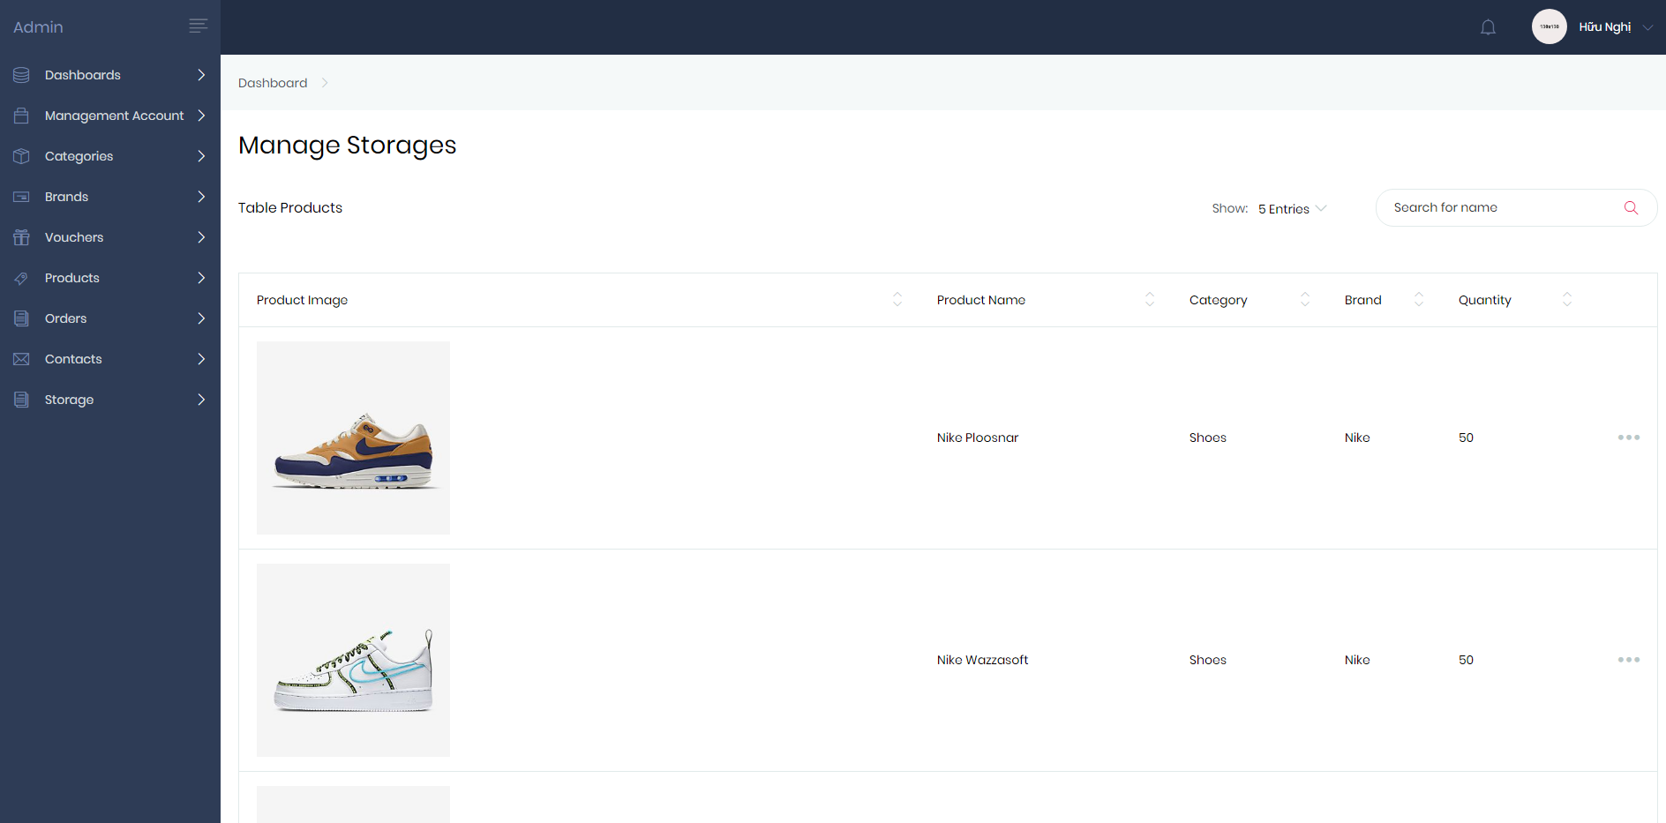

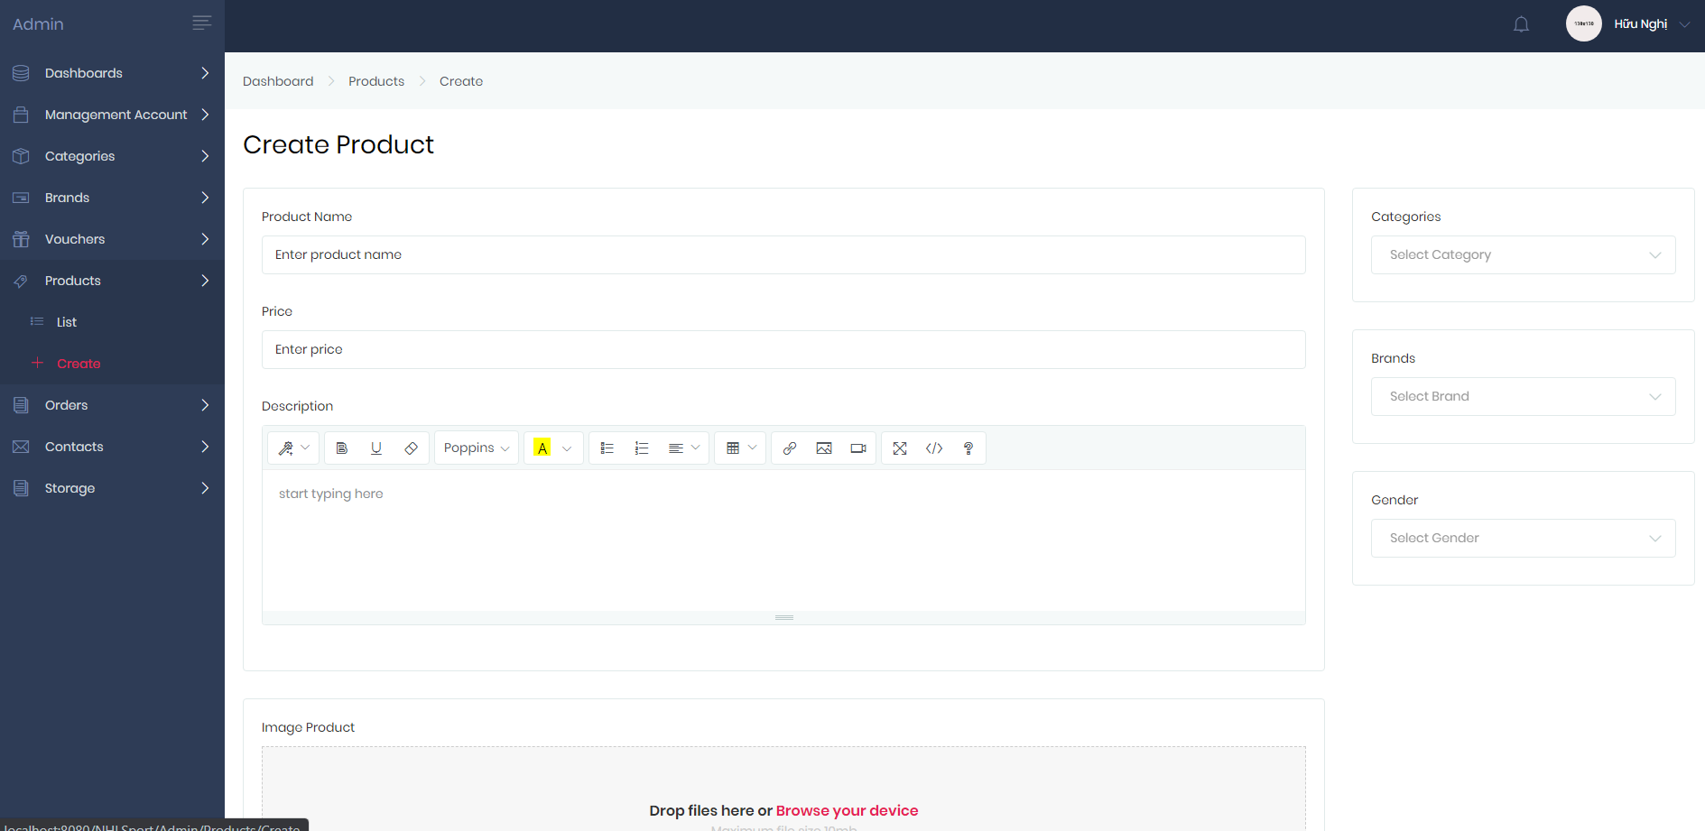

Create new product