

PROJECT:. NHLSport
GROUP NO: . 02 . . . ., BATCH: . . . .T1.1807.M0 . . . . . . .
- Software and Hardware Requirement
- Hardware requirement
Component | Requirement
Server | Processor type:  Pentium III-compatible processor or faster  Processor speed:  Recommended: 2.0 GHz or faster
OS | Microsoft Windows Server 2003 or higher
Memory (RAM) | RAM:  Minimum: 512 MB  Recommended: 2.0 GB or more  Maximum: Operating system maximum
Hard Drive | Free space:  Minimum: 50 MB  Recommended: 50 GB or more  Maximum: Operating system maximum
- Software requirement
Component | Requirement
Java Development Kit | Version 1.8.x
NetBeans | 7.4
RDBMS | Microsoft SQL Server 2012 or higher
Hosting | Glassfish 4.0
Web Browser | Chrome (recommended), Firefox, IE 7 or higher
- CONFIGURATION
- After you have downloaded our project file, please extract it. There are 5 sub-folders inside the folder:
+ “Database” folder: storing query script for the database.
+ “Source code” folder: where the package for the application is stored.
+ “Document” where the eProject report, feedback, user guide and the installation guide in document format are stored. These file have a copy in PDF format in root.

Please read the installation guide and then the user guide before running our application.
- Database Configuration
Step 1: Open Microsoft SQL Server Management Studio and the Connect to Server window opens. If not, you can open it manually by selecting Object Explorer > Connect > Database Engine.
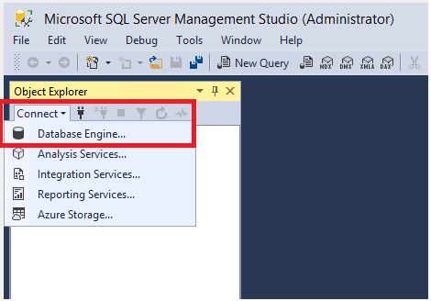

Step 2: In the Connect to Server window, do the following:
- For Server name, enter the name of your SQL Server (it would be filled normally).
- For Authentication, select SQL Server Authentication
- For User Name, enter your user name
- For Password, enter your password
- After you've completed all the fields, select Connect.
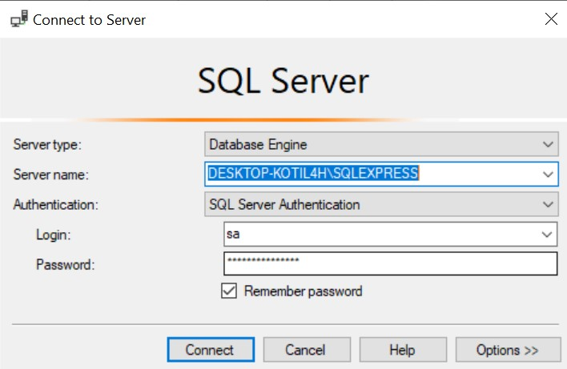
Step 3: Go to the Database folder, find and open (double click) the SQL-Query file – “Database.sql”

Step 4: This file will automatically open in the Microsoft SQL Server Management Studio. Then please click on Execute button on the top Menu bar (If this button is not available, please click on blank space of the query document).
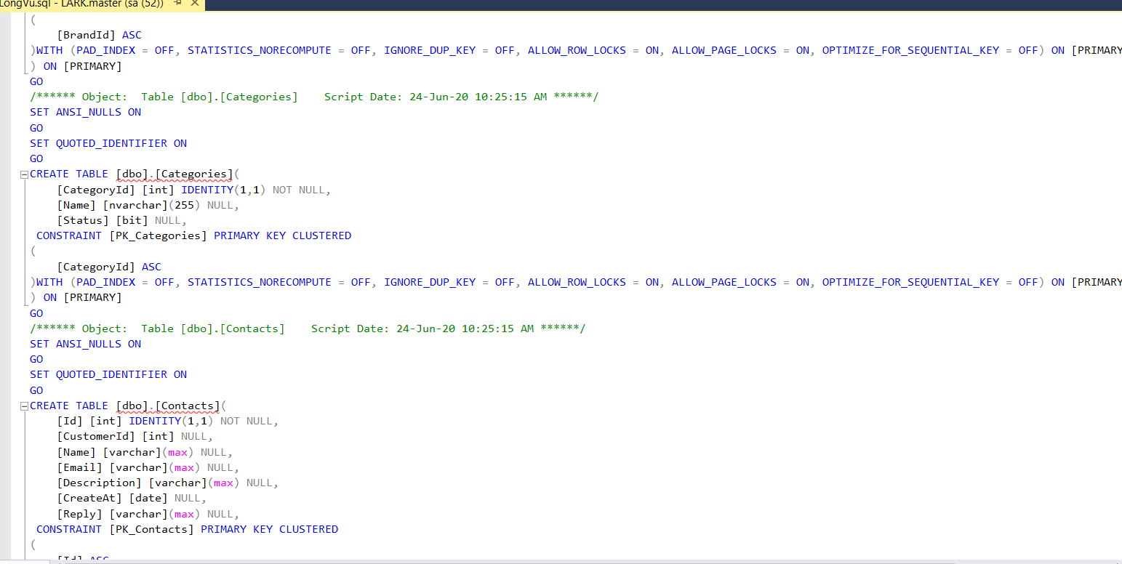

Step 5: After the script is executed successfully, right-click on Database and select Refresh. You can see the database named ThunderShop appears in Object Explorer.
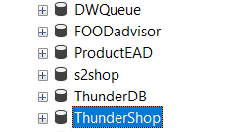

- Project Configuration
If glassfish4 is not installed please go to this page to download and install it.
https://javaee.github.io/glassfish/download
Step 1: Find location of your glassfish 4.0 server which usually be glassfish4 in the test computer. Navigate to bin folder in glassfish4 and open Command Prompt Windows here.
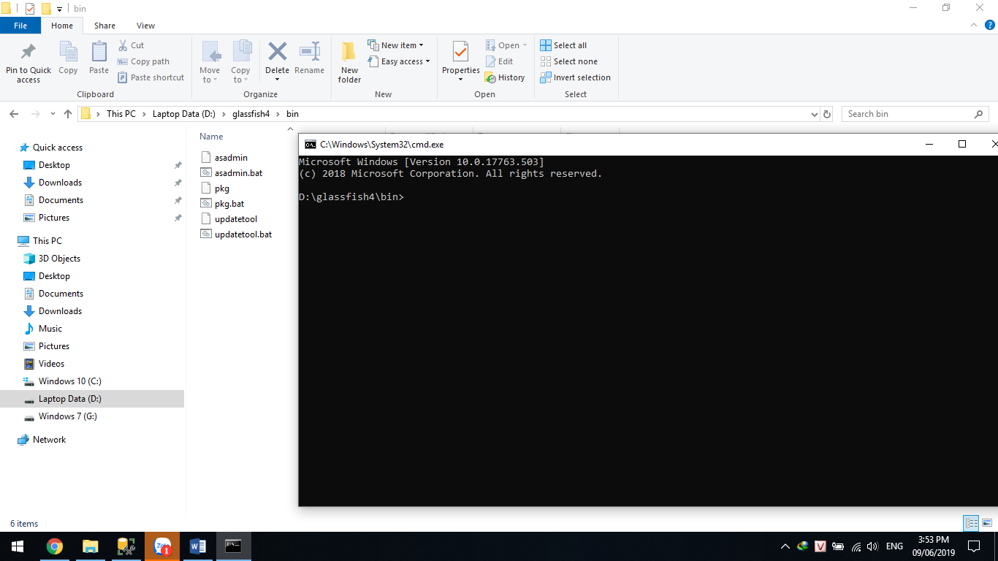
Step 2: Type in Command Prompt Windows “asadmin start-domain domain1” to start domain1 on glassfish server. The result must be command executed successfully.
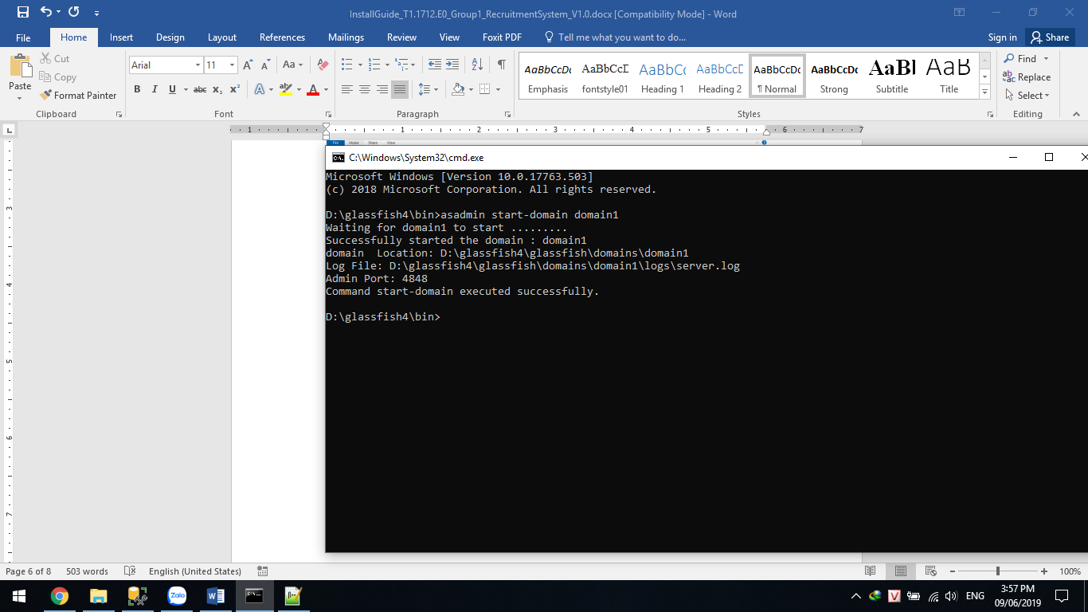
Step 3: Open the browser (Chrome or Firefox) and type in this address “http://localhost:4848” to go to glassfish admin page.

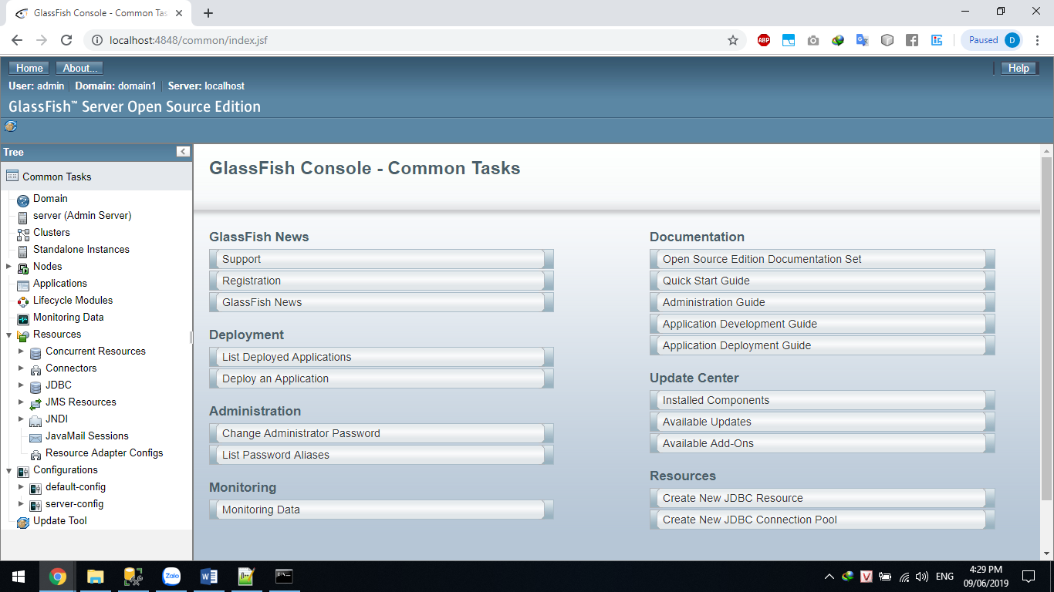

Step 4: Click on “Deploy an Application” button on Deployment menu, then click on Choose file and navigate to the NHLSport.war file on the Source Code folder. Finally, click ok on the top-right of the web screen and wait till the success screen appear.
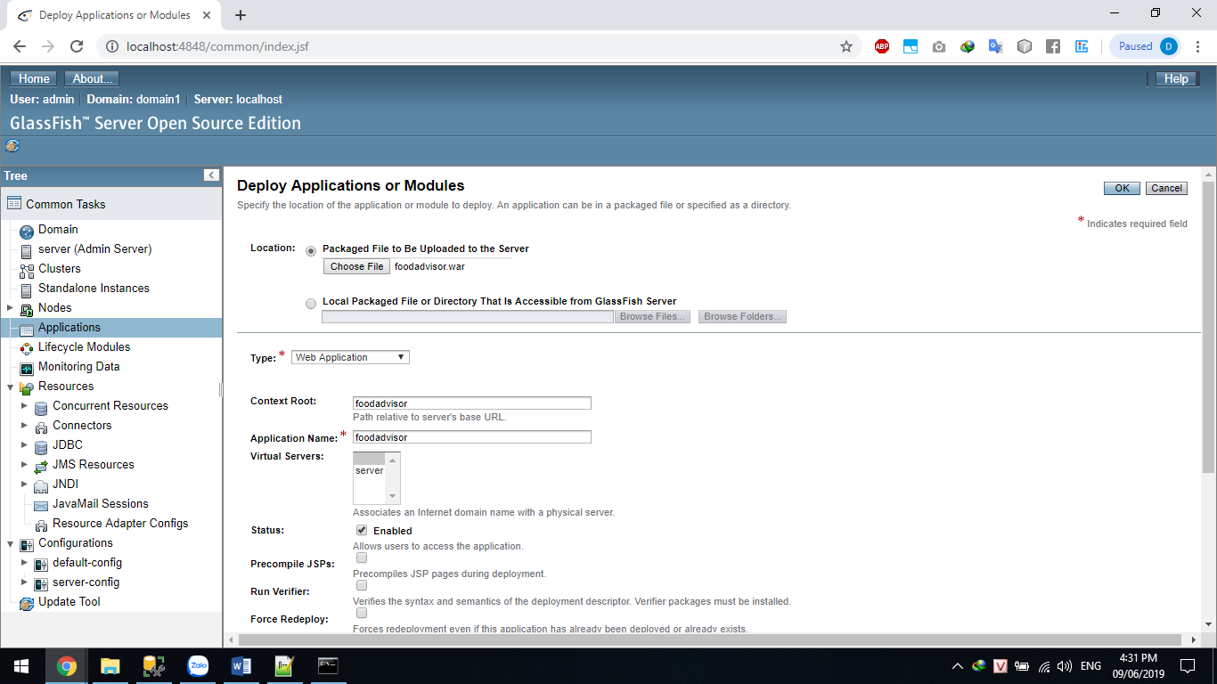

Resources -> JDBC Connection Pools -> new

- New JDBC Connection Pool (Step 1 of 2),
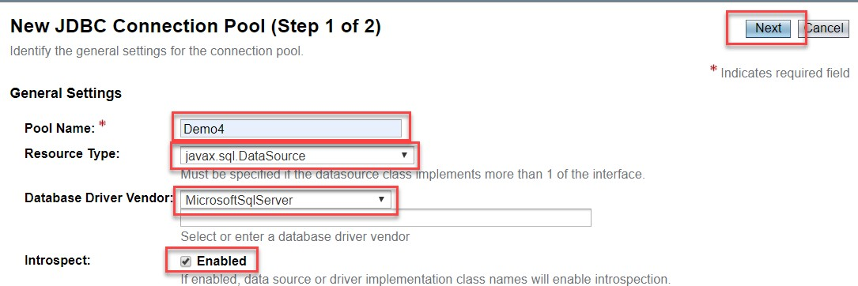
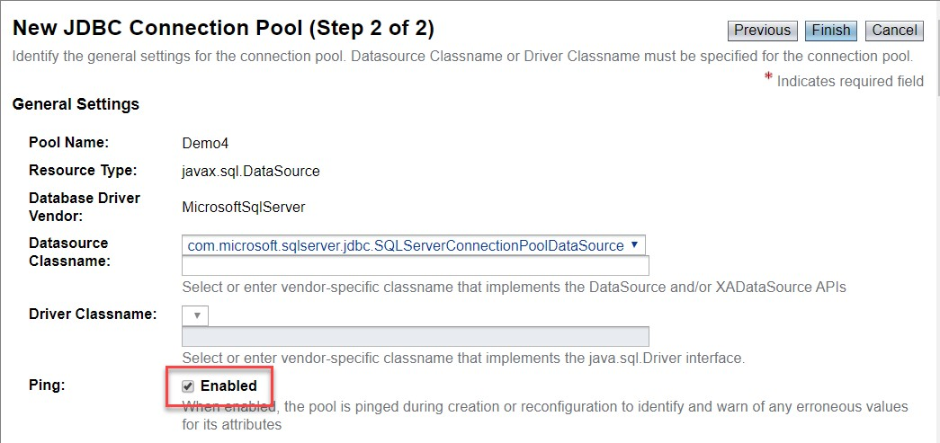
New JDBC Connection Pool (Step 2 of 2),

