实验一~实验四报告

备注：我的学号后四位是8152

# 实验一:Led灯控制电路

## 激励文件:

module led_tb;

reg CLK;

wire [1:0] led_out;

// 被测试的模块实例化

led led_152 (

.CLK(CLK),

.led_out(led_out)

);

// 生成时钟信号

initial begin

CLK = 0;

forever #1.52 CLK = ~CLK; // 使用学号后三位作为时钟周期的一半

end

initial begin

$monitor("Time = %t, CLK = %b, led_out = %b", $time, CLK, led_out);

#1000000000;

$finish;

end

endmodule

## 仿真结果截图:

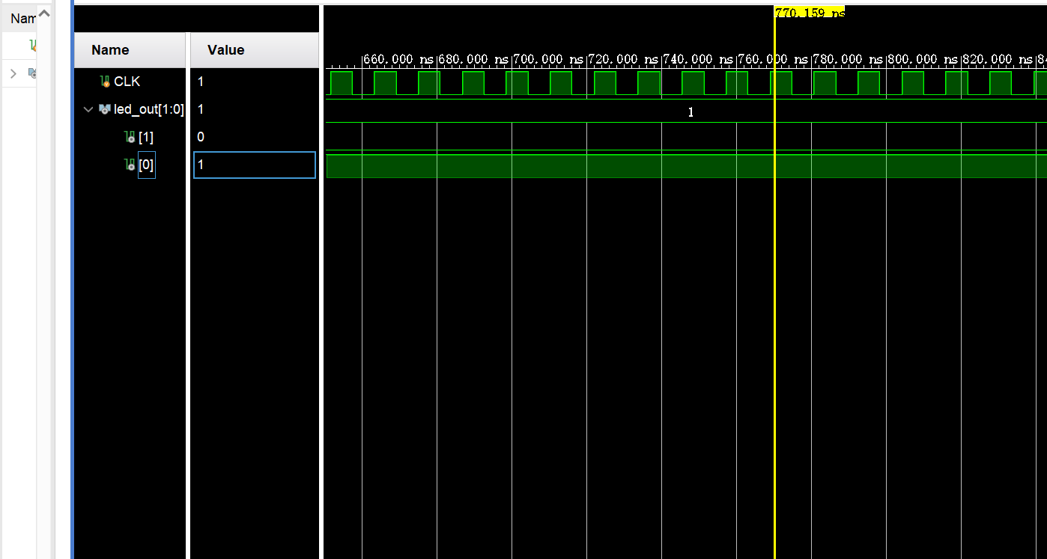

## 电路图:

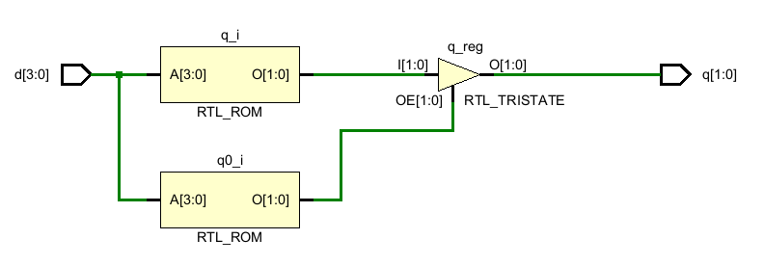

## 编码器:

## 激励文件:

module encoder4_2_tb(

);

reg [3:0] d;

wire [1:0] q;

encoder4_2 encoder(

.d(d),

.q(q)

);

initial begin

d <= 4'b0111;

#10

d <= 4'b1011;

#10

d <= 4'b1101;

#10

d <= 4'b1110;

end

endmodule

## 仿真结果截图:

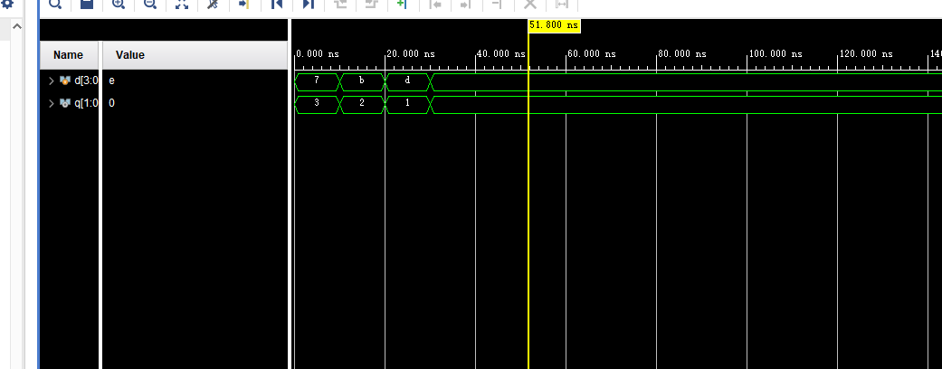

## 电路图:

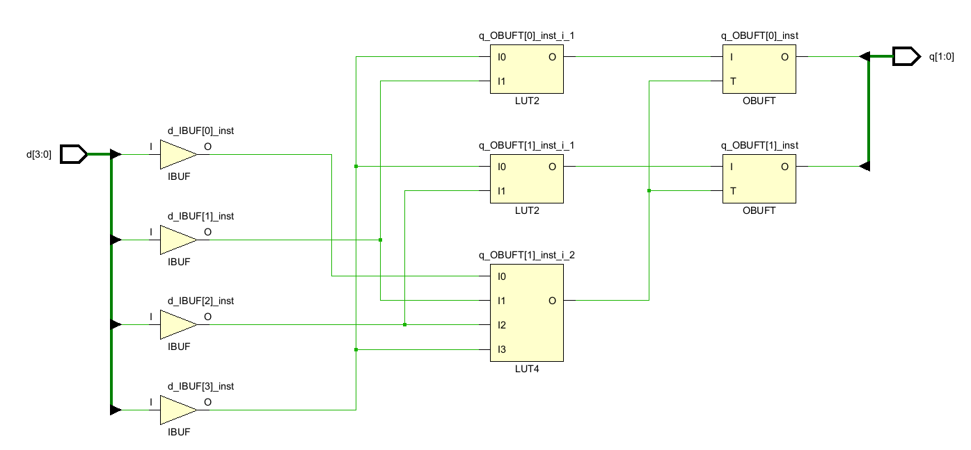

## 比较器:

## 激励文件:

module comp_tb(

);

reg CLK,RST;

reg [1:0] A,B;

wire AEQB,AGTB,ALTB;

comp comp2021218152(.CLK(CLK),.RST(RST),.A(A),.B(B),.AGTB(AGTB),.ALTB(ALTB),

.AEQB(AEQB));

initial begin

CLK <=0;

RST <=0;

A <=2'b00;

B <=2'b00;

#10

RST <=1;

#10

A <=2'b01;

#10

B <=2'b01;

#10

B <=2'b11;

#10

A <=2'b11;

end

always #10 CLK =~CLK;

endmodule

## 仿真结果截图:

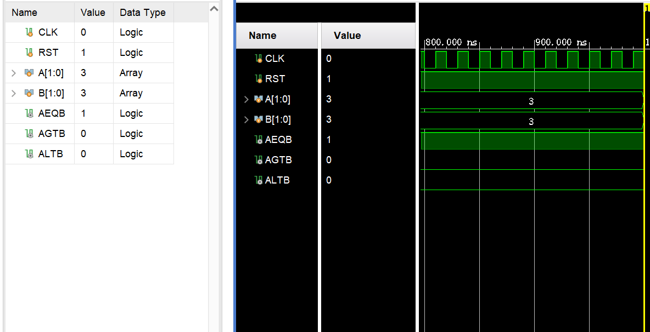

## 电路图:

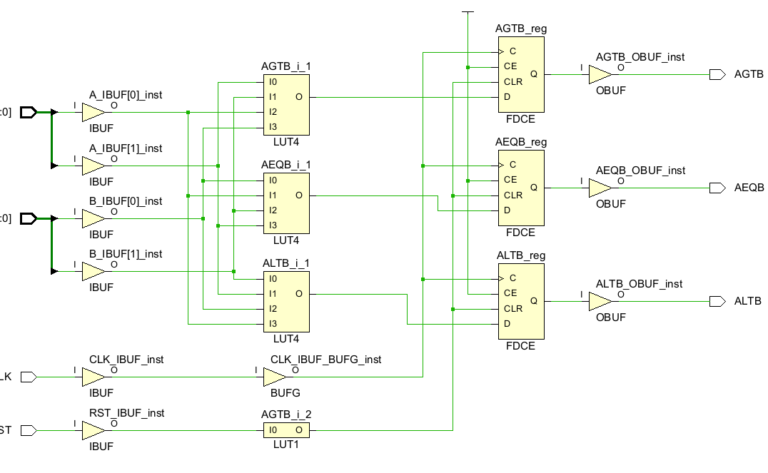

## 全加器:

## 激励文件:

module add_tb();

reg a, b, cin;

wire sum, cout;

add add152(.cout(cout), .sum(sum), .a(a), .b(b), .cin(cin));

initial begin

a = 0;

b = 0;

cin = 0;

repeat (10) begin

#15.2 {a, b, cin} = {a, b, cin} + 5;//我的学号是2021218152 设置时间为15.2毫秒

end

end

endmodule

## 仿真结果截图:

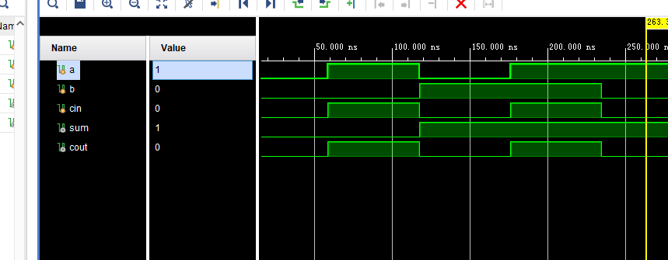

## 电路图:

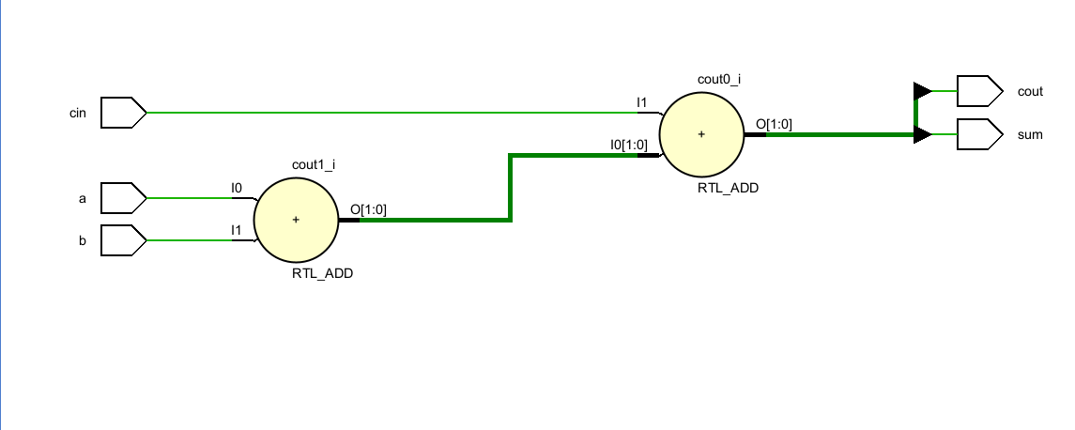

# 实验二:加法计数器

## 激励文件:

module addcount_tb();

reg clk;

reg reset;

wire [3:0] Q;

addcount addcount152(.clk(clk), .Q(Q), .reset(reset));

initial begin

clk = 0;

reset = 0;

#20 reset = 1;

end

always #15.2 clk = ~clk; //学号后三位作为时钟信号

endmodule

## 仿真结果截图:

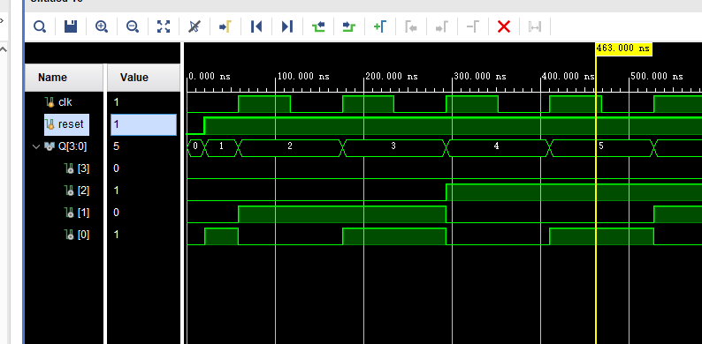

## 电路图:

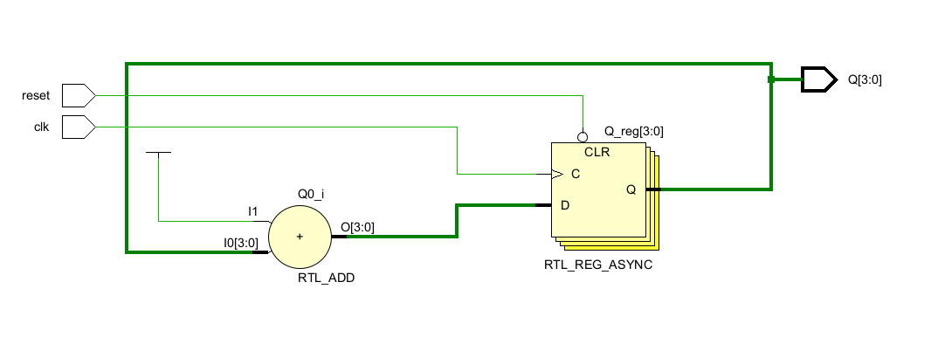

## 减法计数器:

## 激励文件:

module reducecounter_tb(

);

reg clk;

reg reset;

wire [3:0] Q;

reducecounter reducecount152(.clk(clk), .Q(Q), .reset(reset));

initial begin

clk =0;

reset = 0;

#20 reset =1;

end

always #15.2 clk =~clk; //学号后三位作为时钟信号

endmodule

## 仿真结果截图:

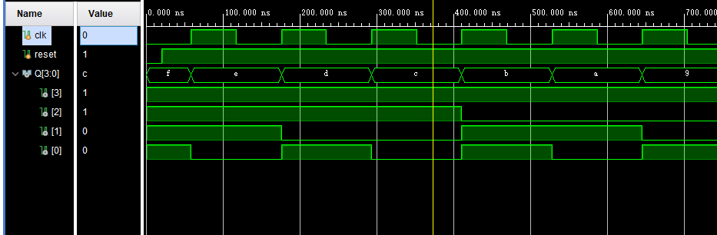

## 电路图:

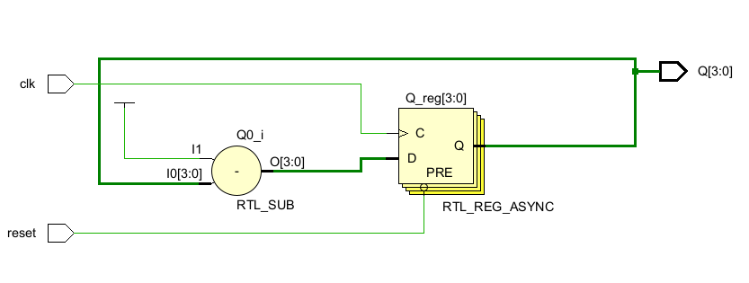

## 状态机:

## 激励文件:

module FSM_tb();

reg Clock;

reg Reset;

reg A;

wire F;

wire G;

fsm Fsm_152(

.Clock(Clock),

.Reset(Reset),

.A(A),

.F(F),

.G(G)

);

always #15.2 Clock = ~Clock; //学号后三位

initial begin

Clock <=0;

Reset <=1;

A <=0;

#1.52 Reset<=0; //当第一个Clock上升沿出现时state为1000 F为0 G也为0

//之后将A设置为1在下一个

#30.4 Reset<=1; //保证后面的状态可以全部展现

A<=1; #30.4;

A<=0; #30.4;

A<=1; #30.4; //学号*2

A<=0; #30.4;

#30.4

$finish;

end

initial begin

$monitor("Time=%t, Reset=%b, A=%b, State=%b, F=%b, G=%b", $time, Reset, A,Fsm_152.state, F, G);

end

endmodule

仿真结果截图:

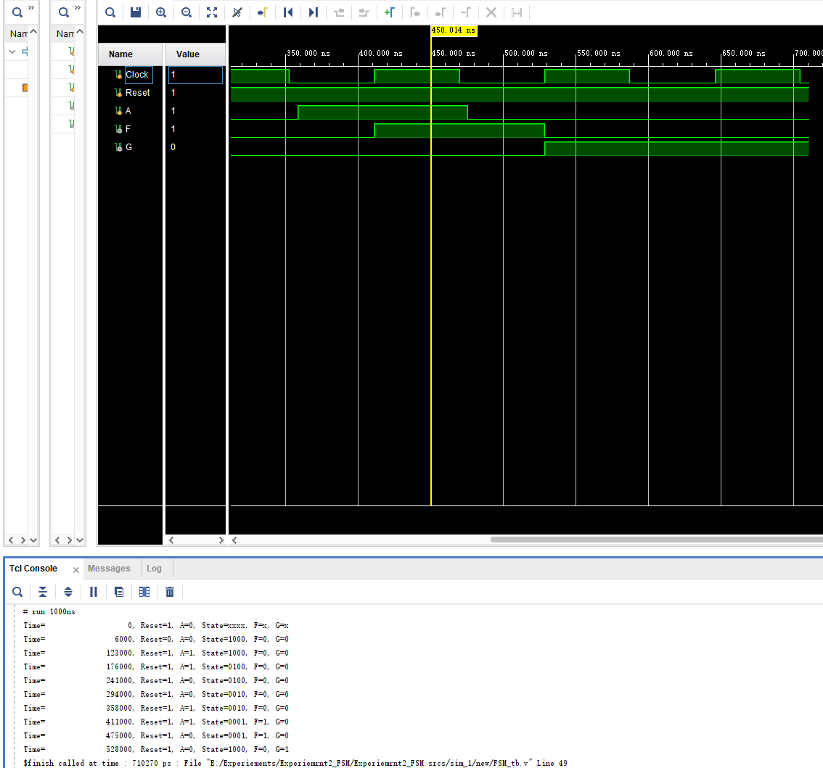

## 电路图:

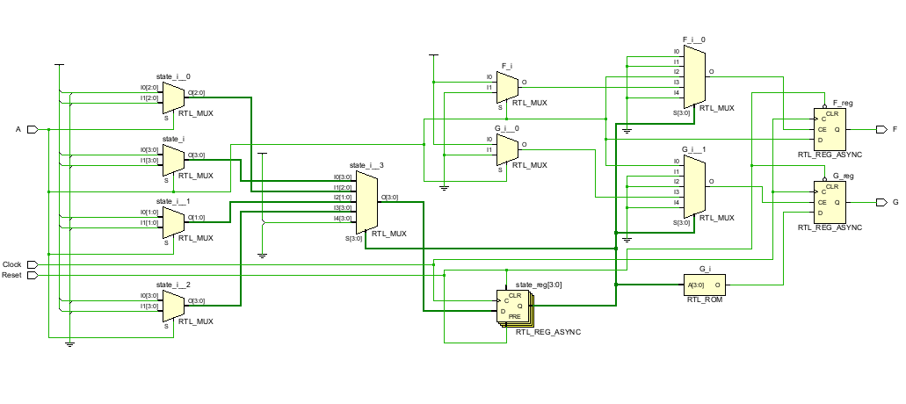

流水灯:

## 激励文件:

module led_tb;

reg clk;

reg sw;

wire [3:0] data;

led led_152 (

.clk(clk),

.sw(sw),

.data(data)

);

initial begin

clk = 0;

sw = 0;

#1.52;

sw = 1;

end

always #0.152 clk = ~clk; // 学号后三位

initial begin

$monitor("Time = %t, clk = %b, sw = %b, data = %b", $time, clk, sw, data);

end

initial begin

#1000; // 运行仿真一段时间，确保分频器有足够的时钟周期工作

$finish;

end

endmodule

## 仿真结果截图:

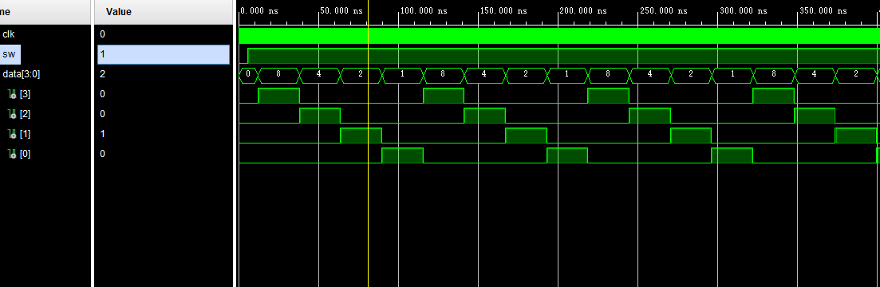

## 电路图:

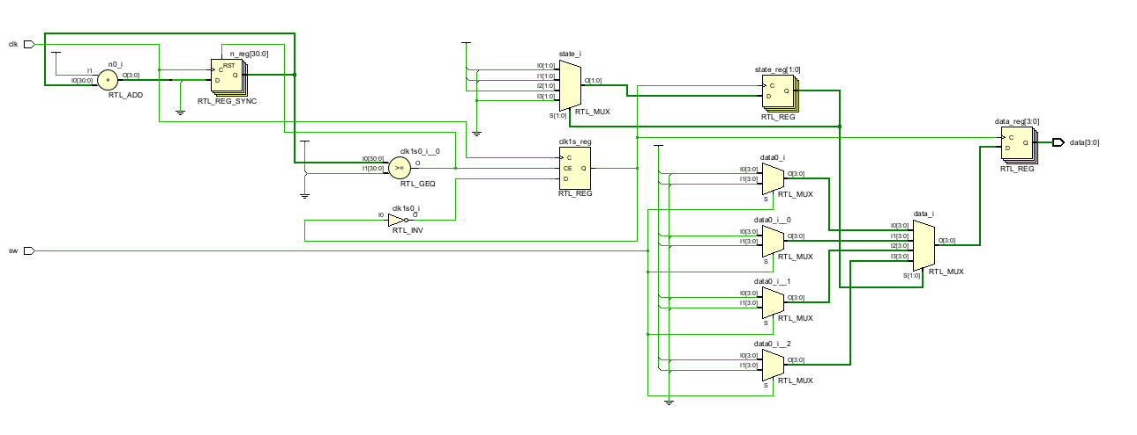

# 实验三:超前进位加法器

## 激励文件:

module ahead_adder_tb;

reg [3:0] A;

reg [3:0] B;

reg c_in;

wire [3:0] F;

wire c_out;

ahead_adder ahead_adder_152 (

.A(A),

.B(B),

.c_in(c_in),

.F(F),

.c_out(c_out)

);

initial begin

A = 4'b0000;

B = 4'b0000;

c_in = 0;

#152; //学号后三位

A = 4'b1010;

B = 4'b1001;

c_in = 1;

#152;

A = 4'b0010;

B = 4'b1110;

c_in = 0;

#152;

A = 4'b0110;

B = 4'b1101;

c_in = 1;

#152;

A = 4'b1010;

B = 4'b1001;

c_in = 0;

#152;

$finish;

end

initial begin

$monitor("Time=%t, A=%b, B=%b, c_in=%b --> F=%b, c_out=%b", $time, A, B, c_in, F, c_out);

end

endmodule

## 仿真结果截图:

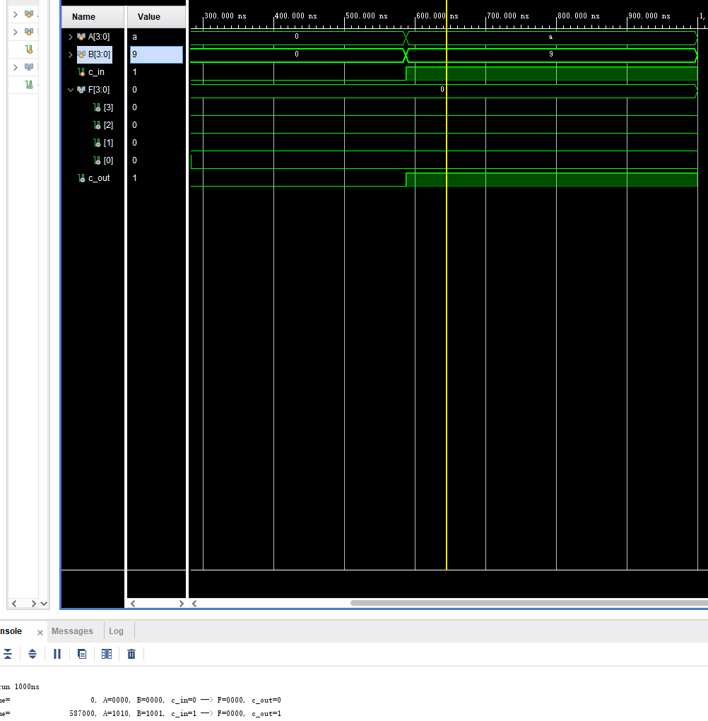

## 电路图:

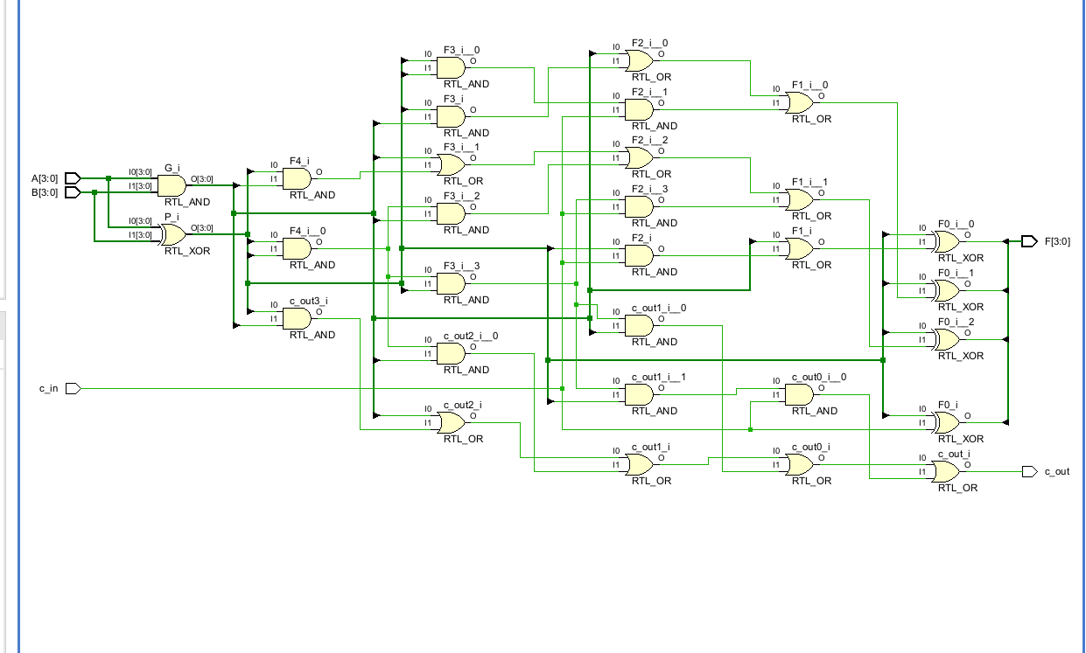

# 实验四:智力抢答器

## 激励文件代码如下：

`timescale 1ns / 1ps

module Smart_responder_tb;

reg clk,rst_n;

reg [3:0]btn;

wire [3:0] an;

wire [7:0] seg_code;

initial begin

clk = 1'b0;

rst_n = 1'b0;

btn = 4'd0;

#1.52 rst_n = 1'b1; //采用学号后三位作为延迟时间

#1.52 btn = 4'd1;

#1.52 btn = 4'd3;

#1.52 btn = 4'd0;

#1.52 rst_n = 1'b0;

#1.52 rst_n = 1'b1;

#1.52 btn = 4'd2;

#1.52 btn = 4'd6;

#1.52 btn = 4'd0;

end

always #5 clk <= ~clk;

Smart_responder Smart_responder(

.clk( clk ),

.rst_n( rst_n ),

.btn( btn ),

.an( an ),

.seg_code( seg_code )

);

endmodule

## 仿真结果截图:

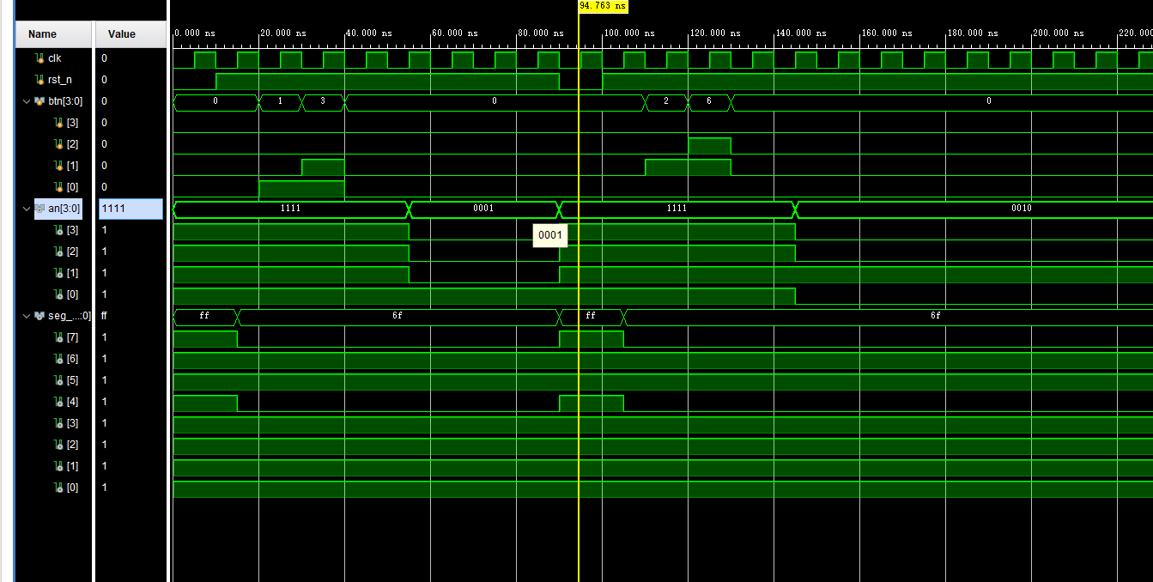

**电路图:**  
