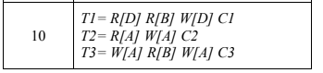

* 1. HT1,T2,T3 = *R1[D] R2[A] X3[A] W3[A] R1[B] X2[A]W2[A] R3[B] X1[D] W1[D]- Wait X3[A]W3[A]*

*1.2*

*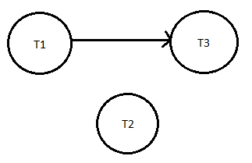*

1.3 HT1,T2,T3 *= S1[D]R1[D]S2[A]R2[A]X3[A]W3[A] S1[B]R1[B]X2[A]W2[A] S3[B]R3[B]-Wait X1[D]W[D]-WAIT X3[A]W3[A]- Deadlock*

*1.4*

*