**Questions to ask:**

* Where does the process start?
* What does this feature need to do?
* How might we meet this business need?
* Where would the user access this feature?
* Where would the user be located physically when using this feature?
* When will this feature be used?
* Do you have any project documentation you can provide us?
* What programs would you like us to use? (Any suggestions)
* How many industries did you want us to list?
* How many categories did you want us to list?

Things we have to do:

Finished

* Create a GUI using NetBeans inbuilt system.
* Provide a detailed review of the project results, the issues identified and approaches used in managing the issues and the project as a whole, and adjustments to the project plan
* Required to select and report on at least 3 current software project management tools
* Create and use macros to automate repetitive programming actions and program building.
* Course & Unit List Admin
* Implement drag and drop feature
* Flow charts

Started

* Construct a MS Project file which is the project plan
* Complete a preliminary analysis report (<http://shovancoleman.tripod.com/id1.html>)
* Determine and report the methodology
* Create a ER Diagram

Not started

* Demonstrate the use of your selected Project Management, Source Code Control and Collaboration software as you proceed (or would proceed) with your development project.

Use a video-cam software and screenshots to record performing work and team cooperation

* Show evidence of using debugging tools to detect logical and coding errors and corrections applied to comply with program specification.

Used traces and watches to examine variables value and capture log of syntax and logic errors

Outlined solutions applied

Created a technical report

Screenshots and steps included in the technical report

* Show evidence of individual work, comment code, and label who has done what.
* Create a technical report

Error trapping:

[Error Trapping 1](https://msdn.microsoft.com/en-us/library/aa478986.aspx)

[Error Trapping 2](https://msdn.microsoft.com/en-us/vba/access-vba/articles/error-trapping)

**Preliminary Analysis Report**

**Introduction:**

Our team of four has been assigned with developing an application designed to assist EITS with client administration and supporting client activity. The users of this application will select from a list of desired industries, within the industries it provides information about educational courses which they can take and the skills required for them. The administrator can then view and track this information from the system which recorded the users' name, email, number, and activity throughout the application. EITS would like this application to welcome clients to the office and track their attendance and training progress throughout their use on this application and would like the information to be accessible via her computer tablet to easily access and see the data. Our team must look for the necessary hardware and software like a desktop based database application and interface components to be developed for user access which might be from a computer tablet, laptop or PC and for software being a web-based database and windows based software.

**System Request Summary:**

EITS would like a new easily accessed system to track and view attendance, records, and results of the users. This system will need to have a database and GUI built using MySQL and NetBeans to allow EITS to easily view and obtain the necessary information she needs.

All requested features include:

* Welcoming clients to the office and tracking their attendance throughout the app
* Interacting with clients about training options based on the selected industry they desire to look at.
* Keeping a record of the clients' choices training and progress through each visit.
* For the system to store record details for later review, reporting and statistical reporting purposes and for later use to plan future company’s shops work practices.

**Findings:**

**Project Scope**

Business Requirements:

* Who was it built for ?: EITS
* Goals: To create a new GUI application to allow clients to view and enrol in courses, admins to edit client and caseworker data and to implement and edit courses, and for caseworkers to view client data, attendance and progress.

Process Requirements:

The application must be able to allow clients, admins and caseworkers to interact with the GUI in a easy manner while also being connected to the database which in some cases they can modify and interact with it. This will be done through the sign up, client data (Admin), course list (Admin), Unit list (Admin) and Industry List (Admin) pages.

Feasibility:

For the project to take place, it must first be deemed technically feasible to develop and economically justifiable. The project must first be checked for not having too many resources before development to ensure the project is worth the investment. We must first check the required hardware, software and technologies to develop this project.

NetBeans, Sourcetree, MySQL, MS Project, and Windows 7,8, or 10 which are all software which is either free to use or the team already has at their disposal so the software and time management tools to develop this project is feasible.

The Hardware to develop this project requires an average system needing no more than 4 Core 2.5Ghz CPU, 4GB of RAM, 100 GB of storage, and a good connection to the internet. The Team already has systems with this level of hardware and more so the hardware to develop this project is feasible.

With the project only requiring a small database and GUI Interface to be developed and connected to each other, it is definitely feasible to construct on time and within budget to what is appropriate for the Project manager.

Some Constraints for the project development could be that a member of the development team has left so some features of the application might be delayed somewhat since the other developers must now take on the work of the team member who has left. This will impact the overall time and cost to develop the application.

Number of pages:

* Login
* Sign Up
* Course list
* Course list (Admin)
* Industry List (Admin)
* Unit List
* Unit List (Admin)
* Admin Panel (Admin)
* Caseworker Panel (Caseworker)
* Client Data (Admin)
* Client Data (Caseworker)
* Client Progress (Caseworker)
* 2 Thank you and 1 error message pages

**Recommendations:**

Recommendations for going about developing and planning the application is to firstly have easy and effective communication between team members. This would be done through an online chat service, primarily Discord. Discord is a free online chat service which allows multiple people to join in on a call and easily share their screens. This will allow all team members to easily work together and help each other with problems which might arise. Finding and using a quality chart service will improve communication and overall performance of the group leading to a higher quality product.

Another recommendation is that we must be reasonable about what we can accomplish and not try to produce or develop something that just isn't practical. This will just waste time and resources and lead to a failed project. Instead, we must develop an application which is within our time and cost budget and can be done by all team members.

**Time and Cost Estimates:**

For our team to complete this project on time and in budget we will have planned and utilised the necessary tools, programs, hardware and tactics. To do this we would have used programs such as Microsoft Project to plan out our schedules and deadlines for each task and to allocate costs to each task to get an accurate budget which the team must remain in.

Give Cost Estimate:

**Expected Benefits:**

The expected benefits for creating this application is that it will boost student enrolments by allowing them to easily navigate and discover information about the courses and if it will be a good fit for them overall increasing profits for EITS.

**ER Diagram (Or Equivalent):**

**Screen Designs:**

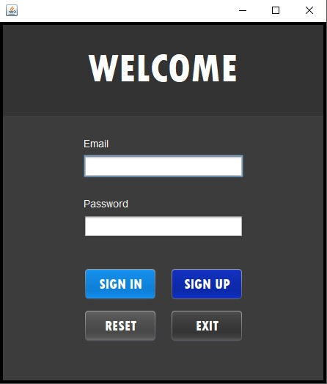

**Login Screen**

Functionality: The functionality for this page is to link and tie all pages together. The welcome page is used to enter an email and password which has already been given to you inside the database. The welcome screen displays four buttons

* Sign in: Used to log the user in from the database
* SIgn up: Used to put a user in to the database.
* Reset: Used to reset the text inputted
* Exit: Used to exit the application.

Design: The colours and design of the page have been made to allow for simple and easy use of the application. This has been accomplished with clean and simple to use buttons to guide the user to their desired location and colours which pair up nicely with each other.

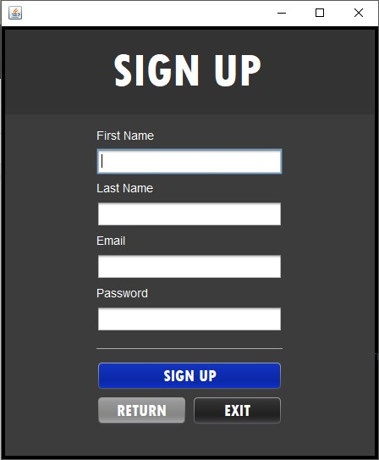

**Sign Up Screen**

Functionality: The functionality for the signup page is to allow a user to input their first name, last name, email and password and for it to be registered inside the database to be later used to login with. The Signup screen displays three buttons

* Sign up: Logs the information given in to the database
* Return: Takes the user back to the Login screen
* Exit: Used to exit the application

Design: The colours and design have been kept the same from the Login screen to keep consistency.

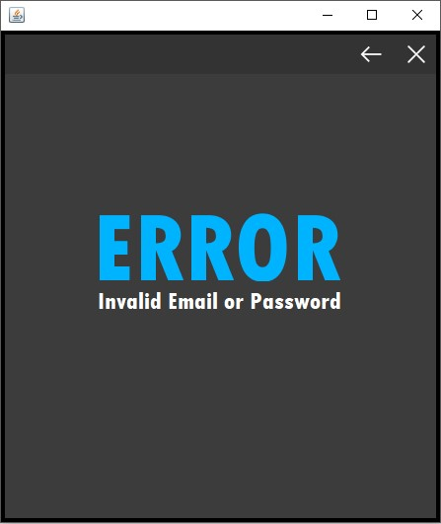

**Error Invalid Email or Password**

Functionality: This page is used to alert the user that their email or password which they entered in to the login page is incorrect or invalid. The error page displays two buttons

* Return: Takes the user back to the Login screen
* Exit: Used to exit the application

Design: The design has been kept the same with a simple GUI and colours which have remained the same throughout the pages.

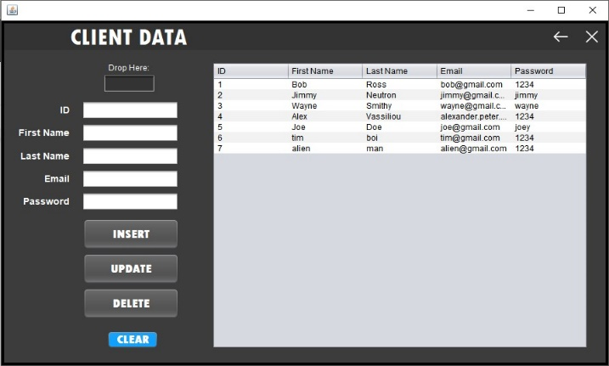**Client Data Admin page**

Functionality: This page allows an admin to view, insert, update or delete client data inside the database. The Client data admin page displays 6 buttons and a drop here box.

* Drop here: Drag and drop information from the table in to the drop here box to display the information in the boxes underneath
* Clear: Clears information inside the text boxes
* Insert: Inputs text inside the text boxes in to the database
* Update: Updates the existing information with modified text inside the text boxes.
* Delete: Deletes the selected client data from the database
* Back: Takes you back to the admin main gui
* Exit: Closes the application

Design: The design has been made wider to hold the table and extra text boxes and buttons but still keeping the same colours and feel.

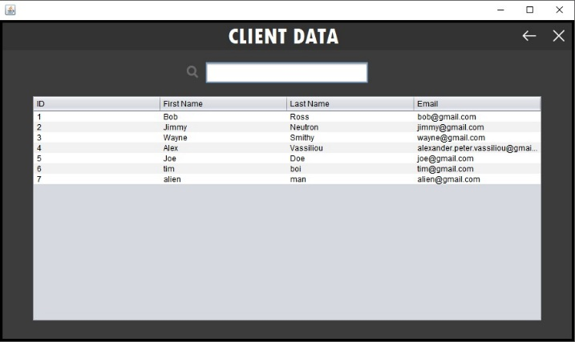

**Client Data Caseworker Page**

Functionality: This page allows a caseworker to only view and search the client data but does not allow them to insert, update or delete any information. The client data caseworker page displays 2 buttons and a search box

* Back: Takes you back to the caseworker main gui
* Exit: Closes the application
* Search: allows you to type in a clients name and it automatically appears at the top.

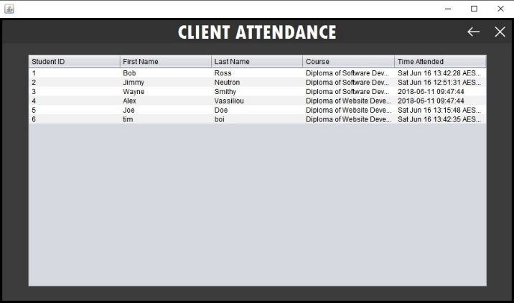**Client Attendance Page**

Functionality: This page allows a caseworker to view and search individual client attendance throughout the application and see when clients login. This page has 2 buttons

* Back: Takes you back to caseworker main gui
* Exit: Closes the application

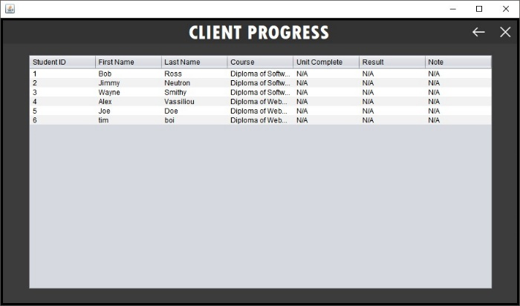

**Client Progress Page**Functionality: This page allows a caseworker to view and search individual client progress, enrolments and results. This page displays 2 buttons

* Back: Takes you back to caseworker main gui
* Exit: Closes the application

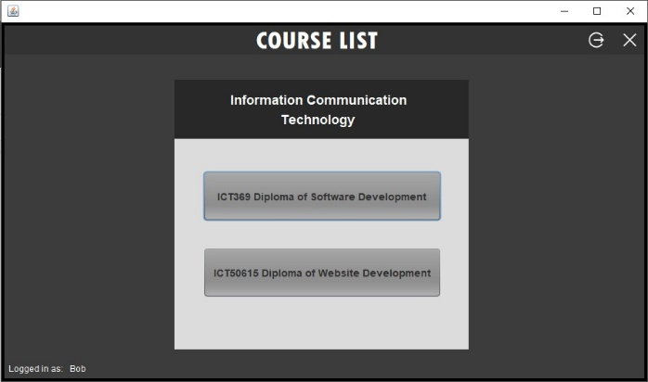**Client Course List Page**

Functionality: This page is the main page after the login screen clients will see when signing in. A client is displayed two courses to choose from. This page displays 4 buttons

* Sign Out: Takes you back to login page
* Exit: Closes the application
* First and second course: Takes you to the first and second course to choose what you want to enrol in.

**Client Unit List Page**

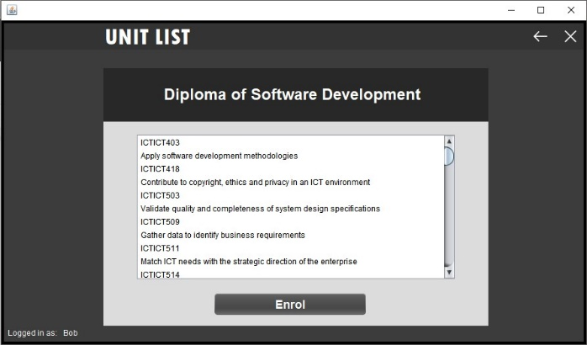Functionality: This page is the unit list page which displays all the units within the selected course. From here the client can decide to enrol in the course and it will be updated in the database.

There is 3 buttons

* Back: Takes you back to client course list page
* Exit: Closes the application
* Enrol: Enrols the logged in user in the certain course they picked.

**Client Unit List Admin Page**

Functionality: This page is the unit list admin page and displays all the units for each course for the admin to insert, update, and delete original or new units. There are 6 buttons on this page

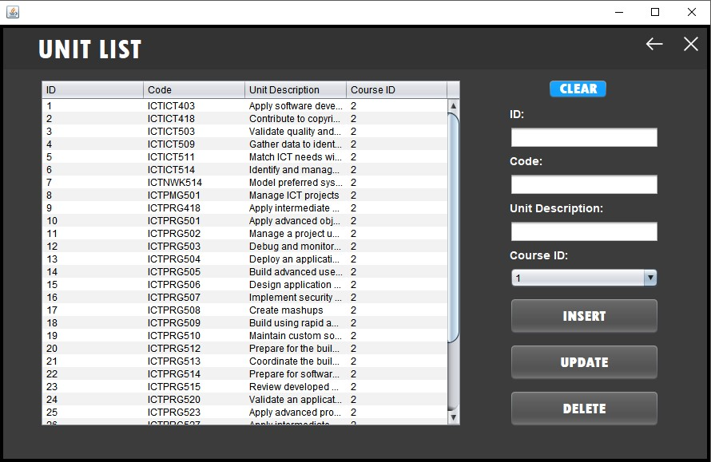

* Back: Takes you back to client course list page
* Exit: Closes the application
* Clear: Clears information inside the text boxes
* Insert: Inputs text inside the text boxes in to the database
* Update: Updates the existing information with modified text inside the text boxes.
* Delete: Deletes the selected unit data from the database

**6. Software Project Management tools**

**Sourcetree:** Sourcetree is one of the software project management tools which would be utilized to increase productivity, collaboration management, and source code control. Sourcetree allows for you to easily interact with your Git repositories on projects so you can modify and create new code and easily push it to your team. Sourcetree provides Source code control to allow teams to view and keep track of changes to the code. This allows members to easily check back at old code and compare the differences letting them see the changes which have been made.

**Microsoft project:** Microsoft is another software project management tool which we would utilize to help organise and focus the team. Microsoft project developed by Microsoft is primarily designed to help the project manager in developing a plan, managing the budget, and attaching people or resources to tasks. We will use Microsoft project to find the estimated cost, time and features for the project we will be undertaking. This will give the whole development team a better understanding of when features have to get done and what to do after that task. This will increase productivity and team management while decreasing confusion throughout development since everyone will have a clear understanding of the deadlines and features which they must do.

**JIRA:** JIRA is another great software project management tool which we could use in the development of the project. JIRA is an issue and feature tracking product developed by Atlassian. JIRA provides an easy to use interface which provides bug tracking, issue tracking and requested features/updates to parts of the project. JIRA is great for collaboration management since everyone on the team can view small posts from each other about the current bugs, issues or requests and their priority. Once a team member decides to take on the challenge of fixing an issue someone else has put on to the board it will be marked with them working on that certain issue. Using JIRA allows the team to very easily see what need to be changed, added, who requested it and who will be working on the issue. JIRA will increase productivity by improving communication to give team members instant updates on work which must get done and how important that issue/feature might be.

**7. Report Methodology**

Methodology we will or would be utilising for the development of the project consist of gathering information and data through interviews with the client to understand what is necessary and required for the development. Research will also be conducted and we will be searching for similar projects conducted, looking for costs and quality of the product. By doing this it will give our team a better guideline for the industry standard for the task we are taking on, and how to better prepare and plan.

**8. Project Plan**

**9. Demonstrating use of the selected project management, source code control and collaboration software**

**10. Project Results**

The final project results for our application development has been a successful but challenging task to undertake. The team has found that the initial planning phases which were completed before the development of the project was a big help towards completing the task on time and done so with a high-quality finish. This is not to say there has been no challenges and adjustments made throughout the development of the project. An issue which we had to overcome was getting the login page to work correctly. We were having trouble with the error page displaying when the user enters incorrect values or data which was not in the database. We finally overcame this issue by collectively working as a team, utilizing NetBeans Debugging tools and research to fix the issue. Adjustments made to the project would be the time which it took to finish certain features. Some features took longer than expected to complete so adjustments had to be made to the timeline to fit the delays.

**11. Review of management tools**

The management tools used have been effective at increasing productivity, team effort and cooperation. The tools utilized Sourcetree, Microsoft Project… have been used throughout the development of the application and have had their pros and cons. The pros of the management tools used is that with their easy to use UI and features it has allowed for increased productivity for the development of the application and allowing for quality source code control to view changes and modifications by team members.

**12. References**

**Technical Report**

**- An explanation of the mechanism you would use that enables inter-process communication in your application.**

Inter-process-communication is a way for switching information amongst application process threads across many applications on different computers across a network on a single computer and the applications which take advantage of IPCs are referred to as a client server application. For this project we can use many different mechanisms to enable inter-process communication within our application but we decided on using .NET Remoting. Using .NET removing within our application allows us to build it to be widely distributed easily whether the application components are all on the one computer or are spread out across other computers possibly across the world.

**- An explanation of what is an Interface in object-oriented programming and how would you use it to apply multiple inheritances.**

An interface in object oriented programming is nothing like a user interface but instead is something that is very similar to a class but have no actual functionality and no actual code. The benefit to using an interface is that you can have different classes choose to implement the same interface while letting other parts of the app use objects with interfaces. Also using an interface will improve the efficiency of your code throughout loose coupling and abstraction.

Multiple inheritance is when a class or object inherits features and properties from more than one parent class or object. Inheritances can and are implemented in a variety of ways depending on what language you are coding with. For Java including an inheritance requires you to type extends and then the name of the class you want to inherit from.

**- Explain the concept of design patterns in the Java.**

Design patterns are practices that have been used to solve many design problems. Design patterns are used to help devs in producing higher quality software in a considerably faster amount of time. They are also not tied to any type of language or development platform.