**Pharmacare**

**Technical Documentation**

**Date | 21 – 11 – 18**

**PharmaCare Development Team**

# **Table of contents**

# **About the Application**

The RightCare hospital is currently looking for an upgrade to its systems and operations to allow the staff to have an easier and more efficient work experience. Currently, multiple staff members are experiencing different Information Technology issues which they would like addressed. PharmaCare which is the new planned system and was proposed by Jack Smith, Director of systems development at RightCare Hospital and will be a “three-tier” system. The purpose of the new program is to reduce workload and increase efficiency for doctors, staff, and pharmacists to complete their work and help patents. This will be done by creating an easy to use website UI which enables all staff to browse, update, and create new prescriptions, drugs, and room information for patients.

# **Interface States**

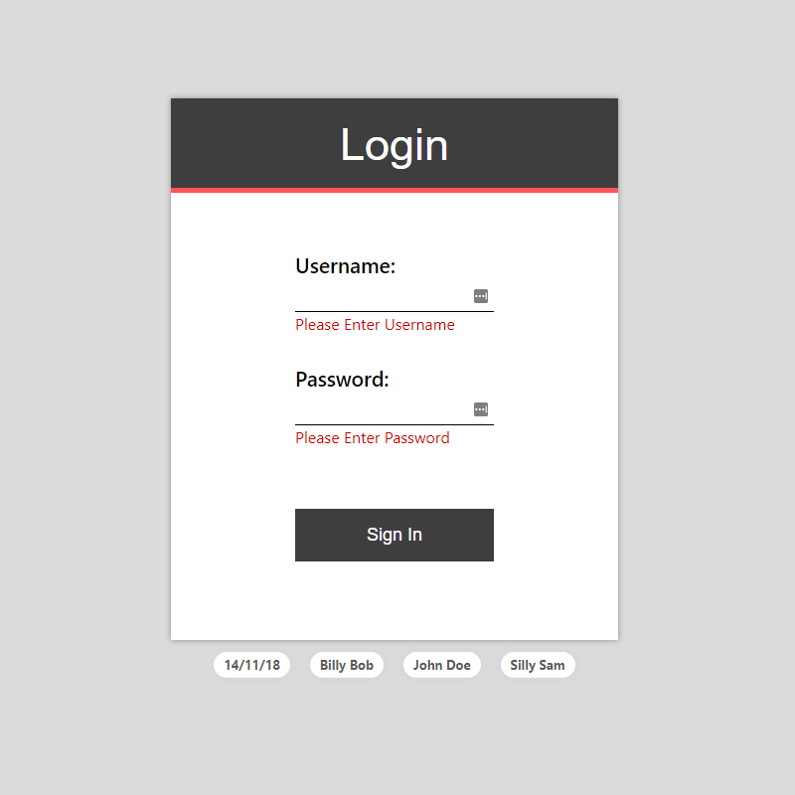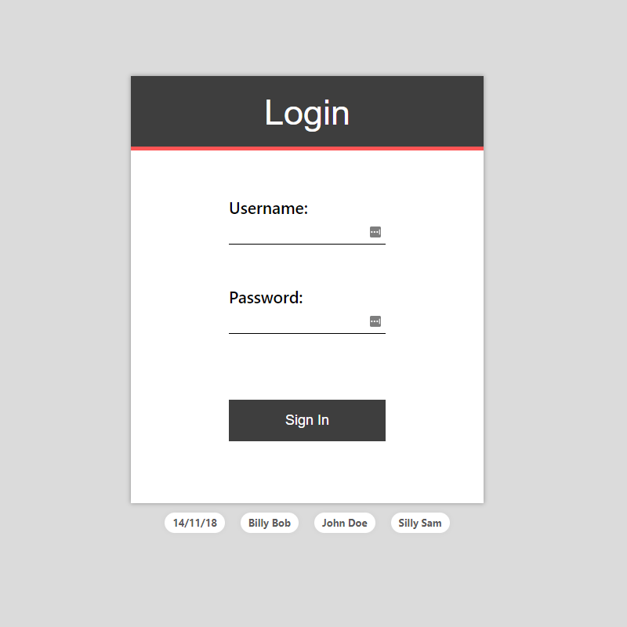**Login and login error messages**

Figure 1: Login page at startup

Figure 2: Login with validation activated

**After login & Main Prescription page**

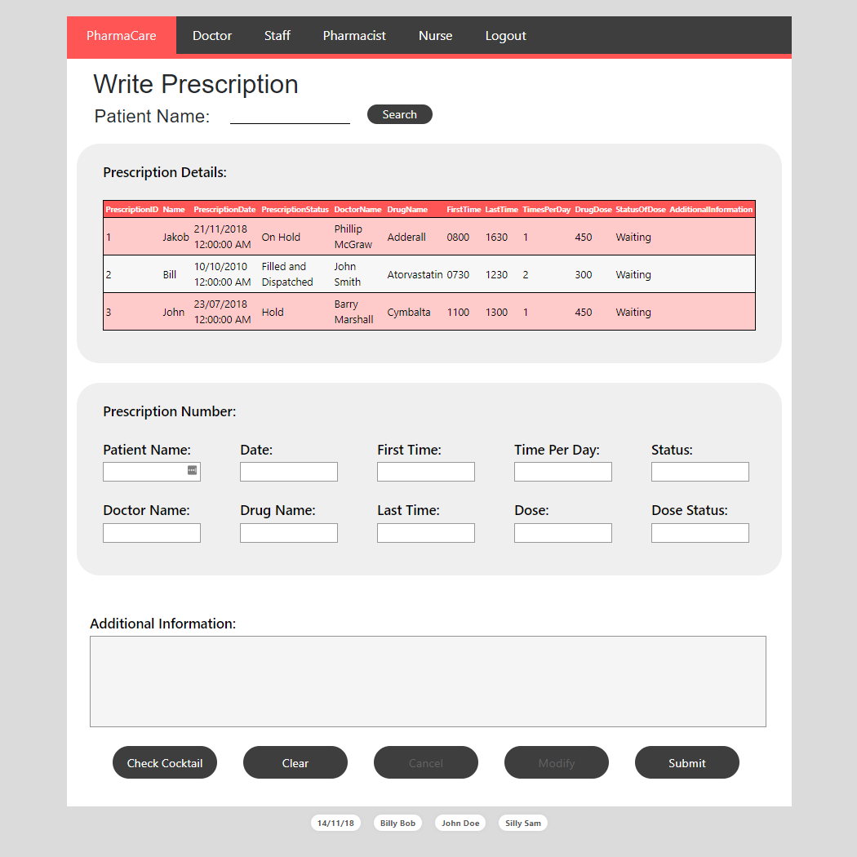

Figure 3: After login the write prescription page will be displayed

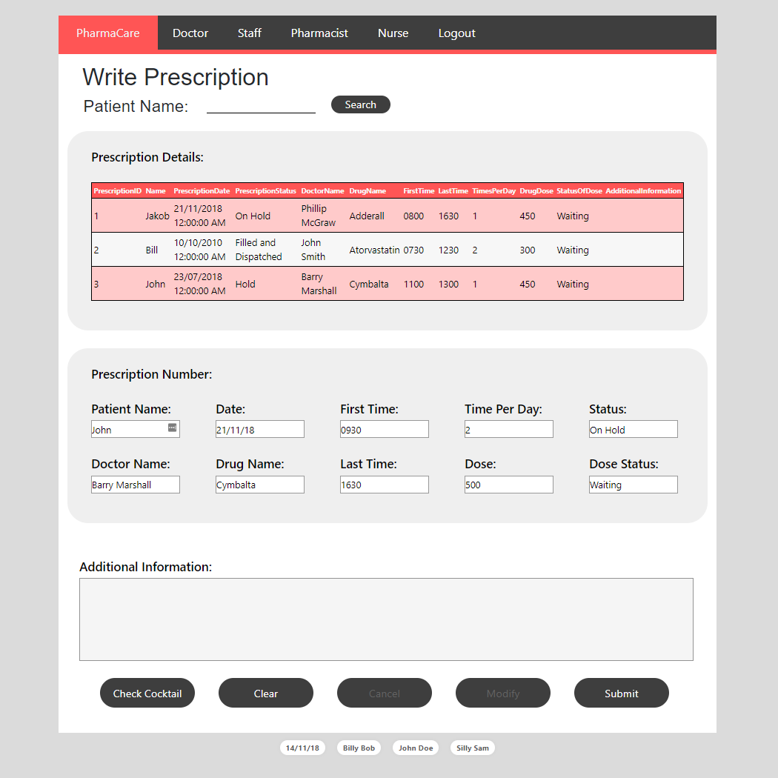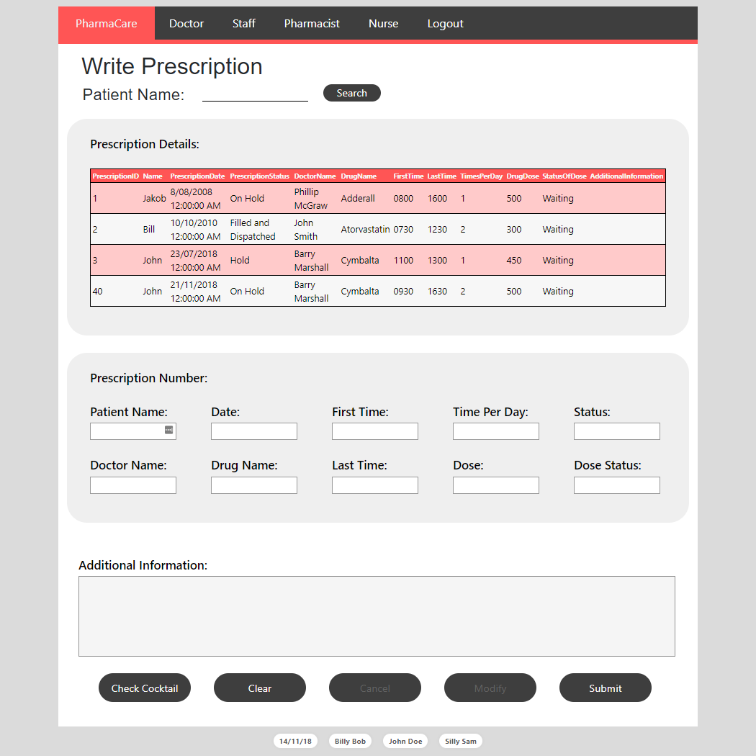**Adding new item**

Figure 4: After clicking submit and info adding to table

Figure 5: Before clicking submit

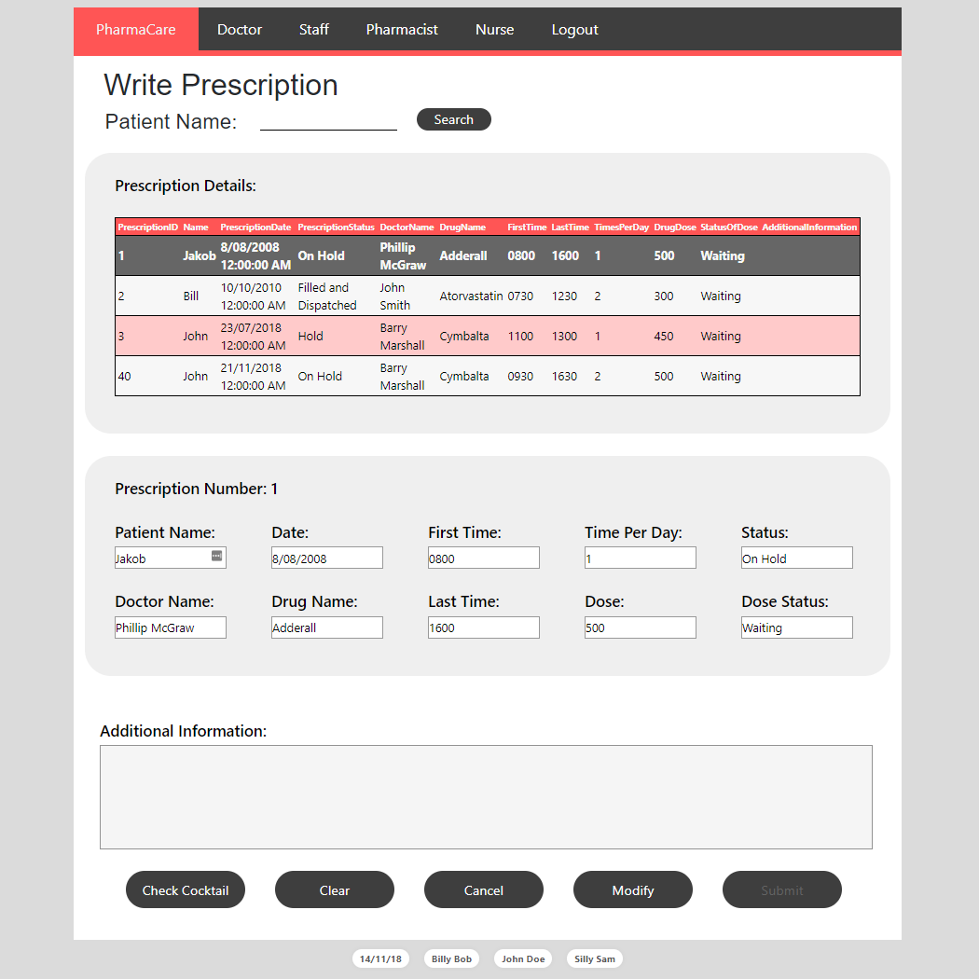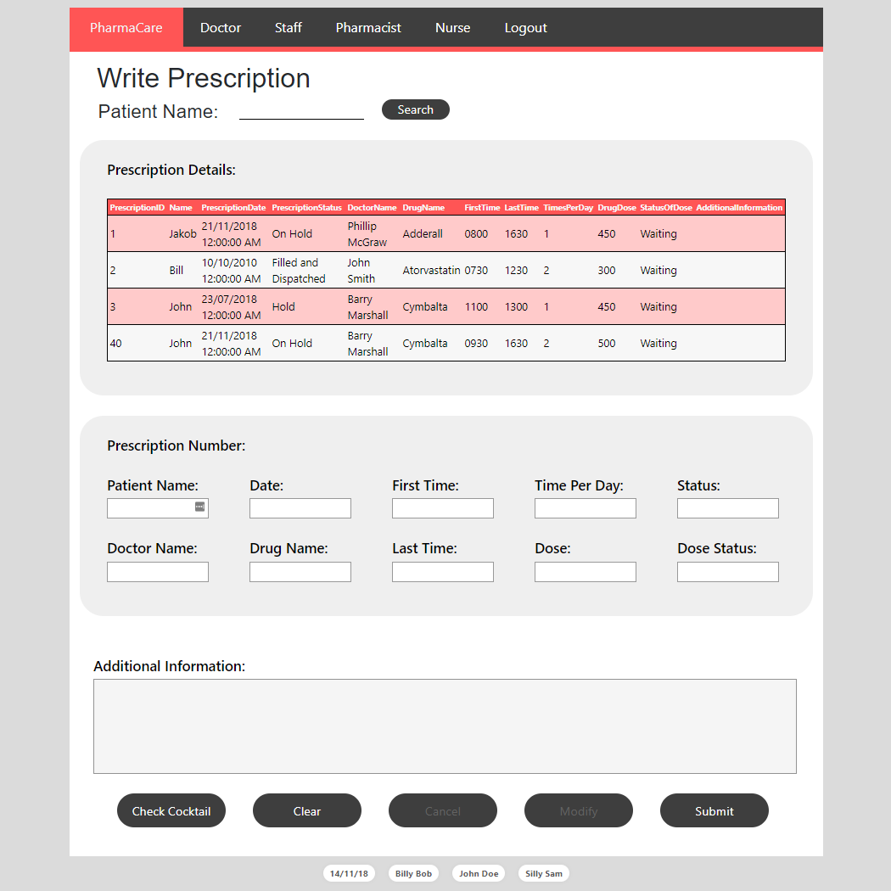**Updating existing item**

Figure 6: After clicking modify and information is updated in the table

Figure 7: Before clicking modify

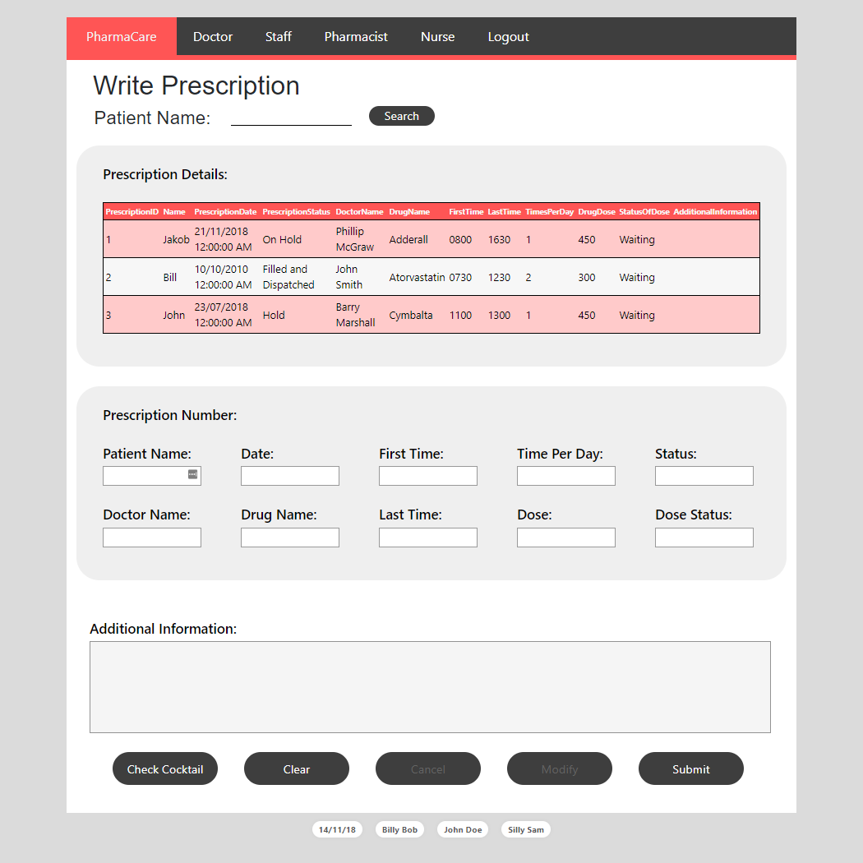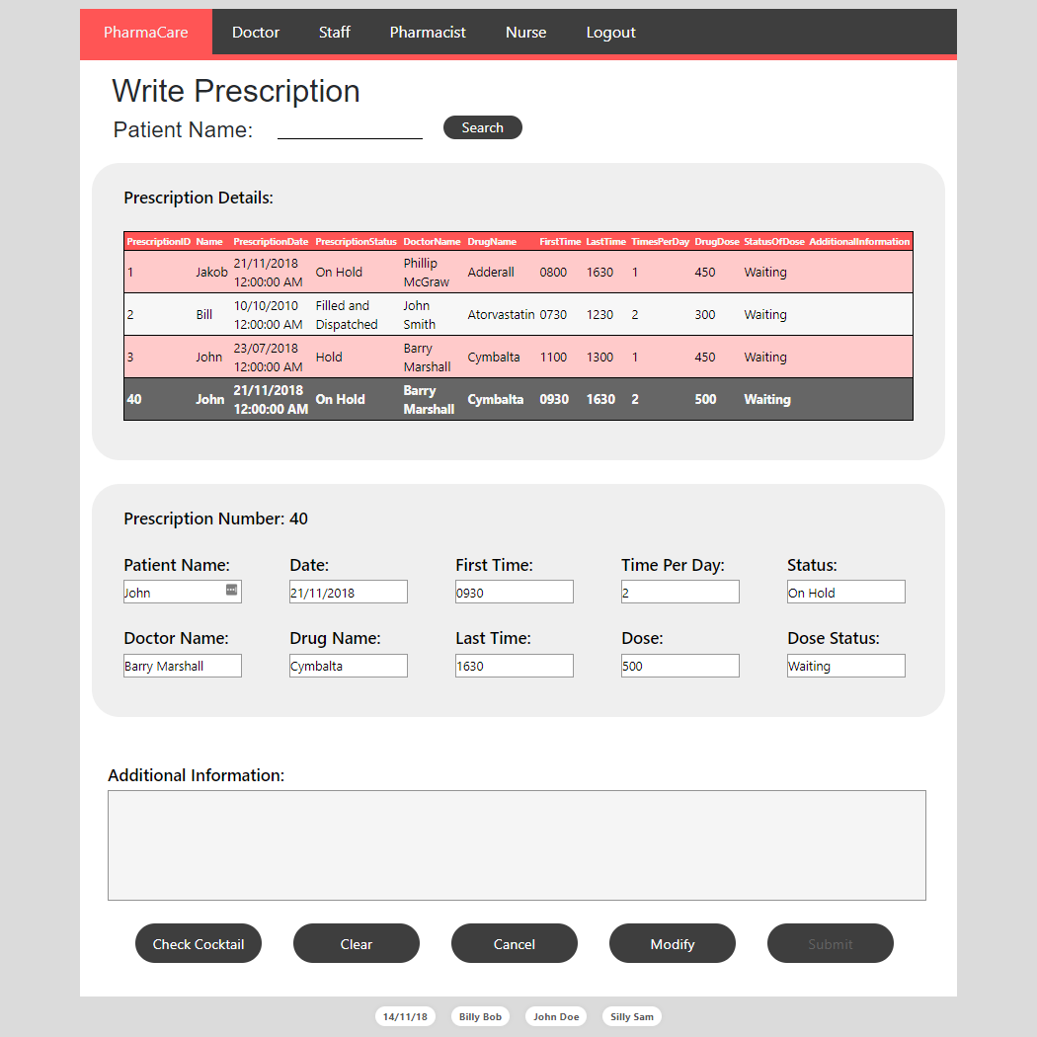**Delete existing item**

Figure 8: After clicking cancel on prescription

Figure 9: Before clicking cancel

**Logout**

Figure 11: After clicking logout

Figure 10: Before clicking logout

