PharmaCare
System Testing

Date | 23 – 11 – 18
PharmaCare Development Team
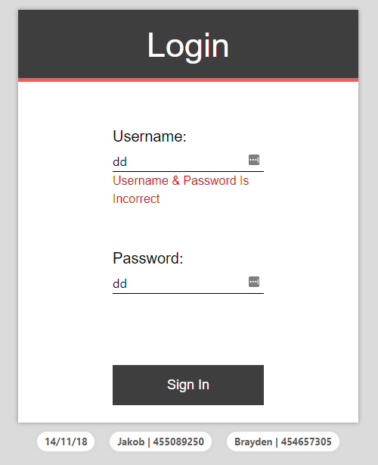
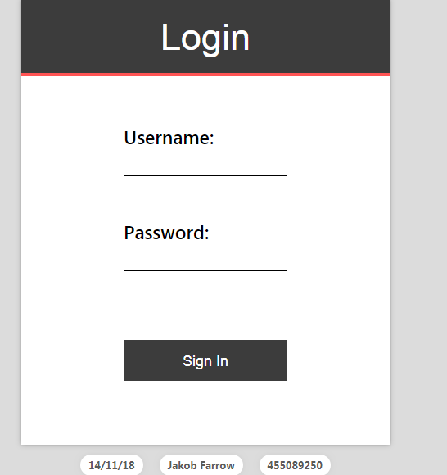
Table 1: LOGIN PAGE
Test Case ID | Test Functionality | Test cases | Expected Output | Actual Output | Status
1 | User Enters Valid Username and Password | As a user, enter valid User Name and Password  EX: Mich123  1234 | User should see the homepage | As expected | Pass
2 | User Submits Blank Form | As a User, submit blank form | User should see the required field error | As expected | Pass
3 | User Enters Either Invalid Username or Password | As a user, enter either invalid user Name (or)password | Error message appears and should stay on the same page. | As expected | Pass
Table 2: DOCTOR PAGE
Test case ID | Test Functionality | Test cases | Expected Output | Actual output | Status
1 | Doctor Write Prescriptions | A Doctor, should be able to write prescription by filling in the new details form and hit submit | Doctor will be able to Add the details to the Database | Doctor is able to Add the new prescription to the database | Pass
2 | Doctor modify prescription | A Doctor should be able to modify prescription by selecting the prescription ID or Name and hit Modify button | Doctor Should be able to search the prescription by Prescription ID or Name | Doctor is able to search the prescription by  Prescription Name | Pass
3 | Doctor Cancel prescription | A Doctor should be able to Cancel prescription | A Doctor should be able to search the prescription by prescription ID or Name and cancel the Prescription | Doctor is able to cancel the prescription by prescription Name | Pass
4 | Doctor Check Cocktail | A Doctor should be able to check Cocktail for dangerous cocktails by clicking the check cocktail button | A” warning check dangerous cocktail “should appear | As expected | Pass
5 | Place Digital signature | Doctor should be able to provide a Digital signature on the new written prescription | Doctor should be able to place Digital signature in the Signature box | There is no such Facility | Fail

Previously Failed (Test case 1, 2)
4 | Doctor Check Cocktail | A Doctor should be able to check Cocktail for dangerous cocktails by clicking the check cocktail button | A” warning check dangerous cocktail “should appear | No message appeared | Fail

Table 3: STAFF PAGE
Test case ID | Test Functionality | Test cases | Expected output | Actual output | Status
1 | Staff able View OPD prescription | Staff able to view OPD prescription after entering registered patient name and hit search | Staff able to view OPD prescription | As Expected | Pass
2 | Staff Enters Unregistered Patient Name | Staff enter Unregistered patient name and hit search | Error message appears | As Expected | Pass

Previously Failed (Test case 1)
4 | Staff Enters Unregistered Patient Name | Staff enter Unregistered patient name and hit search | Error message appears | No message appears | Fail

Table 4: PHARMACIST VIEW /DISPATCH PRESCRIPTION
Test case ID | Test Functionality | Test cases | Expected output | Actual output | Status
1 | Pharmacist Display Prescription | Click the link to load pages | Once the page is loaded display prescriptions | The page displays prescriptions | Pass
2 | Pharmacist Mark “Filled and Dispatched” | Click on the desired prescriptions and click recall or dispatch | Pharmacist able to mark prescription filled or dispatched | As Expected | Pass
3 | Pharmacist Print Dose Label | Click on desired prescription and click print | Pharmacist should be able to be able to print the prescription | As expected | Pass
4 | Pharmacist Return to Original Display | Once finished with the page click return to the original display | Pharmacist should be able to return to original display | Pharmacist is unable to return to the original display | Fail
Table 5: PHARMACIST PRINT INDOOR MEDICATION LABELS
Test case ID | Test Functionality | Test cases | Expected output | Actual output | Status
1 | Pharmacist Search with Registered Patient ID | Enter patient ID and click search | Patient prescription details appear | As expected | Pass
2 | Pharmacist Stop Search with Unregistered Patient ID | Enter unregistered patient ID and click search | Error message appears | As expected | Pass
3 | Pharmacist Print Indoor Prescription Labels | Select desired prescription and click print | Pharmacist able to print indoor prescription labels | As expected | Pass
4 | Pharmacist Return to Pharmacist Menu | Once finished with the page click to return to the pharmacist menu | Return to pharmacist menu page | Does not automatically return to the pharmacist page | Fail
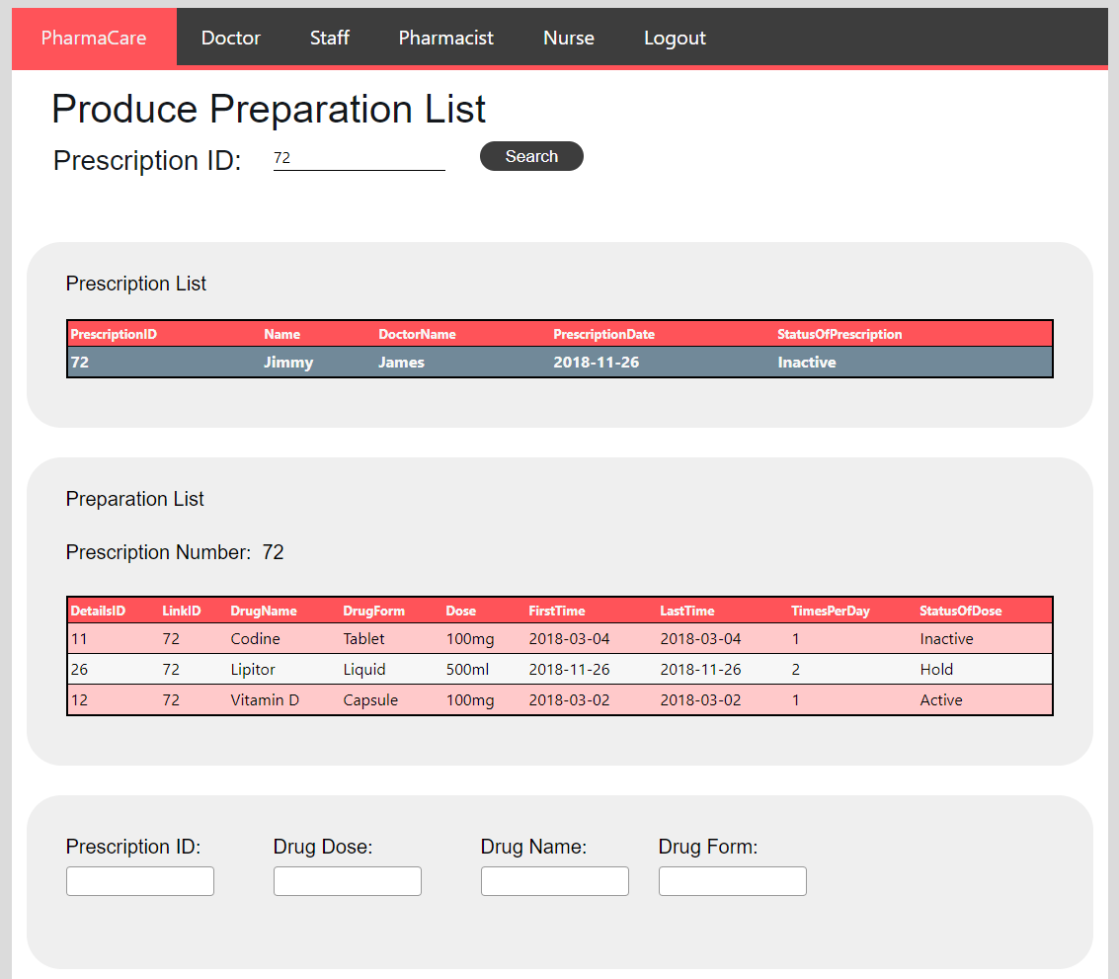

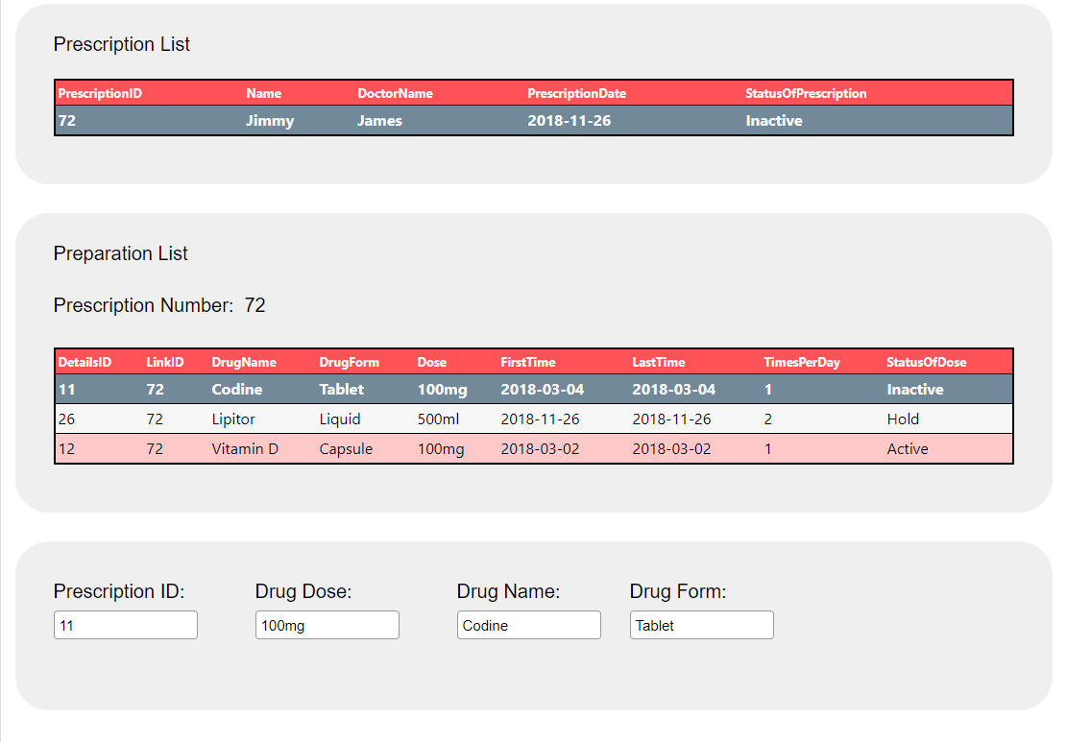

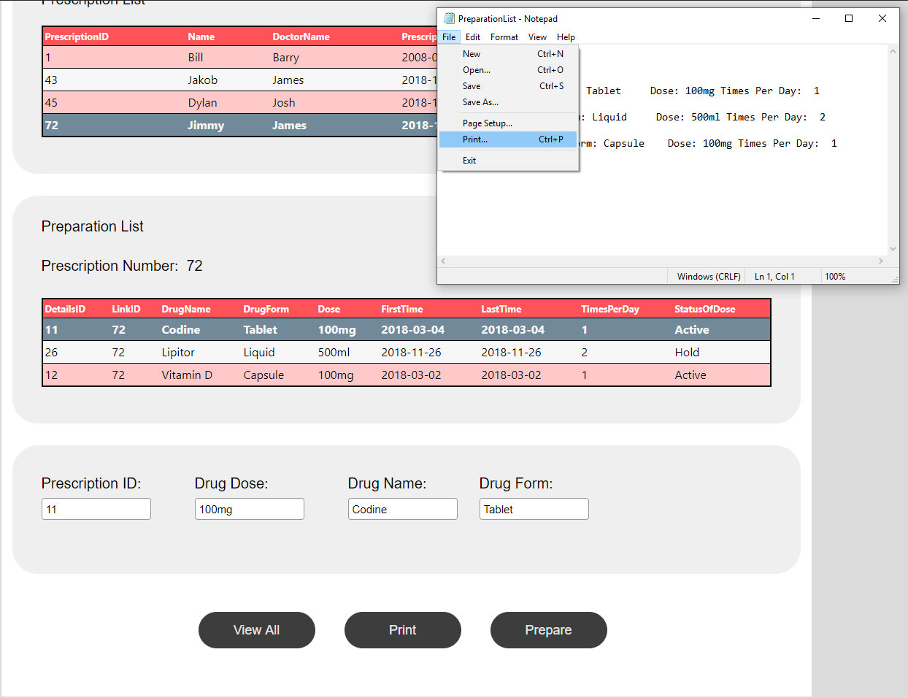

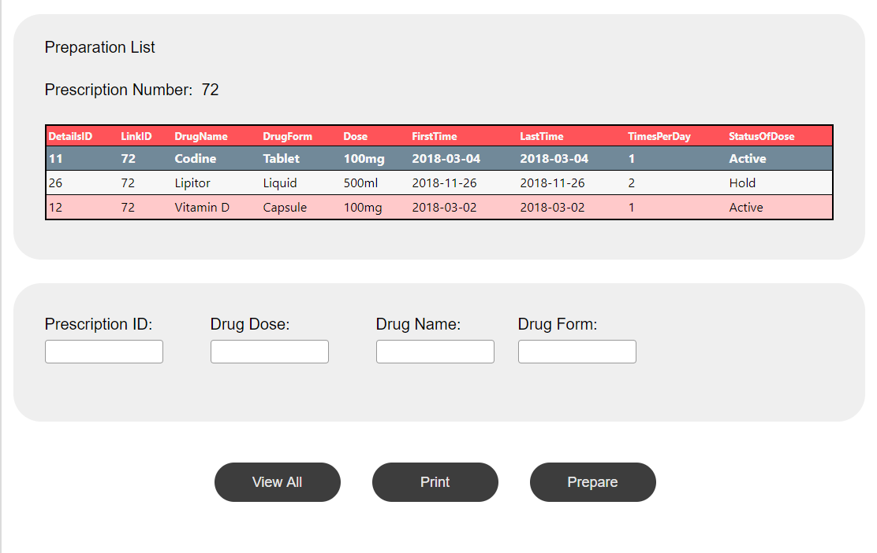

Table 6: PHARMACIST PRODUCE PREPARATION LIST
Test case ID | Test Functionality | Test cases | Expected output | Actual output | Status
1 | Pharmacist Search with Registered Prescription ID | Enter prescription ID and click search | Patient prescription details appear | As expected | Pass
2 | Pharmacist Sort List of Drugs by Number and Name | Sort the list of drugs on load and during click | Able to sort the list by number and name | As expected | Pass
3 | Pharmacist Print Prescription List | Select Desired Prescription and Click Print | Pharmacist able to print prescription list | As expected | Pass
4 | Pharmacist Prepare Medications | Once prescription is loaded click prepare button | Prescription should be updated to be active | As expected | Pass
5 | Pharmacist Return to Main Menu After Finishing the Prescription | Once finished with the page click to return to the main menu | Return to menu page | Does not automatically return to the main menu | Fail

Table 7: PHARMACIST/NURSE VIEW DISTRIBUTION SCHEDULE
Test Case ID | Test Functionality | Test cases | Expected Output | Actual Output | Status
1 | View Distribution Schedule | Select view distribution schedule from the drop-down list | Able to select a wing from the drop-down menu sorted by floor | As expected | Pass
2 | Print distribution schedule | Print distribution schedule by clicking print | Able to print distribution schedule | As expected | Pass
3 | Return to nurse menu by clicking close button | Return to nurse menu | Return to nurse menu | Close button is not included | Fail

Table 8: PHARMACIST/NURSE VIEW NURSING STATION LIST
Test Case ID | Test Functionality | Test cases | Expected Output | Actual Output | Status
1 | View list for nursing station | Selecting nursing station ID from the drop-down list | Selected nursing station details appear | As expected | Pass
2 | Retrieve data and sort the data against floor and room number | Display the list and the sort by floor and room number | First the list is Displayed and then sorted by floor and room number | The list is already sorted | Pass
3 | Print list for nursing station | Print list for nursing station to a printer | Pharmacist/nurse able to print list for nursing station. | As expected | Pass
4 | Return to nurse/pharmacist menu | Return to nurse /pharmacist to menu after printing the list | Return to nurse /pharmacist menu page | Does not automatically return to pharmacist page | Fail

Table 9: VIEW PRESCRIPTION NURSE

Test Case ID | Test Functionality | Test cases | Expected Output | Actual Output | Status
1 | Nurse View prescription | Enter registered patient data to View prescription page that displays all the current patient prescriptions | View prescription page displays all the current patient prescriptions | As expected | Pass
2 | Nurse Enter Unregistered Patient Name | Enter unregistered patient Name | Error message “patient is not registered” appears | As expected | Pass

