Joint Robot Scheduling with Intersection Reservations and Charging

Abstract
Four robots operating on two fixed directed loops must complete pickup-and-delivery tasks while sharing one intersection and limited charging bays. Task order, resource queues, and battery state are coupled because waiting also consumes energy. This project jointly determines robot assignment, visit order, intersection slots, charging-bay selection, and charging amount in a finite integer scheduling model. Joint Greedy supplies an initial schedule, CP-SAT searches for improvements, and a rolling version replans using only released tasks. Returned action traces are checked for precedence, resource capacity, and battery safety. In archived 40-task experiments over ten seeds, CP-SAT reduces mean composite objective J by 53.2% and makespan by 28.3% relative to FCFS (FCFS revision 75afc09; CP-SAT revision c87fb9f; eight workers and a 120 s CP-SAT limit). For a separate 12-task instance with seed 6, CP-SAT reduces makespan by 30.4% under one worker, a 30 s wall cap, and a 0.5 deterministic budget. Short-budget batch runs find no improvement beyond Joint Greedy. Overall, these findings highlight the potential of integrated task, intersection, and charging scheduling to improve performance in fixed-route multi-robot systems.

Keywords
Multi-Robot Scheduling; Charging Scheduling; Constraint Programming; Intersection Reservation; Rolling Horizon; Discrete-Event Simulation.

1 Introduction

Research Background
Multi-robot systems are widely used for transportation and material handling in automated manufacturing and warehouse environments. Efficient scheduling requires not only assigning tasks to robots and determining their execution sequences, but also coordinating access to shared resources and managing limited battery capacity. Previous studies have investigated multi-robot task allocation and conflict-aware scheduling [1, 2], battery-aware scheduling with flexible charging [3–5], and integrated scheduling using mathematical optimization and constraint programming [6, 7]. Rolling-horizon approaches have also been applied to transportation tasks that arrive dynamically [8]. Building on these approaches, this project investigates the joint scheduling of task execution, intersection reservations, and charging decisions in a fixed-route multi-robot system.

System Overview and Problem Statement
This project considers a multi-robot pickup-and-delivery system consisting of four robots operating on two fixed directed loops. Two robots are assigned to each loop, and each transport task requires a robot to collect and deliver an item between two stations on the same loop. The two loops share a single intersection, which can accommodate only one robot at a time. The robots also share a charging area with up to two charging bays, each serving one robot at a time.
The scheduling problem is to determine which robot performs each task, in what order the tasks are executed, when robots traverse the shared intersection, and when and how much they charge. These decisions must satisfy task precedence, resource capacity, and battery safety constraints. The objective is to minimize a composite measure of makespan, priority-weighted tardiness, resource waiting time, and energy consumption.

Motivation and Scheduling Challenges
Multi-robot task allocation requires choices about which robot performs each task and how robots coordinate their work [1]. AGV studies also couple task assignment with conflict-aware movement [2] and scheduling with limited charging capacity [3]. In this project, four robots serve two fixed loops but share intersection X and the charging area. An assignment changes when a robot reaches its pickup station, X, and a charging bay. Queues then delay completion and consume battery energy. Makespan, tardiness, waiting, and energy are therefore linked by the same assignment and timing decisions.
For example, when a robot R1 receives its next task, its battery may appear sufficient to complete the pickup and delivery but still be insufficient to reach a charging bay safely afterward. The scheduler must then arrange charging first. To reach the charging area, the robot must first reserve and traverse the shared intersection. It may then need to wait for an available charging bay, consuming additional energy while queuing. After charging, the robot must reserve the intersection again to return to its assigned loop. These additional movements and waiting periods may delay subsequent tasks and cause them to miss their deadlines. Therefore, task scheduling, resource reservations, and battery state must be considered jointly.

Research Questions
Based on the coupled relationships above, this project investigates the following questions:
RQ1: Under identical tasks, maps, initial state of charge (SOC) values, and offline information, how does joint decision-making affect the makespan, total tardiness, resource waiting, energy consumption, and normalized composite objective J compared with Firt-Come, First-Serve (FCFS) and staged methods?
RQ2: What performance cost is incurred by requiring robots to retain enough energy at the end of the horizon to reach the charging area safely? How do task load, the number of charging bays, and the distribution of tasks between Loops A and B change the system bottleneck?
RQ3: When tasks become visible only after their release_time, what scheduling performance can the rolling-horizon method achieve, and how much replanning and solution overhead does it incur?

Contributions and Report Organization
This project provides a joint scheduling model for task assignment, robot visit order, intersection reservations, charging-bay selection, charging duration, and SOC evolution. Offline CP-SAT and rolling optimization use the same discrete-event execution engine and output validator as the heuristic baselines. Experiments retain task inputs, actions, resource reservations, SOC traces, and solver records so that aggregate results can be checked against individual decisions. The contribution is this integration and its evaluation for a fixed two-loop system.
Section 2 reviews related scheduling and charging methods. Section 3 defines the system, inputs, and scope. Sections 4–6 present the model, solution methods, and implementation checks. Sections 7–10 describe the experiments, analyze the results, discuss limitations, and conclude. The appendices provide model details, the worked experiment’s complete task list, schedule records, and key code.

3 Problem Definition

Network and Resource Configuration
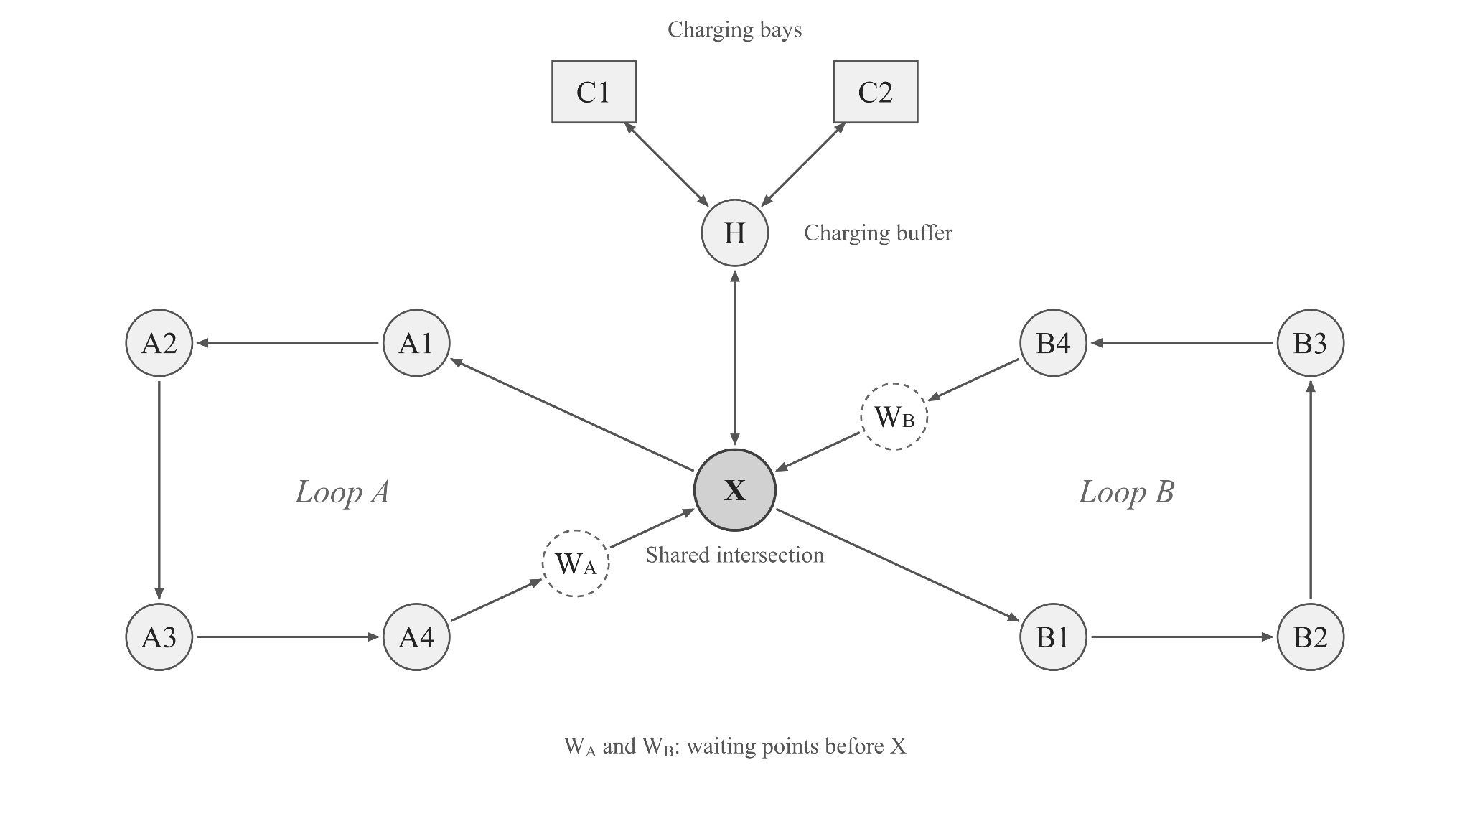
The system contains two unidirectional loops with fixed connectivity. Loop A follows X→A1→A2→A3→A4→WA→X, whereas Loop B follows X→B1→B2→B3→B4→WB→X. Robots R1 and R2 serve only Loop A, whereas R3 and R4 serve only Loop B. WA and WB are the waiting points before robots enter the shared intersection X. The charging branch is X→H→C1/C2→H→X, where H is the charging buffer and queuing location, and C1 and C2 are configurable charging bays. A robot entering X must have exclusive use of the resource and satisfy the safety buffer between consecutive traversals; each enabled charging bay likewise has a capacity of one. Waiting caused by resource conflicts may occur only at WA, WB, or H. Robots cannot stop inside X or queue inside an occupied charging bay.
The map comprises 18 directed edges, and travel direction is uniquely determined by the topology above. Multiple robots may traverse ordinary loop edges simultaneously. Mutual-exclusion constraints apply only to X and the charging bays, so the model does not address geometric collision avoidance on ordinary edges. The map editor allows the length of each directed edge, the global speed, and the energy consumption per unit distance to be modified. Travel time equals edge length divided by speed, and movement energy consumption equals edge length multiplied by the per-distance energy-consumption rate. These parameter changes neither add nor remove edges, nor alter node connectivity. The network diagram in the interface is only a topological illustration: its labels show the configured physical lengths, but node positions are not drawn to geometric scale.

Tasks and Operational Assumptions
Each transport task is defined by eight fields: task_id is the unique identifier; release_time is the earliest time at which the task may be executed; pickup and dropoff are the pickup and delivery stations; load_time and unload_time are the loading and unloading durations; due_time is the delivery deadline; and priority is an integer priority level from 1 to 5. The pickup and drop-off points must be distinct stations on the same loop, and a robot may carry only one task at a time.
Table 3.1 shows sample records supplied with the project. These records illustrate the input schema and are not the 12-task experiment in Section 8; the complete input for that experiment appears in Appendix B, Table B.1.
Table 3.1 Sample Input Records from examples/tasks.csv
task_id | release_time | pickup | dropoff | load_time | unload_time | due_time | priority
T036 | 30 | A3 | A1 | 20 | 20 | 787 | 1
T012 | 40 | B4 | B2 | 10 | 20 | 887 | 2
T016 | 40 | B4 | B3 | 15 | 15 | 825 | 3
The model uses deterministic, piecewise-linear travel and battery updates. Edge travel times and loading and unloading durations are deterministic, while movement, loading, unloading, waiting, and charging continuously update SOC according to the action log; charging follows a linear rate. Task execution, intersection traversal, and each charging visit are non-preemptive. A robot consumes no energy while powered down and idle between tasks, but waiting caused by queues for the intersection or charging resources consumes energy. Automatic strategies leave a charging bay immediately after charging finishes. The four heuristic strategies automatically charge to 95%, whereas offline CP-SAT may determine a partial charging amount. The current implementation has no mechanism for interrupting a charging operation and temporarily releasing the charging bay. In manual command mode, the system instead follows the externally specified target SOC exactly and continues to occupy the charging bay after charging is complete until a leave command is received.

Inputs Outputs and Information Availability
Model inputs include the task table, the two-loop map and parameters for its 18 edges, initial robot SOC values, the safety threshold, the number of charging bays and charging rate, travel and resource-buffer parameters, and options such as the CP-SAT time limit, parallel worker count, and rolling horizon. Outputs include each task's robot assignment and completion result, per-robot action timelines, reservation intervals for X and the charging bays, SOC trajectories, independent validation results, and the makespan, weighted tardiness, average resource waiting time, energy consumption, utilization, and normalized objective value J. The complete JSON output also retains the tasks, configuration, map, actions, events, reservations, validation, and comparison results. CSV files can separately export tasks, schedules, events, robot states, and summary metrics for review and experimental reproduction.
The system supports offline scheduling, rolling-horizon scheduling, and manual command replay. In offline scheduling, heuristic methods and CP-SAT have access to the complete task list, although tasks cannot begin before their release times. In contrast, rolling-horizon CP-SAT periodically replans using only released tasks while preserving previously committed operations and resource reservations. Manual command replay executes and validates externally specified plans without performing automatic task assignment or conflict resolution. It is therefore excluded from comparisons between automatic scheduling methods.

4 Mathematical Formulation
This project schedules tasks, intersection access, and charging for four robots on two fixed directed loops. R1/R2 serve A and R3/R4 serve B. Each task stays within one loop, and each robot carries one task at a time. X and charging bays are exclusive resources; ordinary loop edges are not. The model checks resource conflicts and optimizes assignment and timing on fixed routes, without geometric collision avoidance. Each task follows empty travel, loading, loaded travel, and unloading. Once started, a task is not preempted; charging is also continuous.

Sets Parameters and Decision Variables
Tables 4.1 and 4.2 define the notation. Times are in seconds; SOC and energy are in battery percentage points. Index 0 denotes the dummy initial vertex.
Table 4.1 Sets and Parameters
Notation | Meaning
$$I,K,K_{i}$$ | Tasks, robots, and robots compatible with task i
$$P,Q_{k}$$ | Enabled charging bays and candidate charging visits of robot k
$$r_{i},d_{i},p_{i}$$ | Release time, due time, and task priority
$$L_{i},U_{i},g_{h}$$ | Loading and unloading times, and SOC consumption per handling operation
$$τ_{uv},g_{uv}$$ | Travel time and SOC consumption on directed edge (u,v)
$$ρ_{w},ρ_{c}$$ | Queueing drain and charging rate in SOC percentage points per second
$$S_{min},β,δ$$ | Safety SOC floor, buffer parameter, and crossing clearance; delta equals twice beta
$${R^{}}_{C},{R^{}}_{T},{R^{}}_{W},{R^{}}_{E}$$ | Normalization references for makespan, weighted tardiness, waiting, and energy
Table 4.2 Decision Variables
Group | Notation | Meaning
Assignment and order | $$x_{ik},a_{kab}$$ | Binary task assignment and arc selecting visit b after a for robot k
Task and visit times | $$s_{i},c_{i},s_{kn},f_{kn}$$ | Task start and delivery completion; start and finish of visit n by robot k
Tardiness and makespan | $$T_{i},C_{max}$$ | Task tardiness and the last delivery completion time
Crossing reservations | $$e_{kr},l_{kr},w_{kr}$$ | Crossing entry, exit, and preceding queue duration
Charging decisions | $$y_{kq},b_{kqp},u_{kq},D_{kq}$$ | Charging visit activation, bay selection, start time, and duration
Battery state | $$S^{H},S^{−},S^{+}$$ | SOC at H, before charging, and after charging
Waiting and energy | $$w^{C},W_{X},W_{C},E$$ | Charging queue duration, total crossing/charging queues, and positive SOC consumption

Assignment and Temporal Constraints
Each robot orders its assigned tasks and optional charging visits using AddCircuit through a dummy initial vertex. A task vertex is active exactly when assigned; a charge vertex is active when enabled. Absent vertices use self-loops, and a dummy self-loop permits an unused robot. Assignment, arc, activation, and bay variables are binary. Selected arcs impose
$\sum_{k∈K_{i}}{x_{ik}=1,s_{i}≥r_{i},a_{kab}=1⇒s_{kb}≥f_{ka}(b≠0).}$ (4.1)
Here $s_{i}$ includes empty travel to pickup, $c_{i}$ is unloading completion, and $f_{ka}$ ends the preceding visit. For an assigned robot k, completion satisfies the expression below. The selected predecessor determines empty-travel time; loaded travel follows the fixed pickup-to-delivery route. The sum includes permitted resource queues. Travel time is edge length divided by speed, and movement consumption is length times consumption per metre. The closing dummy arc ends the sequence without physical return travel, so makespan ends at the final delivery. The set $ℛ_{ki}$ contains the crossings on the selected empty and loaded paths.
$c_{i}=s_{i}+τ_{ki}^{empty}+L_{i}+τ_{i}^{loaded}+U_{i}+\sum_{r∈ℛ_{ki}}{w_{kr}.}$ (4.2)

Resource Capacity and Battery Safety
Every selected crossing reserves an interval in one NoOverlap constraint, where e and l are entry and exit times. The implementation uses $δ=2β$: the default buffer parameter of 2 seconds therefore gives a 4-second clearance between crossings. Robots wait at WA, WB, or H and may not stop inside X. Each selected charging visit queues at H, enters one chosen bay, charges without interruption, and immediately returns to H. Bay intervals are also non-overlapping. Charging amount and duration are decisions; the heuristics instead use a fixed 95% SOC target. Bay selection satisfies $\sum_{p}{b_{kqp}=y_{kq}}$. With H arrival time h, charging begins at $u=h+w^{C}+τ_{Hp}$ and the visit ends at $u+D+τ_{pH}$.
SOC decreases by movement, handling, and resource queueing, but powered-down standby between tasks is free. For a segment without replenishment and with $n_{h}$ handling operations, the recurrence below applies. It is checked before replenishment and after each action, within $\left[100\right]$.
$S_{out}=S_{}−\sum_{\left(v\right)}{g_{uv}−n_{h}g_{h}−ρ_{w}∑w.}$ (4.3)
For a charging visit, let $S^{H}$ be SOC on arrival at H, $w^{C}$ its queue duration, and D its charging duration. Safe arrival, replenishment, and departure require
$S^{−}=S^{H}−ρ_{w}w^{C}−g_{Hp}≥S_{min},S^{+=S^{−}+ρ_{c}D≤100,S^{+−g_{pH}≥S_{min}.}}$ (4.4)
The default terminal reserve requires every robot serving tasks to retain enough energy after its final delivery to reach a bay and withstand conservative queueing. It includes an allowance for three other recharges; the integer model adds a 0.5-percentage-point margin and checks the decoded plan against the actual calendars. The cpsat-nores ablation removes only this terminal requirement, retaining battery safety during execution. The no-reserve variant is evaluated separately because it permits more schedules. Rolling optimization always retains the reserve.
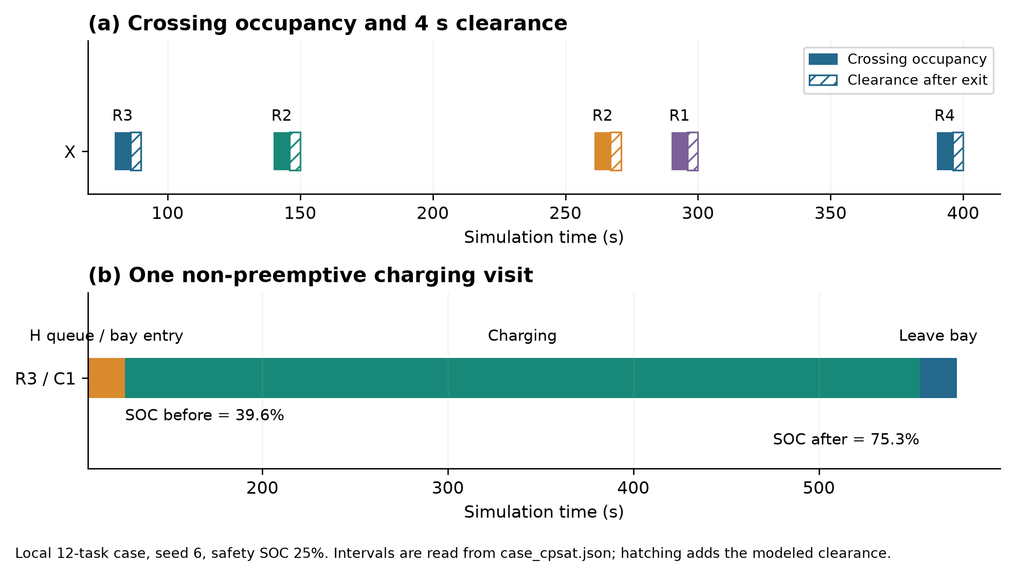
Figure 4.1 Intersection Reservations and a Charging Visit. New local 12-task run, seed 6, safety SOC 25%. Solid crossing intervals exclude the hatched 4 s clearance. The charging visit includes travel from H, charging, and immediate departure.

Objective and Model Scope
The optimizer minimizes a composite objective that combines makespan, tardiness, waiting, and energy consumption. Define $T_{i}=max(0,c_{i}−d_{i})$ and $C_{max}=\max_{i}c_{i}$. Let $W_{X},W_{C}$ be total intersection and charging queues, and E total positive consumption. The objective is
$minJ=\frac{1}{4}\left(\frac{E}{{R^{}}_{E}}\right).$ (4.5)
References normally come from First-Come, First-Served(FCFS) on the same instance, with denominator floors of 1 s, 60 s, 60 s, and 1 SOC percentage point. If FCFS fails, Staged and Deadline are tried before floor-only references. Consequently, FCFS need not score exactly 1. Energy excludes replenishment, and weighted tardiness differs from the unweighted CSV total_tardiness field. Battery safety is a hard constraint, not a compensable objective term.
CP-SAT uses a 1 ms time grid, conservative integer approximations, and a finite number of optional charging slots. OPTIMAL applies only to that bounded integer model; a time-limited feasible solution is not a physical global-optimality proof. All candidates must be decoded and validated, and a returned fallback does not inherit the solver's optimality certificate.

5 Solution Methodology

Baselines and Joint Greedy Scheduling
All automatic methods share the executor, map, energy rules, and metrics. Table 5.1 summarizes their decision rules. FCFS charges before a task when SOC is below 20%; accepted tasks must also pass completion and terminal-reserve checks.
Table 5.1 Baseline Scheduling Policies
Policy | Decision Rule | Comparison Purpose
FCFS | Process by release time; choose earliest predicted completion, including queues, charging, and reserve checks | Simple executable reference
Staged | Fix assignment and order from nominal travel times, then add reservations and necessary charging | Measure the cost of separate planning stages
Deadline | Order by due time, break ties by priority, and check resource and battery feasibility | Compare due-date priority
Joint Greedy | Score up to eight pending tasks and compatible robots; commit the best feasible candidate | Joint heuristic and CP-SAT initial schedule
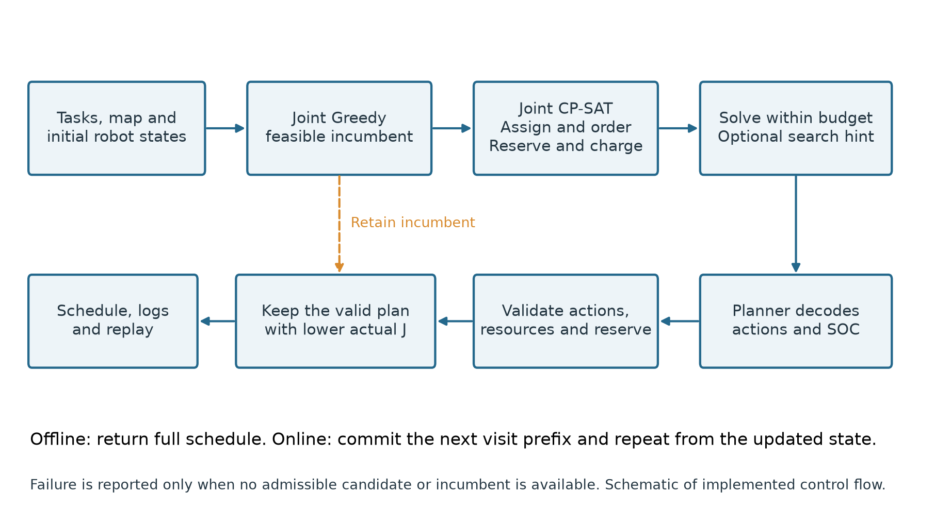
Figure 5.1 Joint Planning and Validation Pipeline. Schematic of the implemented solver, decoder, validator, and incumbent fallback; the same execution rules apply across automatic strategies.
Joint Greedy considers up to eight pending tasks in release-time order and both compatible robots. Each candidate is evaluated on a cloned state: try the task, check its post-task reserve, and insert charging first if needed. Infeasible candidates are discarded without changing the committed schedule. The selected candidate minimizes the local score below, with task and robot identifiers breaking ties. Here the incremental wait and positive consumption include any inserted charging visit.
${score}_{ik}=c_{i}+3p_{i}T_{i}+0.5ΔW_{i}+2ΔE_{i}.$ (5.1)
This score uses raw units and fixed coefficients rather than the normalized J. It gives a fast joint initial schedule, but finite lookahead does not guarantee the best complete schedule. The four heuristics can inspect the full task list, although execution never begins before release. They therefore provide offline comparators, not baselines with the same information restrictions as the rolling method. If no candidate passes the checks, the strategy reports that it did not find a safe plan; this does not prove that no feasible physical schedule exists.

Offline Joint Optimization
CP-SAT fits this model because assignment and visit choices are Boolean, while optional intervals, AddCircuit, and NoOverlap represent sequence and resource capacity directly. Linear time and SOC constraints connect those choices to feasible execution. Inputs are validated task records, the directed map, robot states, resource counts, and solver options; outputs are assignments, timed actions, reservations, SOC traces, and performance metrics. Joint Greedy supplies an initial physical schedule and, when it can be projected onto the grid, an AddHint search hint. The hint guides search without fixing decisions. The valid initial schedule is also retained outside the solver; CP-SAT can attempt a solve without it if the heuristic fails. The use of CP for coupled AGV scheduling is consistent with [7], although the resource model here is different.
Selected circuits are decoded through Planner using the model's visit order, crossing times, bay choices, and charging targets. Actual durations and SOC changes are recomputed from the map instead of copied from integer variables. The decoder then checks the resulting actions and enabled terminal reserve. The returned plan is the valid decoded candidate or admissible heuristic incumbent with lower actual J. An explicit charging-slot cap also constrains fallback admissibility. This policy guarantees comparison only with the retained Joint Greedy incumbent, not with every baseline.
Solver status, bound, gap, decoded objective, and fallback reason are stored separately. FEASIBLE means that the integer model has a candidate; successful fallback is neither solver-proven optimality nor a failed run. Overall runtime includes initial planning, model construction, solving, decoding, and validation, whereas solver wall time covers search only. Exact bitwise repetition is not guaranteed by a fixed seed under parallel, wall-clock-limited search. Actual archived budgets are specified in Section 7.
A decoder or reserve violation discards that candidate and leaves an admissible incumbent available. If neither survives, the system reports that no safe plan was found. UNKNOWN means the search has not established feasibility or infeasibility within its budget. INFEASIBLE concerns only the bounded integer model; MODEL_INVALID is an implementation error. These statuses must remain separate from the validation result of any returned physical schedule.

Rolling Horizon Optimization
At decision time t, rolling optimization sees only released, uncommitted tasks. By default it replans every 60 seconds and selects a window using roughly 600 seconds of available workload capacity per robot. Tasks are prioritized by due time, priority, and identifier. The window is a workload limit rather than a strict completion deadline: travel to pickups, queueing, or charging can extend the plan beyond it. Current robot states and committed reservations define the next solve's initial conditions.
Only each robot's visit prefix starting before the next decision epoch is committed. The whole committed visit is frozen, including actions and reservations extending beyond that epoch; ongoing tasks and charging are not interrupted. Uncommitted tasks may be reassigned later. Each solve computes normalization from currently known tasks and state, while full-instance references are used only for retrospective scoring. Unreleased orders therefore do not affect current decisions or objective coefficients. Local solver bounds are not an online global-optimality certificate.
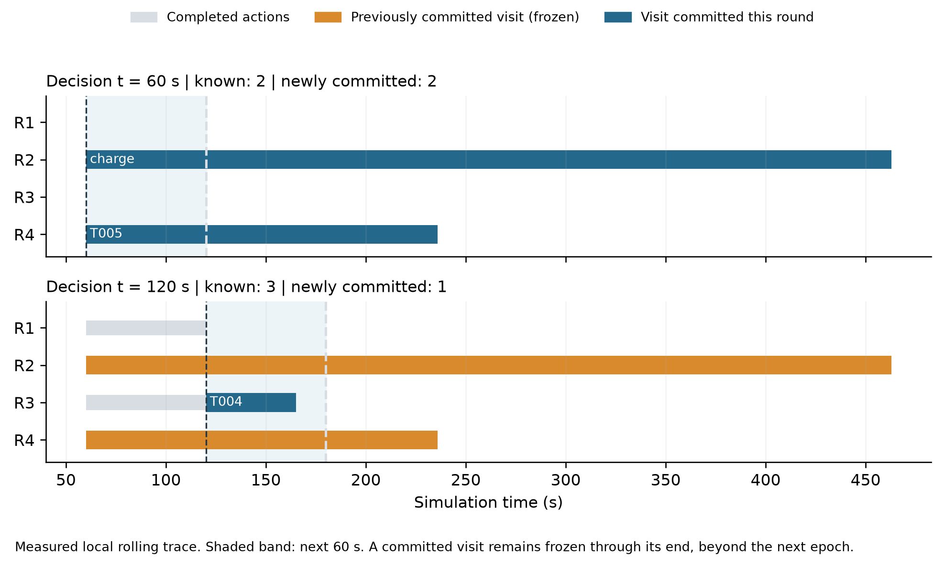
Figure 5.2 Rolling Horizon Commitment in a Local Run. Decision epochs at 60 and 120 s from the recorded rolling trace. Visits committed in the first round remain frozen beyond the next decision epoch.

6 System Implementation and Validation

Shared Execution and Traceability
LoopLab combines a Python backend with browser replay. simulator.py maintains robot states, reservation calendars, action generation, metrics, and validation; optimizer.py provides joint and rolling optimization. experiments.py reuses instances and aggregates results. The frontend visualizes the returned trace rather than running another scheduler. Actions record robot/task identifiers, endpoints, start/end times, SOC, consumption, and resources. Events, Gantt charts, battery curves, and CSV/JSON exports refer to the same run, allowing an aggregate result to be traced to specific actions and reservations.
Strict command replay provides a separate interface for execute_task, move_to, charge, and wait commands with absolute start times. It rejects timing, resource, and battery conflicts instead of automatically queueing commands or inserting charging. Charging robots remain parked until explicitly moved, unlike automatic schedules. Omitted tasks remain unexecuted. Command-plan duration ends with the final command, whereas task_makespan ends with the final delivery; manual plans are therefore kept separate from automatic algorithm rankings.
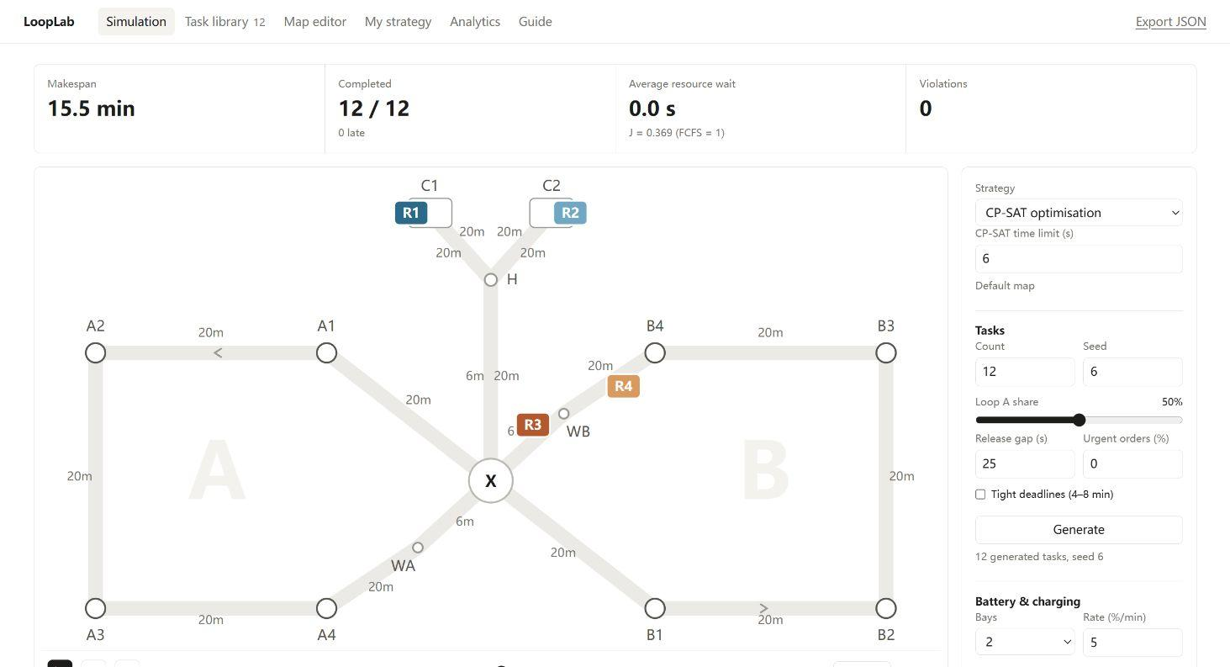
Figure 6.1 Local Simulator Replay. Browser map, robot positions, and summary metrics for a separate 12-task run. Its interactive solver settings differ from the controlled case in Chapter 8; quantitative comparisons use the saved case outputs.

Independent Validation
The validator recomputes correctness from output tasks, actions, maps, and reservations. It checks unique task execution, release and pickup-before-delivery precedence, robot continuity and non-overlap, legal directed travel, load capacity, X/bay occupancy and clearance, legal waiting locations, and SOC continuity and bounds. Rebuilding occupancy from actions also detects missing or inconsistent reservation records. A candidate that fails these checks is rejected, even if the optimizer reports feasibility.
A one-task check uses A1 to A2, release 0, due time 600 s, priority 1, 15 s loading and unloading, and initial SOC 80%. The default 20 m edge takes 20 s and consumes 2 SOC points; each handling operation consumes 0.5. Thus completion is 50 s and final SOC is 77%. FCFS references with the specified floors are $\left(3\right)$, giving $J=\frac{1}{4}({50}/{50}+0/{60}+0/{60}+3/3)=0.5$. Table 6.1 compares this calculation with a fresh program run. A forged final SOC of 78% fails consistency even though it exceeds the safety floor.
Table 6.1 Hand Calculation and Program Output
Quantity | Hand calculation | Program output
Completion time (s) | 50.0 | 50.0
Energy (SOC pp) | 3.0 | 3.0
Final SOC (%) | 77.0 | 77.0
Objective J | 0.500 | 0.500
Constraint violations | 0 | 0
Objective verification is separate from feasibility checking: recompute the last delivery time, task tardiness and priorities, resource queues, and positive action consumption, then apply the stored normalization references. Repository tests check this normalized objective and reject traces with altered timing, SOC, or occupancy. The validator is independent of planner state but shares map and rule utilities, so its acceptance establishes conformity with the encoded model.
The implementation and experimental data are available in the project repository:
Repository: https://github.com/Eth4nMurpHy/robot-simulator
Code snapshot: 9bf0b705d91313ea851286a71e13000ba18687b1

7 Experimental Setup

Evaluation Questions and Dataset Generation
RQ1 evaluates whether joint scheduling improves completion time, tardiness, waiting, and energy relative to staged and single-rule baselines. RQ2 examines terminal reserves and resource sensitivity; RQ3 examines online solution quality and replanning cost. The experiments use synthetic tasks for the four-robot, dual-loop system.
For n base tasks, releases are sampled uniformly from a 10-second grid within [0,12n) seconds. Pickup and delivery stations are distinct and belong to the same loop. Loading and unloading each take 10, 15, or 20 seconds; due times add 480–900 seconds to release. Priorities 1, 2, and 3 have probabilities 50%, 25%, and 25%. Separate seeded streams generate urgent orders and per-robot initial SOC of 50–100%, rounded to one decimal place. Adding urgent orders preserves the base workload.
The synthetic inputs represent recurrent transport decisions rather than measurements from a factory. Same-loop orders respect the fixed guideway layout; release times create competing requests; several handling durations and due allowances create workload and urgency variation; and different initial SOC values create charging demand. These choices reproduce the scheduling mechanisms being tested. The numerical ranges are experimental assumptions, without calibration against operational records, so the results support controlled comparisons within this simulator.

Experimental Factors and Computing Environment
The base setting uses 40 tasks, two bays, a 10% safety threshold, equal zone-assignment probabilities, and no urgent orders. One factor varies at a time (Table 7.1). Each configuration uses seeds 1–10 and identical inputs across strategies. Ten distinct configurations × ten seeds × seven strategies yield 700 deduplicated strategy-run records; the CSV's 1,050 rows include repeated base results across experiment groups. Increasing task count also lengthens the release window, rather than isolating arrival intensity within a fixed horizon.
Table 7.1 Experimental Factors and Solver Budgets
Factor | Levels or Budget
Task count | 20, 40, 60; release window 12n seconds
Charging bays | 1 or 2
Zone imbalance | Expected A:B ratios 1:1, 2:1, 3:1
Safety SOC | 10%, 20%, 30%
Urgent orders | Additional 0%, 10%, 20%; due allowance 180–360 seconds; priority 4 or 5
Solver budgets | Offline: 120 s, 8 workers. Rolling: 1 worker, deterministic budget 0.1 per solve, 30 s wall cap; 60 s replanning, approximately 600 s lookahead.
Archived experiments used Python 3.13 and OR-Tools 9.15.6755. Heuristics and rolling optimization ran on two-vCPU Colab machines at commit 75afc09; offline CP-SAT used high-RAM Colab machines with Intel Xeon 2.20 GHz processors. The no-reserve runs used 75afc09, while reserve-preserving runs used c87fb9f with an SOC margin of 0.5 percentage points. These are historical results, not a current-version rerun. Hardware differs, so runtimes do not establish strict speedup ratios. The rolling deterministic budget is computational work, not 0.1 elapsed seconds.
The local illustration runs use snapshot 9bf0b705, Windows 11, Python 3.12.14, and OR-Tools 9.15.6755. Their seeds, budgets, and sample sizes are reported with the results in Chapter 8. Historical and local observations are kept separate, and the new one-task check in Table 6.1 uses this same snapshot.

Metrics Statistics and Fair Comparison
Metrics include J, makespan, unweighted and priority-weighted tardiness, late-task rate, resource waiting, energy, charging sessions, runtime, and violations. Average resource waiting is $(W_{X}+W_{C})/{}I∨$, excluding powered-down standby. Energy sums positive SOC consumption and excludes replenishment. Tables report means and sample standard deviations where shown; local figures show medians and individual seeds. Paired objective reduction is $1−{J_{s}}/{J_{FCFS}}$, so a positive value means improvement. It uses actual FCFS J, which can be below 1 because of denominator floors.
Heuristics and offline CP-SAT know future tasks but respect release times; rolling sees only released tasks and uses known-task normalization until final evaluation. Main comparisons retain terminal reserves; no-reserve CP-SAT is an ablation. Heuristics charge to 95%, whereas CP-SAT selects amounts, so gains do not isolate charging effects. Queueing excludes powered-down standby. Feasible solutions do not establish optimality; incumbent retention is not failure. All 700 archived records report success and zero violations. These records come from the archived runs; statistical significance has not been established.

8 Results and Analysis
The archive provides the ten-seed, seven-strategy comparison described in Chapter 7. Local figures use three seeds, four configurations, and five offline strategies, giving 60 runs, plus a separate 12-task case with FCFS, CP-SAT, and rolling plans. The archive supplies the broader comparison; the local traces explain individual decisions. Budgets and versions differ, so their samples are not pooled.

Overall Scheduling Performance
Table 8.1 reports the archived base setting of 40 tasks, two bays, and a 10% safety SOC. Reserve-preserving CP-SAT has mean J = 0.468 against 1.000 for FCFS, a 53.2% reduction. Mean makespan falls from 3,233 to 2,317 s, or 28.3%, while consumption falls from 443.2 to 358.8 SOC percentage points, or 19.0%. These are separate outcomes: the reduction in J does not represent an equal reduction in completion time.
Table 8.1 Archived Base Performance over Ten Seeds
Method | J  mean ± SD | Makespan (s)  mean ± SD | Tardiness  (s) | Bay queue  (s) | Energy  (SOC pp)
FCFS | 1.000 ± 0.000 | 3233 ± 384 | 26,028 | 1,437 | 443.2
Staged | 1.067 ± 0.156 | 3441 ± 543 | 27,264 | 1,487 | 449.0
Deadline | 1.003 ± 0.240 | 3210 ± 499 | 25,994 | 1,290 | 438.3
Joint Greedy | 0.793 ± 0.154 | 3021 ± 479 | 17,826 | 909 | 386.4
CP-SAT | 0.468 ± 0.062 | 2317 ± 477 | 9,934 | 0 | 358.8
CP-SAT no reserve | 0.349 ± 0.072 | 1732 ± 542 | 5,032 | 0 | 316.1
Rolling CP-SAT | 0.636 ± 0.136 | 2741 ± 531 | 15,651 | 255 | 388.9
Tardiness, bay queueing, and energy in the table are means; tardiness is unweighted and energy excludes replenishment. Joint Greedy reduces mean J by 20.7%, but Staged and Deadline have little average advantage over FCFS. Fixing assignment before reserving resources can leave charging conflicts for the execution stage to absorb. Rolling and no-reserve CP-SAT are shown separately because they use different information or constraints.
The objective also needs a consistent reference. Each instance uses its own FCFS-based denominators, with lower bounds for small components. FCFS can therefore score below one, as it does in some 20-task local runs. A smaller J at one task count should not be interpreted as proportionally less physical work than at another count. The paired method comparisons, raw quantities, and distributions together describe the outcome.

Solver Budget and Local Verification
Archived offline CP-SAT used 120 s and eight workers; its recorded solutions are FEASIBLE, so the results are not proofs of optimal schedules. For the base setting, total runtime averages 120.67 s, against 0.29 s for Joint Greedy. The methods ran on different Colab machines, which prevents a strict speedup comparison. The result supports a quality–computation trade-off under the recorded budgets.
The local check uses one CP-SAT worker, a deterministic budget of 0.15, and a 6 s wall cap per solve. Figure 8.1 shows every seed for the 40-task base setting. All 12 local CP-SAT runs return the same J as Joint Greedy; nine explicitly retain the incumbent through fallback. No improvement beyond the initial schedule is established at this budget. All 60 batch outputs pass validation, as do the three case plans and the browser-exported plan. The repository test suite also passes all 69 tests.
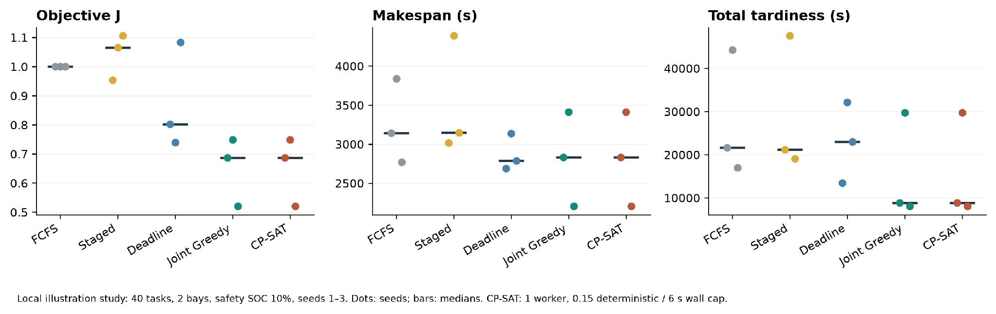
Figure 8.1 Local Algorithm Comparison. Three seeds, 40 tasks, two bays, safety SOC 10%. Dots show individual runs and horizontal marks show medians. CP-SAT and Joint Greedy coincide under the short budget.
The solver records explain the overlap in Figure 8.1. The nine fallback runs have status UNKNOWN because the search finds no CP-SAT incumbent within budget. They still return a validated external Joint Greedy plan. The other three runs, all with 20 tasks, are FEASIBLE with reported gaps of about 36%–64%, and their returned J still matches the initial plan. The local 12-task offline solution is also FEASIBLE, with a gap of about 56%. None of these cases supplies an optimality certificate. Counting fallback as failure would hide the executable schedules; counting it as solver success would hide the search limitation.

Worked Example and Bottleneck Analysis
The local case has 12 tasks, seed 6, release gap 25 s, two bays, and a 25% safety floor. Initial SOC for R1–R4 is 50.1%, 53.9%, 52.2%, and 80.8%. Offline CP-SAT uses one worker, deterministic budget 0.5, and a 30 s wall cap; its measured total runtime is 2.62 s. Figure 8.2 uses identical time axes for FCFS and CP-SAT. Table 8.2 includes rolling on the same input. The complete 12-task input is given in Appendix B, Table B.1; all three methods use those same records.
Table 8.2 New Local Twelve Task Case
Method | J | Makespan  (s) | Tardiness  (s) | Bay queue  (s) | Minimum  SOC (%)
FCFS | 1.000 | 1673.2 | 2518.4 | 634.4 | 35.4
CP-SAT | 0.447 | 1165.2 | 275.2 | 0.0 | 25.9
Rolling CP-SAT | 0.505 | 1237.6 | 1011.0 | 0.0 | 33.4
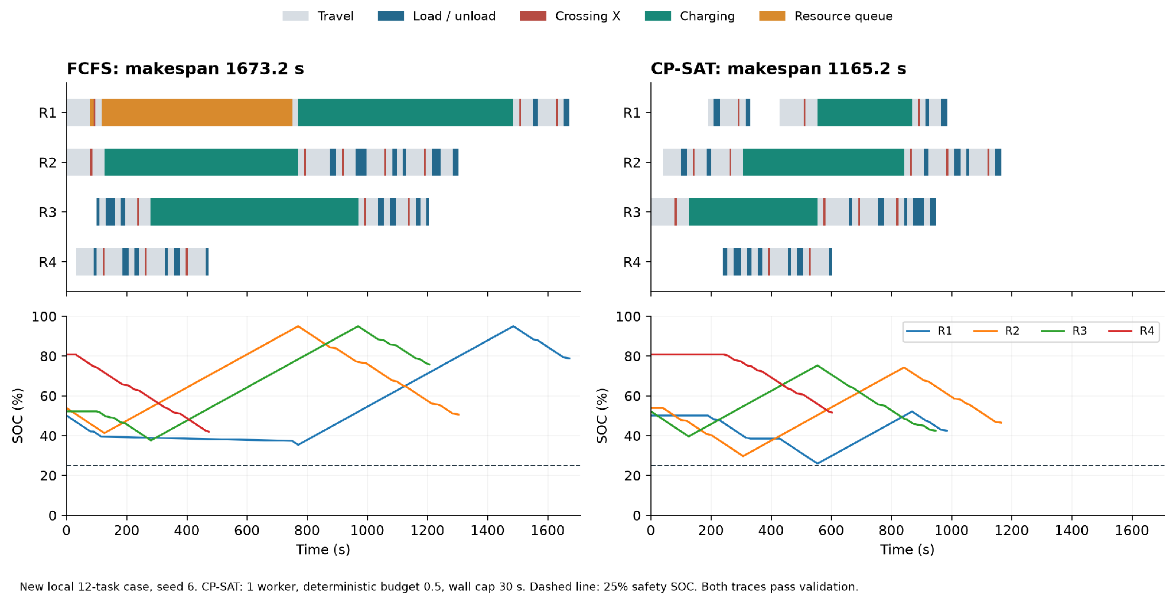
Figure 8.2 Local Schedule and SOC Comparison. The upper panels show robot actions; the lower panels show SOC. The dashed line marks the 25% safety floor. Both schedules retain terminal reserves and pass validation.
Under FCFS, R1 waits at H from 116.0 to 750.4 s: 634.4 s of charging queueing. Its recharge then lasts until 1,486.2 s. CP-SAT charges R3 first from 126.0 to 554.4 s, then admits R1 immediately at 554.4 s; R1 finishes charging at 868.8 s. The three CP-SAT charge targets are 75.3%, 74.3%, and 52.1%, rather than 95%. These recorded changes remove bay queueing and shorten the schedule. Makespan falls by 30.4% and unweighted tardiness by 89.1%. Energy remains almost unchanged, at 160.548 versus 160.400 SOC points. This case supports a timing and charging explanation, not a large energy-saving claim. Zero queueing also does not mean zero idle time. Average resource waiting falls from 53.7 s per task to zero; this includes the 10 s of FCFS intersection queueing as well as its bay queue.

Terminal Reserve and Resource Sensitivity
In the archived base setting, removing terminal reserve lowers mean J from 0.468 to 0.349, and makespan from 2,317 to 1,732 s. Battery safety during execution remains enforced; only the post-batch reserve is removed. The lower values therefore describe a larger feasible region, not a better method under identical requirements. The summary files do not establish charger reachability after the final task for this ablation, so continued operation cannot be inferred from its batch completion metrics.
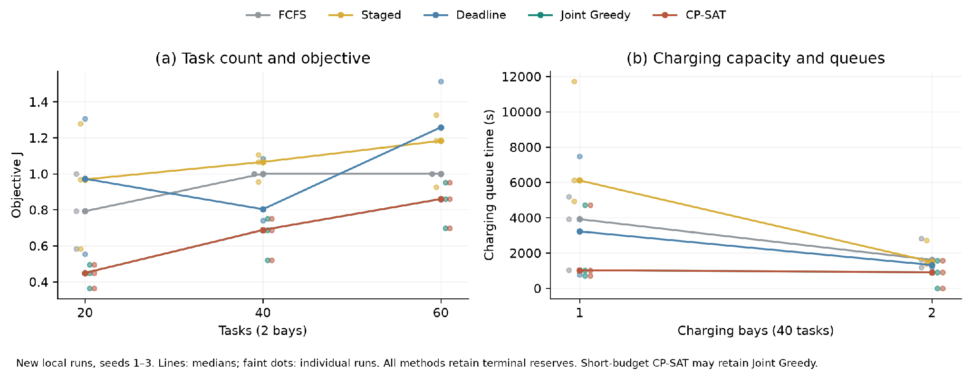
Figure 8.3 Local Workload and Charging Sensitivity. Lines show medians over seeds 1–3 and faint dots show individual runs. The left panel varies task count with two bays; the right varies bay count with 40 tasks.
Figure 8.3 shows the local Joint Greedy median J rising from 0.449 at 20 tasks to 0.687 at 40 and 0.860 at 60. At 40 tasks, reducing capacity from two bays to one raises median charging queues from 1,604.6 to 3,913.8 s for FCFS, but from 910.4 to 1,012.2 s for Joint Greedy. Scheduling therefore changes how strongly a resource shortage is felt. Increasing task count also lengthens the release window, so this is not an isolated test of arrival intensity. Three seeds show these observed cases, without establishing statistical significance.
The archived sensitivity results cover conditions beyond the local check. With the expected A:B task ratio changed from 1:1 to 3:1, reserve-preserving CP-SAT mean makespan increases from 2,317 to 3,010 s. Raising the safety floor from 10% to 30% increases its late-task fraction from 32.5% to 48.0%. Adding 20% urgent tasks increases mean makespan to 2,820 s and the late fraction to 48.8%. Both constraints and workload can therefore limit delivery performance even when every returned plan is feasible.
These factors answer different questions. Bay count tests resource availability, zone imbalance tests where work is concentrated, and safety SOC reduces the usable battery range. Urgent-order experiments change both the number of tasks and their deadlines and priorities, so they do not isolate a pure priority effect. The four-robot fleet and single intersection remain fixed throughout; task-count results are not evidence of scalability to larger fleets.

Online Replanning
On the local 12-task input, rolling CP-SAT performs 18 replans with no incumbent fallbacks. Total runtime is 5.40 s, of which solver wall times sum to 5.10 s; makespan is 1,237.6 s and J is 0.505. It finishes later than offline CP-SAT but receives tasks only after release. The archived base mean J of 0.636 is also between FCFS and offline CP-SAT. These comparisons describe operation with restricted information; they do not isolate algorithm quality from future knowledge. Aggregate runtime alone does not establish a worst-case or 95th-percentile replanning latency.

9 Discussion

Interpretation of Results
The archive and local experiments support the benefits of jointly scheduling task assignment, intersection reservations, and charging decisions in the tested system. Joint Greedy reduces the mean composite objective by 20.7% relative to FCFS, providing a feasible schedule through coordinated resource and battery checks. Offline CP-SAT achieves further improvement under the archived search budget, although the gain cannot be attributed solely to the solver because CP-SAT also allows flexible charging amounts.
The worked trace identifies a concrete bottleneck: charging to a fixed 95% target can occupy charging bays long enough to delay other robots. Partial charging and task reordering can reduce such delays, but their individual contributions have not been isolated.
The short-budget results also demonstrate the importance of computational limits. CP-SAT may return the validated Joint Greedy schedule without improving it. Joint Greedy therefore provides a practical initial solution and fallback, while CP-SAT can improve scheduling quality when sufficient search time is available. The results should be interpreted using the measured objective, resource queues, and computation time rather than the solver label alone.

Limitations
The results apply to the four-robot, fixed-route system and synthetic workloads considered in this project. Validation establishes compliance with the modeled resource and battery constraints, but does not prove general collision avoidance or physical deployment safety.
The heuristics use a fixed charging target, whereas CP-SAT permits flexible charging amounts, so the effects of charging flexibility and task reordering cannot be separated. Offline methods also have access to future tasks, unlike rolling-horizon CP-SAT, preventing a direct comparison under identical information conditions.
Finally, archived and local experiments differ in hardware, code revisions, and solver budgets. The archived study uses ten seeds per configuration, while the local check uses three, and no formal statistical significance test has been conducted. More controlled comparisons would be needed to isolate the effects of individual scheduling decisions.

10 Conclusion
This project implements joint task, intersection, and charging scheduling for a fixed dual-loop system. In the archived base study, reserve-preserving CP-SAT reduces mean J by 53.2% and makespan by 28.3% relative to FCFS. The new local case links a shorter schedule to reduced bay occupancy and queueing, while the short-budget batch check finds no improvement beyond Joint Greedy. Solver budget therefore matters alongside the scheduling model.
Terminal reserve trades finite-batch performance for post-task charging access. Rolling planning handles released tasks with frozen commitments, but a fair online ranking still needs baselines with the same information. The present evidence supports the tested synthetic system and its resource rules. Broader traffic safety, real-time guarantees, and factory deployment require further modeling and measurements.

References
[1] Athira K. A., Divya Udayan J., and Umashankar Subramaniam. A Systematic Literature Review on Multi-Robot Task Allocation. ACM Computing Surveys, vol. 57, no. 3, pp. 1–28, 2025. https://doi.org/10.1145/3700591
[2] Shuqin Li, Lubin Fan, Shuai Jia. A hierarchical solution framework for dynamic and conflict-free AGV scheduling in an automated container terminal. Transportation Research Part C: Emerging Technologies, vol. 165, Art. 104724, 2024. https://doi.org/10.1016/j.trc.2024.104724
[3] Yantong Li, Bo Ren, Xin Wen, Sai-Ho Chung. An adaptive large neighborhood search method for the AGV scheduling problem with a limited number of chargers. International Journal of Production Research, vol. 63, no. 15, pp. 5749–5781, 2025. https://doi.org/10.1080/00207543.2025.2462670
[4] Xiang Huo, Xiaozheng He, Zhongxia Xiong, Xinkai Wu. Multi-objective optimization for scheduling multi-load automated guided vehicles with consideration of energy consumption. Transportation Research Part C: Emerging Technologies, vol. 161, Art. 104548, 2024. https://doi.org/10.1016/j.trc.2024.104548
[5] Yantong Li, Xin Wen, Shanshan Zhou, Sai-Ho Chung. Smart Automated Guided Vehicle scheduling with flexible battery management: A new formulation and an exact approach. Computers & Operations Research, vol. 183, Art. 107156, 2025. https://doi.org/10.1016/j.cor.2025.107156
[6] Youjie Yao, Qihao Liu, Ling Fu, Xinyu Li, Yanbin Yu, Liang Gao, Wei Zhou. A Novel Mathematical Model for the Flexible Job-Shop Scheduling Problem With Limited Automated Guided Vehicles. IEEE Transactions on Automation Science and Engineering, vol. 22, pp. 7449–7462, 2025. https://doi.org/10.1109/TASE.2024.3356255
[7] Youjie Yao, Qihao Liu, Xinyu Li, Liang Gao. Constraint Programming for AGV and Machine Integrated Scheduling Problem in Flexible Manufacturing System. IEEE Transactions on Automation Science and Engineering, vol. 23, pp. 2378–2390, 2026. https://doi.org/10.1109/TASE.2025.3650678
[8] Jianbin Xin, Quan Yuan, Andrea D’Ariano, Guanqin Guo, Yanhong Liu, Yanjie Zhou. Dynamic unbalanced task allocation of warehouse AGVs using integrated adaptive large neighborhood search and Kuhn–Munkres algorithm. Computers & Industrial Engineering, vol. 195, Art. 110410, 2024. https://doi.org/10.1016/j.cie.2024.110410
[9] Xiao Chang, Xiaoliang Jia, Hao Hu. Energy-efficient and self-adaptive AGV scheduling approach based on hierarchical reinforcement learning for flexible shop floor. Computers & Industrial Engineering, vol. 205, Art. 111140, 2025. https://doi.org/10.1016/j.cie.2025.111140
[10] Léa Ricard, Guy Desaulniers, Andrea Lodi, Louis-Martin Rousseau. Chance-constrained battery management for electric bus scheduling. European Journal of Operational Research, advance online publication, 2026. https://doi.org/10.1016/j.ejor.2026.05.046

Appendix A Full Model and Reproducibility

Finite Scheduling Model
The project implementation uses $V_{k}=\{0\}∪I_{k}∪Q_{k}$. Presence $z_{ki}=x_{ik}$ for a task and $z_{kq}=y_{kq}$ for charging; $z_{k0}=1$. Assignment $x$, arc $a$, activation $y$, and bay $b$ are Boolean. Equations below use seconds and SOC percentage points. Internally, time variables are integer ticks in $\left[\underline{H}\right]$, except the charging duration bound below. Node arrival/end SOC and charging targets lie in $\left[100U\right]$. The dummy state fixes initial availability, position, and SOC.
$\sum_{k:i∈I_{k}}{x_{ik}=1,a_{knn}=1−z_{kn}(n≠0),Circuit(a_{k}).}$ (A.1)
Each selected non-self arc belongs to the single circuit through 0; the dummy self-loop permits an idle robot. Selected $a→n$ enforces $s_{kn}≥f_{ka}$ and replays fixed incoming travel to pickup or H. Task copies share $s_{i},c_{i}$ when selected, with $s_{i}≥r_{i}$; loading, loaded travel, and unloading advance time by equality. Absent visits have zero start/ready/end times, and inactive crossings/charge waits are zero. For charging, $y_{k,q+1}≤y_{kq}$ and $s_{k,q+1}≥f_{kq}$ when present. Final charge-to-dummy arcs are forbidden; closing task-to-dummy arcs add no return travel.
$e=arrival+w,l=e+τ_{X},NoOverlap\{$ (A.2)
$\sum_{p}{b_{kqp}=y_{kq},u=h+w^{C}+τ_{Hp},f=u+D+τ_{pH}.}$ (A.3)
$S^{−}=S^{H}−ρ_{w}w^{C}−g_{Hp}≥S_{min},S^{+=S^{−}+ρ_{c}D≤100,S^{+−g_{pH}≥S_{min}.}}$ (A.4)
Waiting occurs at WA, WB, or H, never inside X. The charging equalities apply only to the selected bay; its interval is optional and shares that bay’s NoOverlap. Active D is at least one tick and at most $⌈100U/α⌉$, where $α=⌊ρ_{c}U/T⌋$. On every selected uncharged path, $S_{out}=S_{}−∑g−ρ_{w}∑w$, including handling. Frozen reservations are mandatory. A last delivery retains travel-to-bay consumption plus $3(95−S_{min}){ρ_{w}}/{ρ_{c}}$ and a 0.5-point model margin above the floor; decoding also checks actual reachability.
$minJ=\frac{1}{4}\left(\frac{E}{{\hat{R}}_{E}}\right),C_{max}=\max_{i}c_{i}.$ (A.5)
Normalization denominators use FCFS terms floored at $\left(1\right)$; E excludes replenishment. Rolling solves retain fixed past contributions and normalize on known tasks only. Let T=1000 ticks/s and U=60,000,000 SOC units/point. Durations/releases/consumption/drain round up; due dates, initial SOC, and charging gain round down. Non-grid paths add 20 ticks of drain per crossing/charging approach as a model guard, also included in modeled E but absent from decoded actions. Only X and bays are exclusive. The visit-time bound is $\underline{H}=⌈T\left[t_{0}+(∨I∨+8)(20τ_{max}+5000)\right]⌉$, with latest initial/release time $t_{0}$. Automatic charge slots are $max(q_{k}^{hint},1,⌊∨I_{k}∨5⌋)$; an explicit cap also limits fallback. The valid decoded candidate or admissible Joint Greedy plan with lower actual J is returned; neither available means failure. OPTIMAL concerns this bounded integer model.

Appendix B Experimental Data and Scheduling Output

Input Task List
Table B.1 gives all 12 tasks used in the worked experiment. Tasks are synthetic and fixed across FCFS, CP-SAT, and rolling optimization. Each task is identified by its pickup/delivery stations, release time, due time, handling durations, and priority. All time values are in seconds. R1–R4 start with SOC 50.1%, 53.9%, 52.2%, and 80.8%; the safety floor is 25% and two charging bays are enabled.
Table B.1 Complete Input Task List
Task | Pickup → delivery | Release | Due | Load | Unload | Priority
T005 | B4 → B3 | 30 | 835 | 10 | 20 | 2
T012 | A4 → A2 | 40 | 547 | 20 | 15 | 1
T004 | B1 → B2 | 100 | 989 | 10 | 15 | 3
T002 | B4 → B3 | 110 | 729 | 15 | 10 | 3
T008 | B2 → B3 | 130 | 911 | 15 | 15 | 1
T003 | B4 → B3 | 170 | 748 | 20 | 10 | 2
T007 | B2 → B3 | 180 | 1072 | 20 | 20 | 1
T009 | A2 → A1 | 190 | 829 | 20 | 15 | 1
T010 | A2 → A1 | 190 | 937 | 10 | 20 | 1
T011 | A2 → A1 | 200 | 1023 | 15 | 20 | 2
T001 | B1 → B2 | 240 | 720 | 15 | 10 | 1
T006 | A1 → A3 | 280 | 944 | 10 | 20 | 3

Robot Schedules and Waypoint Records
Table B.2 gives the decoded CP-SAT task order for every robot. “Last delivery” is the completion of that robot’s last transport task; final SOC and consumption refer to its complete automatic action trace. Loop A finishes at 1165.2 s and loop B at 947.4 s. The overall makespan is therefore 1165.2 s, with J=0.4472, minimum SOC 25.9%, and zero reported constraint violations.
Table B.2 Robot Task Sequences and Outcomes
Robot | Task order | Last delivery (s) | Final SOC (%) | Consumption (pp)
R1 | T009, T006 | 984.8 | 42.5 | 33.8
R2 | T012, T011, T010 | 1165.2 | 46.5 | 52
R3 | T005, T004, T007 | 947.4 | 42.5 | 45.4
R4 | T001, T008, T002, T003 | 602.001 | 51.6 | 29.2
Table B.3 expands R1’s charging visit into arrival/departure, resource queueing, charging duration, and SOC. FCFS leaves R1 queueing at H for 634.4 s; CP-SAT schedules its arrival after the bay becomes available and charges only to 52.1%. Travel from H to C1 takes 20 s. These records explain the changed resource usage behind the aggregate results.
Table B.3 R1 Charging Visit Records
Policy | Node | Arrival / departure (s) | Queue (s) | Charge (s) | SOC in / out (%)
FCFS | H | 116 / 750.4 | 634.4 | 0 | 39.467 / 37.352
FCFS | C1 | 770.4 / 1486.176 | 0 | 715.776 | 35.352 / 95
CP-SAT | H | 534.4 / 534.4 | 0 | 0 | 27.9 / 27.9
CP-SAT | C1 | 554.4 / 868.8 | 0 | 314.4 | 25.9 / 52.1
The full outputs contain 36 task records, 372 action records, and 265 waypoint visits for the three strategies. Action records retain robot/task IDs, from/to nodes, start/end time, energy, SOC, and resource. Energy is measured in SOC percentage points: positive values denote consumption and negative values denote replenishment. The 60-run local supplement and 700 distinct historical strategy runs are retained separately because their code versions and budgets differ.

–

