Master of AI

Faculty of Engineering & IT
42172 AT2 Mini AI Application Example
UTS CRICOS 00099F
Link to solution notebook:
https://drive.google.com/file/d/1JHB591IzjoFRuYpKgzoy2Yl620LxxdRq/view?usp=sharing
Full source code (GitHub):
https://github.com/EthAnHoangg/IAI-ass1

Part: Example I – Local Search / Optimisation Problem (Travelling Salesman Problem)

Author: Van An Hoang, 26046146

Date: [Insert date submitted]

Semester: Spring

Year: 2026

University of Technology Sydney

Table of Contents
Contents 3
Summary or Executive Summary 4
Introduction 5
Report Body 5
Methods/AI techniques used 5
Implementation of AI techniques 5
Comparisons of different AI techniques 5
Conclusions and Recommendations 5
List of References 6
Appendices 7
Individual reflection 7

Summary or Executive Summary
This report documents a mini AI application that solves a local search / optimisation problem: finding the shortest walking order for a self-guided food tour through 19 real food and drink stops in the Old Quarter of Hanoi, Vietnam. The stops were located with the Google Places API and the walking distance between every pair of stops was retrieved from OpenStreetMap's OSRM routing service, so the optimisation runs on real street-network distances rather than straight-line approximations.
Two AI techniques covered in the unit's labs were implemented and compared: Simulated Annealing (SA), a single-solution local search that gradually cools from an exploratory to a greedy acceptance policy, and a Genetic Algorithm (GA), a population-based method that evolves a pool of candidate tours through tournament selection, Order Crossover (OX1) and swap mutation. Both operate on the same permutation representation and the same tour-cost function, so the comparison isolates the effect of the search strategy itself.
Because both algorithms are stochastic, each was run 10 times with different random seeds on the 19-stop problem. Both techniques found a tour of identical best length (8,742.3 m), confirming that either is capable of reaching a near-optimal solution given enough attempts. Simulated Annealing was, however, the more reliable performer overall: its mean tour cost across the 10 runs (9,708.8 m) was about 5% shorter than the Genetic Algorithm's mean (10,224.8 m), and its mean wall-clock runtime (0.124 s) was roughly 16% faster. A second test on an unrelated, randomly generated 15-stop instance reproduced the same pattern with an even wider gap in consistency (SA's standard deviation of 78.8 m versus GA's 454.3 m), showing the result generalises beyond the specific Hanoi dataset.
Based on this evidence, the report recommends Simulated Annealing as the better-suited technique for this problem: it matches the Genetic Algorithm's best-case solution quality while being more consistent, faster, and simpler to configure (two tuned parameters versus six). The Genetic Algorithm remains a reasonable alternative, particularly where population diversity is valuable, but for a single closed-loop tour of around 19 stops SA is the more practical choice.

Introduction
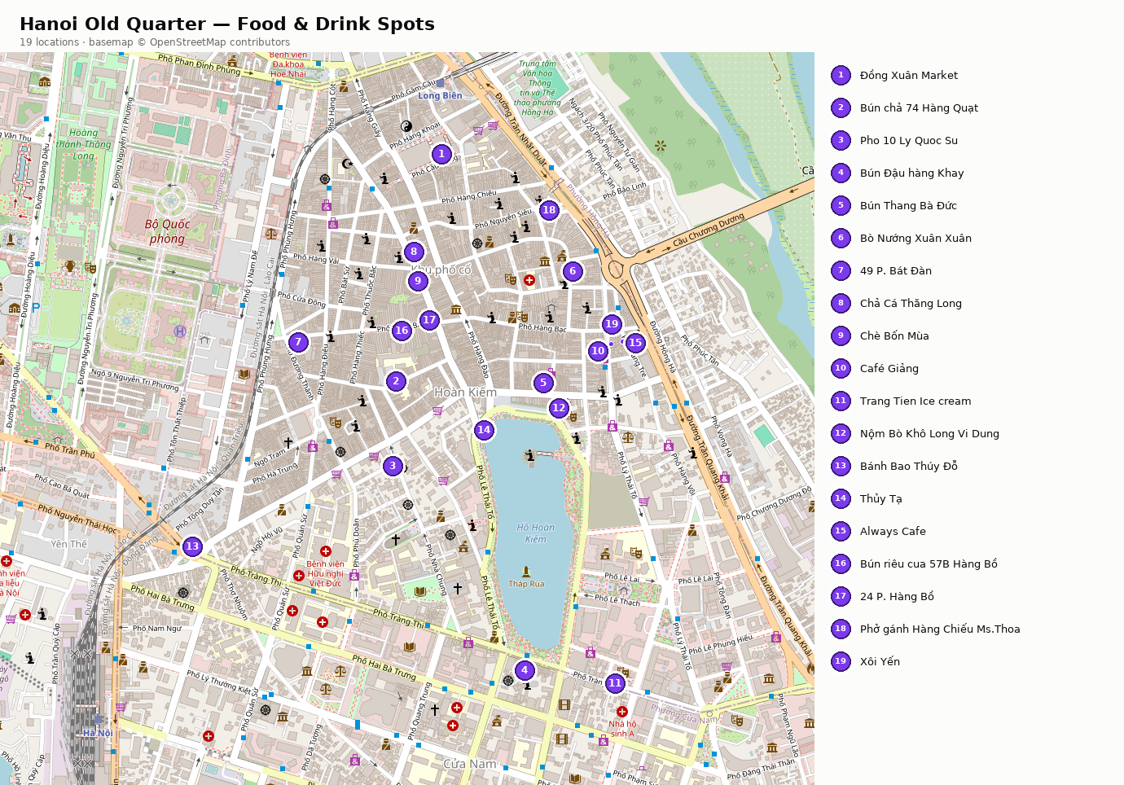
Planning an efficient walking route through a dense historic district is a problem every visitor to Hanoi's Old Quarter faces informally, and it is a clean real-world instance of the Travelling Salesman Problem (TSP): given a set of locations, find the order of visiting all of them exactly once, returning to the start, that minimises total travel distance (Applegate et al., 2006). This project frames a self-guided “food tour” of 19 well-reviewed food and drink stops - markets, “phở” and “bún” restaurants, cafés and dessert stalls - in Hanoi's Old Quarter as exactly this problem. The 19 stops were located using the Google Places API text-search endpoint (Google, n.d.), and the walking distance between every ordered pair of stops was retrieved from Project OSRM's public Table Service using the pedestrian (“foot”) routing profile (Project OSRM, n.d.), which itself routes over OpenStreetMap's street network (OpenStreetMap contributors, 2026). Using real, asymmetric walking distances rather than straight-line (haversine) distances matters here: the Old Quarter's one-way streets and pedestrian-only alleys mean the distance from stop A to stop B is not always the same as B to A, and a route that looks efficient “as the crow flies” can be markedly less efficient on foot.
With 19 stops, fixing a starting point (any rotation of the same loop is the same tour) leaves 18! - over 6.4 quadrillion - distinct possible orderings. Exhaustively checking everyone to guarantee the shortest tour is computationally infeasible on any realistic timescale, and the underlying decision problem is NP-hard in general (Applegate et al., 2006), so an exact algorithm does not scale even for a “small” 19-stop instance. This is exactly the situation local-search and metaheuristic techniques are designed for: rather than exploring the whole search space, they exploit the structure of good solutions to converge on a very good - though not provably optimal - tour in a fraction of a second.
Solving this well matters beyond the specific Hanoi dataset: the same closed-loop ordering problem underlies real delivery-route planning, warehouse picking, and any scenario where a fixed set of stops must be visited efficiently, so a working local-search solution to a small, human-interpretable version of the problem demonstrates the same technique that scales to those larger operational cases. This report solves the food-tour instance using two AI techniques from the unit's labs - Simulated Annealing and a Genetic Algorithm - implemented from scratch in Python, run under a controlled, repeated-trial experimental design, and compared on solution quality, consistency and runtime, ending in a recommendation of which technique is the better fit for this problem. The Methods section explains how each technique works in this problem's context; Implementation describes the data, environment and experimental results; Comparisons contrasts the two techniques directly; and Conclusions and Recommendations draws the final recommendation.

Report Body

Methods/AI techniques used

Problem representation
Both techniques operate on the same problem representation, which keeps the comparison fair. A state (candidate solution) is a complete tour: a permutation of the 19 stop indices, representing the order in which the stops are visited before returning to the first stop. This differs from classic path-finding search - the kind used for a road-map or maze-solving agent - where a state is a partial path from a start node built up one edge at a time towards a fixed goal node (Russell & Norvig, 2021). Here there is no single goal state to search towards: every complete permutation is a valid state, and the search problem is to find the minimum-cost permutation rather than a path to a destination. The cost function, shared by both algorithms, sums the real walking distance between each consecutive pair of stops in the tour, plus the distance of the closing edge back to the first stop - a closed loop, matching how a self-guided walking tour is actually used. An action, or move, is a small, local edit to a complete tour, and this is where the two techniques diverge: SA edits a single tour, GA combines two.

Simulated Annealing
Simulated Annealing (SA) is a single-solution local search technique inspired by the physical process of annealing metal, where a material is heated and then slowly cooled to reach a low-energy, stable structure (Kirkpatrick et al., 1983). SA keeps exactly one current tour. At each iteration it proposes a neighbour by swapping two randomly chosen stops in the tour - the simplest edit that can still reach any permutation given enough iterations - and evaluates its cost. The neighbour is always accepted if it improves the tour cost; if it is worse, it is still accepted with probability exp(−Δcost / T), where Δcost is the cost increase and T is the current temperature (the Metropolis acceptance criterion). This is what lets SA escape poor local optima early in the search, when T is high and almost any move is accepted, while behaving like a strictly-improving hill-climb late in the search, once T has cooled close to zero.
The temperature follows a geometric cooling schedule, T ← α·T, with α = 0.9995 applied once per iteration, starting from a value derived automatically from the initial random tour's average edge cost - rather than a fixed constant - so the schedule scales sensibly to the problem's actual distance units. The search stops when the temperature falls below a floor set at 0.01% of the starting temperature, or after a hard cap of 20,000 iterations, whichever comes first. These two settings - the cooling rate and the iteration cap - are the only parameters SA needs to be tuned, which is one of its practical attractions.

Genetic Algorithm
Where SA evolves a single candidate solution, a Genetic Algorithm (GA) evolves an entire population of candidate tours at once, drawing an analogy with natural selection: fitter individuals (shorter tours) are more likely to contribute to the next generation (Holland, 1992). The implementation starts from a population of 100 random tours. Each generation, parents are chosen by tournament selection - three individuals are sampled at random and the shortest tour among them wins - which favours good tours without requiring the population's costs to be converted into a probability distribution. Selected parents are combined using Order Crossover (OX1), applied with probability 0.9: a contiguous slice of stops is copied from one parent, and the remaining positions are filled with the other parent's stops in their original order, skipping any stop already placed. OX1 is used specifically because it always produces a valid permutation - a naive single-point crossover on two orderings would typically duplicate some stops and omit others (Goldberg & Lingle, 1985). Each offspring is then mutated with probability 0.02 by swapping two random stops, which maintains enough diversity in the population to avoid premature convergence. The best two individuals in each generation are carried over unchanged (elitism), guaranteeing the best tour found so far can never be lost. The search stops after 300 generations, or earlier if 50 consecutive generations pass with no improvement to the best tour.

Implementation of AI techniques

Data collection and pre-processing
The 19 stops were selected by hand from well-reviewed food and drink venues across the Old Quarter (https://vinpearl.com/vi/food-tour-ha-noi) and located with the Google Places API's text-search endpoint, one query per venue (e.g. “Phở 10 Lý Quốc Sư, 10 Lý Quốc Sư, Hoàn Kiếm, Hà Nội”), storing the returned name, latitude and longitude in `locations.csv` alongside the exact query used, for traceability. A couple of the returned place names included long marketing descriptions after a “ - ” separator (e.g. “Always Cafe - A magical wizard cafe”); these are shortened to the short venue name wherever a stop is displayed, without altering the underlying coordinates used for distance calculations.
A single request to Project OSRM's public Table Service, using the pedestrian (“foot”) routing profile and all 19 coordinates, returned the full 19×19 matrix of real walking distances in metres in one call. This matrix, together with metadata recording the fetch timestamp, source URL and routing profile, was cached to `data/distance_matrix.csv` and `data/distance_matrix_meta.json`, so every later experiment reads a fixed, reproducible distance matrix rather than making repeated network calls. Had OSRM returned no walkable route for a particular pair of stops, the implementation falls back to straight-line (haversine) distance for that pair only, logging a warning rather than failing the whole build - in this dataset that fallback was never triggered, since OSRM was able to route every one of the 19 × 18 ordered pairs.
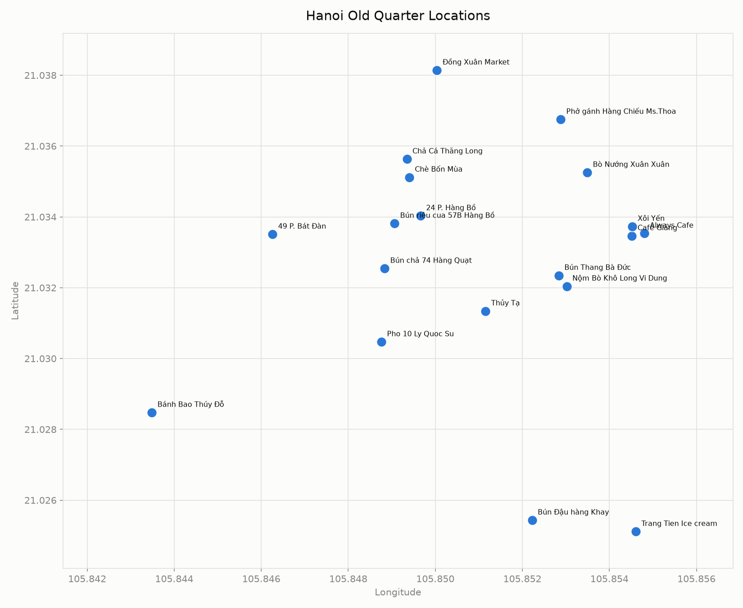
Figure 1. The 19 Hanoi Old Quarter food-tour stops, plotted by geocoded coordinate before any route optimisation.

Software environment
The project is implemented in Python 3.13, managed with the uv package/environment manager, and organised as a small internal package (`tsp/`) with one module per concern: `problem.py` (the `TSPProblem` class and cost function), `simulated_annealing.py`, `genetic_algorithm.py`, `compare.py` (running repeated trials and aggregating statistics) and `visualize.py` (plots). Its runtime dependencies are `requests` (for the OSRM API calls), `matplotlib` and `staticmap` (for the plots and the real-basemap route map). No machine-learning framework is required, since both techniques are implemented directly from their algorithmic definitions rather than via a library.

The notebook submitted for this assignment focuses specifically on algorithm implementation, comparison, and validation. Because it is required to run standalone in Google Colab, the SA and GA implementations are reproduced inline in the notebook rather than imported from the `tsp` package, though the logic is identical; it reads the pre-computed distance matrix directly, so it assumes the data-collection and pre-processing scripts (`data_collection/`) have already been run to produce the cached data files it depends on. The full modular codebase - the `tsp/` package, the pytest test suite, and the data-collection scripts - is published on GitHub at https://github.com/EthAnHoangg/IAI-ass1.

Experimental setup
Because both SA and GA rely on randomness - the initial tour, the neighbour swaps, the crossover points, the mutations - a single run of either algorithm is not a reliable measure of its performance: a lucky or unlucky random seed could make either technique look better than it typically is. Each algorithm was therefore run 10 times on the 19-stop problem, each run seeded independently (seeds 42–51), using the default parameters summarised in Table 1 and Table 2. For each run, the best tour found, its cost, the number of iterations/generations used, and the wall-clock runtime were recorded, and the ten runs' cost-so-far histories were averaged to produce a fair convergence comparison. SA's iteration count and GA's generation count are on different scales, so both are expressed on a common x-axis of cost evaluations - one per SA iteration, 100 (the population size) per GA generation.
Table 1. Simulated Annealing - key parameters used.
Parameter | Value | Purpose
alpha (cooling rate) | 0.9995 | Controls how fast the temperature decays each iteration.
min_temperature_fraction | 0.0001 (0.01% of start) | Sets the temperature floor as a fraction of the starting temperature, so the schedule scales to the problem's own distance units.
max_iterations | 20,000 | Hard cap so a single run always terminates quickly.

Table 2. Genetic Algorithm - key parameters used.
Parameter | Value | Purpose
population_size | 100 | Population diversity across 19-stop tours without making each generation too slow to evaluate.
tournament_size | 3 | Moderate selection pressure - favours good tours while still giving weaker ones an occasional chance.
crossover_rate | 0.9 | Crossover happens on almost every offspring; it is the main way good sub-tours from two parents get combined.
mutation_rate | 0.02 | Deliberately low - mutation exists to maintain diversity, not to be the primary search mechanism.
elite_count | 2 | Guarantees the best-known tour is never lost to selection or crossover, without letting elitism dominate.
max_generations / no_improvement_stop | 300 / 50 | A generation cap, plus an early stop after 50 generations with no improvement, to avoid wasted computation.

Results
Table 3 summarises the outcome of the 10 trials for each algorithm on the 19-stop Hanoi dataset.
Table 3. Comparison summary over 10 trials per algorithm (19-stop Hanoi Old Quarter instance).
Algorithm | Best cost (m) | Mean cost (m) | Std dev (m) | Mean runtime (s) | Mean evaluations to best
Simulated Annealing | 8,742.3 | 9,708.8 | 624.7 | 0.124 | 4,932.6
Genetic Algorithm | 8,742.3 | 10,224.8 | 568.5 | 0.147 | 3,300.0

Both algorithms found a tour of identical best cost, 8,742.3 m, at least once across their 10 trials - Figure 3 shows this winning route, walked as an actual OSRM path over an OpenStreetMap basemap of the Old Quarter, in the order the stops are visited. Figure 2 shows the mean best-cost-so-far curve for both algorithms, plotted against cost evaluations: both improve rapidly over the first ~2,000 evaluations, after which the Genetic Algorithm's curve flattens earlier (its early-stopping condition typically triggers well before its 300-generation cap), while Simulated Annealing continues making small improvements for longer before settling close to its own best cost.
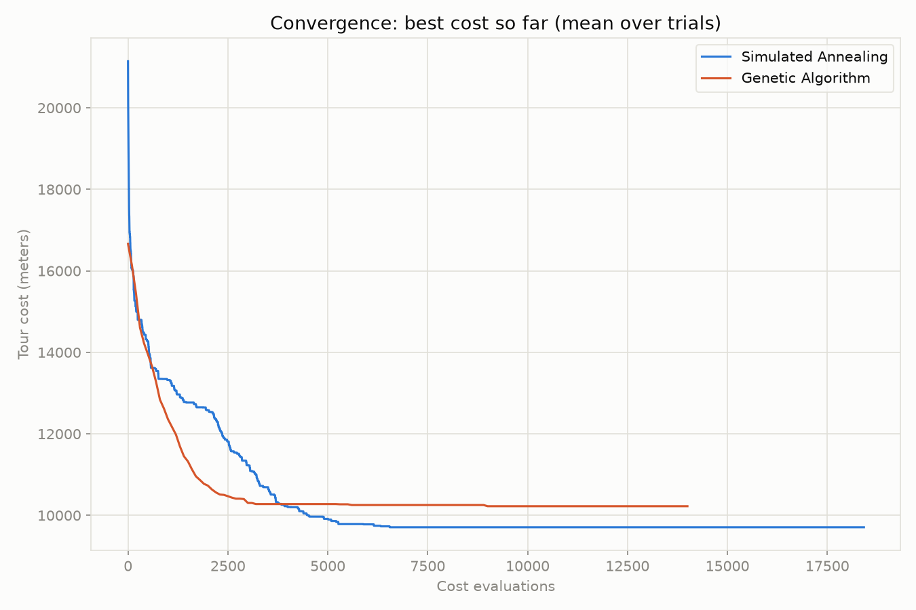
Figure 2. Mean best-cost-so-far convergence for Simulated Annealing and the Genetic Algorithm, averaged over 10 trials each, plotted against cost evaluations.
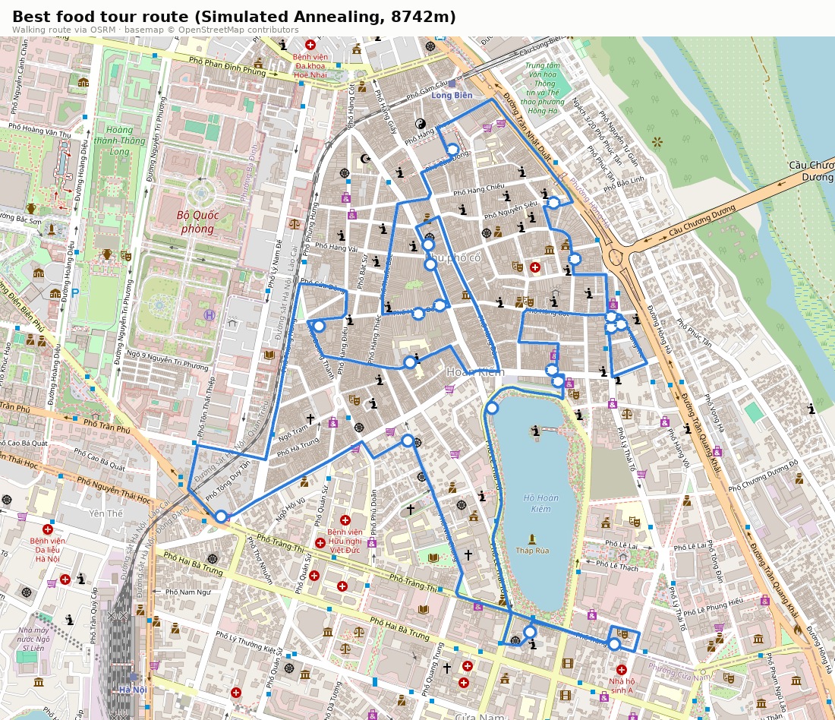
Figure 3. Best tour found (Simulated Annealing, 8,742 m), rendered along real OSRM walking paths over an OpenStreetMap basemap of Hanoi's Old Quarter, numbered in visiting order.

Solution quality assurance
Correctness of the implementation itself was validated with a 46-test automated pytest suite (`tests/`), covering the distance-matrix loader and tour-cost function, the SA neighbour-move and acceptance logic, the GA's order-crossover (checking that every child is always a valid permutation with no duplicate or missing stops) and mutation operators, and the end-to-end comparison pipeline; all 46 tests pass. As a further check of general applicability rather than dataset-specific tuning, both algorithms - with no code or parameter changes - were also run 10 times each on an unrelated, randomly generated 15-stop instance using straight-line distance (Appendix B). The same pattern held, with an even larger consistency gap between the two techniques (SA standard deviation 78.8 m vs. GA 454.3 m), supporting that the comparison's conclusions are a property of the two search strategies rather than an artefact of this particular 19-stop dataset.

Comparisons of different AI techniques
On the primary evaluation measures - solution quality, consistency, and computational efficiency - the two techniques are evenly matched on the easiest measure and clearly differentiated on the harder ones. Best-case solution quality is identical: both algorithms reached the same 8,742.3 m tour at least once in 10 trials (Table 3), so neither has an advantage in raw optimisation power at this problem size (19 stops). Typical-case solution quality favours Simulated Annealing: its mean cost across trials (9,708.8 m, 11.1% above the shared best) was lower than the Genetic Algorithm's (10,224.8 m, 17.0% above the shared best), meaning a single “average” SA run is a noticeably better solution than a single “average” GA run.
Consistency is a genuine trade-off, not a clean win for one side, on the 19-stop dataset alone: SA's standard deviation (624.7 m) was slightly higher than GA's (568.5 m), so GA's outcomes cluster a little more tightly - but around a worse typical value. On the 15-stop generalisation instance (Appendix B), however, this trade-off disappears and SA is unambiguously more consistent (standard deviation 78.8 m vs. 454.3 m), suggesting SA's reliability advantage strengthens, rather than weakens, on a fresh, untuned instance.
Computational efficiency also favours Simulated Annealing in wall-clock terms: its mean runtime per trial (0.124 s) was around 16% faster than the Genetic Algorithm's (0.147 s), even though GA reached its own trial-best using fewer total cost evaluations on average (3,300 vs. SA's 4,932.6). This apparent contradiction is explained by per-step overhead: each SA iteration does one cheap operation (swap two stops, evaluate one cost), whereas each GA generation must rank the whole population, run tournament selection and crossover repeatedly, and evaluate 100 tours - bookkeeping that costs more real time per generation than its raw evaluation count suggests, in a pure-Python implementation without vectorisation.
Finally, the two techniques differ in how much they need to be configured, and in how well that balance is likely to hold as the problem scales. SA has two parameters to tune (the cooling rate α and the iteration cap); GA has six (population size, tournament size, crossover rate, mutation rate, elite count, and the generation/early-stop caps), each interacting with the others - a larger surface to get right. Set against that, GA's population-based search does carry a genuine structural advantage that this 19-stop problem is too small to expose: because it evaluates many candidate tours in parallel every generation, it is naturally more parallelisable and explores more of the search space early on, which is more likely to matter as the number of stops - and therefore the size and ruggedness of the search space - grows well beyond 19.

Conclusions and Recommendations
This project set out to solve a real, if small-scale, optimisation problem - the shortest walking order for a 19-stop Hanoi Old Quarter food tour - using two AI techniques from the unit's labs, and to compare and recommend between them. Both Simulated Annealing and a Genetic Algorithm are genuinely working solutions: implemented independently, validated by an automated test suite, and each capable of finding the same best-known 8,742.3 m tour across repeated trials. The evidence from 10 repeated trials on the Hanoi dataset, and a second independent 15-stop instance, points to a consistent finding: the two techniques are equally capable of finding a near-optimal tour when given several attempts, but Simulated Annealing is the more dependable technique at this problem size - better average solution quality, a faster wall-clock runtime, and, on the generalisation test, a substantially tighter spread of outcomes.
On that basis, this report recommends Simulated Annealing as the better-suited technique for a single closed-loop tour of around 15–20 stops such as this one. Its simplicity is also a practical advantage outside of pure performance: with only two parameters to tune, it is quicker to configure correctly and easier to reason about than the Genetic Algorithm's six interacting hyperparameters, which matters for a self-contained tool intended to be reused on a different set of stops without re-tuning.
This recommendation is scoped to problems of this size and structure, and should not be read as a general claim that SA outperforms GA on TSP-style problems as a rule. The Genetic Algorithm's core advantage - evaluating a diverse population of candidate solutions in parallel each generation - is a structural strength that a 19-stop instance is simply too small to exercise; on substantially larger instances, where the search space is far more rugged and single-solution local search is more prone to getting trapped, a well-tuned GA (or a hybrid that combines GA's population diversity with a stronger local-search operator such as 2-opt) would be a reasonable next technique to evaluate. A natural extension of this project would therefore be to re-run the same comparison on a larger instance - 50 or 100 stops, for example - to test whether the recommendation made here still holds at that scale.

List of References
Applegate, D. L., Bixby, R. E., Chvátal, V., & Cook, W. J. (2006). The traveling salesman problem: A computational study. Princeton University Press.
Goldberg, D. E., & Lingle, R. (1985). Alleles, loci, and the traveling salesman problem. In J. J. Grefenstette (Ed.), Proceedings of the First International Conference on Genetic Algorithms and Their Applications (pp. 154–159). Lawrence Erlbaum Associates.
Google. (n.d.). Places API (New) overview. Google for Developers. Retrieved September 5, 2026, from https://developers.google.com/maps/documentation/places/web-service/overview
Holland, J. H. (1992). Adaptation in natural and artificial systems: An introductory analysis with applications to biology, control, and artificial intelligence. MIT Press. (Original work published 1975)
Kirkpatrick, S., Gelatt, C. D., & Vecchi, M. P. (1983). Optimization by simulated annealing. Science, 220(4598), 671–680. https://doi.org/10.1126/science.220.4598.671
OpenStreetMap contributors. (2026). OpenStreetMap [Map data]. Retrieved September 5, 2026, from https://www.openstreetmap.org
Project OSRM. (n.d.). OSRM API documentation. Retrieved September 5, 2026, from http://project-osrm.org/docs/v5.24.0/api/
Russell, S., & Norvig, P. (2021). Artificial intelligence: A modern approach (4th ed.). Pearson.

Appendices

Appendix A: Full list of food-tour stops
Table A1 lists all 19 stops used in the main Hanoi Old Quarter problem instance, in the order they appear in `locations.csv` (not visiting order).
Table A1. The 19 Hanoi Old Quarter food-tour stops.
# | Stop name | Latitude | Longitude
1 | Đồng Xuân Market | 21.03814 | 105.85004
2 | Bún chả 74 Hàng Quạt | 21.03254 | 105.84884
3 | Pho 10 Ly Quoc Su | 21.03047 | 105.84876
4 | Bún Đậu hàng Khay | 21.02543 | 105.85222
5 | Bún Thang Bà Đức | 21.03235 | 105.85284
6 | Bò Nướng Xuân Xuân | 21.03526 | 105.85349
7 | 49 P. Bát Đàn | 21.03351 | 105.84626
8 | Chả Cá Thăng Long | 21.03563 | 105.84935
9 | Chè Bốn Mùa | 21.03512 | 105.84940
10 | Café Giảng | 21.03347 | 105.85452
11 | Trang Tien Ice cream | 21.02511 | 105.85461
12 | Nộm Bò Khô Long Vi Dung | 21.03204 | 105.85302
13 | Bánh Bao Thúy Đỗ | 21.02848 | 105.84349
14 | Thủy Tạ | 21.03134 | 105.85115
15 | Always Cafe | 21.03354 | 105.85480
16 | Bún riêu cua 57B Hàng Bồ | 21.03382 | 105.84906
17 | 24 P. Hàng Bồ | 21.03403 | 105.84966
18 | Phở gánh Hàng Chiếu Ms.Thoa | 21.03675 | 105.85288
19 | Xôi Yến | 21.03373 | 105.85452

Appendix B: Generalisation test on unseen data
To check that the implementation is a genuine general-purpose TSP solver rather than something tuned to the specific Hanoi dataset, both algorithms - with no code or parameter changes - were also run 10 times each on a second, independent problem instance: 15 randomly scattered points in the same approximate area, using straight-line (haversine) distance instead of an OSRM query (seeds 100–109). Table B1 summarises the result; the pattern from the main 19-stop comparison (Table 3) holds, with the consistency gap between the two techniques even more pronounced.
Table B1. Comparison summary over 10 trials per algorithm on an independent, randomly generated 15-stop instance.
Algorithm | Best cost (m) | Mean cost (m) | Std dev (m)
Simulated Annealing | 7,204.5 | 7,256.1 | 78.8
Genetic Algorithm | 7,204.5 | 7,557.1 | 454.3

Appendix C: Core algorithm code excerpts
The following excerpts from `tsp/simulated_annealing.py` and `tsp/genetic_algorithm.py` show the acceptance/cooling step and the Order Crossover (OX1) operator referenced in the Methods section. The complete implementation - every module plus the 46-test pytest suite described in Solution quality assurance - is available in full on GitHub: https://github.com/EthAnHoangg/IAI-ass1.
# tsp/simulated_annealing.py - acceptance + cooling step
candidate = swap_neighbor(current, rng)
candidate_cost = problem.tour_cost(candidate)
delta = candidate_cost - current_cost
if delta <= 0 or rng.random() < math.exp(-delta / temperature):
current, current_cost = candidate, candidate_cost
if current_cost < best_cost:
best, best_cost = current, current_cost
temperature *= config.alpha

# tsp/genetic_algorithm.py - Order Crossover (OX1)
def order_crossover(parent_a, parent_b, rng):
n = len(parent_a)
i, j = sorted(rng.sample(range(n), 2))
child = [None] * n
child[i:j + 1] = parent_a[i:j + 1]
fill_values = [c for c in parent_b if c not in child]
pos = 0
for k in range(n):
if child[k] is None:
child[k] = fill_values[pos]
pos += 1
return child

Individual reflection
Working on this assignment, the first real decision was not algorithmic but one of scope: choosing a Travelling-Salesman-style local-search problem over a navigational path-finding one, and picking a concrete, personally meaningful scenario - a self-guided food tour of the kind of stops I actually enjoy in Hanoi's Old Quarter - rather than an abstract dataset. That choice made every later decision easier to reason about, because I could sanity-check the algorithms' output against a route I could genuinely imagine walking, not just a number going down.
The biggest technical decision was using real walking distances from OSRM's routing API instead of straight-line (haversine) distance between coordinates. It would have been simpler to stick with haversine, but the Old Quarter's dense one-way streets and pedestrian alleys make straight-line distance a poor proxy for how “close” two stops actually are on foot, and I wanted the optimisation to be solving the problem people actually face, not a simplified stand-in for it. That decision had a downstream cost: it meant caching a distance matrix up front and handling the case where OSRM couldn't find a route between a pair of stops, rather than being able to compute any distance on the fly.
I also ran into and fixed a genuine issue along the way: an early version of the geocoding script had a live Google Maps API key hardcoded directly in the file. Catching this before it reached a public repository - and switching to reading the key from an environment variable with a `.env.example` template - was a useful, if slightly uncomfortable, reminder that “quick throwaway script” code still needs the same basic security hygiene as anything else, especially the moment it touches an API key.
Structuring the algorithms as a small, tested Python package rather than notebook-only code before writing the report was a deliberate choice, and one I would repeat: writing a 46-test suite against `tsp/` caught a handful of subtle bugs early - a permutation-validity edge case in the order-crossover operator, in particular - that would have been much harder to notice by eye in aggregate cost numbers alone. Working from a written design spec before writing any code also meant fewer “wait, what were we even trying to do” moments partway through implementation.
If I were to extend this project, the clearest next step is testing both algorithms on a meaningfully larger instance - 50 or 100 stops - since the 19-stop Hanoi dataset, while realistic, is small enough that both algorithms comfortably find a near-optimal tour; a larger instance would be a fairer test of where the Genetic Algorithm's population-based exploration might start to pay off relative to Simulated Annealing's simplicity. The main lesson I am taking from this task is a fairly general one: spending time up front on a real, well-sourced dataset and a tested implementation paid for itself many times over once it came to writing the comparison and drawing a defensible recommendation.

