**Instructions for creating a desktop application to store Arduino data in Excel files:**

Prerequisites: Windows OS with [Visual Studio Community](https://visualstudio.microsoft.com/vs/community/) installed (make sure you have ‘.NET desktop development’ selected in the installer), and [Arduino](https://www.arduino.cc/en/software)* installed (optionally Visual Micro, see [debugging](https://docs.google.com/document/d/1QkrkIZ-MU8yB-zQCiiEAo70gQaDHsIA4mv2YUWBunoY/edit#heading=h.hoe020vwufaj) section).

* If you don’t want to view/modify code, you don’t really need to install Visual Studio. After unzipping from step 1 below, you can just run the EXE directly which is located at B_B_C_A -> bin -> Debug.

* DO NOT install Arduino using Windows App Store, just download the regular Windows installer (or ZIP) and 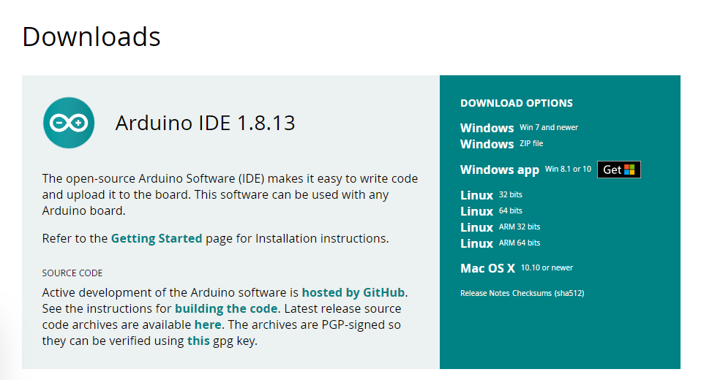

1. Go to <https://github.com/semoyerVT/electronicsGuide> and download the ‘Bare Bones’ folders, one has the full Visual Studio solution, and the other the Arduino code (‘MCU’).

2. Once unzipped, double click the solution file (.sln) in the App folder and it should open up in Visual Studio (or go to Visual Studio, and open that solution that way).

3. Upload the Arduino code to your compatible board (don’t forget to set your board and COM port in the Tools menu).

5. Connect USB to the PC and your Arduino. For a quick test, open the Arduino IDE Serial Monitor to see the data stream (it’s just random data every 2 seconds).

6. Start the App in Visual Studio (defaults to Debug mode, which is fine). Follow instructions shown on the window for use (pick COM port, open port, optionally set file path and log to Excel).