|  |  |
| --- | --- |
|  | Ethan  Biekert Web Designer | Software Engineer |
| CONTACT **+1 (610) 310-0122**  [biekertfreelance@gmail.com](mailto:biekertfreelance@gmail.com) Communication **I have received several commendations from customers on my helpful service and the quality of my work.** Leadership I have a history of roles in a high pace environment bringing me experience with taking charge and communicating. I have a history of training new hires after gaining experience in certain positions. | **Exeter Township Senior High School | Reading PA** 2022– Present  Relevant Course Work   * Computer Science * (H) Algebra II * Electronics * Literature * Biology * (H) Geometry   Silver Eagle - Award for Academic performance  Lights Technician for School Play & Musical  TSA (Technology Student Association)  Clubs  Awards **Berks Career and Technology Center | Leesport PA** 2023 - Present  Relevant Course Work   * Information Technology * Programing in a variety of languages * Cyber Security * Microsoft 365 * Web design |

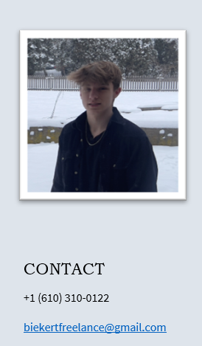

## Experience

**Crew Member and CSR**

*November 2023 | Present*

I take pizza orders over the phone and in person, as well as make subs, sandwiches, salads, and individual pizza slices. I build pizza boxes, restock the fridge, and refill food ingredients. I clean and close the store often, as well as bus tables when we get busy.

**Car Audio Installation Technician & Website Manager (Apprentice)**

*April 2022 | November 2023*

### My duties include but are not limited to: Managing Inventory, Car Audio Installation, Website Development, Sales, Customer Service, Social Media Management

### **Landscaper | School House Landscaping LLC**

*July 2021 | August 2022*

Assigned Multiple lawns to complete, which include mowing, mulching, trimming, weeding, edging, landscaping.

## Certifications

* **Cyber Security** (Carrersafeonline.org)
* Lawn Care
* Computer Science
* Communication And Leadership
* Git
* Linux
* Web Development
* HTML5/CSS3/JS
* C++
* Visual Studio GUI Development
* Visual Basic
* Visual Studio
* Microsoft 365 Products
* Culinary Experience
* Casual Dining Experience

## Skills

* **English** (Fluent, Birth Language)
* **Japanese** (Proficient in basic verbal conversations and Reading/Writing Hiragana)

peerless-performance.com

A website I built and manage for the sale of a large variety of ecommerce and brick and mortar merchandise.

Ethan-BCTC.github.io/ResumeWebsite/Home.html

My website with a more detailed interactive resume

## Links

**Proof of authorization to work in the United States for any employer available upon request.**

## Languages