Ethan Hess, Ethan Kidd, Preston Little, Ryan Carbine
The Backlog Blackhole
Motorminder
Base Line

Table of Contents
Project Description 2
Software Requirement Specification 2
Functional Requirements 2
Non-Functional Requirements 3
Adress to Customer Feedback 4
Design 5
Design Patterns 5
Model-View-Controller (MVC) 5
Singleton Pattern 5
Command Pattern 6
Additional Patterns and Principles 6
Architecture Diagram 6
Use Case Diagram 7
Class Diagram 8
Testing and QA 8
Testing Plan 8
Testing Objectives 8
Types of Testing 9
Test Environment 10
Defect Tracking 10
Bug Report 10
Test Cases 11
Quality Assessment 11
Design Metric 11
Testing Metric 11
QA Metric 11
Process Metric 12
Maintenance Metric 12
README 12

Project Description
This project proposes the development of a car maintenance tracking and recommendation application designed to help vehicle owners better understand, manage, and maintain their vehicles' health. A lot of drivers have a hard time keeping track of routine maintenance, like oil changes, tire rotations, inspections, etc. This can lead to unnecessary repairs, wasted money, and reduced vehicle lifespan. This application aims to consolidate vehicle information to give the user valuable maintenance recommendations based on vehicle condition data.

Software Requirement Specification

Functional Requirements
All maintenance services in the system are predefined and configurable through the service_intervals.json file. The system does not dynamically generate new service types at runtime.
Maintenance Status Definitions:
- OK: The service is within acceptable limits and does not require attention.
- Due Soon: The service has reached the minimum threshold (mileage or time) and should be scheduled soon.
- Overdue: The service has exceeded the maximum threshold and requires immediate attention.
FR1: Mileage Input
- FR1.1: The system shall allow users to input current vehicle milage as a positive integer.
- FR1.2: The system shall validate that mileage input is numeric and greater than zero.
- FR1.3: The system shall prevent mileage entries less than previously recorded mileage.
- FR1.4: The system shall display vehicle information after the mileage has been updated.
FR2: Maintenance Item Management
- FR2.1: The system shall store at least 10 standard maintenance items with their recommended service intervals.
- FR2.2: The system shall allow users to record the mileage at which each maintenance item was last performed.
- FR2.3: The system shall calculate the next due mileage for each maintenance item based on last service mileage + service interval.
FR3: Maintenance Recommendations
- FR3.1: The system shall display all maintenance items that are overdue (current mileage >= next due mileage).
- FR3.2: The system shall display maintenance items due within 1,000 miles of current mileage.
- FR3.3: The system shall categorize recommendations as “Overdue”, “Due Soon”, or “OK”.
FR4: Service History
- FR4.1: The system shall allow users to mark maintenance items as completed with date and mileage.
- FR4.2: The system shall maintain a history of all completed maintenance with timestamps.
- FR4.3: The system shall check that dates follow the required YYYY-MM-DD format and reject invalid entries. It also prevents future dates from being entered.
FR5: Multiple Vehicles
- FR5.1: The system shall allow users to add up to *4* vehicles to their account.
- FR5.2: The system shall prevent users from adding more than 4 vehicles and display an error message when the limit is reached.
- FR5.3: The system shall require each vehicle to have a unique identifier (e.g., nickname or license plate) within a user’s account.
- FR5.4: The system shall display a list of all vehicles showing vehicle name and current maintenance status for each.
- FR5.5: The system shall allow users to select a specific vehicle to view detailed maintenance recommendations.
FR5: Multiple Vehicles
- FR6.1: The system shall retrieve the user’s current location via their address when the mechanic finder feature is accessed.
- FR6.2: The system shall display mechanic finder results only when a vehicle has one or more maintenance items categorized as “Overdue” or “Due Soon”.
- FR6.3: The system shall display each mechanic result with the following information: business name, address, and phone number if available.

Non-Functional Requirements
The system shall maintain consistent performance, with CLI response times under 1 second for standard operations (e.g., loading vehicles, displaying recommendations) under normal usage conditions.
The system shall be maintainable through a modular architecture using the Model-View-Controller (MVC) pattern, allowing developers to modify or extend components (e.g., adding new services or data sources) without affecting unrelated parts of the system.
NFR1: Performance
- NFR1.1: The system shall calculate and display maintenance recommendations within 2 seconds of milage input.
- NFR1.2: The system shall support at least 100 concurrent users without degradation.
NFR2: Usability
- NFR2.1: The system shall be accessible via standard web browsers (Chrome, Firefox, Safari, Edge).
- NFR2.2: Users shall be able to input mileage and view recommendations in 3 clicks or less from the home page.
- NFR2.3: The system shall display error messages that clearly indicate the problem and solution.
NFR3: Reliability
- NFR3.1: The system shall have 99% uptime during business hours (8AM – 8PM).
- NFR3.2: User data shall be persisted and survive the system restarts without loss.
NFR4: Security
- NFR4.1: User accounts require authentication before accessing vehicle data.
- NFR4.2: Passwords shall be encrypted using industry-standard hashing algorithm.
NFR5: Maintainability
- NFR5.1: The system shall use a modular architecture allowing individual component updates.
- NFR5.2: Code shall include inline comments for complex business logic sections.

Adress to Customer Feedback
- Feedback: “There isn’t input validation. For example, if I entered ‘Year: abc’ the program crashes. Or if I type ‘Select vehicle index: 999’ sometimes it handles it and sometimes it doesn’t.”
  - Solution: We improved input validation throughout the CLI to prevent crashes by invalid user input. Validation was added for numeric fields such as vehicle year, mileage, and vehicle index selection. The system now catches invalid data types and out-of-range values, displays user-friendly warning messages, and reprompts the user until valid input is entered. This makes the application more stable and improves usability for first-time users. FR1.2 was updated to cover this. A function called get_valid_vehicle_index was added in cli.py to correct this issue.
- Feedback: “The mileage logic isn’t explained. In the dashboard, I see ‘OK’, ‘Due Soon’, and ‘Overdue’ but I don’t know what the threshold is, what ‘soon’ means, or what rule triggered it.”
  - Solution: We improved the dashboard by adding a status legend to explain what each maintenance label means. The dashboard now communicates that “OK” means the service is within the recommended interval, “Due Soon” means the service is approaching its limit, and “Overdue” means the mileage threshold has been exceeded. This makes the maintenance recommendations easier to understand and gives users more confidence in the system’s outputs. FR3 was updated to cover this. See the added section in the function maintenance_dashboard in the class cli.py.
- Feedback: “When I edit mileage or make it say “updated” I don’t see the new full vehicle details. I’d expect it to reprint the updated vehicle.”
  - Solution: We updated the edit workflow so that after the user finishes making changes and exits the edit menu, the application reprints the full updated vehicle record. This gives immediate confirmation that the requested changes were successfully applied and improves transparency in the editing process. FR1.4 was added to cover this. See the added section in the function edit_vehicle in the class cli.py.
- Feedback: “Logging a service doesn’t validate the date. If I enter ‘Service data: banana’ it’ll likely break when parsed later.”
  - Solution: We added validation for service date input when logging maintenance. The system now checks that dates follow the required YYYY-MM-DD format and rejects invalid entries. It also prevents future dates from being entered. If the input is invalid, the user receives a clear error message and is prompted to try again. This prevents malformed data from being stored and reduces the likelihood of errors later in the application. FR4.3 was added to cover this. A function called get_valid_date was added in cli.py to correct this issue.

Design

Design Patterns
MotorMinder is a Python-based CLI application for vehicle maintenance tracking. The project is architected to ensure scalability, maintainability, and clear separation of concerns. This documentation summarizes the design patterns incorporated into the project.
Although MotorMinder uses a CLI rather than a graphical interface, it still follows the MVC pattern:
- The CLI acts as the View, handling user input and output
- The Controller processes user commands and coordinates system behavior
- The Model manages data and business logic
The Controller functions as an adapter between the CLI and the data/model layer, ensuring that user actions are correctly translated into system operations and responses.

Model-View-Controller (MVC)
- Model: Handles data logic and persistence (models.py, data_handler.py).
- View: Manages CLI formatting and user output (view.py).
- Controller: Bridges user actions and model updates (controller.py).
- CLI: Entry point for user interaction (cli.py).
Benefit: Promotes separation of concerns, easier maintenance, and scalability.

Singleton Pattern
- Where: DataHandler class in data_handler.py.
- How: Uses a class-level _instance and custom __new__ method to ensure only one instance exists for data management.
Benefit: Centralizes data access and persistence, prevents conflicting data states.

Command Pattern
- Where: CLI class in cli.py.
- How: Maps user menu selections to method calls, acting as a command dispatcher.
Benefit: Simplifies user input handling, makes adding new commands straightforward.

Additional Patterns and Principles
Dataclass/Value Object: ServiceRecord, Vehicle, and ServiceStatus use Python's @dataclass for clean, immutable data structures.
Adapter (Implicit): The Controller adapts between CLI and model/data layers.
Enum Usage: ServiceName enum for type-safe service names.
Composition: Controller composes a DataHandler instance.

Architecture Diagram
This diagram follows the C4 Model for software architecture, representing the highest level of abstraction. It illustrates how the MotorMinder application interacts with the user and the local environment.
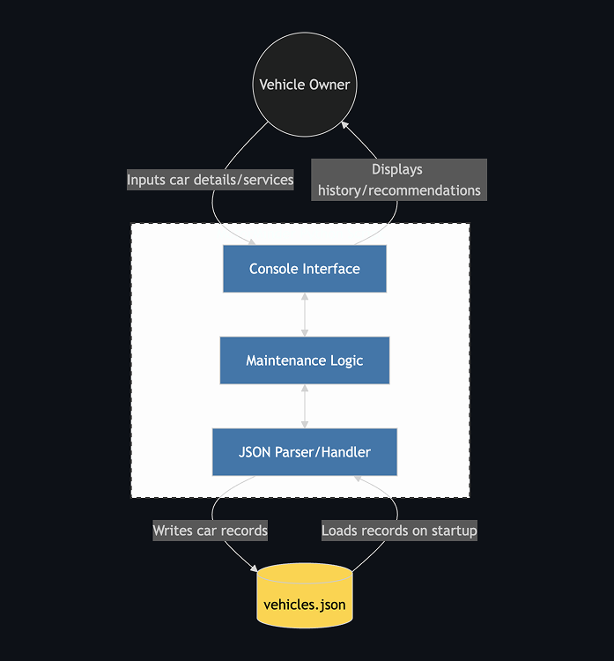
For the Minimum Viable Product (MVP), the system is implemented as a Console-Based Python Application. To ensure simplicity and portability during initial development, the system relies on local JSON persistence rather than external database servers or cloud APIs.

Use Case Diagram
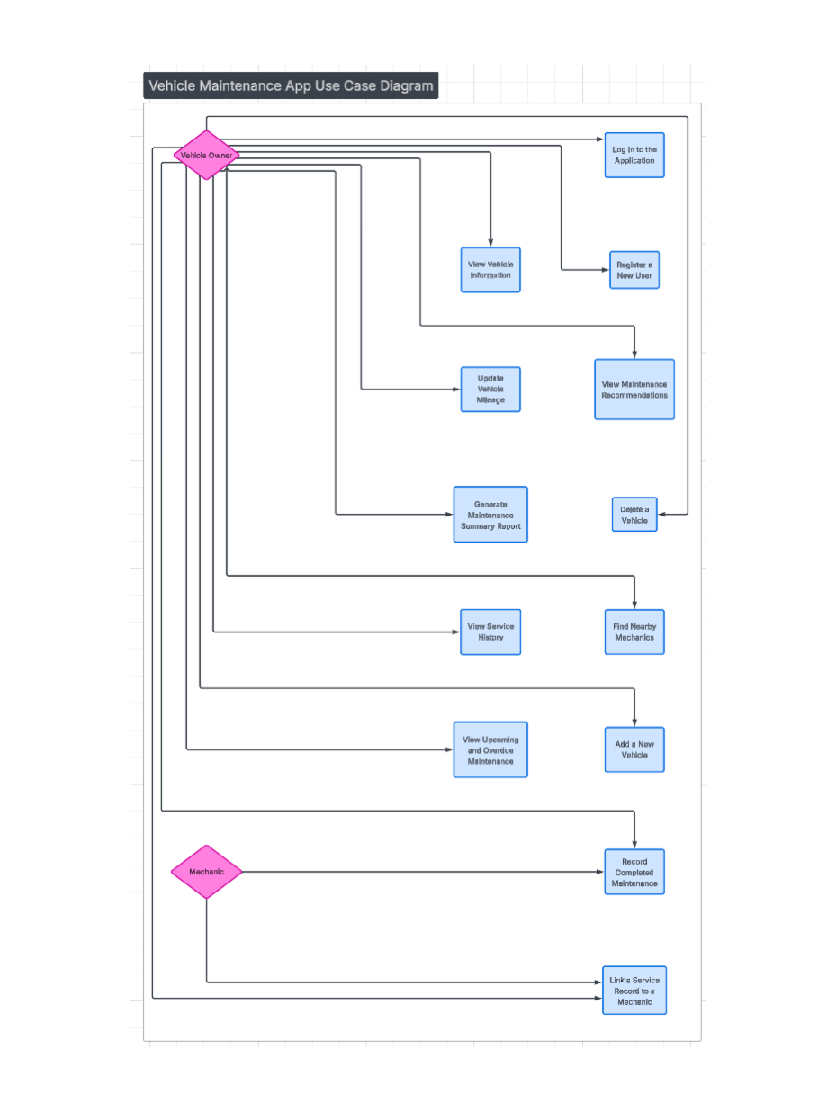
This diagram shows how the two different users (vehicle owner and mechanic) interact with the system, including actions such as adding vehicles, logging services, and viewing maintenance recommendations.

Class Diagram
This diagram represents the relationships between core classes such as Vehicle, Service, and DataManager, and InteractionController including their attributes and methods.
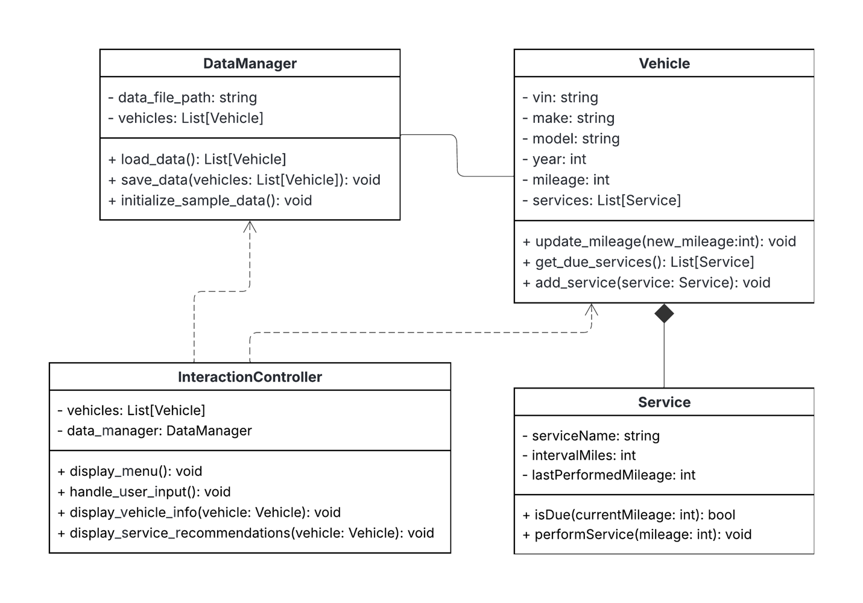

Testing and QA

Testing Plan
Testing in Sprint 1 focuses on validating the core functionality of the MVP, including data handling, vehicle and service logic, and basic user interaction through the terminal-based prototype. Because the system uses simulated vehicle data, testing is limited to logical correctness rather than real-world accuracy.

Testing Objectives
- Verify vehicle data is correctly loaded, stored, and persisted in JSON format
- Ensure maintenance service status (OK, Due Soon, Overdue, Missing) is calculated accurately based on mileage and date rules from service_intervals.json
- Validate user interaction flows through the CLI menu and vehicle management operations
- Identify and document defects early in development

Test Framework & Automation
The project uses Python's unittest framework with unittest.mock for mocking and isolation. All tests are automated and can be run via python -m unittest discover from the src/tests directory.

Types of Testing

Unit Testing
- test_models.py (4 tests): Vehicle and ServiceRecord serialization/deserialization
  - ServiceRecord.to_dict() and from_dict()
  - Vehicle.to_dict() and from_dict() with multiple service records
  - Test Cases #21-24
- test_data_handler.py (7 tests): DataHandler JSON persistence and CRUD
  - Loading and saving vehicle data
  - Adding, updating, and deleting vehicles
  - Logging service records with mileage and date
  - Verifies persistent storage
- test_controller.py (5+ tests): Business logic for service status calculations
  - Service status determination (OK, Due Soon, Overdue, Missing states)
  - Mileage-based service rules (e.g., oil change at 5,000-7,500 mile intervals)
  - Date-based service rules integration
  - Handling unknown services and case-insensitive service names
  - Vehicle retrieval and filtering
  - Test Case #25-30
- test_cli.py (6 tests): CLI user interaction flows
  - Menu navigation and exit handling with mocked input
  - Vehicle listing, adding, and editing
  - Service logging with date and mileage
  - Maintenance dashboard display
  - Output validation via mocked print

Integration Testing
Integration tests verify end-to-end data flow across Controller → DataHandler → JSON storage:
- test_integration.py (4+ tests): Vehicle lifecycle operations tested as complete workflows
  - Add vehicle: persists to JSON and retrieves as Vehicle model
  - Edit vehicle: updates both in-memory and persisted storage
  - Delete vehicle: removes from storage and shifts remaining records
  - Reload persistence: vehicle data survives full reload from JSON file
  - Test Cases #31-34

Maintenance Services Covered
The system supports 10 maintenance services with configurable intervals (from service_intervals.json):
- Oil Change: 5,000-7,500 miles, 3-6 months
- Air Intake Filter: 15,000-30,000 miles
- Cabin Air Filter: 15,000-25,000 miles, 12 months
- Tire Rotation: 5,000-7,500 miles
- Transmission Fluid: 30,000-60,000 miles
- Brake Pads Inspection: 25,000-70,000 miles
- Battery: 30,000-50,000 miles, 3-5 years
- Coolant Flush: 30,000-50,000 miles
- Spark Plugs: 30,000-100,000 miles
- Brake Fluid: 20,000-45,000 miles, 2-3 years

Service Status States Tested
- OK: Service is current and has acceptable mileage/date remaining
- Due Soon: Service interval approaching (within 1,000 miles)
- Overdue: Service interval exceeded by mileage or date
- Missing: Service has never been recorded for the vehicle
- Unknown: Service name not recognized in system

System Testing
System testing validates the complete application from the user's perspective through realistic usage scenarios:
Example scenarios include:
- Add a new vehicle (Toyota Camry, 2020, 50,000 miles)
- Log an oil change service at 45,000 miles
  - System calculates next due: 52,500 miles (7,500 mile interval)
- Check maintenance status as mileage increases:
  - At 51,000 miles: displays "Due Soon"
  - At 55,000 miles: displays "Overdue"
- Edit a vehicle (update model from Focus to Mustang, adjust mileage)
- Verify data persists and retrieves correctly
- Navigate CLI menu and exit gracefully
Expected Behavior: System correctly updates data, calculates service status based on defined rules, displays results through CLI interface, and persists all changes to JSON files across sessions.

Test Environment
- Programming Language: Python 3.10+
- Testing Framework: unittest with unittest.mock
- Execution Environment: Local development machines
- Data Storage: JSON files (vehicles.json, service_intervals.json)
- Interface: Terminal-based CLI

Defect Tracking
Defects identified during testing are documented with the following information: description, steps to reproduce, expected vs. actual behavior, and priority. Bug resolution is prioritized based on severity and impact to core functionality.

Known Issues & Recommended Improvements
Issue #1: Code Quality & Maintainability (Priority: Medium, Severity: Low)
Title: Missing Type Annotations, Unused Imports, and Input Validation
Description: The project contains several code quality improvements:
- Functions and methods lack type annotations, reducing static analysis and readability
- Unused imports are present in some modules
- User input conversion (e.g., int(input(...))) lacks error handling in CLI
- Unused or redundant imports could be consolidated
Recommended Actions:
- Add type annotations to all functions and methods (e.g., def add_vehicle(self, make: str, model: str, year: int, mileage: int) -> None)
- Remove unused imports
- Wrap user input conversions in try-except blocks to handle ValueError on invalid input
- Consolidate repeated imports
Environment:
- OS: Windows
- Python version: 3.11
- Project location: D:/VSCode/Classes/The-Backlog-Blackhole
Assignee: Future Sprint

Quality Assessment

Design Metric
Measures the degree of dependency (coupling) between different modules. Lower coupling is desirable because it means components are more independent and maintainable. The current architecture separates concerns well with Model, DataHandler, Controller, and CLI layers.

Testing Metric
Measures the percentage of code that is executed during testing. Higher test coverage indicates that more of the system has been tested, increasing confidence that the application behaves correctly and reducing the likelihood of undetected bugs.

QA Metric
Measures the number of defects relative to the size of the codebase (e.g., defects per lines of code). This metric helps assess overall software quality, with lower defect density indicating a more stable and reliable system.

Process Metric
Measures the amount of work completed during a sprint, typically in story points or tasks. This metric helps the team estimate future work, track productivity, and improve planning accuracy over time.

Maintenance Metric
Measures the average time required to resolve identified defects. This metric is useful for evaluating the efficiency of the development and debugging process, with shorter times indicating faster response to issues and better maintainability.

