**Instruction**

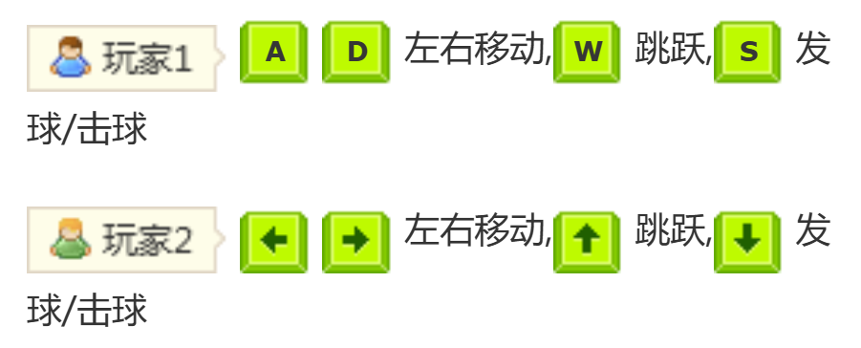

**Try your best to have fun!!!**