**CompE-271**

* I declare that all material in this assignment is my own work except where there is clear reference to the work of others.
* I have read, understood and agree to the SDSU Policy on Plagiarism and Cheating on the university website at <http://go.sdsu.edu/student_affairs/srr/cheating-plagiarism.aspx> , the syllabus and the student-teacher contract for the consequences of plagiarism, including both academic and punitive sanctions.

___________________________________________________________________

*Remark*. By submitting this assignment report electronically, you are deemed to have signed the declaration above.*

9/22/2019

[Homework #3]

[Homework 3]

Ckick below to enter/change your Name and RedID

Ethan Nagelvoort, 821234668

**Content**

(* - Mandatory)

1*. Description of the problem/method

I mainly had to create the function checkEndianess(), which returns an int and has nothing in the parameters. The function is meant to return 0 if the machine uses little endian notation and 1 if the machine uses big endian notation. To do this, I declared an int num to equal 0x89AB and an int endian to equal 0. Then I stored num into a char pointer as followed: char *check = (char*) &num. I did this because the size of characters is one byte and so when the char* is dereferenced, *check will contain the first byte of num. Then depending on what that first byte contains; you can determine weather the machine uses little or big endian. I used two if statements to do this, if *check equals 0x89, then the machine uses big endian notation and endian would now equal 1. Then if *check equals 0xAB, then the machine uses small endian notation and endian would now equal 0.

2. Pseudocode (if required. Mandatory for the Lab assignments, starting from #5 and Projects)

3*. C-code

#include <stdio.h>

#include <stdlib.h>

#include <math.h>

#include <string.h>

extern int checkEndianess() ;

int main()

{

int check; // Variable: "check" will hold the value returned by the function

//Call the function to check the Endianness here

// This is where your function will be called to return endianness

check = checkEndianess ();

if (check == 0)

{

printf ("Machine/Architecture is Little Endian. \n");

}

else

{

printf ("Machine/Architecture is Big Endian. \n");

}

// TODO for TAs and Students who will use this function to check the student function

// TODO Write the code to check the value returned by the function

// TODO print if the system uses little Endian or big Endian notation

return(0);

}

/* Function "checkEndianess" checks the Endianness of the machine on which

this program is executed.

The function should return 0 if the architecture is "Little Endian" and

return 1 if the architecture is "Big Endian".

*/

#include <stdio.h>

#include <stdlib.h>

#include <math.h>

#include <string.h>

int checkEndianess()

{

int num = 0x89AB;

int endian = 0;

char *check = (char*) &num;

if (*check == 0x89)

{

endian = 1;

}

if(*check == 0xAB)

{

endian = 0;

}

return endian;

}

4*. Screen capture of the code and the resulting display(s)

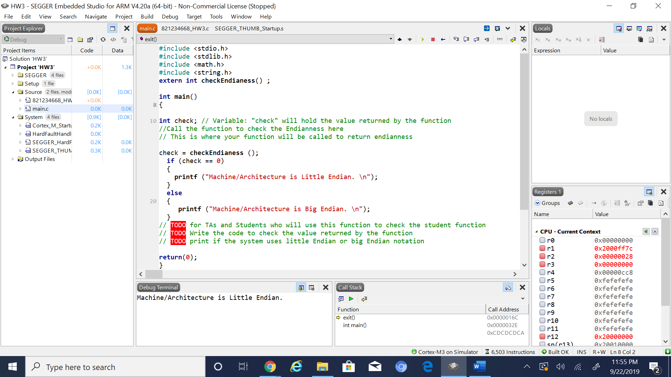

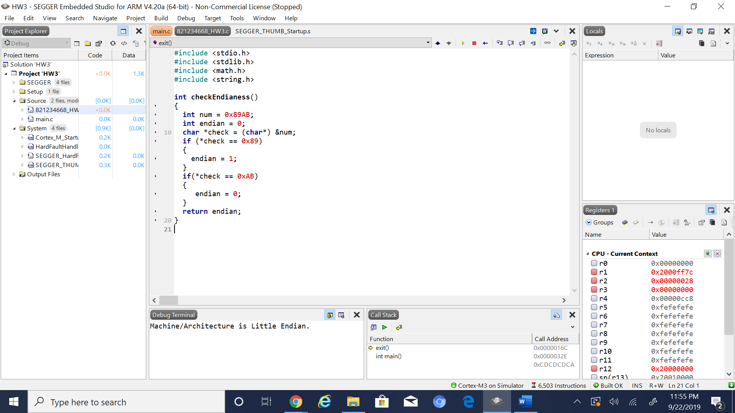

5. Conclusion (if applicable)

6*. References.

Professor Arnolds slides on blackboard on chapter 6, mainly the part about big and little endian.