**NYCU OS HW1 report 2021**

|  |  |  |  |
| --- | --- | --- | --- |
| Name | 吳原博 | Student Id | 0816004 |

**Q1. hw1_1**

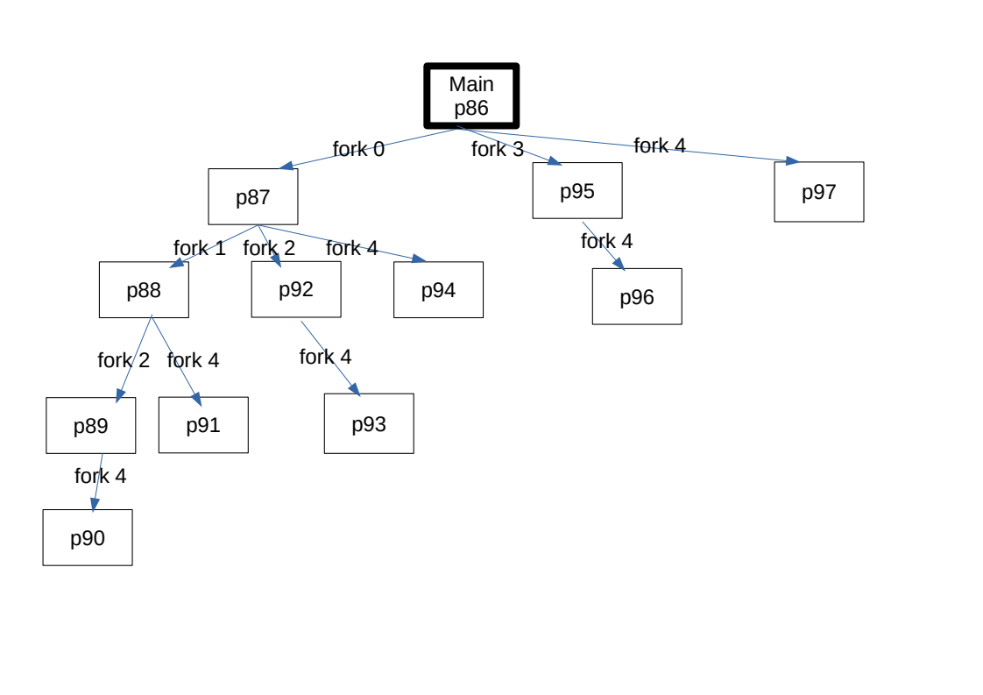Tree format(according to OS_HW1.pdf/p.7):

|  |
| --- |
|  |

**註解：方塊內的 p86等代表 process 40686，那是實際執行程式後印出的 process id 後兩碼**

**Q2. hw1_2**

Please put your result(screenshot).

Also, write down the problems you met and solutions.

|  |
| --- |
| Result |
| Problems & solutions  剛學習 fork 和 wait 函數在實際撰寫 code 時常常在細節上出錯，不過多花點時間習慣後也終於可以完成作業 |

**Q3. hw1-3**

Please put your result(screenshot).

|  |
| --- |
|  |