SQL查询作业

1.查询每个制造商及其生产的最低价格的笔记本型号

select P.maker,L.model

from Laptop L

join Product P on L.model = P.model

join(select P_sub.maker,MIN(L_sub.price) as min_price

from Laptop L_sub

join Product P_sub on L_sub.model = P_sub.model

group by P_sub.maker

) as MinPrices on P.maker = MinPrices.maker and L.price = MinPrices.min_price;

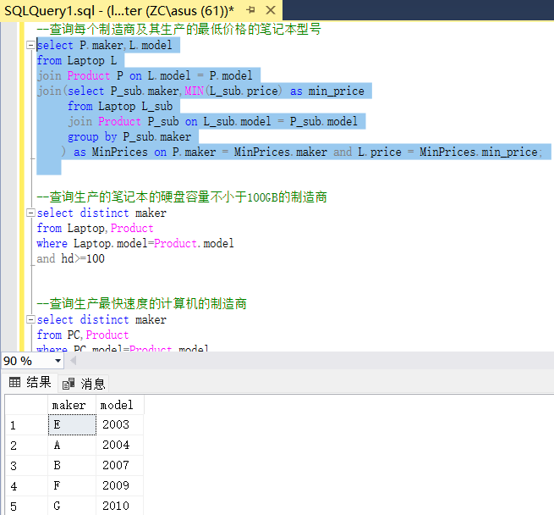

2.查询生产的笔记本的硬盘容量不小于100GB的制造商

select distinct maker

from Laptop,Product

where Laptop.model=Product.model

and hd>=100

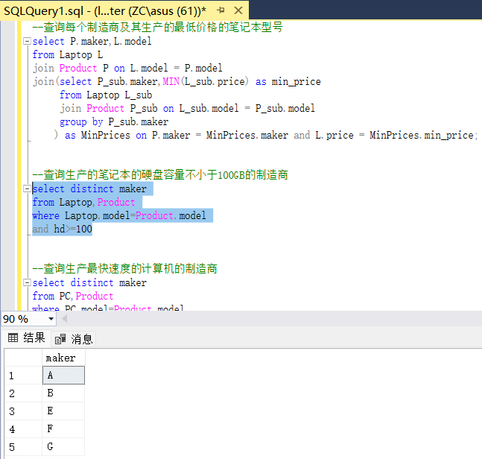

3.查询生产最快速度的计算机的制造商

select distinct maker

from PC,Product

where PC.model=Product.model

and speed >=ALL(

select speed

from PC

)

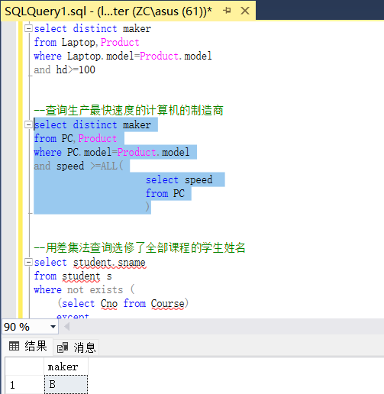

4.用差集法查询选修了全部课程的学生姓名

select student.sname

from student s

where not exists (

(select Cno from Course)

except

(select Cno from SC where Sno = s.Sno)

)