How to use RAK14007
- Introduction
RAK14007 is a joystick and only can be connected with fpc in slot IO. Its IC is same as RAK12035, ATTiny441. It supports 5 keys and x-y direction move.
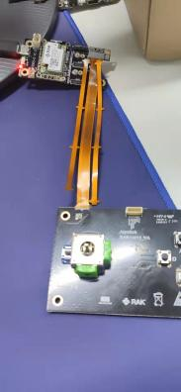

- Use in Arduino
We provide two examples about this module.



2.1 RAK14007_ATTINY441_Joystick
It shows how to use the key and joystick. There are 5 keys and x-y joystick.

2.2 RAK14007_ATTINY441_Joystick_SetI2C
We support i2c address change, so user can use this example to change the I2C slave address. The default address is 0x21, it will be stored in EEPROM of ATTINY441. When write successfully, it will effect after power off and then power on.

2.3 RRAK14007_ATtiny441_Firmware
Firmware of Attiny441, no advise to change.

2.4 RAK14007_ATTINY441_SetThreshold
This example can set the left and right threshold of X, up ad down threshold of Y. The middle position of X and Y are 507,507. The whole range is from 1-1024.

- About the ATTINY441
Actually there is a 8-bit AVR on the RAK14007, which also needs firmware. We will not open this part of code. Because ATTINY441 is really different to upload, no matter use ISP tools or Arduino. During the upload, if user is not really carefully with its fuse set, it will completely dead, which means there is no any way to save it.... We have 4 dead board now..... The code of firmware is not the key point, but if user want to use own code, it is easy to make it dead. We will not open it because of the support is a question and risk is really high. We will burn it in factory.
So we just use it as a normal I2C sensor. Below is the information:
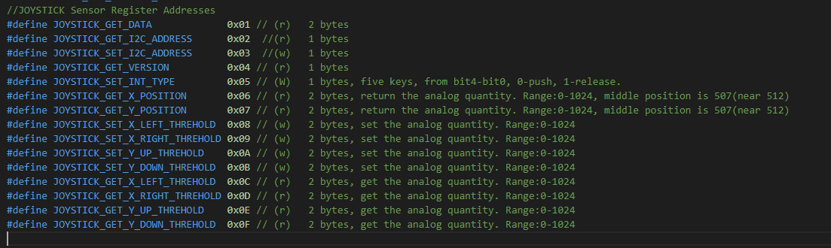

- How to upload ATTiny441
This part is just internal illustrate, do not open to user. Ready to install
ATtiny core, add below to preference in IDE. Search for Attiny in tools-Boards Manager

http://drazzy.com/package_drazzy.com_index.json

Install this.
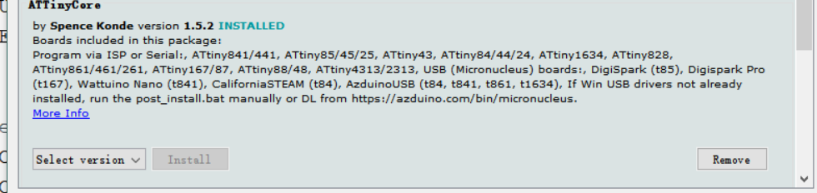

1. Use Arduino nano as the programmer tool. Choose the Arduino ISP example and upload.
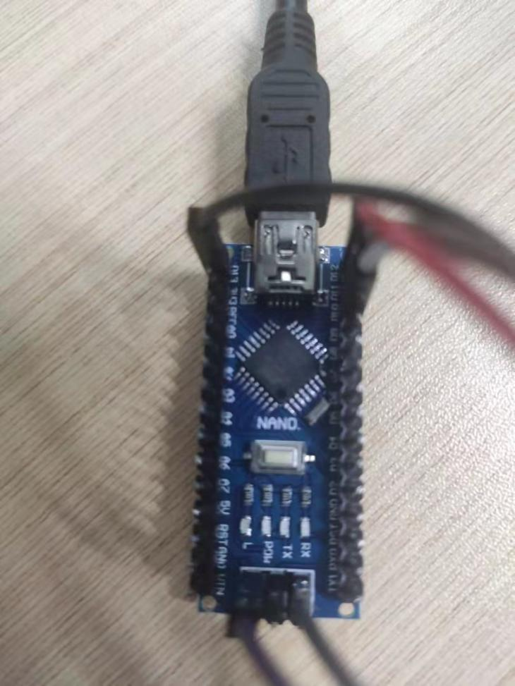
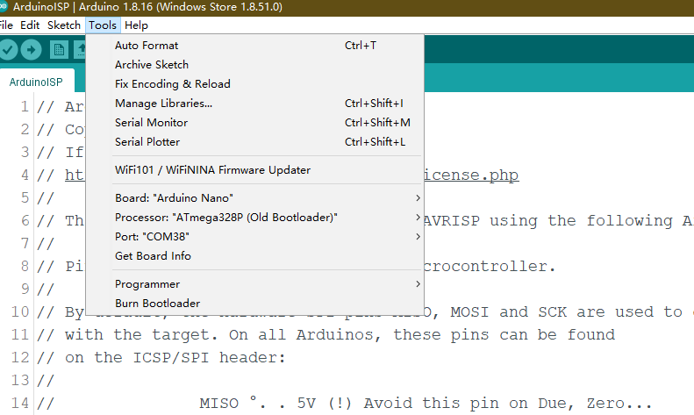 2. Connect the RAK14007 with Arduino nano,maybe need to make the lines by yourself. And then choose the in Arduino like below. Remember to click the Burn bootloader to upload.

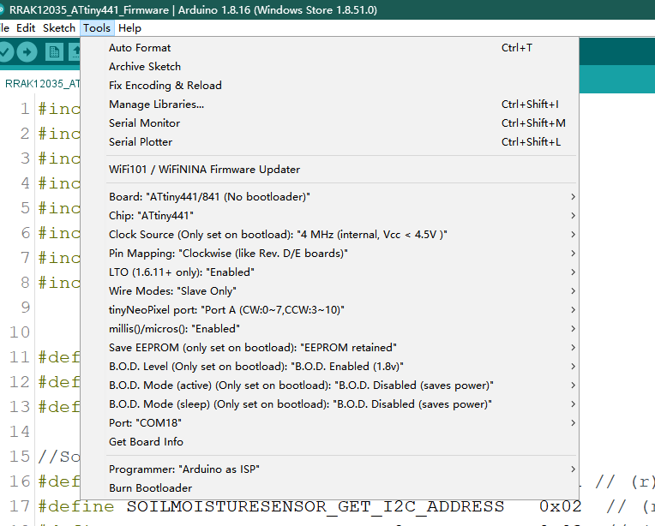

- Finally use normal upload way to upload code.
