江南大学物联网工程学院实验报告
课程名称 《计算机图形学》 实验名称 Ex1: Interactive 2d drawing 实验日期 2017.10.19
班级 计科1404 姓名 阎覃 学号 1030414414
实验报告要求 1．实验目的 2．实验内容 3．实验步骤 4．运行情况 5．实验体会
- 实验目的
使用GLUT和OPENGL实现2D绘图操作。
- 实验内容
- 用鼠标绘制一条直线
- 用鼠标绘制许多图形
- 实验步骤

操作系统为macOS Sierra 使用Windows时需要稍作修改。

CMakeLists.txt

cmake_minimum_required(VERSION 3.6)
project(ex1)
set(CMAKE_CXX_FLAGS "${CMAKE_CXX_FLAGS} -std=c++11 -framework GLUT -framework OpenGL")
set(SOURCE_FILES main.cpp Entities/Entity2D.h Entities/Point2D.h Entities/Line2D.cpp Entities/Line2D.h Tools/Tool.h Tools/LineTool.cpp Tools/LineTool.h App.h App.cpp Entities/Polygon2D.cpp Entities/Polygon2D.h Tools/PolygonTool.cpp Tools/PolygonTool.h Entities/Circle2D.cpp Entities/Circle2D.h Tools/CircleTool.cpp Tools/CircleTool.h)
add_executable(ex1 ${SOURCE_FILES})

main.cpp

#include "App.h"
#pragma clang diagnostic push
#pragma clang diagnostic ignored "-Wdeprecated-declarations"
int main(int argc, char **argv) {
glutInit(&argc, argv);
App::init(500, 500, "Lighthouse3D - GLUT Tutorial");
return 0;
}
#pragma clang diagnostic pop

App.h
//
// Created by Ethan on 2017/10/25.
//
#ifndef EX1_APP_H
#define EX1_APP_H
#include <vector>
#include <cstdlib>
#include "Entities/Entity2D.h"
#include "Entities/Point2D.h"
#ifdef __APPLE__
#include <GLUT/glut.h>
#else
#include <GL/glut.h>
#endif
class Tool;
class App {
private:
App(int width, int height, const char *title) : view_width(width), view_height(height), title(title) {};
static App *instance;
void resizeScene(int width, int height);
void renderScene();
void createGlutMenus();
void changeTool(Tool *tool);
void clearEntities();
public:
App(const App &) = delete;
App &operator=(const App &) = delete;
static void init(int width, int height, const char *title);
static App *getInstance() {
return instance;
}
//Called once when the application starts and again every time the window is resized by the user.
static void sResizeScene(int width, int height);
static void sRenderScene();
static void sMouseFunc(int button, int state, int x, int y);
static void sPassiveMotionFunc(int x, int y);
static void sMotionFunc(int x, int y);
static void sMenuEvent(int option);
int view_width = 500, view_height = 500;
const char *title = "";
float left = -100, right = 100, bottom = -100, top = 100;
Tool *currentTool = nullptr;
std::vector<Entity2D *> entities;
enum Menu {
SPACE, CLEAR, LINE, POLYGON,CIRCLE, QUIT
};
Point2D convertPoint(Point2D p);
};
#endif //EX1_APP_H

App.cpp
//
// Created by Ethan on 2017/10/25.
//
#pragma clang diagnostic push
#pragma clang diagnostic ignored "-Wdeprecated-declarations"
#include "App.h"
#include "Tools/Tool.h"
#include "Tools/LineTool.h"
#include "Tools/PolygonTool.h"
#include "Tools/CircleTool.h"
App *App::instance = nullptr;
void App::renderScene() {
glClear(GL_COLOR_BUFFER_BIT | GL_DEPTH_BUFFER_BIT);
for (auto &entity :entities) {
entity->drawMe();
}
glutSwapBuffers();
}
void App::resizeScene(int width, int height) {
//--------------reset the viewport--------------
// avoid divide by zero
if (height == 0) {
height = 1;
}
view_width = width;
view_height = height;
// reset the viewport to the new dimensions
glViewport(0, 0, width, height);
}
void App::changeTool(Tool *tool) {
delete currentTool;
currentTool = tool;
char str[100];
sprintf(str, "%s [%s]", title, tool->name);
glutSetWindowTitle(str);
}
// static functions
void App::sRenderScene() {
instance->renderScene();
}
void App::sResizeScene(int width, int height) {
instance->resizeScene(width, height);
}
void App::sMouseFunc(int button, int state, int x, int y) {
instance->currentTool->mouseFunc(button, state, x, y);
}
void App::sPassiveMotionFunc(int x, int y) {
instance->currentTool->passiveMotionFunc(x, y);
}
void App::sMotionFunc(int x, int y) {
instance->currentTool->motionFunc(x, y);
}
void App::createGlutMenus() {
glutCreateMenu(sMenuEvent);
glutAddMenuEntry("Line", LINE);
glutAddMenuEntry("Polygon", POLYGON);
glutAddMenuEntry("Circle", CIRCLE);
glutAddMenuEntry("Clear", CLEAR);
glutAddMenuEntry("------------", SPACE);
glutAddMenuEntry("Exit", QUIT);
glutAttachMenu(GLUT_RIGHT_BUTTON);
}
void App::sMenuEvent(int option) {
switch (option) {
case LINE:
getInstance()->changeTool(new LineTool());
break;
case POLYGON:
getInstance()->changeTool(new PolygonTool());
break;
case CIRCLE:
getInstance()->changeTool(new CircleTool());
break;
case CLEAR:
getInstance()->clearEntities();
break;
case QUIT:
exit(0);
default:
break;
}
}
void App::init(int width, int height, const char *title) {
delete instance;
instance = new App(width, height, title);
glutInitDisplayMode(GLUT_DEPTH | GLUT_DOUBLE | GLUT_RGBA);
glutInitWindowPosition(500, 500);
glutInitWindowSize(width, height);
glutCreateWindow(title);
gluOrtho2D(instance->left, instance->right, instance->bottom, instance->top);
glutReshapeFunc(sResizeScene);
glutDisplayFunc(sRenderScene);
glutMouseFunc(sMouseFunc);
glutPassiveMotionFunc(sPassiveMotionFunc);
glutMotionFunc(sMotionFunc);
instance->createGlutMenus();
instance->changeTool(new LineTool());
glutMainLoop();
}
// static functions end
void App::clearEntities() {
auto tmp = entities;
entities.clear();
for (auto &entity : tmp) {
delete entity;
}
glutPostRedisplay();
}
Point2D App::convertPoint(Point2D p) {
p.y = view_height - p.y;
float xf = (p.x - (float) view_width / 2) / view_width * (right - left);
float yf = (p.y - (float) view_height / 2) / view_height * (top - bottom);
return {xf, yf};
}
Entities/Point2D.h
//
// Created by Ethan on 2017/10/19.
//
#ifndef EX1_POINT2D_H
#define EX1_POINT2D_H
class Point2D {
public :
float x = 0, y = 0;
Point2D() = default;
Point2D(int x, int y) : x(x), y(y) {}
Point2D(float x, float y) : x(x), y(y) {}
};
#endif //EX1_POINT2D_H

Entities/Entity2D.h
//
// Created by Ethan on 2017/10/19.
//
#ifndef EX1_ENTITY2D_H
#define EX1_ENTITY2D_H
#ifdef __APPLE__
#include <GLUT/glut.h>
#else
#include <GL/glut.h>
#endif
class Entity2D {
public:
virtual void drawMe()= 0;
virtual ~Entity2D() = default;
};
#endif //EX1_ENTITY2D_H

Entities/Line2d.h

//
// Created by Ethan on 2017/10/24.
//
#ifndef EX1_LINE2D_H
#define EX1_LINE2D_H
#include <iostream>
#include "Entity2D.h"
#include "Point2D.h"
class Line2D : public Entity2D {
public:
void drawMe() override;
~Line2D() override {
std::cout << "Line cleaned" << std::endl;
}
Point2D sP, eP;
};
#endif //EX1_LINE2D_H

Entities/Line2d.cpp
//
// Created by Ethan on 2017/10/24.
//
#include "Line2D.h"
void Line2D::drawMe() {
glBegin(GL_LINES);
{
glVertex2f(sP.x, sP.y);
glVertex2f(eP.x, eP.y);
}
glEnd();
}
Entities/Polygon2D.h

//
// Created by Ethan on 2017/10/26.
//
#ifndef EX1_POLYGON2D_H
#define EX1_POLYGON2D_H
#include <iostream>
#include <vector>
#include "Entity2D.h"
#include "Point2D.h"
class Polygon2D : public Entity2D {
public:
void drawMe() override;
~Polygon2D() override {
points.clear();
std::cout << "Polygon cleaned" << std::endl;
}
std::vector<Point2D> points;
};
#endif //EX1_POLYGON2D_H

Entities/Polygon2D.cpp
//
// Created by Ethan on 2017/10/26.
//
#include "Polygon2D.h"
void Polygon2D::drawMe() {
glBegin(GL_POLYGON);
{
for (auto &point : points)
glVertex2f(point.x, point.y);
glVertex2f(points.front().x, points.front().y);
}
glEnd();
}
Entities/Circle2D.h

//
// Created by Ethan on 2017/10/30.
//
#ifndef EX1_CIRCLE2D_H
#define EX1_CIRCLE2D_H
#include <iostream>
#include "Entity2D.h"
#include "Point2D.h"
class Circle2D : public Entity2D {
public:
void drawMe() override;
~Circle2D() override {
std::cout << "Circle cleaned" << std::endl;
}
Point2D centre;
float radius;
float n = 50;
const float PI=3.1415926f;
};
#endif //EX1_CIRCLE2D_H

Entities/Circle2D.cpp
//
// Created by Ethan on 2017/10/30.
//
#include "Circle2D.h"
#include <cmath>
void Circle2D::drawMe() {
glBegin(GL_POLYGON);
{
for (int i = 0; i < n; i++) {
float x = centre.x + radius * cosf(2 * PI * i / n);
float y = centre.y + radius * sinf(2 * PI * i / n);
glVertex2f(x, y);
}
}
glEnd();
}

Tools/Tool.h
//
// Created by Ethan on 2017/10/24.
//
#ifndef EX1_RUBBLETOOL_H
#define EX1_RUBBLETOOL_H
#include "../App.h"
class Tool {
protected:
Entity2D *entity;
App *app = App::getInstance();
public:
const char *name;
explicit Tool(const char *name) {
this->name = name;
}
virtual void mouseFunc(int button, int state, int x, int y) = 0;
virtual void passiveMotionFunc(int x, int y) = 0;
virtual void motionFunc(int x, int y) = 0;
virtual ~Tool() = default;
};
#endif //EX1_RUBBLETOOL_H

Tools/LineTool.h
//
// Created by Ethan on 2017/10/25.
//
#ifndef EX1_LINETOOL_H
#define EX1_LINETOOL_H
#include "../Entities/Line2D.h"
#include "Tool.h"
class LineTool : public Tool {
private:
bool first;
public:
explicit LineTool() : Tool("Line") {
first = true;
}
void mouseFunc(int button, int state, int x, int y) override;
void passiveMotionFunc(int x, int y) override;
void motionFunc(int x, int y) override;
};
#endif //EX1_LINETOOL_H

Tools/LineTool.cpp
//
// Created by Ethan on 2017/10/25.
//
#include "LineTool.h"
#pragma clang diagnostic push
#pragma clang diagnostic ignored "-Wdeprecated-declarations"
void LineTool::passiveMotionFunc(int x, int y) {
if (!first) {
Point2D p = app->convertPoint({x, y});
((Line2D *) entity)->eP = p;
glutPostRedisplay();
}
}
void LineTool::mouseFunc(int button, int state, int x, int y) {
if (state == GLUT_DOWN && button == GLUT_LEFT_BUTTON) {
Point2D p = app->convertPoint({x, y});
if (first) {
entity = new Line2D;
((Line2D *) entity)->sP = ((Line2D *) entity)->eP = p;
App::getInstance()->entities.push_back(entity);
} else {
((Line2D *) entity)->eP = p;
}
first = !first;
glutPostRedisplay();
}
}
void LineTool::motionFunc(int x, int y) {
}
#pragma clang diagnostic pop

- 运行情况
程序启动时为黑色背景，标题显示了当前绘制的图形为Line。右键菜单可以选择当前绘制的图形
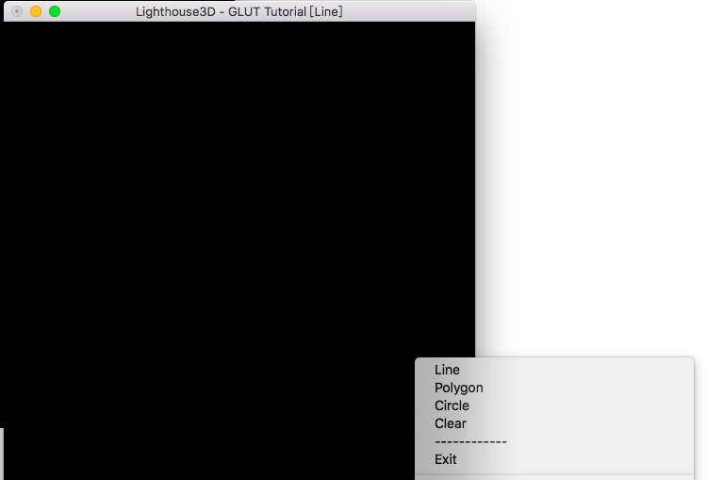
本程序支持绘制直线，多边形，圆形。
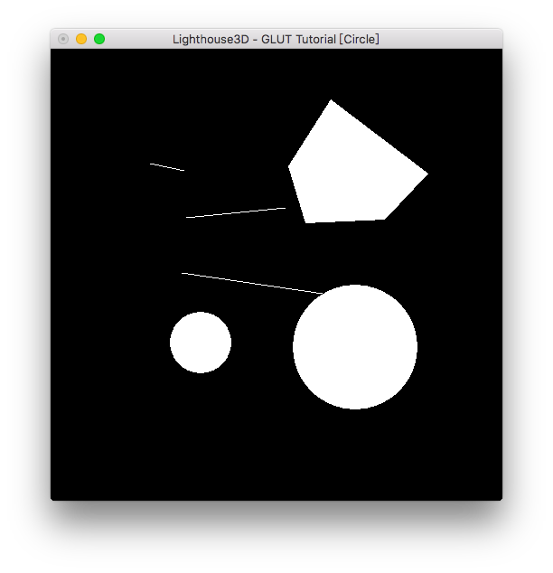
选择Clear可以清空当前所有图形。

- 实验体会
通过这次实验，我复习了C++的很多内容，尤其是类和对象方面，我使用了纯虚函数将基类作为接口。在类互相引用的时候，还需要注意前向声明，否则会报错。在清空图形的时候，还需要注意重载析构函数，基类析构函数必须声明为虚函数，否则将会造成内存泄漏。
教师评价 | 优 |  | 良 |  | 中 |  | 及格 |  | 不及格 |  | 教师签名 |  | 日期

